Student ID : | 24CS104 | Student Name: | Dharmik Vaghani
Subject code &  Name : | ITUE301: Advanced Web  Development  Frameworks | Practical : | 7 | Academic Year : | 2026-27

Task - 7
Aim
To implement secure token-based user authentication using JSON Web Tokens (JWT) and bcryptjs password hashing, constructing an Express authentication pipeline with registration, login, and custom authentication middleware to protect private API endpoints against unauthorized access.
Code
GitHub Link / Repository Link: https://github.com/Dharmikvaghani/AWDF-PRACTICAL.git
Key Implementation Highlights:
1. User model password encryption using bcryptjs salt rounds in pre-save middleware.
2. JWT token issuance upon registration/login with 7-day expiration.
3. authMiddleware verifying Authorization: Bearer <token> headers and attaching user context.

// middleware/auth.js
export const authenticate = (req, res, next) => {
const authHeader = req.headers.authorization;
if (!authHeader?.startsWith('Bearer ')) {
return res.status(401).json({ error: 'Unauthorized: Missing token' });
}
const token = authHeader.split(' ')[1];
try {
req.user = jwt.verify(token, process.env.JWT_SECRET);
next();
} catch (err) {
res.status(401).json({ error: 'Unauthorized: Invalid token' });
}
};
Output

Output
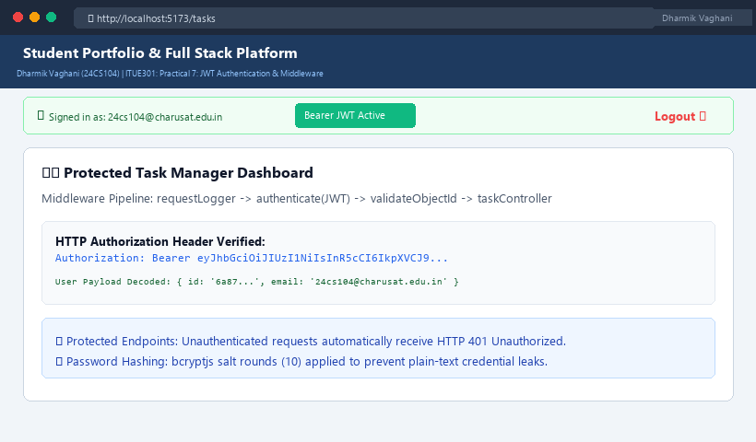
Figure 7: Execution Output & Functional Verification for Practical 7

