Student ID : | 24CS104 | Student Name: | Dharmik Vaghani
Subject code &  Name : | ITUE301: Advanced Web  Development  Frameworks | Practical : | 8 | Academic Year : | 2026-27

Task - 8
Aim
To optimize the performance and bundle delivery of a React web application using code-splitting via React.lazy() and Suspense, isolating component re-renders with React.memo(), memoizing expensive operations with useMemo() and useCallback(), and configuring Vite manual chunk splitting.
Code
GitHub Link / Repository Link: https://github.com/Dharmikvaghani/AWDF-PRACTICAL.git
Key Implementation Highlights:
1. Lazy loaded components (TaskAnalytics) dynamically imported on demand with skeleton fallback.
2. TaskItem wrapped in React.memo with internal edit state to eliminate full-list re-renders.
3. Vite manualChunks splitting vendor-react and vendor-router into independent cached bundles.

// frontend/src/pages/TaskManager.jsx
const TaskAnalytics = lazy(() => import('../components/TaskAnalytics'));
// vite.config.js (Chunk Splitting)
build: {
rollupOptions: {
output: {
manualChunks(id) {
if (id.includes('node_modules/react') || id.includes('node_modules/react-dom')) return 'vendor-react';
if (id.includes('node_modules/react-router')) return 'vendor-router';
}
}
}
}
Output

Output
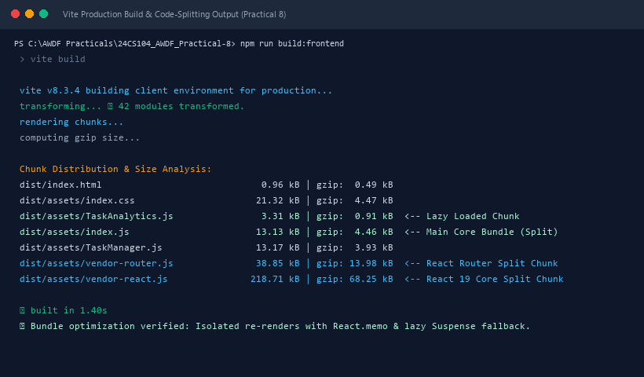
Figure 8: Execution Output & Functional Verification for Practical 8

