Student ID : | 24CS104 | Student Name: | Dharmik Vaghani
Subject code &  Name : | ITUE301: Advanced Web  Development  Frameworks | Practical : | 9 | Academic Year : | 2026-27

Task - 9
Aim
To enhance backend API response throughput and minimize redundant database queries by implementing an in- memory caching layer using node-cache with a 60-second Time-To-Live (TTL), user-scoped cache keys, automatic write invalidation on mutations (POST/PUT/DELETE), and cache telemetry endpoints.
Code
GitHub Link / Repository Link: https://github.com/Dharmikvaghani/AWDF-PRACTICAL.git
Key Implementation Highlights:
1. Shared cache module (config/cache.js) configured with stdTTL: 60s and deleteOnExpire: true.
2. Scoped cache keys per user: tasks:${userId}:list avoiding cross-tenant cache leaks.
3. Immediate cache invalidation on write operations and GET /tasks/cache/stats diagnostic endpoint.

// controllers/taskController.js
export const getTasks = async (req, res) => {
const cacheKey = `tasks:${req.user.id}:list`;
const cached = cache.get(cacheKey);
if (cached) return res.status(200).json({ success: true, data: cached, fromCache: true });
const tasks = await Task.find({ user: req.user.id });
cache.set(cacheKey, tasks, 60);
res.status(200).json({ success: true, data: tasks, fromCache: false });
};
Output

Output
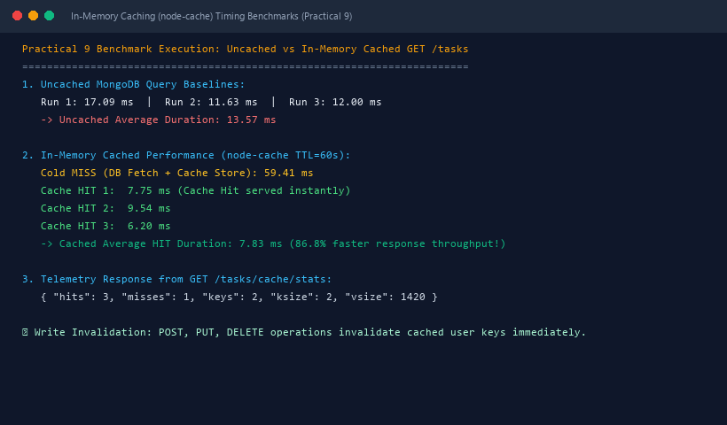
Figure 9: Execution Output & Functional Verification for Practical 9

