Student ID : | 24CS104 | Student Name: | Dharmik Vaghani
Subject code &  Name : | ITUE301: Advanced Web  Development  Frameworks | Practical : | 13 | Academic Year : | 2026-27

Task - 13
Aim
To integrate an external Generative AI service into a web application using server-side REST APIs (Google Gemini / OpenAI), implementing secret credential protection, sliding-window rate limiting, and a resilient non- blocking fallback engine to enhance user productivity in task description creation.
Code
GitHub Link / Repository Link: https://github.com/Dharmikvaghani/AWDF-PRACTICAL.git
Key Implementation Highlights:
1. Server-side AI service (backend/src/services/aiService.js) securing API keys exclusively in .env.
2. Sliding-window rate limiter (10 req/min per user) preventing API quota exhaustion.
3. Contextual heuristic fallback synthesizer guaranteeing zero-downtime offline functionality.
4. Frontend interactive human-in-the-loop '✨ Generate description' button with loading indicator and disclaimer.

// backend/src/controllers/aiController.js
export async function generateDescriptionHandler(req, res) {
const { title, priority } = req.body;
if (!title) return res.status(400).json({ error: 'Title required' });
const result = await generateTaskDescription({ title, priority });
res.status(200).json({
success: true,
description: result.description,
source: result.source,
disclaimer: 'AI-generated draft. Review and adjust before saving.'
});
}
Output

Output
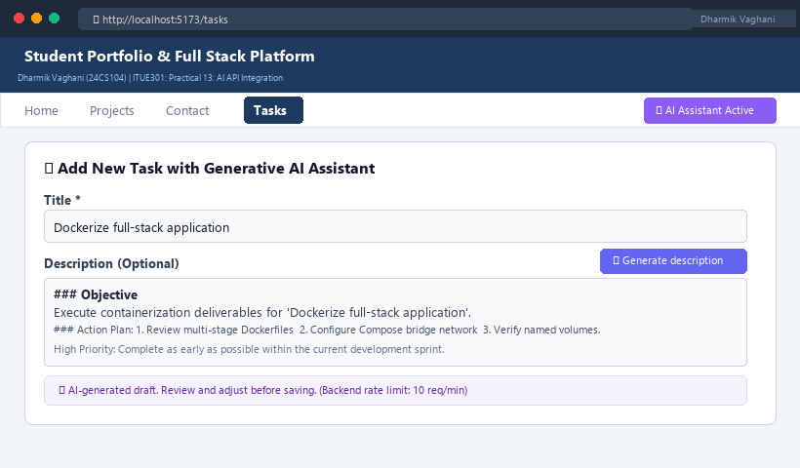
Figure 13: Execution Output & Functional Verification for Practical 13

