

Chapter-1

Introduction



**1.1 Existing System**

 Human resource management system is a suite of software applications used to manage human resources and related processes throughout the employee lifecycle. An HRMS enables a company to fully understand its workforce while staying compliant with changing tax laws and labor regulations.

## 1.2 Need for the New System

 It refers to a suite of software that organizations use to manage internal HR functions. From employee data management to payroll, recruitment, benefits, training, talent management, employee engagement, and employee attendance, HRMS software helps HR professionals manage the modern workforce.

## 1.3 Objective of the New System

 The major objective of the system is HR can easily maintain all information of the Employee and also Employee can see all the data related it.

**1.4 Problem Definition**

 HR leaders and staff are the primary users, given that they run day-to-day workforce operations and are responsible for compliance and performance reporting. However, HR isn’t the only department that benefits. Companies can empower managers and employees with self-service for common tasks—an important selling point for younger hires. Executives can use an HRMS to generate data on workforce trends and their business implications



## 1.5 Core Component

 **Web App**

Angular JS Angular 15



.Net MVC

Ionic Bootstrap Html

Css

## 1.6 Project Profile

|  |  |
| --- | --- |
| **Project Title** | HRMS |
| **Technology Used** | **Angular 15**  **.Net MVC**  **Ionic** |
|  | **Prof. Rashmi Chouhan** |
| **Team Member** | **5** |
| **Developed By** | Nandani Borse (ET21MTCA007) Urvashi Borse (ET21MTCA008) Khan Gosiya (ET21MTCA037) Dharmin Prajapati (ET21MTCA074) Anjali Shimpi (ET21MTCA093) |
| **Front End** | Angular JS, Bootstrap, Html, Css |



**1.7 Assumption and Constrains**

 User must have basic knowledge of user interface of the system.  Internet connection is needed.

## 1.8 Advantages and Limitations of the Proposed System

### Advantages :

* HRMS System Provide an effective way to manage employees .
* Manage Attendance of all the employees with face recognition and also store its location which implement in phone.
* Manage Payroll system which contain Appraisal ,Loan Management, Pay slip functionality .
* Employee can see its profile and also its Attendance in App.
* Employee also can download its Pay slip.
* Employee also can download Reports like Employee Report, Pay slip etc.
* Employee also can download Document like Joining letter and Offer later etc .

### Limitations:

* Internet connection is required.



Chapter-2

Requirement Determination & Analysis



## 2.1 Requirement Determination

 To develop any application, it is important to identify the user requirements therefore it is very important to analyze the existing application.

 During analysis, initially, we started with studying the web with specification documents to understand the system and refer to an existing system. We started to collect the basic requirements of the web. During the discussion of the system, we had questions and answers in between the discussion, which helps us to clear the idea about the system. We met us project guide with basic details. He told us the changes to be made in the work completed.

 By discussion We were able to get a lot of important information for the proposed web We observed that output the personnel give to their existing application and what kind of output they are getting.

 The new web is proposed to organize all the above activities so the work becomeseasy and any person can operate the app easily.



## 2.2 Targeted Users

 HR(Admin)

Manage Login Manage Employee Manage Dashboard



Manage Employee Data View Employee Attendance

Manage Employee Salary Details

Employee

View Own Profile View Own Attendance



Manage Own Attendance View Own Salary Details



Chapter-3

System Design





## 3.1 Use Case Diagram

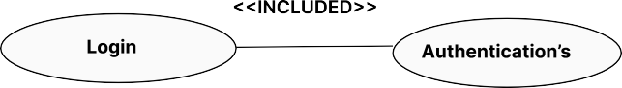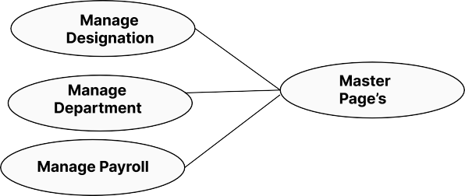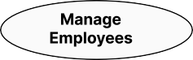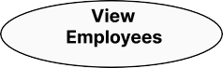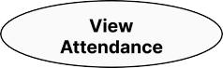

**[Figure: 3.1.1 Use Case Diagram for HR( Admin)]**

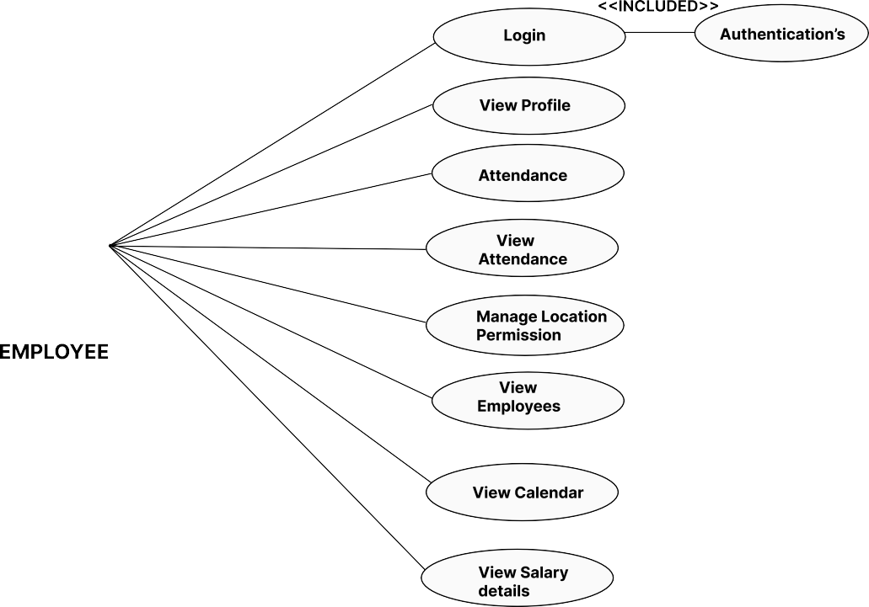

**[Figure: 3.1.2 Use Case Diagram for Employee (Application)]**



## 3.2 Interaction Diagram



### [Figure: 3.2.1 Interaction Diagram for Admin.]



**[Figure: 3.2.1 Interaction Diagram for App.]**



## 3.3Activity Diagram

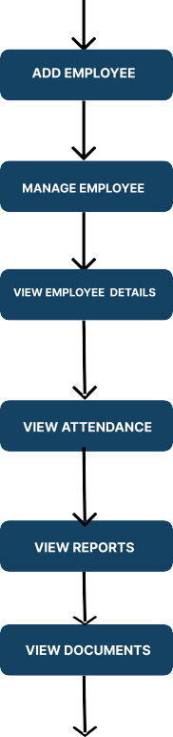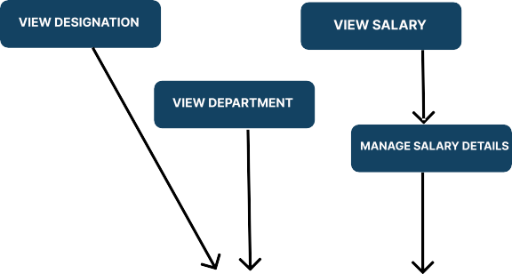

### [Figure: 3.3.1 Activity Diagram for Web.]

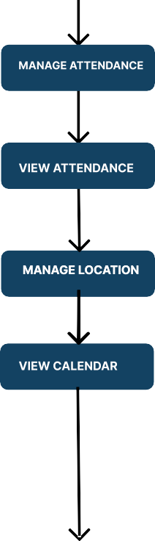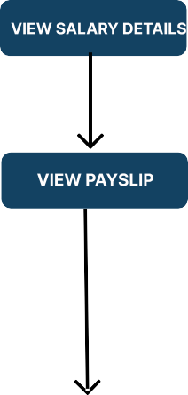

**[Figure: 3.3.2 Activity Diagram for App.]**



Chapter-4

Development

**4.1 Coding Standard**

**Fundamentals**

* + AngularJS is a toolset for building the framework most suited to your application development. It is fully extensible and works well with other libraries.

**Naming**

* Include all the words needed to avoid ambiguity for a person reading code where thename is used.
* Omit needless words. Every word in a name should convey salient information at theuse site.
* Name variables, parameters, and associated types according to their roles, rather thantheir type constraints.

**Conventions**

**File Format**

* **Essential:** These rules help prevent errors, so learn and abide by them at all costs.
* **Strongly Recommended:** These rules have been found to improve readability and/ordeveloper experience in most projects.
* **Recommended:** Where multiple, equally good options exist, an arbitrary choice can be made to ensure consistency. In these rules, we describe each acceptable option andsuggest a default choice.



* + The most basic Angular js project will include an HTML, JavaScript, css, and JQuery Ionic file.



**4.1 Screenshots**

LOGIN PAGE

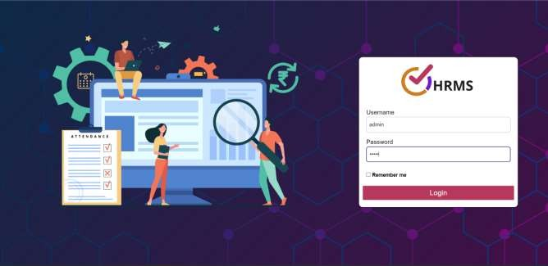



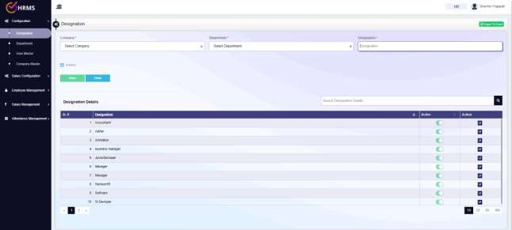





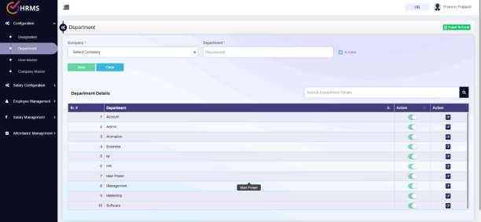

# COMPANY MASTER

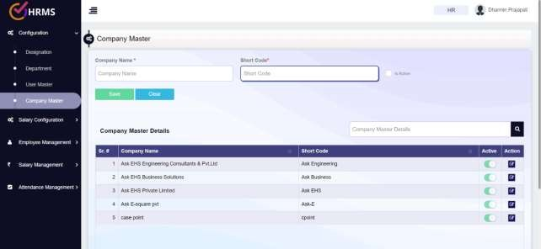





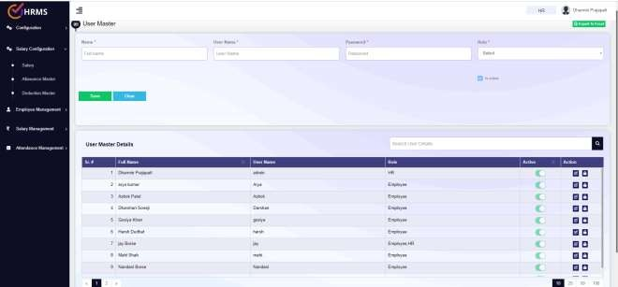

**SALARY MASTER**

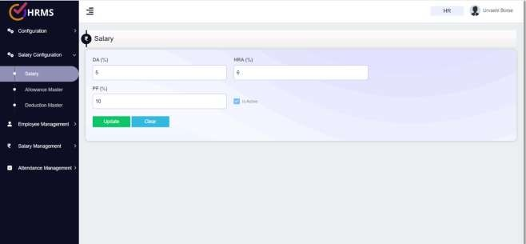



# ALLOWANCE MASTER

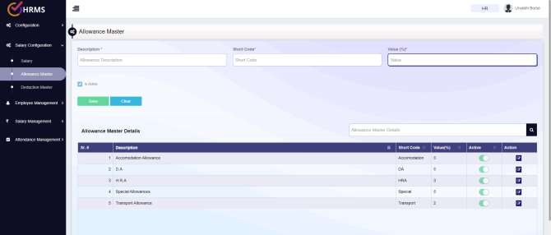

**DEDUCTION MASTER**

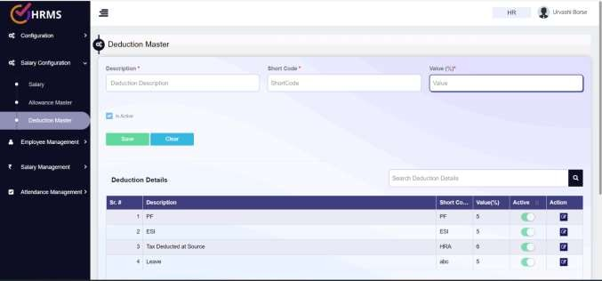





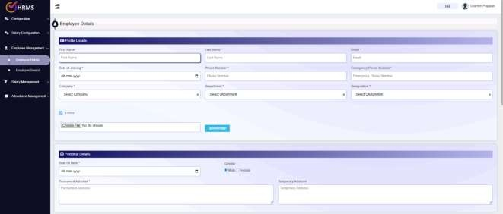

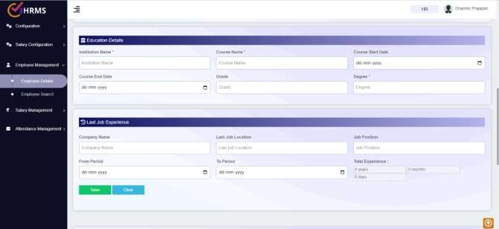



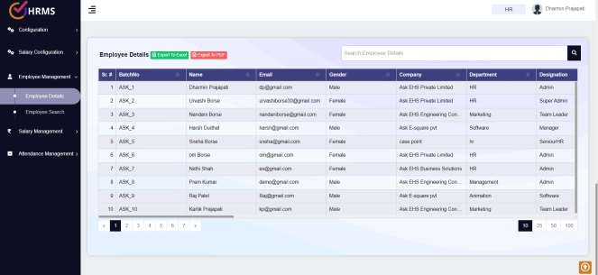



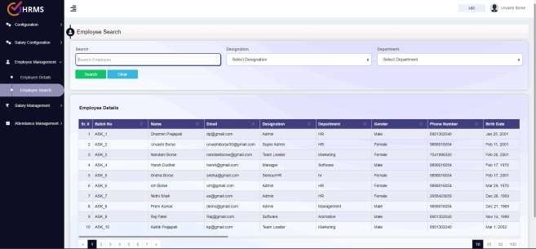





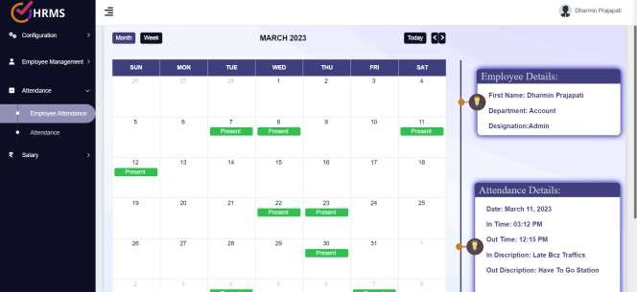

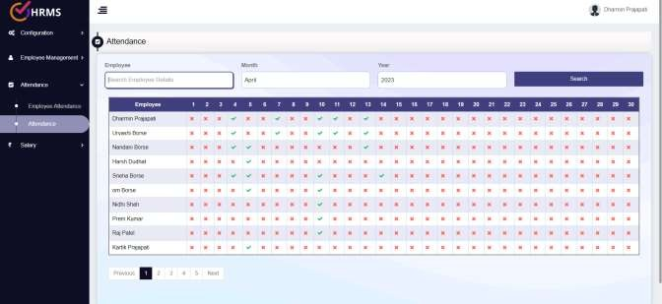



# SALARY MANAGEMENT

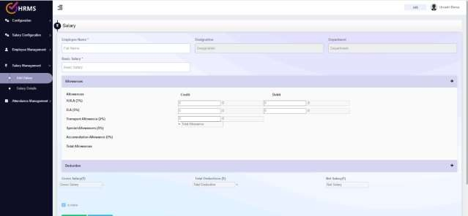

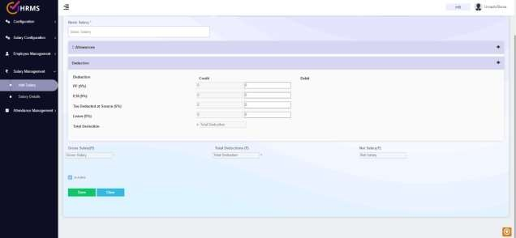



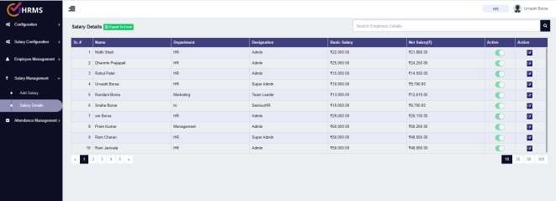

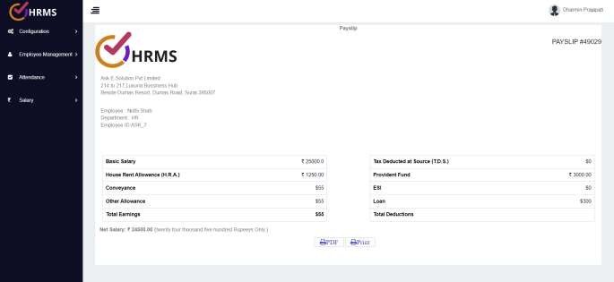



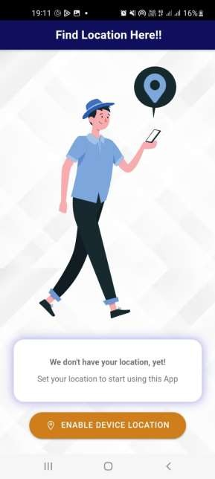 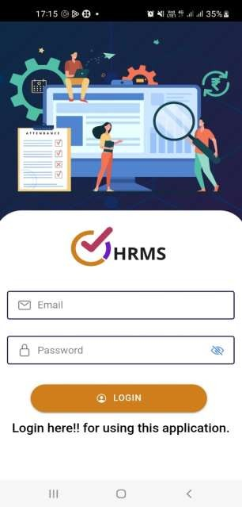



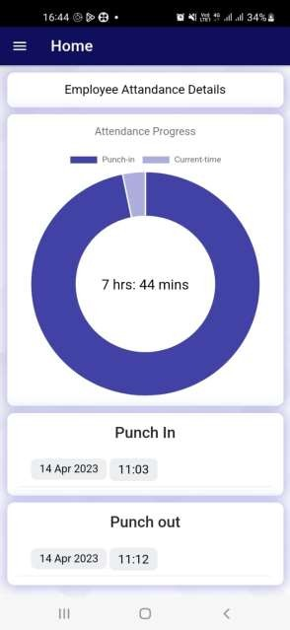 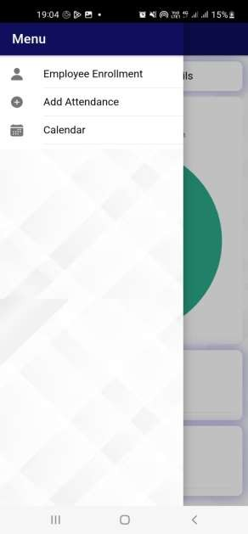



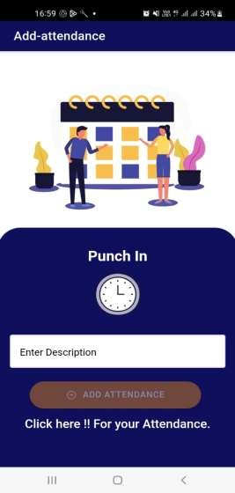 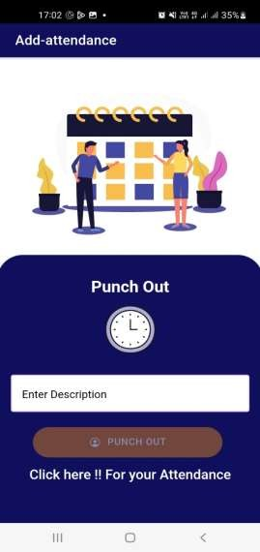



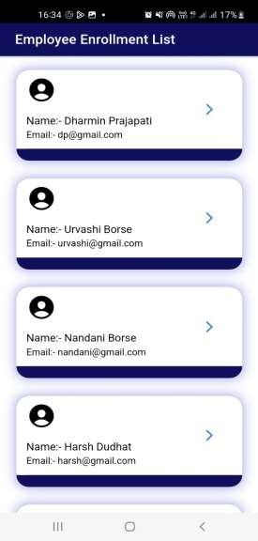 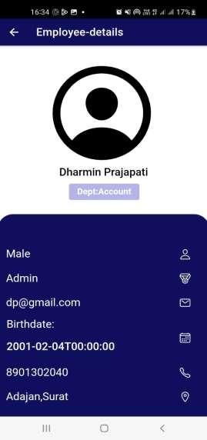



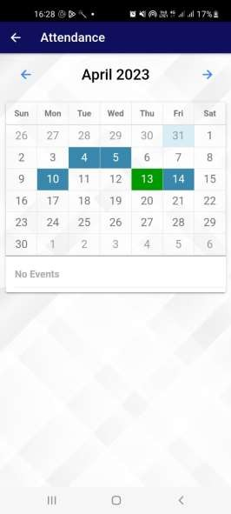 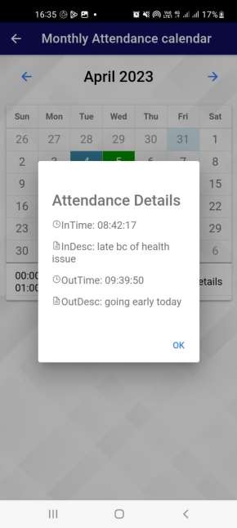



Chapter-5

Agile Documentation

**5.1 Agile Project Charter**

**General Project Information**

**Vision: The main purpose of the project is to offercomplete solution of the need by inspection companies**

### Objective: HR can handle all Employee information like personal data, Attendance, Salary, Etc.

**Organization: Success Criteria:**

### ASK E-Square Business Solutions Pvt. Ltd.. Employee Data can easily handled

**Project Size Estimate:**

### Large scale project - total roles are HR, Employee



**Technology: Approaches:**

### Web application(Angular JS, .Net MVC, Ionic)

**Strategies, methodologies, processes, tools, andtechniques the team will follow.**

|  |  |  |  |  |  |  |  |
| --- | --- | --- | --- | --- | --- | --- | --- |
| **HUMAN RESOURCE MANAGEMENT SYSTEM**  **5.2 Agile Roadmap/Schedule** | | | | | | | |
|  | Home Inspector Tech | **February 9-20** | **February 21-28** | **March**  1 - 10 | **March**  10-20 | **March 21-30** | **April 1-15** |
| Learning Angular JS, Ionic, Bootstrap  .Net |  |  |  |  |  |  |
|  |  |  |  |  |  |
| Some Task Complete in Angular JS and .Net  ,Design |  |  |  |  |  |  |
|  |  |  |  |  |  |
| Address Book Project For GitHub |  |  |  |  |  |  |
|  |  |  |  |  |  |
| Refer Project |  |  |  |  |  |  |
|  |  |  |  |  |  |
| Find New Module |  |  |  |  |  |  |
|  |  |  |  |  |  |
| Create Plan Module and Testing |  |  |  |  |  |  |
|  |  |  |  |  |  |
| Project Related language Change |  |  |  |  |  |  |
|  |  |  |  |  |  |
| Some Bugs slove, testing And document |  |  |  |  |  |  |
|  |  |  |  |  |  |
|  |  |  |  |  |  |
| 33 | | | | | | | |



**5.3 Agile Roadmap/Schedule**

|  |  |
| --- | --- |
| **1st QUARTER** | **2nd QUARTER** |
| **9-02-2023 to 20-02-2023**  **Understand project definition, gatherrequirement and finalize the project scope.** | **21-02-23 to 10-03-2023**  **We design the system and drawvarious diagram such as:**   * **Use Case Diagram** * **Interaction Diagram** * **Data Dictionary** |
| **3rd QUARTER** | **4th QUARTER** |
| **11-03-2023 to 25-03-2023** | **26-03-2023 to 05-04-2023** |
| **We implement the crude operation ofthe project, tested the module and documentation is prepared side by**  **side.** | **We integrate all modules and testedoverall system; whatever changes**  **happen are incorporated also documentation is made side by side.** |
| **FINAL QUARTER** | |
| **14-04-2023**  **Final presentation and final documentation to be done.** | |



**5.4 Agile User Story**

 A user story is a tool used in agile software development to capture a description of a software featurefrom other organization perspective. A user story describes the type of user, what they want and why. A user story helps to create a simplified description of a requirement.

|  |  |  |
| --- | --- | --- |
| **Sr no.** | **Module Name** | **Description** |
| User Story 1 | Storage detail | The detail for different type of storing facility. |
| User Story 2 | Plan | Organization check the plan an after purchase the plan |
| User Story 3 | Developer | Login and check activity |



**5.5 Agile Release Plan**

|  |  |  |  |  |  |
| --- | --- | --- | --- | --- | --- |
| TASK NAME | RESPONSIBL E | STAR T | END | DA YS | STATUS |
| SPRINT 1 | **Nandani Urvashi** | **9/02/23** | **22/02/23** | **13** | Complete |
| Project Definition | **Gosiya**  **Dharmin Anjali** | **9/02/23** | **18/02/23** | **9** | Complete |
| Gather Requirement | **Nandani Urvashi** | **18/02/2**  **3** | **29/02/23** | **11** | Complete |
|  | **Gosiya** |  |  |  |  |
|  | **Dharmin** |  |  |  |  |
|  | **Anjali** |  |  |  |  |
| Project scope | **Dharmin Anjali** | **29/02/23** | **05/03/23** | **7** | Complete |
| SPRINT 2 | **Nandani Urvashi Gosiya Dharmin**  **Anjali** | **05/03/23** | **23/03/22** | **18** | Complete |
| Use Case Diagram | **Anjali** | **05/03/23** | **07/03/23** | **2** | Complete |
| Activity Diagram | **Urvashi Gosiya** | **08/03/23** | **10/03/23** | **2** | Incomplet e |
| Sequence Diagram | **Dharmin** | **10/03/2** | **13/03/2** | **3** | Incomplet |
| **Anjali** | **3** | **3** |  | e |
| SPRINT 3 | **Nandani Gosiya** | **13/03/2**  **3** | **20/03/2**  **3** | **7** | Complete |
|  | **Anjali** |  |  |  |  |
| Testing characters | **Nandani Urvashi** | **13/03/2**  **3** | **01/04/2**  **3** | **19** | Complete |
|  | **Gosiya** |  |  |  |  |
|  | **Dharmin** |  |  |  |  |
|  | **Anjali** |  |  |  |  |
| Test the Module | **Nandani Urvashi** | **14/03/22** | **25/03/2**  **2** | **11** | Complete |
|  | **Gosiya** |  |  |  |  |
|  | **Dharmin** |  |  |  |  |
|  | **Anjali** |  |  |  |  |
| Documentation | **Nandani** | **26/03/2** | **01/04/2** | **7** | Incomplet |
| **Urvashi** | **2** | **1** |  | e |
|  | **Gosiya** |  |  |  |  |



|  |  |  |  |  |  |
| --- | --- | --- | --- | --- | --- |
|  | **Dharmin Anjali** |  |  |  |  |
| SPRINT 4 | **Nandani Urvashi** | **02/04/22** | **04/04/2**  **2** | **3** | Complete |
|  | **Gosiya** |  |  |  |  |
|  | **Dharmin** |  |  |  |  |
|  | **Anjali** |  |  |  |  |
| Integrate Modules | **Anjali** | **05/04/22** | **05/05/2**  **2** | **30** | Complete |
| Test System | **Nandani Urvashi** | **05/04/2**  **2** | **10/04/2**  **2** | **5** | Complete |
|  | **Gosiya** |  |  |  |  |
|  | **Dharmin** |  |  |  |  |
|  | **Anjali** |  |  |  |  |
| Changes Incorporated | **Nandani Urvashi** | **10/04/2**  **2** | **25/04/2**  **2** | **15** | Complete |
|  | **Gosiya** |  |  |  |  |
|  | **Dharmin** |  |  |  |  |
|  | **Anjali** |  |  |  |  |
| Documentation | Nandani Urvashi | 26/04/22 | 30/04/2  2 | 4 | Complete |
|  | Gosiya |  |  |  |  |
|  | Dharmin |  |  |  |  |
|  | Anjali |  |  |  |  |



## 5.6 Agile Test Plan

|  |  |  |  |  |  |  |  |  |
| --- | --- | --- | --- | --- | --- | --- | --- | --- |
| **PROJECT NAME** | | HUMAN RESOURCE MANAGEMENT  SYSTEM | | | **BROWSER** | | **GOOGLE** |  |
| **CHROME** | |
|  | |
| **WRITTEN BY** | | Nandani Borse(ET21MTCA007)  Urvashi Borse(ET21MTCA008) Gosiya Khan (ET21MTCA037) Dharmin Prajapati (ET21MTCA074)  Anjali Shimpi(ET21MTCA093) | | | **DESCRIPTION** | | **09-02-2023** | |
| **TESTED BY** | | Nandani Borse(ET21MTCA007)  Urvashi Borse(ET21MTCA008) Gosiya Khan (ET21MTCA037) Dharmin Prajapati (ET21MTCA074)  Anjali Shimpi(ET21MTCA093) | | | **TESTED ON** | | **25-04-2023** | |
| **TEST #** | **DATE** | **ACTION** | | **EXPECTED RESULTS** | | **ACTUAL RESULTS** | **PASS** | |
| **1** | **27-01-23** | | **Understand definition** | **Understand the objective of**  **definition** | | **Definition is understood.** | ✓ | |
| **2** | **01-02-23** | | **Draw diagrams** | **All the diagrams are drawn**  **correctly.** | | **Diagrams are completed** | ✓ | |
| **3** | **08-02-23** | | **organization data** | **All the details of the organization**  **are stored properly.** | | **Obtained trained data.** | ✗ | |
| **7** | **11-02-23** | | **Module Designs** | **Module designed for system** | | **Designed successfully** | ✗ | |
| **8** | **21-02-23** | | **Test the module** | **Module should be error free** | | **Module has errors** | ✓ | |



|  |  |  |  |  |  |
| --- | --- | --- | --- | --- | --- |
| **9** | **22-03-23** | **Task work flow** | **Check for**  **proper task workflow of the system.** | **completed** | ✓ |
| **10** | **05-03-23** | **Tested overall system** | **System is completed with**  **no errors** | **System works properly** | ✓ |
| **11** | **30-04-23** | **Documentation** | **Report is generated** | **Report generation is**  **completed** | ✓ |



**5.7 Earned-Value and Burn Chart**

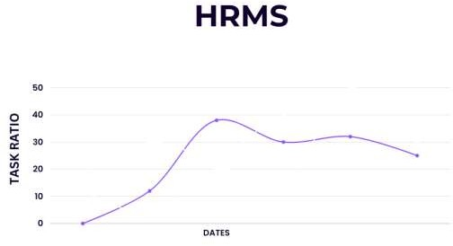



Chapter-6

Proposed Enhancement



**6. Proposed Enhancement**

 Human resource management is the strategic approach to nurturing and supporting employees and ensuring a positive workplace environment.

 Some module’s will be added like leave management or Experience.  Server will be change in future.



Chapter-7

Conclusion



## 7. Conclusion

 The Project is almost complete with all the modules integrated with each other thus, completing the application and making it whole. The client provides further work such as feature requested, live support training, discussion in comment approve.



Chapter-8

Bibliography



## 8. Bibliography

<https://www.w3schools.com/angular/> <https://getbootstrap.com/> <https://ionicframework.com/> <https://getbootstrap.com/docs/3.3/> <https://dotnet.microsoft.com/en-us/apps/aspnet/mvc>

