QUBIT: Evidence-Bound, Human-Governed Post-Quantum Cryptography Migration
Dharsan L and Akshay Kumar S
Department of Computer Science and Engineering with Cyber Security, Sathyabama Institute of Science and Technology, Chennai, India
dharsanlingadurai24@gmail.com; akshaykumar.sak6@gmail.com
Abstract—Post-quantum cryptography (PQC) migration is not a simple algorithm substitution: a source location can be coupled to a protocol, a persisted format, or a remote party, and a syntactically valid patch can still violate behavior. QUBIT is a local-first desktop workbench that binds source-level migration tasks to evidence, human approval, and validation before a working tree is changed. This paper presents the architecture, a formal evidence model, an auditable task workflow, and a four-repository desktop case study. The evaluation is deliberately scoped: the supplied repositories form a fixed corpus, scanner counts are not treated as proof of correctness, and applied edits are not claimed to preserve full-suite behavior where the sandbox could not execute the suite. In a deterministic desktop replication, four re-scans completed with zero parse failures and scanner findings moved from 92 to 86 after six reviewed source edits. Current regression tests additionally exercise stale-location re-anchoring, approval-only application, validation accounting, and task resolution. The result is a research prototype for evidence-preserving migration, not a claim of a universal or fully automated PQC upgrade solution.
Index Terms—post-quantum cryptography, secure software migration, evidence-based validation, metamorphic testing, human-in-the-loop automation

I. INTRODUCTION
Long-lived confidentiality and cryptographic agility make migration planning a software-engineering problem as well as a cryptographic one. Mosca framed the timing problem as the relationship between protection lifetime, migration duration, and the expected arrival of a cryptanalytically relevant quantum computer [1]. Recent PQC migration surveys and frameworks emphasise inventory, governance, prioritisation, and staged adoption [2]–[6].
QUBIT addresses a narrower operational question: when a repository scanner reports a potentially quantum-vulnerable primitive, what evidence is sufficient for a tool to propose, approve, apply, and verify a source change without silently rewriting a value that belongs to a protocol or stored format? The implementation combines a Tauri desktop shell, a Python API, rule-based discovery, task orchestration, patch validation, and local-first generation. External model access is optional and candidates from any model remain untrusted until validation succeeds.
The paper makes four bounded contributions: (1) an evidence-bound source-location task model; (2) a human-governed workflow with explicit stale-evidence recovery; (3) an acceptance model separating proposal, approval, application, and validation; and (4) a desktop replication case study across four supplied repositories. We do not claim a new cryptographic primitive, the first PQC lifecycle, or general performance beyond this fixed corpus.
The threat model is operational. Repository source is untrusted input to the scanner and generator. A generated patch, whether produced locally or by an explicitly configured external provider, is untrusted candidate content. The assets are the integrity of the working tree, the accuracy of the evidence bound to a task, and the confidentiality of source that an operator elects to send outside the device. QUBIT does not claim to verify a standards catalogue at runtime, prove a patch semantically correct, or defend a parser against every adversarial source file.
This scope matters because a migration system can otherwise turn a useful inventory into an unsafe editor. A source occurrence may resemble a weak primitive while actually encoding an interoperable protocol commitment, a legacy storage format, or a retained document identifier. The safe outcome in those cases is a documented refusal, dual-path proposal, or request for a fresh scan, not an optimistic rewrite.
II. POSITIONING AND RESEARCH SCOPE
Existing IEEE work establishes valuable migration planning and governance baselines. PQC Planner focuses on migration planning [3]; sector-agnostic and institutional frameworks focus on policy, lifecycle, and organisational transition [4], [5]; and phased transition guidance identifies the migration context [6]. QUBIT complements these efforts at the source-change boundary. Its claim is not that planning frameworks are insufficient, but that a source-level workbench needs an explicit evidence and approval trail before it writes a change.
The literature therefore supplies the surrounding lifecycle, while QUBIT supplies an implementable control point within it. A project team can use an inventory or risk plan to decide what to investigate, but the final source edit still has to be associated with a concrete occurrence, a reviewer decision, a validation record, and the exact diff that reached the working tree. The prototype deliberately keeps these records distinct so that a scanner finding, a proposed patch, and an applied patch cannot be conflated in later reporting.
This distinction also changes how results are interpreted. A smaller scanner count can show that a rule no longer reports an occurrence; it cannot alone establish crypto-agility, interoperability, or application-level correctness. The research question is consequently about whether the workflow prevents unsupported application and preserves traceability, rather than about a single aggregate migration score.
TABLE I. POSITIONING OF THE RESEARCH PROTOTYPE
Aspect | Planning / governance literature | QUBIT prototype
Primary unit | portfolio, policy, dependency, or effort plan | located repository finding and patch task
Change authority | organisational decision process | explicit human approval before apply
Evidence boundary | migration readiness / planning evidence | source location, validation record, and applied diff
Claimed scope | PQC transition process | fixed-corpus source-level case study

III. SYSTEM ARCHITECTURE AND FORMAL MODEL
Fig. 1 identifies the trust boundary that drives the design. Repository content and generated patches are candidate data. The validator, reviewer, and application boundary are separate because successful parsing is not evidence that a proposed migration is safe. The desktop UI exposes scans, tasks, evidence, and review actions rather than hiding the state transition behind an automatic write.
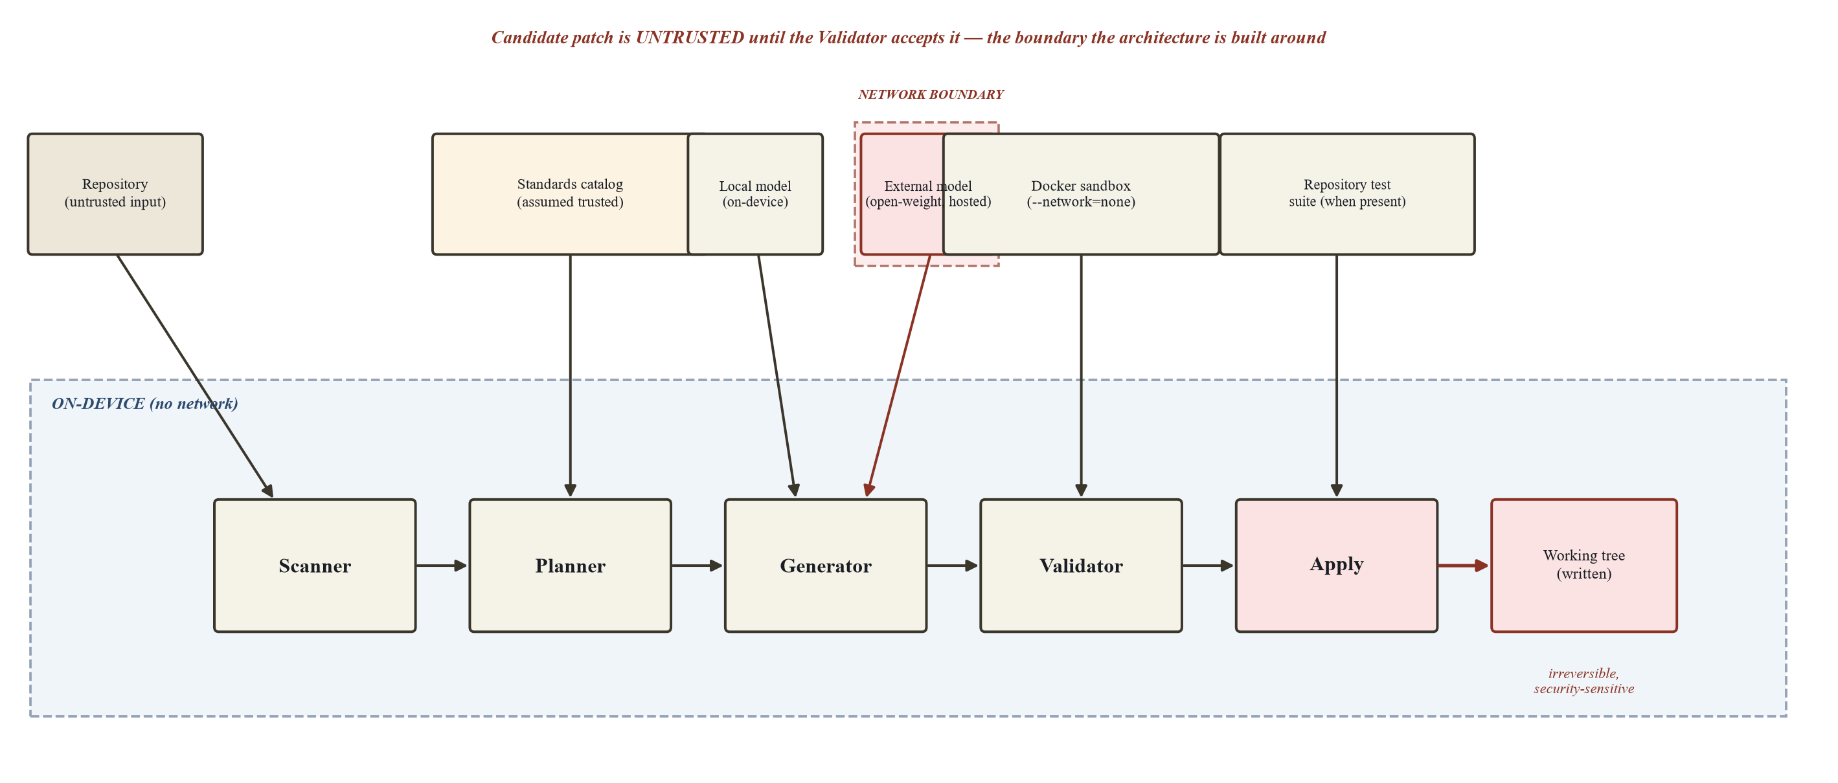
Fig. 1. Recovered QUBIT trust-boundary architecture. A candidate patch remains untrusted until validation and review permit application.
A. Discovery and normalisation
The scanner uses language-aware tree-sitter parsing and a rule catalogue to locate cryptographic uses in source files. Rule output is normalised into a finding that records a file, location, algorithm family, rule identifier, and surrounding evidence. Parsing gives syntax-aware locations but is intentionally not treated as type inference, whole-program data-flow analysis, or a proof that the occurrence is reachable. This boundary prevents the paper from overstating what a static source location can establish.
B. Planning, ownership, and target selection
For a finding f, QUBIT derives an ownership classification from structural context S(f) and bounded documentation context D(f). The classification is a decision aid, not an oracle: protocol- or storage-bound material can require human review or a dual-path approach rather than direct replacement. The current system additionally re-anchors evidence after an earlier edit shifts a source location. Only a unique match may restore a task; ambiguous or missing evidence is deferred for a fresh scan.
Target resolution is separated from ownership. A target may be approved by a project policy while still being inappropriate for a particular call site, and a source location may be technically editable while still being operationally owned by a remote counterparty. The planner consequently produces a proposal boundary and evidence record instead of treating a rule match as permission to edit.
$$O(f) = classify(S(f), D(f)); O(f) ∈ \{code, protocol, storage, kdf\}$$
$$L(P) = max \{ k ∈ \{0,…,4\} : every required gate at k passed or is not applicable \}$$
$$Accept(P) = 1 iff L(P) ≥ Lmin(rule(P)) ∧ state(P) = approved$$
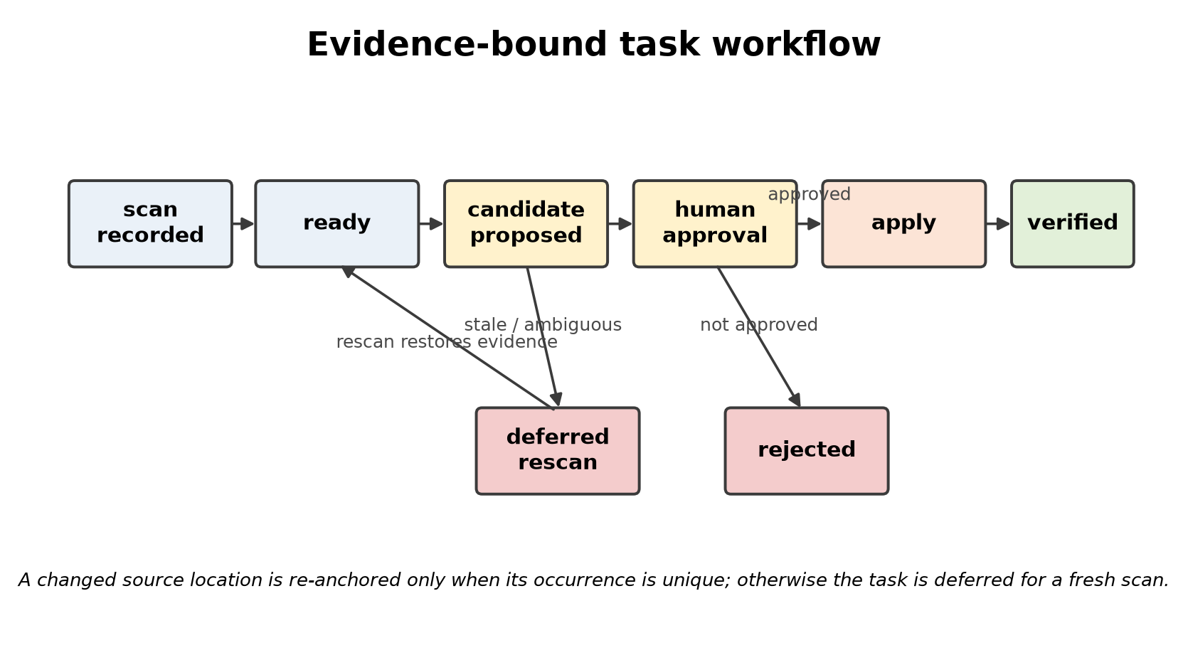
Fig. 2. Evidence-bound task workflow implemented by QUBIT. A stale or ambiguous source occurrence is not silently applied.
C. Validation and application
The evidence ladder retains the distinction between an inapplicable gate and a skipped gate. This design follows the broader lesson that a patch can satisfy a visible check while still violating a security property [7], and motivates behaviour-oriented test oracles such as metamorphic relations [8].
At the lowest level QUBIT checks whether the diff is well formed and parses. Higher levels can include symbol, compilation, scanner-removal, behaviour, and repository-suite checks according to language and rule applicability. A missing sandbox or unavailable dependency is a skipped check, not a success. Only an explicit approval may move a proposal into the apply path, after which the written file is re-examined rather than assumed to match the reviewed candidate.
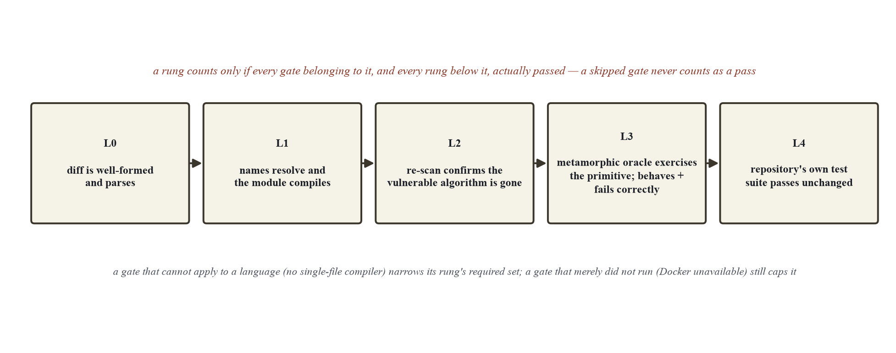
Fig. 3. Recovered evidence ladder. A skipped validation stage does not count as a pass.
IV. STUDY DESIGN
The case study uses four supplied repositories at recorded commits. The repositories were selected as a controlled project corpus, not as a statistically representative sample of production systems. Each includes a project-authored manifest of findings and negative controls; therefore all discovery metrics are reported as internal corpus evidence rather than an independent benchmark result. The four languages provide implementation diversity but only one repository per language.
TABLE II. FIXED CASE-STUDY CORPUS
Repository | Language | Findings | Negative controls
medivault-emr | Python | 14 | 5
inkwell-esign | Ruby | 14 | 3
sentinel-idp | Go | 15 | 5
paymesh-gateway | Java | 14 | 3
Total | 4 languages | 57 | 16

The study asks three operational questions: can the scanner locate labelled findings without confusing negative controls; does the workflow preserve a reviewable chain from discovery to application; and does a controlled desktop run re-scan cleanly after approved edits? Precision, recall, and F1 remain defined conventionally from true and false discovery decisions, but this paper does not use the corpus to infer population-level accuracy. The central application-level measure is more modest: post-apply scanner count together with parse-failure status and the recorded validation basis.
The evaluation protocol freezes a repository revision before scanning and retains both pre- and post-apply scan records. A migration task contains the finding evidence, proposed diff, validation basis, reviewer decision, and final state. This creates a lineage from a reported scanner location to an application decision. The protocol is designed to make failures visible: a task can be rejected, deferred for a rescan, or remain unresolved when a deterministic transformation is unavailable.
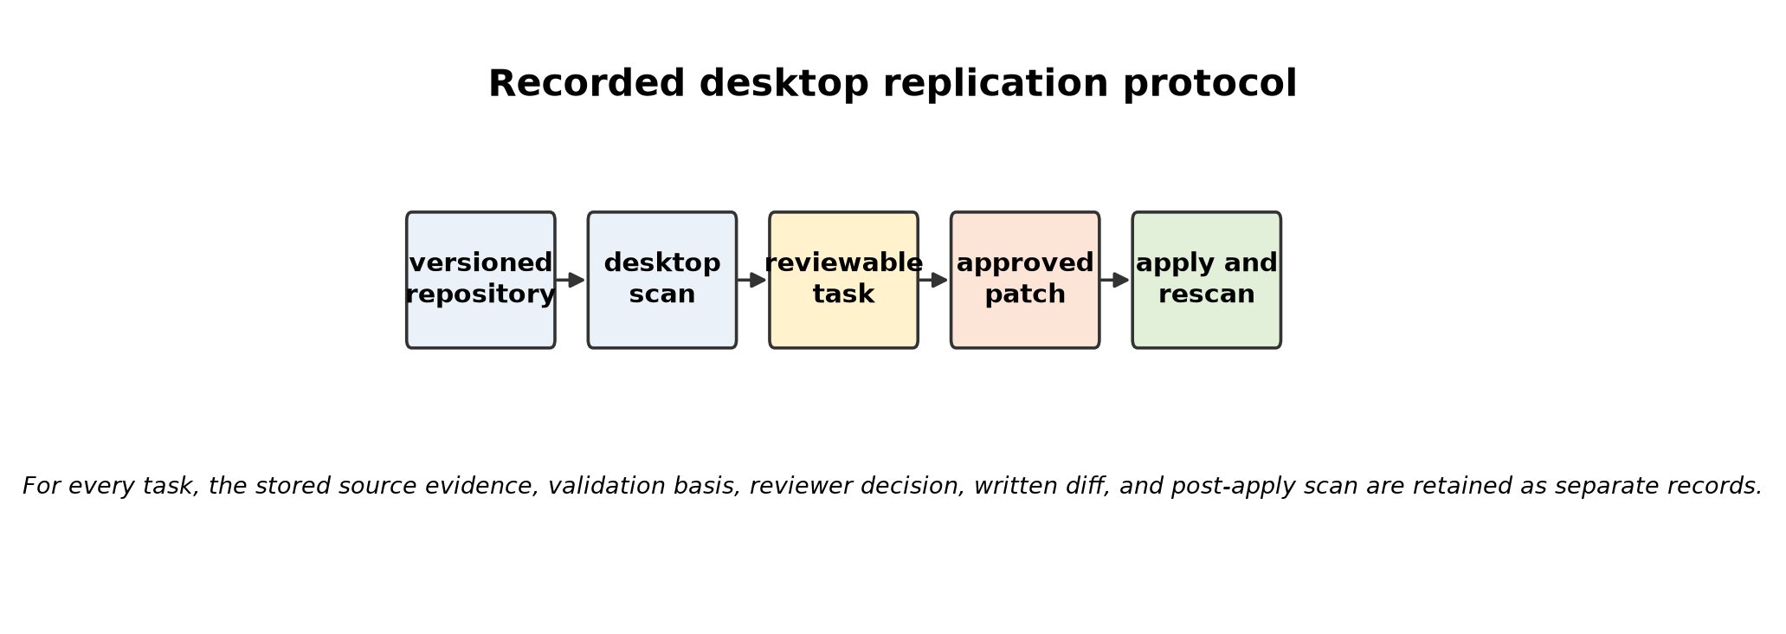
Fig. 4. Recorded desktop replication protocol. The artefact distinguishes a scan record from a reviewed, written, and re-scanned change.
The desktop interface in Fig. 5 is used to inspect the queue, not to infer the outcome of a migration from visual appearance. The UI is important because the operator must be able to see evidence and controls, but the authoritative artefacts for this study are the persisted task state, validation JSON, applied diff, and scan output. This separation is essential when tests cannot be executed under the sandbox configuration.
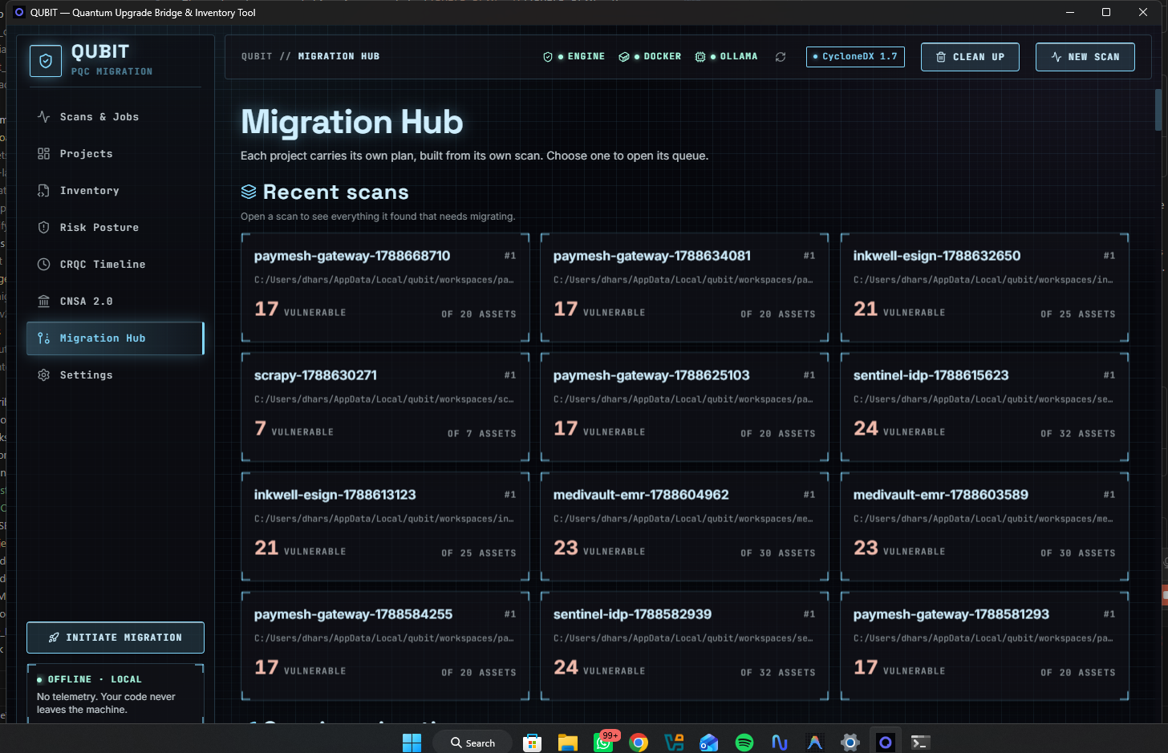
Fig. 5. QUBIT Migration Hub during a recorded campaign. The screenshot is interface evidence; it is not a substitute for test or correctness evidence.
V. DESKTOP REPLICATION EVIDENCE
A deterministic desktop replication was performed on 13 September 2026 using the recorded repository commits and the template generator, without sending source to an external model provider. Six reviewed source edits were applied across three repositories. The desktop workflow then re-scanned every repository. All four scans completed and reported zero parse failures. The count reduction in Table III and Fig. 5 is deliberately labelled as scanner evidence: it shows that the edited occurrence was no longer reported by the scanner, not that a full independent correctness oracle was satisfied.
TABLE III. DETERMINISTIC DESKTOP REPLICATION
Repository | Commit | Findings | Edits | Rescan
MediVault | 6a08a584b9fa | 28 → 27 | 1 | succeeded
Inkwell | f0426d3ccf55 | 21 → 18 | 3 | succeeded
Sentinel | 680984a3c8ff | 26 → 24 | 2 | succeeded
Paymesh | fc410f718faa | 17 → 17 | 0 | succeeded
Total | — | 92 → 86 | 6 | 4 / 4

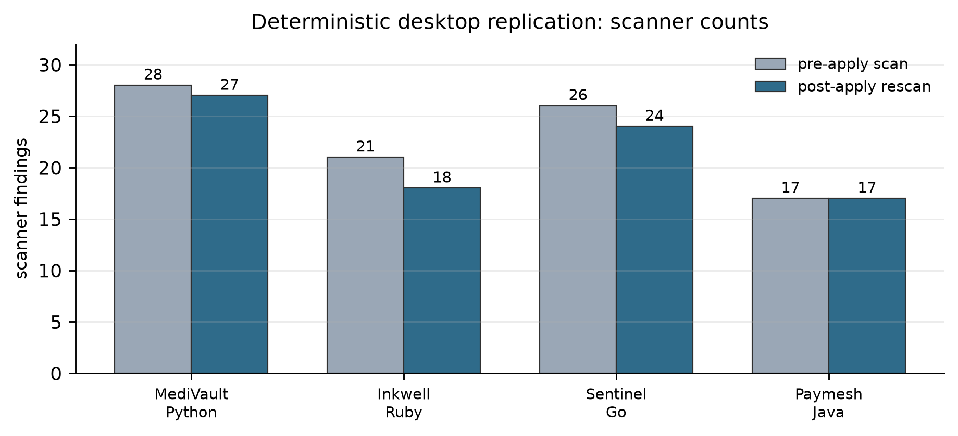
Fig. 6. Pre-apply and post-apply scanner findings. This is a reduction in findings, not an adjudicated correctness score.
The run also exposed an important failure mode: a same-file edit can shift the location recorded for a later task. Treating the stale line as current risks approving the wrong occurrence. The hardened implementation requires re-anchoring against stored evidence and defers the task if the occurrence is ambiguous or missing. This makes non-application an explicit safety outcome rather than a hidden failure.
The repository-level results are intentionally asymmetric. MediVault changed by one finding, Inkwell by three, Sentinel by two, and Paymesh by none. The zero-change case is useful evidence: the workflow does not need to manufacture a source edit when the template generator has no safe local transformation. Across the corpus, nine semantically unsafe proposals were rejected and two additional Inkwell proposals were left unapplied after earlier edits made their evidence stale. These dispositions are retained because suppressing them would make the six successful writes appear more general than they are.
Validation evidence also varies by language and task. The project suites were unavailable to the sandbox for the six applied patches because dependencies and network policy prevented reliable suite execution. The final evidence therefore does not establish full-suite preservation for those edits. Three Inkwell patches reached a Ruby behavioural oracle; the remaining applied edits were limited to scanner and syntactic evidence. This is why Table III contains no correctness column and why Fig. 6 is not described as a security-improvement graph.
VI. VALIDATION AND RELEASE HARDENING
The research artefact and the release build are evaluated at different levels. Research evidence concerns the fixed desktop case study. Software-quality evidence concerns the current implementation: migration engine ordering, sandbox selection, evidence re-anchoring, task resolution, line-scoped satisfaction, API accounting, and API routes. The targeted regression command completed 98 tests successfully (two environmental warnings) in 69.47 s. The dashboard build, lint, and desktop production build also completed successfully.
A compiled desktop smoke test exercised the real desktop backend: a one-file scan completed with status succeeded, one task was reopened into ready state, and an attempt to apply a non-approved patch was rejected with the expected policy response. A lifecycle defect discovered during desktop validation was also corrected: closing the desktop now terminates the API process tree so that the service port does not remain listening. These checks demonstrate release behaviour; they do not replace the case-study evaluation or prove semantic migration correctness.
A. Current regression evidence
The current targeted regression set focuses on the failure modes most likely to corrupt an evidence trail: a migration engine must preserve its deterministic ordering; a sandbox must select the expected image; a line-scoped satisfaction rule must not credit another occurrence in the file; a stale location must either re-anchor uniquely or stop; and API accounting must record a completed job consistently. These are not benchmark claims. They are executable guards against defects found while running the workbench on real repositories.
The current release also persists scan completion timestamps across filesystem, network, and vault paths, disables external source processing by default, and exposes a task reopening route for operator-controlled recovery. The desktop launch path was changed to shut down the descendant API process tree on window destruction. These changes improve observability and lifecycle correctness; they do not alter the study's scanner-count interpretation.
B. Safety properties exercised
Approved-only application prevents a candidate from changing the working tree merely because generation or validation produced output. Re-anchoring prevents an earlier write from turning a later line number into a different target. The evidence ladder records which gates ran, which were inapplicable, and which were skipped. Task reopening permits an operator to re-queue a resolvable task without rewriting the source. Together these properties make the audit trail inspectable in the interface and testable at the API boundary.
VII. FINDINGS, LIMITATIONS, AND THREATS TO VALIDITY
The strongest empirical finding is not that every detected primitive can be migrated automatically. It is that evidence has to survive changes in the repository itself. The controlled run produced six reviewed edits and six fewer scanner findings, while many tasks remained unedited because no safe deterministic transformation was available. This separation between applied, rejected, deferred, and unresolved tasks is an operational finding: a migration workbench should make a refusal or rescan requirement observable rather than recasting it as success.
Several limits constrain interpretation. First, the project-authored ground truth and one repository per language create construct and external-validity risks. Second, scanner removal is weaker than semantic correctness; project suites could not be executed for all applied edits under the sandbox's dependency and network constraints. Third, the ownership model is source-local and may not capture a value whose protocol or storage constraint is documented in a different function. Fourth, external model results are intentionally excluded from the deterministic replication, so no general claim is made about LLM-assisted migration quality or cost.
A. Measurement validity
A scanner result is an operational proxy, not a cryptographic proof. The reported 92 to 86 change can be reproduced from the stored desktop scans, but it has no denominator for true secure migrations and does not test downstream interoperating systems. Similarly, a parser's acceptance is narrower than compilation, and compilation is narrower than an end-to-end behavioural property. QUBIT records this hierarchy to avoid hiding a missing check behind a binary passed label.
B. Internal and external validity
The four repositories are related evaluation artefacts rather than independently sampled industrial systems. Their self-documenting fixtures make a controlled study possible, but they can also make a rule appear more aligned with its authors' vocabulary than it would be in the field. The experiments should therefore be interpreted as a stress test for workflow integrity. A broad empirical claim would require independently curated codebases, multiple projects per language, fresh reviewers, and published negative results.
C. Negative outcomes as evidence
Rejected, deferred, and unresolved tasks are part of the result. They identify where a deterministic generator is not authorised or not capable of proposing a safe local change. Reporting these outcomes makes it possible to distinguish a system that safely declines work from one that silently runs out of attempts. It also prevents a denominator from being reduced after the fact to only the tasks that happened to reach an applied state.
The appropriate next experiment is preregistered and independent: have external reviewers label a versioned corpus, run multiple repeats per repository, publish raw task records and configurations, compare a planning-only baseline with the evidence-bound workflow, and add native behavioural harnesses for Go and Java. Any future accuracy claim should report confidence intervals, failure categories, and the number of unresolved tasks rather than collapsing non-application into correctness.
VIII. REPRODUCIBILITY AND ETHICAL RELEASE PRACTICE
Reproducibility requires more than source publication. Each reported desktop run should identify the repository commit, QUBIT revision, operating system, configured generator, validation configuration, task records, applied diff, scan output, and exact test command. Generated candidates must not be treated as evidence by themselves. Where an external provider is used, source-transfer policy and model configuration must be recorded; the default release setting disables external source processing.
The study treats the working tree as a security-sensitive asset. QUBIT therefore keeps proposal and application separate, preserves a validation record, and rejects an unapproved apply request. This stance is consistent with safety-property reasoning in automated patch generation [7] and metamorphic security testing where a fixed expected output is unavailable [8]. The artefact should be evaluated as a decision-support tool for human reviewers, not as an autonomous security authority.
A. Artifact record
A complete replication bundle should contain the immutable repository SHA, QUBIT commit, operating-system version, configuration file, generator identity, test command, task-state export, validation JSON, scan logs, and a patch-level diff. The bundle must also identify whether a validation stage was not applicable, skipped, passed, or failed. This representation enables a reviewer to challenge the claim at the right level: a scanner count, a syntax check, a behavioural relation, or a full suite result.
B. Responsible source handling
The local-first configuration is a privacy boundary, not a guarantee that every deployment is private. Users who enable external generation must assess whether source code, secrets, or customer data may be transmitted. QUBIT's design keeps external output on the candidate side of the trust boundary and requires local validation and approval before application. This minimises the authority granted to an external model but does not remove the operator's data-governance responsibilities.
C. Publication readiness
For a future conference submission, the case study should be accompanied by an archival data package and a signed release manifest. The manuscript should distinguish historical exploratory records from the current released build, and it should report unsuccessful transformations with the same care as successful ones. Claims about standards, algorithms, and comparative performance should be tied to primary or peer-reviewed sources; this eight-page revision retains only verified IEEE publications in its bibliography.
IX. CONCLUSION
QUBIT is an evidence-bound research prototype for source-level PQC migration. Its contribution is a workflow in which source evidence, approval, validation, and application are explicit states rather than implicit assumptions. On the four-repository deterministic desktop replication, four re-scans completed without parse failures and reviewed edits reduced scanner findings from 92 to 86. The result is encouraging but intentionally narrow: it supports continued evaluation of evidence-preserving migration workflows, not a claim that scanner reduction proves cryptographic or semantic correctness. The next credible step is an independently labelled, repeatable multi-repository evaluation with full behavioural coverage.

APPENDIX A. TASK RECORD AND VALIDATION PROTOCOL
A QUBIT task is an evidence-bearing record rather than a mutable instruction to edit a line. At a minimum it identifies a project, repository revision, finding rule, relative file path, source location, surrounding occurrence evidence, task state, validation result, reviewer decision, and patch identity where a candidate exists. The record allows the user interface and API to distinguish a finding that was discovered from one that was proposed, approved, written, or verified. This is the key data-model safeguard against a dashboard reporting a completed migration merely because a scan produced a finding.
The protocol begins with a versioned repository and ends with a fresh scan. A scanner output becomes a task only with enough source evidence to locate the occurrence. Generation produces a candidate; it does not modify the repository. Validation produces a structured record of gates and evidence basis. Review decides whether a proposed candidate may be applied. Application writes an approved patch and re-examines the source. Verification records the post-apply result. Every transition can be inspected independently, which makes rollback, re-queueing, and error diagnosis possible without rewriting the history of the task.
TABLE IV. TASK-STATE SAFETY CONDITIONS
State / event | Required evidence | Permitted outcome
scan recorded | parser and rule record | create a ready or deferred task
candidate proposed | candidate diff and validation record | review, reject, or defer
approval | explicit reviewer decision | apply only if approved
source changed | unique re-anchor match | restore readiness or require rescan
application | approved patch identity | write, rescan, then verify
verification | post-write evidence | verified, failed, or reopen

A. Evidence basis
A validation record names the checks that were established, reduced because a defined gate was inapplicable, skipped because the environment could not run them, or failed. This distinction is especially important for build and test stages. A language may lack a meaningful single-file compilation command, while a missing container image is an environmental failure. Treating both as a pass would make a later aggregate claim impossible to audit. QUBIT therefore preserves the basis with the numerical evidence level instead of reducing all outcomes to a boolean field.
B. Re-anchoring procedure
Re-anchoring is triggered when an earlier patch touches the same file as a later task. The stored occurrence is searched in the written source. If one unambiguous matching occurrence remains, the task evidence is updated to that location. If none or more than one match remains, the task is deferred and requires a new scan. This rule favours a visible pause over an incorrect application. The regression suite contains cases for a successful re-anchor and for safe non-application when evidence is stale or ambiguous.

APPENDIX B. CURRENT RELEASE-VALIDATION MATRIX
The following matrix separates current software-quality checks from the fixed desktop case study. It is included so that an evaluator can see which aspects of the implementation have executable regression coverage. The run result is a single targeted execution of the listed tests: 98 passed with two environmental warnings in 69.47 s. It should not be interpreted as 98 independent research trials or as a measure of PQC security.
TABLE V. TARGETED CURRENT REGRESSION COVERAGE
Coverage area | Representative guard | Observed outcome
engine ordering | deterministic selection and escalation | passed
sandbox selection | expected runtime image choice | passed
test oracle | validation-stage accounting | passed
stale location | unique re-anchor or safe stop | passed
task resolution | reopen and transition controls | passed
line scope | one occurrence cannot satisfy another | passed
API accounting | job completion records remain consistent | passed
API routes | migration controls obey policy | passed

The desktop build was also checked as an application, not only as a Python service. The dashboard production build and lint completed, the Tauri desktop build completed, and a compiled executable ran a one-file scan through its backend. The scan succeeded with zero detections for the selected file, a reopened task reached ready state, and an attempt to apply a non-approved patch was blocked. A shutdown probe confirmed that closing the desktop no longer leaves the API service listening on its port.
The startup changes are intentionally small and low risk. The dashboard now loads reduced Latin font subsets rather than a larger default set, and the API base configuration uses a static import rather than an ineffective dynamic import. The largest remaining desktop performance issue is a lazy Plotly bundle; it is deferred from initial render but should be split further before a broad distribution release. These observations are release-engineering data, not claims about the research contribution.
A. Test interpretation
The targeted test set is intentionally narrower than the full repository suite. It was selected to protect new safety and lifecycle behaviours introduced during the release hardening pass. Passing tests establish that the implemented contracts hold for their fixtures; they do not establish security of every rule, portability to every operating system, or correctness of a generated source transformation. This is why the paper reports the test total next to its scope rather than treating it as a general quality score.
B. Operational readiness checks
The desktop smoke procedure supplements unit and API tests with a deployed executable path. It confirms that the desktop shell can start the backend, obtain a health response, create a scan, expose task-state controls, reject an unauthorized apply request, and shut down cleanly. These are practical release gates: they detect wiring and process-lifecycle failures that an in-process test can miss. The test is repeatable on Windows but remains a smoke test rather than a usability study.

APPENDIX C. DATA STATUS AND NEXT EXPERIMENT
The repository retains an earlier, much larger exploratory manuscript and historical campaign records. This eight-page revision does not present unreplicated historical ablations, model-routing comparisons, or aggregated correctness counts as current results. They remain useful leads for future experiments, but their exact configurations, denominators, and independent adjudication must be reproduced before they support a publication claim. The current paper therefore elevates only the preserved desktop replication table and the current targeted release-validation result to primary evidence.
A publishable next experiment should start with an independently labelled benchmark package. For every repository, the package should freeze the commit, list positive and negative instances, define what constitutes a safe refusal, and record the expected behaviour of a migrated program. Each arm should be run at least three times where generation is stochastic. Reported outcomes should include true positives, false positives, applied patches, rejected patches, deferred tasks, unresolved tasks, runtime, and the strongest validation level achieved. Raw data must be released with the exact command line and environment manifest.
The comparison should be pre-specified. A scanner-only arm measures discovery; a planning-only arm measures evidence and ownership decisions; an approval-gated, validation-enabled arm measures the full workflow. The analysis should never assign a successful outcome to a task merely because it was not applied. For source changes, an independent reviewer or maintained project test suite should adjudicate semantic correctness. Where full suites are unavailable, the paper should report the limitation directly rather than promote a scanner-removal result to a behavioural claim.
A. Reporting policy
Every headline metric should have an explicit numerator, denominator, unit of analysis, and decision rule. A paper should say whether it counts findings, tasks, candidate patches, reviewed proposals, applied diffs, or verified behaviours. It should also preserve the reason a task ended: accepted, rejected by review, rejected by validation, deferred for stale evidence, failed, or unresolved. This policy prevents a scan-derived metric from drifting into a claim about application correctness as data flows between the interface, database, and manuscript.
B. Data availability
The reproducibility bundle should include machine-readable scan exports, task records, validation JSON, applied-diff hashes, and a release-manifest file that maps each reported table entry to its source artefact. Generated source must be redacted or replaced with a public fixture when repository licensing or confidentiality prevents release. The published bundle should allow an evaluator to reconstruct Table III, inspect every non-application disposition, and run the targeted release tests without depending on screenshots or manually transcribed counts.
C. Claim-to-evidence traceability
TABLE VI. PRIMARY CLAIMS AND THEIR EVIDENCE BOUNDARIES
Claim | Evidence artefact | What it does not establish
92 → 86 findings | desktop scan records | semantic or cryptographic correctness
4 / 4 rescans | post-apply job status | full-suite preservation
98 targeted tests | current regression output | independent research trials
stale task safety | re-anchor regression tests | all source-location edge cases
apply policy enforced | desktop and API smoke checks | human-review quality

This map is deliberately included in the paper so that future revisions retain the distinction between evidence and inference. It is the minimum audit trail for a research prototype whose interface, tests, and source-level migration actions could otherwise be mistaken for a stronger guarantee than the data supports.

APPENDIX D. MINIMUM ARTIFACT MANIFEST
A release manifest gives every reported result a stable identity. It should declare the QUBIT revision, operating system, repository URL and commit, rule-catalogue revision, generator configuration, external-processing setting, validation policy, test command, and timestamp of the scan and run. The manifest must be generated with the run rather than reconstructed from a narrative after the fact. This turns a paper table into a set of inspectable artefacts and exposes configuration drift before it is mistaken for a research effect.
TABLE VII. MINIMUM MANIFEST FIELDS
Field | Purpose | Example evidence
input identity | bind result to exact source | repository SHA and path
tool identity | bind result to release | QUBIT commit and configuration
execution identity | recreate environment | OS, command, generator setting
decision trail | audit task outcomes | task export and validation JSON
written result | verify applied change | diff hash and post-apply scan

The manifest is also a publication safeguard. It makes clear whether a figure comes from a desktop run, a unit test, a historical exploratory record, or a manually constructed illustration. It records whether an external model handled source code and whether a test was skipped. A future archive can use the same format to support replication without publishing confidential source material: sensitive paths and content can be redacted while hashes, task-state transitions, and measurement definitions remain auditable.
REFERENCES
[1] M. Mosca, “Cybersecurity in an era with quantum computers: Will we be ready?” IEEE Security & Privacy, vol. 16, no. 5, pp. 38–41, 2018, doi: 10.1109/MSP.2018.3761723.
[2] C. Näther, D. Herzinger, S.-L. Gazdag, J.-P. Stegöfer, S. Daum, and D. Loebenberger, “Migrating Software Systems Toward Post-Quantum Cryptography—A Systematic Literature Review,” IEEE Access, vol. 12, pp. 132107–132126, 2024, doi: 10.1109/ACCESS.2024.3450306.
[3] M. S. Gharote et al., “PQC Planner: Post-Quantum Cryptographic Migration Planner,” 2026 International Conference on COMmunication Systems & NETworkS, pp. 1013–1017, 2026, doi: 10.1109/COMSNETS67989.2026.11418114.
[4] B. Birgin and B. Celiktas, “From Policy to Practice: A Sector-Agnostic Operational Framework for Post-Quantum Cryptography Transition,” IEEE Access, vol. 14, pp. 33534–33551, 2026, doi: 10.1109/ACCESS.2026.3669437.
[5] M. El Bizri, A. M. El-Hajj, L. Sliman, and A. M. Haidar, “Institutional Approaches to Post-Quantum Cryptography: A Comparative Analysis of Migration Frameworks,” IEEE Access, vol. 14, pp. 3259–3283, 2026, doi: 10.1109/ACCESS.2025.3650465.
[6] A. Aydeger et al., “Towards a Quantum-Resilient Future: Strategies for Transitioning to Post-Quantum Cryptography,” 2024 IEEE International Conference on Networks of the Future, pp. 195–203, 2024, doi: 10.1109/NoF62948.2024.10741441.
[7] Z. Huang, D. Lie, G. Tan, and T. Jaeger, “Using Safety Properties to Generate Vulnerability Patches,” 2019 IEEE Symposium on Security and Privacy, pp. 539–554, 2019, doi: 10.1109/SP.2019.00071.
[8] P. X. Mai, F. Pastore, A. Goknil, and L. C. Briand, “Metamorphic Security Testing for Web Systems,” 2020 IEEE International Conference on Software Testing, Verification and Validation, pp. 186–197, 2020, doi: 10.1109/ICST46399.2020.00028.

