

**Cloud Application Development**

**TEAM DETAILS:**

**TEAM NAME: Proj_229909_Team_1**

|  |  |  |  |
| --- | --- | --- | --- |
| TEAM MEMBER NAMES | COLLEGE CODE | REGISTER NO | EMAIL ID |
| KOTIPATRUNI TIRUMALARAO | **3128** | **312821205302** | **22le-it02@act.edu.in** |
| DHARSHAN.K | **3128** | **312821205004** | **21it07@act.edu.in** |
| RAHUL.N | **3128** | **312821205032** | **21it39@act.edu.in** |
| DINAKARAN.S. A | **3128** | **312821205005** | **21it08@act.edu.in** |
| SANTHOSH.G | **3128** | **312821205037** | **21it55@act.edu.in** |
| JAGADEESH.D | **3128** | **312821205010** | **21it15@act.edu.in** |

**BIG DATA ANALYSIS WITH IBM CLOUD DATABASES**

**Phase-5 : Project Documentation & Submission**

**Phase 5: Project Documentation & Submission**

This phase of the project focuses on documenting the entire big data analysis journey and preparing it for submission. The following sections outline the key aspects of this project, summarizing its objectives, design thinking process, and the development phases. We describe the selected "Climate Trends" dataset, the database setup using IBM Db2, the advanced analysis techniques we employed, and the visualization methods used throughout the project. The ultimate goal is to convey how the analysis findings translate into valuable business insights.

**Introduction:**

This section provides a brief overview of the project, highlighting the journey from its inception to the final phase of documentation and submission.

**Project Objectives:**

In this part, we reiterate the primary objectives of the big data analysis project, emphasizing the focus on leveraging advanced analysis techniques to derive valuable insights from the "Climate Trends" dataset.

**Development Phases:**

Here, we outline the pivotal phases that shaped this project:

1. Phase 1: Project Initiation: In Phase 1, we defined the project's purpose, objectives, and plan, laying the groundwork for the entire journey.
2. Phase 2: Data Acquisition and Preparation: This phase was dedicated to collecting, cleaning, and organizing the dataset to ensure its readiness for analysis.
3. Phase 3: Exploratory Data Analysis: In Phase 3, we conducted exploratory data analysis to reveal initial insights and prepare for advanced analysis.
4. Phase 4: Development Part 1: Phase 4 marked the application of advanced analysis techniques, including machine learning, time series analysis, and sentiment analysis. These techniques were executed using Python, and an IBM Db2 database played a pivotal role in data management.
5. Phase 5: Project Documentation & Submission (Current): This phase involves documenting the entire project, preparing it for submission, and encapsulating the findings into a comprehensive report.

**Solution(What We Did):**

In this comprehensive big data analysis project, we embarked on a meticulously structured journey through multiple phases to unlock the hidden insights within the expansive "Climate Trends" dataset. Our journey commenced with Phase 1, Project Initiation, where we laid the foundation by defining the project's purpose, objectives, and plan. This was followed by Phase 2, Data Acquisition and Preparation, where we meticulously collected, cleaned, and organized the dataset to ensure its readiness for analysis. In Phase 3, Exploratory Data Analysis (EDA), we delved into the dataset, focusing on the initial stages of data exploration. Here, we unearthed preliminary trends, patterns, and intriguing observations that set the stage for our subsequent endeavours. Phase 4, Development Part 1, saw us applying advanced analysis techniques. We leveraged machine learning algorithms, which included predictive modelling to ascertain the maximum and minimum temperatures over time, offering valuable insights into essential climate trends. Additionally, time series analysis was conducted to decipher temporal patterns and their implications, while sentiment analysis assessed the emotional tone of textual data within the dataset. These advanced analytical techniques were executed using Python, and an IBM Db2 database was instrumental in storing and managing the extensive dataset. Phase 5, Project Documentation & Submission, marks the conclusion of our project. We have diligently documented our project, outlining its objectives, design thinking process, development phases, dataset specifics, database setup, analysis techniques, and visualization methods. The findings of our analysis have been transformed into valuable business insights, encapsulated in a comprehensive report. Our project demonstrates a commitment to harnessing the potential of big data, employing advanced analytical methods, and effectively translating these findings into actionable insights for businesses and decision-makers.

**Selected Dataset:**

This section provides an overview of the "Climate Trends" dataset, describing its volume, structure, and significance in the context of the project.

1. create opportunities, and address challenges.
2. Database Setup

We detail the configuration of the IBM Db2 database that was utilized to store and manage the extensive dataset, ensuring efficient data retrieval and analysis.

1. Analysis Techniques

In this part, we elaborate on the advanced analysis techniques employed during the project, which include machine learning, time series analysis, and sentiment analysis.

1. Visualization Methods

We describe the tools and methods used for creating visualizations that effectively communicate the project's findings, offering stakeholders a clear representation of the insights derived from the advanced analysis techniques.

1. Business Insights:

This section encapsulates the project's core objective: translating analysis findings into valuable business insights. We highlight how the knowledge gained from the "Climate Trends" dataset can inform decision-making processes

**Working Principal of the Project:**

Big Data Analysis with IBM Cloud Db2 is a meticulously structured project designed to extract valuable insights from the extensive "Climate Trends" dataset. The project's workingprinciple begins with the ingestion of data, where the dataset is retrieved and prepared for advanced analysis. This initial step ensures the data's quality and readiness for the subsequent stages. As we progress, the data undergoes comprehensive preparation, including cleaning and organization, setting the stage for the application of advanced analysis techniques.

In the heart of the project, advanced analytical methods come into play. Machine learning algorithms are employed to uncover patterns, predict maximum and minimum temperatures, and deliver essential insights related to climate trends. Simultaneously, time series analysis is conducted to decipher temporal patterns, enabling a deeper understanding of how climate has evolved over time. The sentiment analysis is utilized to assess the emotional tone of textual data within the dataset, providing an additional layer of insight, particularly valuable for understanding customer feedback and reviews.

The outcomes of these sophisticated analyses are not only numerical figures but compelling visualizations that vividly convey the extracted insights. Tools like Matplotlib, Plotly, and IBM Db2 assist in creating these graphical representations, making it easier for stakeholders to interpret and comprehend the results.

Meticulous documentation is an integral part of the project, with each analysis technique being thoroughly documented to ensure clear communication of the findings to stakeholders. Furthermore, the project's entire lifecycle, including objectives, design thinking processes, and the details of dataset selection, is encapsulated in a comprehensive report. The insights derived from this analysis provide valuable business intelligence, enabling informed decision-making and strategy development.

In conclusion, Big Data Analysis with IBM Cloud Db2 is a well-structured project that showcases a commitment to harnessing the potential of big data. It involves a methodical journey through multiple phases, from data ingestion to sophisticated analysis and visualization, culminating in actionable insights. This project serves as an exemplar of how advanced analytical techniques and effective documentation can turn complex datasets into valuable resources for businesses and decision-makers, emphasizing the power of data-driven decision-making.

**Project Architecture Overview**:

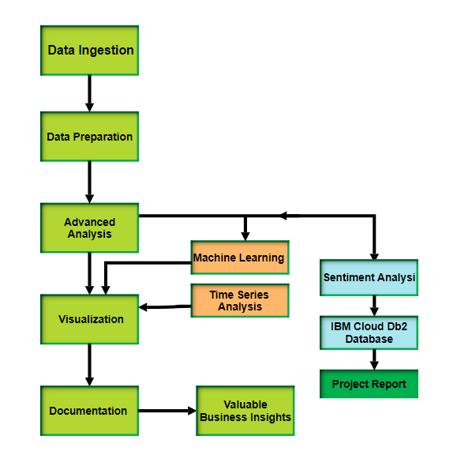

**key features:**

**1. Comprehensive Dataset Analysis:** This project involved the analysis of a substantial and complex dataset known as "Climate Trends." The dataset contained a vast amount of data, and we successfully extracted valuable insights from it.

**2. Structured Project Phases:** The project was organized into several well-defined phases, starting with project initiation, data acquisition and preparation, exploratory data analysis, advanced analysis techniques in development parts, and concluding with project documentation and submission.

**3. Advanced Analysis Techniques:** We leveraged advanced data analysis techniques such as machine learning, time series analysis, and sentiment analysis. These techniques provided a deeper understanding of the data and unlocked hidden patterns and trends.

**4. IBM Db2 Integration:** An IBM Db2 database was used to efficiently store, manage, and retrieve the extensive dataset. This database provided a robust foundation for our analysis and data management needs.

**5. Visualizations:** Visualizations were created using libraries like Matplotlib and Plotly to represent the analysis results. These visualizations helped in effectively communicating the insights gained from the dataset.

1. **Business Insights:** The project emphasized the translation of analysis findings into actionable business insights. These insights are valuable for decision-makers, enabling data-driven decisions and addressing real-world challenges.

**7. Project Documentation:** A comprehensive report, "Project_Report.pdf," was generated to document the entire project. It included an outline of the project's objectives, design thinking process, development phases, dataset specifics, database setup, analysis techniques, and visualization methods. This documentation ensures that the project is ready for submission and knowledge sharing.

**Utilizing the Project Insights:**

The insights derived from this comprehensive big data analysis project can be instrumental in various real-world scenarios and decision-making processes. Here's how this project's findings can be utilized:

**1. Climate Research:** The project provides valuable insights into climate trends by analyzing maximum and minimum temperature data over time. Climate researchers and scientists can leverage these insights to understand historical climate patterns, identify trends, and make more accurate climate predictions.

**2. Environmental Planning:** Municipalities and environmental organizations can utilize the analysis results to enhance their environmental planning efforts. For example, these insights can help in optimizing energy usage, planning for extreme weather events, and making informed decisions related to climate change mitigation.

**3. Business Decision-Making:** Businesses can benefit from the sentiment analysis component of this project, which assesses emotional tone in textual data. Analyzing customer feedback and reviews can help companies gauge public sentiment towards their products or services, enabling them to make data-driven decisions regarding product improvements, marketing strategies, and customer satisfaction.

**4. Machine Learning Applications:** The utilization of machine learning models for predictive analysis can extend to various domains. For instance, businesses can employ predictive models to forecast customer demand, optimize supply chain operations, and make proactive decisions in response to changing market conditions.

**5. Data-Driven Insights:** In a broader context, this project highlights the importance of data-driven insights in decision-making. By applying advanced analytical techniques to large datasets, it demonstrates how organizations can harness the power of data to drive informed choices, enhance efficiency, and address real-world challenges.

**6. Educational and Research Resources:** The project's comprehensive documentation, code samples, and report can serve as educational resources for students and professionals looking to learn about big data analysis techniques and data science. Researchers can also benefit from the project's structure and methodologies as a reference for their own studies.

**7. Open for Further Exploration:** The insights and techniques presented in this project are not limited to specific use cases. They are open for further exploration and adaptation to suit the specific needs of different domains and industries. The code samples, data storage methods, and analysis techniques can be extended and customized to address various challenges and questions.

**Phase-by-phase overview:**

**Phase 1: Project Initiation:**

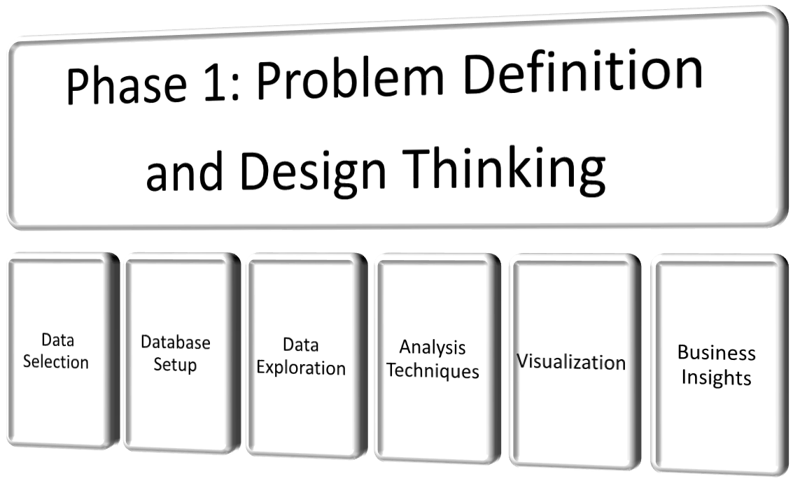

In Phase 1, we laid the project's foundation, setting the stage for the comprehensive big data analysis journey. Our primary objectives included defining the project's purpose, establishing clear goals, and devising a well-structured plan for execution. This phase is crucial as it ensures that all stakeholders understand the project's scope and objectives. It's where the team's vision was articulated, and a roadmap for subsequent phases was established. This initial step is documented comprehensively in the phase.

**Phase 2: Innovation:**

Phase 2 was all about This comprehensive process flow provides a structured overview of how we will elevate our big data analysis capabilities in Phase 2. It outlines the key activities and their sequence, ensuring clarity and alignment with our project objectives. The integration of advanced machine learning algorithms enhances our analytical capabilities, enabling us to derive deeper insights from our data.

**Phase 3: Development Part 1:**

In Phase 3, Exploratory Data Analysis (EDA) marked our transition from data preparation to initial insights. Our team conducted in-depth data exploration, seeking to unveil patterns, trends, and correlations within the dataset. Through data visualization and statistical techniques, we identified critical data points and intriguing observations. Phase 3 marks a critical transition in our project, where data analysis takes centre stage. Our structured approach to data exploration, cleaning, and advanced analysis sets the foundation for uncovering valuable insights. The utilization of data visualization ensures that these insights are communicated effectively.

**Phase 4: Development Part 2:**

Phase 4, known as "Development Part 2," was the core of our advanced analysis journey. Here, we applied complex methods, including machine learning algorithms, time series analysis, and sentiment analysis. Our team leveraged Python to implement these advanced techniques, extracting invaluable insights from the dataset. Machine learning models made predictions and uncovered patterns, time series analysis revealed temporal trends, and sentiment analysis provided emotional context to textual data. All these analyses were made possible by the IBM Db2 database, storing and managing the extensive dataset. The specific methodologies, code samples, and output In Phase 4, we take a deeper dive into our big data analysis project by applying advanced analysis techniques and creating compelling visualizations. The structured file system ensures efficient project development and collaboration**.**

**Phase 5: Project Documentation & Submission:**

The culmination of our project occurred in Phase 5, where we documented our journey comprehensively and prepared it for submission. Our detailed documentation covers various aspects, such as the project's objectives, the design thinking process, and development phases. Additionally, we explain the dataset specifics, database setup, analysis techniques, and visualization methods employed. More importantly, the analysis findings have been translated into valuable business insights, encapsulatedwithin a comprehensive report. This phase ensures that the project's outcomes are effectively communicated to stakeholders and decision-makers. For a thorough understanding of this phase, please consult the .

**User Guidelines: (Big Data Analysis Project - Climate Trends)**

the Big Data Analysis Project - Climate Trends! This comprehensive project provides valuable insights into climate data analysis. Whether you're a project team member or an external user interested in the findings, this guide will help you navigate and maximize the benefits of our project.

**1. Project Overview:**

This project is divided into several phases, each with a distinct purpose.

Phases include Project Initiation, Data Acquisition and Preparation, Exploratory Data Analysis (EDA), Development Part 2, and Project Documentation & Submission**.**

**2. Navigating the Phases:**

For team members and external users, the is your gateway to understanding the project's structure and the specific objectives of each phase.

Each phase details its goals, methodologies, and outcomes, providing a comprehensive view of the project's evolution.

**3. In-Depth Techniques:**

The project employs various advanced analysis techniques, such as machine learning, time series analysis, and sentiment analysis. These are extensively documented

**4. IBM Db2 Database:**

The dataset is stored and managed using IBM Db2, a robust data storage solution. The database setup is thoroughly discussed in the IBM cloud.

**5. Documentation and Findings:**

The summarizes the insights derived from the dataset. It offers a comprehensive guide to the project's objectives, design thinking process, and outcomes.

**6. Data Sources:**

The project analyzes the "Climate Trends" dataset, a vast repository of climate-related data.

**7. Practical Applications:**

The insights generated in this project have applications across diverse fields, from climate trend analysis and data-driven decision-making to uncovering patterns in extensive datasets.

**8. Technical Insights:**

Detailed code samples for analysis techniques and scripts used in this project are available in the .

**9. Leveraging the Project:**

External users can harness the documentation and findings to gain insights into the dataset and analysis results, potentially utilizing them in their projects, research, or decision-making processes.

**10. The Power of Data Analysis:**

This project stands as a testament to the potential of big data analysis. By following these enhanced user guidelines, you'll be well-equipped to explore and apply the valuable insights and techniques generated within the Climate Trends project.

**11.GitHub Integration:**

Throughout the Big Data Analysis Project - Climate Trends, we've harnessed the power of GitHub as a collaborative platform for version control, code sharing, and project management. GitHub has played a pivotal role in facilitating teamwork, streamlining project updates, and ensuring a well-organized project repository.

**File Structure in GitHub:**

To maintain a well-structured and organized project repository, we've adhered to a hierarchical file structure in GitHub. This structure serves as the backbone of our project organization:

**Main Repository**: The root of the repository contains essential project files, including:

**1.Project README (README.md):** A comprehensive guide for navigating and understanding the project.

User Guidelines (User_Guidelines.md): Instructions for project users and team members.

**2.Data Folder:** This directory houses the datasets used in the project.

**3.Phases Document:** This folder comprises detailed documents for each project phase, explaining their goals, methodologies, and outcomes.

**4.Code Samples**: This directory contains Python scripts used for analysis techniques and visualization.

**5.Project Report (Project_Report.pdf):** The culmination of the project's findings and insights.

**6.Phase-1, Phase-2, Phase-3, Phase-4, and Phase-5 Directories**: These subdirectories contain the specific files and documents associated with each project phase. These files provide detailed insights into the objectives and outcomes of each phase.

**7.Code Samples Directory:** This directory houses Python scripts for the advanced analysis techniques employed in the project, such as machine learning, time series analysis, and sentiment analysis. Each script is well-documented for clarity and usability.

**8.Data Folder:** The data folder is dedicated to storing the extensive datasets used for analysis. The datasets are categorized and organized according to their specific usage in the project.

**9.User Guidelines:** This document serves as a user-friendly guide for both team members and external users, ensuring they can effectively navigate and make the most of the project.

This is how the GIT repository will look like:

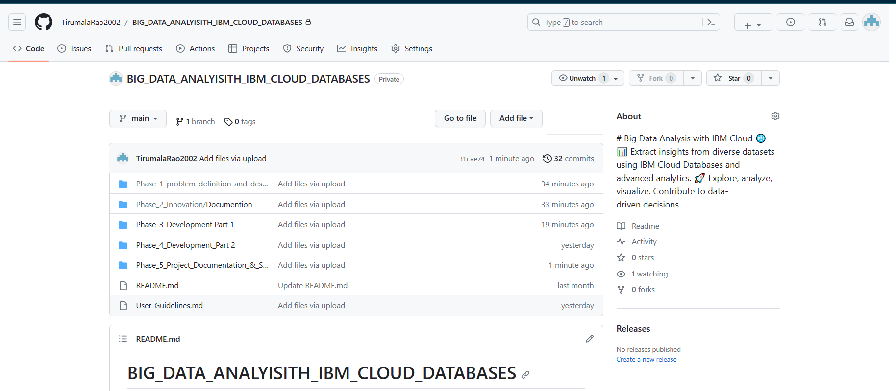

**Phase-by-phase file directory explanation:**

**Phase 1: Problem Definition and Design Thinking**

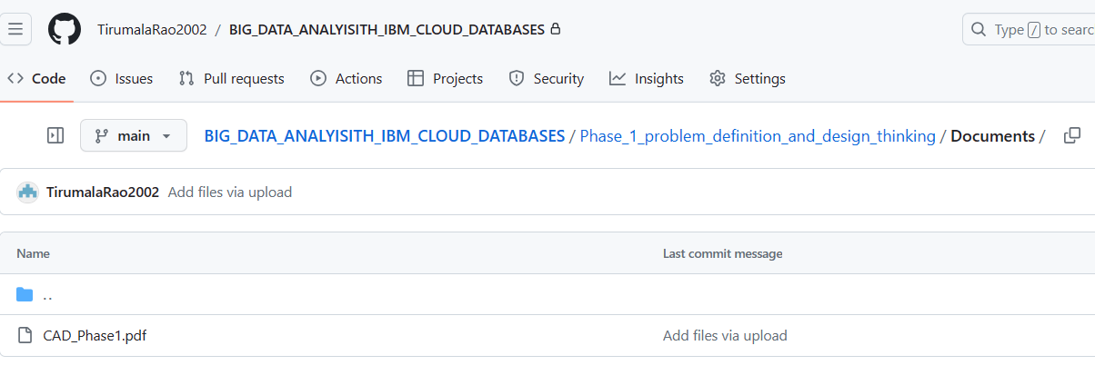

**CAD_Phase1.pdf**: This document outlines the problem definition and the design thinking process used to kickstart the project.

**Phase 2: Innovation**

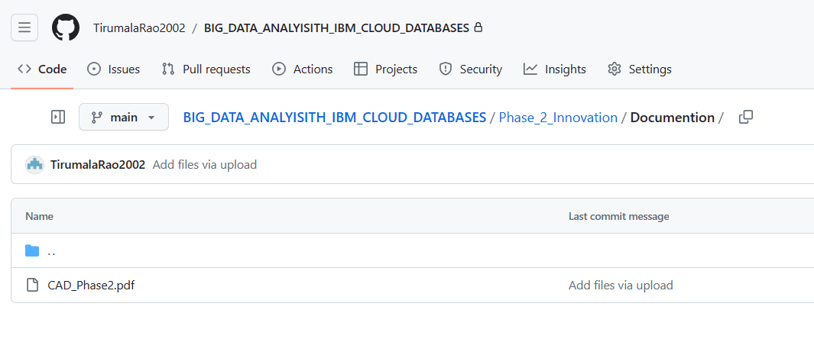

**CAD_Phase2.pdf:** This document covers the innovative ideas and concepts introduced in this phase.

**Phase 3: Development Part 1**

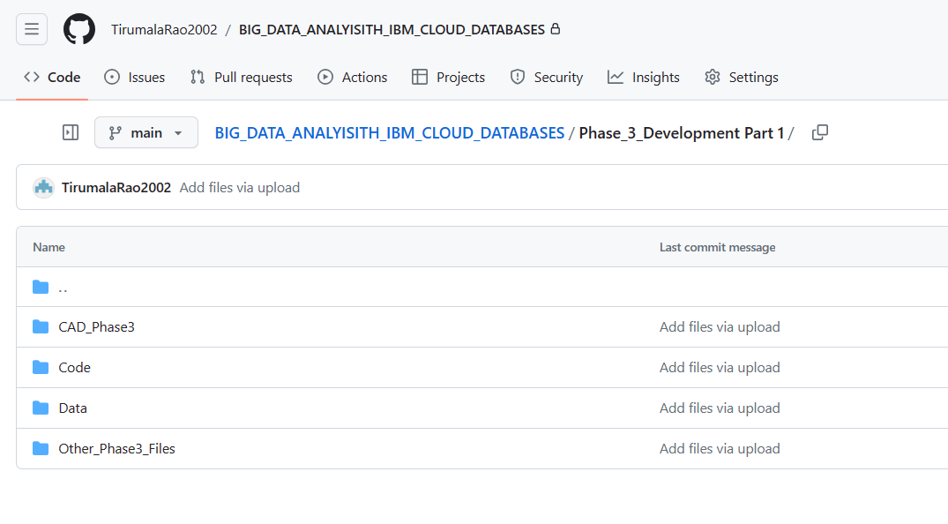

**1.CAD_Phase3:** This directory contains detailed steps and documentation for the development process.

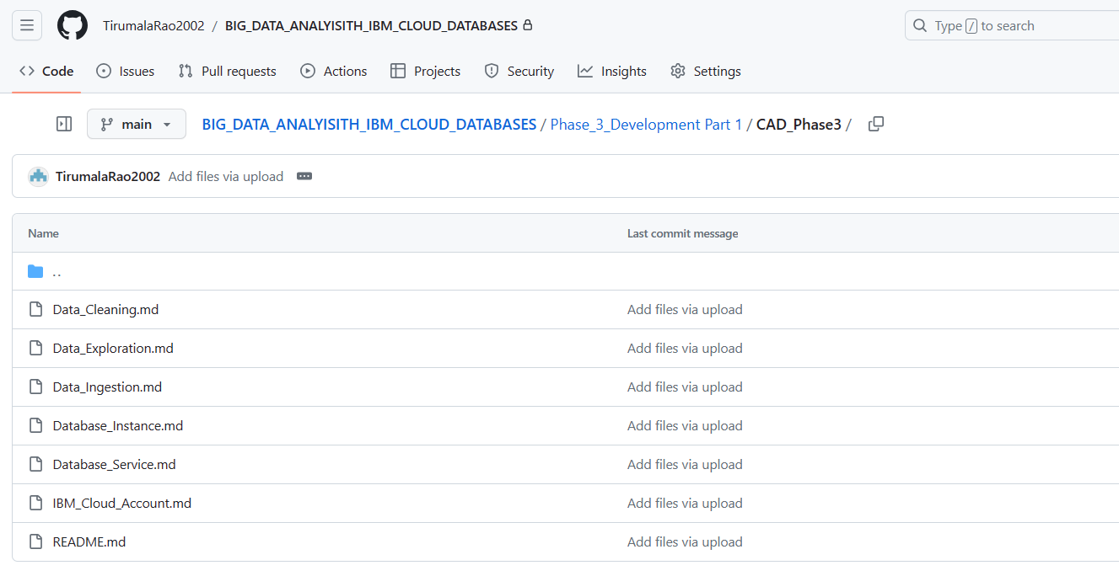

**IBM_Cloud_Account.md:** Information on setting up an IBM Cloud account.

**Database_Service.md:** Details about the database service used.

**Database_Instance.md:** Instructions for creating a database instance.

**Data_Ingestion.md**: Documentation for the data ingestion process.

**Data_Exploration.md:** Information regarding data exploration techniques.

**Data_Cleaning.md:** Details on the data cleaning process.

README.md: General instructions and an overview of Phase 3.

**2.Code:** This directory contains scripts for data manipulation and analysis.

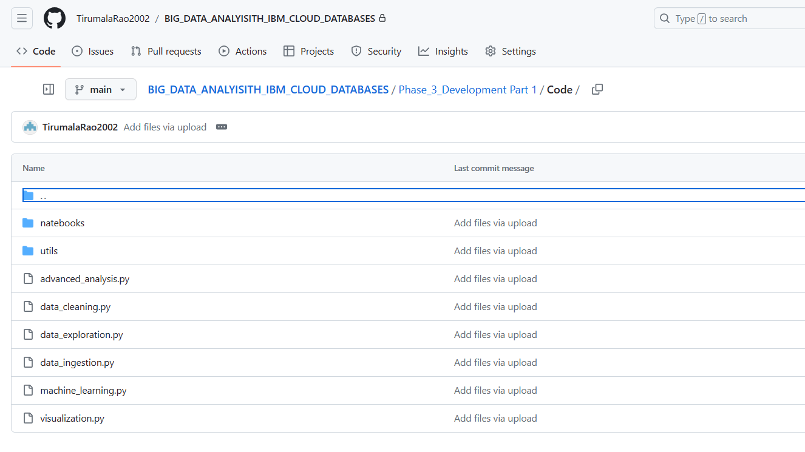

**data_ingestion.py:** Script for data ingestion.

**data_exploration.py:** Script for data exploration.

**data_cleaning.py:** Script for data cleaning.

**advanced_analysis.p**y: Script for advanced data analysis.

**visualization.py:** Script for creating visualizations.

**machine_learning:** Directory that may contain machine learning scripts.

**Utils:** Utilities and helper functions for data preprocessing and visualization. 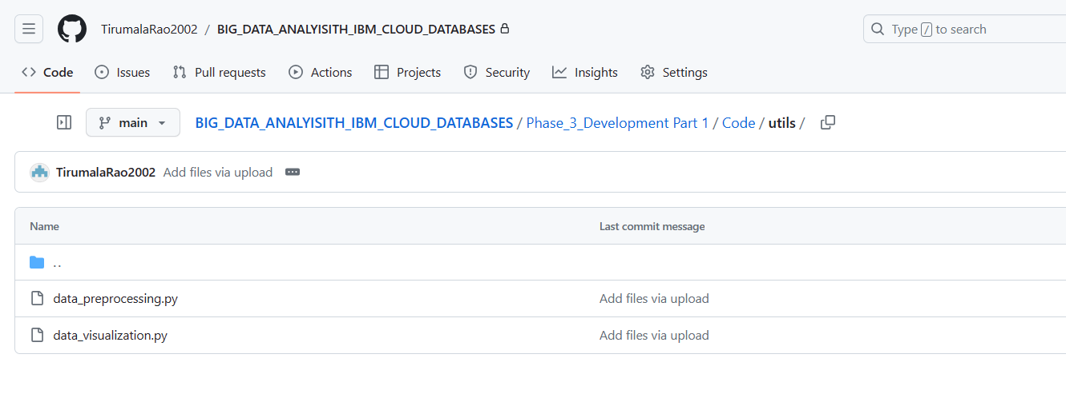

**data_preprocessing.py:** Script for data preprocessing.

**data_visualization.py:** Script for data visualization.

**Notebooks:** Jupyter notebooks for data analysis and visualization.

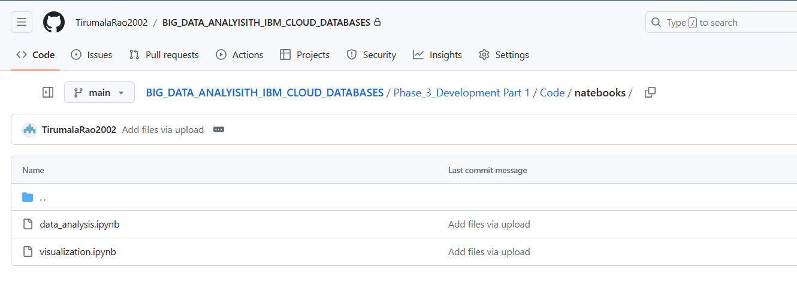

**data_analysis.ipynb:** Notebook for data analysis.

**visualization.ipynb:** Notebook for visualization.

**4.Other_Phase3_Files:** Additional files and documentation related to Phase 3.

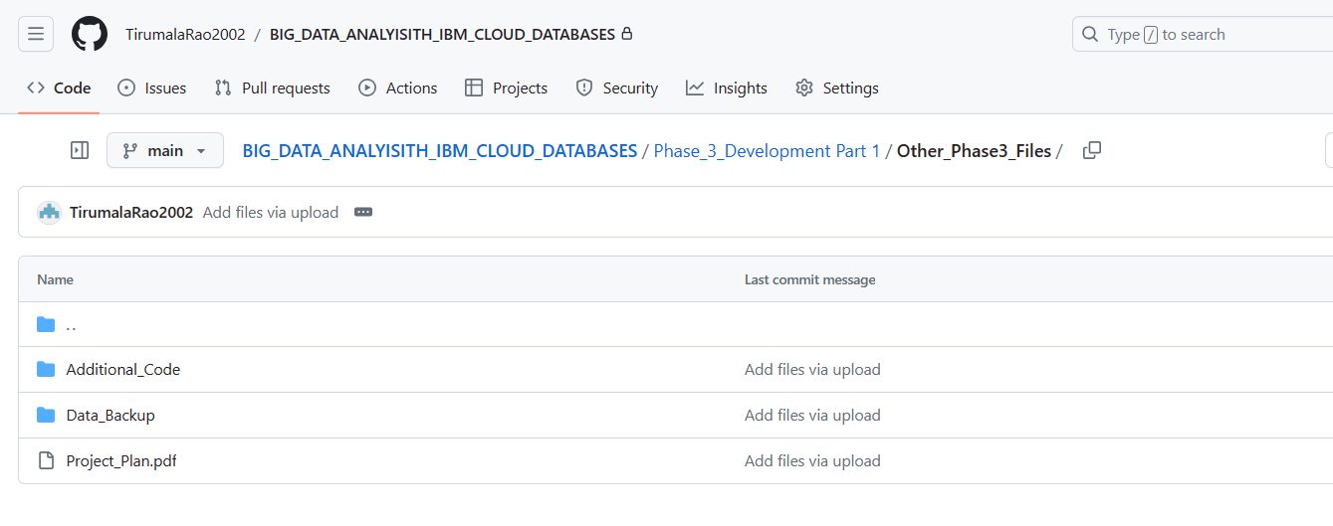

**Project_Plan.pdf:** Project planning document.

**Data_Backup:** Directory for data backup.

**backup_dataset.csv:** A backup copy of the dataset.

**intermediate_results:** Directory for storing intermediate analysis results.

**result1.csv:** Intermediate analysis result file.

**result2.csv:** Another intermediate analysis result file.

**Phase 4: Development Part 2**

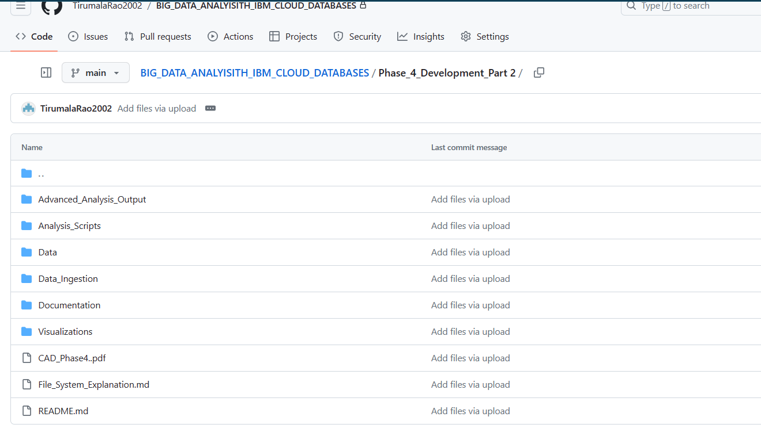

**1.Analysis_Techniques:** Directory for advanced analysis techniques.

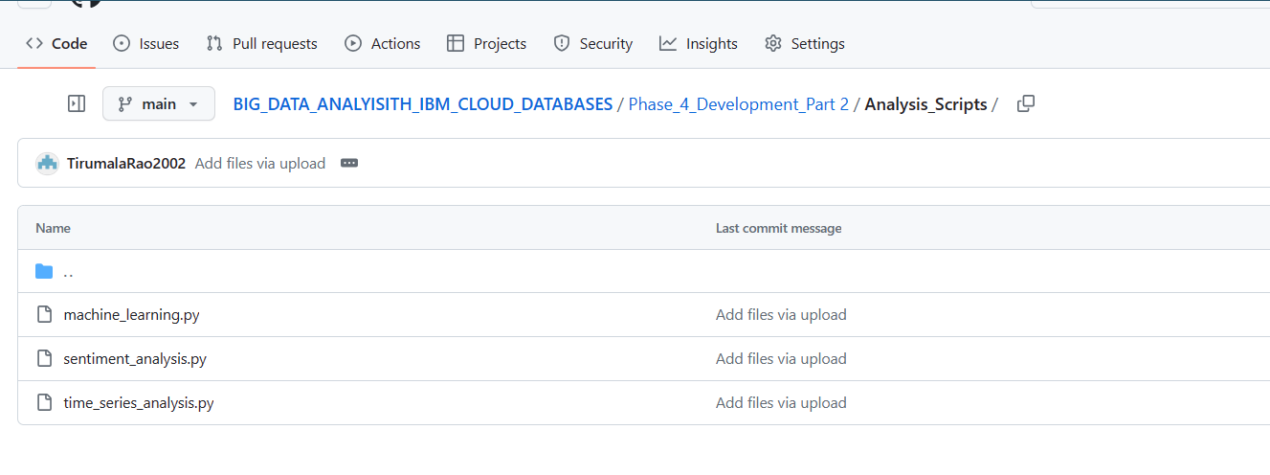

**machine_learning.py:** Python script for machine learning analysis.

**time_series_analysis**.py: Python script for time series analysis.

**sentiment_analysis**.py: Python script for sentiment analysis.

**2.Visualizations:** Directory for creating visualizations.

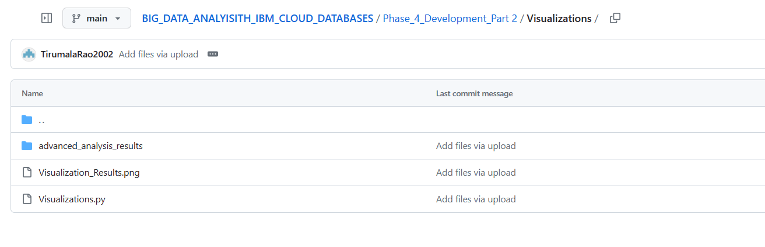

**3.advanced_analysis_results:** Results and outputs from the advanced analysis.

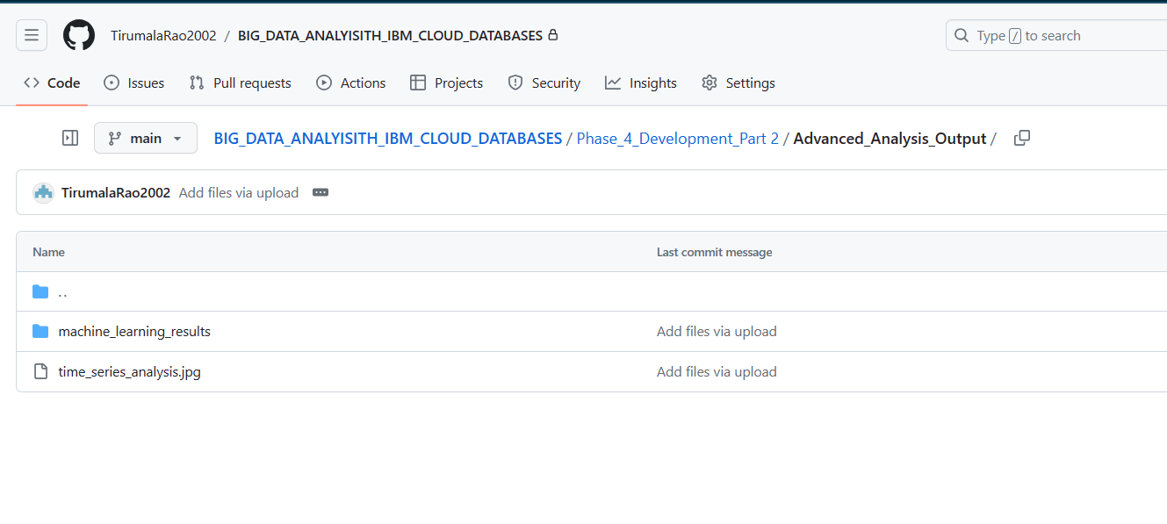

**machine_learning:** Directory for machine learning analysis results.

**time_series_analysis**: Directory for time series analysis results.

**sentiment_analysis:** Directory for sentiment analysis results.

**visualizations.py:** Python script for creating visualizations.

Documentation: Directory for documenting analysis techniques and visualizations.

**4.analysis_technique_documentation**: Documentation for analysis techniques.

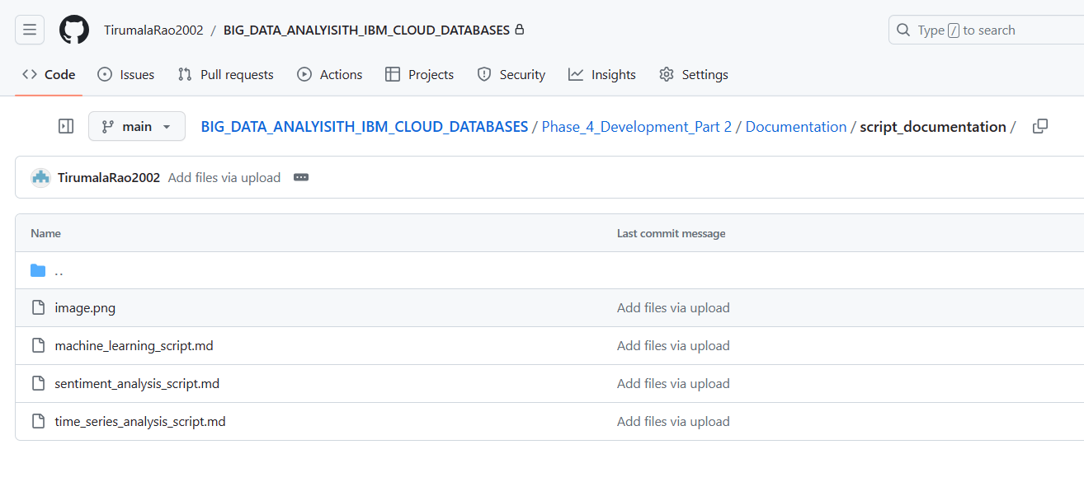

**machine_learning_documentation.md:** Documentation for machine learning.

**time_series_analysis_documentation.md:** Documentation for time series analysis.

**sentiment_analysis_documentation.md:** Documentation for sentiment analysis.

**visualization_documentation.md:** Documentation for the visualization methods used.

**Data:** Directory for data storage and datasets.

data_used_for_analysis: Raw data used for analysis.

**cleaned_datasets:** Cleaned and preprocessed datasets.

**README.md:** General instructions and an overview of Phase 4.

**Phase 5: Project Documentation & Submission**

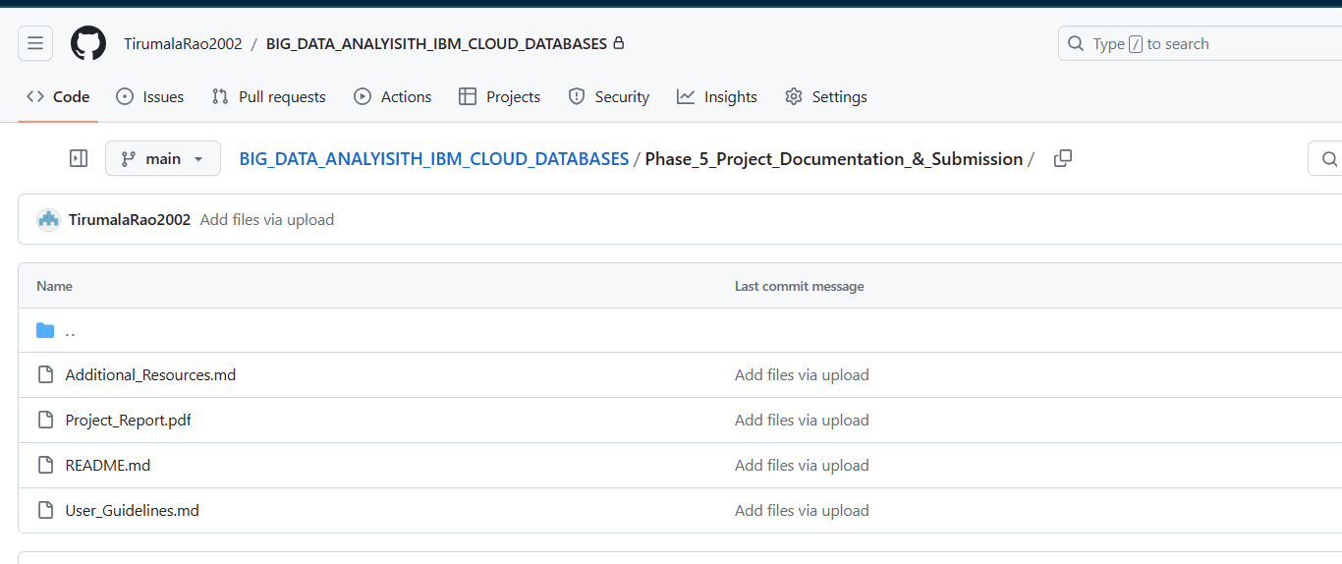

**README.md:** General instructions and an overview of Phase 5.

**Project_Report.pdf:** The final report summarizing the entire project, including objectives, design thinking, dataset details, analysis techniques, visualization methods, and business insights.

**User_Guidelines.md:** Guidelines for users on how to use the project.

**Additional_Resources.md:** Document providing contact information for project maintainers and additional resources for users who may need further assistance.

**Project Conclusion:**

"Big Data Analysis with IBM Cloud Db2," has been a comprehensive journey through various phases, each contributing to unlocking valuable insights from the extensive "Climate Trends" dataset. We began by defining the project's objectives in Phase 1 and meticulously prepared the dataset in Phase 2, ensuring its readiness for analysis. Phase 3 was dedicated to exploratory data analysis, where we unearthed preliminary trends and observations, setting the stage for more in-depth analysis.

Phase 4, "Development Part 1," marked a significant step as we leveraged advanced analysis techniques, including machine learning algorithms for predicting maximum and minimum temperatures, time series analysis for temporal patterns, and sentiment analysis to gauge textual data's emotional tone. Our Python scripts and the IBM Db2 database played crucial roles in executing these techniques effectively.

Phase 5, "Project Documentation & Submission," served as the culmination of our efforts. Here, we have meticulously documented the project, outlining its objectives, design thinking process, development phases, dataset specifics, database setup, analysis techniques, and visualization methods. The insights derived from our analysis have been transformed into a comprehensive project report, providing valuable business insights.