Dharshan R
251901036

Ex.No.3 | Experiments on CISCO PACKET TRACER (Simulation Tool):  - To understand environment of CISCO PACKET TRACER to design simple network.  - Analyse the behaviour of network devices using CISCO PACKET TRACER simulator.  Design a simple network with multiple nodes and connect via networking devices available in library. Perform simulation and trace communication behaviour of specified network devices.  1: Use only HUB to design a small network having 4 to 6 hosts  2: Use only a Switch to design a small network with 4 to 6 hosts.  3: Use both the device (HUB and SWITCH) for a network and find out functioning difference between switch and hub.  Find out the network topology implemented in your college and draw and label that topology in your observation book.
Date:
AIM: To study the Packet tracer tool Installation and analyse the behaviour of network devices using CISCO PACKET TRACER
INSTALLING PACKET TRACER
Windows
Visit the Cisco Networking Academy website (www.netacad.com).
Log in using your Cisco NetAcad account.
Download the Packet Tracer installer for Windows.
Run the setup file, accept the license agreement, and complete the installation.
Linux
Download the appropriate Packet Tracer package for your Linux distribution.
Open the terminal and make the installer executable:
chmod +x PacketTracer601_i386_installer-rpm.bin
Run the installer:
./PacketTracer601_i386_installer-rpm.bin
Follow the on-screen instructions to complete the installation.

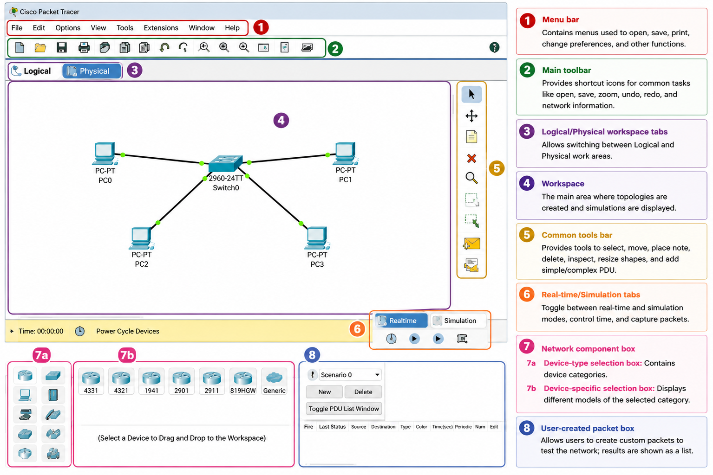
b) Analyse the behaviour of network devices using CISCO PACKET TRACER simulator.
Scenario 1: Network Using Only a Hub

Procedure

Step 1
Open Cisco Packet Tracer.

Step 2
From Network Devices, drag a Hub to the workspace.

Step 3
Drag 4 PCs (PC0, PC1, PC2, and PC3) from End Devices.

Step 4
Connect each PC to the Hub using Copper Straight-Through cables.

Step 5
Assign the following IP addresses.

Device | IP Address | Subnet Mask
PC0 | 192.168.1.1 | 255.255.255.0
PC1 | 192.168.1.2 | 255.255.255.0
PC2 | 192.168.1.3 | 255.255.255.0
PC3 | 192.168.1.4 | 255.255.255.0

Step 6
Switch to Simulation Mode.

Step 7
Click Add Simple PDU and send a packet from PC0 to PC2.

Step 8
Observe the packet movement.
Observation
- The Hub broadcasts the packet to all connected hosts.
- Every PC receives the packet.
- Only the destination PC accepts the packet.
- Network collisions may occur because all devices share the same communication channel.
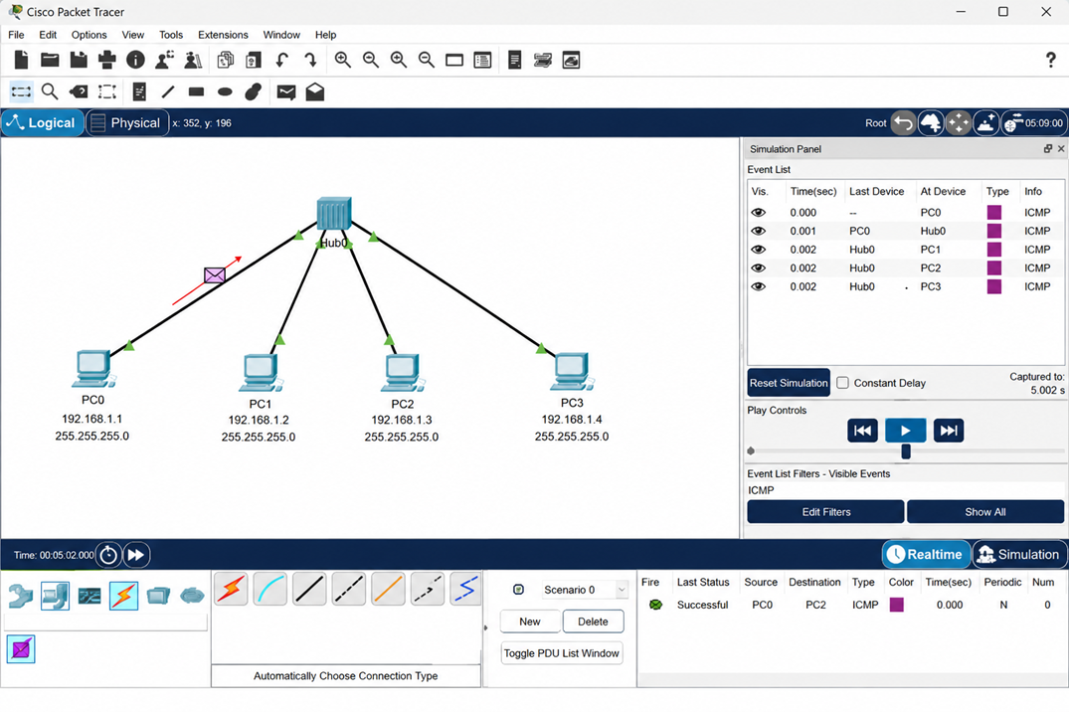

c) Scenario 2: Network Using Only a Switch

Aim
To design a simple network using a switch and observe the communication behaviour during simulation.

Network Topology
Switch0
/ | | \
PC0 PC1 PC2 PC3

Devices Required
Device | Quantity
Switch 2960 | 1
PC-PT | 4
Copper Straight-Through Cable | 4

Procedure
Step 1
Open Cisco Packet Tracer.
Step 2
From Network Devices → Switches, drag a 2960 Switch into the workspace.
Step 3
Drag four PCs (PC0, PC1, PC2, and PC3) from End Devices.
Step 4
Connect each PC to the switch using Copper Straight-Through cables.
Step 5
Assign the following IP addresses.
Device | IP Address | Subnet Mask
PC0 | 192.168.1.1 | 255.255.255.0
PC1 | 192.168.1.2 | 255.255.255.0
PC2 | 192.168.1.3 | 255.255.255.0
PC3 | 192.168.1.4 | 255.255.255.0
Step 6
Switch to Simulation Mode.
Step 7
Select Add Simple PDU.
Step 8
Click PC0 and then PC2.
Step 9
Observe the packet movement.
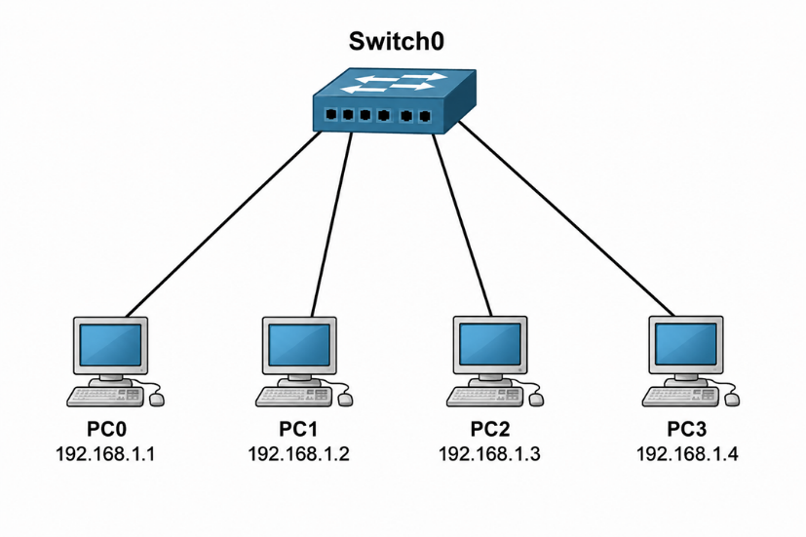
Observation
- The switch learns the MAC addresses of connected devices.
- Initially, the switch may flood the frame if the destination MAC address is unknown.
- Once the MAC address table is learned, the switch forwards packets only to the destination port.
- Other PCs do not receive the packet.
- No collisions occur because each switch port forms a separate collision domain.
Scenario 3: Network Using Both Hub and Switch

Aim
To design a network using both a hub and a switch and compare their communication behaviour.

Network Topology

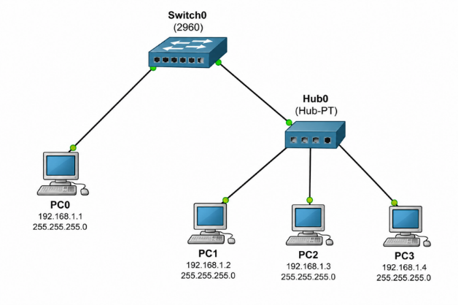
Devices Required
Device | Quantity
Switch 2960 | 1
Hub | 1
PC-PT | 4
Copper Straight-Through Cable | 5

Procedure
Step 1
Open Cisco Packet Tracer.
Step 2
Place one 2960 Switch and one Hub in the workspace.
Step 3
Add four PCs.
Step 4
Connect:
PC0 → Switch
Hub → Switch
PC1 → Hub
PC2 → Hub
PC3 → Hub

Step 5
Assign the following IP addresses.
Device | IP Address | Subnet Mask
PC0 | 192.168.1.1 | 255.255.255.0
PC1 | 192.168.1.2 | 255.255.255.0
PC2 | 192.168.1.3 | 255.255.255.0
PC3 | 192.168.1.4 | 255.255.255.0
Step 6
Switch to Simulation Mode.
Step 7
Send a Simple PDU from PC0 to PC2.
Step 8
Observe the packet movement.

Observation
- The switch forwards the frame only toward the hub.
- The hub broadcasts the frame to all devices connected to it.
- PC1 and PC3 receive the frame but discard it.
- PC2 accepts the packet because it is the intended destination.
- The switch limits unnecessary traffic, while the hub broadcasts within its segment.

OUTPUT:

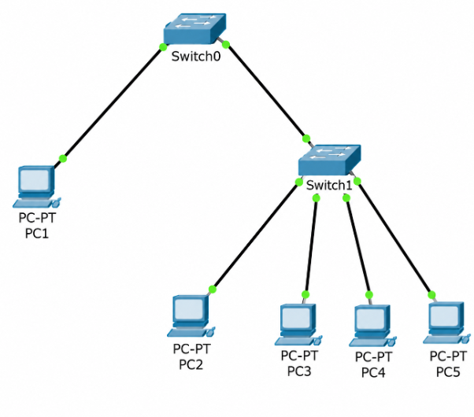

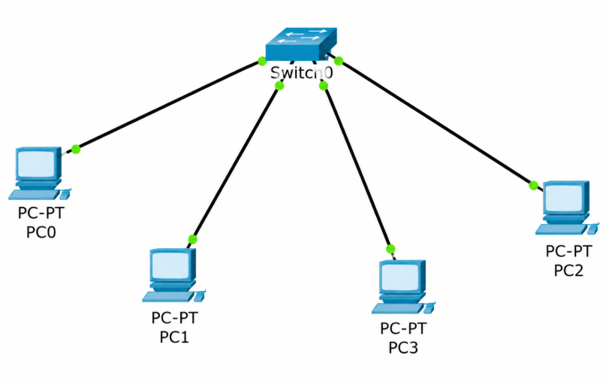
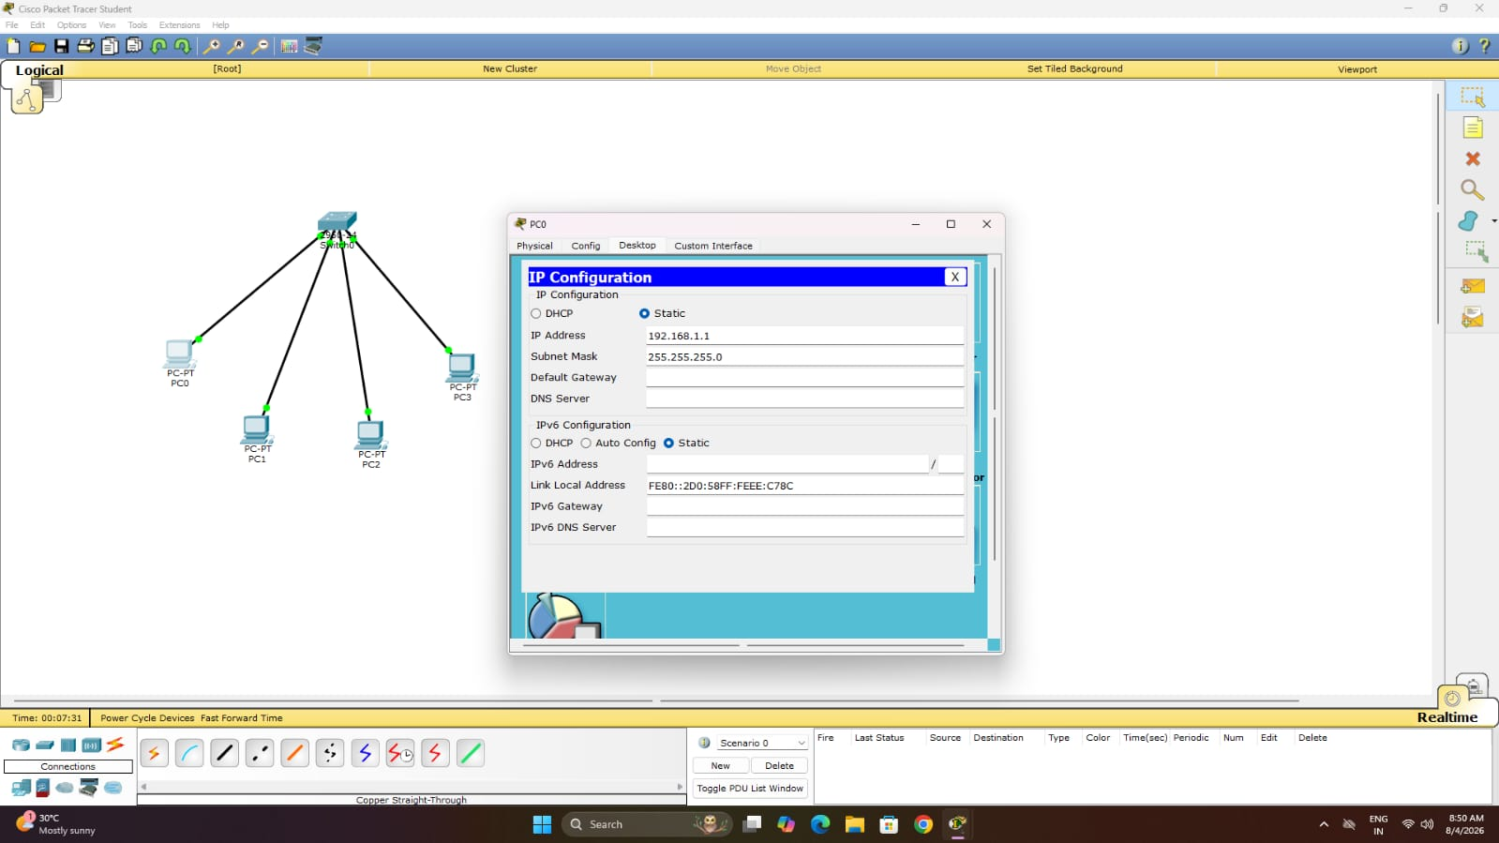

RESULT: Cisco Packet Tracer was successfully installed and studied.The behaviour and communication of various network devices were successfully analyzed using Cisco Packet Tracer.

