

DEPARTMENT OF ARTIFICIAL INTELLIGENCE AND
DATA SCIENCE LAB MANUAL

AD23431 - STATISTICAL ANALYSIS AND COMPUTING

(REGULATION 2023)
RAJALAKSHMI ENGINEERING COLLEGE
Thandalam, Chennai-602015

Name: Dharshana S
Register No: 231801032
Year / Branch / Section: 2nd / AI&DS / FA
Semester: IV
Academic Year: 2024 - 2025

INDEX
S.No. | Date | Title | Page No
1. | 05/2/25 | Implement Simple Programs in R | 3
2. | 19/2/25 | Perform Data Preprocessing in R | 9
3. | 05/3/25 | Perform Statistical Analysis for a Given Dataset | 12
4. | 26/3/25 | Implement Decision Tree Algorithm in R | 17
5. | 02/4/25 | Implement K-Nearest Neighbor Algorithm in R | 21
6. | 16/4/25 | Implement Naive Bayesian Classifier in R | 26
7. | 16/4/25 | Implement Linear Regression in R | 30
8. | 23/4/25 | Implement K-means Clustering Algorithm in R | 33

EXP NO: 1 | IMPLEMENT SIMPLE PROGRAMS IN R

Aim:
To Implement Simple Programs using R.
Algorithm:
1. Basic Arithmetic Operations
a. Finding Area of Circle
- Input: Read radius r.
- Process: Calculate the area using the formula:
Area=π×r2\text{Area} = \pi \times r^2Area=π×r2
- Output: Print the calculated area.

2. Control Structures (if-else, for loop)
- Check Whether the Given Year is Leap or Not
  - Input: Read a year ly.
  - Process: o If ly is divisible by 400, it’s a leap year.
    - Else, if divisible by 100 (but not by 400), it’s not a leap year. o Else, if divisible by 4, it’s a leap year.
    - Otherwise, it’s not a leap year.
  - Output: Print whether the year is a leap year or not.

- Reverse a Given Number • Input: Read a number num.
  - Process:
    - Initialize rev = 0.
    - While num > 0:
      - Extract last digit: ld = num % 10.
      - Update rev = rev * 10 + ld.
      - Remove last digit: num = num // 10.
  - Output: Print the reversed number.

- Finding Prime Numbers for the Given Range
  - Input: Read the number n (upper limit).
  - Process:
    - For each number i from 1 to n, check if it's prime:
      - If divisible by any number from 2 to √i, it’s not prime. ▪ If no divisors found, it is prime.
  - Output: Print all prime numbers from 1 to n.

3. Functions and Recursive Functions
- Print the Fibonacci Sequence using Functions (Iterative)
  - Input: Read n (number of terms in the sequence).
  - Process: o Initialize first two terms: a = 0, b = 1. o Print a and b.
    - Loop (n-2) times:
      - Calculate next term c = a + b.
      - Update a = b, b = c.
    - Print the sequence of n terms.

- Print the Fibonacci Sequence using Recursive Functions
  - Input: Read n (number of terms in the sequence).
  - Process:
    - Define a recursive function fibo(n):
      - If n == 0, return 0 (base case).
      - If n == 1, return 1 (base case).
      - Else, return fibo(n-1) + fibo(n-2).
    - Call fibo(i) for each i from 0 to n-1 and print the sequence.

Programs:
- Basic Arithmetic Operations
a. Finding Area of Circle r=as.integer(readline(("Enter the radius: "))) area=pi*r*r print(area)

Output:
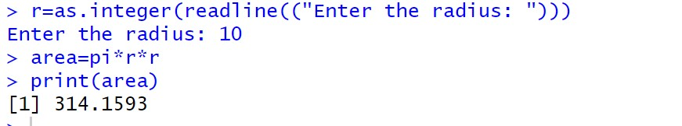

- Control Structure (if-else, for loop)
  - To Check Whether the Given Year is Leap or Not ly=as.integer(readline(("Enter a Number: "))) if(ly%%400==0){ print("Leap Year") }else if(ly%%100==0){ print("Not a Leap Year") }else if(ly%%4==0){ print("Leap Year")
}else{ print("Not a Leap Year") }
Output:
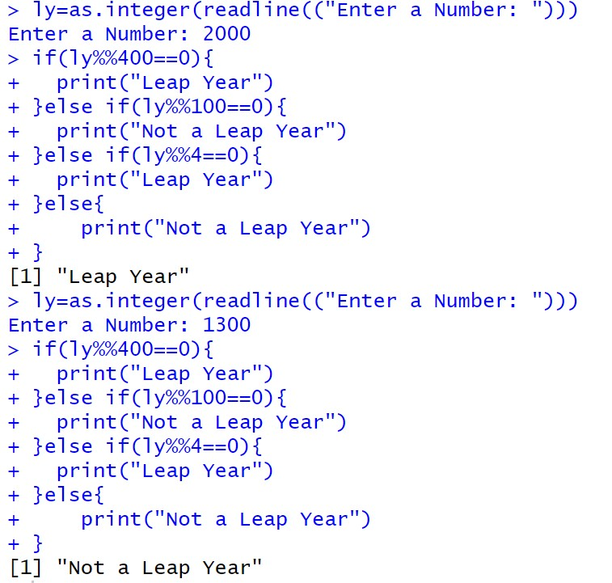

  - Reverse a Given Number num=as.integer(readline("Enter a number: ")) rev=0 while(num>0){ ld=num%%10 rev=rev*10+ld
num=num%/%10
}
cat("Reversed NUmber",rev)

Output:
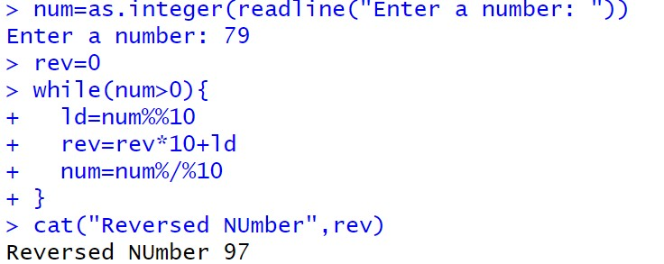

  - Finding Prime Numbers for the Given Range prime<-function(n){ if(n<=1){ return (FALSE)} for (i in 2:sqrt(n)){
if(n%%i==0){ return (FALSE)
}
}
return (TRUE)
}

n=as.integer(readline("Enter a number: ")) for (i in 1:n){ if(prime(i)){ print(i)
}
}

Output:
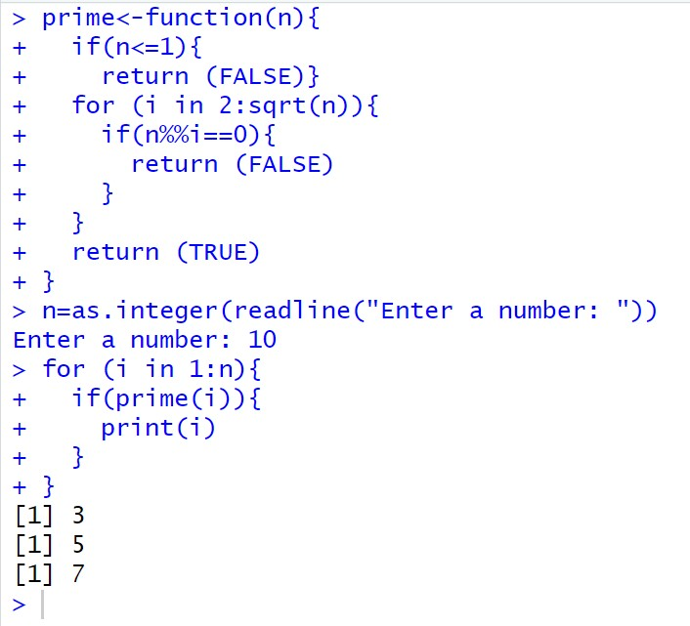

- Functions and Recursive Functions
a. Print the Fibonacci Sequence using Functions fibonacci_iterative <- function(n) { fib_series <- numeric(n) fib_series[1] <- 0 if (n > 1) fib_series[2] <- 1

for (i in 3:n) { fib_series[i] <- fib_series[i-1] + fib_series[i-2]
}

return(fib_series)
}

n <- as.integer(readline("How many terms? ")) print(fibonacci_iterative(n))

Output:
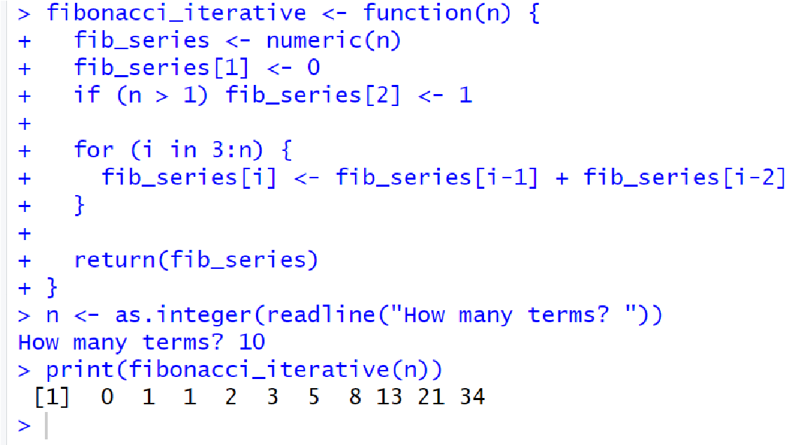

b. Print the Fibonacci Sequence using Recursive Functions fibonacci_recursive <- function(n) { if (n == 1) { return(0) } else if (n == 2) { return(1) } else { return(fibonacci_recursive(n-1) + fibonacci_recursive(n-2))
}
}

n <- as.integer(readline("How many terms? ")) fib_series <- sapply(1:n, fibonacci_recursive) print(fib_series)

Output:
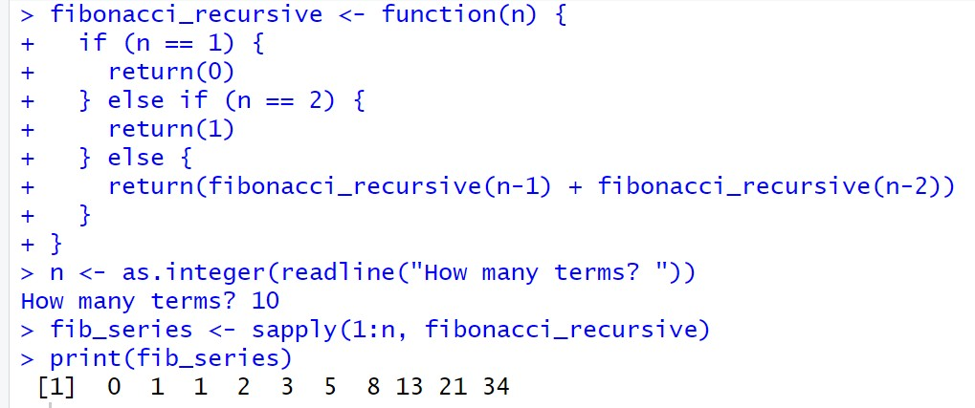

Result:
The Simple Program using R is Successfully Implemented.
EXP NO: 2 | PERFORM DATA PREPROCESSING IN R

Aim:
To Perform Preprocessing of data using R.
Algorithm:
  - Loading Data / Cleaning the Data:
o Create emp_df2 with columns: emp_id, age, dept, salary, experience.
  - Storing / Uploading Data to Excel Sheet:
o Create a workbook wb, add a worksheet "Employee Data Preprocessing", and save emp_df2 to emp_df2.xlsx.
  - Cleaning the Data:
    - Replace missing age and salary with their respective mean values.
    - Convert dept to numeric.
- Scaling the Data:
o Scale the age, salary, and experience columns using z-score and update emp_df2.
- Splitting the Data into Train and Test:
o Set seed, split data into 80% train and 20% test (dataTrain, dataTest).
- Correlation Matrix:
o Compute the correlation matrix for the scaled features (age, salary, experience) to examine relationships between them.

Programs:
library(openxlsx)

emp_df2<-data.frame( emp_id=1:10,
age=c(25,30,35,NA,55,65,NA,25,85,78), dept=c("AI&DS","IT","AI&ML","CSE","PHY","FT","BIOTECH","CSBS","CIVIL","MECH"), salary=c(50000,85100,52802,144510,552410,520000,445100,5552410,524160,NA), experience=c(2,5,8,14,4,6,3,2,4,5)
)

wb<-createWorkbook()

addWorksheet(wb,"Employee Data Preprocessing")

writeData(wb,"Employee Data Preprocessing",emp_df2)

saveWorkbook(wb,"C:\\Users\\karthick.S\\OneDrive\\Documents\\231801079-
4\\SAC\\emp_df2.xlsx",overwrite = TRUE) emp_df2$age[is.na(emp_df2$age)]<-floor(mean(emp_df2$age,na.rm = TRUE))

emp_df2$salary[is.na(emp_df2$salary)]<-floor(mean(emp_df2$salary,na.rm = TRUE))

emp_df2$dept<-as.numeric(as.factor(emp_df2$dept))

emp_df_scaled<-scale(emp_df2[,c("age","salary","experience")]) emp_df2<-data.frame(emp_df2[,c("emp_id","dept")],emp_df_scaled)

correlation_matrix <- cor(emp_df2[, c("age", "salary", "experience")]) print("Correlation Matrix:") print(correlation_matrix)

set.seed(42) trainIndex<-sample(1:nrow(emp_df2),0.8*nrow(emp_df2)) dataTrain<-emp_df2[trainIndex,] dataTest<-emp_df2[-trainIndex,]

print(dataTrain) print(dataTest)

Output:
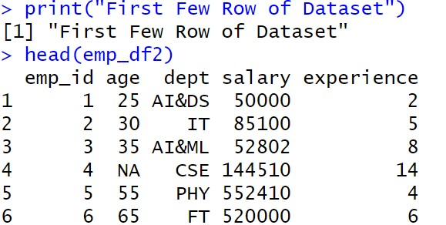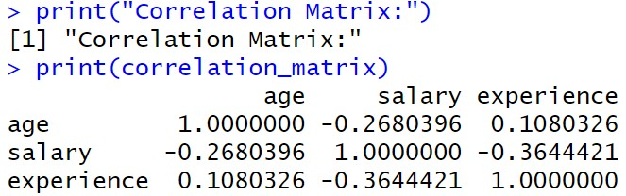

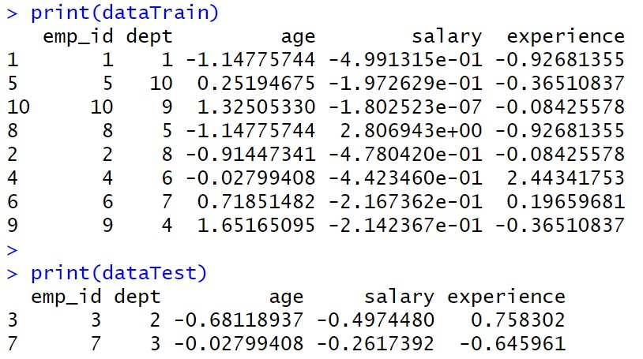

Result:
Thus, Preprocessing data is cleaned, transformed and formatted dataset ready for analysis or modelling.
EXP NO: 3 | PERFORM STATISTICAL ANALYSIS FOR A GIVEN  DATASET

Aim:
To Perform Statistical Analysis for Given Dataset.
Algorithm:
- Loading Libraries:
  - Load the necessary libraries: dplyr, summarytools, psych.
- Loading Data:
  - Create a dataset data with columns Age and Salary.
- Statistical Analysis:
  - Mean: Calculate the mean of Age.
  - Median: Calculate the median of Age.
  - Mode: Calculate the mode of Age using the table function.
  - Variance: Calculate the variance of Age.
  - Standard Deviation: Calculate the standard deviation of Age.
  - Correlation: Calculate the correlation between Age and Salary.
- Descriptive Statistics:
  - Use the summary() function to generate summary statistics for the dataset.
- Quantile Analysis:
  - Calculate the quantiles for both Age and Salary.
- Interquartile Range (IQR):
  - Calculate the IQR for both Age and Salary.
- Hypothesis Testing (T-Test):
  - Perform a one-sample t-test on Salary with a hypothesized mean of 70,000.
- Visualization:
  - Boxplot: Create a boxplot for Age and Salary to visualize their distributions.
- Detailed Descriptive Statistics:
  - Use describe() from the psych package to get detailed statistics for Age and Salary.
  - Use descr() from the summarytools package for detailed descriptive statistics.

Program:
library(dplyr) library(summarytools) library(psych)

data <- data.frame(Age = c(25, 30, 28, 35, 40, 45, 50, 32, 38, 42),
Salary = c(50000, 60000, 55000, 75000, 80000, 85000, 90000, 65000, 78000,
82000)) cat("Dataset:\n") print(data)

mean_age <- mean(data$Age) median_age <- median(data$Age) mode_age <- as.numeric(names(sort(table(data$Age), decreasing = TRUE))[1])

var_age <- var(data$Age) sd_age <- sd(data$Age)

corr <- cor(data$Age, data$Salary)

cat("\nStatistical Analysis Results:\n") print(mean_age) print(median_age) print(mode_age) print(var_age) print(sd_age) print(corr)

data_summary <- summary(data) print(data_summary)

quantile_age <- quantile(data$Age) quantile_salary <- quantile(data$Salary)

IQR_age <- IQR(data$Age)
IQR_salary <- IQR(data$Salary)

cat("Quantile Age", quantile_age) cat("\nQuantile Salary", quantile_salary)

cat("\nIQR Age", IQR_age) cat("\nIQR Salary", IQR_salary)

t_test_result <- t.test(data$Salary, mu = 70000) print(t_test_result)

boxplot(data$Age, main = "Boxplot of Age", ylab = "Age", col = "lightblue") boxplot(data$Salary, main = "Boxplot of Salary", ylab = "Salary", col = "lightgreen")

cat("\nDescribe Method From Describe of psych") descr_stats <- describe(data[, c("Age", "Salary")]) print("Detailed Descriptive Statistics:") print(descr_stats) cat("\nDescribe Method From Descr of SummaryTools") print(descr(data))
Output:
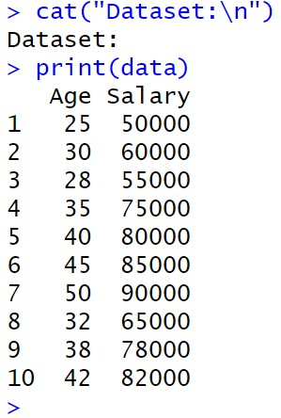

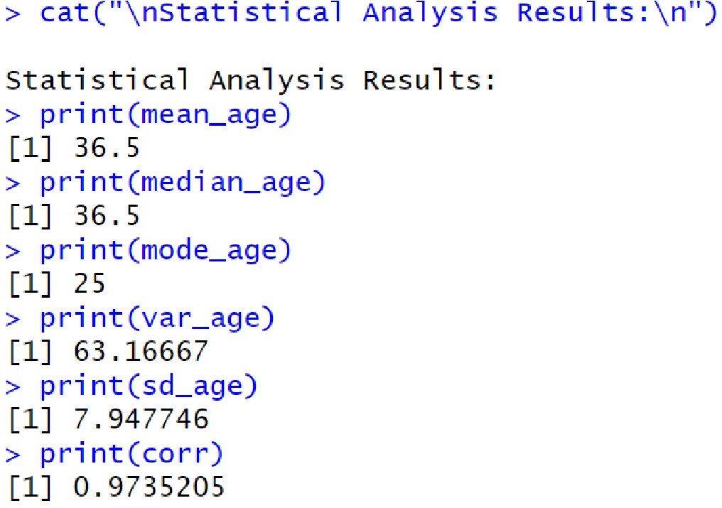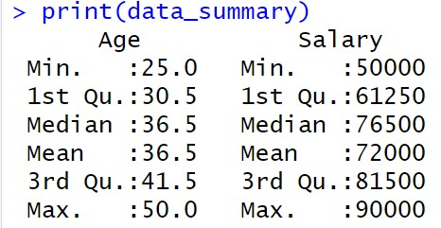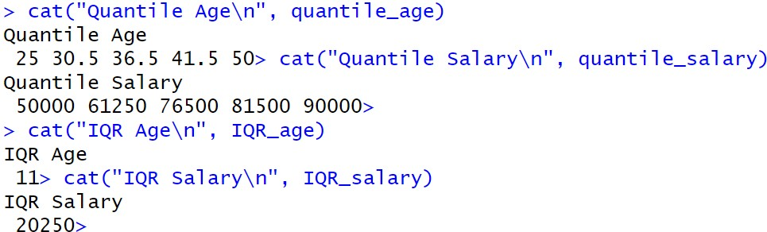

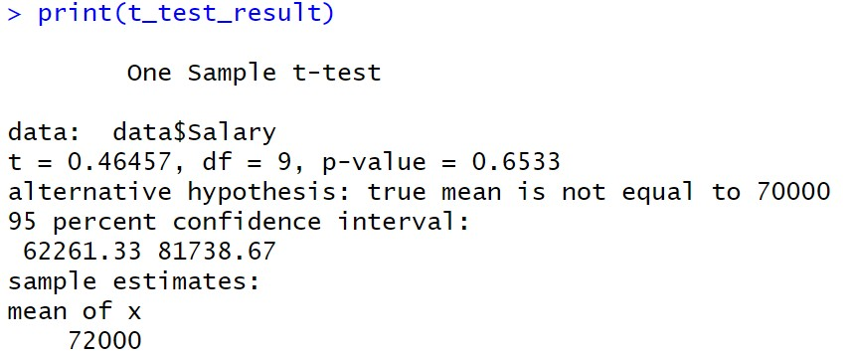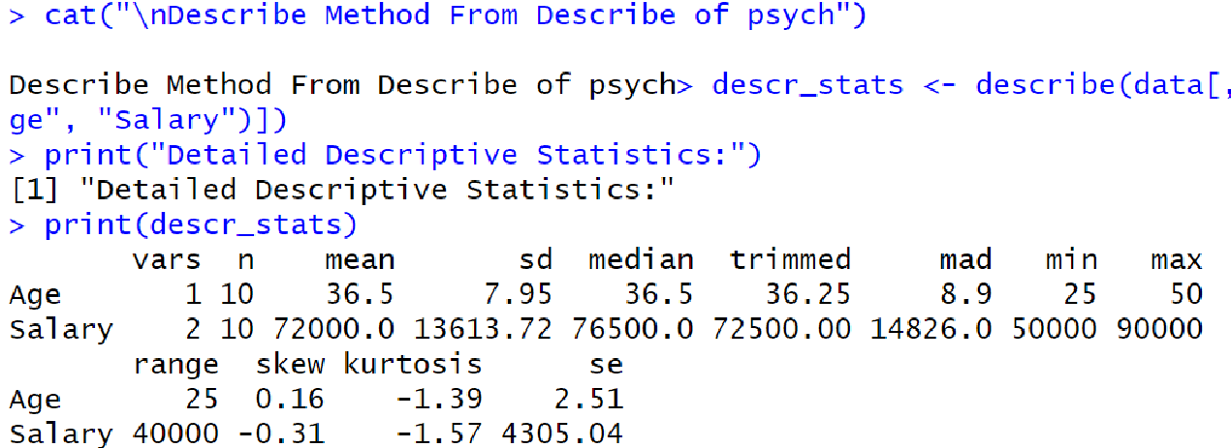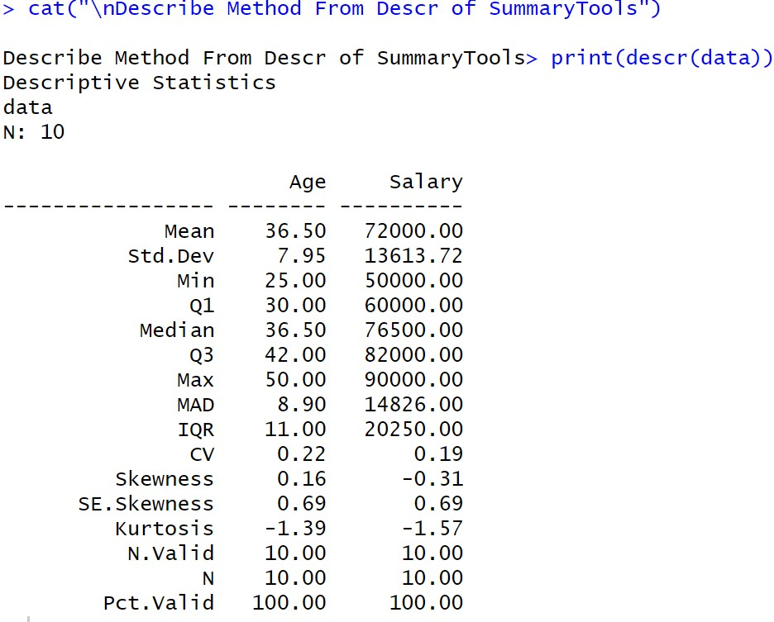

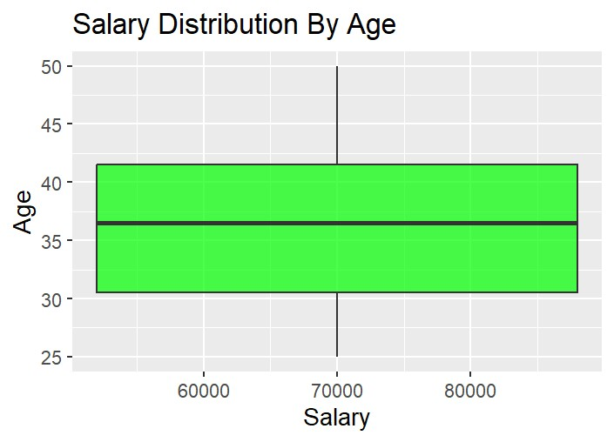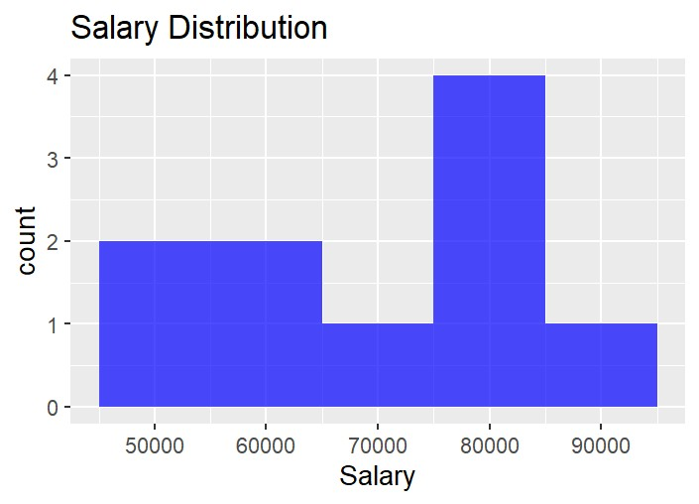

Result:
Thus, Statistical Analysis for a Given Dataset using is Analysed and Scaled.

EXP NO: 4 | IMPLEMENT DECISION TREE ALGORITHM IN R

Aim:
Implement a Decision Tree Classification on the Given Dataset.

Procedure:
- Load Required Libraries
  - Load the necessary libraries:
    - rpart for building decision tree models. o rpart.plot for visualizing decision trees.
    - caret for data splitting and model evaluation.
Code:
library(rpart) library(rpart.plot) library(caret)

- Load the Dataset
  - Load the Iris dataset (built-in in R).
  - Display the first few rows to understand the data structure.
Code:
data("iris") print("First Few Rows of Dataset") head(iris)

- Split the Data into Training and Testing Sets
  - Set a seed for reproducibility.
  - Use createDataPartition to split the data into:
    - 80% training set o 20% testing set Code:
set.seed(123) train_index <- createDataPartition(iris$Species, p = 0.8, list = FALSE) train_data <- iris[train_index, ] test_data <- iris[-train_index, ]

- Train a Decision Tree Model
  - Build a decision tree classifier using rpart, predicting Species based on the features. Code:
tree_model <- rpart(Species ~ ., data = train_data, method = "class") print(tree_model)

- Visualize the Decision Tree
  - Plot the trained decision tree using rpart.plot with enhanced formatting.
Code:
rpart.plot(tree_model, main = "Decision Tree for Iris Dataset", type = 3, extra = 101, under = TRUE, tweak = 1.2, box.palette = "RdBu")

- Make Predictions on Test Data
  - Use the trained model to predict the species on the test dataset. Code:
pred <- predict(tree_model, test_data, type = "class")

- Evaluate Model Performance
  - Create a confusion matrix to compare predicted vs actual labels.
  - Print evaluation metrics like accuracy, sensitivity, specificity, etc. Code:
conf_mat <- confusionMatrix(pred, test_data$Species) print(conf_mat)

Output:
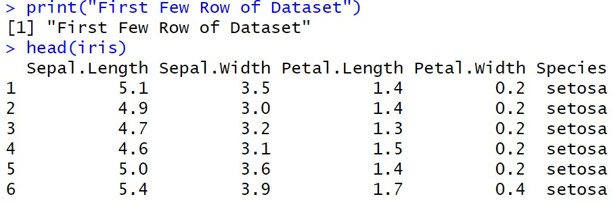

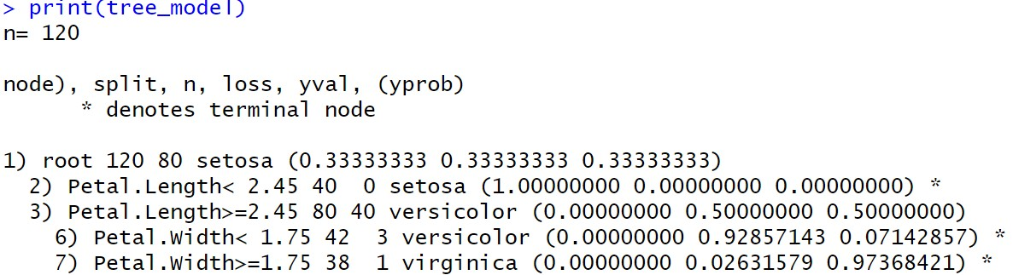

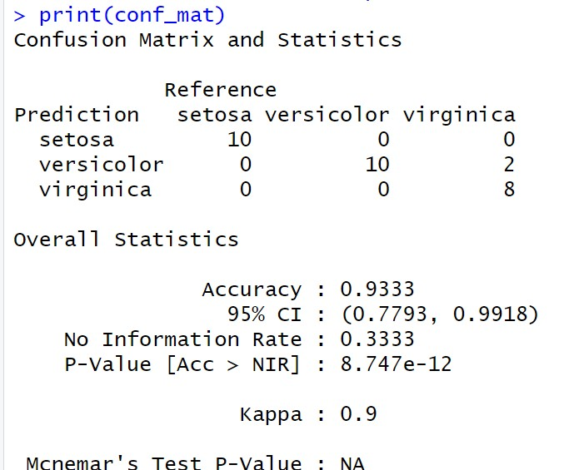

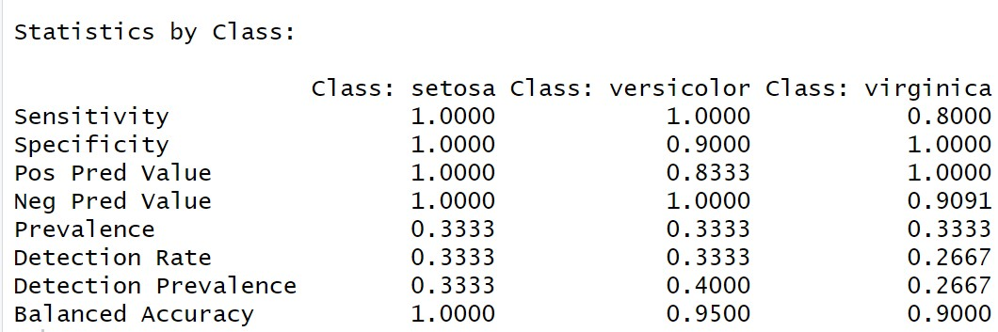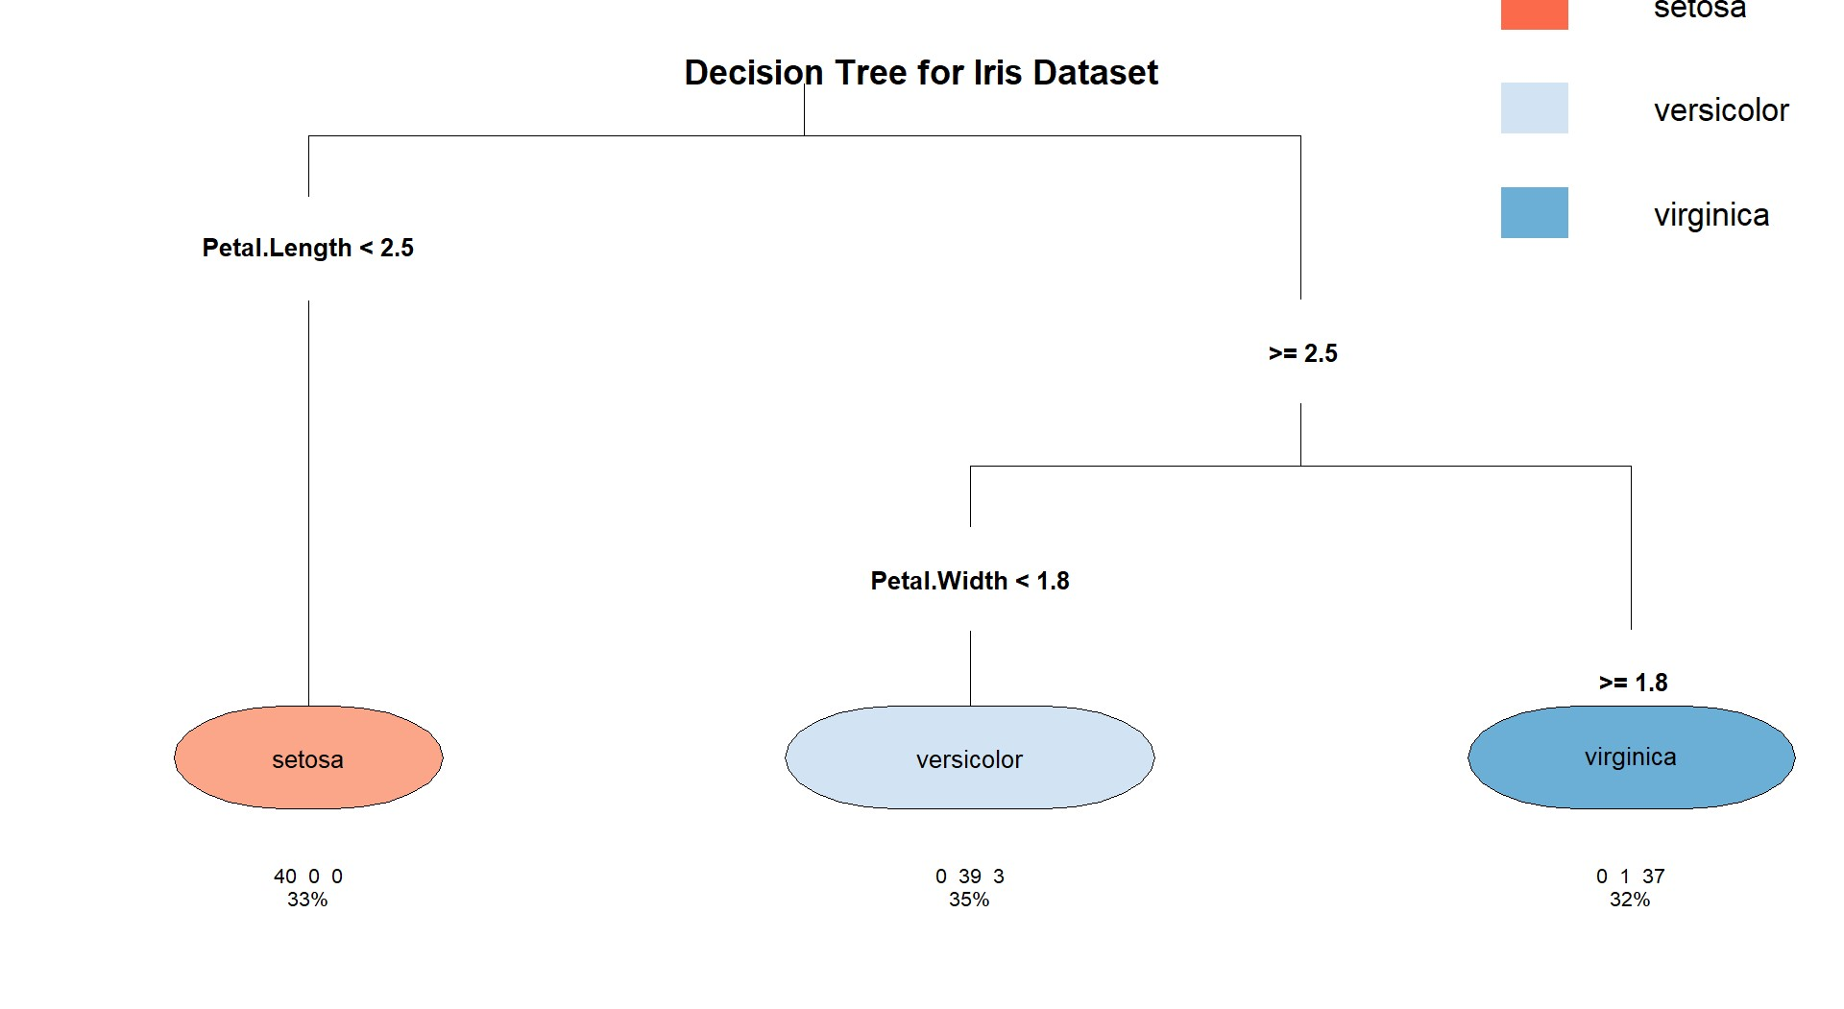

Result:
The Decision Tree is Implemented Successfully.

EXP NO: 5 | IMPLEMENT K-NEAREST NEIGHBOR ALGORITHM  IN R

Aim:
Implement a KNN Classification on the Given Dataset.
Procedure:
- Load Required Libraries
  - Load the necessary libraries:
    - class for KNN model. o ggplot2 for plotting. o GGally for advanced plots (pairwise plots). o caret for data partitioning and evaluation.
Code:
library(class) library(ggplot2) library(GGally) library(caret)

- Load the Dataset
  - Load the Iris dataset.
  - Display the first few rows to understand the structure.
Code:
data("iris") print("First Few Rows of Dataset") head(iris)

- Define a Normalize Function
  - Create a custom function to normalize (scale between 0 and 1) the numerical feature columns.
Code:
normalize <- function(x) { return((x - min(x)) / (max(x) - min(x))) }

- Normalize the Feature Columns
  - Apply the normalization function to the first four feature columns.
  - Add back the Species column separately.

Code:
iris_norm <- as.data.frame(lapply(iris[1:4], normalize)) iris_norm$Species <- iris$Species

- Split the Data into Training and Testing Sets
  - Set a random seed for reproducibility.
  - Use createDataPartition to split:
    - 80% for training o 20% for testing
Code:
set.seed(123) train_index <- createDataPartition(iris$Species, p = 0.8, list = FALSE) train_data <- iris_norm[train_index, ] test_data <- iris_norm[-train_index, ]
- Extract Training and Test Labels
  - Separate the labels (Species) from the feature data for both train and test sets.
Code:
train_labels <- train_data$Species test_labels <- test_data$Species

- Train the KNN Model
  - Train the K-Nearest Neighbors model using:
    - Normalized feature columns o k = 5 neighbors.
Code:
knn_model <- knn(train = train_data[, 1:4], test = test_data[, 1:4], cl = train_labels, k
= 5)
print(knn_model)

- Visualize the Data
  - Create visualizations to understand feature distributions:
    - Scatter plot of Sepal Length vs Sepal Width. o Pairwise plots (all feature combinations).
Code:
ggplot(data = iris, aes(x = Sepal.Length, y = Sepal.Width, color = Species)) + geom_point() +
labs(title = "Scatter Plot of Sepal Dimensions", x = "Sepal Length", y = "Sepal Width") + theme_minimal() ggpairs(iris, aes(color = Species)) + theme_minimal()

- Evaluate Model Performance
  - Generate a confusion matrix comparing predictions and true labels.
  - Print classification results including accuracy, sensitivity, and specificity.
Code:
conf_mat <- confusionMatrix(knn_model, test_labels) print(conf_mat)

Output:
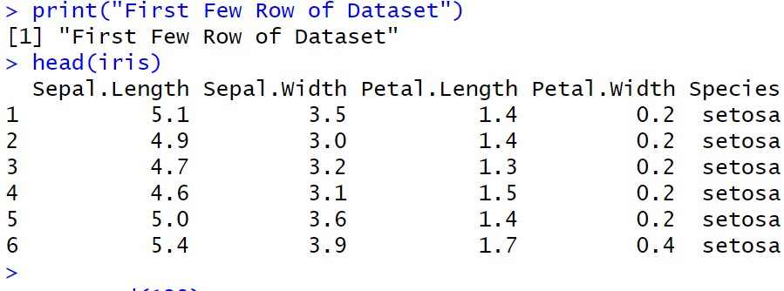
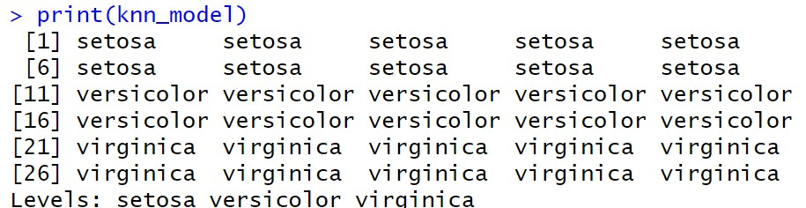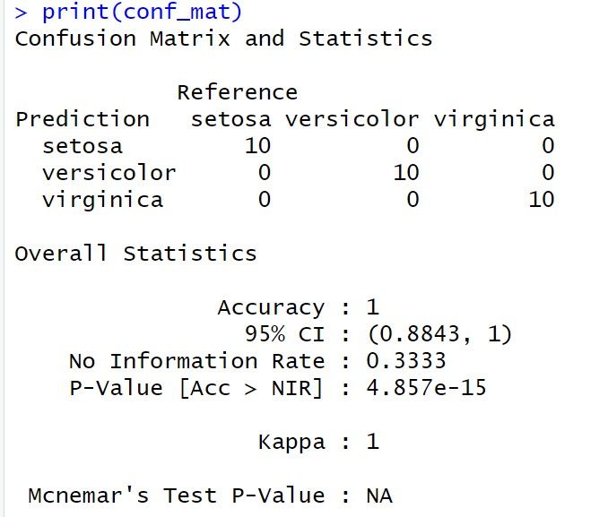

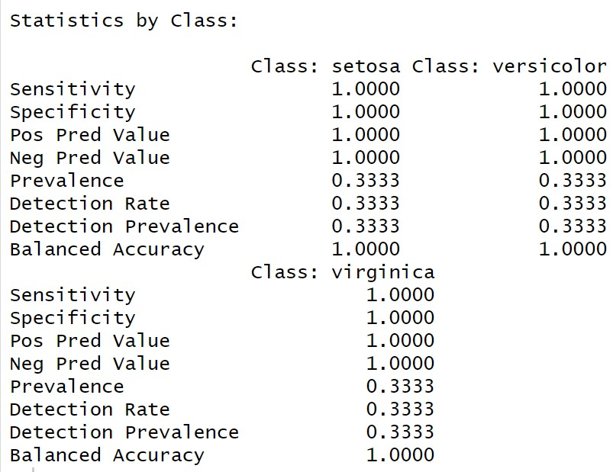
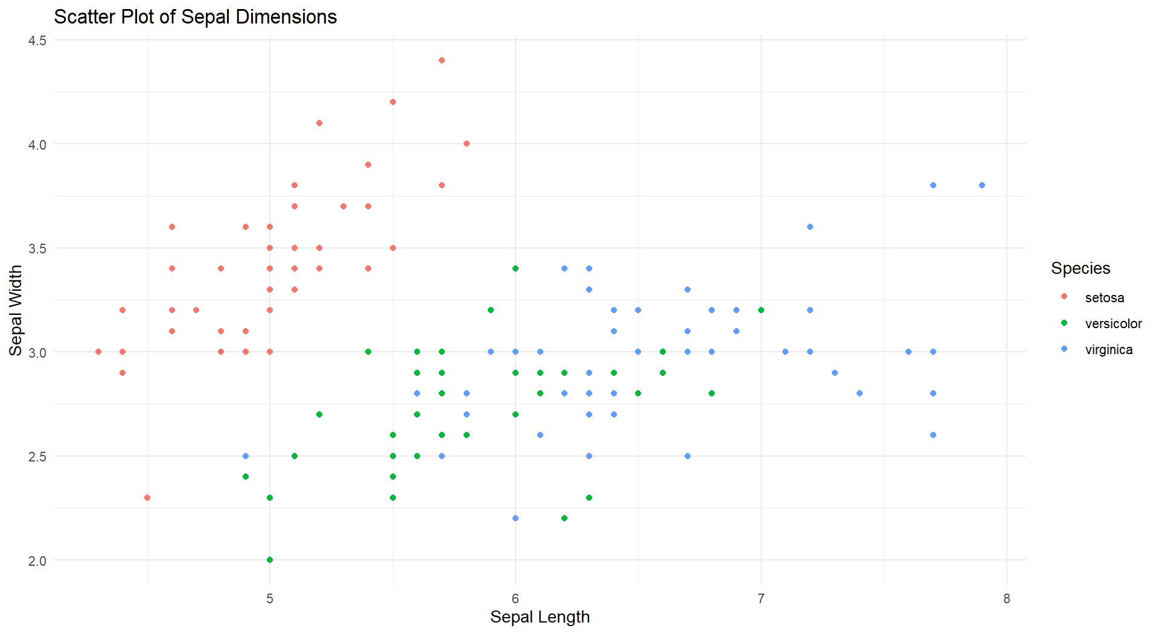
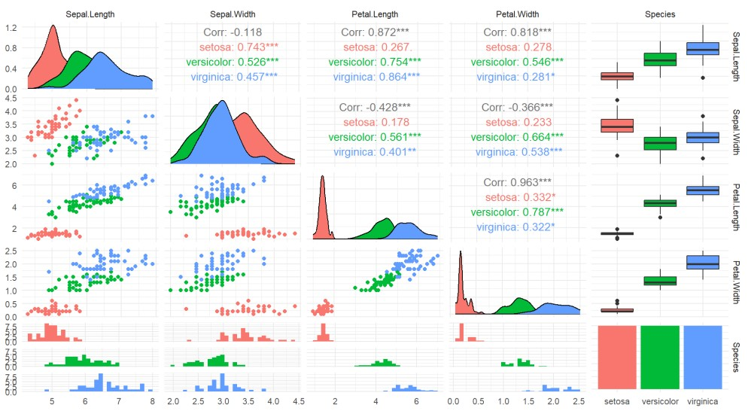

Result:
The KNN Classification is Successfully Implemented.
EXP NO: 6 | IMPLEMENT NAIVE BAYESIAN CLASSIFIER IN R

Aim:
Implement a Naïve Bayes Classification on the Given Dataset.
Procedure:
- Load Required Libraries
  - Load the necessary libraries: o e1071 for the Naive Bayes model. o ggplot2 for visualization.
o caret for data partitioning and evaluation.
Code:
library(e1071) library(ggplot2) library(caret)

- Load the Dataset
  - Load the Iris dataset.
  - Display the first few rows for a quick overview.
Code:
data("iris") print("First Few Rows of Dataset") head(iris)

- Split the Data into Training and Testing Sets • Set a random seed to ensure reproducibility.
  - Split the data into: o 80% for training o 20% for testing
Code:
set.seed(123) train_index <- createDataPartition(iris$Species, p = 0.8, list = FALSE) train_data <- iris[train_index, ] test_data <- iris[-train_index, ]

- Extract Training and Test Labels
  - Assign the Species column as the labels for training and testing.
Code:
train_labels <- train_data$Species test_labels <- test_data$Species

- Train the Naive Bayes Model
  - Train the Naive Bayes classifier using the training data. Code:
nb_model <- naiveBayes(Species ~ ., data = train_data) print(nb_model)

- Visualize the Data
  - Create a scatter plot of Sepal Length vs Sepal Width colored by species.
Code:
ggplot(data = iris, aes(x = Sepal.Length, y = Sepal.Width, color = Species)) + geom_point() +
labs(title = "Scatter Plot of Sepal Dimensions", x = "Sepal Length", y = "Sepal Width") + theme_minimal()

- Make Predictions on the Test Data
  - Predict the species for the test dataset using the trained model.
Code:
pred <- predict(nb_model, test_data)

- Evaluate Model Performance
  - Generate a confusion matrix to compare the predicted labels and true labels.
  - Print evaluation metrics like accuracy, sensitivity, and specificity.
Code:
conf_mat <- confusionMatrix(pred, test_labels) print(conf_mat)

Output:
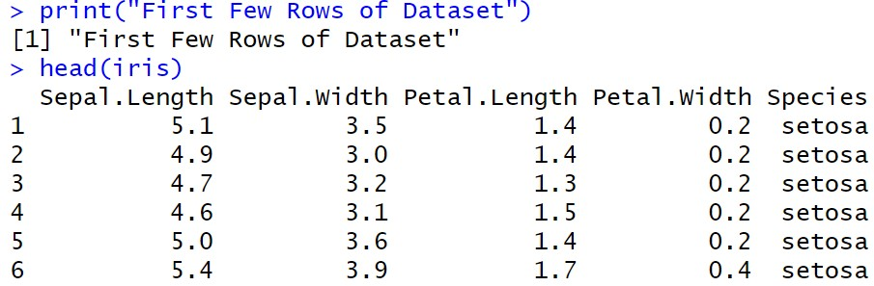
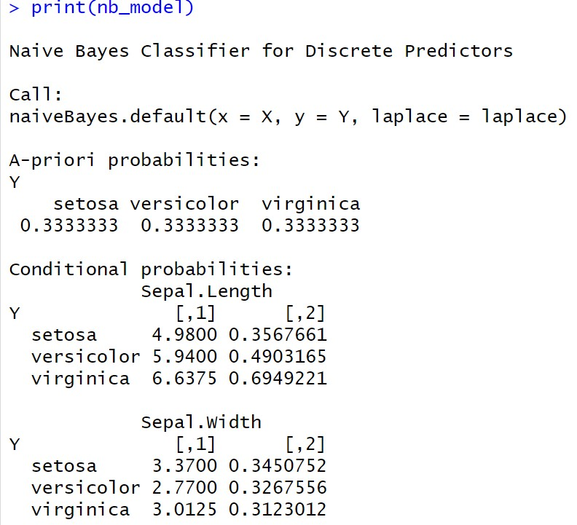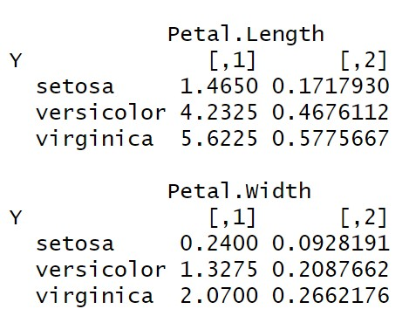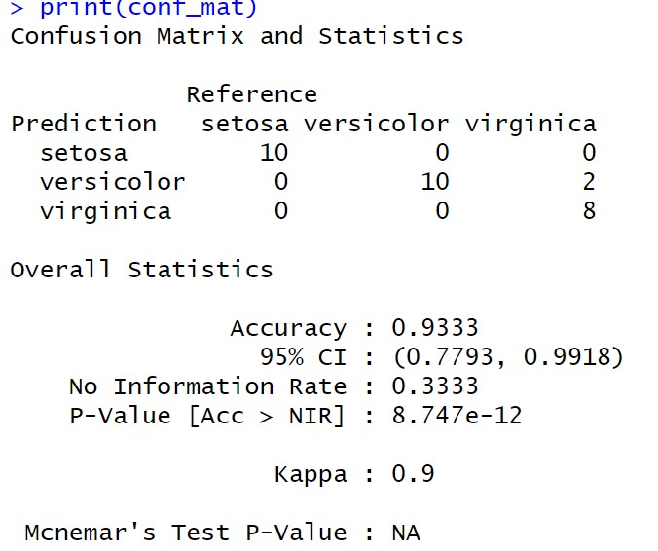

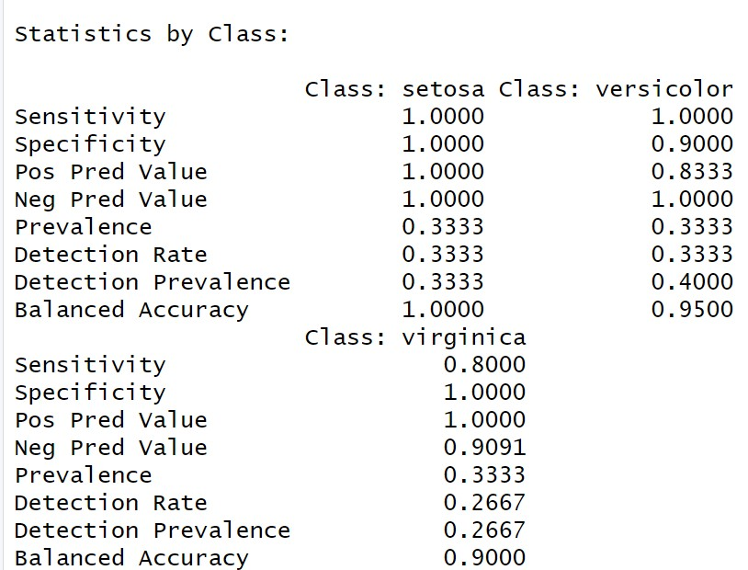

Result:
The Naïve Bayes Classification is Successfully Implemented.

EXP NO: 17 | Title IMPLEMENT LINEAR REGRESSION IN R

Aim:
Implement a Linear Regression on the Given Dataset.
Procedure:
- Load Required Libraries
  - Load the necessary libraries:
    - ggplot2 for visualization.
    - caret for splitting the data and evaluating the model.
Code:
library(ggplot2) library(caret)

- Load the Dataset
  - Load the Headbrain dataset from a CSV file.
  - Display the first few rows to inspect the data. Code:
df <- read.csv("C:/Users/karthick.S/OneDrive/Documents/231801079-
4/SAC/headbrain.csv") print("First Few Rows of Dataset") head(df)

- Split the Data into Training and Testing Sets
  - Set a random seed for reproducibility.
  - Split the data into: o 70% for training o 30% for testing
Code:
set.seed(123) index <- createDataPartition(df$Brain.Weight.grams., p = 0.7, list = FALSE) train <- df[index, ] test <- df[-index, ]

- Train the Linear Regression Model
  - Train a linear regression model to predict Brain.Weight.grams. based on Head.Size.cm.3..
Code:
print("Linear Regression Model") model <- lm(Brain.Weight.grams. ~ Head.Size.cm.3., data = train) print(model)
- Make Predictions on the Test Data
  - Use the trained model to predict brain weight values for the test dataset.
Code:
pred <- predict(model, newdata = test)

- Evaluate Model Performance
  - Use postResample to calculate evaluation metrics: o RMSE (Root Mean Squared Error) o R-squared (Coefficient of Determination) o MAE (Mean Absolute Error)
Code:
evaluation <- postResample(pred, test$Brain.Weight.grams.) cat("RMSE:", evaluation["RMSE"], "\n") cat("R-squared:", evaluation["Rsquared"], "\n") cat("MAE:", evaluation["MAE"], "\n")

- Visualize the Data
  - Plot the scatter points of the original data.
  - Overlay the regression line based on the model’s predictions.
Code:
x_vals <- seq(min(df$Head.Size.cm.3.) - 100, max(df$Head.Size.cm.3.) + 100, length.out = 1000) pred_line <- data.frame(Head.Size.cm.3. = x_vals) pred_line$Brain.Weight.grams. <- predict(model, newdata = pred_line)

plot(df$Head.Size.cm.3., df$Brain.Weight.grams., col = "green", pch = 19, xlab = "Head Size (cm³)", ylab = "Brain Weight (grams)", main = "Head Size vs Brain Weight with Regression Line")

lines(pred_line$Head.Size.cm.3., pred_line$Brain.Weight.grams., col = "red", lwd = 2)

Output:
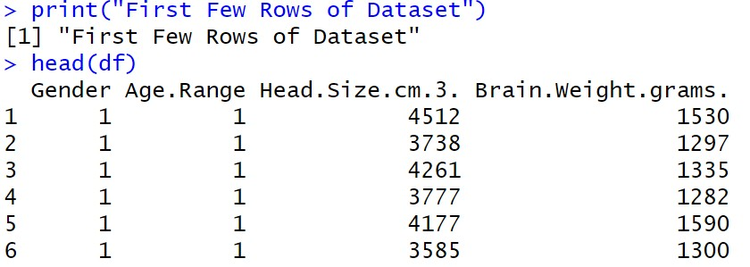

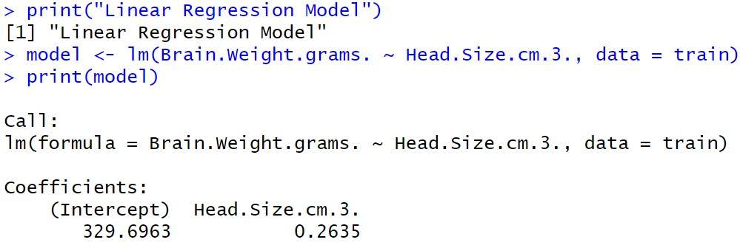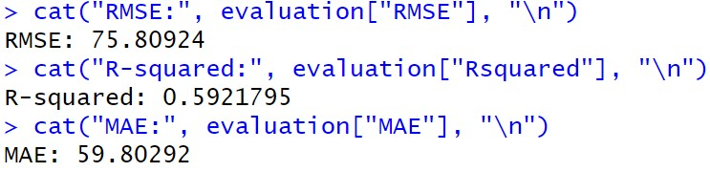
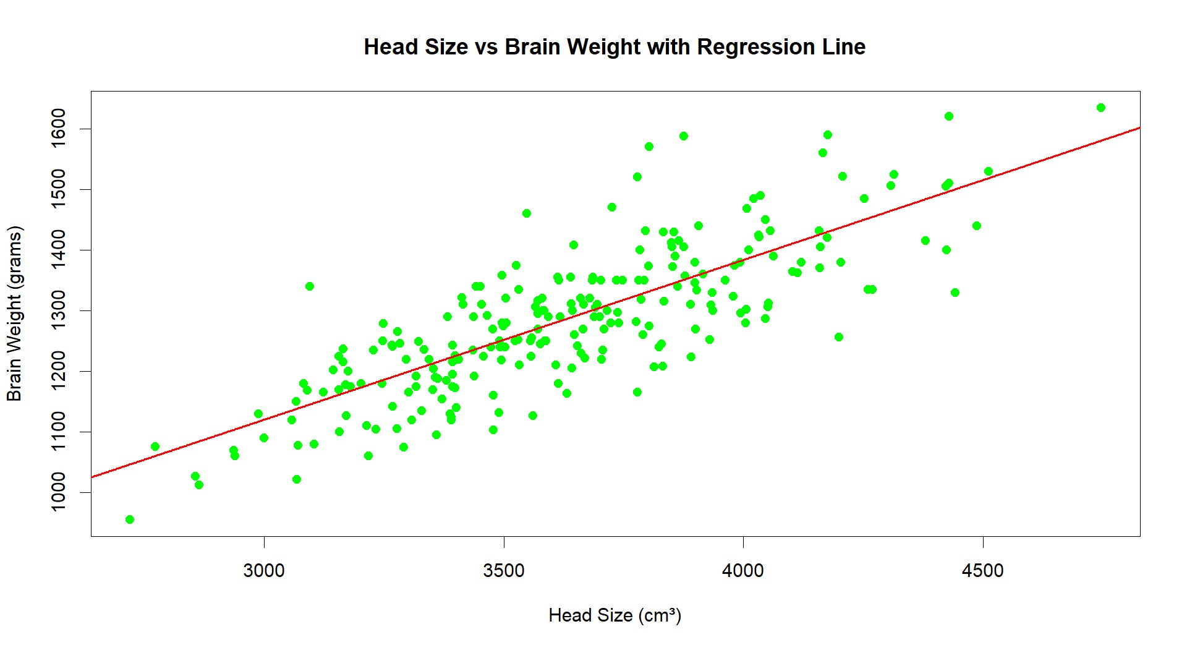

Result:
The Linear Regression is Successfully Implemented.
EXP NO: 8 | IMPLEMENT K-MEANS CLUSTERING ALGORITHM  IN R

Aim:
Implement a Kmeans Clustering on the Given Dataset.
Procedure:
Procedure for Performing and Evaluating K-means Clustering in R
- Load Required Libraries
  - Load the necessary libraries:
    - ggplot2 for plotting. o cluster for silhouette analysis.
    - factoextra for easy visualization of clustering.
Code:
library(ggplot2) library(cluster) library(factoextra)

- Load the Dataset
  - Load the Iris dataset.
  - Remove the Species column to focus only on the numeric features for clustering.
Code:
data(iris) iris_data <- iris[, -5] head(iris_data)

- Determine the Optimal Number of Clusters Using Elbow Method
  - Use the Within-Cluster Sum of Squares (WSS) method to decide how many clusters are appropriate.
Code:
fviz_nbclust(iris_data, kmeans, method = "wss") + ggtitle("Elbow Method for Optimal K")

- Apply K-means Clustering with 3 Clusters
  - Set a random seed for reproducibility.
  - Apply K-means clustering specifying 3 clusters (since Iris has 3 species).
Code:
set.seed(123)
kmeans_model <- kmeans(iris_data, centers = 3, nstart = 25)

- Print Cluster Centers and Cluster Assignments
  - View the center points of the clusters and how the data points were assigned.
Code:
print(kmeans_model$centers) print(kmeans_model$cluster)

- Visualize the Clusters
  - Visualize the clustering result using a scatter plot with convex hulls around clusters. Code:
fviz_cluster(kmeans_model, data = iris_data, geom = "point", ellipse.type =
"convex") +
ggtitle("K-means Clustering on Iris Dataset")

- Evaluate the Clustering (Silhouette Analysis)
  - Perform silhouette analysis to assess the quality of the clustering. Code:
silhouette_score <- silhouette(kmeans_model$cluster, dist(iris_data)) fviz_silhouette(silhouette_score)

Output:
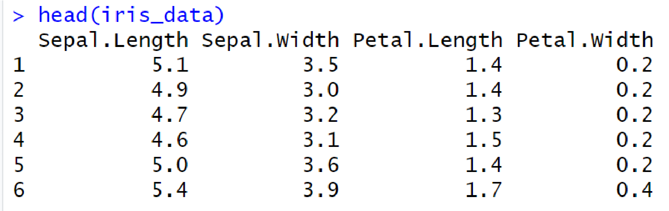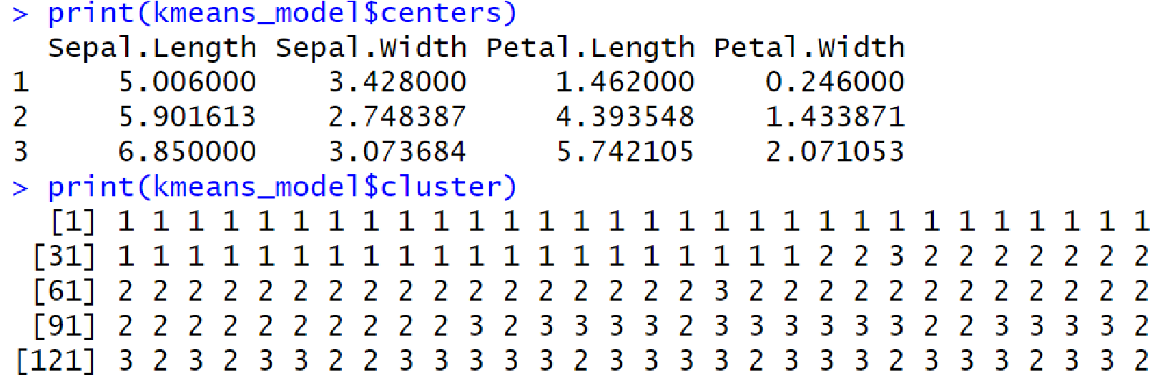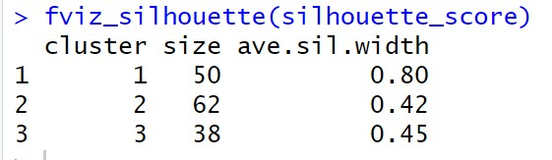

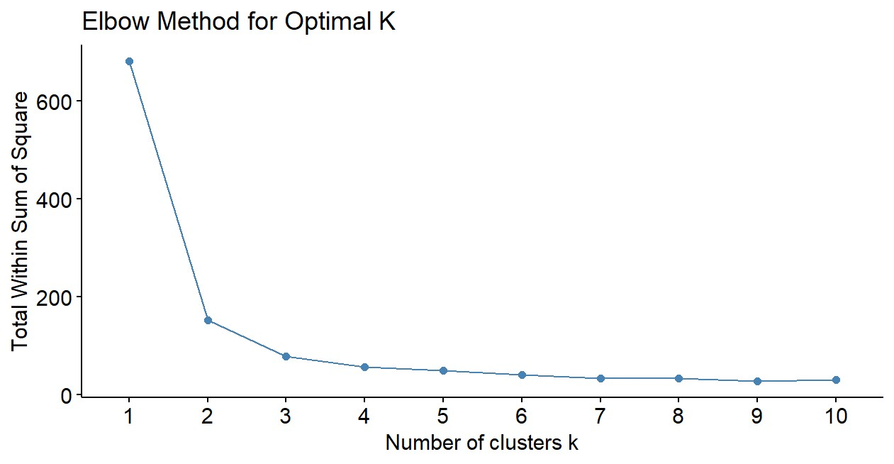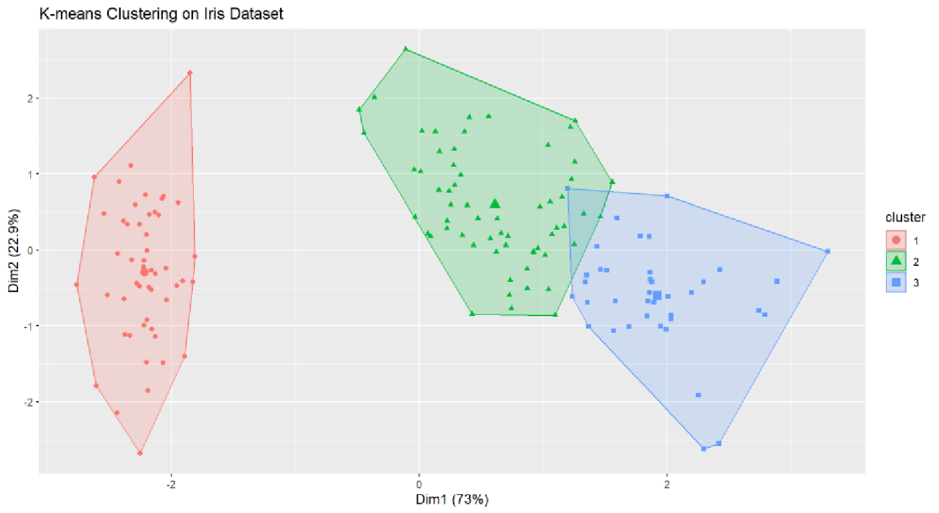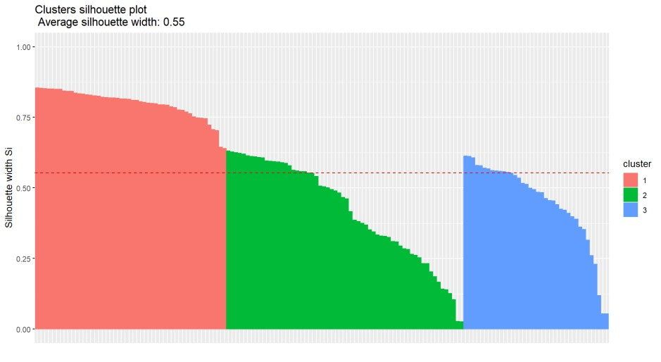

Result:
The Kmeans is Successfully Implemented.

