# Software Modules – Crime Management System

## Dashboard Module

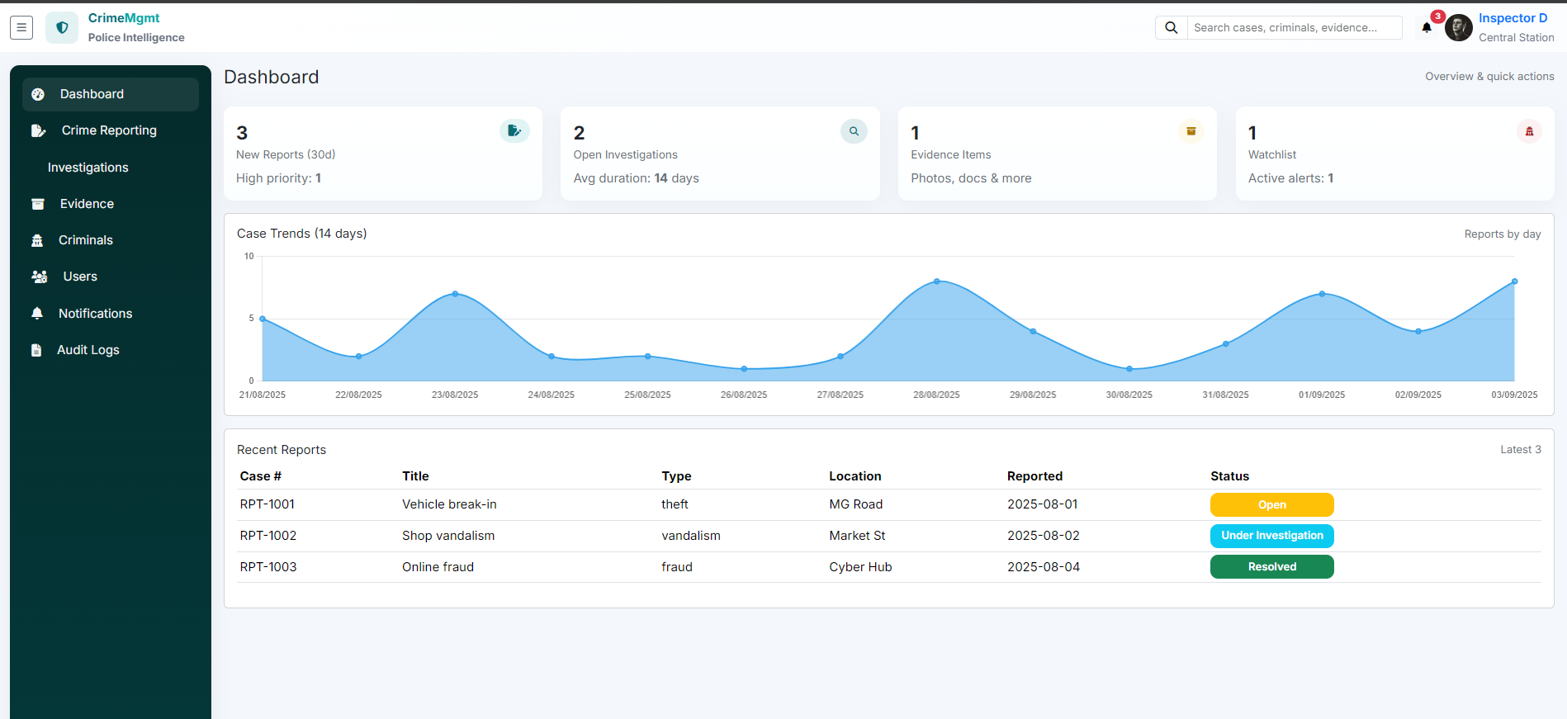

* Provides a centralized overview of the system.
* Displays key statistics (total crimes reported, active investigations, evidence count, criminal records, notifications).
* Offers quick navigation links to all other modules.

## Crime Reporting Module

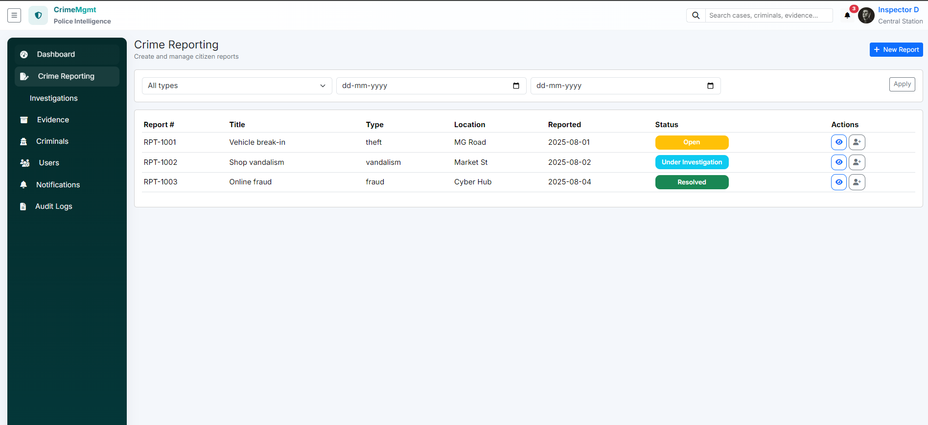

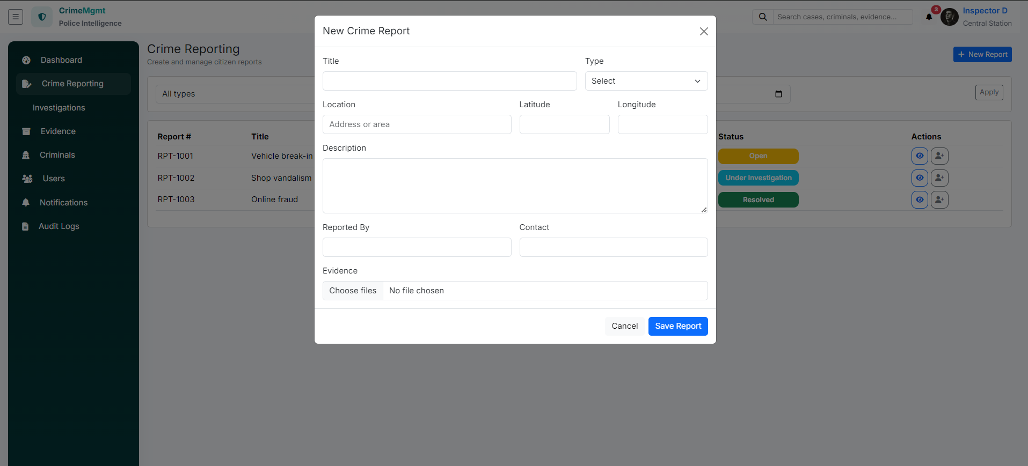

* Allows police officers or authorized users to register new crime reports (FIR).
* Captures details such as crime type, date, location, and description.
* Assigns cases to investigators for follow-up.
* Tracks the status of each crime report (Open, Under Investigation, Closed).

## Investigation Module

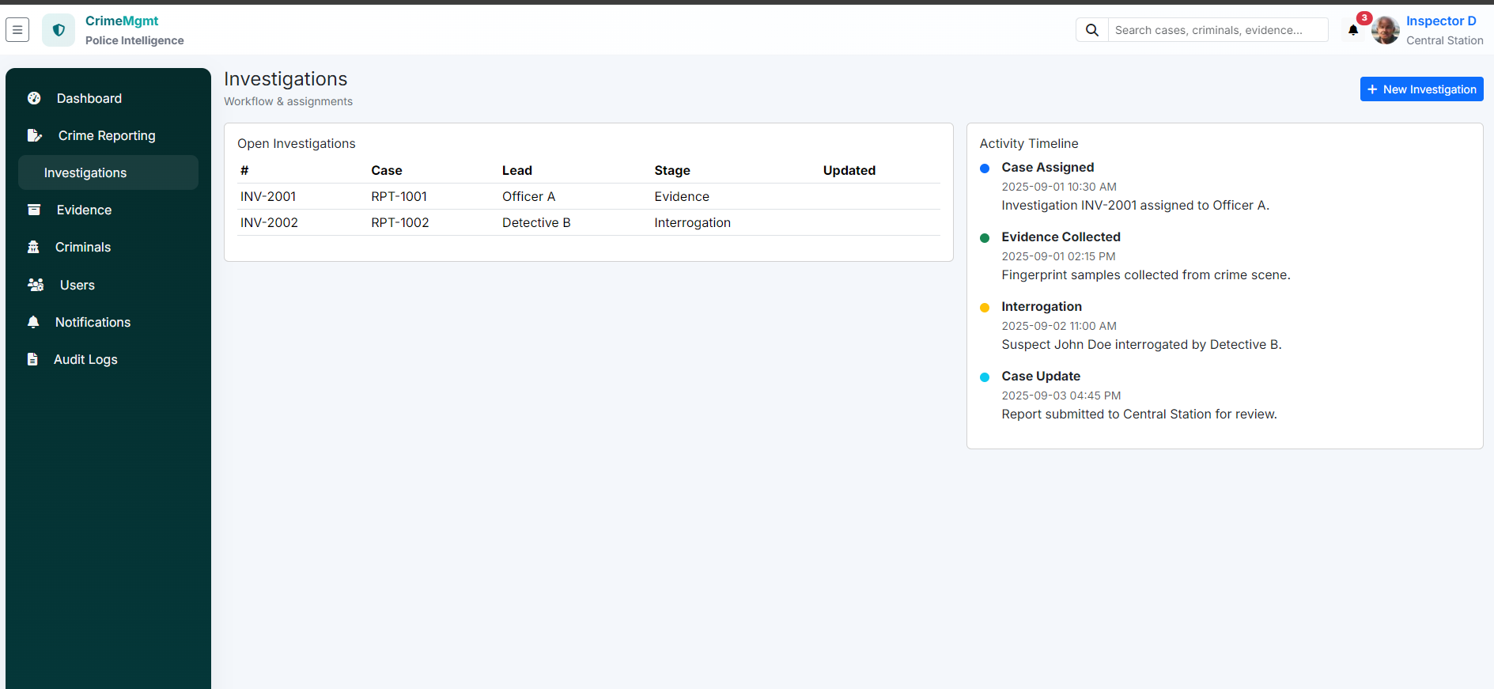

* Manages case assignments and tracks investigation IDs.
* Allows updating investigation stage (Evidence, Interrogation, etc.).
* Links with crime reports, evidence, and suspects.
* Maintains an activity timeline of updates.

## Evidence Module

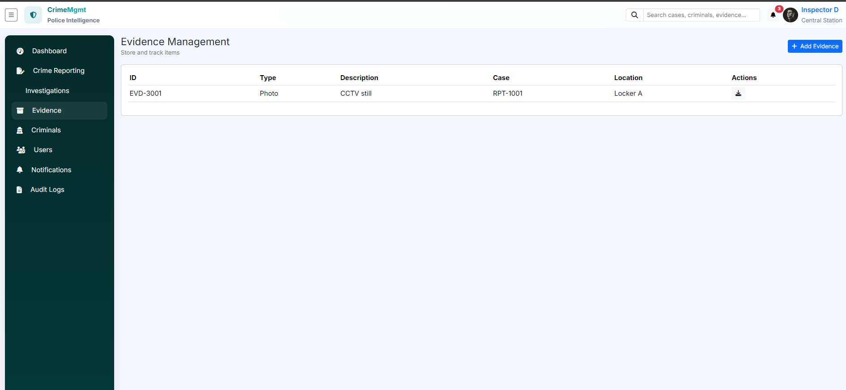

* Stores and manages digital and physical evidence.
* Tags evidence with related crime reports or investigation IDs.
* Ensures chain of custody is maintained for legal accountability.
* Supports uploading documents, images, and videos.

## Criminals Module

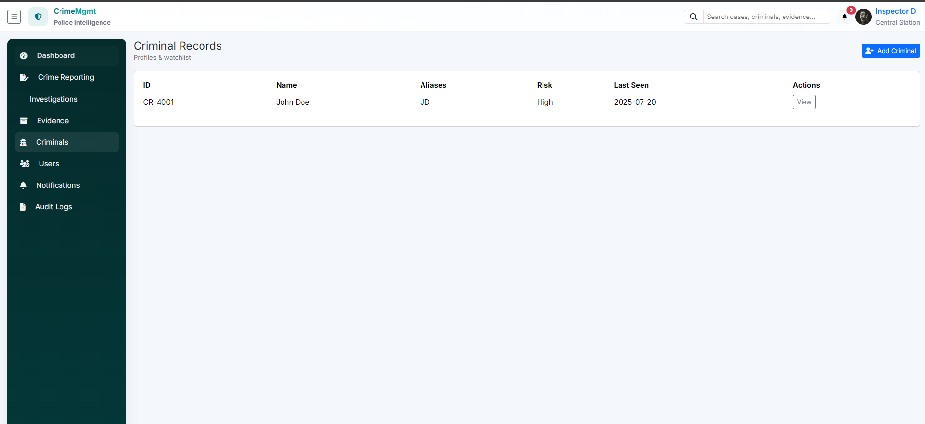

* Maintains detailed profiles of criminals (personal details, photograph, biometrics).
* Tracks criminal history and past offenses.
* Links criminals with specific cases and investigations.
* Provides search and filtering options.

## Users Module

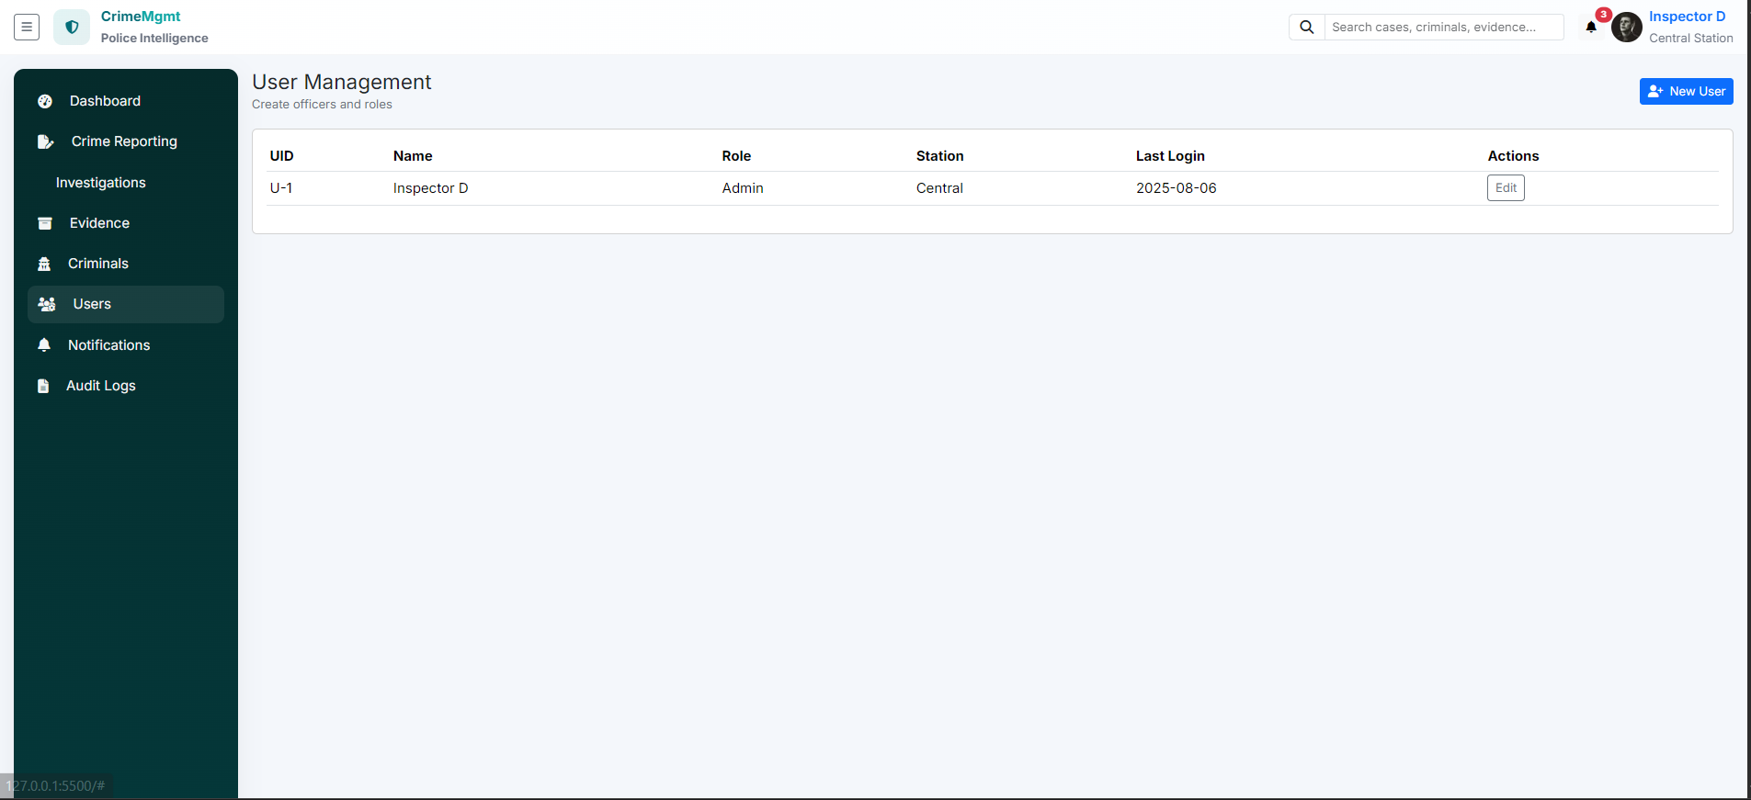

* Manages system users (Admin, Police Officers, Investigators).
* Provides role-based access control (RBAC).
* Supports adding, updating, or removing users.
* Ensures secure authentication and authorization.

## Notifications Module

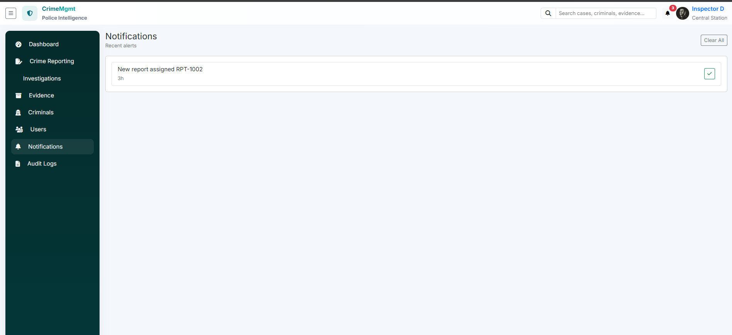

* Sends alerts to users regarding assigned cases, deadlines, or updates.
* Supports email and SMS integration (optional).
* Displays real-time notifications on the dashboard.

## Audit Logs Module

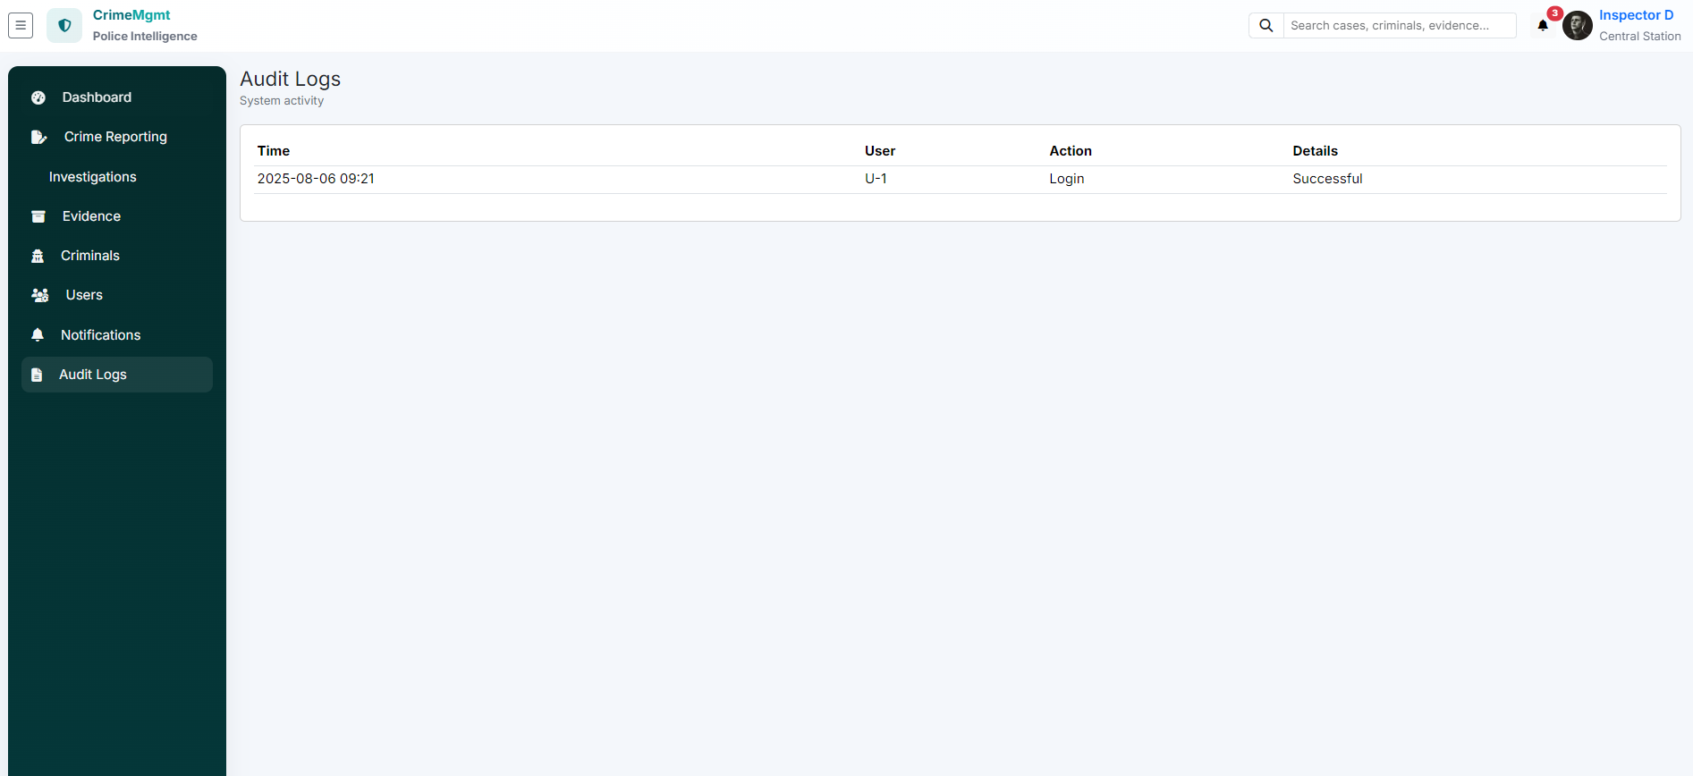

* Records all user activities within the system.
* Tracks login history, data changes, and case updates.
* Provides administrators with accountability and security insights.
* Useful for compliance and forensic analysis.

## Authentication & Login Module

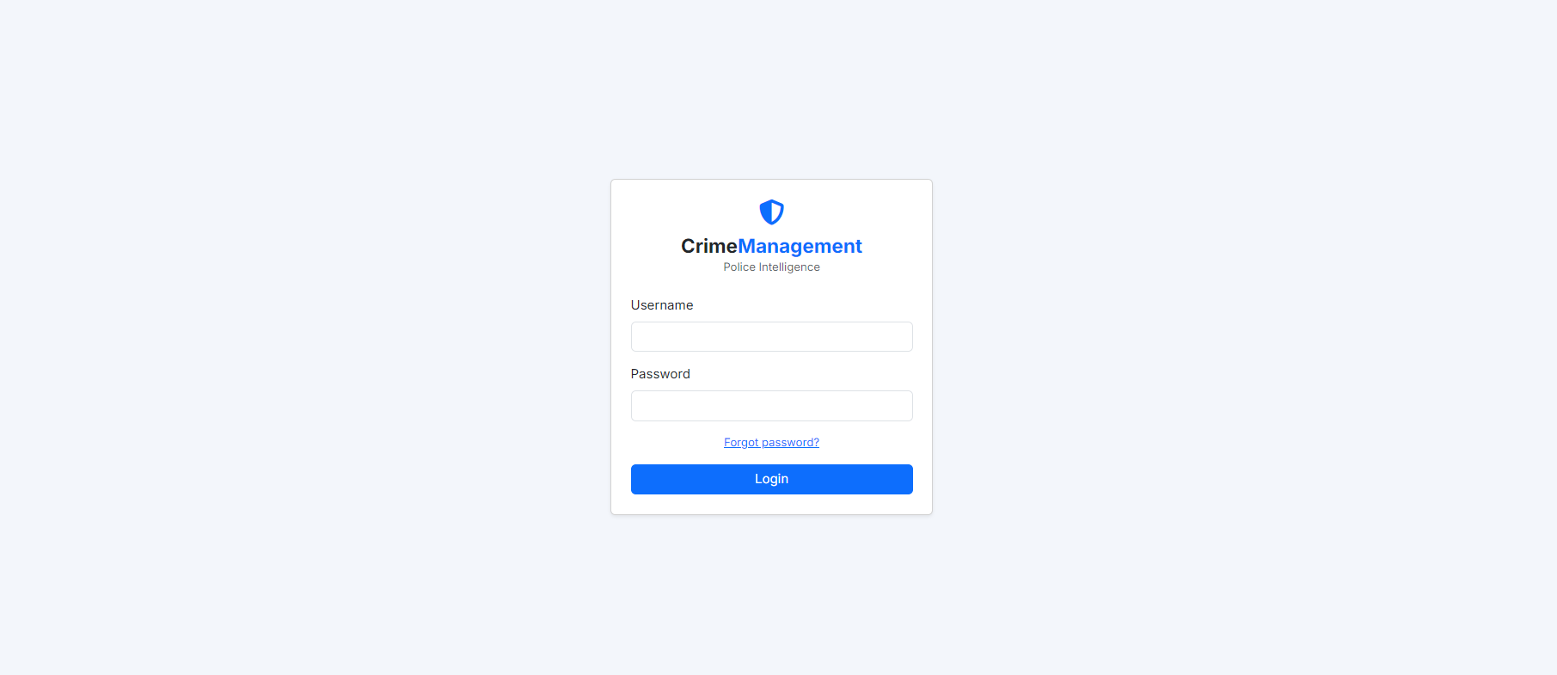

* Provides secure login functionality for all users.
* Supports username/password-based authentication.
* Integrates with role-based access control (RBAC) to limit features based on user roles (Admin, Officer, Investigator).
* Includes session management and logout functionality.