**Random Forest Classifier**

Random forests or random decision forests are an ensemble learning method for classification, regression and other tasks, that operate by constructing a multitude of decision trees at training time and outputting the class that is the mode of the classes (classification) or mean prediction (regression) of the individual trees. Random decision forests correct for decision trees’ habit of over fitting to their training set. Random forest is a type of supervised machine learning algorithm based on [ensemble learning](https://en.wikipedia.org/wiki/Ensemble_learning). Ensemble learning is a type of learning where you join different types of algorithms or same algorithm multiple times to form a more powerful prediction model. The [random forest](https://en.wikipedia.org/wiki/Random_forest) algorithm combines multiple algorithm of the same type i.e. multiple decision trees*,* resulting in aforest of trees*,* hence the name "Random Forest". The random forest algorithm can be used for both regression and classification tasks.

The following are the basic steps involved in performing the random forest algorithm:

* Pick N random records from the dataset.
* Build a decision tree based on these N records.
* Choose the number of trees you want in your algorithm and repeat steps 1 and 2.

In case of a regression problem, for a new record, each tree in the forest predicts a value for Y (output). The final value can be calculated by taking the average of all the values predicted by all the trees in forest. Or, in case of a classification problem, each tree in the forest predicts the category to which the new record belongs. Finally, the new record is assigned to the category that wins the majority vote.

[**Decision Tree**](https://www.geeksforgeeks.org/decision-tree/)**Classifier**

It is one of the most powerful and popular algorithm. Decision-tree algorithm falls under the category of supervised learning algorithms. It works for both continuous as well as categorical output variables. Assumptions of Decision tree:

* At the beginning, we consider the whole training set as the root.
* Attributes are assumed to be categorical for information gain, attributes are assumed to be continuous.
* On the basis of attribute values records are distributed recursively.
* We use statistical methods for ordering attributes as root or internal node.

Decision tree builds classification or regression models in the form of a tree structure. It breaks down a data set into smaller and smaller subsets while at the same time an associated decision tree is incrementally developed. A decision node has two or more branches and a leaf node represents a classification or decision. The topmost decision node in a tree which corresponds to the best predictor called root node. Decision trees can handle both categorical and numerical data. Decision tree builds classification or regression models in the form of a tree structure. It utilizes an if-then rule set which is mutually exclusive and exhaustive for classification. The rules are learned sequentially using the training data one at a time. Each time a rule is learned, the tuples covered by the rules are removed.

This process is continued on the training set until meeting a termination condition. It is constructed in a top-down recursive divide-and-conquer manner. All the attributes should be categorical. Otherwise, they should be discretized in advance. Attributes in the top of the tree have more impact towards in the classification and they are identified using the information gain concept. A decision tree can be easily over-fitted generating too many branches and may reflect anomalies due to noise or outliers.

**xgboost:**

Gradient Boosting or [XGBoost](https://xgboost.readthedocs.io/en/latest/" \t "_blank) is a library of gradient boosting algorithms optimized for modern data science problems and tools. It leverages the techniques mentioned with boosting and comes wrapped in an easy to use library. Some of the major benefits of XGBoost are that its highly scalable/parallelizable, quick to execute, and typically out performs other algorithms.

**Bagging**: Bootstrap Aggregation or Bagging has two distinct features which define its training and prediction. For training it leverages a Bootstrap procedure to separate the training data into different random subsamples, which different iterations of the model use to train on. For prediction, a bagging classifier will use the prediction with the most votes from each model to produce its output and a bagging regression will take an average of all models to produce an output. Bagging is typically applied to high variance models such as Decision Trees and the Random Forest algorithm is a very close variation on bagging.

**Stacking**: A Stacking model is a “meta-model” which leverages the outputs from a collection of many, typically significantly different, models as input features. For instance, this allows you to train a K-NN, Linear Regression, and Decision Tree with all of your training data, then take those outputs and merge them with a Logistical Regression. The idea is that this can reduce overfitting and improve accuracy.

**Flask (Web FrameWork) :**

Flask is a micro web framework written in Python.

It is classified as a micro-framework because it does not require particular tools or libraries.

It has no database abstraction layer, form validation, or any other components where pre-existing third-party libraries provide common functions.

However, Flask supports extensions that can add application features as if they were implemented in Flask itself.

Extensions exist for object-relational mappers, form validation, upload handling, various open authentication technologies and several common framework related tools.

Flask was created by [Armin Ronacher](https://en.wikipedia.org/wiki/Armin_Ronacher) of Pocoo, an international group of Python enthusiasts formed in 2004. According to Ronacher, the idea was originally an [April Fool’s](https://en.wikipedia.org/wiki/April_Fool%27s) joke that was popular enough to make into a serious application. The name is a play on the earlier [Bottle](https://en.wikipedia.org/wiki/Bottle_(web_framework)) framework.

When Ronacher and Georg Brand created a bulletin board system written in Python, the Pocoo projects Werkzeug and [Jinja](https://en.wikipedia.org/wiki/Jinja_(template_engine)" \o "Jinja (template engine)) were developed.

In April 2016, the Pocoo team was disbanded and development of Flask and related libraries passed to the newly formed Pallets project.

Flask has become popular among Python enthusiasts. As of October 2020, it has second most stars on [GitHub](https://en.wikipedia.org/wiki/GitHub) among Python web-development frameworks, only slightly behind Django, and was voted the most popular web framework in the Python Developers Survey 2018.

The micro-framework Flask is part of the Pallets Projects, and based on several others of them.

**Flask is** based on Werkzeug, [Jinja2](http://quintagroup.com/cms/python/jinja2) and inspired by Sinatra Ruby framework, available under BSD licence. It was developed at pocoo by Armin Ronacher. Although Flask is rather young compared to most [Python](https://quintagroup.com/services/python) frameworks, it holds a great promise and has already gained popularity among Python web developers. Let’s take a closer look into Flask, so-called “micro” framework for Python

**FEATURES:**

**Flask** was designed to be **easy to use and extend**.  The idea behind Flask is to build a solid foundation for web applications of different complexity. From then on you are free to**plug in any extensions** you think you need. Also you are free to build your own modules. Flask is great for all kinds of projects.  It's especially good for prototyping. Flask depends on two external libraries: the Jinja2 template engine and the Werkzeug WSGI toolkit.

Still the question remains why use Flask as your web application framework if we have immensely powerful [Django](https://quintagroup.com/services/python/django), [Pyramid,](https://quintagroup.com/cms/python/pyramid) and don’t forget web mega-framework [Turbo-gears](https://quintagroup.com/cms/python/turbogears)? Those are supreme[Python web frameworks](https://quintagroup.com/services/python/python-web-development.png) BUT out-of-the-box [Flask](http://quintagroup.com/cms/python/flask) is pretty impressive too with its:

* Built-In Development server and Fast debugger
* integrated support for unit testing
* RESTful request dispatching
* Uses [Jinja2](https://quintagroup.com/cms/python/jinja2) Templating
* support for secure cookies
* Unicode based
* Extensive Documentation
* Google App Engine Compatibility
* Extensions available to enhance features desired

Plus Flask gives you so much more **CONTROL** on the development stage of **your project**. It follows the principles of minimalism and let you decide  how you will build your application.

* Flask has a lightweight and modular design, so it easy to transform it to the web framework you need with a few extensions without weighing it down
* ORM-agnostic: you can plug in your favourite ORM e.g. [SQLAlchemy](https://quintagroup.com/cms/python/sqlalchemy).
* Basic foundation API is nicely shaped and coherent.
* Flask documentation is comprehensive, full of examples and well structured. You can even try out some sample application to really get a feel of Flask.
* It is super easy to deploy Flask in production (Flask is 100%WSGI 1.0 compliant”)
* HTTP request handling functionality
* High Flexibility

The configuration is even more flexible than that of Django, giving you plenty of solution for every production need.

To sum up, Flask is one of the most polished and feature-rich micro frameworks, available. Still young, Flask has a thriving community, first-class extensions, and an **elegant API**.  Flask comes with all the benefits of fast templates, strong WSGI features, **thorough unit testability** at the web application and library level, **extensive documentation**. So next time you are starting a new project where you need some good features and a vast number of extensions, definitely check out Flask.

Flask is an API of Python that allows us to build up web-applications. It was developed by Armin Ronacher. Flask's framework is more explicit than Django framework and is also easier to learn because it has less base code to implement a simple web-Application

Flask is a micro web framework written in Python. It is classified as a micro-framework because it does not require particular tools or libraries. It has no database abstraction layer, form validation, or any other components where pre-existing third-party libraries provide common functions.

Overview of Python Flask Framework Web apps are developed to generate content based on retrieved data that changes based on a user’s interaction with the site. The server is responsible for querying, retrieving, and updating data. This makes web applications to be slower and more complicated to deploy than static websites for simple applications.

Flask is an excellent web development framework for REST API creation. It is built on top of Python which makes it powerful to use all the python features.

Flask is used for the backend, but it makes use of a templating language called Jinja2 which is used to create HTML, XML or other markup formats that are returned to the user via an HTTP request.

Django is considered to be more popular because it provides many out of box features and reduces time to build complex applications. Flask is a good start if you are getting into web development. Flask is a simple, un-opinionated framework; it doesn't decide what your application should look like developers do.

Flask is a web framework. This means flask provides you with tools, libraries and technologies that allow you to build a web application. This web application can be some web pages, a blog, a wiki or go as big as a web-based calendar application or a commercial website.

**Advantages of Flask:**

* Higher compatibility with latest technologies.
* Technical experimentation.
* Easier to use for simple cases.
* Codebase size is relatively smaller.
* High scalability for simple applications.
* Easy to build a quick prototype.
* Routing URL is easy.
* Easy to develop and maintain applications.

Framework Flask is a web framework from Python language. Flask provides a library and a collection of codes that can be used to build websites, without the need to do everything from scratch. But Framework flask still doesn't use the Model View Controller (MVC) method.

Flask-RESTful is an extension for Flask that provides additional support for building REST APIs. You will never be disappointed with the time it takes to develop an API. Flask-Restful is a lightweight abstraction that works with the existing ORM/libraries. Flask-RESTful encourages best practices with minimal setup.

Flask Restful is an extension for Flask that adds support for building REST APIs in Python using Flask as the back-end. It encourages best practices and is very easy to set up. Flask restful is very easy to pick up if you're already familiar with flask.

Flask is a web framework for Python, meaning that it provides functionality for building web applications, including managing HTTP requests and rendering templates and also we can add to this application to create our API.

**Parameters**

* **rule** ([str](https://docs.python.org/3/library/stdtypes.html" \l "str" \o "(in Python v3.9))) – The URL rule string.
* **endpoint** (Optional[[str](https://docs.python.org/3/library/stdtypes.html" \l "str" \o "(in Python v3.9))]) – The endpoint name to associate with the rule and view function. Used when routing and building URLs. Defaults to view\_func.\_\_name\_\_.
* **view\_func** (Optional[Callable]) – The view function to associate with the endpoint name.
* **provide\_automatic\_options** (Optional[bool]) – Add the OPTIONS method and respond to OPTIONS requests automatically.
* **options** (Any) – Extra options passed to the [Rule](https://werkzeug.palletsprojects.com/en/2.0.x/routing/#werkzeug.routing.Rule) object.

Return type -- [None](https://docs.python.org/3/library/constants.html#None)

After\_Request(f)

Register a function to run after each request to this object.

The function is called with the response object, and must return a response object. This allows the functions to modify or replace the response before it is sent.

If a function raises an exception, any remaining after request functions will not be called. Therefore, this should not be used for actions that must execute, such as to close resources. Use [teardown\_request()](https://flask.palletsprojects.com/en/2.0.x/api/" \l "flask.Flask.teardown_request" \o "flask.Flask.teardown_request) for that.

**Parameters:**

**f** (Callable[[[Response](https://flask.palletsprojects.com/en/2.0.x/api/#flask.Response)], [Response](https://flask.palletsprojects.com/en/2.0.x/api/#flask.Response)])

Return type

Callable[[[Response](https://flask.palletsprojects.com/en/2.0.x/api/#flask.Response)], [Response](https://flask.palletsprojects.com/en/2.0.x/api/#flask.Response)]

after\_request\_funcs: t.Dict[AppOrBlueprintKey,

t.List[AfterRequestCallable]]

A data structure of functions to call at the end of each request, in the format {scope: [functions]}. The scope  key is the name of a blueprint the functions are active for, or None for all requests.

To register a function, use the [after\_request()](https://flask.palletsprojects.com/en/2.0.x/api/" \l "flask.Flask.after_request" \o "flask.Flask.after_request) decorator.

This data structure is internal. It should not be modified directly and its format may change at any time.

app\_context()

Create an [AppContext](https://flask.palletsprojects.com/en/2.0.x/api/" \l "flask.ctx.AppContext" \o "flask.ctx.AppContext). Use as a with block to push the context, which will make [current\_app](https://flask.palletsprojects.com/en/2.0.x/api/" \l "flask.current_app" \o "flask.current_app) point at this application.

An application context is automatically pushed by [RequestContext.push()](https://flask.palletsprojects.com/en/2.0.x/api/" \l "flask.ctx.RequestContext.push" \o "flask.ctx.RequestContext.push) when handling a request, and when running a CLI command. Use this to manually create a context outside of these situations.

With app.app\_context():

Init\_db()

**24. HTML Introduction**

**HTML** stands for Hyper Text Markup Language. It is used to design web pages using a markup language. HTML is the combination of Hypertext and Markup language. Hypertext defines the link between the web pages. A markup language is used to define the text document within tag which defines the structure of web pages. This language is used to annotate (make notes for the computer) text so that a machine can understand it and manipulate text accordingly. Most markup languages (e.g. HTML) are human-readable. The language uses tags to define what manipulation has to be done on the text.

#### Basic Construction of an HTML Page

These tags should be placed underneath each other **at the top of every HTML page** that you create.

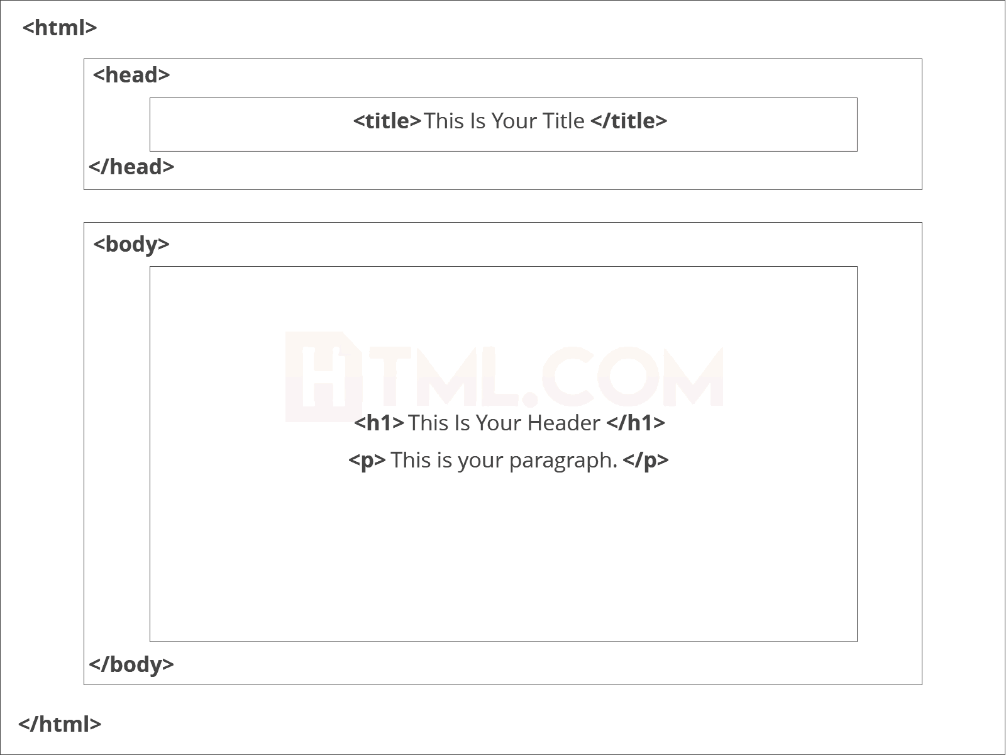

<!DOCTYPE html> — This tag**specifies the language** you will write on the page. In this case, the language is HTML 5.

<html> — This tag signals that from here on we are going to write in HTML code.

<head> — This is where all the **metadata for the page** goes — stuff mostly meant for search engines and other computer programs.

<body> — This is where the**content of the page** goes.

#### Further Tags

Inside the <head> tag, there is one tag that is always included: <title>, but there are others that are just as important:

<title>

This is where we**insert the page name** as it will appear at the top of the browser window or tab.

<meta>

This is where information about the document is stored: character encoding, name (page context), description.

**Head Tag**  
<head>

<title>My First Webpage</title>

<meta charset="UTF-8">

<meta name="description" content="This field contains information about your page. It is usually around two sentences long.">.

<meta name="author" content="Conor Sheils">

</header>

### Adding Content

Next, we will make<body> tag.

The HTML <body> is where we add the content which is designed for viewing by human eyes.

This includes **text, images, tables, forms**and everything else that we see on the internet each day.

#### Add HTML Headings To Web Page

In HTML, [headings](https://html.com/tags/heading/) are written in the following elements:

* <h1>
* <h2>
* <h3>
* <h4>
* <h5>
* <h6>

As you might have guessed <h1> and <h2> should be used for the most important titles, while the remaining tags should be used for sub-headings and less important text.

**Search engine bots use this order**when deciphering which information is most important on a page.

##### Creating Your Heading

Let’s try it out. On a new line in the HTML editor, type:

<h1> Welcome To My Page </h1>

And hit save. We will save this file as “index.html” in a new folder called “my webpage.”

**Add Text In HTML**

Adding text to our HTML page is simple using an element opened with the tag <p> which **creates a new paragraph**. We place all of our regular text inside the element <p>.

When we write text in HTML, we also have a number of other elements we can use **to control the text or make it appear in a certain way.**

#### Add Links In HTML

As you may have noticed, the internet is made up of lots of [links](https://html.com/anchors-links/).

Almost everything you click on while surfing the web is a link **takes you to another page** within the website you are visiting or to an external site.

Links are included in an attribute opened by the [**<a>**](https://html.com/tags/a/) tag. This element is the first that we’ve met which uses an attribute and so it**looks different to previously mentioned tags.**

<a href=<http://www.google.com>>Google</a>

**Image Tag**

In today’s modern digital world, [images](https://html.com/blog/100-legal-sources-free-stock-images/) are everything. The [**<**img**>**](https://html.com/tags/img/) tag has everything you need to display images on your site. Much like the <a> anchor element, <img> also contains an attribute.

The attribute features information for your computer regarding the source, height, width and alt text of the image

<img src=”yourimage.jpg” alt=”Describe the image” height=“X” width=“X”>

**25. CSS**

CSS stands for Cascading Style Sheets. It is the language for describing the presentation of Web pages, including colours, layout, and fonts, thus making our web pages presentable to the users.CSS is designed to make style sheets for the web. It is independent of HTML and can be used with any XML-based markup language. Now let’s try to break the acronym:

* Cascading: Falling of Styles
* Style: Adding designs/Styling our HTML tags
* Sheets: Writing our style in different documents

## **CSS Syntax**

Selector {

Property 1 : value;

Property 2 : value;

Property 3 : value;

}

For example:

h1

{

Color: red;

Text-align: center;

}

#unique

{

color: green;

}

* Selector: selects the element you want to target
* Always remains the same whether we apply internal or external styling
* There are few basic selectors like tags, id’s, and classes
* All forms this key-value pair
* Keys: properties(attributes) like color, font-size, background, width, height,etc
* Value: values associated with these properties

## **CSS Comment**

* Comments don’t render on the browser
* Helps to understand our code better and makes it readable.
* Helps to debug our code
* Two ways to  comment:
  + Single line

## **CSS How-To**

* There are 3 ways to write CSS in our HTML file.
  + Inline CSS
  + Internal CSS
  + External CSS
* Priority order
  + Inline > Internal > External

**Inline CSS**

* Before CSS this was the only way to apply styles
* Not an efficient way to write as it has a lot of redundancy
* Self-contained
* Uniquely applied on each element
* The idea of separation of concerns was lost
* Example:

<h3 style = “color:red”> Have a great day </h3>

<p style = “color:green”> I did this, I did that </p>

**Internal CSS**

* With the help of style tag, we can apply styles within the HTML file
* Redundancy is removed
* But the idea of separation of concerns still lost
* Uniquely applied on a single document
* Example:

<style>

H1{

Color:red;

}

</style>

<h3> Have a great day </h3>

**External CSS**

* With the help of <link> tag in the head tag, we can apply styles
* Reference is added
* File saved with .css extension
* Redundancy is removed
* The idea of separation of concerns is maintained
* Uniquely applied to each document
* Example:

<head>

<link rel= “stylesheet” type= “text/css” href= “name of the CSS file”>

</head>

h1{

color:red; //.css file

}

## **CSS Selectors**

* The selector is used to target elements and apply CSS
* Three simple selectors
  + Element Selector
  + Id Selector
  + Class Selector
* Priority of Selectors

## **CSS Colors**

* There are different colouring schemes in CSS
* **RGB**-This starts with RGB and takes 3 parameter
* **HEX**-Hex code starts with # and comprises of 6 numbers which are further divided into 3 sets
* **RGBA**-This starts with RGB and takes 4 parameter

**CSS Background**

* There are different ways by which CSS can have an effect on HTML elements
* Few of them are as follows:
  + Color – used to set the color of the background
  + Repeat – used to determine if the image has to repeat or not and if it is repeating then how it should do that
  + Image – used to set an image as the background
  + Position – used to determine the position of the image
  + Attachment – It basically helps in controlling the mechanism of scrolling.

## **CSS BoxModel**

* Every element in CSS can be represented using the BOX model
* It allows us to add a border and define space between the content
* It helps the developer to develop and manipulate the elements
* It consists of 4 edges
  + Content edge – It comprises of the actual content
  + Padding edge – It lies in between content and border edge
  + Border edge – Padding is followed by the border edge
  + Margin edge – It is an outside border and controls the margin of the element