Objective Questions

1. List the different types of columns in table “ball_by_ball” (using information_schema)

Ans: Data types: Data types are classifications of data that tell the compiler or interpreter how the programmer intends to use the data.

SELECT COLUMN_NAME, DATA_TYPE FROM information_schema.columns
WHERE table_name = 'Ball_by_Ball' AND table_schema = "ipl";
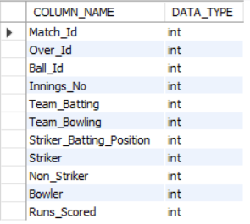

2. What is the total number of runs scored in 1st season by RCB (bonus: also include the extra runs using the extra runs table)
Ans.In this we calculate the total runs scored by RCB by summing up the scores (runs + extras) for each match.

WITH extra_run_data AS (

SELECT

Team_Batting AS team_Id,

SUM(e.Extra_Runs) as total_extra

FROM ball_by_ball b

JOIN extra_runs e ON e.Match_Id = b.Match_Id AND e.Innings_No = b.Innings_No AND e.Over_Id = b.Over_Id AND e.Ball_Id = b.Ball_Id

WHERE Team_Batting = 2

AND b.Match_Id IN(

SELECT distinct Match_Id FROM matches WHERE Season_Id = ( SELECT MIN(Season_Id) as first_season FROM Matches WHERE Team_1 = 2 OR Team_2 = 2))

),

run_scored_data AS (

SELECT

Team_Batting AS team_Id,

SUM(b.Runs_Scored) AS total_score

FROM ball_by_ball b

JOIN matches m ON m.Match_Id = b.Match_Id

WHERE Team_Batting = 2 AND (Team_1 = 2 OR Team_2 = 2) AND m.Season_Id = ( SELECT MIN(Season_Id) as first_season FROM Matches WHERE Team_1 = 2 OR Team_2 = 2)

)

SELECT

(total_score + total_extra) AS total_runs

FROM run_scored_data s

JOIN extra_run_data e ON e.team_Id = s.team_Id;

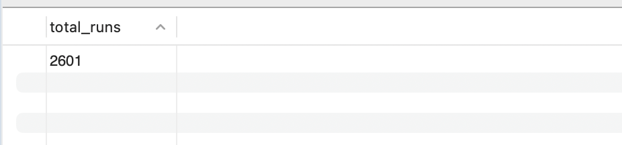

3. How many players were more than the age of 25 during season 2014?
Ans.
SELECT COUNT(DISTINCT p.Player_Id) AS Players_Age_Above_25
FROM Player p
JOIN Player_Match pm ON p.Player_Id = pm.Player_Id
JOIN Matches m ON pm.Match_Id = m.Match_Id
JOIN Season s ON m.Season_Id = s.Season_Id
WHERE s.Season_Year = 2014
AND TIMESTAMPDIFF(YEAR, p.DOB, '2014-12-31') > 25;
- There were 102 players who were above 25 during Season 2.

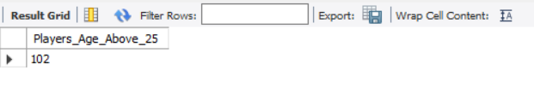

4. How many matches did RCB win in 2013?
Ans.
SELECT COUNT(*) AS Matches_Won
FROM Matches m
JOIN Season s ON m.Season_Id = s.Season_Id
JOIN Team t ON m.Match_Winner = t.Team_Id
WHERE s.Season_Year = 2013
AND t.Team_Name = 'Royal Challengers Bangalore'
AND m.Match_Winner IS NOT NULL;

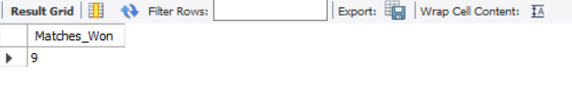

5. List the top 10 players according to their strike rate in the last 4 seasons
Ans.
- The following are the players with the most strike rate in the last 4 seasons.

WITH Last_4_Seasons AS (
SELECT Season_Year FROM Season ORDER BY Season_Year DESC LIMIT 4
),
Striker_Rate AS (
SELECT
B.Striker,
ROUND((SUM(B.Runs_Scored) / NULLIF(COUNT(B.Ball_Id), 0)) * 100, 2) AS Strike_Rate
FROM Ball_by_Ball B
JOIN Matches M ON B.Match_Id = M.Match_Id
JOIN Season S ON M.Season_Id = S.Season_Id
JOIN Last_4_Seasons L4S ON S.Season_Year = L4S.Season_Year
GROUP BY B.Striker
HAVING COUNT(B.Ball_Id) > 100
)
SELECT
RANK() OVER (ORDER BY SR.Strike_Rate DESC) AS Ranking,
P.Player_Name,
SR.Strike_Rate
FROM Striker_Rate SR
JOIN Player P ON SR.Striker = P.Player_Id
ORDER BY SR.Strike_Rate DESC
LIMIT 10;

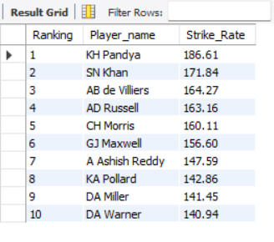

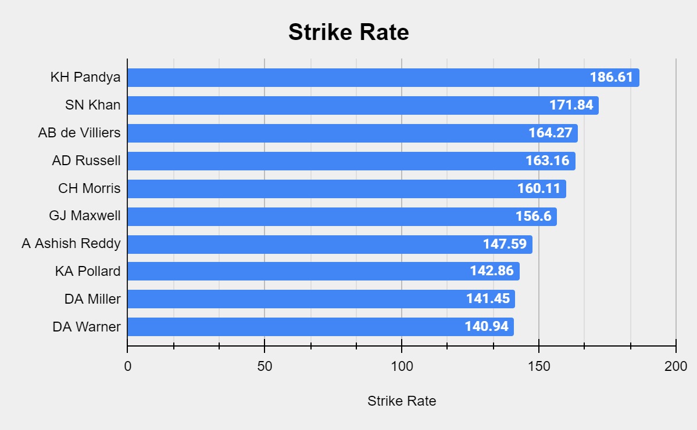
6.What are the average runs scored by each batsman considering all the seasons?
Ans.
SELECT
p.Player_Name,
SUM(COALESCE(b.Runs_Scored, 0)) AS Total_Runs,
COUNT(DISTINCT CONCAT(b.Match_Id, '-', b.Innings_No)) AS Innings_Played,
ROUND(SUM(COALESCE(b.Runs_Scored, 0)) / NULLIF(COUNT(DISTINCT CONCAT(b.Match_Id, '-', b.Innings_No)), 0), 2) AS Avg_Runs
FROM Ball_by_Ball b
JOIN Player p ON b.Striker = p.Player_Id
GROUP BY p.Player_Name
ORDER BY Avg_Runs DESC;

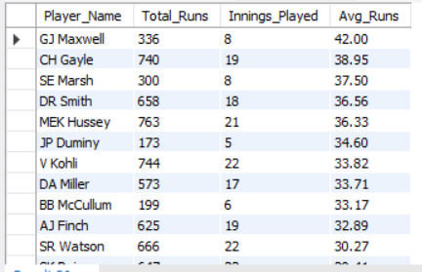

1.Calculate the total runs scored by each player.
2.Count the number of innings each player has played.
3.Divide total runs by the number of innings to get the average runs.
4.Join the Ball_by_Ball table with Player to get player names.
5.Sort the results in descending order of average runs.

7. What are the average wickets taken by each bowler considering all the seasons?
Ans.
WITH wickets_count_per_player_per_season AS
(SELECT b.Bowler, m.Season_Id, COUNT(w.Player_Out) AS wickets_taken
FROM ball_by_ball b
JOIN wicket_taken w
ON b.Match_Id = w.Match_Id AND
b.Over_Id = w.Over_Id AND
b.Ball_Id = w.Ball_Id AND
b.Innings_No = w.Innings_No
JOIN Matches m
ON m.Match_Id = w.Match_Id
GROUP BY 1,2
ORDER BY b.Bowler ASC, m.Season_Id ASC),

avg_per_season AS (
SELECT *, AVG(wickets_taken) OVER(PARTITION BY Bowler) AS avg_wicket_per_bowler
FROM wickets_count_per_player_per_season)
SELECT DISTINCT p.Player_Name,ROUND(a.avg_wicket_per_bowler,2) AS Avg_wicket
FROM avg_per_season a
JOIN Player p
ON p.Player_Id = a.Bowler
WHERE a.avg_wicket_per_bowler > 0
ORDER BY Avg_wicket DESC;

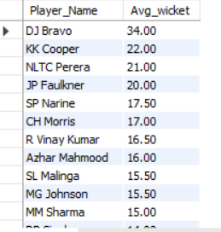

- Calculates Wickets per Season:
Counts the total wickets taken by each bowler per season.
Joins Ball_by_Ball, Wicket_Taken, and Matches tables to associate wickets with bowlers and seasons.
- Computes Average Wickets per Bowler:
Uses AVG(wickets_taken) OVER(PARTITION BY Bowler) to determine the average wickets per season for each bowler.
- Retrieves Player Names:
Joins with the Player table to fetch bowler names.
- Filters and Sorts Results:
Excludes bowlers with zero wickets.
Orders results by average wickets in descending order.

8. List all the players who have average runs scored greater than the overall average and who have taken wickets greater than the overall average
Ans.

1. Calculate Overall Averages
- Overall Batting Average = Total runs scored / Total balls faced.
- Overall Wickets Average = Total wickets taken / Total matches played.

2. Identify Players Meeting the Criteria
- Batsmen: Players whose average runs scored > overall batting average.
- Bowlers: Players who have taken wickets > overall wickets average.

WITH Player_Avg_Runs AS (
SELECT
bb.Striker AS Player_Id,
p.Player_Name,
COUNT(bb.Ball_Id) AS Balls_Faced,
SUM(bb.Runs_Scored) AS Total_Runs,
SUM(bb.Runs_Scored) * 1.0 / NULLIF(COUNT(bb.Ball_Id), 0) AS Avg_Runs
FROM Ball_by_Ball bb
JOIN Player p ON bb.Striker = p.Player_Id
GROUP BY bb.Striker, p.Player_Name
), Overall_Avg AS (
SELECT SUM(Runs_Scored) * 1.0 / NULLIF(COUNT(Ball_Id), 0) AS Overall_Avg_Runs
FROM Ball_by_Ball
)
SELECT p.Player_Id, p.Player_Name, p.Total_Runs, p.Avg_Runs
FROM Player_Avg_Runs p
JOIN Overall_Avg oa
ON p.Avg_Runs > oa.Overall_Avg_Runs
ORDER BY p.Avg_Runs DESC;

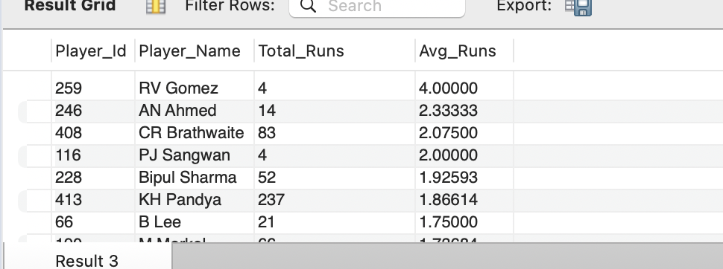

WITH Player_Wickets AS (
SELECT
wt.Player_Out AS Player_Id,
p.Player_Name,
COUNT(*) AS Total_Wickets
FROM Wicket_Taken wt
JOIN Player p ON wt.Player_Out = p.Player_Id
GROUP BY wt.Player_Out, p.Player_Name
), Overall_Wickets AS (
SELECT AVG(Total_Wickets) AS Overall_Avg_Wickets
FROM (
SELECT COUNT(*) AS Total_Wickets FROM Wicket_Taken GROUP BY Player_Out
) AS Wicket_Data
)
SELECT pw.Player_Id, pw.Player_Name, pw.Total_Wickets
FROM Player_Wickets pw
JOIN Overall_Wickets ow
ON pw.Total_Wickets > ow.Overall_Avg_Wickets
ORDER BY pw.Total_Wickets DESC;

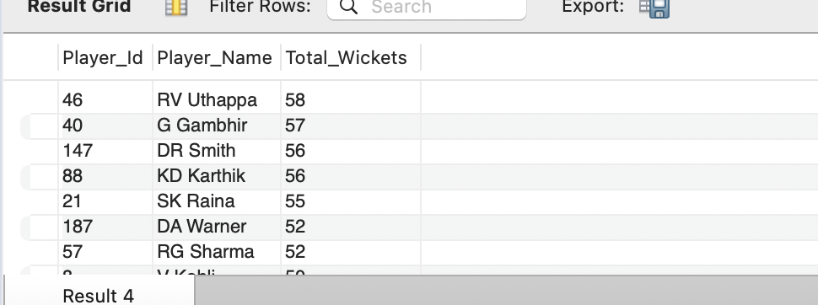

9. Create a table rcb_record table that shows the wins and losses of RCB in an individual venue.
Ans.
DROP TABLE IF EXISTS rcb_record_table;
CREATE TABLE IF NOT EXISTS rcb_record_table AS
WITH rcb_record AS
(SELECT m.Venue_Id, v.Venue_Name,
SUM(CASE WHEN Match_Winner = 2 THEN 1 ELSE 0 END) AS Win_record,
SUM(CASE WHEN Match_Winner != 2 THEN 1 ELSE 0 END) AS Loss_record
FROM matches m
JOIN venue v
ON m.Venue_Id = v.Venue_Id
WHERE (Team_1 = 2 OR Team_2 = 2) AND m.Outcome_type != 2
GROUP BY 1,2)
SELECT *, Win_record + Loss_record AS Total_Played,
ROUND((Win_record/(Win_record + Loss_record))*100,2) AS Win_percentage, ROUND((Loss_record/(Win_record + Loss_record))*100,2) AS Loss_percentage
FROM rcb_record
ORDER BY Venue_Id;
SELECT Venue_Name,Win_record,Loss_record,Total_Played,Win_percentage,Loss_percentage FROM rcb_record_table;

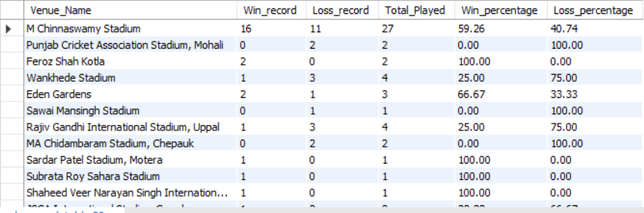
- Creates a Table:
Drops the rcb_record_table if it exists and then creates it.
- Calculates Wins and Losses:
Counts matches won and lost by RCB (Team_Id = 2) at each venue.
Excludes matches with an abandoned outcome (Outcome_type = 2).
- Computes Total Matches and Percentages:
Calculates total matches played (Win_record + Loss_record).
Computes win and loss percentages.
- Stores and Retrieves Data:
Saves results in rcb_record_table and sorts by venue.
Selects relevant columns for final output.

10. What is the impact of bowling style on wickets taken?
Ans.
WITH no_of_wicket_per_bowler AS (
SELECT bb.bowler, COUNT(w.Player_Out) AS no_of_wickets
FROM wicket_taken w
JOIN ball_by_ball bb
ON w.Match_Id = bb.Match_Id
AND w.Over_Id = bb.Over_Id
AND w.Ball_Id = bb.Ball_Id
AND w.Innings_No = bb.Innings_No
GROUP BY bb.Bowler),
bowler_skill_wicket AS
(SELECT n.bowler, st.Bowling_skill, no_of_wickets
FROM no_of_wicket_per_bowler n
JOIN player p
ON n.bowler = p.Player_Id
JOIN bowling_style st
ON st.Bowling_Id = p.Bowling_skill
ORDER BY no_of_wickets DESC)
SELECT Bowling_skill AS Bowling_Style, SUM(no_of_wickets) AS total_wickets_taken
FROM bowler_skill_wicket
GROUP BY Bowling_skill
ORDER BY total_wickets_taken DESC;

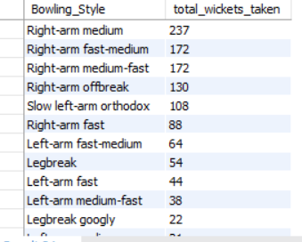

1.Calculates Wickets per Bowler:
Counts the total wickets taken by each bowler.
2.Links Bowlers with Their Bowling Styles:
Joins Player and Bowling_Style tables to associate bowlers with their respective
bowling skills.
3.Aggregates Wickets by Bowling Style:
Sums up wickets for each bowling style.
4.Orders Results:
Displays bowling styles in descending order of total wickets taken.

11. Write the SQL query to provide a status of whether the performance of the team is better than the previous year's performance on the basis of the number of runs scored by the team in the season and the number of wickets taken
Ans.
WITH total_run_match_id AS (
-- Total runs per innings per match
SELECT
Match_Id,
Innings_No,
SUM(Runs_Scored) AS total_runs
FROM Ball_by_Ball
GROUP BY Match_Id, Innings_No
),
total_runs_per_season AS (
-- Total runs per season for Team_Id = 2
SELECT
m.Season_Id,
SUM(CASE
WHEN m.Toss_Decide = 1 AND m.Toss_Winner = 2 AND t.Innings_No = 2 THEN t.total_runs
WHEN m.Toss_Decide = 2 AND m.Toss_Winner = 2 AND t.Innings_No = 1 THEN t.total_runs
WHEN m.Toss_Decide = 1 AND m.Toss_Winner != 2 AND t.Innings_No = 1 THEN t.total_runs
WHEN m.Toss_Decide = 2 AND m.Toss_Winner != 2 AND t.Innings_No = 2 THEN t.total_runs
ELSE 0
END) AS total_runs
FROM total_run_match_id t
JOIN Matches m ON t.Match_Id = m.Match_Id
WHERE m.Team_1 = 2 OR m.Team_2 = 2
GROUP BY m.Season_Id
),
total_wickets_per_match_innings AS (
-- Total wickets per match per innings
SELECT
w.Match_Id,
w.Innings_No,
COUNT(w.Player_Out) AS total_wickets
FROM Wicket_Taken w
JOIN Matches m ON m.Match_Id = w.Match_Id
WHERE m.Team_1 = 2 OR m.Team_2 = 2
GROUP BY w.Match_Id, w.Innings_No
),
total_wickets_per_season AS (
-- Total wickets per season for Team_Id = 2
SELECT
m.Season_Id,
SUM(CASE
WHEN m.Toss_Decide = 1 AND m.Toss_Winner = 2 AND w.Innings_No = 1 THEN w.total_wickets
WHEN m.Toss_Decide = 2 AND m.Toss_Winner = 2 AND w.Innings_No = 2 THEN w.total_wickets
WHEN m.Toss_Decide = 1 AND m.Toss_Winner != 2 AND w.Innings_No = 2 THEN w.total_wickets
WHEN m.Toss_Decide = 2 AND m.Toss_Winner != 2 AND w.Innings_No = 1 THEN w.total_wickets
ELSE 0
END) AS total_wickets
FROM total_wickets_per_match_innings w
JOIN Matches m ON m.Match_Id = w.Match_Id
GROUP BY m.Season_Id
)
SELECT
s.Season_Id,
COALESCE(r.total_runs, 0) AS total_runs,
COALESCE(w.total_wickets, 0) AS total_wickets
FROM Season s
LEFT JOIN total_runs_per_season r ON s.Season_Id = r.Season_Id
LEFT JOIN total_wickets_per_season w ON s.Season_Id = w.Season_Id
ORDER BY s.Season_Id;

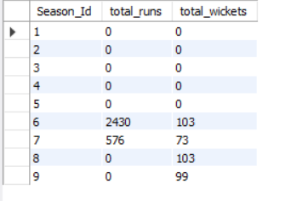

Q12. Can you derive more KPIs for the team strategy if possible?
Ans.
-- KPI #1 Boundary %
SELECT pm.Player_Id, p.Player_Name,
ROUND((SUM(CASE WHEN b.Runs_Scored = 4 THEN 1 ELSE 0 END) / COUNT(*)) * 100, 2) AS Four_Percentage,
ROUND((SUM(CASE WHEN b.Runs_Scored = 6 THEN 1 ELSE 0 END) / COUNT(*)) * 100, 2) AS Six_Percentage
FROM Ball_by_Ball b
JOIN Matches m
ON m.Match_Id = b.Match_Id
JOIN Player_Match pm
ON m.Match_Id = pm.Match_Id AND pm.Player_Id = b.Striker
JOIN Player p
ON pm.Player_Id = p.Player_Id
WHERE m.Season_Id IN (SELECT DISTINCT Season_Id FROM Matches WHERE Team_1 = 2 OR Team_2 = 2)
GROUP BY pm.Player_Id, p.Player_Name
ORDER BY Six_Percentage DESC, Four_Percentage DESC
LIMIT 15;
-- KPI #2 Bowling strike rate (Lower is better)
SELECT bb.Bowler, p.Player_Name,
ROUND(COUNT(bb.Ball_Id) / COUNT(w.Player_Out),2) AS Strike_Rate
FROM ball_by_ball bb
LEFT JOIN wicket_taken w
ON bb.Match_Id = w.Match_Id
AND bb.Over_Id = w.Over_Id
AND bb.Ball_Id = w.Ball_Id
JOIN player p
ON p.Player_Id = bb.Bowler
WHERE bb.Team_Bowling = 2
GROUP BY bb.Bowler
HAVING Strike_Rate IS NOT NULL
ORDER BY Strike_Rate ASC
LIMIT 15;
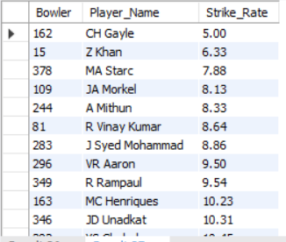

KPI #1 - Boundary Percentage:
- Calculates the percentage of fours and sixes hit by each player.
- Helps analyze aggressive batting strategies.
- Sports players by six-hitting ability, followed by fours.
KPI #2 - Bowling Strike Rate (Lower is Better):
- Measures the number of balls bowled per wicket taken.
- Helps identify effective bowlers who take wickets quickly.
- Filters for RCB bowlers and ranks them in ascending order.
Q13. Using SQL, write a query to find out average wickets taken by each bowler in each venue. Also rank the gender according to the average value.
Ans.
WITH player_wickets AS (
SELECT v.Venue_Id, v.Venue_Name,
p.Player_Name,
COUNT(w.Player_Out) AS total_wickets,
COUNT(DISTINCT m.Match_Id) AS matches_played -- Distinct matches where the player bowled
FROM Wicket_Taken w
JOIN Ball_by_Ball b
ON w.Match_Id = b.Match_Id
AND w.Over_Id = b.Over_Id
AND w.Ball_Id = b.Ball_Id
AND w.Innings_No = b.Innings_No -- Ensuring correct innings mapping
JOIN Matches m
ON b.Match_Id = m.Match_Id
JOIN Player_Match pm
ON pm.Match_Id = m.Match_Id
AND pm.Player_Id = b.Bowler -- Ensuring only actual bowlers are counted
JOIN Player p
ON p.Player_Id = pm.Player_Id
JOIN Venue v
ON v.Venue_Id = m.Venue_Id
GROUP BY v.Venue_Id, v.Venue_Name, p.Player_Name
),
unranked_table AS (
SELECT Venue_Id, Venue_Name, Player_Name,
total_wickets,
matches_played,
ROUND(total_wickets / matches_played, 2) AS avg_wickets
FROM player_wickets
)
SELECT *, DENSE_RANK() OVER(ORDER BY avg_wickets DESC) AS Ranking
FROM unranked_table
WHERE matches_played > 10;

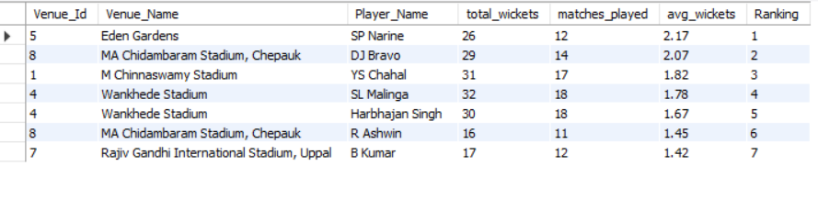

Calculates Wickets per Player at Each Venue:
- Counts total wickets taken by each player at different venues.
- Ensures only actual bowlers are considered.
Computes Average Wickets per Match:
- Divides total wickets by matches played at each venue.
Ranks Players by Performance:
- Uses DENSE_RANK() to rank bowlers based on average wickets per match.
Filters for Consistency:
- Includes only bowlers who have played more than 10 matches at a venue.
- Sorts in descending order of average wickets.

14. Which of the given players have consistently performed well in past seasons? (will you use any visualization to solve the problem)
Ans.

Approach:
- Data Aggregation (Player_Season_Performance CTE):
  - Retrieves each player's runs and wickets per season.
  - Joins Ball_by_Ball to track batting (Striker) and bowling (Bowler).
  - Uses Wicket_Taken to count wickets for bowlers.
  - Counts distinct matches played per season.
- Filtering & Ranking:
  - Averages total runs and wickets per season for each player.
  - Filters players who have played in more than 3 seasons.
  - Orders by average runs and wickets to rank top performers.
WITH Player_Season_Performance AS (
SELECT
p.Player_Name,
s.Season_Year,
SUM(bbb.Runs_Scored) AS Total_Runs,
COUNT(wt.Player_Out) AS Total_Wickets,
COUNT(DISTINCT m.Match_Id) AS Matches_Played
FROM Player p
INNER JOIN Ball_by_Ball bbb ON p.Player_Id = bbb.Striker
LEFT JOIN Wicket_Taken wt ON bbb.Match_Id = wt.Match_Id
AND bbb.Over_Id = wt.Over_Id
AND bbb.Ball_Id = wt.Ball_Id
AND bbb.Innings_No = wt.Innings_No
INNER JOIN Matches m ON bbb.Match_Id = m.Match_Id
INNER JOIN Season s ON m.Season_Id = s.Season_Id
WHERE p.Player_Id = bbb.Bowler OR p.Player_Id = bbb.Striker
GROUP BY p.Player_Name, s.Season_Year
)
SELECT
Player_Name,
AVG(Total_Runs) AS Avg_Runs_Per_Season,
AVG(Total_Wickets) AS Avg_Wickets_Per_Season,
COUNT(Season_Year) AS Seasons_Played
FROM Player_Season_Performance
GROUP BY Player_Name
HAVING Seasons_Played > 3
ORDER BY Avg_Runs_Per_Season DESC, Avg_Wickets_Per_Season DESC
LIMIT 10;

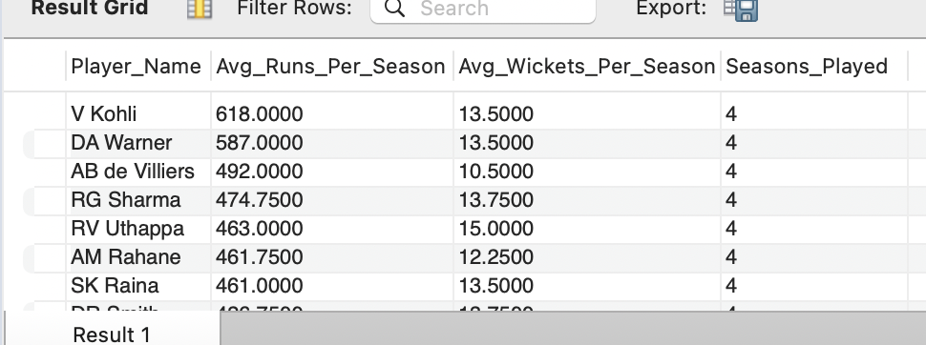

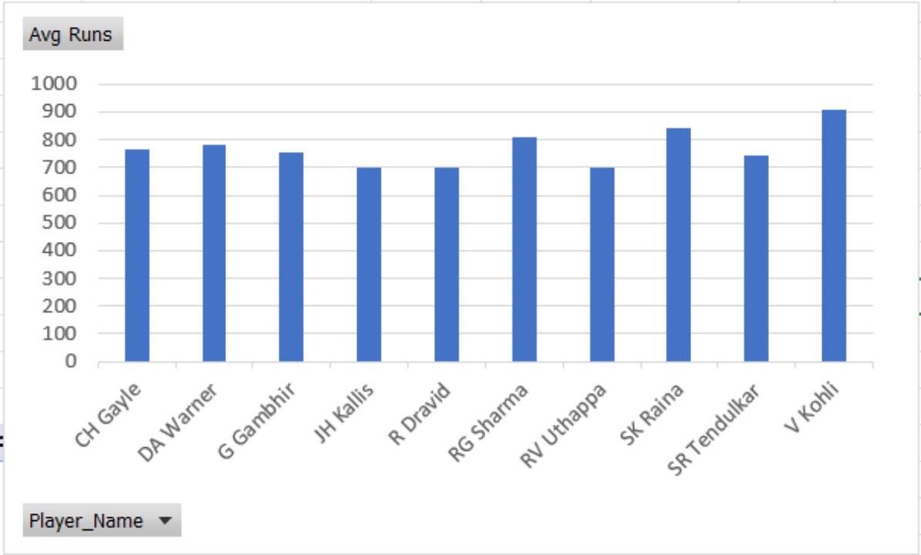

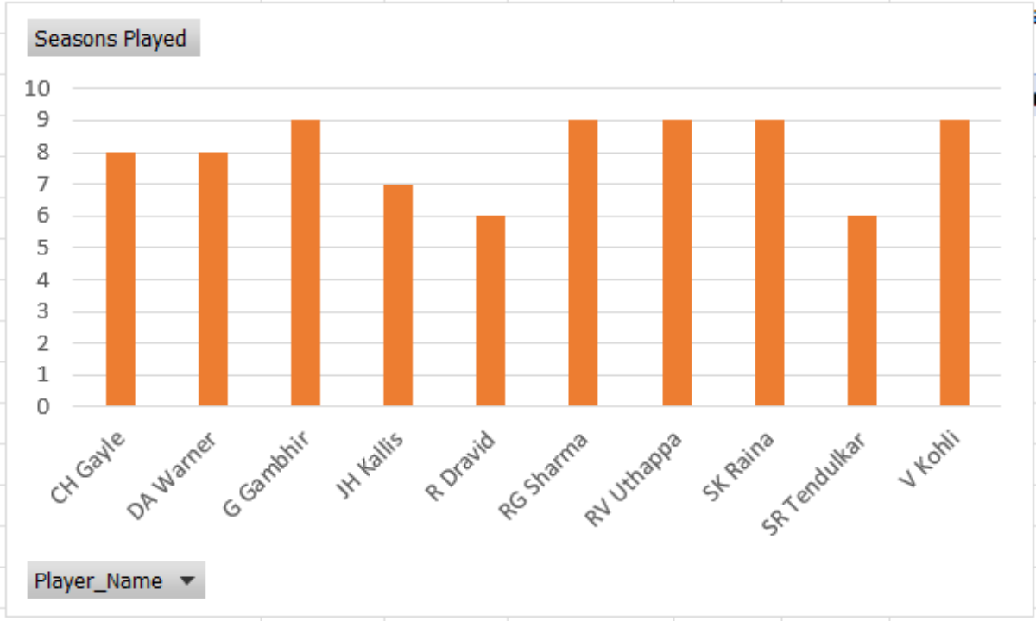

Derived Insights:
- Consistency Over Time:
Identifies players who consistently deliver strong performances across multiple seasons.
- Balanced Performers:
Highlights players who contribute both as batsmen and bowlers, making them valuable all-rounders.
- Strategic Importance:
Helps teams analyze players for long-term team planning and match-winning strategies.

15. Are there players whose performance is more suited to specific venues or conditions?
Ans.
#Batting performance
SELECT p.Player_Name, v.Venue_Name,
SUM(b.Runs_Scored) AS Total_Runs,
COUNT(b.Ball_Id) AS Balls_Faced,
ROUND(SUM(b.Runs_Scored) / COUNT(b.Ball_Id), 2) * 100 AS Strike_Rate
FROM Ball_by_Ball b
JOIN Matches m ON m.Match_Id = b.Match_Id
JOIN Player p ON p.Player_Id = b.Striker
JOIN Venue v ON m.Venue_Id = v.Venue_Id
GROUP BY p.Player_Name, v.Venue_Name
HAVING Total_Runs > 0 AND Balls_Faced > 100
ORDER BY Total_Runs DESC, p.Player_Name;
#Bowling performance
SELECT p.Player_Name, v.Venue_Name,
COUNT(w.Player_Out) AS Wickets_Taken,
COUNT(b.Ball_Id) AS Balls_Bowled
FROM ball_by_ball b
JOIN wicket_taken w ON b.Match_Id = w.Match_Id
AND b.Over_Id = w.Over_Id AND b.Ball_Id = w.Ball_Id AND b.Innings_No = w.Innings_No
JOIN matches m ON m.Match_Id = w.Match_Id
JOIN player p ON p.Player_Id = b.Bowler
JOIN venue v ON m.Venue_Id = v.Venue_Id
GROUP BY p.Player_Name, v.Venue_Name
HAVING Balls_Bowled > 5
ORDER BY Wickets_Taken DESC,p.Player_Name;

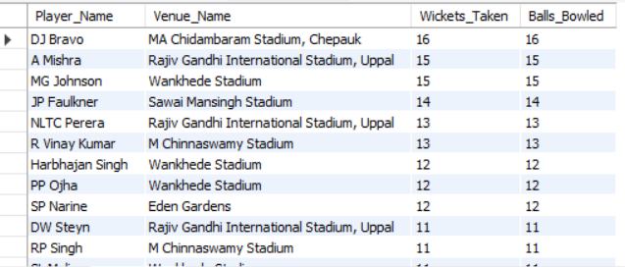

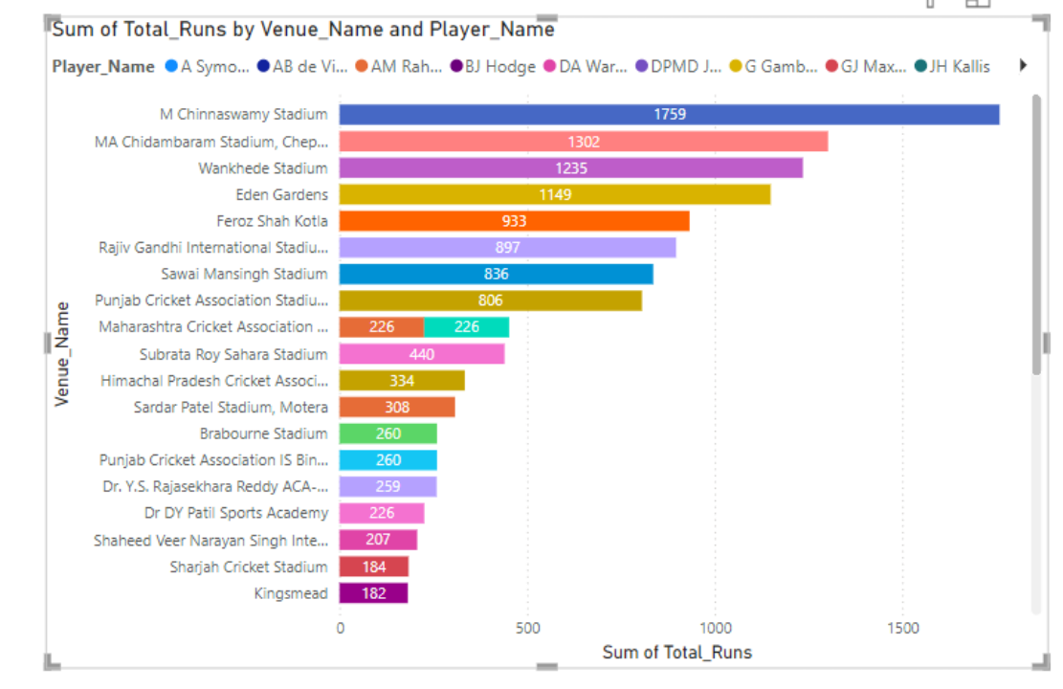

SUBJECTIVE QUESTIONS
--
1. How does the toss decision affect the result of the match? (which visualizations could be used to present your answer better) And is the impact limited to only specific venues?
Ans.
SELECT v.Venue_Id, v.Venue_Name,
CASE WHEN m.Toss_Decide = 1 THEN 'Field' ELSE 'Bat' END AS Toss_Decide,
COUNT(*) AS Total_Matches,
SUM(CASE WHEN m.Toss_Winner = m.Match_Winner THEN 1 ELSE 0 END) AS Toss_Winner_Wins,
SUM(CASE WHEN m.Toss_Winner != m.Match_Winner THEN 1 ELSE 0 END) AS Toss_Winner_Losses,
ROUND((SUM(CASE WHEN m.Toss_Winner = m.Match_Winner THEN 1 ELSE 0 END) * 100.0) / COUNT(*), 2) AS Win_Percentage
FROM Matches m
JOIN Venue v ON m.Venue_Id = v.Venue_Id
GROUP BY v.Venue_Id, v.Venue_Name, m.Toss_Decide
ORDER BY v.Venue_Name, Toss_Decide;

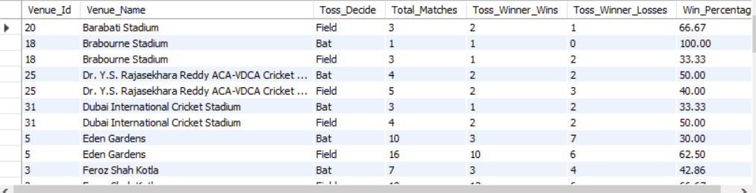
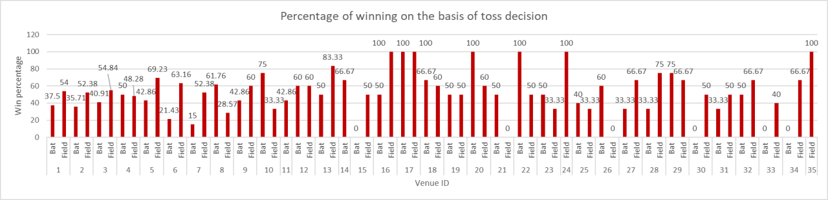

- We have used Venue ID instead of Venue Name for purpose of visualization.
- We can see that there is no specific pattern in win percentage on the basis of toss decision when we see the data for all the venues.
- However, we can see that there are some venues were winning the toss and selecting to field first increases your chances of winning.
- An example of this is Venue with ID 13 “SuperSport Park” where if you win the toss and decide to field your chance of winning is 83.33% whereas if you choose to bat first your chance of winning drops down to 50%.
- There are also some venues where the difference in win percentage based on toss decision is negligible, such as Venue with ID 4 “Wankhede Stadium” where if you choose to Field your chances of winning are 48.20% and if you chose to bat then your chances increase to 50.0%.
- Therefore, we can conclude that most of the venues are favorable to teams which choose to Field first after winning the toss. However, that is not the case for all venues.
2. Suggest some of the players who would be best fit for the team?
Ans.
#List of consistently performing batsmen
SELECT p.Player_Name,
SUM(b.Runs_Scored) AS Total_Runs,
COUNT(b.Ball_Id) AS Balls_Faced,
ROUND((SUM(b.Runs_Scored) / COUNT(b.Ball_Id)) * 100, 2) AS Strike_Rate,
ROUND(SUM(b.Runs_Scored) / COUNT(DISTINCT m.Match_Id), 2) AS Average_Runs
FROM Player p
JOIN Ball_by_Ball b ON p.Player_Id = b.Striker
JOIN Matches m ON b.Match_Id = m.Match_Id
WHERE m.Season_Id >= 4
GROUP BY p.Player_Name
ORDER BY Total_Runs DESC, Strike_Rate DESC
LIMIT 10;
#List of consistent bowlers
SELECT p.Player_Name,
COUNT(w.Player_Out) AS Wickets_Taken,
ROUND(SUM(bb.Ball_Id) / COUNT(w.Player_Out),2) AS Strike_Rate,
ROUND(SUM(bb.Runs_Scored) / (SUM(bb.Ball_Id)/6),2) AS Economy_Rate
FROM Player p
JOIN Ball_by_Ball bb ON p.Player_Id = bb.Bowler
JOIN Matches m ON bb.Match_Id = m.Match_Id
JOIN Wicket_Taken w
ON bb.Match_Id = w.Match_Id AND bb.Over_Id = w.Over_Id AND bb.Innings_No = w.Innings_No AND bb.Ball_Id = w.Ball_Id
WHERE m.Season_Id >= 4
GROUP BY p.Player_Id, p.Player_Name
ORDER BY Wickets_Taken DESC, Economy_Rate ASC, Strike_Rate ASC
LIMIT 10;
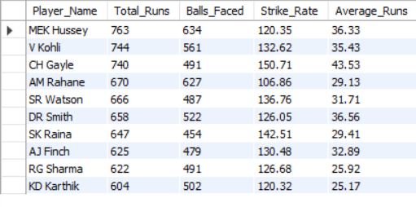

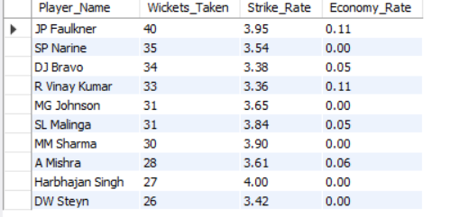

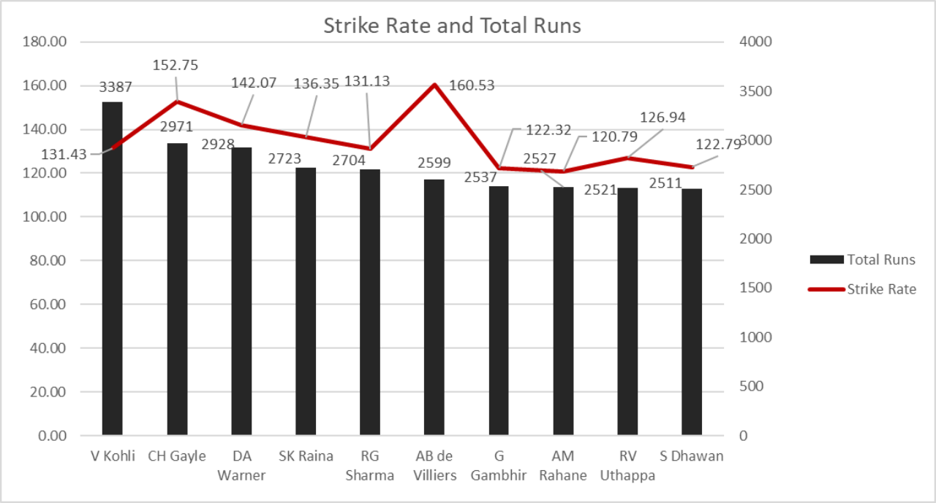

Best Batsmen for the Team:
- High Run-Scorers – Players with a high total runs tally indicate strong scoring ability over multiple seasons.
- Good Strike Rate – A high strike rate shows the ability to score quickly, essential in T20 and ODI formats.
- Consistent Average Runs per Match – Indicates reliability in scoring runs across different matches.
- Performance Under Pressure – Players who maintain composure in crucial situations add value to the team.

Best Bowlers for the Team:
- High Wicket-Takers – Players with the most wickets are crucial for breaking partnerships.
- Low Economy Rate – Indicates a bowler’s ability to control runs and maintain pressure.
- Better Bowling Strike Rate – Shows efficiency in taking wickets with fewer balls bowled.
- Match Impact – Bowlers who perform well in crunch situations help the team win crucial games.

3.What are some of the parameters that should be focused on while selecting the players?
#Key parameters for selecting players
Ans.
# A. Death over bowling performance
SELECT p.Player_Name,
SUM(CASE WHEN bb.Over_Id >= 16 AND bb.Over_Id <= 20 AND p.Player_Id IN (SELECT Bowler FROM ball_by_ball) THEN bb.Runs_Scored ELSE 0 END) AS Death_Over_Runs_Conceded
FROM Player p
JOIN ball_by_ball bb ON p.Player_Id = bb.Striker OR p.Player_Id = bb.Bowler
JOIN Matches m ON bb.Match_Id = m.Match_Id
WHERE m.Season_Id >= 4
GROUP BY p.Player_Name
HAVING COUNT(bb.Ball_Id) > 100 AND Death_Over_Runs_Conceded != 0
ORDER BY Death_Over_Runs_Conceded ASC
LIMIT 10;
# B. Batting performance accross different venues
SELECT p.Player_Name,
v.Venue_Id, v.Venue_Name,
SUM(bb.Runs_Scored) AS Total_Runs,
COUNT(bb.Ball_Id) AS Balls_Faced,
ROUND(SUM(bb.Runs_Scored) / COUNT(bb.Ball_Id), 2) * 100 AS Strike_Rate
FROM Player p
JOIN Ball_by_Ball bb ON p.Player_Id = bb.Striker
JOIN Matches m ON bb.Match_Id = m.Match_Id
JOIN Venue v ON m.Venue_Id = v.Venue_Id
JOIN Ball_by_Ball bb2
ON bb.Match_Id = bb2.Match_Id
AND bb.Over_Id = bb2.Over_Id
AND bb.Ball_Id = bb2.Ball_Id
AND bb.Innings_No = bb2.Innings_No
GROUP BY p.Player_Name, v.Venue_Id, v.Venue_Name
ORDER BY Total_Runs DESC, Strike_Rate DESC
LIMIT 10;

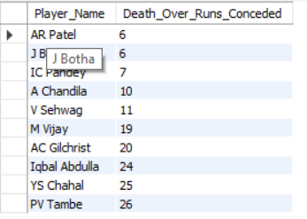

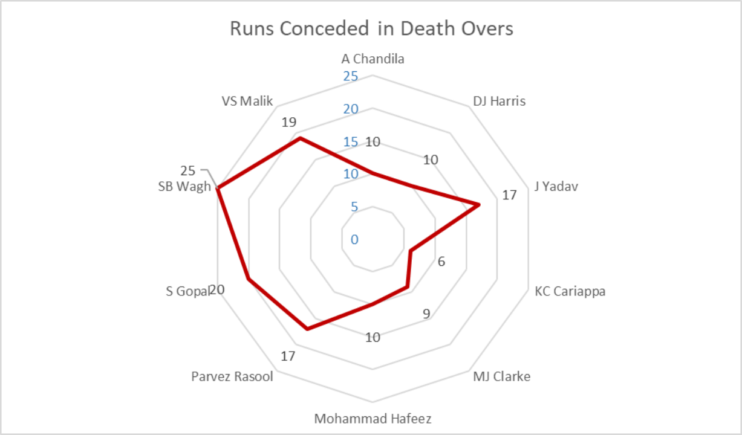

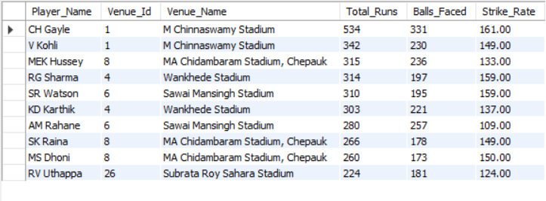

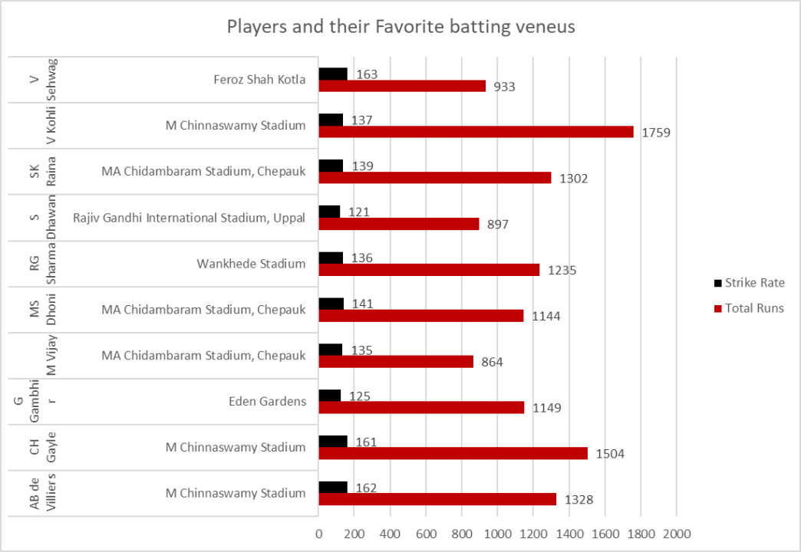

- We can see that some players perform their best at certain venues.
- For RCB we know half of our league matches will be at home, we can select players accordingly.
- If we have strong batsmen who perform well at home venue our chances of winning home games increase a lot.
- In our case, we can observe that Virat Kohli has the most run at Chinnaswamy Stadium followed by CH Gayle and AB de Villiers.
- All of these batsmen have a healthy strike rate too, which means they score runs at a quicker rate the others.

Q4. Which players offer versatility in their skills and can contribute effectively with both bat and ball? (can you visualize the data for the same)
Ans.
#We can find all-rounder performance for all players
WITH batting_performance AS (
SELECT p.Player_Id, p.Player_Name,
SUM(b.Runs_Scored) AS Total_Runs,
COUNT(bb.Ball_Id) AS Balls_Faced,
ROUND((SUM(b.Runs_Scored) / COUNT(bb.Ball_Id)) * 100, 2) AS Batting_Strike_Rate
FROM Player p
JOIN Ball_by_Ball bb ON p.Player_Id = bb.Striker
JOIN Ball_by_Ball b
ON bb.Match_Id = b.Match_Id
AND bb.Over_Id = b.Over_Id
AND bb.Ball_Id = b.Ball_Id
AND bb.Innings_No = b.Innings_No
WHERE b.Runs_Scored IS NOT NULL -- Ensuring only valid scoring deliveries are considered
GROUP BY p.Player_Id, p.Player_Name
),
bowling_performance AS (
SELECT p.Player_Id, p.Player_Name,
COUNT(w.Player_Out) AS Total_Wickets,
ROUND(SUM(bb.Team_Batting) / COUNT(bb.Ball_Id),2) AS Economy_Rate
FROM player p
JOIN ball_by_ball bb ON p.Player_Id = bb.Bowler
JOIN wicket_taken w ON bb.Match_Id = w.Match_Id
AND bb.Over_Id = w.Over_Id
AND bb.Ball_Id = w.Ball_Id
AND bb.Innings_No = w.Innings_No
GROUP BY p.Player_Id, p.Player_Name
)
SELECT bp.Player_Id, bp.Player_Name,
bp.Total_Runs, bp.Batting_Strike_Rate, bp.Balls_Faced,
bw.Total_Wickets, bw.Economy_Rate
FROM batting_performance bp
JOIN bowling_performance bw ON bp.Player_Id = bw.Player_Id
ORDER BY bp.Batting_Strike_Rate DESC, bw.Economy_Rate ASC
LIMIT 10;

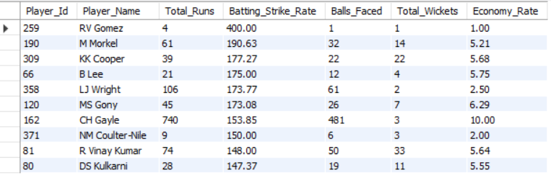

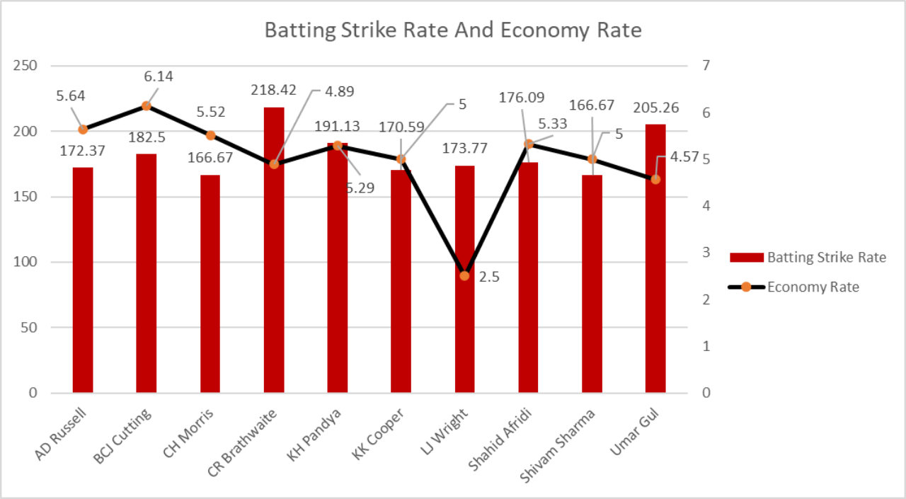

- All-rounders are very important in a cricket team as they provide flexibility in selecting the playing IX.
- Additionally, they also help the captain implement on the fly bowling strategies or change the batting line-up to counter their opponents.

Q5. Are there players whose presence positively influences the morale and performance of the team? (justify your answer using visualisation)
Ans.

This SQL script calculates the percentage of runs scored from boundaries (fours and sixes) for players in the 2015 and 2016 IPL seasons, and filters players with a total run count of 100 or more. Here's a summary of each part:
It analyzes the performance of batsmen in the 2015 and 2016 IPL seasons, focusing on the percentage of their runs scored from boundaries (fours and sixes). It calculates the total runs and boundary runs for each player, filters for those who have scored 100 or more total runs, and orders the results by the percentage of runs from boundaries, in descending order. The output includes the player ID, player name, total runs, runs from boundaries, and the boundary percentage.
WITH cte AS (
-- Extract relevant match details for the 2015 and 2016 seasons
SELECT bbb.Striker, m.Season_Id, s.Season_Year,
bbb.Match_Id, bbb.Over_Id, bbb.Ball_Id,
bbb.Innings_No, bbb.Runs_Scored
FROM ball_by_ball bbb
JOIN matches m
ON bbb.Match_Id = m.Match_Id
JOIN season s
ON m.Season_Id = s.Season_Id
WHERE s.Season_Year IN (2015, 2016)
),
cte2 AS (
-- Calculate total runs per player
SELECT Striker, SUM(Runs_Scored) AS Total_Runs
FROM cte
GROUP BY Striker
),
cte3 AS (
-- Calculate runs from boundaries (4s and 6s) per player
SELECT Striker, SUM(Runs_Scored) AS Runs_In_Boundaries
FROM cte
WHERE Runs_Scored IN (4, 6)
GROUP BY Striker
)
-- Final output with boundary percentage calculation
SELECT c2.Striker AS Player_Id, p.Player_Name,
c2.Total_Runs, c3.Runs_In_Boundaries,
ROUND((c3.Runs_In_Boundaries * 100.0 / c2.Total_Runs), 2) AS Boundary_Percentage
FROM cte2 c2
JOIN cte3 c3 ON c2.Striker = c3.Striker
JOIN player p ON c2.Striker = p.Player_Id
WHERE c2.Total_Runs >= 100
ORDER BY Boundary_Percentage DESC;

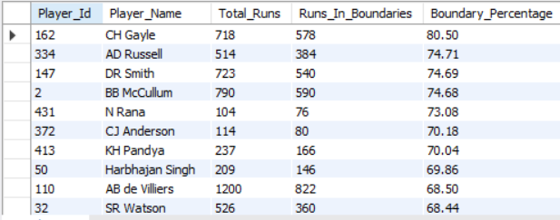

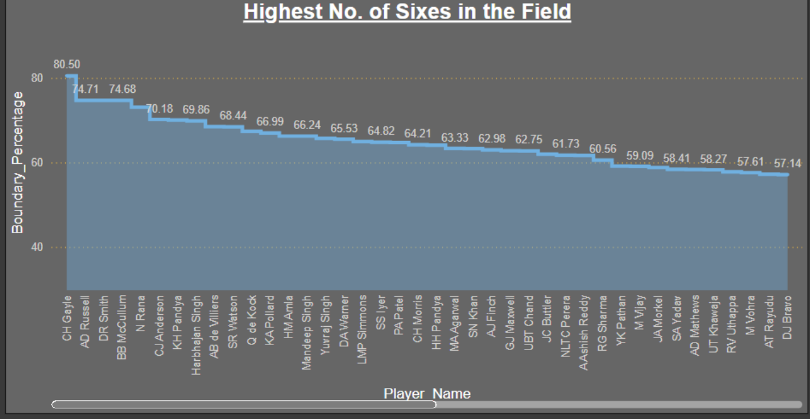

6. What would you suggest to RCB before going to mega auction?
Ans.
# Identify good all-rounders for better team combinations.
WITH batting_performance AS (
SELECT p.Player_Id, p.Player_Name,
SUM(bb.Runs_Scored) AS Total_Runs,
COUNT(bb.Ball_Id) AS Balls_Faced,
ROUND((SUM(bb.Runs_Scored) / COUNT(bb.Ball_Id)) * 100, 2) AS Batting_Strike_Rate
FROM player p
JOIN ball_by_ball bb
ON p.Player_Id = bb.Striker
JOIN matches m
ON bb.Match_Id = m.Match_Id
JOIN ball_by_ball b
ON bb.Match_Id = b.Match_Id
AND bb.Over_Id = b.Over_Id
AND bb.Ball_Id = b.Ball_Id
AND bb.Innings_No = b.Innings_No
WHERE bb.Runs_Scored IS NOT NULL
GROUP BY p.Player_Id, p.Player_Name
),
bowling_performance AS (
SELECT p.Player_Id, p.Player_Name,
COUNT(w.Player_Out) AS Total_Wickets,
ROUND(SUM(bb.Runs_Scored) / (COUNT(bb.Ball_Id) / 6.0), 2) AS Economy_Rate
FROM player p
JOIN ball_by_ball bb ON p.Player_Id = bb.Bowler
LEFT JOIN wicket_taken w
ON bb.Match_Id = w.Match_Id
AND bb.Over_Id = w.Over_Id
AND bb.Ball_Id = w.Ball_Id
AND bb.Innings_No = w.Innings_No
JOIN ball_by_ball bs
ON bs.Match_Id = bb.Match_Id
AND bs.Over_Id = bb.Over_Id
AND bs.Ball_Id = bb.Ball_Id
AND bs.Innings_No = bb.Innings_No
GROUP BY p.Player_Id, p.Player_Name
HAVING COUNT(bb.Ball_Id) > 100
)
SELECT DISTINCT bp.Player_Id, bp.Player_Name,
bp.Total_Runs, bp.Batting_Strike_Rate, bp.Balls_Faced,
bw.Total_Wickets, bw.Economy_Rate
FROM batting_performance bp
JOIN bowling_performance bw ON bp.Player_Id = bw.Player_Id
JOIN player_match pm ON bp.Player_Id = pm.Player_Id
WHERE pm.Role_Id NOT IN (SELECT Role_Id FROM rolee WHERE Role_Desc IN ("Keeper","CaptainKeeper"))
AND bp.Balls_Faced > 100
ORDER BY bp.Batting_Strike_Rate DESC, bw.Economy_Rate ASC
LIMIT 10;

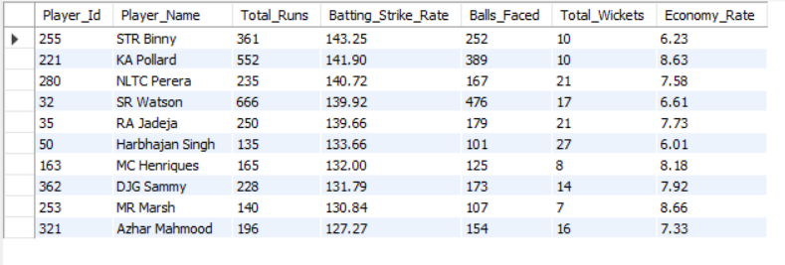

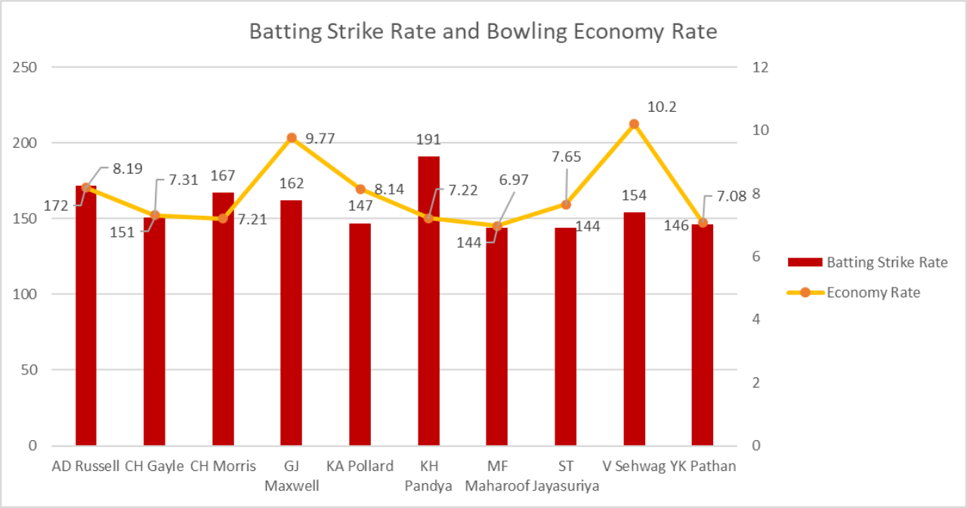

- Having good all-rounders can help RCB stabilize the middle order while also strengthening their bowling line-up.
- For all-rounders their strength lies in scoring runs at an explosive rate and restricting opposition to low totals.
- Batting strike rate is important because all-rounder usually comes to bat at a time where no. of balls is low and economy rate is important because they provide a support to bowlers by creating pressure with dot balls.

7. What do you think could be the factors contributing to the high-scoring matches and the impact on viewership and team strategies?
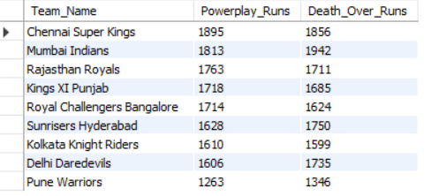
Ans.
/* Powerplay and Death Over Utilization: In high-scoring matches, teams aim to maximize the powerplay (overs 1-6) and death overs (Overs 16-20) by scoring aggressively. */
SELECT t.Team_Name,
SUM(CASE WHEN bb.Over_Id BETWEEN 1 AND 6 THEN bb.Runs_Scored ELSE 0 END) AS Powerplay_Runs,
SUM(CASE WHEN bb.Over_Id BETWEEN 16 AND 20 THEN bb.Runs_Scored ELSE 0 END) AS Death_Over_Runs
FROM team t
JOIN matches m ON t.Team_Id = m.Team_1 OR t.Team_Id = m.Team_2
JOIN ball_by_ball bb ON m.Match_Id = bb.Match_Id
GROUP BY t.Team_Name
ORDER BY Powerplay_Runs DESC, Death_Over_Runs DESC;
/* High Scoring Venues: Some venues favour the batsmen more then others, venues play a significant role in a high-scoring match */
SELECT v.Venue_Name,
AVG(match_runs.Total_Runs) AS Avg_Runs_Per_Match,
COUNT(m.Match_Id) AS Total_Matches
FROM venue v
JOIN matches m ON v.Venue_Id = m.Venue_Id
JOIN (
SELECT bb.Match_Id, SUM(bb.Runs_Scored) AS Total_Runs
FROM ball_by_ball bb
GROUP BY bb.Match_Id
) AS match_runs ON m.Match_Id = match_runs.Match_Id
GROUP BY v.Venue_Name
ORDER BY Total_Matches DESC, Avg_Runs_Per_Match DESC
LIMIT 10;

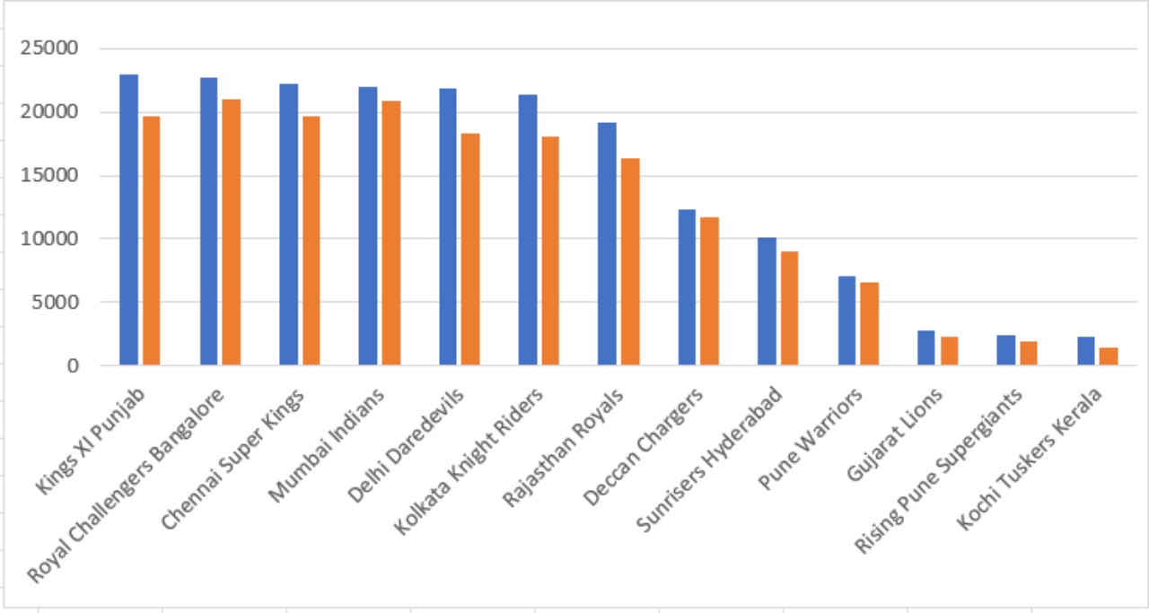

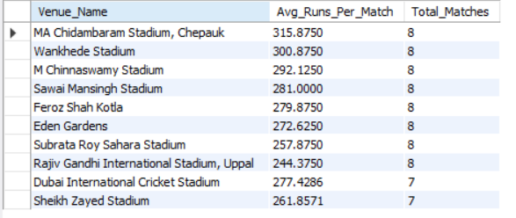

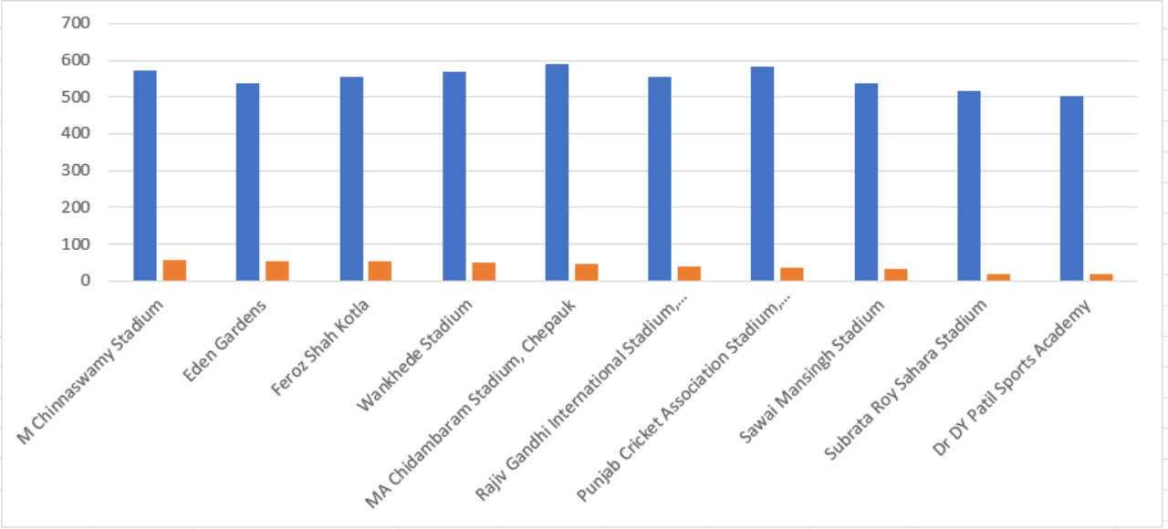

- Venues play an important role in high scoring matches as shorter boundaries means more runs.
- Also, some venues have pitches which are more favorable to the batsmen then they are to the bowlers.
- In our visual we can see that M Chinnaswamy Stadium has the highest average runs scored due to the fact that it has really small boundaries and a good batting pitch.
- This is followed by Eden Garden where boundaries are not small but the outfield is very quick and the pitch favors the batsmen.
- High scoring matches leads to teams strategizing explosive opening partnerships.
- All the teams aim to cross the 200+ runs mark and have fiery start in the powerplay and in the death overs.
- The teams starts increasing the number of batsman or all-rounder batsmen in the lineup and reduce full time bowlers in favor of part time bowlers that score with the bat also.
- High score matches sky rockets the viewership as they are generally more entertaining
8. Analyze the impact of home ground advantage on team performance and identify strategies to maximize this advantage for RCB.
Ans.
# Home vs Away Win/Loss record
WITH win_loss_record AS (
SELECT m.Match_Id, v.Venue_Name,
CASE WHEN m.Match_Winner = 2 THEN 'Win' ELSE
'Loss'
END AS Result,
CASE WHEN v.Venue_Id = 1 THEN 'Home' ELSE 'Away'
END AS Venue_Type
FROM matches m
JOIN venue v ON m.Venue_Id = v.Venue_Id
WHERE (m.Team_1 = 2 OR m.Team_2 = 2) AND Outcome_type != 2
)
SELECT
Venue_Type,
COUNT(CASE WHEN Result = 'Win' THEN 1 END) AS Wins,
COUNT(CASE WHEN Result = 'Loss' THEN 1 END) AS Losses,
COUNT(*) AS Total_Matches,
ROUND(COUNT(CASE WHEN Result = 'Win' THEN 1 END) / COUNT(*) * 100, 2) AS Win_Percentage
FROM win_loss_record
GROUP BY Venue_Type;
#Home away batting performance
WITH rcb_run_stats AS (
SELECT m.Match_Id, v.Venue_Name,
CASE WHEN v.Venue_Id = 1 THEN 'Home' ELSE 'Away' END AS Venue_Type,
SUM(CASE WHEN bb.Team_Batting = 2 THEN bb.Runs_Scored ELSE 0 END) AS Runs_Scored,
SUM(CASE WHEN bb.Team_Bowling = 2 THEN bb.Runs_Scored ELSE 0 END) AS Runs_Conceded
FROM matches m
JOIN venue v ON m.Venue_Id = v.Venue_Id
JOIN ball_by_ball bb ON m.Match_Id = bb.Match_Id
WHERE (m.Team_1 = 2 OR m.Team_2 = 2) -- 2 is the team ID for RCB
GROUP BY m.Match_Id, v.Venue_Name
)
SELECT Venue_Type,
ROUND(AVG(Runs_Scored), 2) AS Avg_Runs_Scored,
ROUND(SUM(Runs_Scored), 2) AS Total_Runs_Scored
FROM rcb_run_stats
GROUP BY Venue_Type;
WITH bowling_performance AS (
SELECT v.Venue_Name,
CASE WHEN v.Venue_Id = 1 THEN 'Home' ELSE 'Away' END AS Venue_Type,
SUM(CASE WHEN bb.Team_Bowling = 2 THEN bb.Runs_Scored ELSE 0 END) AS Runs_Conceded,
COUNT(CASE WHEN bb.Team_Bowling = 2 AND w.Player_Out IS NOT NULL THEN 1 ELSE NULL END) AS Wickets_Taken,
COUNT(CASE WHEN bb.Team_Bowling = 2 THEN bb.Ball_Id ELSE NULL END) AS Balls_Bowled
FROM matches m
JOIN venue v ON m.Venue_Id = v.Venue_Id
JOIN ball_by_ball bb ON m.Match_Id = bb.Match_Id
LEFT JOIN wicket_taken w ON bb.Match_Id = w.Match_Id
AND bb.Over_Id = w.Over_Id
AND bb.Ball_Id = w.Ball_Id
AND bb.Innings_No = w.Innings_No -- Ensuring correct innings mapping
WHERE (m.Team_1 = 2 OR m.Team_2 = 2) -- 2 is the team ID for RCB
GROUP BY v.Venue_Name,Venue_Type
)
SELECT Venue_Type,
ROUND(SUM(Wickets_taken),2) AS Total_Wickets_taken,
ROUND(SUM(Runs_Conceded) / SUM(Balls_Bowled), 2) AS Economy_Rate
FROM bowling_performance
GROUP BY Venue_Type;

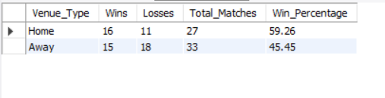

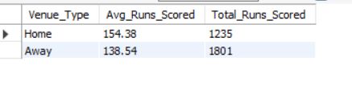

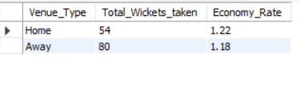

Impact of home ground advantage on team performance

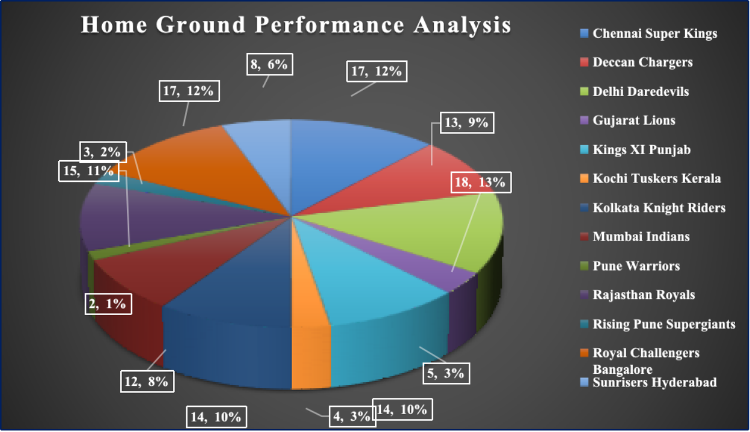

9. Come up with a visual and analytical analysis with the RCB past seasons performance and potential reasons for them not winning a trophy.
Ans.
# A. Win-Loss Performance Over Seasons
WITH win_loss_record AS (
SELECT m.Season_Id,CASE WHEN m.Match_Winner = 2 THEN 'Win' ELSE 'Loss' END AS Result
FROM matches m
WHERE (m.Team_1 = 2 OR m.Team_2 = 2) AND Outcome_type != 2
)
SELECT Season_Id,COUNT(CASE WHEN Result = 'Win' THEN 1 END) AS Wins,
COUNT(CASE WHEN Result = 'Loss' THEN 1 END) AS Losses,
COUNT(*) AS Total_Matches,
ROUND(COUNT(CASE WHEN Result = 'Win' THEN 1 END) / COUNT(*) * 100, 2) AS Win_Percentage
FROM win_loss_record
GROUP BY Season_Id
ORDER BY Season_Id;
# B. Batting performance each season
WITH rcb_batting_in_powerplay AS (
SELECT bb.Match_Id, bb.Innings_No, bb.Striker AS Batsman_Id, p.Player_Name,
SUM(bb.Runs_Scored) AS total_runs_in_power_play,
COUNT(bb.Ball_Id) AS balls_faced_in_power_play
FROM Ball_by_Ball bb
JOIN Matches m ON bb.Match_Id = m.Match_Id
JOIN Player p ON bb.Striker = p.Player_Id
WHERE (m.Team_1 = 2 OR m.Team_2 = 2)
AND bb.Over_Id BETWEEN 1 AND 6
GROUP BY bb.Match_Id, bb.Innings_No, bb.Striker, p.Player_Name
)
SELECT rcb.Player_Name,
SUM(rcb.total_runs_in_power_play) AS total_runs_in_power_play,
SUM(rcb.balls_faced_in_power_play) AS total_balls_faced_in_powerplay,
ROUND((SUM(rcb.total_runs_in_power_play) / NULLIF(SUM(rcb.balls_faced_in_power_play), 0)) * 100, 2) AS strike_rate_in_power_play
FROM rcb_batting_in_powerplay rcb
GROUP BY rcb.Player_Name
HAVING total_balls_faced_in_powerplay > 100
ORDER BY strike_rate_in_power_play DESC;
# C. Bowling performance each season
WITH death_overs_bowling AS (
SELECT bb.Match_Id, bb.Innings_No, bb.Bowler AS Bowler_Id, p.Player_Name,
SUM(bb.Runs_Scored) AS runs_conceded,
COUNT(bb.Ball_Id) AS balls_bowled,
COUNT(w.Player_Out) AS wickets_taken
FROM Ball_by_Ball bb
LEFT JOIN Wicket_Taken w ON bb.Match_Id = w.Match_Id
AND bb.Over_Id = w.Over_Id
AND bb.Ball_Id = w.Ball_Id
AND bb.Innings_No = w.Innings_No
JOIN Player p ON bb.Bowler = p.Player_Id
JOIN Matches m ON bb.Match_Id = m.Match_Id
WHERE (m.Team_1 = 2 OR m.Team_2 = 2)
AND bb.Over_Id BETWEEN 16 AND 20
GROUP BY bb.Match_Id, bb.Innings_No, bb.Bowler, p.Player_Name
)
SELECT d.Player_Name,
SUM(d.runs_conceded) AS runs_conceded_in_death,
SUM(d.balls_bowled) AS total_balls_bowled_in_death,
SUM(d.wickets_taken) AS total_wickets_in_death,
ROUND((SUM(d.runs_conceded) / NULLIF((SUM(d.balls_bowled) / 6), 0)), 2) AS economy_rate_in_death
FROM death_overs_bowling d
GROUP BY d.Player_Name
HAVING total_balls_bowled_in_death > 100
ORDER BY economy_rate_in_death ASC;

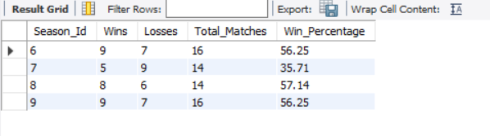

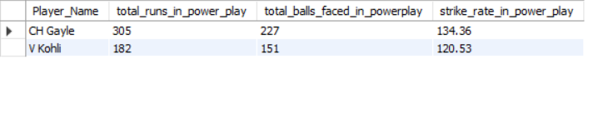

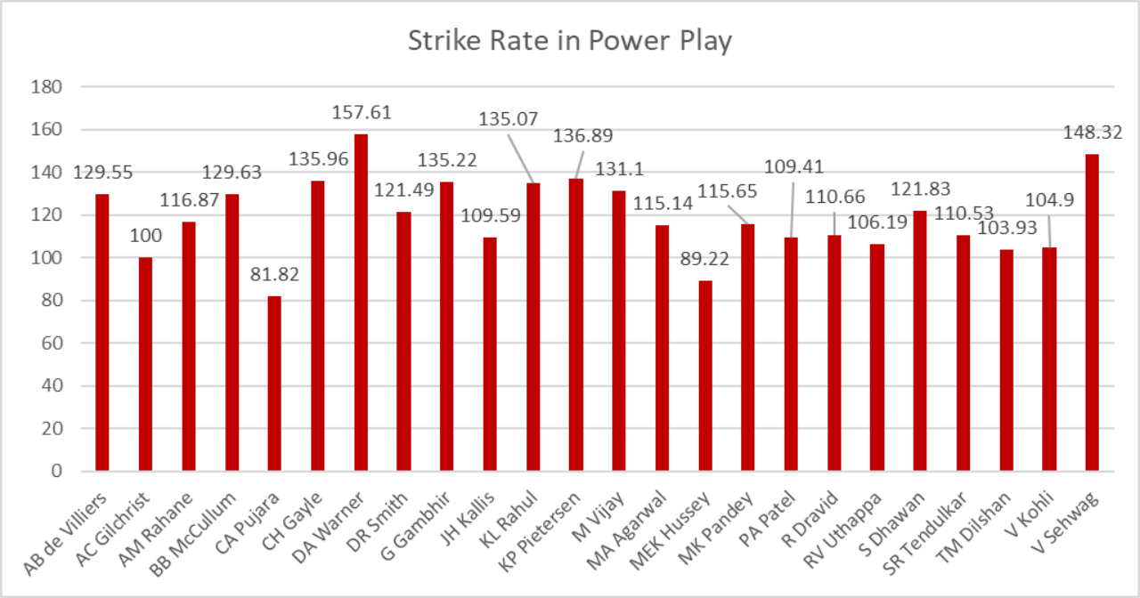

Q.10 How would you approach this problem, if the objective and subjective questions weren't given?
Ans.

If the objective and subjective questions weren't provided, my approach to analyzing the IPL dataset, particularly for a team like RCB, would be as follows:
1. Understand the Dataset:
· First, review the IPL dataset thoroughly to understand its structure, the available tables, and key columns such as players, matches, teams, venues, and performances.
· Identify important metrics related to team performance, such as wins, losses, individual player stats (batting, bowling, and fielding), and venue-related statistics.
2. Define the Analytical Goals:
Without predefined questions, I would focus on generating insights across several dimensions:
· Team Performance Trends: Analyze overall team performance across seasons—win/loss ratios, home/away performance, and tournament progression.
· Player Contributions: Break down individual player contributions to identify key performers, top run-scorers, and wicket-takers, as well as those with all-round abilities.
· Player Performance Under Pressure: Analyze how players perform under critical conditions like knockout matches, death overs, and high-pressure situations.
· Team Strengths and Weaknesses: Identify the team's consistent strengths (e.g., batting power) and weaknesses (e.g., bowling, fielding, middle-order stability).
· Match Results and Patterns: Look for recurring patterns in match results, such as winning the toss, batting first, or playing at certain venues.
3. Perform Statistical Analysis:
· Match Analysis: Investigate match-level statistics to identify key factors contributing to wins and losses (e.g., toss decisions, chasing records, target scores).
· Player-Level Analysis: Explore batting averages, strike rates, bowling economies, and all-rounder effectiveness. Highlight players who contribute consistently in both departments (batting and bowling).
· Venue Advantage: Investigate home ground advantage and how RCB fares at home compared to away matches.
4. Visualize Insights:
· Use data visualization tools (like Excel, Power BI, or Tableau) to create charts and graphs:
o Win/loss trends across seasons.
o Player performances (e.g., top scorers, best bowlers).
o Home vs away performance comparisons.
o Toss impact on match outcomes.
5. Generate Recommendations:
Based on the analysis, provide actionable recommendations:
· Squad composition and potential areas for improvement.
· Strategies for winning in high-stakes matches.
· Player retention and acquisition for a balanced team.

This method would create a comprehensive analysis without relying on predefined questions, enabling insights into RCB’s overall performance and potential improvements.

Q11. In the "Match" table, some entries in the
-- "Opponent_Team" column are incorrectly spelled as "Delhi_Capitals" instead of "Delhi_Daredevils".
-- Write an SQL query to replace all occurrences of "Delhi_Capitals" with "Delhi_Daredevils".
Ans.

1. In the given IPL Dataset there is no such column name i.e "Opponent_Team" is Present.
2. So their will be no scope to replace the name in match column.
3. If we check Team Table
By :: Select * from Team;
we get team name here we can change the team name from
"Delhi_Capitals" to "Delhi_Daredevils".
By:: select Team_Id, replace(Team_name,"Delhi Daredevils","Delhi Capitals") as Team_name from team;
