LEAF HEALTH CHECK: AI-POWERED SYSTEM FOR PLANT DISEASE DETECTION AND DIAGNOSIS

Team ID : SWTID-2026-7638
Team Size : 4
Team Leader: Dharshini S
Team Members:
Shajitha S
Vaishnavi E
Chandhini A

ABSTRACT
The project Leaf Health Check – AI-Powered Plant Disease Detection & Diagnosis is designed to identify diseases in plant leaves using Artificial Intelligence and image processing techniques. Plant diseases can significantly reduce crop productivity and cause major losses for farmers if not detected early. This system enables users to upload an image of a plant leaf, which is then analyzed by an AI model to determine whether the leaf is healthy or affected by a disease.The AI model is trained on comprehensive image datasets using machine learning techniques to recognize various patterns of plant diseases. Additionally, the system provides basic recommendations and treatment suggestions to improve plant health. The application is developed using technologies such as Python, TensorFlow, OpenCV, and Streamlit, offering an interactive and user-friendly interface.The primary objective of this project is to provide a fast, simple, and accurate method for detecting plant diseases, assisting farmers, gardeners, and agricultural researchers in monitoring plant health and taking timely corrective measures.

INTRODUCTION
Agriculture plays a vital role in food production and economic growth. However, one of the major challenges in agriculture is plant diseases, which can severely damage crops and reduce productivity. Traditionally, farmers identify diseases by manually inspecting leaves, which requires expertise and can be time-consuming. In many cases, diseases are detected at a later stage, leading to significant crop loss. With advancements in Artificial Intelligence and Machine Learning, automated plant disease detection using image analysis has become possible.The Leaf Health Check system is designed to assist users in detecting plant leaf diseases efficiently and accurately. By uploading an image of a plant leaf, the system analyzes the image using a trained AI model and determines the plant’s health condition. This approach enables early disease detection and saves time in diagnosis. The system also aims to support farmers and plant enthusiasts by providing basic guidance and information on plant care and disease prevention.

OBJECTIVES
The primary objective of the Leaf Health Check project is to develop an AI-powered system that can automatically detect plant leaf diseases using image recognition techniques. The system analyzes leaf images and classifies them as healthy or diseased using a trained machine learning model.
Another key objective is to provide a user-friendly interface where users can easily upload leaf images and receive instant results. The project also aims to promote awareness about plant health and encourage early detection of diseases. Additionally, the system offers basic recommendations and treatment suggestions to help users maintain healthy plants and improve agricultural productivity.

PROBLEM STATEMENT
Plant diseases are a major cause of crop damage and reduced agricultural productivity. Farmers often rely on manual inspection to identify diseases, which requires expertise and experience. In many cases, diseases are detected at a later stage, resulting in severe crop loss. Furthermore, access to agricultural experts is limited in rural areas, making timely diagnosis difficult.To address this problem, the Leaf Health Check project utilizes Artificial Intelligence to analyze leaf images and detect diseases automatically. The system provides fast and accurate disease detection, helping users identify problems at an early stage and take appropriate corrective actions. This solution aims to improve plant health monitoring and support farmers in protecting their crops.

PROJECT DESCRIPTION
The Leaf Health Check – AI-Powered Plant Disease Detection & Diagnosis system is an intelligent application designed to identify plant diseases from leaf images. Users can upload an image of a plant leaf through a web-based interface, and the system processes the image using image processing techniques and a trained AI model.The AI model analyzes various patterns, color variations, and textures in the leaf to determine whether the plant is healthy or affected by a disease. After analysis, the system displays the prediction result and provides basic recommendations for plant care and treatment.This project integrates machine learning, image processing, and web application development to create an easy-to-use tool for plant disease detection. It is beneficial for farmers, gardeners, and agricultural researchers who need a quick and reliable method to assess plant health.

TECHNOLOGY USED
The Leaf Health Check project utilizes modern technologies to develop an efficient plant disease detection system. The primary programming language used is Python, which is widely adopted for Artificial Intelligence and Machine Learning applications.The machine learning model is built using TensorFlow, enabling the system to train and predict plant diseases from leaf images. OpenCV is employed for image processing tasks such as reading and analyzing leaf images.To create an interactive web interface, Streamlit is used, allowing users to upload images and view results easily. Additional libraries such as NumPy and Pillow assist in handling numerical data and image operations. The integration of these technologies ensures accurate disease detection and a smooth user experience.

SYSTEM ARCHITECTURE

The Leaf Health Check system is designed as an AI-powered Plant Health Advisor that integrates multiple modules to detect, analyze, and provide solutions for plant leaf diseases. The system begins with an interactive web interface built using Streamlit, enabling users to upload leaf images easily. This frontend module displays AI-generated diagnosis results, disease severity levels, and recommended rescue tips in a user-friendly format.
After image upload, the Image Processing Module performs essential preprocessing tasks such as resizing, normalization, RGB conversion, and discoloration detection. These steps standardize the images for accurate analysis and help identify disease-affected areas using brown and yellow detection techniques.
The preprocessed image is then processed by the AI Model Layer, which utilizes a CNN-based deep learning model to identify plant species and predict potential diseases. The model provides a confidence score for its predictions, ensuring reliable and meaningful disease diagnosis.
Next, the Severity Grading Engine calculates the percentage of affected areas and classifies the disease severity into categories such as mild, moderate, severe, or dying. This classification helps users understand the urgency of treatment required for the plant.
The Recommendation Engine further enhances the system by matching the identified plant species and disease with stored knowledge about common diseases and treatment methods. It generates practical suggestions and guidance to help users improve plant health and manage diseases effectively.
Additionally, the system includes an optional Export Module that allows users to generate a downloadable PDF report summarizing the diagnosis, disease severity, and recommended actions. This feature enables users to maintain records of plant health assessments for future reference.
The structured architecture of the Leaf Health Check system ensures accurate disease detection and provides actionable insights, making it a valuable tool for farmers, gardeners, and agricultural researchers. By combining artificial intelligence and image processing, the system facilitates early disease detection and promotes effective plant health management.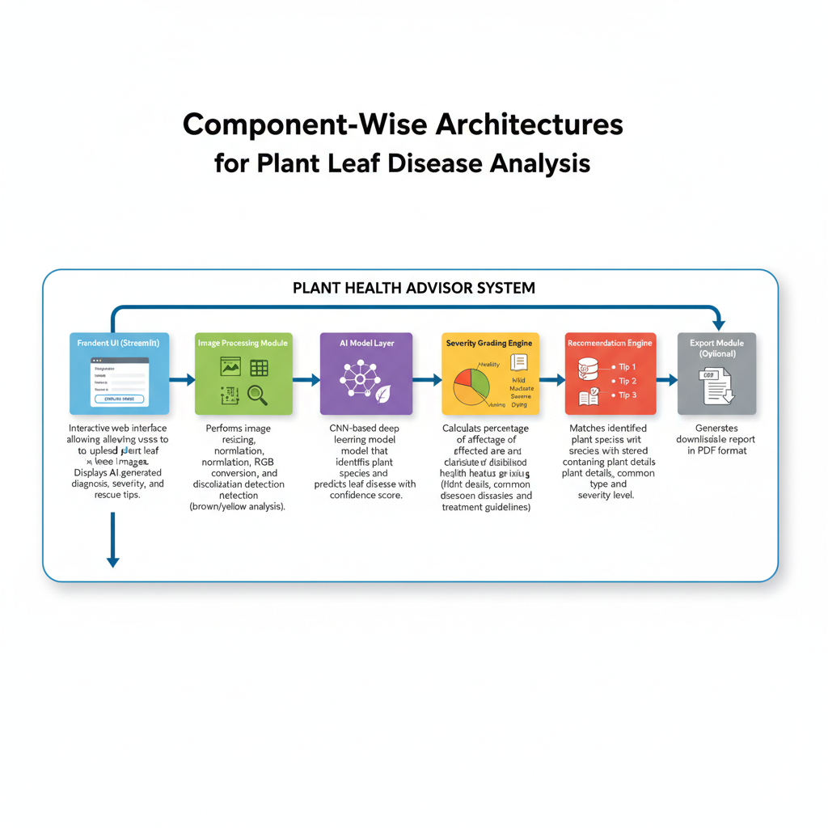
USE CASE SCENARIOS
Scenario 1: Leaf Image Upload and Health Analysis
Users can upload a plant leaf image through the Streamlit interface. The system preprocesses the image by enhancing brightness, resizing it, and removing noise to ensure accurate analysis. The AI model then detects discoloration patterns and predicts whether the leaf is healthy or affected by a disease. The result is displayed along with the severity level and confidence score, enabling users to understand the plant’s health condition effectively.
Scenario 2: Plant Species Identification and Disease Detection
The system matches the uploaded leaf image with a plant species database to identify the plant type. After species identification, it analyzes common diseases associated with that plant and predicts the most probable condition. This plant-specific analysis improves diagnostic accuracy and ensures that disease detection is tailored to the characteristics of the identified species.
Scenario 3: Severity Grading and Rescue Recommendations
Based on the percentage of damaged areas and detected discoloration patterns, the system assigns a severity level ranging from Healthy to Dying. It then generates intelligent rescue tips to guide users in taking immediate corrective actions. These recommendations help in improving plant health and preventing further disease progression, supporting effective plant care and maintenance.

COMPONENT-WISE ARCHITECTURE

Component | Description
Frontend UI (Streamlit) | Interactive web interface allowing users to upload plant leaf images. Displays AI-generated diagnosis, severity grading, and rescue tips.
Image Processing Module | Performs image resizing, normalization, RGB conversion, and discoloration detection (brown/yellow analysis).
AI Model Layer | CNN-based deep learning model that identifies plant species and predicts leaf disease with confidence score.
Severity Grading Engine | Calculates percentage of affected area and classifies health status (Healthy, Mild, Moderate, Severe, Dying).
Species Database Lookup | Matches identified plant species with stored database containing plant details, common diseases, and treatment guidelines.
Recommendation Engine | Generates three personalized rescue tips based on disease type and severity level.
Export Module (Optional) | Generates downloadable health report in PDF format.

SYSTEM WORKFLOW
- User uploads leaf image through Streamlit interface
- Image preprocessing (resize, normalize, noise reduction)
- Discoloration detection (yellow/brown pixel percentage analysis)
- AI model predicts:
  - Plant species
  - Disease class
  - Confidence score
- Severity grading is calculated
- Rescue tips are retrieved from database
- Final diagnosis report is displayed

Severity Grading Logic
- 0–10% Discoloration → Healthy
- 11–30% → Mild
- 31–60% → Moderate
- 61–80% → Severe
- 81–100% → Dying
Severity is calculation Factors:
- Percentage of yellow/brown regions
- Disease probability score
- Leaf texture damage
Output Format
Diagnosis Report
- Plant Name: <Identified Plant>
Disease: <Predicted Disease>
Confidence Score: <Model Accuracy %>
Severity Level: <Health Grade>
- Rescue Tips:
- <Tip 1>
- <Tip 2>
- <Tip 3>

Deployment Architecture (Streamlit Based)
Workflow:
User → Streamlit UI → Image Processing → AI Model → Severity Engine → Recommendation Engine → Output Display
The application can be deployed on:
- Streamlit Cloud
- AWS / Azure
- Local Server

Pre-requisites
- Python 3.8 or above
- Streamlit Framework – for creating the interactive web interface
- TensorFlow / PyTorch
- OpenCV
- Required Libraries (requirements.txt)
Example installation:
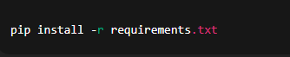
Run the application:
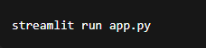

PROJECT WORKFLOW
1. AI Model Setup & Initialization
The first phase involves preparing the deep learning environment and ensuring the AI model can process leaf images accurately. This includes installing Python and required AI libraries, configuring TensorFlow or PyTorch, and downloading the plant leaf disease dataset. GPU or CPU compatibility is verified to ensure smooth model training. A virtual environment is created, required packages are installed via requirements.txt, and model paths along with image preprocessing configurations are set. The detection logic is prepared by designing a discoloration detection algorithm, defining yellow and brown color thresholds, creating plant species classification labels, and testing images.

Activity 1.1: Setup Deep Learning Environment
- Install Python and required AI libraries
- Configure TensorFlow / PyTorch environment
- Download plant leaf disease dataset
- Verify GPU/CPU compatibility for model training

Activity 1.2: Configure Environment and Dependencies
- Create virtual environment
- Install required packages using requirements.txt
- Configure model loading paths
- Setup image preprocessing configurations

Activity 1.3: Prepare Detection Logic
- Design discoloration detection algorithm
- Define yellow and brown color thresholds
- Prepare plant species classification labels
- Test preprocessing with sample leaf images

2. Core Functionality Development

Activity 2.1: Design Streamlit Application Structure
- Create main Streamlit interface (app.py)
- Build modular folder structure
- Implement navigation and layout components
- Configure session state handling

Activity 2.2: Implement Image Upload Module
- Upload JPG/PNG leaf images
- Validate image size and format
- Display preview of uploaded image
- Add loading indicator during analysis

Activity 2.3: Develop AI Prediction Pipeline
- Perform image preprocessing
- Run species identification model
- Detect disease class
- Calculate prediction confidence score

3. Backend Processing Implementation

Activity 3.1: Image Processing Module
- Resize and normalize images
- Convert images to RGB format
- Remove noise using filtering
- Extract discoloration regions using OpenCV

Activity 3.2: Severity Grading Engine
- Calculate percentage of affected pixels
- Apply grading logic:
  - Healthy
  - Mild
  - Moderate
  - Severe
  - Dying
- Combine discoloration + AI prediction results

Activity 3.3: Species Database Integration
- Create plant species database
- Map detected species with diseases
- Store treatment and care information
- Retrieve matching plant details

Activity 3.4: Recommendation Engine
- Generate rescue tips based on disease
- Adjust tips according to severity level
- Ensure minimum three actionable suggestions

4. UI Development (Streamlit)

Activity 4.1: Build Interactive Interface
- Application title and description
- Image upload widget
- Analyze button
- Progress spinner during processing
Activity 4.2: Implement Result Display
- Show detected plant species
- Display disease diagnosis
- Show severity badge
- Display confidence percentage
- Present rescue tips clearly

Activity 4.3: Add Export Functionality (Optional)
- Generate downloadable diagnosis report
- PDF export option
- File naming and download handling

Activity 5.1: Functional Testing
- Test with multiple plant species images
- Validate discoloration detection
- Verify severity grading accuracy
- Check UI responsiveness

Activity 5.2: Model Evaluation
- Measure prediction accuracy
- Validate classification confidence
- Reduce false predictions
- Improve preprocessing quality

Activity 5.3: Performance Optimization
- Optimize image processing speed
- Reduce model loading time
- Improve Streamlit responsiveness
- Handle invalid or low-quality inputs

Activity 5.4: Deployment Readiness
- Prepare requirements.txt
- Configure Streamlit Cloud deployment
- Test application in production environment
- Ensure cross-platform compatibility

MILESTONE 1: Gemini AI Initialization
MILESTONE 1: AI Model Initialization

In this foundational stage, the objective is to establish and configure the core AI infrastructure required for the Leaf Health Check system. The platform utilizes a deep learning–based computer vision model to analyze plant leaf images, detect discoloration patterns, identify plant species, and generate health diagnosis with rescue recommendations.

Activity 1.1: Setup Development Environment and AI Model
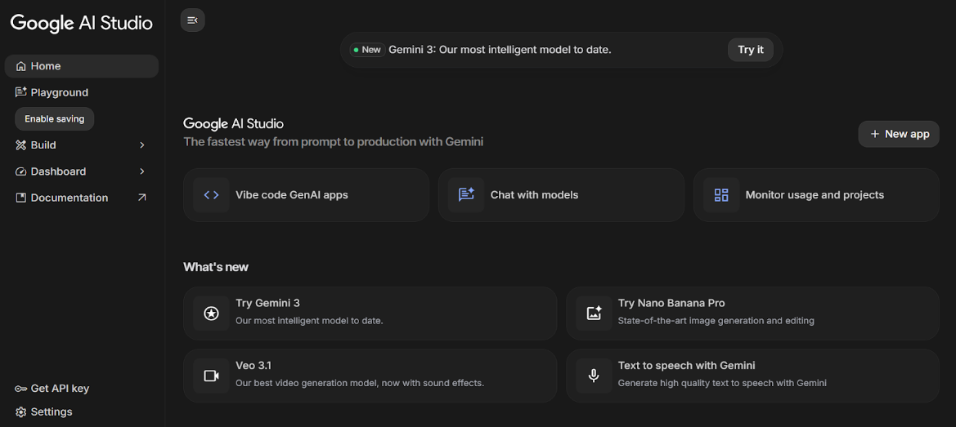
1. Install Required Software
- Install Python (version 3.8 or above)
- Install required IDE (VS Code / PyCharm)
- Setup virtual environment for project isolation

2. Install Required Libraries
3. Prepare AI Model
- Download plant leaf disease dataset
- Configure trained CNN model (TensorFlow/PyTorch)
- Store trained model file inside /model directory
- Verify model loading functionality

Activity 1.2: Configure Environment and Test Setup
1. Create. env File
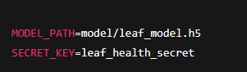
2. Load Environment Variables
Example configuration code:
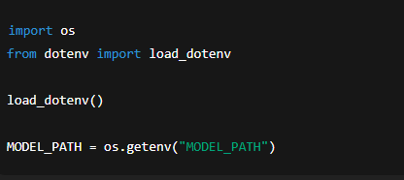
3. Test Model Loading
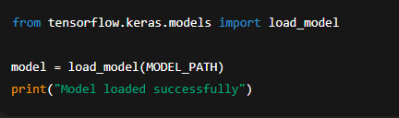
Expected Result:
- Model loads without errors
- Ready for prediction testing
Activity 1.3: Validate Image Processing and Prediction
Test Image Preprocessing
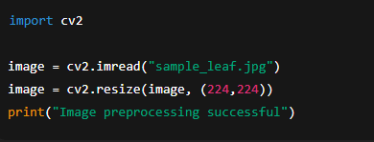

Test Disease Prediction
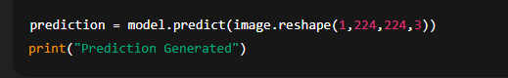
Expected Output:
- Model predicts plant disease class
- Confidence score generated successfully

MILESTONE 2: Core Functionalities Development
This milestone focuses on building the core application using the Streamlit framework integrated with the Google Gemini API. The system accepts plant leaf images, processes visual information, analyzes discoloration patterns, and generates an AI-based diagnosis with severity grading and rescue recommendations.
File Explorer Structure
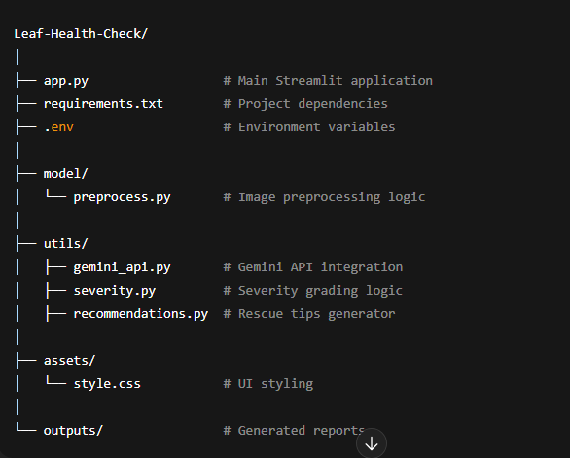

Activity 2.1: Streamlit Initialization and Import Libraries

Import Required Libraries
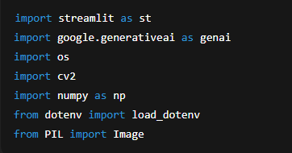

Initialize Environment and Gemini API
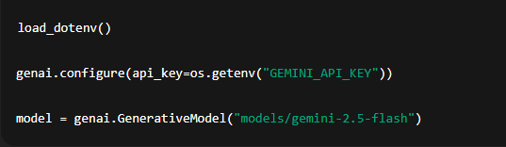

Activity 2.2: Main Functionality – Leaf Analysis Routing

Image Upload Interface
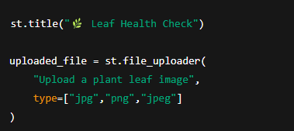

Image Processing
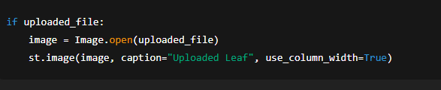

Gemini AI Diagnosis Request
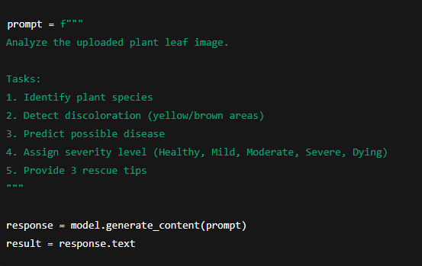
Display Result
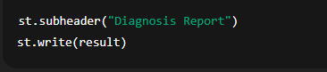

Activity 2.3: Severity Grading Logic
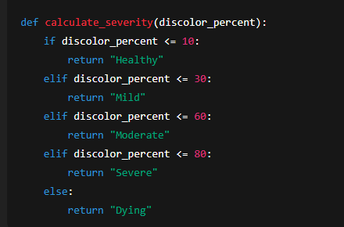

Activity 2.4: Export Functionality

Generate Text Report
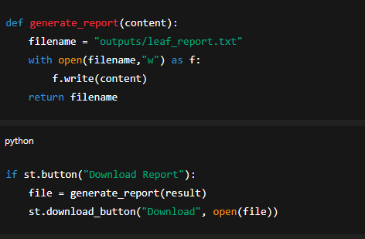

Activity 2.5: Utility Functions

Clean AI Response
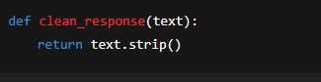

Unique File Generator
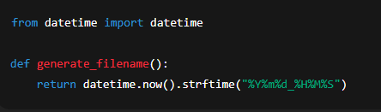

MILESTONE 3: Backend – Streamlit Integration (app.py)
This milestone focuses on implementing the complete backend logic inside the Streamlit application, integrating the Google Gemini AI Studio API, handling image processing, performing diagnosis generation, and enabling export functionality. The system ensures proper validation, structured responses, and smooth interaction between the UI and AI services.
Activity 3.1: Complete Function Definitions
All backend processing is implemented with:
- Input image validation
- Error handling mechanisms
- Gemini API response handling
- Logging and debugging support
- Structured diagnosis output formatting
Image Validation Example
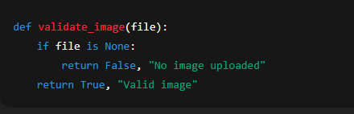

Activity 3.2: Modular Architecture
Main Application Structure
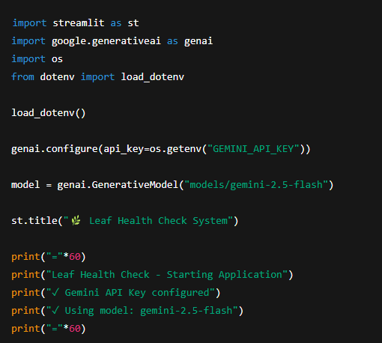
The Streamlit application directly manages:
- User interaction
- AI communication
- Diagnosis generation
- Result visualization
Activity 3.3: Gemini AI Diagnosis Integration
Generate Diagnosis from Image
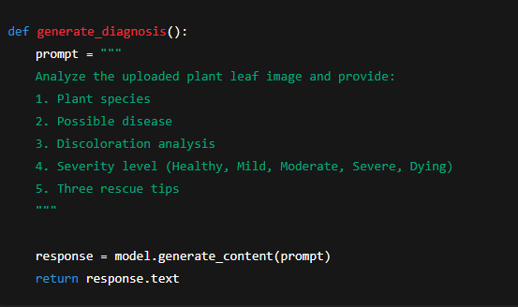
Display AI Response
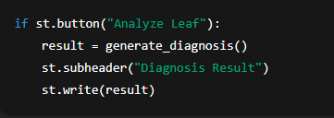
Activity 3.4: Export Implementation
Complete export functionality includes:
- Diagnosis report generation
- Downloadable text/PDF report
- File management and naming
Report Generation
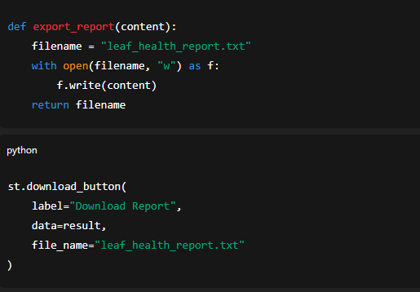
Activity 3.5: Error Handling and Response Formatting
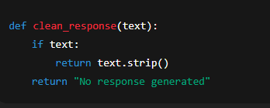

MILESTONE 4: UI Development
This milestone focuses on designing and implementing a user-friendly and responsive interface for the Leaf Health Check application using the Streamlit framework. The UI ensures smooth interaction between the user and the AI system, enabling easy image upload, analysis execution, and result visualization.

Activity 4.1: Home Page Development
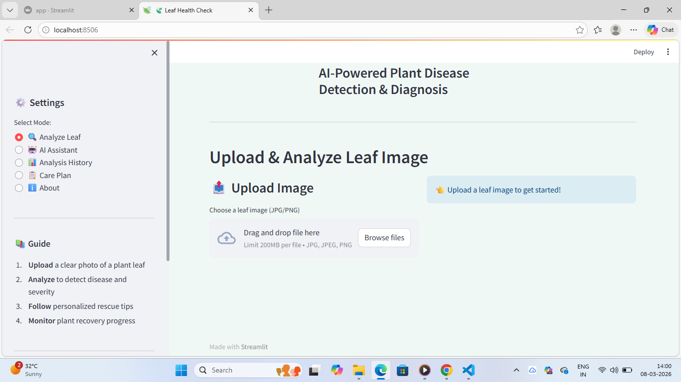
The home page acts as the primary interface for user interaction and provides clear guidance on how to use the application.
Home Page Features:
- Application title and description
- Leaf image upload section
- Supported image format information
- Analyze button for triggering diagnosis
- Clean and responsive layout
UI Design Considerations:
- Simple and minimal design
- Clear instructions for users
- Responsive layout across screen sizes
- Intuitive navigation flow

Activity 4.2: Leaf Analysis Page
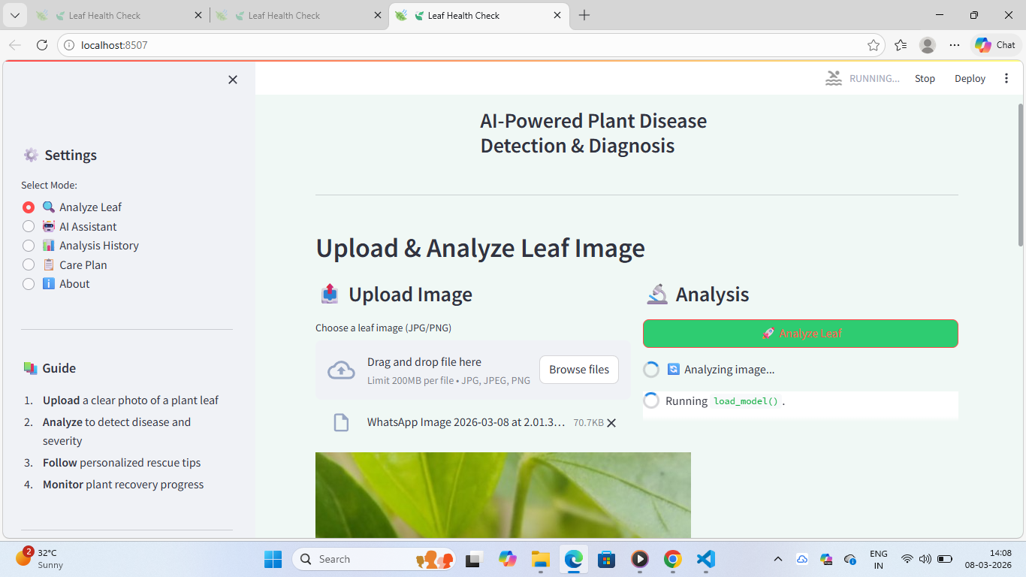
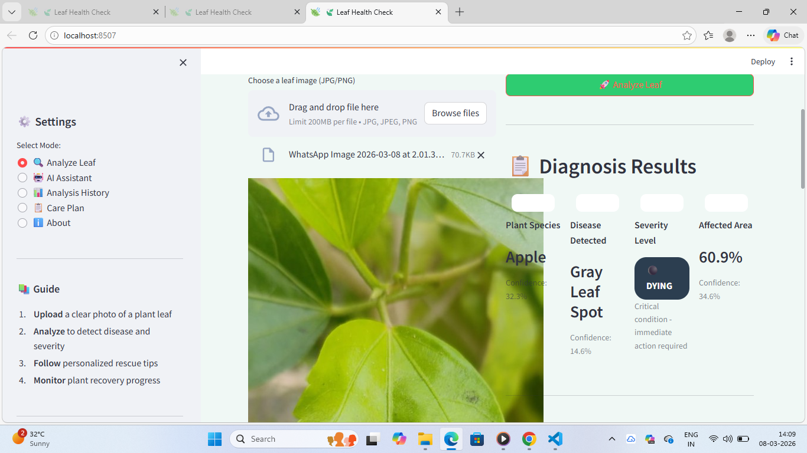
This section handles user input and displays AI-generated results after analysis.
Features Implemented:
- Image preview after upload
- Loading spinner during analysis
- Gemini AI diagnosis display
- Plant species identification
- Disease detection result
- Severity grading badge
Severity Levels Displayed:
- Healthy
- Mild
- Moderate
- Severe
- Dying
Activity 4.3: Rescue Recommendation Display
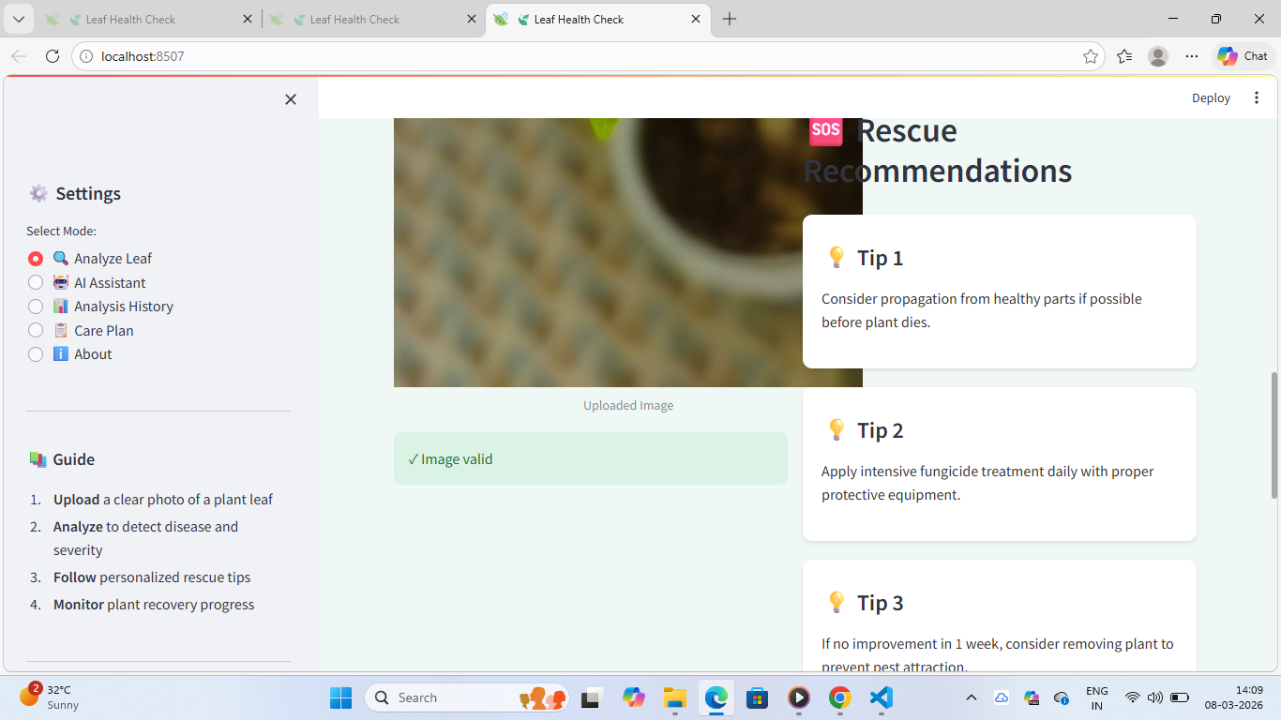
After diagnosis, the system presents actionable rescue recommendations to help users treat the affected plant.
Rescue Tips Section Includes:
- Three personalized rescue tips
- Tips based on disease type and severity
- Easy-to-read bullet format
- Practical and actionable suggestions
Activity 4.4: Result Export Option
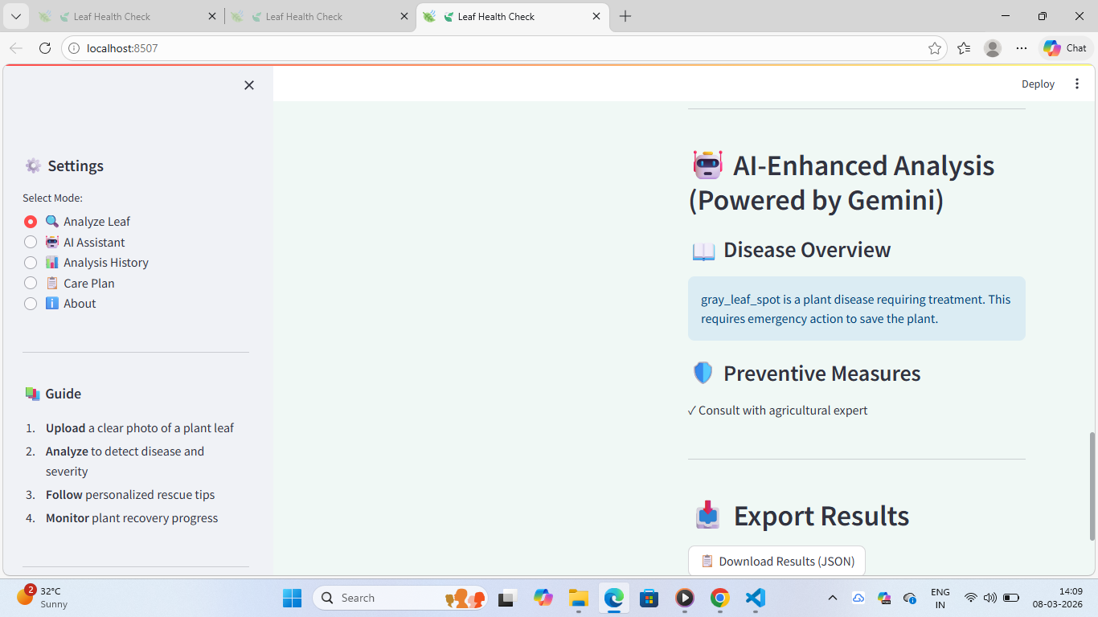

To enhance usability, the UI provides an option to download the diagnosis report.
Export Features:
- Download diagnosis as a text/PDF report
- Automatically generated report name
- Includes plant name, disease, severity, and tips
Activity 4.5: Error Handling and User Feedback
Proper feedback mechanisms are integrated to improve user experience.
Handled Scenarios:
- Invalid image format
- No image uploaded
- AI response failure
- Low-quality image warning
Feedback Methods:
- Warning messages
- Error alerts
- Success notifications

MILESTONE 5: Testing & Optimization
This milestone focuses on comprehensive testing, quality evaluation, and performance optimization of the Leaf Health Check application to ensure accuracy, reliability, and smooth user experience. Multiple test scenarios were executed to validate image analysis, AI diagnosis, severity grading, and rescue recommendations.

Activity 5.1: Comprehensive Testing

Test Scenarios
1. Leaf Image Analysis
- Input Type: Plant leaf images
- Formats Tested: JPG, PNG, JPEG
- Conditions: Healthy, diseased, partially damaged leaves
- Expected Output: Accurate diagnosis with severity grading and rescue tips
Test Cases Executed:
- Healthy green leaf image
- Yellowing leaf image
- Brown spot infected leaf
- Severely damaged leaf image
- Low-quality and blurred images

2. Discoloration Detection
- Colors Tested: Yellow, brown, black
- Severity Levels Verified: Healthy, Mild, Moderate, Severe, Dying
- Expected Result: Correct severity classification based on affected area

3. Gemini AI Diagnosis Testing
- API Used: Gemini AI Studio API Key
- Model Tested: Gemini Vision Model
- Expected Output:
  - Plant species identification
  - Disease prediction
  - Confidence-based severity grading
  - Three actionable rescue tips

4. Error Handling Scenarios
- No image uploaded
- Unsupported image format
- Corrupted image file
- API response delay or failure
Expected Behavior:
- User-friendly error messages
- Graceful failure handling
- No application crash

Activity 5.2: Quality Evaluation

The output quality of the system was evaluated using the following metrics:
- Diagnosis Accuracy
- Severity Classification Correctness
- Relevance of Rescue Tips
- Response Consistency
- User Interface Clarity
- Report Export Quality
Each test output was manually reviewed to ensure logical correctness and practical usefulness.

Activity 5.3: Performance Optimization

Improvements Made
- Faster image preprocessing using optimized resizing
- Reduced Gemini API response latency
- Improved input validation logic
- Optimized Streamlit layout rendering
- Added loading indicators for better user feedback
- Reduced unnecessary re-computation using session state

Activity 5.4: Final Validation

After optimization, the system was re-tested to confirm:
- Stable application performance
- Accurate AI predictions
- Correct severity grading
- Smooth UI interaction
- Successful report downloads
CONCLUSION
The Leaf Health Check project successfully demonstrates the application of AI-powered image analysis to assist in early plant disease detection and health assessment. By integrating the Streamlit framework with Google Gemini AI Studio, the system efficiently analyzes plant leaf images to identify possible diseases, detect discoloration patterns, determine severity levels, and provide actionable rescue recommendations.
The application processes user-uploaded leaf images in real time, leveraging Gemini’s advanced vision and reasoning capabilities to generate accurate and meaningful diagnosis reports. The intuitive and responsive Streamlit interface ensures ease of use, allowing users to quickly upload images, view analysis results, and download reports without technical complexity. The system emphasizes reliability, usability, and performance through structured testing, optimization, and effective error handling.
Overall, Leaf Health Check serves as a smart digital assistant for farmers, gardeners, and agricultural enthusiasts by enabling timely plant health assessment and informed decision-making. The project highlights the potential of AI-driven solutions in modern agriculture and lays a strong foundation for future enhancements such as multi-crop support, real-time camera integration, and advanced disease prediction models, contributing to sustainable and technology-driven farming practices.

