***ODD OR EVEN***

***AIM****: To find whether the given number is even or odd using 8085 processor.*

***ALGORITHM:***

1. *Load the accumulator with the first data.*
2. *Perform AND operation with 01 on first data using ANI instruction.*
3. *Check if zero flag is set then set the value of accumulator to 6 otherwise 5 to accumulator.*
4. *Now load the result value in memory location.*

***INPUT:***

*FOR EVEN* 

*FOR ODD* 

***OUTPUT:***

*FOR EVEN* 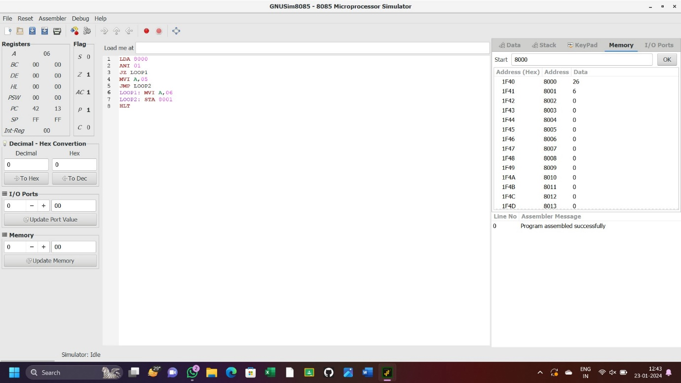

*FOR ODD* 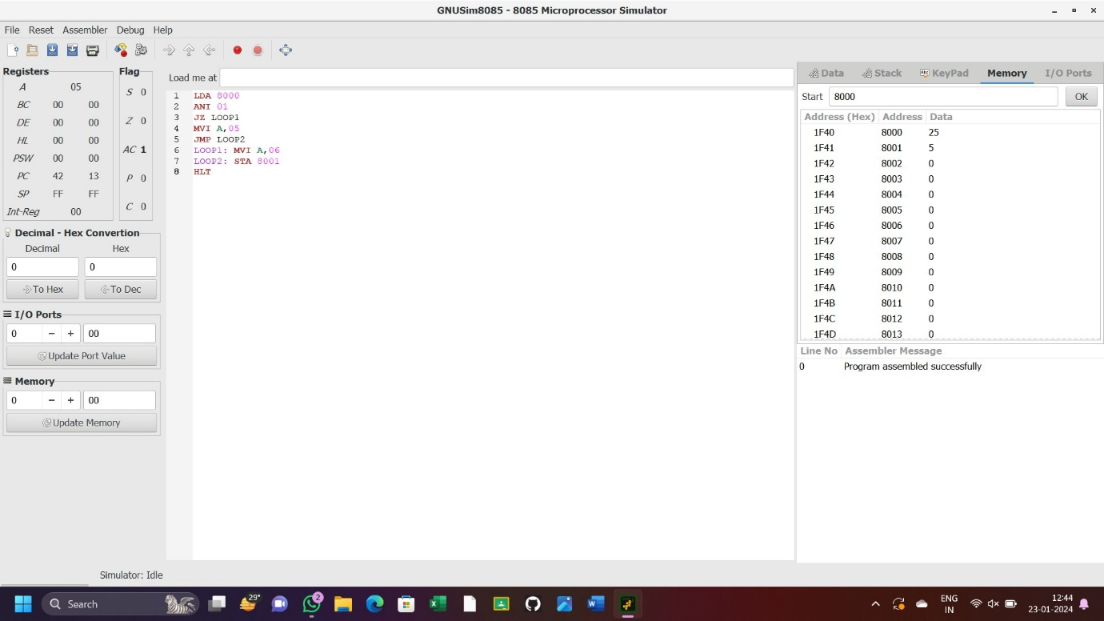

***RESULT: Thus the program was executed successfully using 8085 processor.***