DHARSHINI.S 241901026

EX NO:4 DATE: 19/08/2025

**Develop a customized ping command to test the server connectivity:**

Aim:

The goal of the customized ping program is to test server connectivity by sending multiple

&quot;ping&quot; requests to a server and measuring the Round Trip Time (RTT) for each request. The

program will calculate and display the minimum, maximum, and average RTT for the server

connection.

Algorithm:

1. Initialize Parameters:

o Set the target server address (host), port number (port), and number of ping

requests (count).

2. Send Ping Requests:

o For each ping request (repeat count times):

1. Create a socket to connect to the server.

2. Record the time before the connection attempt (start).

3. Attempt to connect to the server at the specified host and port.

4. If the connection is successful:

▪ Record the time after the connection (end).

▪ Calculate the Round Trip Time (RTT) as the difference (end -

start).

▪ Store the RTT for later analysis.

5. If the connection fails (timeout or error), print &quot;Request timed out.&quot;

3. Calculate RTT Statistics:

o Once all pings are completed:

▪ Calculate the minimum, maximum, and average RTT from the stored

RTT values.

2. Display Results:

o Print each individual RTT for each ping.

o Print the minimum, maximum, and average RTT values.

Code:

import socket

import time

host = &quot;google.com&quot; # you can change this

port = 80 # HTTP port

count = 4 # number of pings

for i in range(count):

try:

s = socket.socket()

start = time.time()

s.connect((host, port))

end = time.time()

s.close()

print(f&quot;Reply from {host}: time={(end-start)*1000:.2f} ms&quot;)

except Exception:

print(&quot;Request timed out&quot;)

Customized Ping Program to Measure Min, Max, and Average RTT

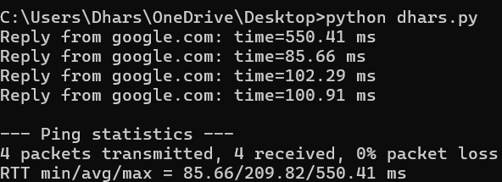

**Customized Ping Program to Measure Min, Max, and Average RTT**

Aim:

The aim of the Customized Ping Program is to measure the Round Trip Time (RTT) between the client

and a target server (in this case, google.com on port 80), and then calculate the minimum, maximum,

and average RTT from multiple ping attempts.

Algorithm:

1. Initialize Parameters:

o Set the target server (host = &quot;google.com&quot;) and port (port = 80).

o Define the number of ping attempts (count = 4).

o Create a list times to store the RTTs for each successful ping.

2. Ping the Server:

o Repeat the process count times (4 pings in this case):

1. Create a socket connection to the target server (host, port).

2. Record the time before initiating the connection (start).

3. Attempt to connect to the server.

4. If the connection is successful:

▪ Record the time after the connection (end).

▪ Calculate the RTT as (end - start) * 1000 (convert to

milliseconds).

▪ Store the calculated RTT in the times list.

▪ Print the RTT for this particular ping.

5. If the connection fails (due to timeout or other exceptions), print &quot;Request

timed out&quot;.

3. Calculate RTT Statistics:

o After all ping attempts, if any successful pings are recorded in the times list:

▪ Minimum RTT: The smallest value in times.

▪ Maximum RTT: The largest value in times.

▪ Average RTT: The average of all values in times.

2. Display Results:

o Print the minimum, maximum, and average RTT based on the data collected in

the times list.

Code:

import socket, time

host = &quot;google.com&quot;

port = 80

count = 4

times = []

for i in range(count):

try:

s = socket.socket()

start = time.time()

s.connect((host, port))

end = time.time()

s.close()

rtt = (end - start) * 1000

times.append(rtt)

print(f&quot;Reply from {host}: time={rtt:.2f} ms&quot;)

except:

print(&quot;Request timed out&quot;)

if times:

print(&quot;\nMin RTT =&quot;, min(times), &quot;ms&quot;)

print(&quot;Max RTT =&quot;, max(times), &quot;ms&quot;)

print(&quot;Avg RTT =&quot;, sum(times)/len(times), &quot;ms&quot;)

**RESULT:**

The program pings the server multiple times and displays the minimum, maximum, and average

Round Trip Time (RTT) in milliseconds for the successful connections.