DHARSHINI.S 241901026

EX NO.5 DATE: 01/09/2025

**PACKET SNIFFING USING RAW SOCKETS**

**AIM:**

To capture and display Ethernet frame details (Destination MAC, Source MAC, and Protocol) from

network traffic using raw sockets.

Algorithm:

1. Create a raw socket to capture all incoming network packets.

2. Enable promiscuous mode to capture all frames, not just those directed to the machine.

3. Unpack the Ethernet frame to extract Destination MAC, Source MAC, and Protocol.

4. Continuously print the extracted details.

CODE:

import socket

import struct

import binascii

import textwrap

def main():

# Get host

host = socket.gethostbyname(socket.gethostname())

print(&#39;IP: {}&#39;.format(host))

# Create a raw socket and bind it

conn = socket.socket(socket.AF_INET, socket.SOCK_RAW,

socket.IPPROTO_IP)

conn.bind((host, 0))

# Include IP headers

conn.setsockopt(socket.IPPROTO_IP, socket.IP_HDRINCL, 1)

# Enable promiscuous mode

conn.ioctl(socket.SIO_RCVALL, socket.RCVALL_ON)

while True:

# Recive data

raw_data, addr = conn.recvfrom(65536)

# Unpack data

dest_mac, src_mac, eth_proto, data = ethernet_frame(raw_data)

print(&#39;\nEthernet Frame:&#39;)

print(&quot;Destination MAC: {}&quot;.format(dest_mac))

print(&quot;Source MAC: {}&quot;.format(src_mac))

print(&quot;Protocol: {}&quot;.format(eth_proto))

# Unpack ethernet frame

def ethernet_frame(data):

dest_mac, src_mac, proto = struct.unpack(&#39;!6s6s2s&#39;, data[:14])

return get_mac_addr(dest_mac), get_mac_addr(src_mac),

get_protocol(proto), data[14:]

# Return formatted MAC address AA:BB:CC:DD:EE:FF

def get_mac_addr(bytes_addr):

bytes_str = map(&#39;{:02x}&#39;.format, bytes_addr)

mac_address = &#39;:&#39;.join(bytes_str).upper()

return mac_address

# Return formatted protocol ABCD

def get_protocol(bytes_proto):

bytes_str = map(&#39;{:02x}&#39;.format, bytes_proto)

protocol = &#39;&#39;.join(bytes_str).upper()

return protocol

main()

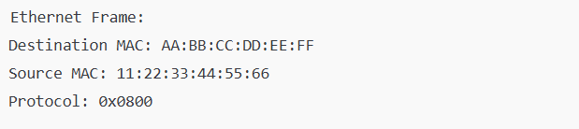

**RESULT:**

The program continuously prints the Destination MAC, Source MAC, and Protocol

of each captured Ethernet frame, running indefinitely until manually stopped.