DHARSHINI.S 241901026

EX NO.7 DATE:23/09/2025

**ANONYMOUS FTP**

**Aim:**

Check whether an FTP server allows anonymous login and, if successful, print the server

welcome message and directory listing.

Algorithm:

1. Accept the target hostname.

2. Create an ftplib.FTP connection to the host.

3. Attempt to login using the credentials user=&#39;anonymous&#39; and passwd=&#39;anonymous&#39;.

4. If login response indicates success (230 Anonymous access granted):

o Print success message, the server welcome text, and call ftp.dir() to list the

directory.

5. If any exception occurs or login fails, print the error and a failure message.

6. Close/exit when done (implicit on program end).

CODE:

import ftplib

def anonymousLogin(hostname):

    try:

        ftp = ftplib.FTP(hostname)

        response = ftp.login(&#39;anonymous&#39;, &#39;anonymous&#39;)

        print(response)

        if &quot;230 Anonymous access granted&quot; in response:

            print(&#39;\n[*] &#39; + str(hostname) +&#39; FTP Anonymous Login Succeeded.&#39;)

            print(ftp.getwelcome())

            ftp.dir()

    except Exception as e:

        print(str(e))

        print(&#39;\n[-] &#39; + str(hostname) +&#39; FTP Anonymous Login Failed.&#39;)

hostname = &#39;ftp.be.debian.org&#39;

anonymousLogin(hostname)

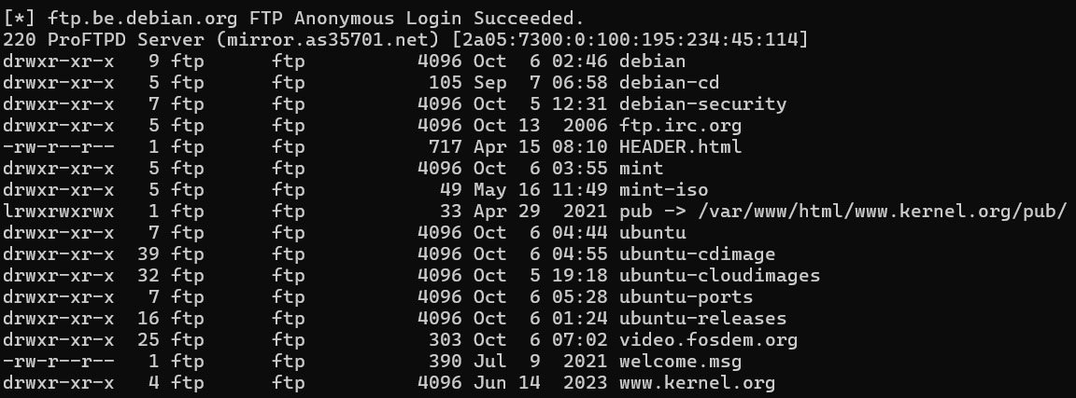

Result :

On success: prints the FTP server response (e.g. 230 Anonymous access granted), a success

notice like

[*] ftp.be.debian.org FTP Anonymous Login Succeeded., the welcome/banner, and the

server directory listing.

• On failure (or exception): prints the exception text and a failure notice like

[-] ftp.be.debian.org FTP Anonymous Login Failed.