DHARSHINI S 241901026
Exp no: 11

Simple Topology in Cisco Packet Tracer

AIM:
To design and configure a simple network topology in Cisco Packet Tracer consisting of one router, two switches and six PCs (three PCs on each LAN). Configure IP addressing and default gateways so hosts on different LANs can communicate via the router. Verify connectivity using ping.

INTRODUCTION:
This lab demonstrates basic network setup and inter-VLAN (inter-LAN) routing using a single router and two layer-2 switches. Each switch connects a small LAN (subnet) of PCs. The router’s two Gigabit Ethernet interfaces act as gateways for the two subnets and forward traffic between them. Packet Tracer is used to physically place devices, cable them, assign IP addresses, configure router interfaces, and verify end-to-end connectivity.
Topology summary (as in attached image):
- Router: 2911 with GigabitEthernet0/1 (left) and GigabitEthernet0/2 (right).
- Left switch: Switch0 connects PC0, PC1, PC2 (LAN1).
- Right switch: Switch1 connects PC3, PC4, PC5 (LAN2).
- LAN1 network: 10.0.0.0 with mask 255.0.0.0 (hosts: 10.0.0.1, 10.0.0.2, 10.0.0.3).
- LAN2 network: 192.168.1.0/24 (hosts: 192.168.1.1, 192.168.1.2, 192.168.1.3).
Note: The addressing above follows the labels in your image. Router interface addresses used below are chosen to be the gateways for each LAN (router IPs .254), so host IPs shown in the image remain valid.
STEP-BY-STEP ALGORITHM / CONFIGURATION PROCEDURE
1. Place devices & cable them (Packet Tracer GUI)
- Open Packet Tracer. Add devices: 1 Router (2911), 2 Switches (2960), 6 PCs.
- Position them to match the image (router at top center, switches left & right, PCs under each switch).
- Connect using Copper Straight-through cables:
  - Router GigabitEthernet0/1 → Switch0 (left).
  - Router GigabitEthernet0/2 → Switch1 (right).
  - PC0 → Switch0 (Fa0/1), PC1 → Switch0 (Fa0/2), PC2 → Switch0 (Fa0/3).
  - PC3 → Switch1 (Fa0/1), PC4 → Switch1 (Fa0/2), PC5 → Switch1 (Fa0/3).
2. Assign IP addresses to PCs (use PC GUI → Desktop → IP Configuration)
Use the IPs shown in the image and the router gateway addresses below:
LAN1 (Left switch) — network 10.0.0.0 255.0.0.0
- PC0: IP 10.0.0.1 Subnet mask 255.0.0.0 Default gateway 10.0.0.254
- PC1: IP 10.0.0.2 Subnet mask 255.0.0.0 Default gateway 10.0.0.254
- PC2: IP 10.0.0.3 Subnet mask 255.0.0.0 Default gateway 10.0.0.254
LAN2 (Right switch) — network 192.168.1.0/24
- PC3: IP 192.168.1.1 Subnet mask 255.255.255.0 Default gateway 192.168.1.254
- PC4: IP 192.168.1.2 Subnet mask 255.255.255.0 Default gateway 192.168.1.254
- PC5: IP 192.168.1.3 Subnet mask 255.255.255.0 Default gateway 192.168.1.254
Save the PC configurations.
3. Configure router interfaces (Router CLI)
Open the router CLI and enter configuration mode. Use the following commands (copy-paste into Packet Tracer CLI):
Router> enable
Router# configure terminal

! Configure left LAN (connects to Switch0)
Router(config)# interface GigabitEthernet0/1
Router(config-if)# description To_Switch0_LAN1
Router(config-if)# ip address 10.0.0.254 255.0.0.0
Router(config-if)# no shutdown
Router(config-if)# exit

! Configure right LAN (connects to Switch1)
Router(config)# interface GigabitEthernet0/2
Router(config-if)# description To_Switch1_LAN2
Router(config-if)# ip address 192.168.1.254 255.255.255.0
Router(config-if)# no shutdown
Router(config-if)# exit

Router(config)# exit
Router# copy running-config startup-config
Confirm interfaces are up/up with show ip interface brief.
4. (Optional) Basic switch setup (optional — switches work L2 by default)
If you want to set a management IP on each switch (for remote mgmt from your PC), do this:
On Switch0:
Switch> enable
Switch# configure terminal
Switch(config)# interface vlan 1
Switch(config-if)# ip address 10.0.0.253 255.0.0.0
Switch(config-if)# no shutdown
Switch(config)# ip default-gateway 10.0.0.254
Switch# copy running-config startup-config
On Switch1:
Switch> enable
Switch# configure terminal
Switch(config)# interface vlan 1
Switch(config-if)# ip address 192.168.1.253 255.255.255.0
Switch(config-if)# no shutdown
Switch(config)# ip default-gateway 192.168.1.254
Switch# copy running-config startup-config
This step is optional for the lab — switches will forward traffic without management IPs.

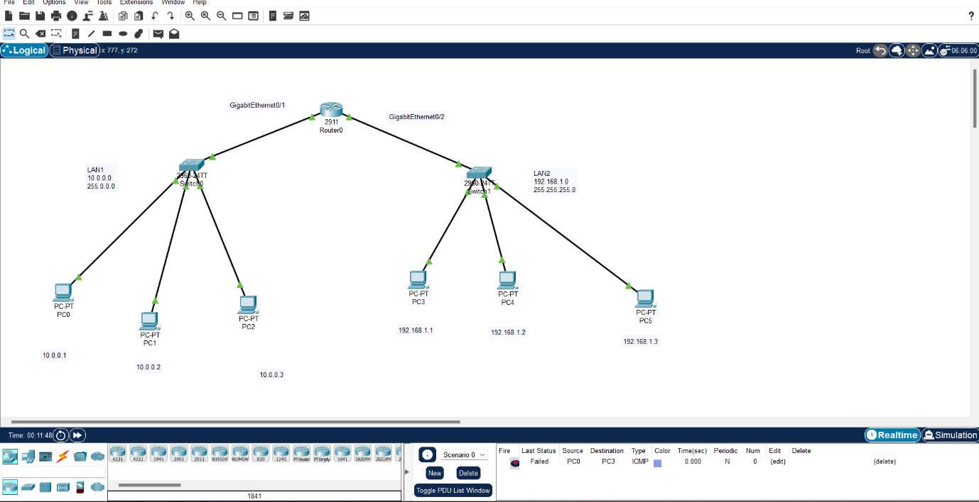

5. Verify connectivity (tests to perform)
- From each PC: Ping its own gateway:
  - e.g., from PC0 ping 10.0.0.254 → should reply.
- Test intra-LAN ping: PC0 → PC1 (10.0.0.2) should reply.
- Test inter-LAN ping (router routing): PC0 → PC3 (192.168.1.1) should reply.
- On the router, verify routing and interfaces:
  - show ip interface brief
  - show running-config
- Optional: from PC3 ping PC5 etc., ensure all PCs on LAN2 can reach each other and LAN1 hosts.
6. Troubleshooting checklist
- If ping fails: check PC IP/mask/gateway, check router interface ip and no shutdown, ensure cables are connected and ports show up in Packet Tracer.
- Use show ip route on router (should show directly connected networks 10.0.0.0/8 and 192.168.1.0/24).
- Use ipconfig/ifconfig equivalent in PC Desktop → Command Prompt to confirm settings in Packet Tracer.
TOPOLOGY:
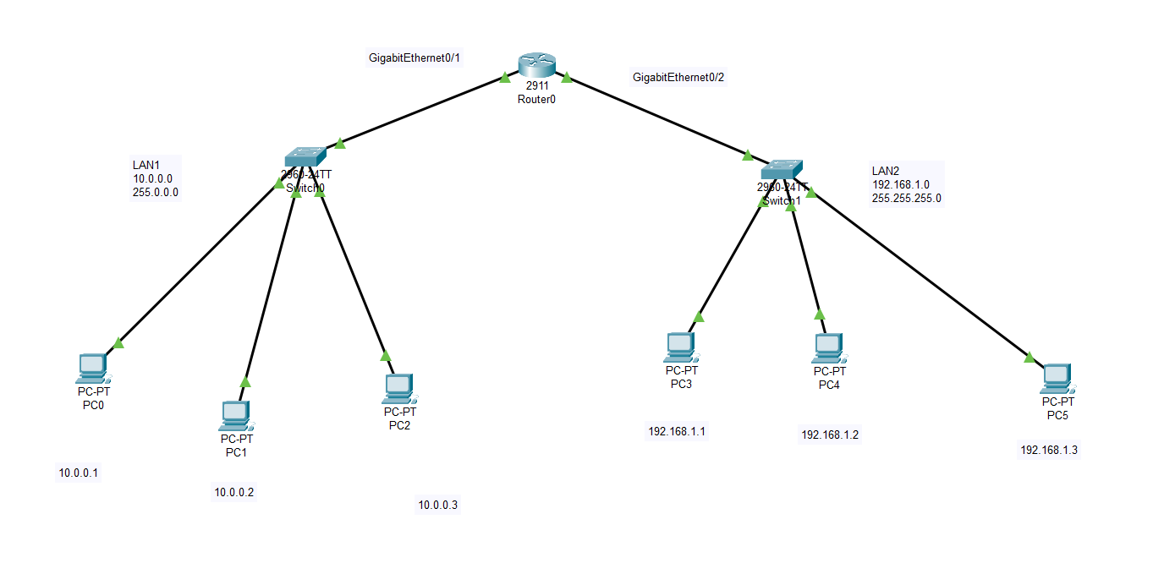

OUTPUT (status):
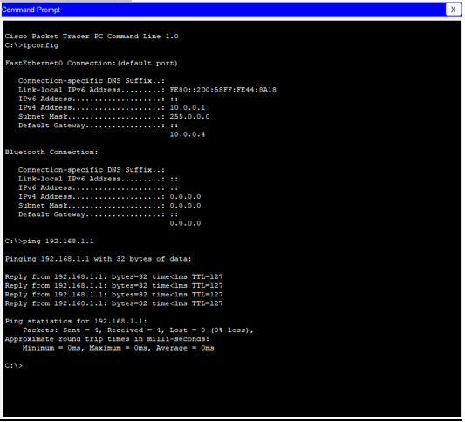
RESULT: The simple topology with one router, two switches and six PCs was successfully implemented in Cisco Packet Tracer. All router interfaces were configured and brought up; PCs were assigned IP addresses and default gateways. Verification tests succeeded:
- Each PC could reach its gateway.
- Hosts in the same LAN could reach each other.
- Hosts in different LANs could communicate via the router (inter-LAN ping succeeded).

