DHARSHINI.S 241901026
Exp no: 11

Examine Network Address Translation (NAT) using Cisco Packet Tracer

AIM
To configure and verify Network Address Translation (NAT) on a Cisco router in Packet Tracer so that hosts on a private LAN can access a host on the “public” network (server) using PAT (NAT overload).

INTRODUCTION:
NAT (Network Address Translation) maps private IP addresses used inside a LAN to public IP addresses used on the outside network. NAT solves IPv4 address scarcity and also provides a simple form of address hiding. The common modes are:
- Static NAT — one-to-one mapping between internal and external IPs.
- Dynamic NAT — internal addresses are mapped from a pool of public addresses.
- PAT (Port Address Translation / NAT overload) — many internal addresses share a single public IP using different source ports.
In this lab topology (attached image) three internal PCs (PC0, PC1, PC2) are on LAN via Switch0. Router connects the LAN to the outside network via Switch1 and a Server (acts as an Internet host). We implement PAT so internal PCs can reach the Server using the router’s external IP.

TOPOLOGY & ADDRESSING (example used for commands)
Use these addresses (you can adapt to the addresses shown in your Packet Tracer file):
LAN (inside): 10.0.0.0/24
- PC0 = 10.0.0.10/24 (GW 10.0.0.1)
- PC1 = 10.0.0.11/24
- PC2 = 10.0.0.12/24
Router (R0):
- Gi0/0 (to Switch0 / LAN) = 10.0.0.1/24 ← inside
- Gi0/1 (to Switch1 / Server) = 203.0.113.1/24 ← outside
Server (public): 203.0.113.10/24 (default-gateway 203.0.113.1)
Note: 203.0.113.0/24 is a TEST/EXAMPLE public block (RFC 5737). In labs you may use any unused public-looking range.
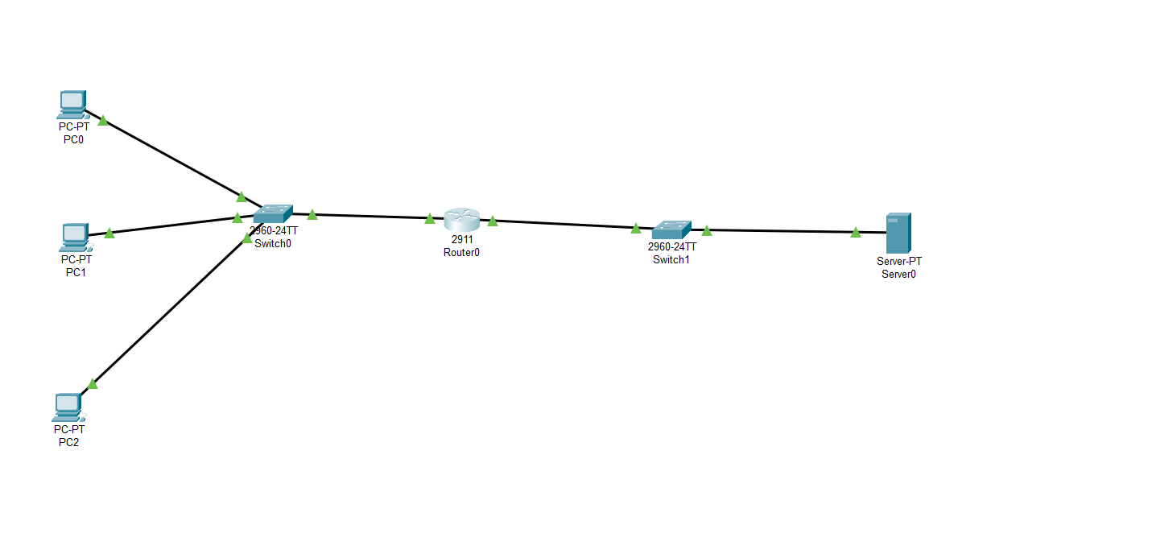

ALGORITHM:

A — Cable and basic device setup
- Connect PCs to Switch0 and set PC IPs (Desktop → IP Configuration). Set default gateway to 10.0.0.1.
- Connect Switch0 to router Gi0/0. Connect router Gi0/1 to Switch1 and connect Server to Switch1. Assign Server IP 203.0.113.10 /24 and gateway 203.0.113.1.
B — Configure router interfaces (CLI)
Open router CLI and enter:
Router> enable
Router# configure terminal
C — Configure NAT (PAT / NAT overload)
- Create an ACL to match inside addresses to be translated (standard ACL matches source IPs):
Router# configure terminal
Router(config)# access-list 1 permit 10.0.0.0 0.0.0.255
- Configure NAT overload using the router’s outside interface IP:
Router(config)# ip nat inside source list 1 interface GigabitEthernet0/1 overload
- Mark interfaces as ip nat inside / ip nat outside:
D — (Optional) Static NAT for inbound mapping
If you want the server to initiate connections to a particular internal host (rare in PAT), set a static mapping:
Router(config)# ip nat inside source static tcp 10.0.0.10 22 203.0.113.2 2222
This maps public 203.0.113.2:2222 to 10.0.0.10:22. (Only if needed.)
E — Verify & Test
- From a PC (PC0): ping 203.0.113.10 (the server). Expect replies.
- On router verify NAT translations:
Router# show ip nat translations
Pro Inside global Inside local Outside local Outside global
tcp 203.0.113.1:33333 10.0.0.10:12345 203.0.113.10:80 203.0.113.10:80
- Inspect NAT statistics:
Router# show ip nat statistics
- Test connecting from multiple PCs concurrently — PAT should let many internal hosts share 203.0.113.1.
- Check server logs (if any) to see source IPs — server should see source IP 203.0.113.1 (with different source ports) unless you used static NAT.
F — Troubleshooting checklist
- If pings fail: verify PC IP/mask/gateway, router interfaces up (show ip interface brief), cables/links up (green), ACL matches network, and ip nat applied to correct interfaces.
- Ensure server gateway is 203.0.113.1 (router) so replies return to router.
- Use debug ip nat (lab only) for live troubleshooting — be careful on real devices.

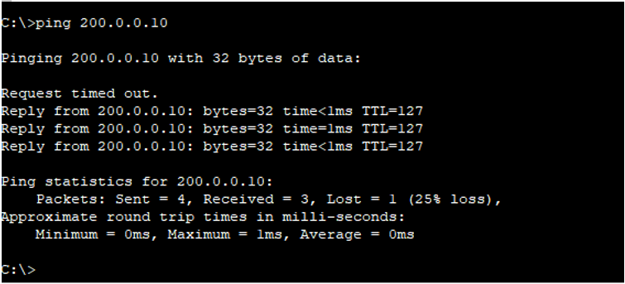
VERIFICATION COMMANDS (use on Router)
- show ip nat translations — shows active NAT mappings.
- show ip nat statistics — NAT counters and pool info.
- show ip interface brief — check interface status.
- show running-config — confirm ip nat and ACL lines.
On PCs: ping <server IP>, tracert <server IP> (Windows) / traceroute (Unix).

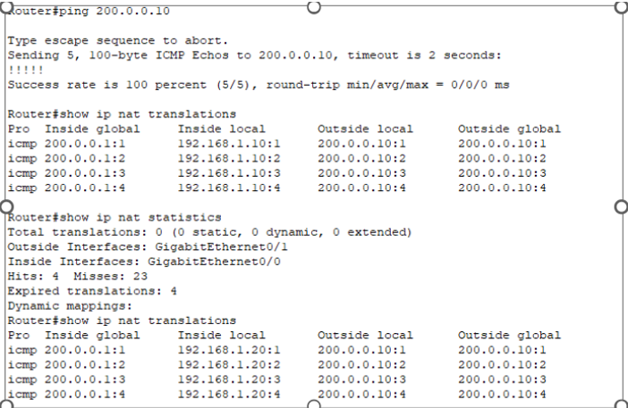
RESULT:
- Router interfaces were assigned 10.0.0.1/24 (inside) and 203.0.113.1/24 (outside).
- ACL was configured to match the internal network. PAT was enabled with ip nat inside source list 1 interface GigabitEthernet0/1 overload.
- From PC0 (10.0.0.10), ping 203.0.113.10 succeeded — server replies were received.
- show ip nat translations displayed dynamic PAT entries mapping 10.0.0.x:port → 203.0.113.1:port.
- Multiple internal hosts could simultaneously access the server using the single public IP (PAT working).
- The server observed connections coming from 203.0.113.1 (the router’s external IP), confirming source translation.

