DHARSHINI.S 241901026
EX NO:3 DATE:19/08/2025
UDP STUDY OF SOCKET PROGAMMING IN PYTHON
AIM:
To study the concepts of socket programming in python.
DESCRIPTION:
INTRODUCTION:
In networks, the services provided to the user follow the traditional client/server
model. One computer acts as a server to provide a certain service and another computer
represents the client side which makes use of this service. In order to communicate over
the network a network socket comes into play, mostly only referred to as a socket.
SOCKET DEFINITION:
A network socket is an endpoint of a two-way communication link between two
programs or processes - client and server in our case - which are running on the network.
This can be on the same computer as well as on different systems which are connected
via the network. Both client/server communicate with each other by writing to or reading
from the network socket. The technical equivalent in reality is a telephone
number of the telephone line, or a contract in case of cell phones.
SOCKET PROGRAMMING IN PYTHON:
Python's core networking library is Socket Module.
Python's socket module has both class-based and instances-based methods.
Class-based method is an intuitive approach which doesn't need an instance of a
socket object.
For example, in order to print a machine's IP address, you don't need a socket
object. Instead, just call the socket's class-based methods.
In instance-based method, if some data needed to be sent to a server application,
it is more intuitive to create a socket object to perform that explicit operation.
This module has everything you need to build socket servers and clients.
ALOGRITHM:
Server Algorithm:
- Initialize Socket:
  - Create a socket using TCP/IP protocol (SOCK_STREAM) and IPv4 addressing (AF_INET).
- Bind the Socket:
  - Bind the server socket to a specific address (localhost) and port number (e.g., 55555).
- Listen for Connections:
  - Set the server socket to listen for incoming connections from clients. Specify the backlog queue size (e.g., 3).
- Accept Client Connections:
  - Wait for a client to connect. Once a client connects, accept the connection, which returns a new socket (clientfd) for communication and the address of the client.
- Receive Data from Client:
  - Receive the message from the client socket, decode it from bytes to a string.
Process and Respond:
  - (Optional) Process the received message as needed (e.g., echo the message back).

  - Send the response (or echoed message) back to the client via the same socket.
- Check for Continuation:
  - Ask the server operator if they want to continue accepting more clients or shut down the server.
- Close Connection:
  - After responding to the client, close the individual client connection.
  - If the server is to stop, break out of the loop and close the server socket.

Client Algorithm:
- Initialize Socket:
  - Create a socket using TCP/IP protocol (SOCK_STREAM) and IPv4 addressing (AF_INET).
- Connect to the Server:
  - rnumber (e.g., 55555).
- Send Data to Server:
  - Accept user input (the message to send) and convert it to bytes.
  - Send the message to the server via the established socket connection.
- Receive Server Response:
  - Wait for a response from the server. This will typically be the same message that was sent (in the case of an echo server).
- Display Response:
  - Decode the received message from bytes to string and display it to the user.
- Close the Connection:
  - Once the response is received and displayed, closed.
Code:
import socket
sockfd=socket.socket(socket.AF_INET, socket.SOCK_STREAM)
print('Socket Created')
sockfd.bind(('localhost',55555))
sockfd.listen(3)
print('Waiting for connections')
while True:
clientfd,addr=sockfd.accept()
receivedMsg=clientfd.recv(1024).decode()
print("Connected with ",addr)
print("Message Received from Client: ",receivedMsg)
clientfd.send(bytes(receivedMsg,'utf-8'))
print("Message reply sent to Client!")
print("Do you want to continue(type y or n):")
choice=input()
if choice=='n':
break

import socket
clientfd=socket.socket(socket.AF_INET, socket.SOCK_STREAM)
clientfd.connect(('localhost',55555))
name=input("Enter your message:")
clientfd.send(bytes(name,'utf-8'))
print("Message Received from Server: ",clientfd.recv(1024).decode())

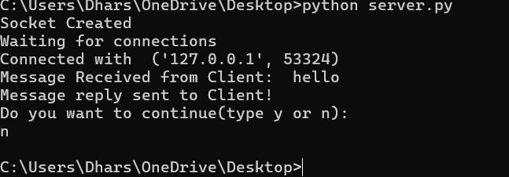
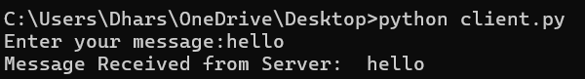

Result:
The server echoes the client's message back after receiving it, and the client displays the server's echoed response.

