Dharshini. S 241901026
Ex.No: 8 Date:2/9/25
NMAP LIVE HOST DISCOVERY Aim: To use Nmap to discover live hosts using ARP scan, ICMP scan, and TCP/UDP ping scan in TryHackMe platform. Introduction: Nmap is a network scanning tool that finds hosts, open ports, and services.

Task 1: Introduction
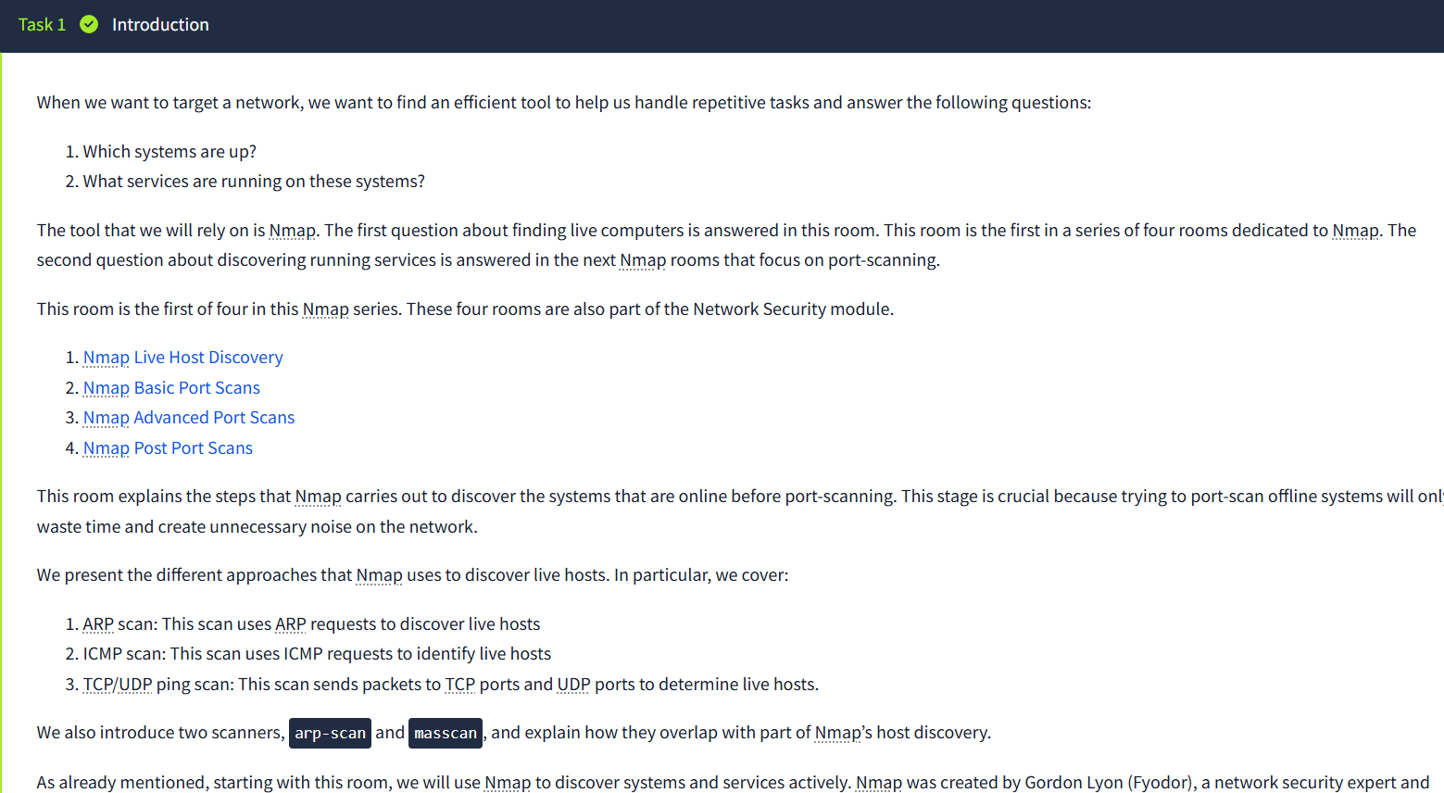
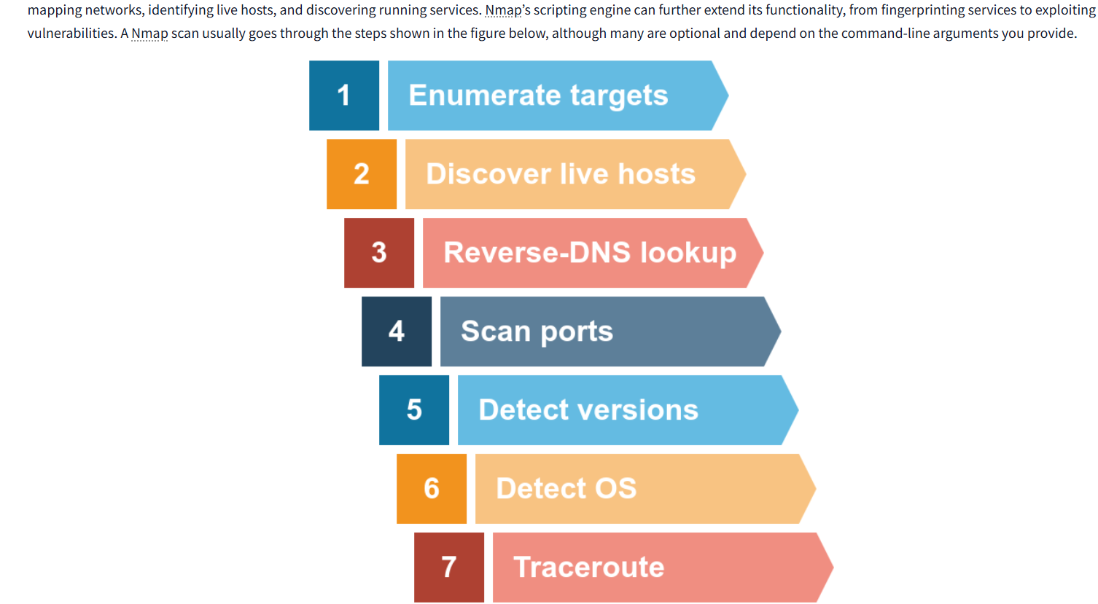
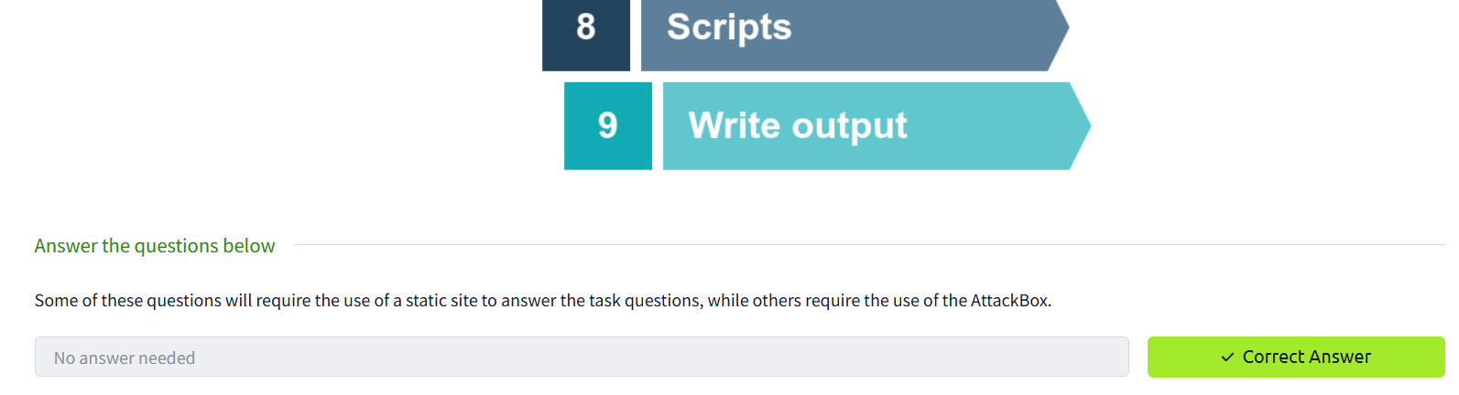
Task 2: Subnetworks
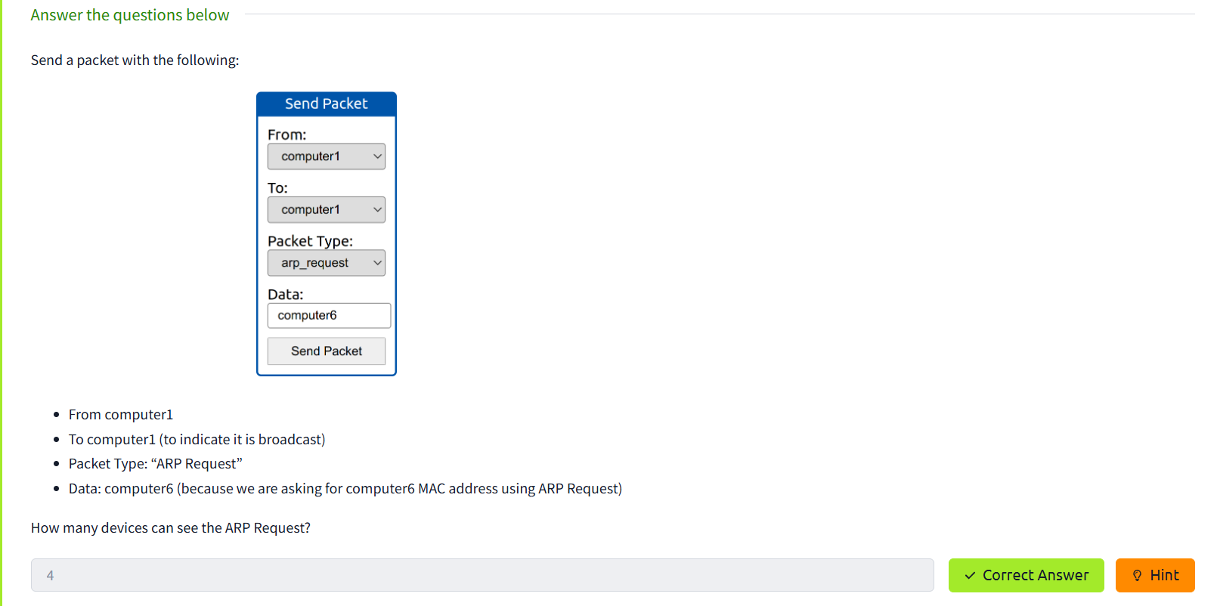
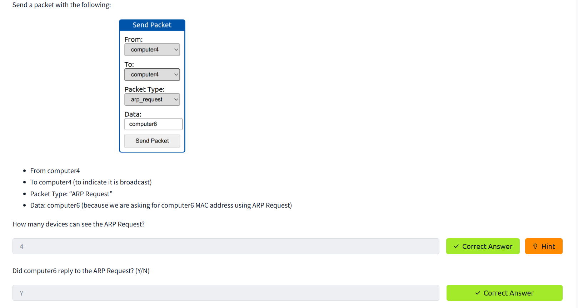
Task 3: Enumerating Targets
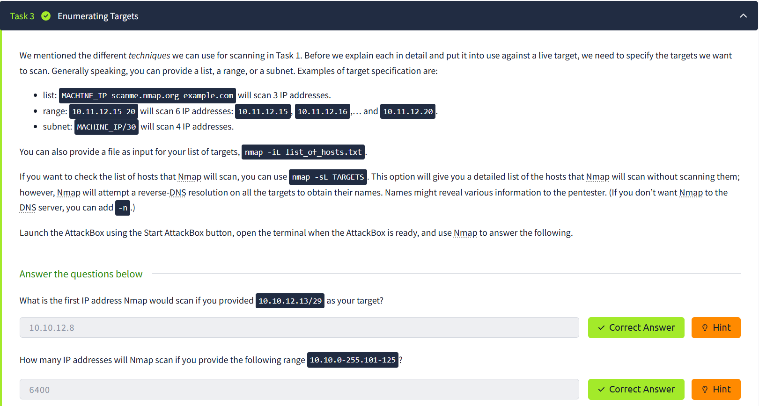
Task 4: Discovering Live Hosts
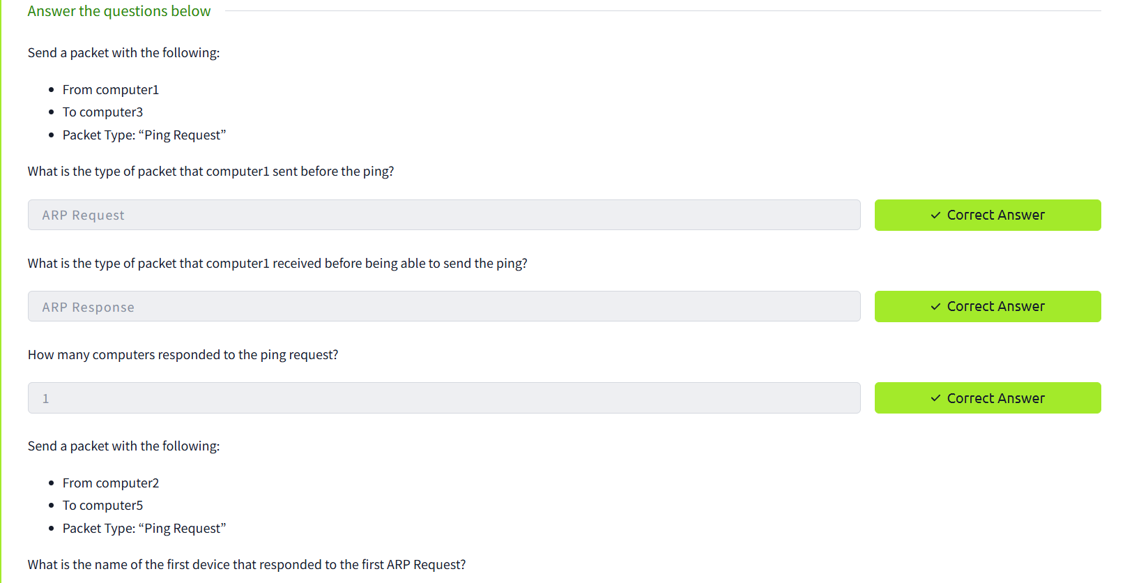
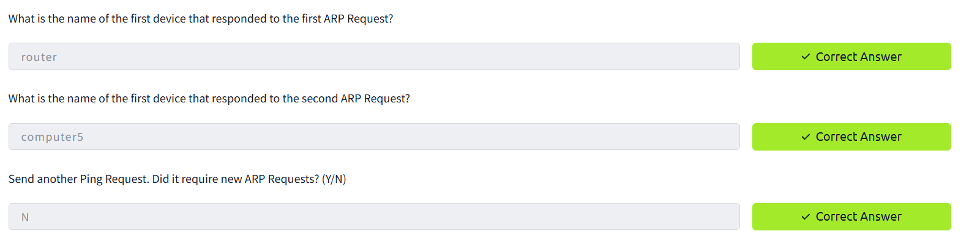
Task 5: Nmap Host Discovery Using ARP
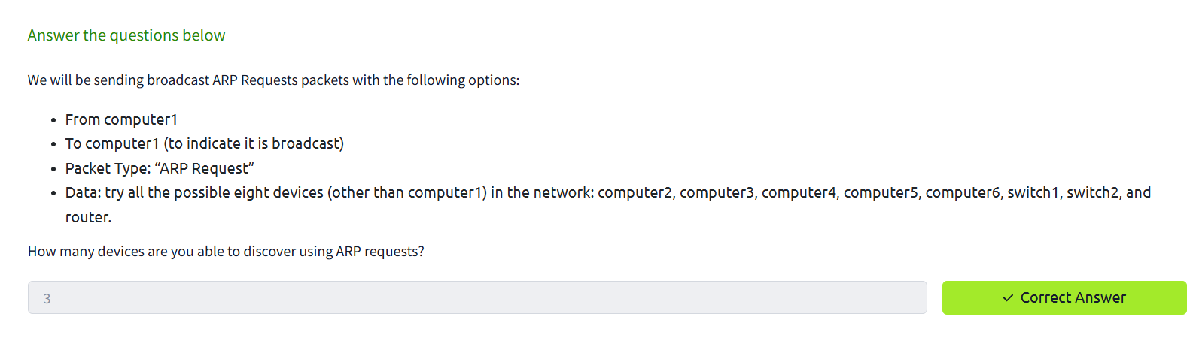
Task 7: Nmap Host Discovery Using TCP and UDP
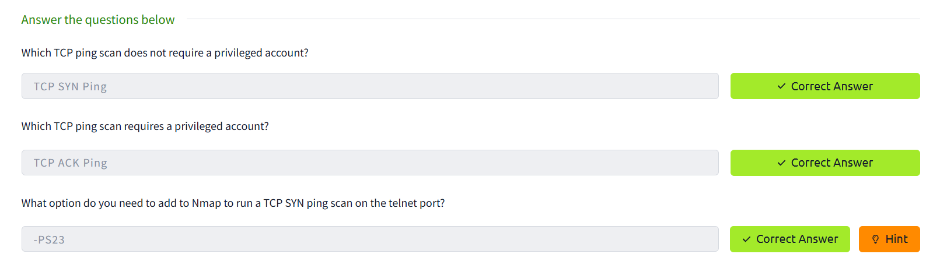
Task 8: Using Reverse-DNS Lookup
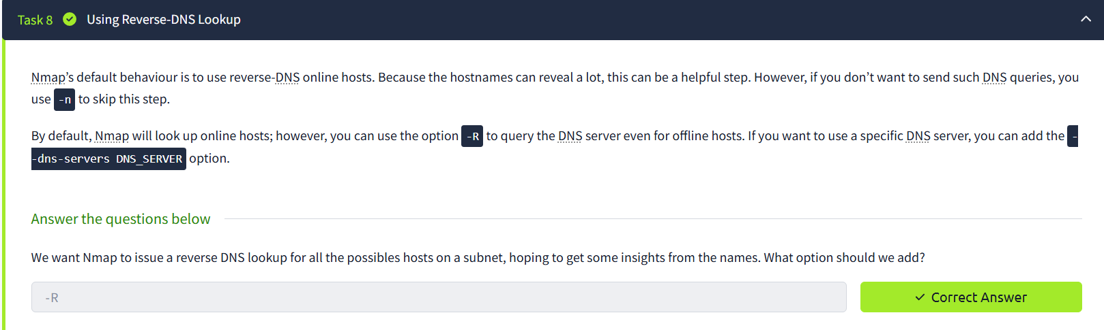
Summary:
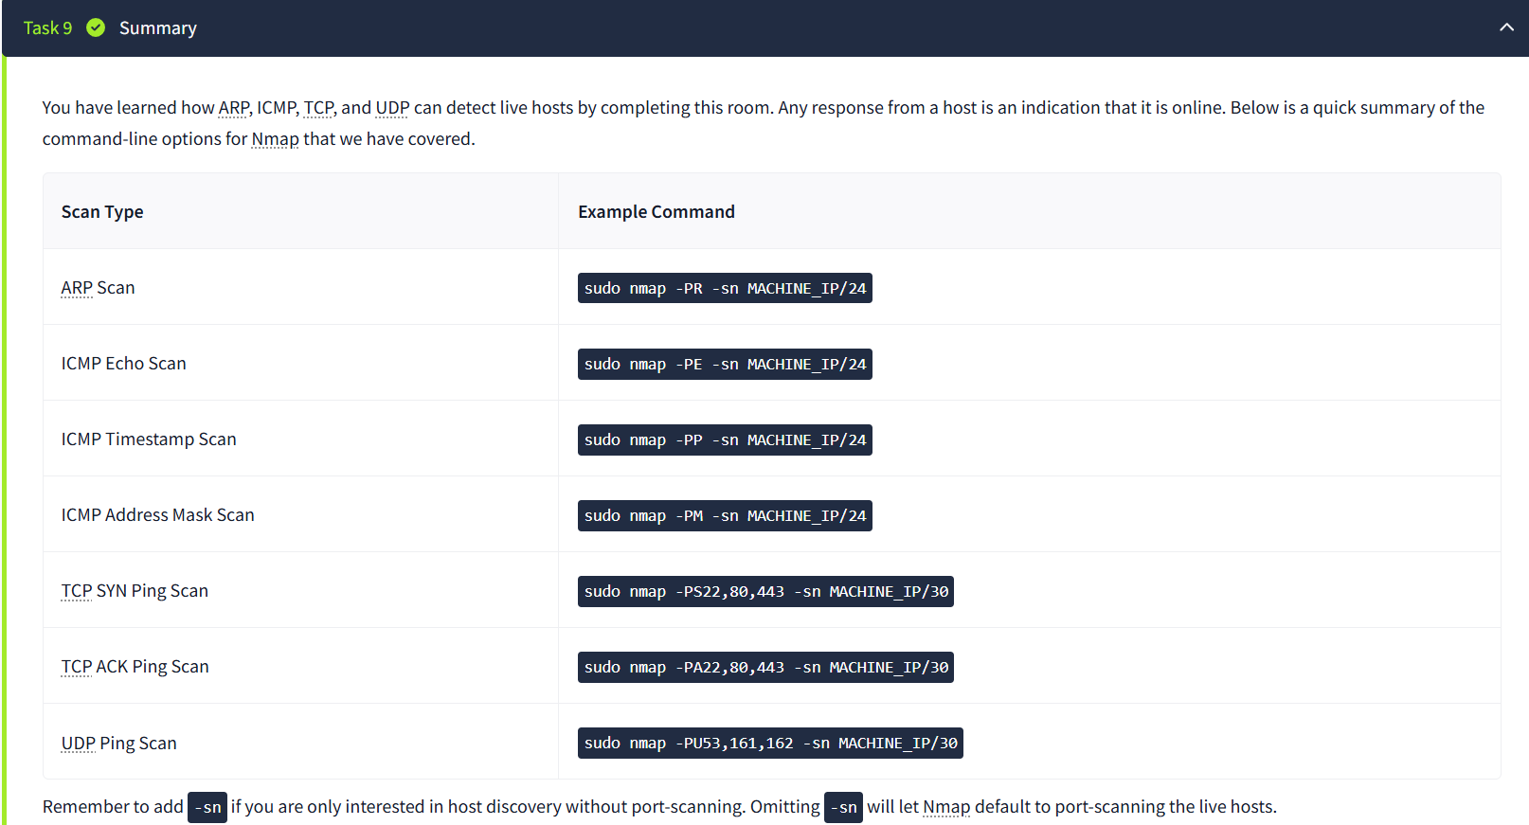
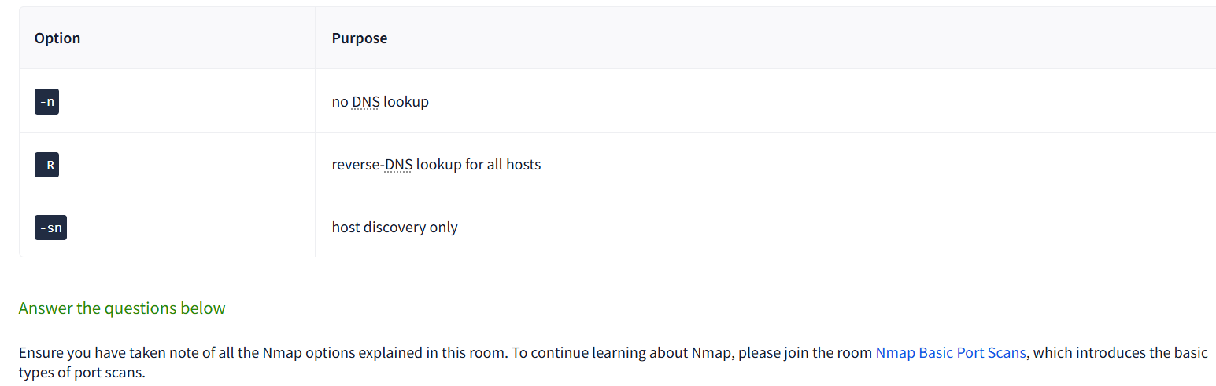
Result:
Thus Nmap was used to discover live hosts using ARP scan, ICMP scan, and TCP/UDP ping scan in TryHackMe platform.

