DHARSHINI S 241901026
Exp no: 10

Customize Switch with Network Modules using Cisco Packet Tracer

AIM:
To install and configure the HWIC-4ESW switch module in a Cisco router in Packet Tracer, connect two PCs in the same subnet, and verify L2 connectivity (ping) between the PCs.

INTRODUCTION:
Many Cisco routers support modular network interface cards (HWIC, WIC, etc.). The HWIC-4ESW is a 4-port Ethernet switch module that provides built-in L2 switching ports on a router. When inserted, those ports behave like switch ports on the same VLAN (L2), allowing connected hosts to communicate without the router performing IP routing. This lab demonstrates insertion of the module (Packet Tracer), cabling PCs into module ports, assigning IPs in the same subnet, and verifying connectivity.
Note: Because both PCs are in the same VLAN/subnet, the router does not route traffic between them — the HWIC module handles L2 switching.

TOPOLOGY :

Router: 2911 or similar with an HWIC-4ESW module installed.
- PC2 — connected to one HWIC port — IP 192.168.1.2/24
- PC3 — connected to another HWIC port — IP 192.168.1.3/24
- Both PCs in same subnet 192.168.1.0/24.

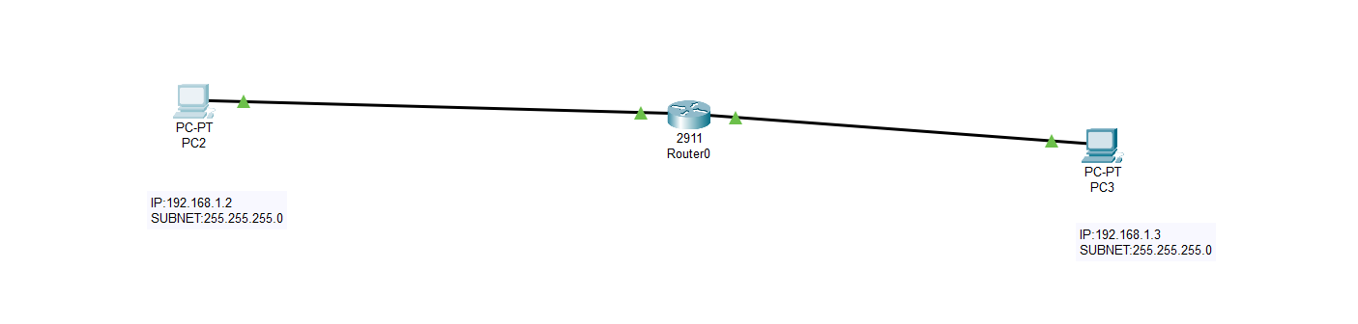

STEP-BY-STEP ALGORITHM / CONFIGURATION:
A. Insert HWIC-4ESW module in Packet Tracer (physical view)
- Open Packet Tracer and place the router (e.g., 2911).
- Click the router → go to the Physical tab.
- If router power is ON, turn it OFF (power switch) before changing modules.
- In the module slots, click a free HWIC slot and choose HWIC-4ESW from the available modules list. Drag/drop to insert.
- Turn the router power ON. Wait a few seconds for module initialization.
- Switch back to the Desktop or Logical workspace.
B. Cable devices
- Use Copper Straight-through cables to connect the PCs to the router’s HWIC ports (these ports appear as HWIC0/0, HWIC0/1 etc or as GigabitEthernet/FastEthernet physical ports depending on Packet Tracer).
  - PC2 → Router (HWIC port 1)
  - PC3 → Router (HWIC port 2)
C. Configure PC IP addresses (PC GUI → Desktop → IP Configuration)
- PC2
  - IP: 192.168.1.2
  - Mask: 255.255.255.0
  - Default gateway: optional (not needed for same-subnet pings; use router IP if you want), e.g., 192.168.1.254 if you assign that to a router SVI later.
- PC3
  - IP: 192.168.1.3
  - Mask: 255.255.255.0
  - Default gateway: same as above if desired.
In this lab, you can omit the gateway since both hosts talk L2. Add a gateway only if you plan to reach other subnets.
D. (Optional) Configure a management IP on the router (if you want router SVI)
If you want the router to have an IP in that subnet (for management), configure a subinterface or use an SVI-like interface if supported. Example (router CLI):
Router> enable
Router# configure terminal
! assign an IP to the physical interface or SVI if required
Router(config)# interface GigabitEthernet0/1
Router(config-if)# ip address 192.168.1.254 255.255.255.0
Router(config-if)# no shutdown
Router(config-if)# exit
Router# copy running-config startup-config
If you used the HWIC module ports, the router may show the module ports as FastEthernet0/1 etc. Check show ip interface brief to find the correct interface name.
E. Verify link status and addressing
- On Packet Tracer, confirm the interface LEDs (green triangles) for the connected ports.
- On the router (CLI):
  - show ip interface brief — verify interfaces are up and the management IP (if configured) is present.
  - show running-config — check interface configuration.
F. Test connectivity (PCs)
- On PC2 (Desktop → Command Prompt): ping 192.168.1.3
- On PC3: ping 192.168.1.2
- Observe replies. Successful replies indicate L2 forwarding by the HWIC-4ESW module (no routing required).
G. Troubleshooting checklist
- If ping fails: verify cable type and physical connection, check PC IP/mask, ensure interfaces are up on router/module (show ip interface brief), and confirm module was inserted properly and router was rebooted after insertion.

Output (status):

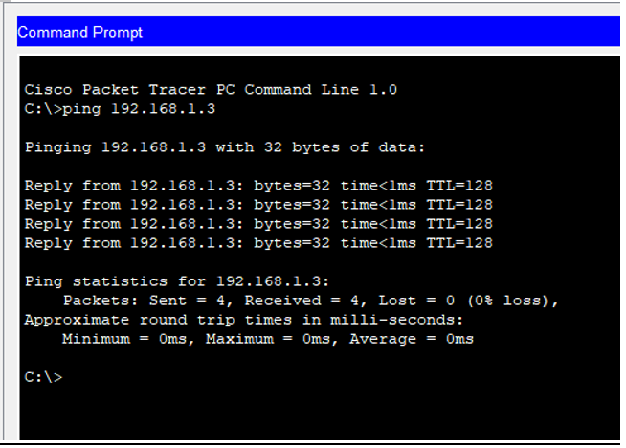

RESULT:

- The HWIC-4ESW module was successfully installed into the router in Packet Tracer.
- Both PCs were configured in the same subnet: 192.168.1.2/24 and 192.168.1.3/24.
- PC2 ↔ PC3 ping succeeded (ICMP replies received). Connectivity OK — L2 switching by HWIC module worked.
- No routing configuration was required because both devices are in the same VLAN/subnet.
The setup demonstrates how a router with a switch module can provide local L2 connectivity for hosts on the same subnet

