Dharshini. S 241901026

Ex.No: 6 Date:2/9/25

**NMAP LIVE HOST DISCOVERY Aim: To use Nmap to discover live hosts using ARP scan, ICMP scan, and TCP/UDP ping scan in TryHackMe platform. Introduction: Nmap is a network scanning tool that finds hosts, open ports, and services.**

**Task 1: Introduction**

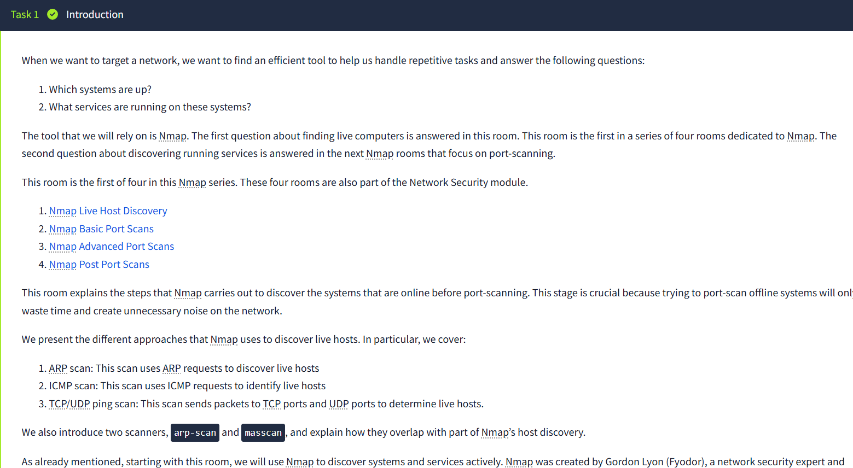

**Task 2: Subnetworks**

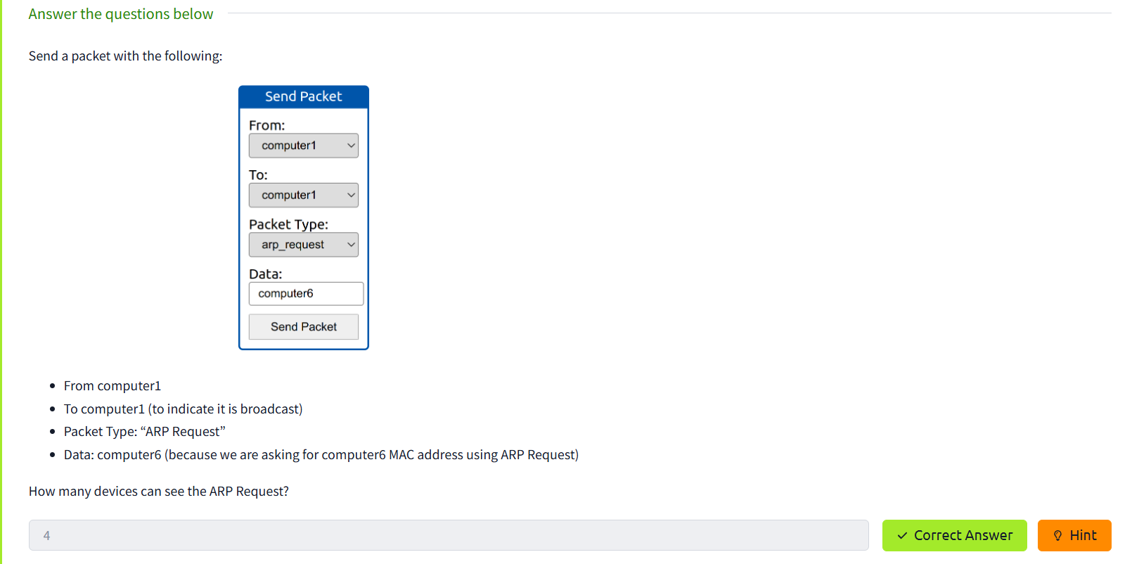

**Task 3: Enumerating Targets**

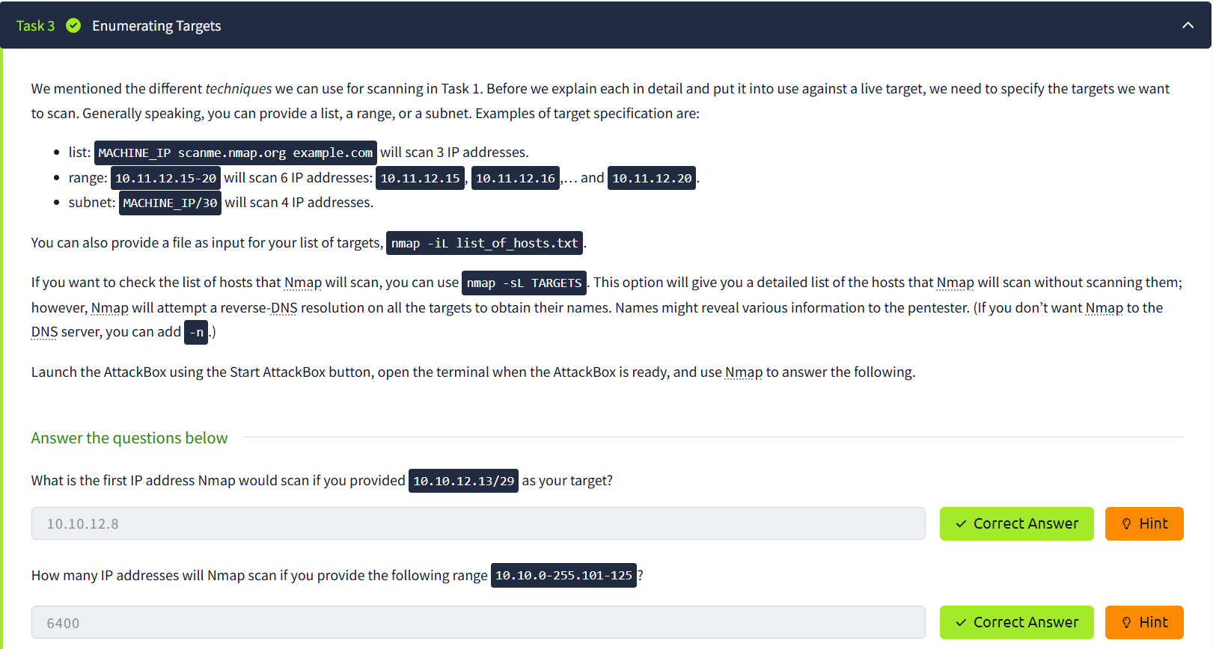

**Task 4: Discovering Live Hosts**

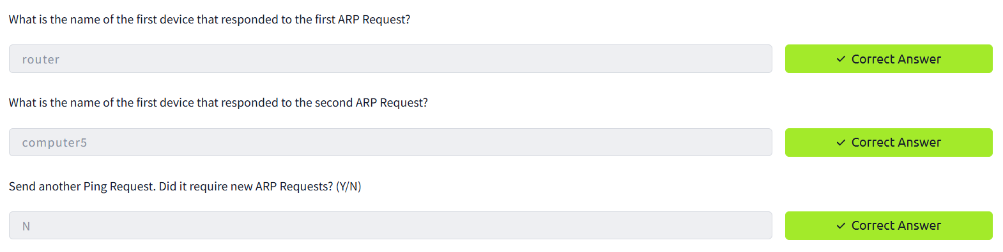

**Task 5: Nmap Host Discovery Using ARP**

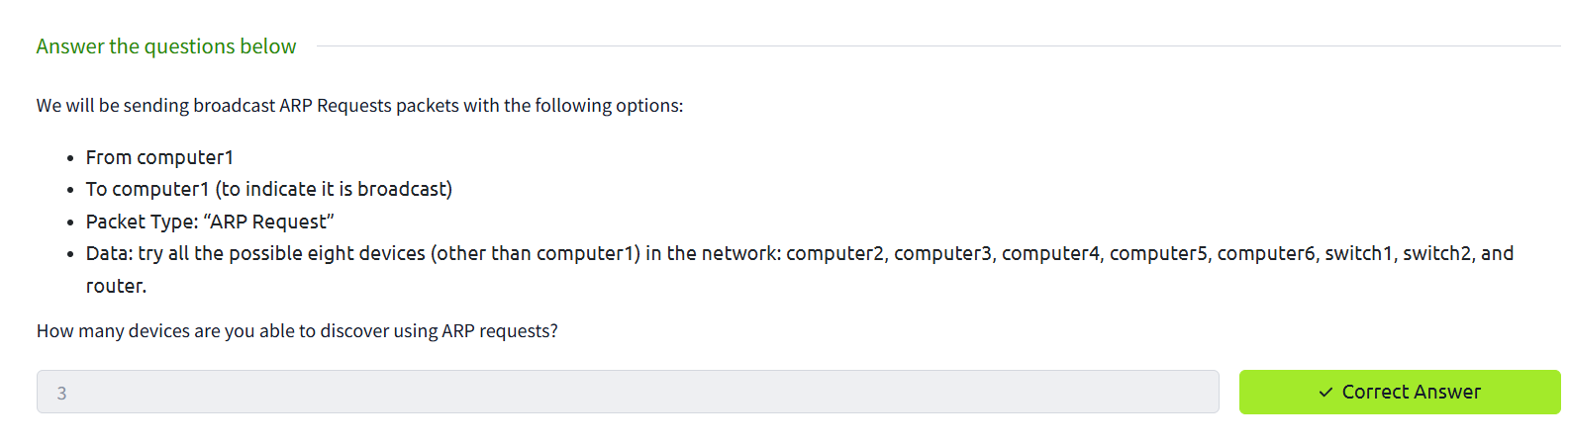

**Task 7: Nmap Host Discovery Using TCP and UDP**

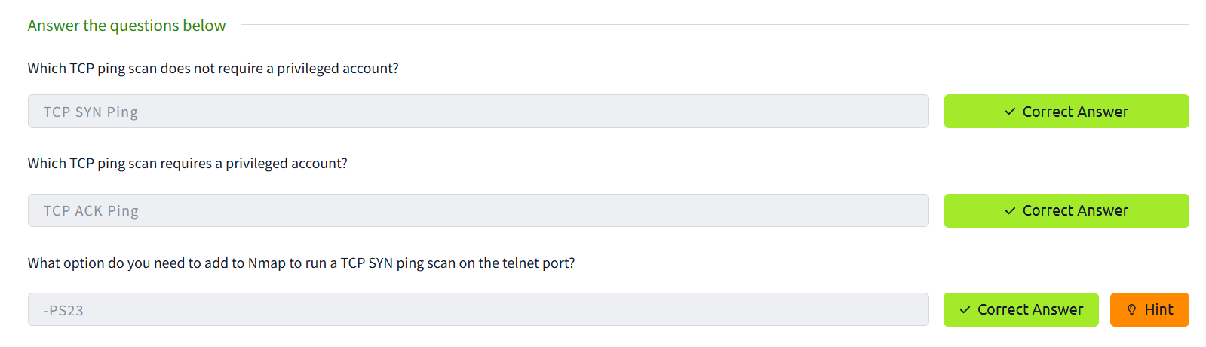

**Task 8: Using Reverse-DNS Lookup**

**Summary:**

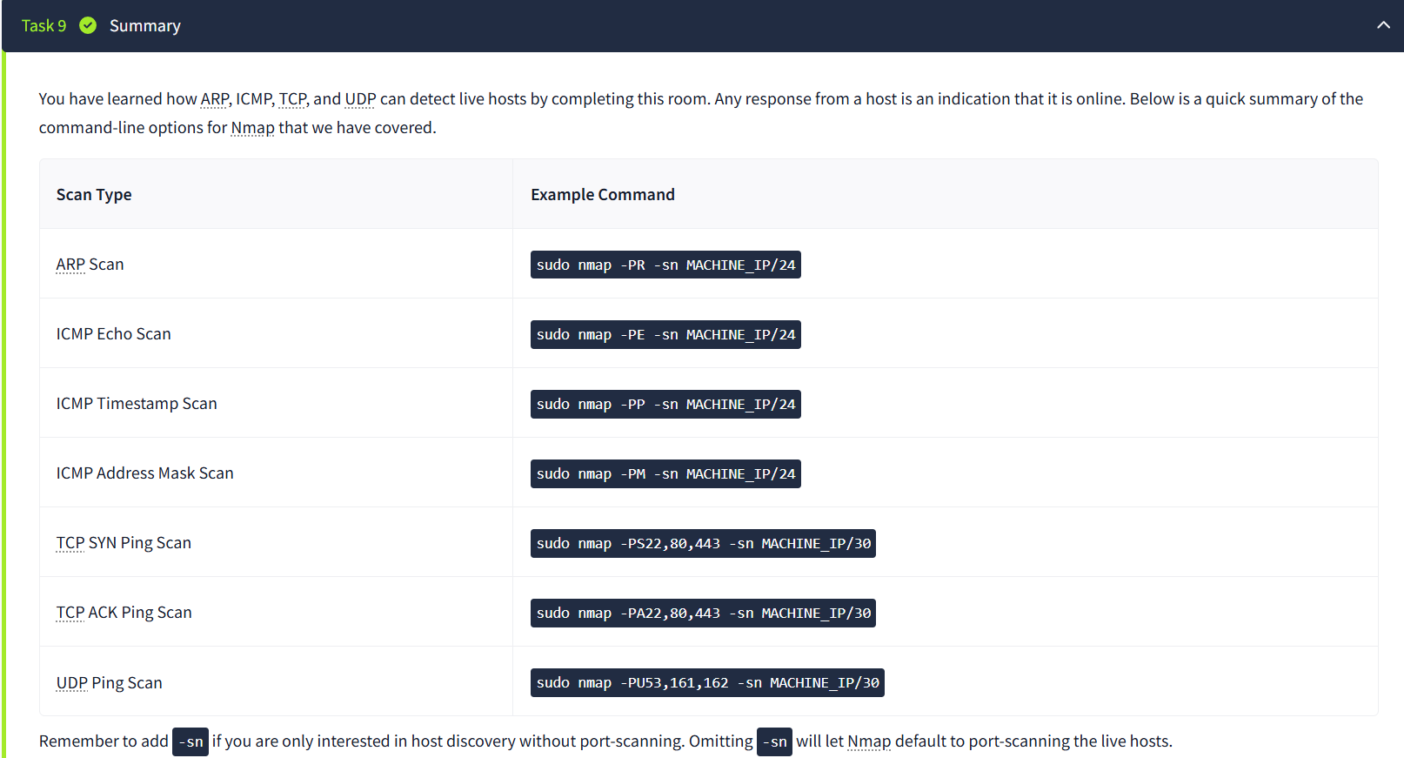

**Result:**

Thus Nmap was used to discover live hosts using ARP scan, ICMP scan, and TCP/UDP ping scan in TryHackMe platform.