Dharshini. S 241901026
EX NO:10 Date:1/10/25
Hiding and Extracting Text Files Behind an Image Using Command Prompt
Aim:
To hide a text file behind an image file and extract the hidden text file using Windows Command Prompt as a basic digital forensic experiment.
Procedure:
Part A: Hiding a Text File Behind an Image
- Create a folder named Forensics on the Desktop.
- Copy an image file named image.jpg into the folder.
- Create a text file named secret.txt in the same folder and enter some sample text.
- Open Command Prompt by pressing Windows + R, typing cmd, and pressing Enter.
- Navigate to the folder by entering:
cd %USERPROFILE%\Desktop\Forensics
- Combine the image and text files using the following command:
copy /b image.jpg + secret.txt hidden.jpg
- A new file named hidden.jpg will be created containing the bytes of both files.
Part B: Extracting the Hidden Text File
- In Command Prompt, execute the following command:
find /v /c "" hidden.jpg
This command counts lines and does not extract the hidden file; it is not required for extraction.
- To recover the appended text, use a binary-aware extraction method or a suitable forensic utility that can locate the appended data.
- For a simple demonstration when the appended text is plain text, open hidden.jpg with a text editor and inspect the end of the file. The text may be visible, but this is not a reliable method of extracting it.
- Compare the recovered text with the original secret.txt and record the result.
Note: The copy /b command appends the text file to the image; it does not encrypt the text or conceal it securely. The resulting file may still open as an image, depending on the image format and viewer.
Observation:
The binary copy command combines the image file and the text file into a single output file. Some image viewers may still display the image because they ignore extra data after the image's normal ending marker.
S. No. | Parameter | Observation
1 | Tool Used | Windows Command Prompt
2 | Original Image | image.jpg
3 | Text File | secret.txt
4 | Command Used | copy /b image.jpg + secret.txt hidden.jpg
5 | Output File | hidden.jpg
6 | Hidden Data | Text data appended after the image bytes
7 | Verification | Compare recovered text with the original file
A forensic examiner can investigate such files by examining their file structure, checking for data after the expected image ending marker, and comparing file sizes or hashes. Appended data may be detectable during forensic analysis.
Output:
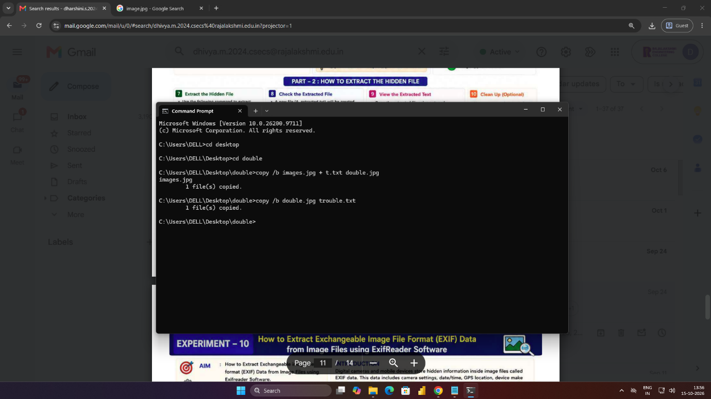
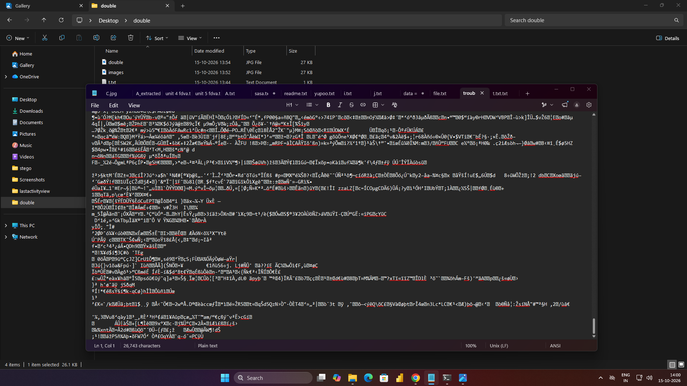

Result:
Thus, a text file was appended to an image file using Windows Command Prompt. The resulting file was examined to understand how extra data can be stored after image data and how such appended content may be detected during digital forensic investigation.

