DHARSHINI.S 241901026
EX NO:3 Date:23/7/26
INTRODUCTION TO DIGITAL FORENSICS (TRYHACKME)
AIM:
To understand the basic concepts of digital forensics and learn how digital evidence is identified, collected, preserved, and analyzed using the TryHackMe learning platform.
TOOLS REQUIRED:
- TryHackMe platform
- Web browser
- Internet connection
PROCEDURE:
- Open a web browser and visit the TryHackMe website.
- Sign in to your TryHackMe account.
- Search for the Introduction to Digital Forensics room.
- Open the room and read the introduction to digital forensics.
- Study the importance of digital evidence in an investigation.
- Learn how digital evidence is collected and preserved without altering the original data.
- Understand the role of forensic investigators in examining digital devices and files.
- Read the room's learning materials and complete the tasks provided.
- Answer the questions based on the information given in the room.
- Review the completed tasks and note the important concepts learned.
OBSERVATION:
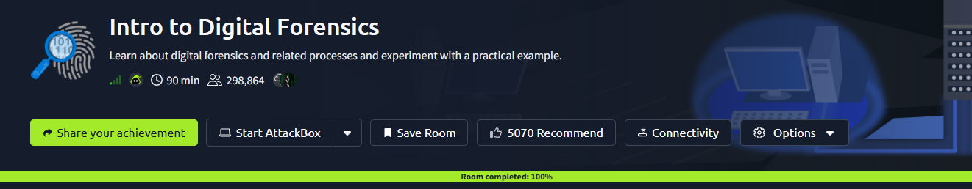
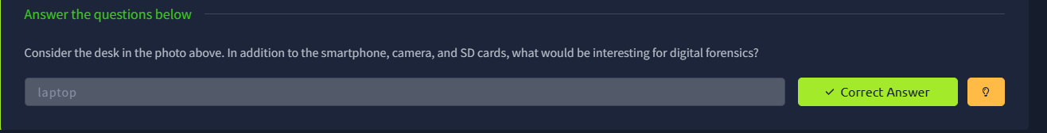
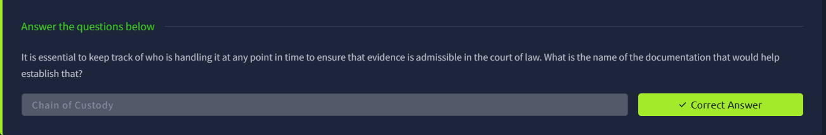
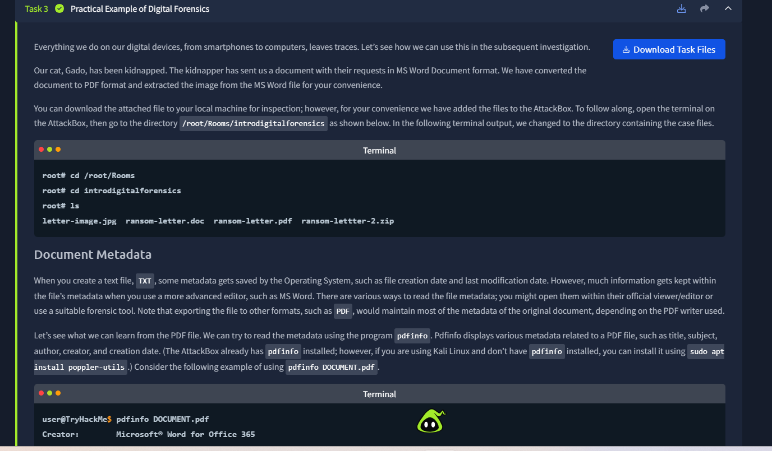

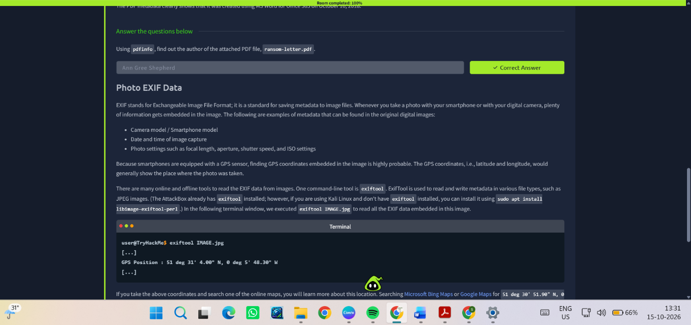
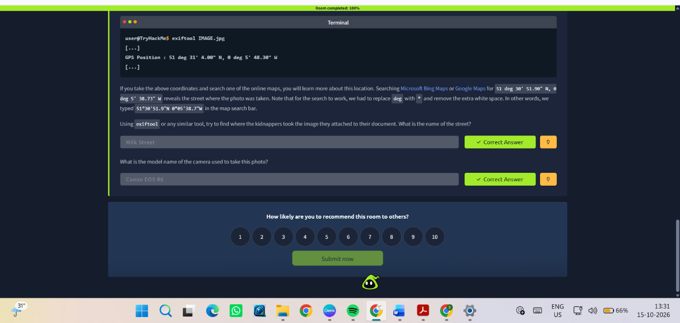
The following concepts were studied:
- Meaning and importance of digital forensics.
- Identification and collection of digital evidence.
- Preservation of evidence and maintaining its integrity.
- Examination and analysis of digital evidence.
- Role of digital forensics in investigating cybercrimes.

RESULT
The Introduction to Digital Forensics room on TryHackMe was studied to understand the basic concepts, procedures, and importance of digital forensics in cybercrime investigations.

