Dharshini. S 241901026
EX NO:4 Date:6/8/26
FTK Imager – Disk Imaging and Evidence Acquisition
Aim:
To study and perform disk imaging and digital evidence acquisition using FTK Imager while maintaining the integrity of the original evidence.

Procedure:
- Download and install FTK Imager from the official AccessData/Exterro source, if it is not already installed.
- Open FTK Imager with the necessary permissions.
- Connect the storage device or select an authorized forensic image file for examination.
- Select File → Create Disk Image to begin the disk imaging process.
- Choose the appropriate source type, such as a physical drive or logical drive, depending on the experiment.
- Select the source device and verify its details carefully.
- Choose the required destination image format, such as E01 or Raw (dd).
- Enter the case number, evidence number, examiner name, and other relevant details when prompted.
- Specify the destination folder where the forensic image will be saved. Do not save the image to the original evidence device.
- Start the imaging process and wait until it is completed.
- If supported by the selected workflow, enable verification and compare the calculated hash values to check the integrity of the acquired image.
- Record the image details, completion status, and hash values in the investigation notes.

Observation:
FTK Imager is a digital forensic tool used to acquire and preview digital evidence without directly modifying the source during a properly conducted acquisition.
The following observations can be recorded during the experiment:
- The selected source device and its storage capacity were identified.
- The appropriate forensic image format was selected.
- The disk imaging process created an image file at the specified destination.
- The image file contained a forensic copy of the selected source data, subject to acquisition limitations.
- Hash values, such as MD5 or SHA-1, could be calculated to help verify the integrity of the acquired image.
- Matching hash values for the source and acquired image indicate that their hashed contents are identical for the data covered by the comparison.
Observation table:
S. No. | Parameter | Observation
1 | Tool Used | FTK Imager
2 | Operation | Disk Imaging and Evidence Acquisition
3 | Image Format | E01 / Raw (dd)
4 | Output | Forensic image file
5 | Integrity Check | Hash verification, if performed
6 | Status | Record the actual completion and verification status

Output
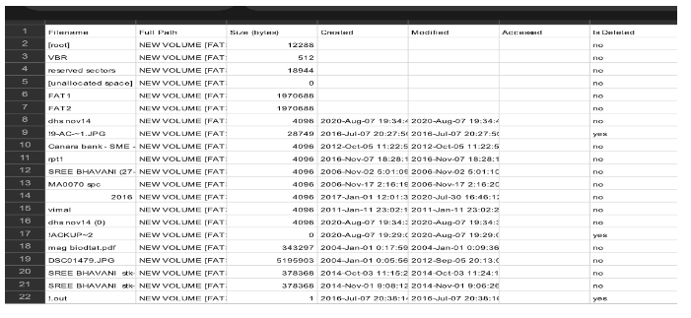
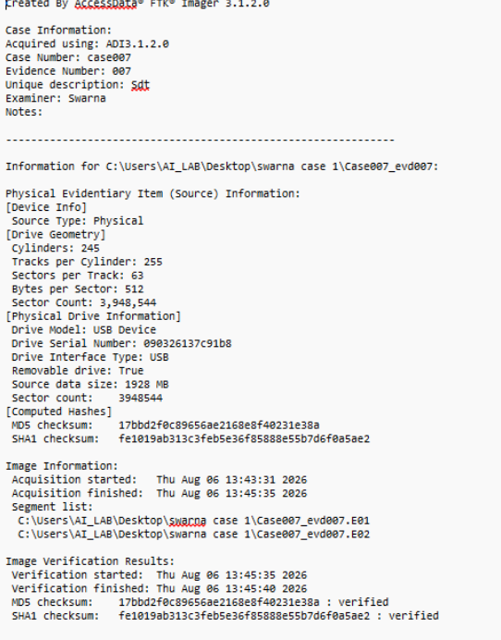

Result
Thus, disk imaging and digital evidence acquisition using FTK Imager were studied and performed. The process of creating a forensic image and verifying its integrity using hash values was understood.

