Dharshini. S 241901026
EX NO:7 Date:27/8/26
Extraction of Browser Artifacts for Digital Forensic Investigation
Aim:
To extract and examine browser artifacts such as browsing history, cookies, cached files, downloads, and saved browsing information for digital forensic investigation.
Procedure:
- Start the computer and log in to the Windows system with the necessary permissions.
- Identify the web browser installed on the system, such as Google Chrome or Microsoft Edge.
- Open the browser and examine its history by pressing Ctrl + H.
- Record the available information, including website URLs, page titles, and visit times.
- Open the browser's download history by pressing Ctrl + J and note the available download details.
- Locate the browser's user profile directory. For example, Chrome commonly stores profile data under %LOCALAPPDATA%\Google\Chrome\User Data\Default.
- Identify relevant browser artifact files, such as:
  - History – browsing history and download records.
  - Cookies – cookie information.
  - Web Data – certain autofill and browsing-related information.
  - Login Data – saved login information stored by the browser.
  - Cache – cached web resources, depending on the browser version.
- Use a forensic tool, such as Autopsy, to examine a forensic image or an authorized copy of the browser profile.
- In Autopsy, create or open a case, add the relevant disk image or data source, and allow the tool to process the available browser artifacts.
- Review the extracted results, including URLs, timestamps, download information, and other available browser records.
- Record the findings in the observation table.
Precaution: Use only data you are authorized to examine. Avoid opening or sharing private passwords or sensitive personal information. For forensic work, preserve the original evidence and analyze a verified copy whenever possible.
Observation:
Browser artifacts provide useful information about a user's web activity. These artifacts can help investigators reconstruct browsing-related events, subject to the information retained by the browser.
S. No. | Artifact | Information Obtained
1 | Browsing History | Visited URLs, page titles, and available timestamps
2 | Download History | Downloaded file names, locations, and related timestamps
3 | Cookies | Website-related session and preference information
4 | Cache | Cached web resources and related metadata
5 | Web Data | Certain autofill and browsing-related records
6 | Login Data | Stored login-related records; sensitive values should not be exposed
7 | Forensic Tool | Autopsy or another suitable browser artifact analysis tool
The examination may reveal website visits, download activity, and other browsing-related information. The availability of artifacts depends on the browser, its version, user settings, and whether the records have been deleted or overwritten.
Output:
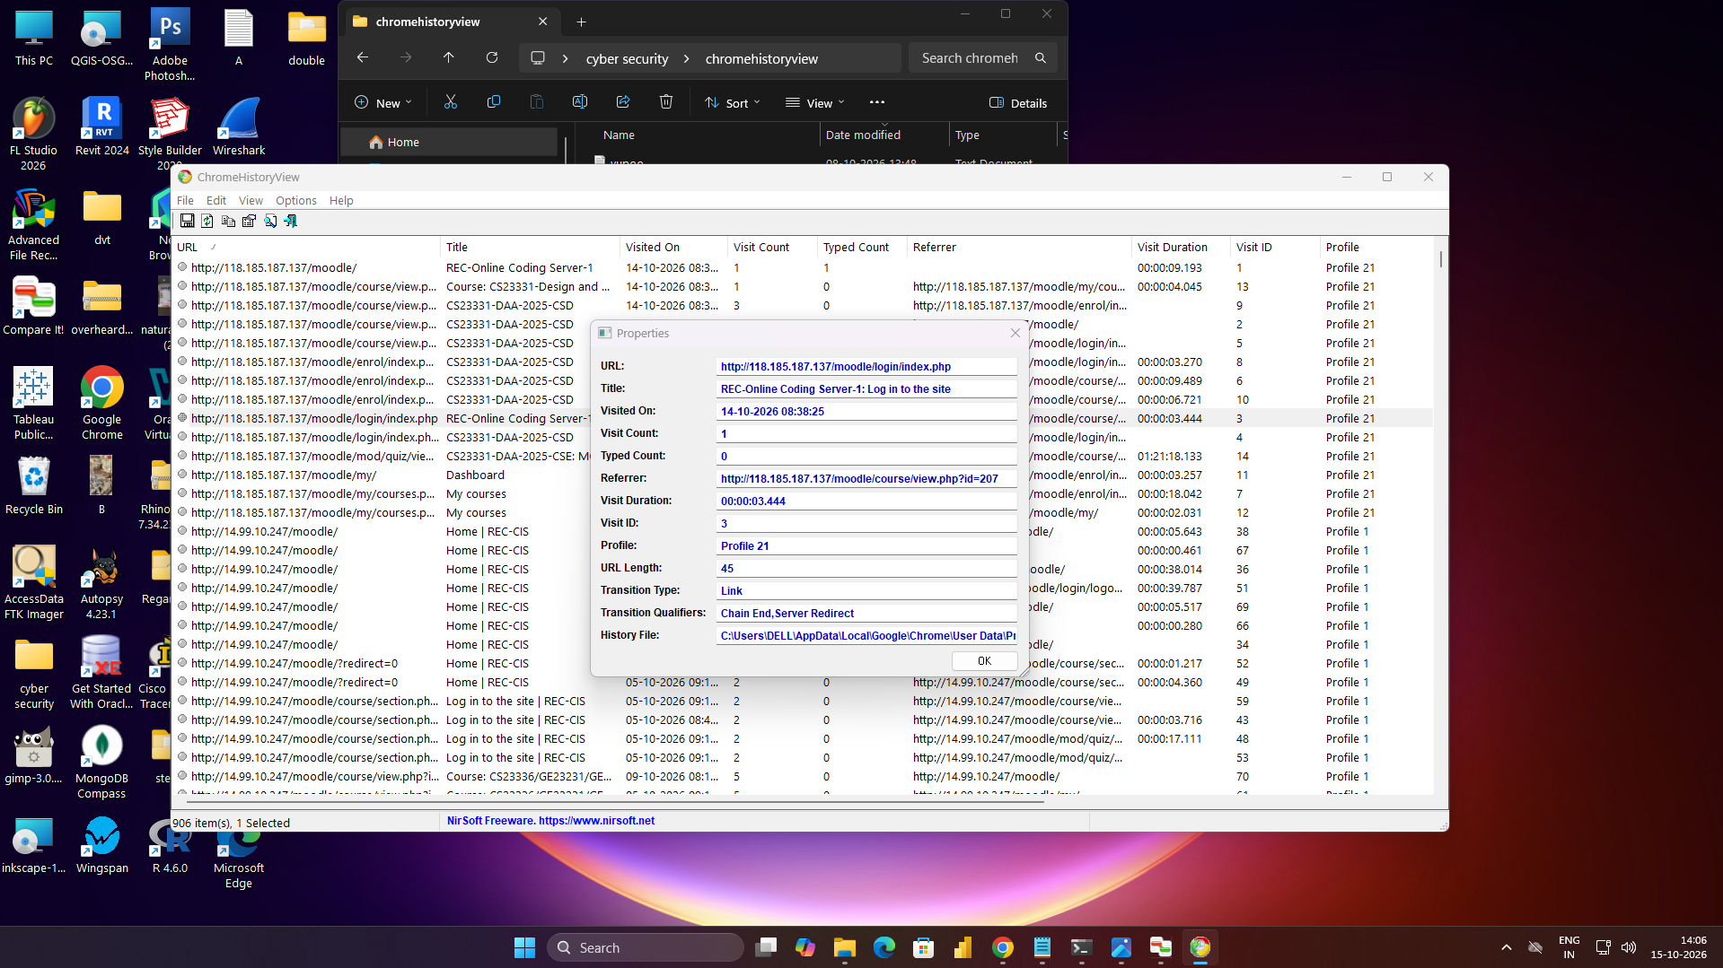
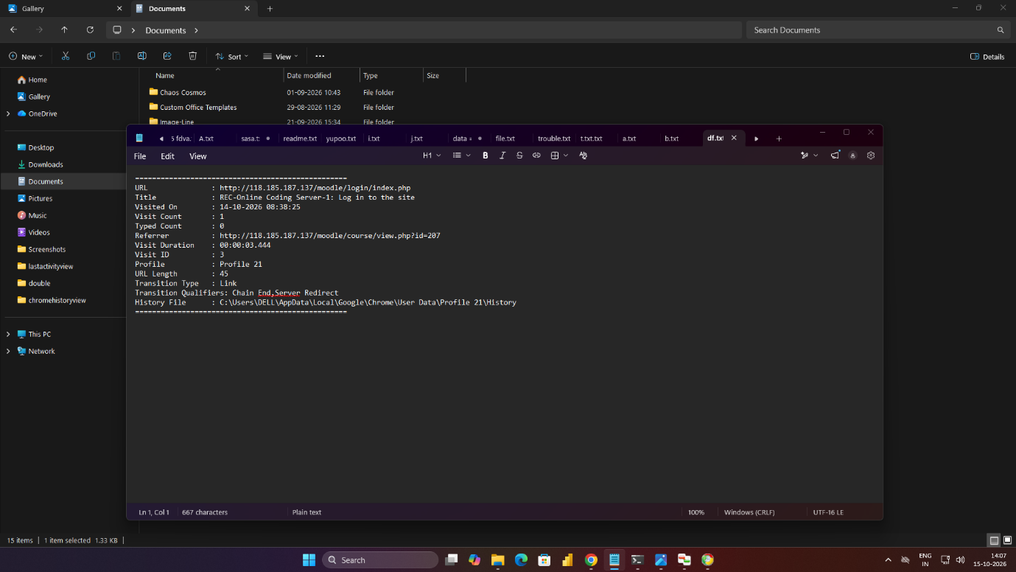

Result:
Thus, browser artifact extraction and examination were studied using browser history, download records, cookies, cache files, and other available browser data. The importance of browser artifacts in reconstructing digital activity during forensic investigations was understood.

