Dharshini. S 241901026
EX NO:6 Date:20/8/26
Viewing the Last Activity of a PC Using Windows Forensics
Aim:
To examine the recent activity of a Windows PC using system logs, recent files, and other Windows artifacts for digital forensic investigation.
Procedure:
- Start the Windows computer and log in with the required permissions.
- View recent files: Open File Explorer and select Home or Quick access to view recently accessed files, if this feature is enabled.
- Check recent activity: Press Windows + R, type recent, and press Enter to open the Recent Items folder, if available.
- Open Event Viewer: Press Windows + R, type eventvwr.msc, and press Enter.
- Expand Windows Logs and select System to examine system events.
- Select Windows Logs → Security to examine available security audit events. Administrative permissions may be required.
- Select Windows Logs → Application to view application-related events.
- Review the event date, time, event ID, and description to understand the recorded activity.
- Check system startup information: In Event Viewer, examine relevant System log events to identify recorded startup and shutdown activity.
- Check browser activity: Open the browser's history page to examine recently visited websites, if the history is available and you are authorized to inspect it.
- Record the relevant activity, timestamps, and observations in the table below.
Observation:
Windows stores different types of activity information in system logs, recent-item records, and application artifacts. These sources can help an investigator understand some of the activities performed on a computer.

S. No. | Activity Source | Observation
1 | Recent Items | Recently accessed files or shortcuts, if available
2 | Event Viewer – System | System startup, shutdown, and other system events
3 | Event Viewer – Security | Recorded login and security events, depending on audit settings
4 | Event Viewer – Application | Application-related events and errors
5 | Browser History | Recently visited websites, if retained
6 | Date and Time | Timestamp associated with the selected event or artifact
The available records depend on Windows settings, user activity, audit policies, and log retention. Recent-file entries and browser history may be incomplete or deleted. A recorded event should not automatically be treated as proof of a person's actions.

Output
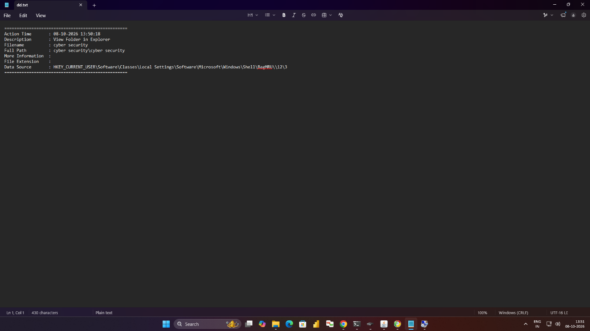

Result:
Thus, the recent activity of a Windows PC was examined using Windows Event Viewer, recent-file records, and browser history. The available artifacts and timestamps were studied to understand how computer activity can be investigated using digital forensic techniques.

