**Air Quality Analysis Project Design and Innovation**

|  |  |
| --- | --- |
| **Date** | **09-10-2023** |
| **Team ID** | **499** |
| **Project Name** | **6112-AIR QUALITY ANALYSIS IN TN** |

**Table of Contents**

|  |  |
| --- | --- |
| 1 | Introduction |
| 2 | Problem Statement |
| 3 | Design and Innovation Strategies |
| 3.1 | Data Collection |
| 3.2 | Data Pre-processing |
| 3.3 | Spatial Analysis and GIS |
| 3.4 | Predictive Modelling |
| 3.5 | Continuous Learning and Improvement |
| 3.6 | Data Visualization |
| 4 | Conclusion |

**1. Introduction**

The project aims to analyze and visualize air quality data from monitoring stations in Tamil Nadu. The objective is to gain insights into air pollution trends, identify areas with high pollution levels, and develop a predictive model to estimate RSPM/PM10 levels based on SO2 and NO2 levels. This project involves defining objectives, designing the analysis approach, selecting visualization techniques in **IBM Cognos**, and creating a predictive model using Python and relevant libraries.

**2. Problem Statement**

Objective: Develop a comprehensive and localized air quality assessment system in Tennessee, leveraging advanced monitoring technologies and data analysis techniques.

Data: To conduct a comprehensive air quality assessment in Tennessee, critical data includes measurements of pollutants like PM2.5, PM10, NO2, SO2, CO, and O3 from monitoring stations. Meteorological data, encompassing temperature, humidity, wind patterns, and precipitation, is vital for understanding atmospheric conditions. Geographic information system (GIS) data aids in assessing how topography and land use influence air quality. Emission inventories offer insights into pollution sources, while population density and demographic data help identify vulnerable communities. Health records, historical data, and air quality modelling outputs provide additional context. Access to policy and regulatory information ensures evaluations align with existing guidelines, while remote sensing data offers a broader perspective on pollution patterns.

**3. Design and Innovation Strategies :**

**3.1.** **Data Collection:**

1. Data Sources :

- Collaborate with environmental agencies, governmental bodies, and research institutions to obtain air quality data.

- Utilize APIs for real-time data retrieval from monitoring stations.

- Consider satellite data for broader geographical coverage.

2. Data Types :

- Gather measurements of pollutants like PM2.5, PM10, NO2, SO2, CO, O3 from monitoring stations.

- Acquire meteorological data including temperature, humidity, wind patterns, and precipitation.

- Obtain geographic information system (GIS) data for topographical and land use details.

- Access emission inventories to understand pollution sources.

- Include demographic data, health records, and air quality modeling outputs for context.

1. Data Quality Assurance :

- Scrutinize data for completeness, consistency, and accuracy.

- Address missing or erroneous values through imputation or exclusion.

**3.2. Data Pre-Processing :**

In Tamil Nadu's air quality analysis, data pre-processing is pivotal. Initially, raw data from monitoring stations is collected, including measurements of pollutants and meteorological variables. This data undergoes rigorous cleaning to handle missing values, outliers, and inconsistencies. Temporal aggregation and spatial interpolation techniques are applied for uniformity. Feature scaling and normalization ensure compatibility across variables. Categorical variables are encoded, and dimensionality reduction methods may be employed. Finally, data is split into training and testing sets for model development. This meticulous pre-processing ensures that the subsequent analysis and modeling stages are based on reliable, high-quality data, enhancing the accuracy of air.

**3.3. Spatial Analysis and GIS:**

- Innovation: Leverage GIS technology to perform spatial interpolation and create high-resolution air quality maps, enabling localized assessments.

- Strategy: Explore emerging technologies like LiDAR and drone-based remote sensing for precise spatial data collection.

**3.4. Predictive Modelling:**

- Innovation: Develop a hybrid model that combines physics-based modelling with data-driven approaches for accurate short-term and long-term predictions.

- Strategy: Implement techniques like Random Forests, Neural Networks, and Gradient Boosting for robust forecasting.

**3.5. Continuous Learning and Improvement:**

- Innovation: Implement a feedback loop that allows the system to learn from its predictions and user interactions to enhance accuracy over time.

- Strategy: Apply reinforcement learning algorithms to optimize model performance based on real-world outcomes.

- Establish a continuous learning framework that incorporates user feedback and new data to update and enhance the model's performance.

- Regularly retrain the model to adapt to changing market dynamics and ensure long-term accuracy.

- Implement automated data pipelines for seamless data ingestion and model retraining.

**3.6. Data Visualization :**

In Tamil Nadu's air quality analysis, data visualization plays a vital role in conveying complex information effectively. Utilizing tools like IBM Cognos, visual representations such as heatmaps, line graphs, and spatial plots can display pollutant levels over time and across locations. Geographic Information System (GIS) maps provide a spatial perspective, highlighting pollution hotspots. Additionally, interactive dashboards allow stakeholders to explore trends and correlations intuitively. Color-coded scales and trend lines enhance readability, aiding in the identification of critical patterns. These visualizations enable policymakers, researchers, and the public to grasp air quality trends, facilitating informed decision-making for environmental improvement initiatives.

FLOW CHART

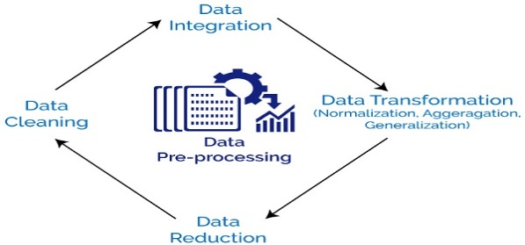

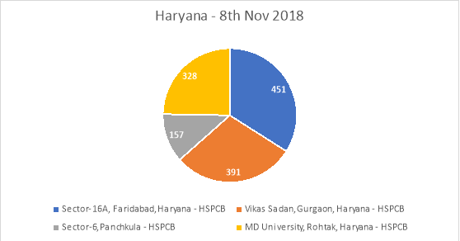

**4. Conclusion:**

In Tamil Nadu's air quality analysis, data pre-processing is pivotal. Initially, raw data from monitoring stations is collected, including measurements of pollutants and meteorological variables. This data undergoes rigorous cleaning to handle missing values, outliers, and inconsistencies. Temporal aggregation and spatial interpolation techniques are applied for uniformity. Feature scaling and normalization ensure compatibility across variables. Categorical variables are encoded, and dimensionality reduction methods may be employed. Finally, data is split into training and testing sets for model development. This meticulous pre-processing ensures that the subsequent analysis and modelling

stages are based on reliable, high-quality data, enhancing the accuracy of air quality assessments.