**Project title:**

Machine learning model deployment with IBM cloud Watson Studio.

**Problem Statement:**

Become a wizard of predictive analytics with IBM Cloud Watson Studio. Train machine learning models to predict the outcomes in real time. Deploy the models as web services and integrate them into your applications. Unlock the magic of data driven insights and make informed decisions like never before.

House Price Prediction Analytics model development - Part 2

* Import WatsonMachineLearningAPIClient library.
* Initialize the WML API Client.
* specify our machine learning model properties and store the model in the WML repository.
* Machine learning model is deployed.
* Web Application for our Machine learning model.

**Project Overview:**

House Price Prediction Analysis aims to use Machine learning analysis algorithms to predict the price of houses based on their features like number of rooms, number of bedrooms, age of the house, population of the respective area where the house is located, location of the house and the area income with other relevant factors if available.By this Machine Learning model user can predict the price of the house that can be sold.

Deployment is the final stage of the lifecycle of a model or script, where you run your models and code. Watson Machine Learning provides the tools that need to deploy an asset, such as a machine learning model or function, or a Decision Optimization solution.

Using IBM Watson Machine Learning, you can deploy models, scripts, and functions, manage your deployments, and prepare assets to put into production to generate predictions and insights.

**Import WatsonMachineLearningAPIClient library.**

Once the library is imported, you can use it to interact with the Watson Machine Learning service and work with your deployed models and assets.

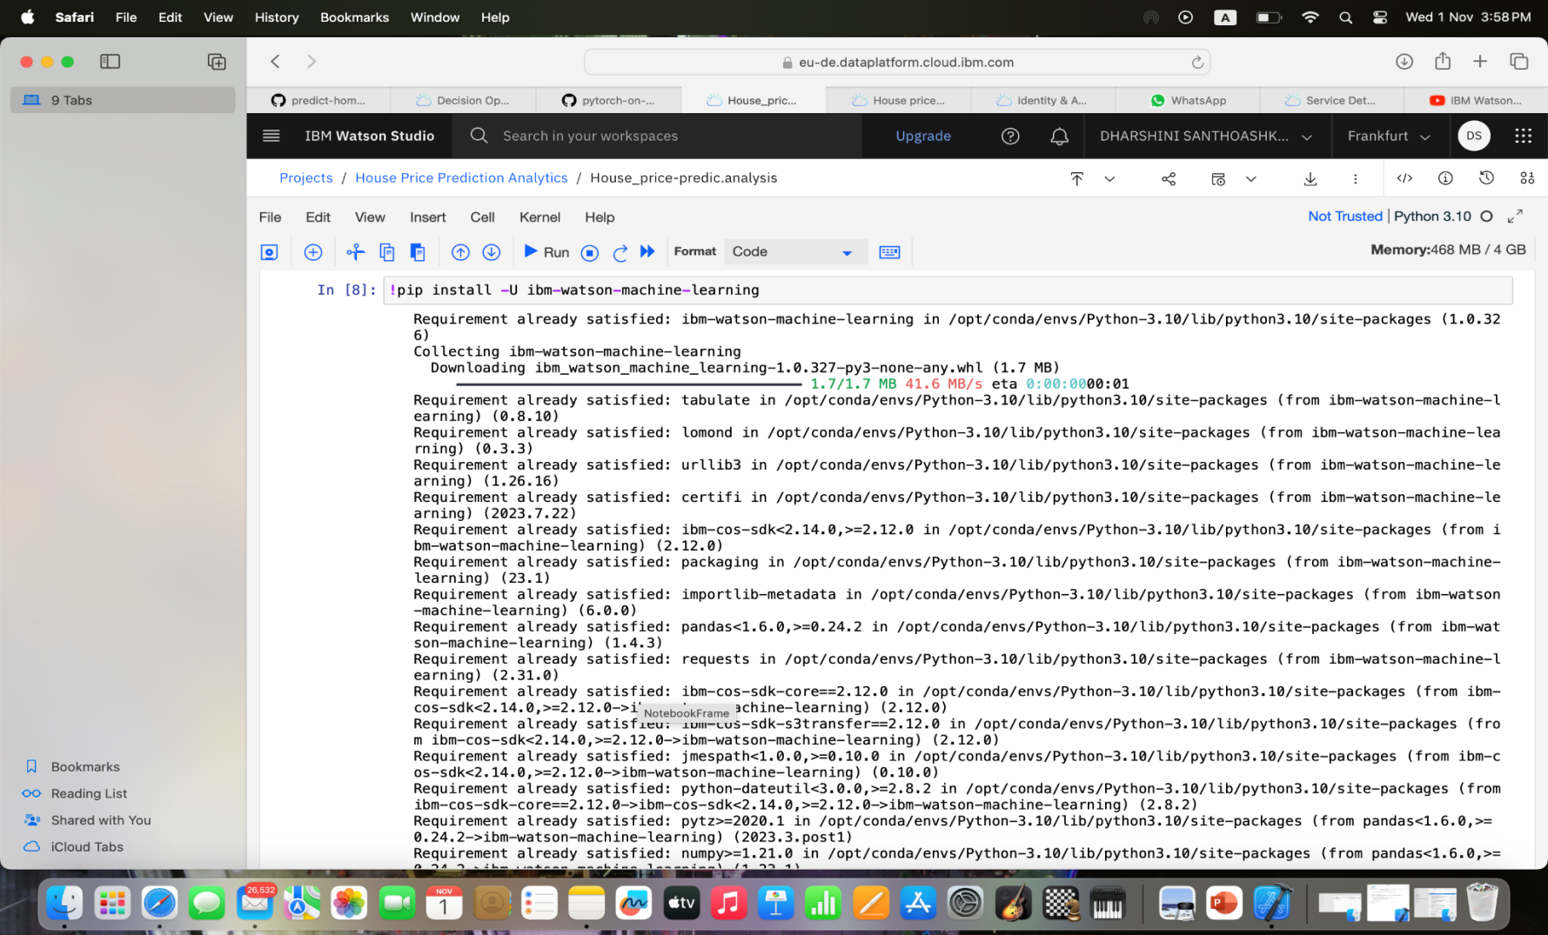

**Initialize the WML API Client.**

Watson studio uses Watson Machine Learning service credentials to access WML service, so paste the credentials.

In this step we have to specify our machine learning model properties and store the model in the WML repository.

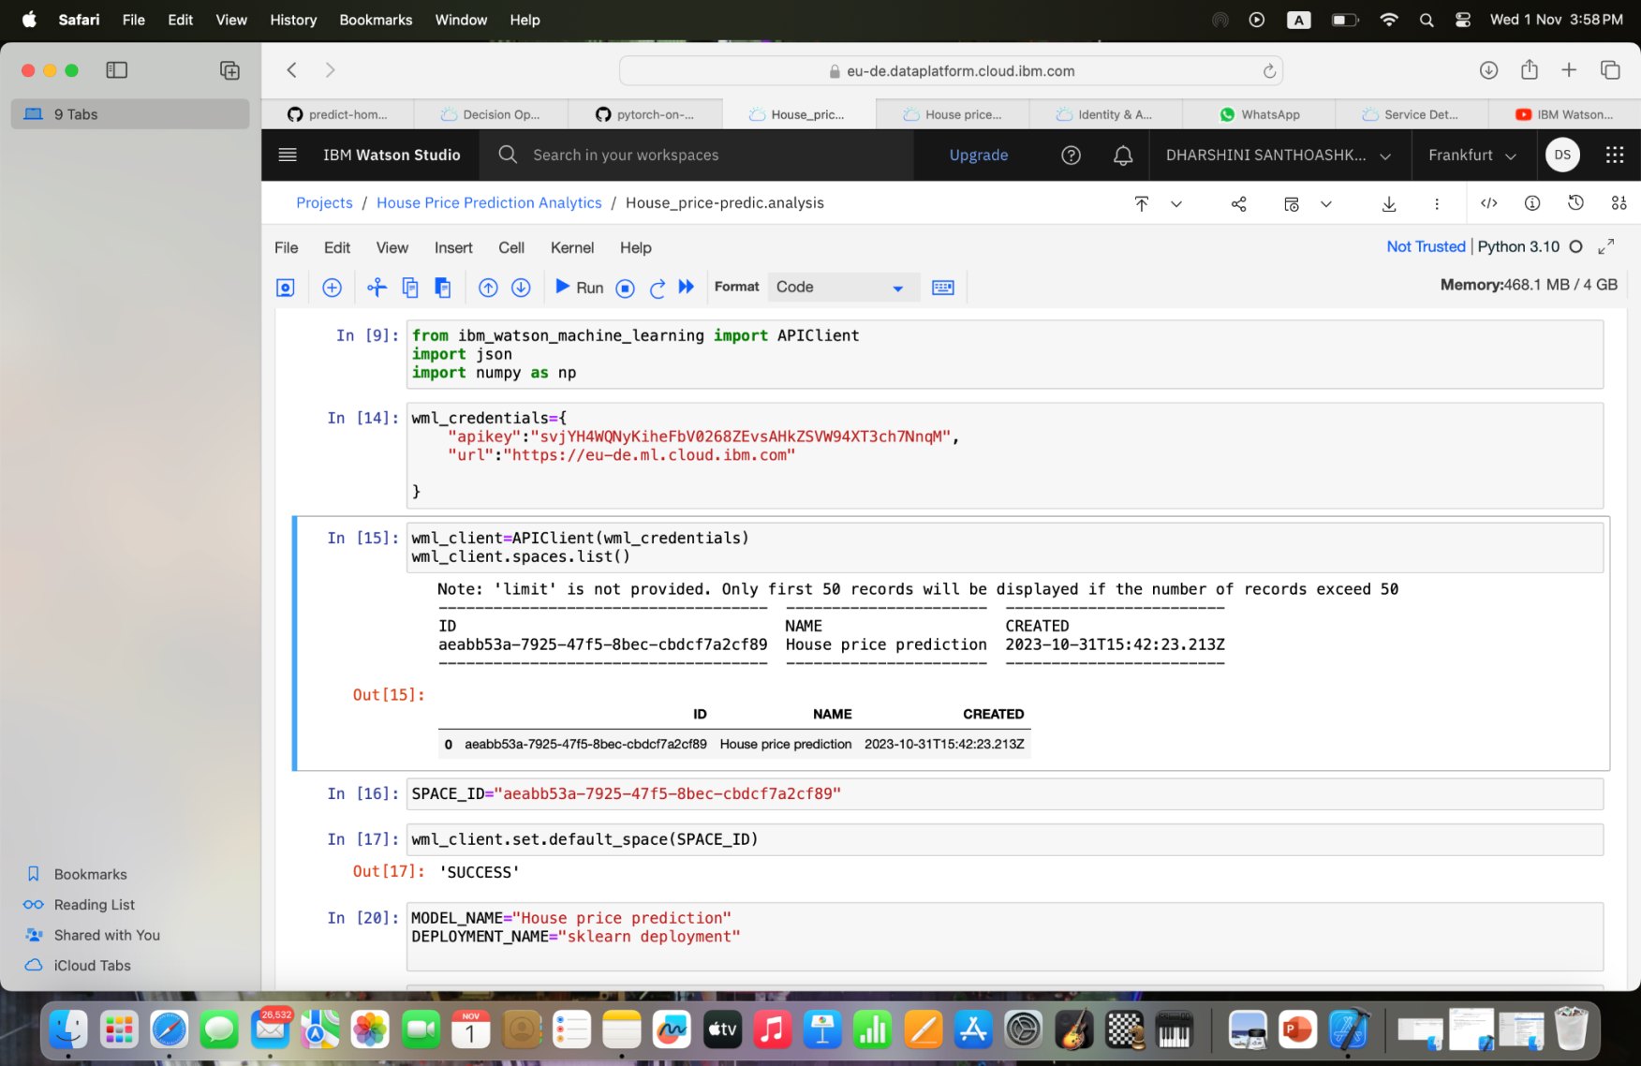

**Machine learning model is deployed.**

Now we are ready to deploy our machine learning model as a Web service.Finally we are done deploying our machine learning model.

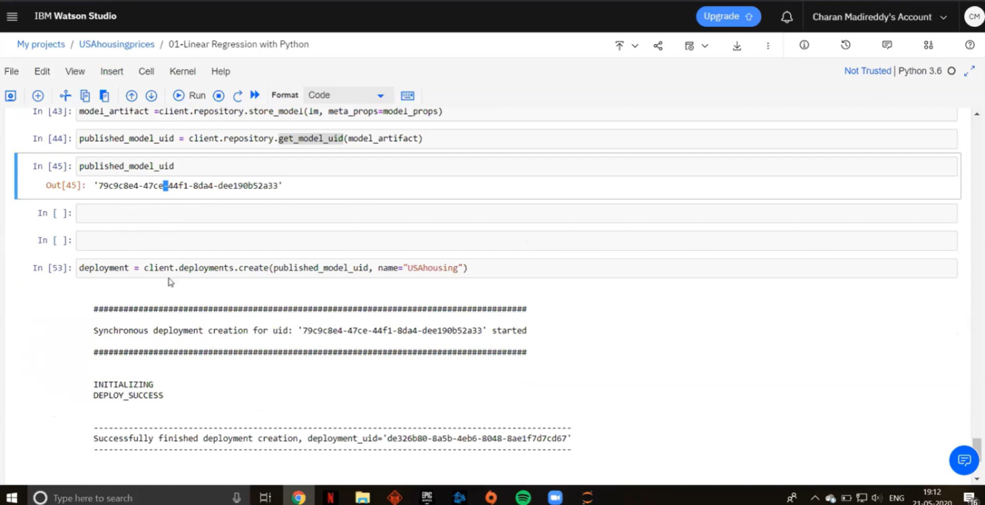

**Web Application for our Machine learning model.**

Our machine learning model was deployed as web service

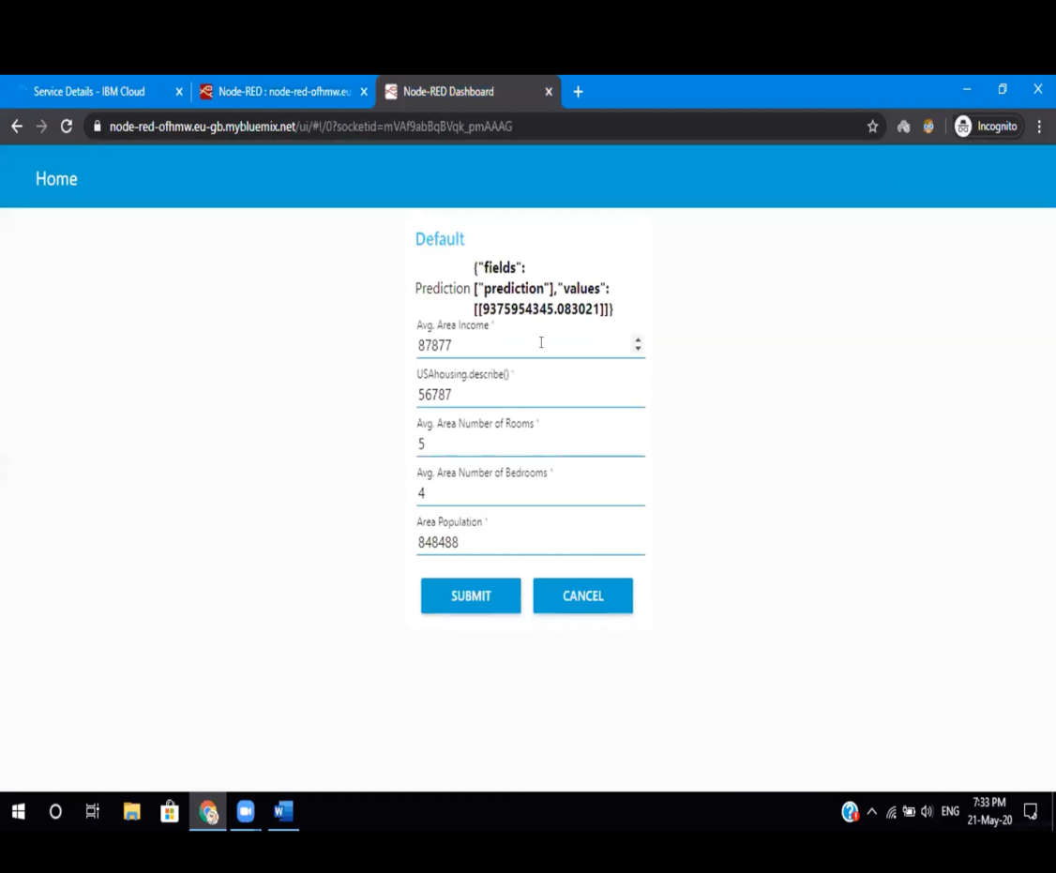

**Conclusion**

Using IBM Cloud Watson Studio, we have learned how to train models to predict outcomes in real-time and deploy them for use in applications. This process helps you optimise resources, reduce risks, and stay ahead . It's about transforming data into action.