Ex.No: Arrays and Array-Based Techniques
-DHARSHINI.P
-25BAD021

AIM:
To implement and analyze array-based techniques such as Two-Pointer, Prefix Sum, Fixed-Size Sliding Window, Variable-Size Sliding Window, and Monotonic Queue for solving different data structure problems efficiently in C.

PSEUDO CODE:

1.Squaring a Sorted Array (Two-Pointer):
START

Read N
Read the sorted array

Set left = 0
Set right = N - 1
Set position = N - 1

Create a result array

WHILE left <= right

IF absolute value of arr[left] > absolute value of arr[right]
Square arr[left] and store it in result[position]
Move left to the next element
ELSE
Square arr[right] and store it in result[position]
Move right to the previous element
END IF

Move position one step backward

END WHILE

Print the result array

STOP

2.Cumulative Resource Consumption (Prefix Sum):
START

Read N
Read the array

Create a prefix array

Set prefix[0] = arr[0]

FOR each element from index 1 to N-1

prefix[i] = prefix[i-1] + arr[i]

END FOR

Print the prefix array

STOP

3.Grouping Active Sectors (Fixed-Size Sliding Window):
START

Read N
Read the binary array

Count the total number of 1s

IF count is 0 or 1
Print Min Swaps = 0
STOP
END IF

Count the number of 1s in the first window of size count

Set maximum = current count

Slide the window through the array

Remove the left element from the count
Add the new right element to the count

Update maximum if needed

END Slide

Minimum Swaps = count - maximum

Print Minimum Swaps

STOP

4.Maximum Task Window Within Budget (Variable-Size Sliding Window):
START

Read N and P
Read the array

Set start = 0
Set currentSum = 0
Set maxLength = 0

FOR each end from 0 to N-1

Add arr[end] to currentSum

WHILE currentSum > P

Subtract arr[start] from currentSum
Move start to the next position

END WHILE

Update maxLength if current window is larger

END FOR

Print maxLength

STOP

5.Sliding Window Maximum Peak (Monotonic Queue):
START

Read N and K
Read the array

Create an empty deque

FOR each element from index 0 to N-1

Remove indices outside the current window

Remove indices from the back whose values are
smaller than or equal to the current element

Insert the current index into the deque

IF window size is K

Print the element at the front of the deque
because it is the maximum

END IF

END FOR

STOP

CODES:

Squaring a Sorted Array (Two-Pointer):
#include <stdio.h>
#include <stdlib.h>

int main()
{
int n;

printf("Enter the number of elements: ");
scanf("%d", &n);

int arr[10000], result[10000];

printf("Enter %d sorted elements: ", n);
for(int i = 0; i < n; i++)
{
scanf("%d", &arr[i]);
}

int left = 0;
int right = n - 1;
int pos = n - 1;

while(left <= right)
{
if(abs(arr[left]) > abs(arr[right]))
{
result[pos] = arr[left] * arr[left];
left++;
}
else
{
result[pos] = arr[right] * arr[right];
right--;
}
pos--;
}

printf("\nSorted Squared Array: ");

for(int i = 0; i < n; i++)
{
printf("%d ", result[i]);
}

return 0;
}

Cumulative Resource Consumption (Prefix Sum):
#include <stdio.h>

int main()
{
int n;

printf("Enter the number of elements: ");
scanf("%d", &n);

int arr[10000], prefix[10000];

printf("Enter %d elements: ", n);
for(int i = 0; i < n; i++)
{
scanf("%d", &arr[i]);
}

prefix[0] = arr[0];

for(int i = 1; i < n; i++)
{
prefix[i] = prefix[i - 1] + arr[i];
}

printf("\nPrefix Sum Array: ");

for(int i = 0; i < n; i++)
{
printf("%d ", prefix[i]);
}

return 0;
}

Grouping Active Sectors (Minimum Swaps):
#include <stdio.h>

int main()
{
int n;

printf("Enter the number of elements: ");
scanf("%d", &n);

int arr[10000];

printf("Enter %d binary elements (0 or 1): ", n);
for(int i = 0; i < n; i++)
{
scanf("%d", &arr[i]);
}

int ones = 0;

for(int i = 0; i < n; i++)
{
if(arr[i] == 1)
ones++;
}

if(ones <= 1)
{
printf("\nMin Swaps: 0");
return 0;
}

int current = 0;

for(int i = 0; i < ones; i++)
{
if(arr[i] == 1)
current++;
}

int maximum = current;

for(int i = ones; i < n; i++)
{
if(arr[i - ones] == 1)
current--;

if(arr[i] == 1)
current++;

if(current > maximum)
maximum = current;
}

printf("\nMin Swaps: %d", ones - maximum);

return 0;
}

Maximum Task Window Within Budget:
#include <stdio.h>

int main()
{
int n, p;

printf("Enter the number of tasks: ");
scanf("%d", &n);

printf("Enter the maximum allowed energy: ");
scanf("%d", &p);

int arr[10000];

printf("Enter the energy cost of %d tasks: ", n);

for(int i = 0; i < n; i++)
{
scanf("%d", &arr[i]);
}

int start = 0;
int sum = 0;
int maxLength = 0;

for(int end = 0; end < n; end++)
{
sum += arr[end];

while(sum > p)
{
sum -= arr[start];
start++;
}

if(end - start + 1 > maxLength)
maxLength = end - start + 1;
}

printf("\nMax Length: %d", maxLength);

return 0;
}

Sliding Window Maximum (Deque):
#include <stdio.h>

int main()
{
int n, k;

printf("Enter the number of elements: ");
scanf("%d", &n);

printf("Enter the window size: ");
scanf("%d", &k);

int arr[10000];
int deque[10000];

printf("Enter %d elements: ", n);

for(int i = 0; i < n; i++)
{
scanf("%d", &arr[i]);
}

int front = 0;
int rear = -1;

printf("\nSliding Window Maximums: ");

for(int i = 0; i < n; i++)
{
while(front <= rear && deque[front] <= i - k)
{
front++;
}

while(front <= rear && arr[deque[rear]] <= arr[i])
{
rear--;
}

deque[++rear] = i;

if(i >= k - 1)
{
printf("%d ", arr[deque[front]]);
}
}

return 0;
}

OUTPUTS:

1: Squaring a Sorted Array (Two-Pointer)
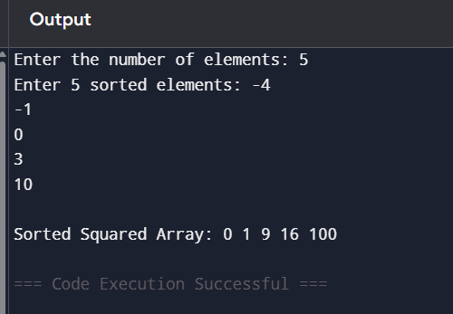

2.Cumulative Resource Consumption (Prefix Sum)

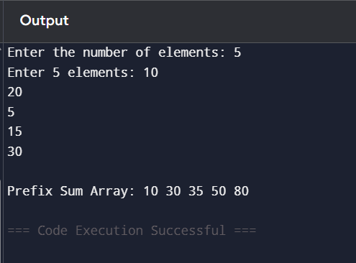

3. Grouping Active Sectors (Minimum Swaps)
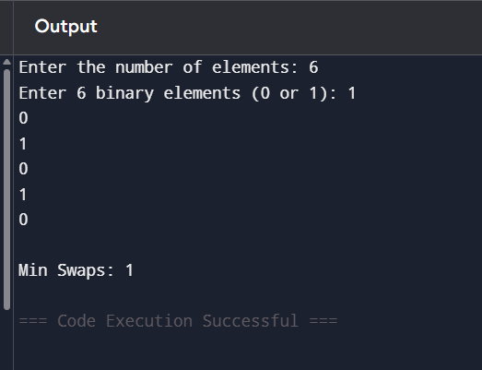

4: Maximum Task Window Within Budget
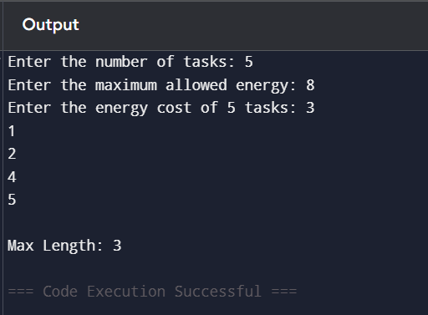

5.Sliding Window Maximum (Monotonic Queue)

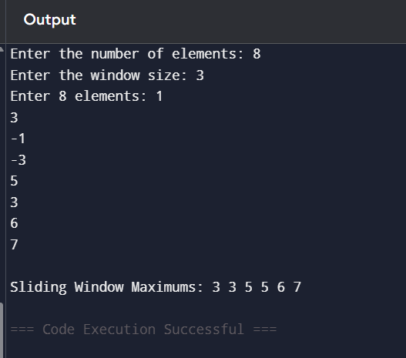

RESULT:
Thus, the programs for implementing array-based techniques using Two-Pointer, Prefix Sum, Fixed-Size Sliding Window, Variable-Size Sliding Window, and Monotonic Queue were successfully executed in C, and the expected outputs were obtained.

