 

**Placement Empowerment Program**

**Cloud Computing and DevOps Centre**

**Set up Git Branching**

**“*Create a new branch in your Git repo for testing. Add a new feature and merge it.*”**

Name: **DHARSHINI P** DEPARTMENT: **IT**



**Introduction**

Git branching allows developers to work on new features, fixes, or experiments without affecting the main project. It helps maintain a clean and organized workflow while enabling collaborative development.

**Overview**

This guide walks through the process of **creating** a new Git branch, **adding** a feature, and **merging** it back into the main branch.

**Objective**

**The primary objectives of this POC are:**

* Understand Git branching.
* Create a new branch for testing.
* Add a new feature.
* Merge the branch into the main branch

**Important Concepts**

* Allows multiple developers to work on different features simultaneously.
* Prevents unstable code from affecting the main branch.
* Enhances code organization and version control

**Step-by-Step Overview**

**Step 1:**

* Create folder in your desktop and
* Open terminal inside the folder

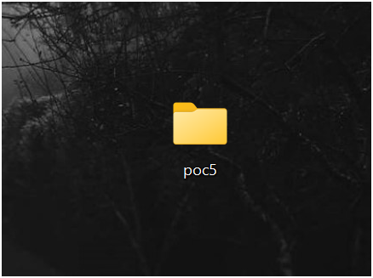

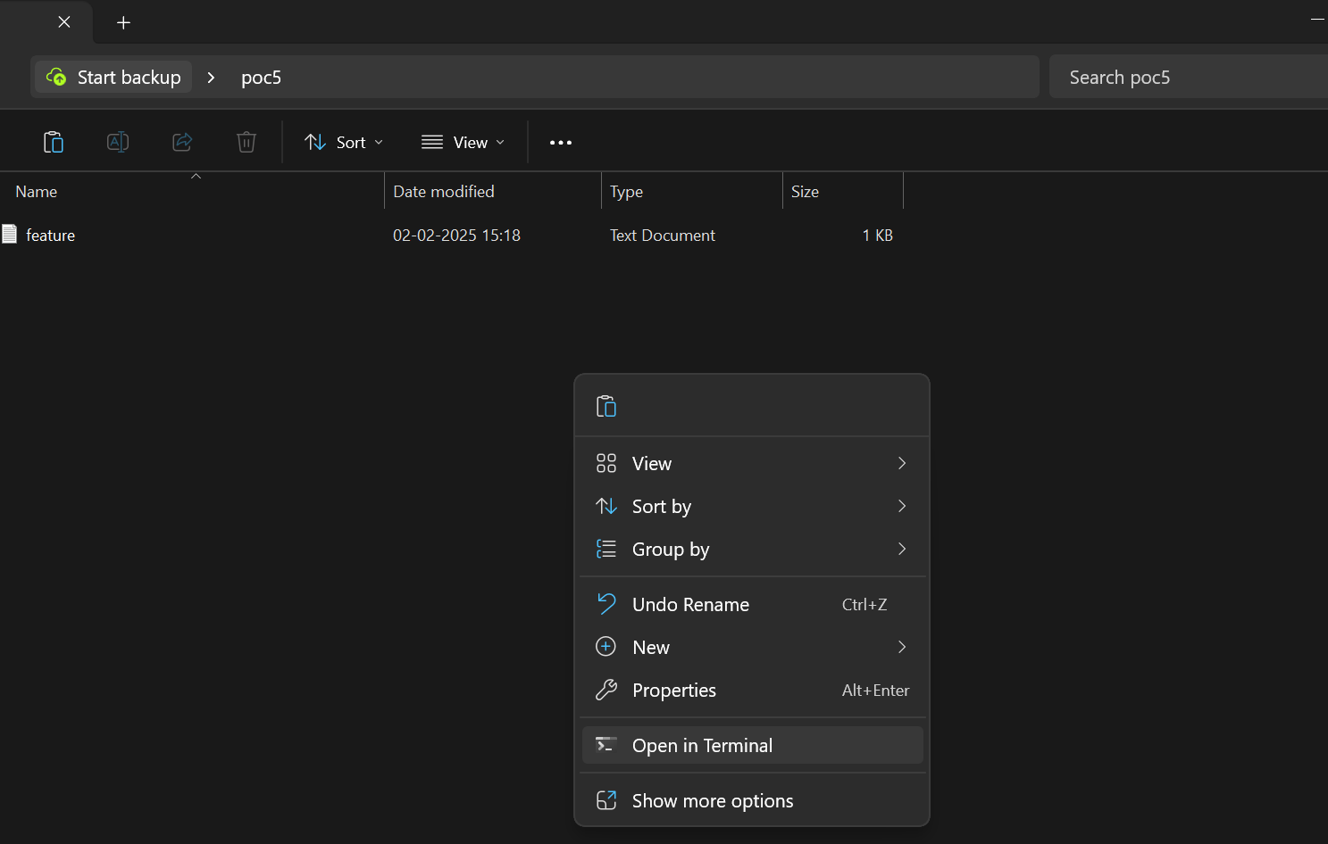

**Step 2:**

**Initialize or Navigate to a Git Repository**

If you don’t have a repository, initialize one using the below command

**git init**

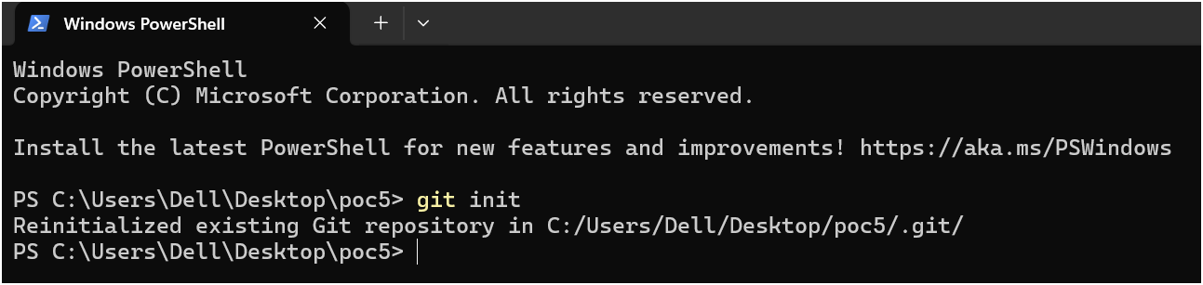

**Step 3 :**

Ensure you're on the main branch:

**Git branch**

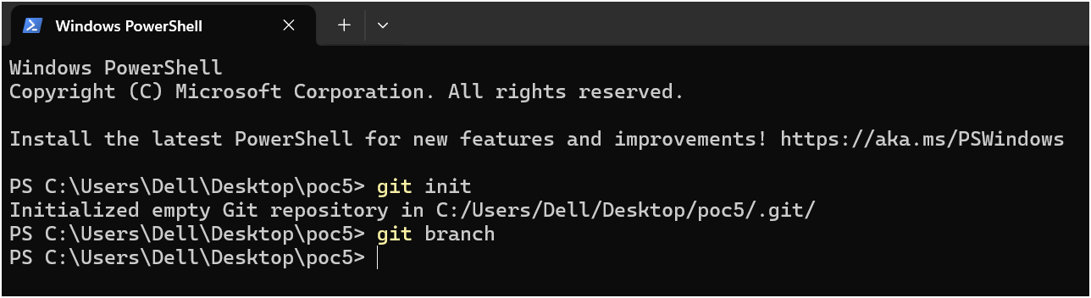

**Step 4:**

Create a new branch named feature-branch:

**git checkout -b feature-branch**

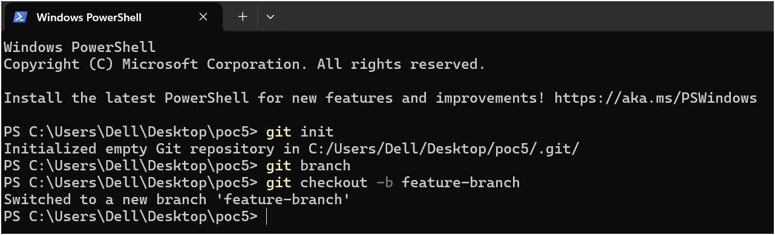

**Step 5:**

Add a New Feature

Make changes to a file or create a new file:

**echo "New feature added" > feature.txt**

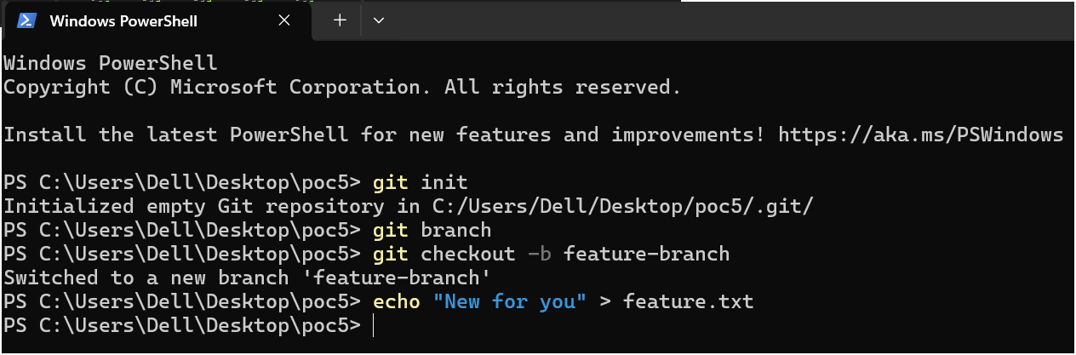

Stage and commit the changes:

**git add feature.txt**

**git commit -m "Added new feature"**

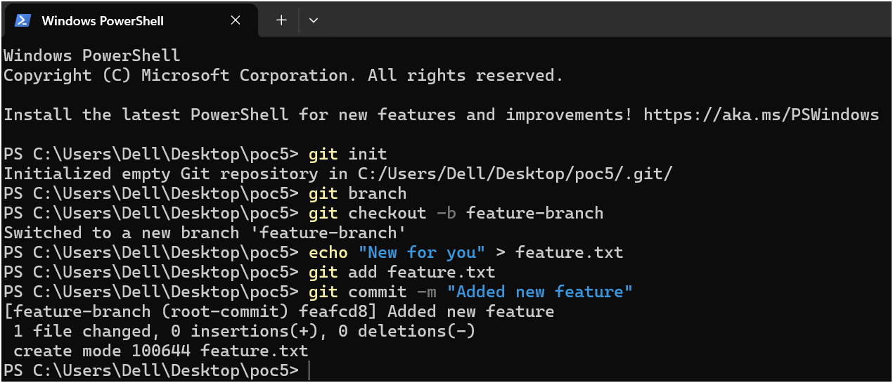

**Step 6:**

Switch Back to the Main Branch

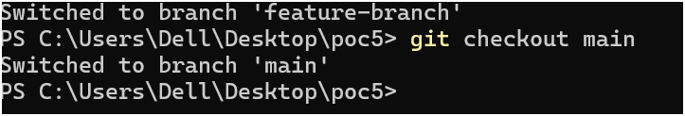

**Step 7:**

Merge feature-branch into main

**git merge feature-branch**

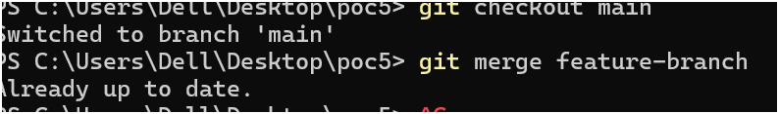



**Expected Outcome:**

**By completing this POC, you will:**

* A new branch is successfully created.
* A new feature is added and committed.
* The feature branch is merged into the main branch.
* The repository remains clean and organized.

This process ensures efficient code management and collaboration using Git.