|  |  |  |
| --- | --- | --- |
|  | **Placement Empowerment Program**  Cloud Computing and DevOps Centre |  |
| **Assignment 1: Linux Assignment Report**  Topics: Linux Introduction, VMs, and Commands |
| **Faculty: Dr. M. Karthi**  **Student Name:** Dharshini P  **Register Number:** 23IT260  **Date:** July 8, 2025 |
| **Contents** |  |
| **1 Task 1:** | **Virtual Environment Setup (10 marks)** | **2** |
| **2 Task 2:** | **System Command Mastery (20 marks)** | **3** |
| **3 Task 3:** | **Linux Internals with Python (30 marks)** | **4** |
| **4 Task 4:** | **Bonus – Disk Usage Visualization (10 bonus marks)** | **6** |

1

# Task 1: Virtual Environment Setup (10 marks)

## Objective

Set up a Linux-based virtual environment to simulate system-level operations.

## Steps Performed

* + Installed Ubuntu 22.04 in VirtualBox.
  + Allocated 2 CPUs, 2GB RAM, 20GB disk.
  + Installed essential packages:

sudo apt update && sudo apt install -y curl vim net-tools openssh-server htop git

Listing 1: Install Essential Packages

* + Enabled and verified SSH from host.

## Output Screenshots

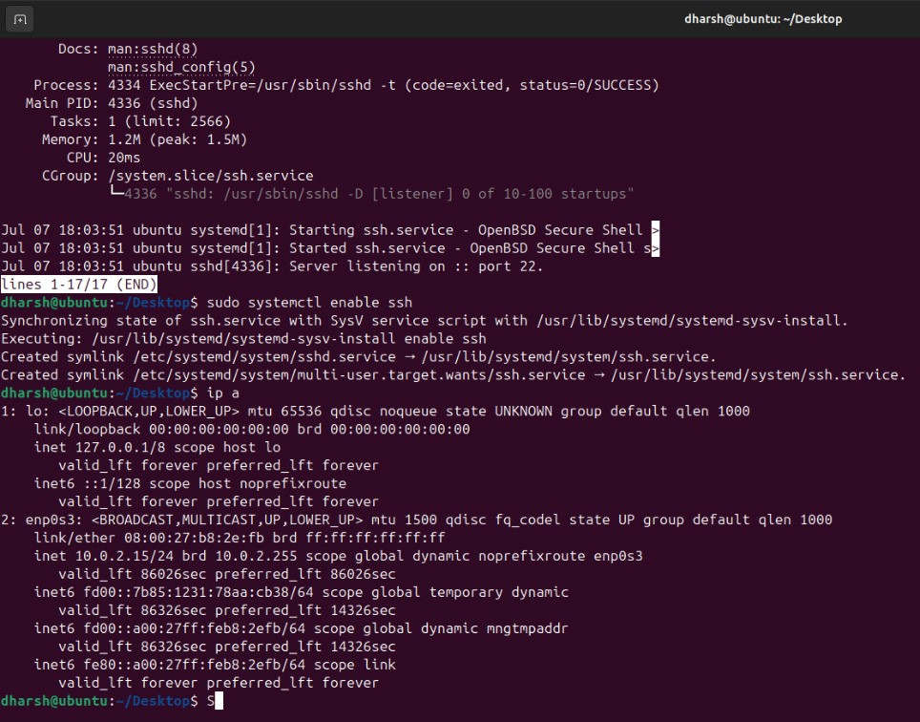

images/vm_terminal.png

Figure 1: Virtual Machine - Terminal Open

lscpu free -h ip a

Listing 2: CPU

# Task 2: System Command Mastery (20 marks)

## Objective

Automate key system tasks using bash scripting.

## Script Name

sys_monitor.sh

## Script Functionality

* + Top 5 memory-consuming processes
  + List open ports and associated services
  + Count number of .sh and .conf files in /etc and /home
  + Schedule cron job every 5 minutes
  + Backup /var/log to user’s home

*#!/bin/bash*

echo "Top 5 memory-consuming processes:" ps aux --sort=-%mem | head -n 6

echo "Open ports:" ss -tuln

echo "File count in /etc and /home:" find /etc -type f -name "*.conf" | wc -l find /home -type f -name "*.sh" | wc -l

echo "Creating log backup..."

tar -czf ~/logs_backup.tar.gz /var/log

Listing 3: System Monitoring Bash Script

## Output Screenshot

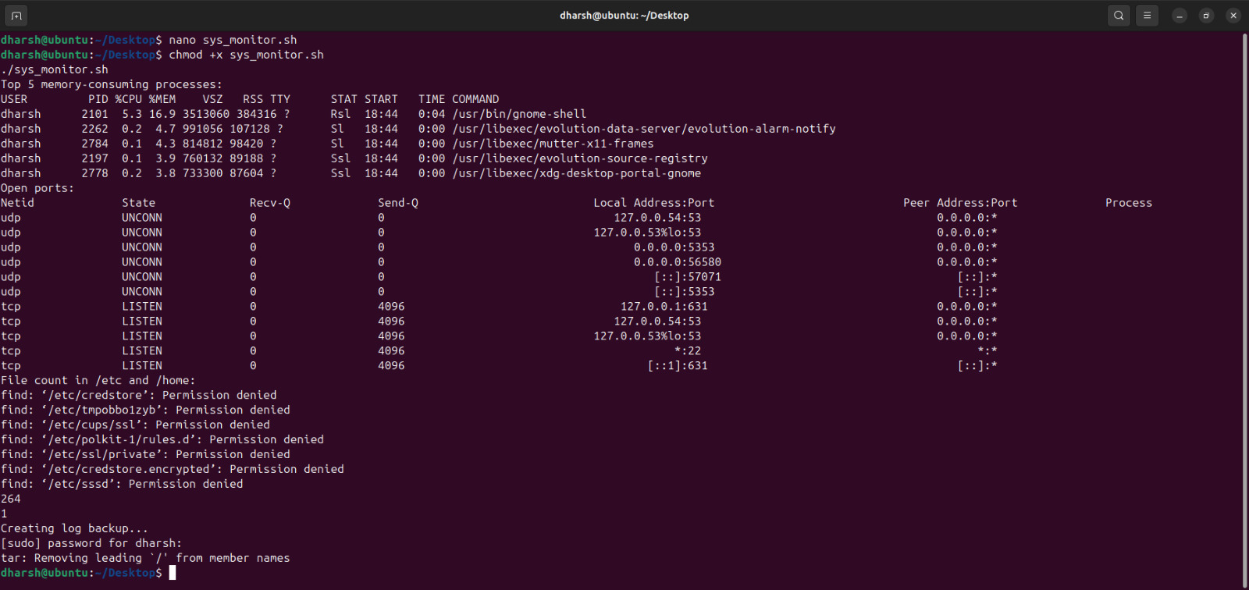

Figure 2: Output of sys_monitor.sh Script

images/sys_monitor_output.png

# Task 3: Linux Internals with Python (30 marks)

## Objective

Extract system details and manipulate files using Python.

## Script Name

sysinfo.py

## Script Objectives

* + Extract CPU info from /proc/cpuinfo
  + Parse users from /etc/passwd
  + Create folder structure and move shell scripts

import os

*# CPU Info*

with open("/proc/cpuinfo") as f: for line in f:

if "model name" in line: print(line.strip()) break

*# Extract bash users*

with open("/etc/passwd") as f:

users = [line.split(":")[0] for line in f if "/bin/bash" in line] print("Users with bash shell:", users)

*# Create folders and move files* os.makedirs("/home/youruser/LinuxExp/Week1/Day1", exist_ok=True) os.system("mv /home/youruser/*.sh /home/youruser/LinuxExp/Week1/Day1/")

Listing 4: System Info Python Script

## Sample Output Screenshot

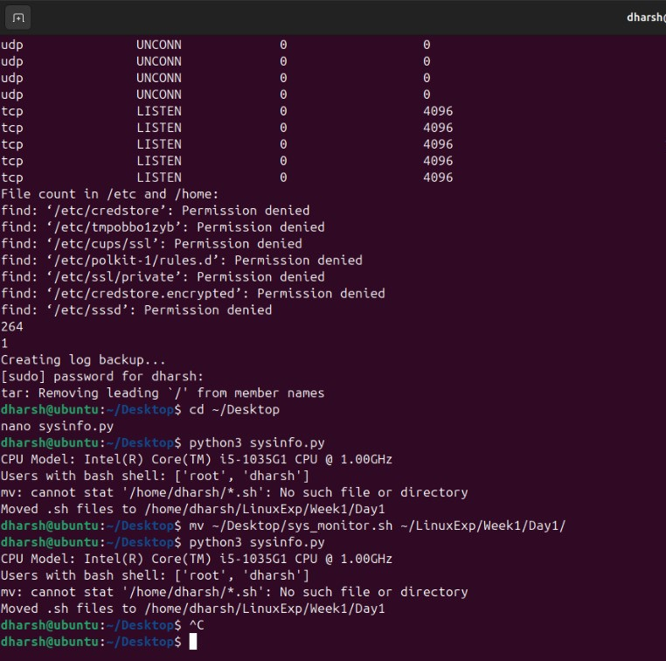

images/sysinfo_output.png

Figure 3: System Info Script Output

# Task 4: Bonus – Disk Usage Visualization (10 bonus marks)

## Objective

Visualize disk usage using Matplotlib and Linux commands.

## Script Name

disk_pie.py

import os

import matplotlib.pyplot as plt

labels = [] sizes = []

for item in os.listdir("/home/youruser"):

path = os.path.join("/home/youruser", item) if os.path.isdir(path):

size = os.popen(f"du -sh {path}").read().split()[0]

size_val = float(size.replace(’M’, ’’).replace(’K’, ’’).replace(’G’, ’’)) labels.append(item)

sizes.append(size_val)

plt.pie(sizes, labels=labels, autopct=’%1.1f%%’) plt.title("Disk Usage in /home") plt.savefig("disk_usage.png")

plt.show()

Listing 5: Disk Usage Pie Chart Script

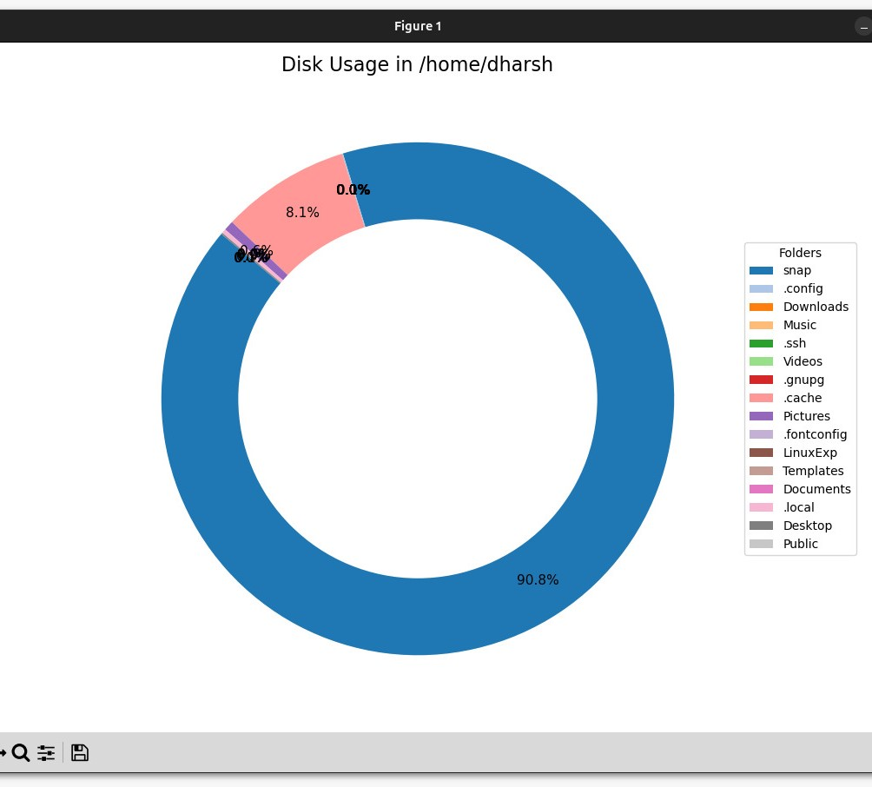

images/disk_usage.png

Figure 4: Pie Chart - Disk Usage in Home Directory

# Conclusion

This assignment introduced key aspects of Linux system usage, VM configuration, and scripting. Tasks such as automated backups, service analysis, and cron jobs provided realistic DevOps exposure.