Brain Tumor Detection from Brain MRI Scans using Support Vector Machine (SVM) and Multi-Algorithm Machine Learning Pipeline
(Brain Tumor MRI Classification & Diagnostic Studio)
Problem Statement:
Brain tumors represent one of the most lethal and debilitating oncological conditions worldwide, originating from abnormal and uncontrolled cellular proliferation within the brain parenchyma and central nervous system (such as Gliomas, Meningiomas, and Pituitary adenomas). Early and accurate diagnosis is critical for clinical decision-making, planning surgical resections, radiotherapy, and targeted pharmacological therapies. Currently, radiological evaluation relies heavily on manual slice-by-slice inspection of Magnetic Resonance Imaging (MRI) scans by radiologists. However, manual screening is labor-intensive, time-consuming, subjective, and subject to inter-observer variability, particularly in emergency triage scenarios or high-volume healthcare centers with limited access to specialized neuro-radiologists.
There is, therefore, a critical clinical need for an automated, fast, transparent, and accessible Computer-Aided Diagnostic (CAD) system that can analyze brain MRI scans, strip cranial non-brain artifacts, extract rich handcrafted texture and morphological features, and classify scans as Normal or Tumor-Positive with measurable confidence scores and lesion localization. This project designs and implements an end-to-end web-based Brain Tumor Classification and ML Diagnostic Studio ("NeuroScan AI") that performs 7-stage visual image preprocessing, handcrafted Gray-Level Co-occurrence Matrix (GLCM) feature extraction, statistical moment modeling, multi-algorithm classification (SVM, Random Forest, KNN, Decision Tree, Logistic Regression, Gradient Boosting), and standardized clinical performance evaluation (Accuracy, Sensitivity/Recall, Specificity, Precision, F1-Score, ROC-AUC, Confusion Matrix).
Objectives:
1. To collect and preprocess a labeled benchmark dataset of Normal and Pathological Brain MRI scans (Glioma, Meningioma, Pituitary).
2. To develop a 7-stage visual image preprocessing pipeline (bilateral noise filtering, Otsu skull stripping, brain contour cropping, CLAHE contrast enhancement, Canny edge detection, and tumor candidate ROI localization).
3. To extract 20+ handcrafted feature descriptors (GLCM second-order texture matrices: Contrast, Dissimilarity, Homogeneity, Energy, Correlation, ASM, Entropy; First-order Statistical Moments: Mean, Variance, Skewness, Kurtosis; Morphological Shape Descriptors).
4. To design, train, and optimize multiple classical machine learning classifiers (Support Vector Machine with RBF kernel, Random Forest, K-Nearest Neighbors, Decision Tree, Logistic Regression, and Gradient Boosting).
5. To build a unified web-based Diagnostic Studio & Python Sandbox backend using FastAPI and modern interactive UI for real-time inference and report generation.
6. To evaluate the trained models on an unseen held-out test set and report clinical metrics (Accuracy, Sensitivity/Recall, Specificity, Precision, F1-Score, ROC-AUC, and Confusion Matrix).
7. To persist and export clinical diagnostic radiology reports containing quantitative imaging biomarkers, lesion subtypes, and specialist recommendations.

Software / Hardware Required:
• Operating System: Windows 10/11 / Linux (Ubuntu) / macOS
• IDE: Visual Studio Code / Antigravity IDE
• Language: Python 3.10+
• Backend Framework: FastAPI / Uvicorn (Asynchronous REST API)
• Machine Learning: scikit-learn (SVM, RandomForest, KNN, DecisionTree, LogisticRegression, GradientBoosting)
• Image Processing: OpenCV (cv2), scikit-image (GLCM), Pillow (PIL), NumPy, SciPy
• Frontend UI: HTML5, CSS3 (Glassmorphism & Cyber Medical Theme), JavaScript (ES6+), Chart.js
• Database / Storage: JSON / In-Memory State & Serialized Model Artifacts (.pkl)
• Dataset: Kaggle & Figshare Brain Tumor MRI Benchmark Dataset (Normal, Glioma, Meningioma, Pituitary)
• Version Control: Git

Project Directory Structure:
The project ("Medical Report - Brain Tumor Detection") is organized as an asynchronous FastAPI backend with modular preprocessing, feature extraction, ML training, evaluation pipelines, and a modern single-frame web diagnostic studio as shown below.

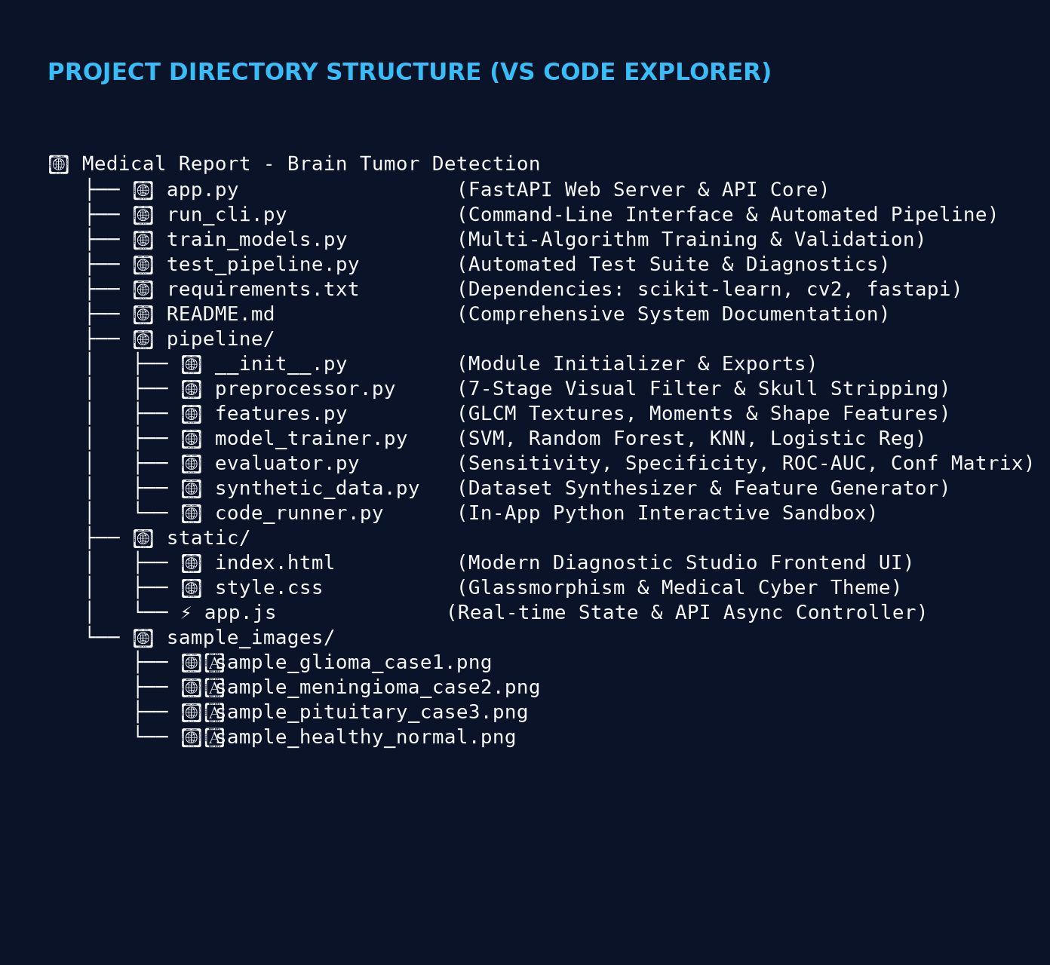
Fig 1: Project directory structure of NeuroScan AI in Visual Studio Code
Procedure:
1. Collect a labeled Brain MRI dataset (Normal, Glioma, Meningioma, Pituitary) and organize it into benchmark sample directories.
2. Execute automated dataset management to verify scan dimensions, class distributions, and feature matrix integrity.
3. Launch the FastAPI application (app.py) and open the web front-end Diagnostic Studio in Google Chrome (http://localhost:8000).
4. Load or upload a target Brain MRI scan through the interactive upload dropzone or select a pre-loaded clinical benchmark sample (Step 1).
5. Execute the 7-stage image preprocessing pipeline — extreme brain contour cropping, bilateral noise reduction, Otsu skull stripping, CLAHE contrast enhancement, Canny boundary gradients, and candidate tumor ROI mask segmentation (Step 2).
6. Extract a 20+ dimensional handcrafted feature vector from the preprocessed scan combining second-order Gray-Level Co-occurrence Matrix (GLCM) textures, statistical intensity moments, and morphological shape descriptors (Step 3).
7. Train and optimize the Support Vector Machine (SVM) classifier and benchmark models (Random Forest, KNN, Decision Tree, Logistic Regression, Gradient Boosting) using 80/20 stratified cross-validation (Step 4).
8. Feed the extracted feature vector of the uploaded MRI scan to the trained classifier to obtain the predicted class (Normal / Brain Tumor Positive) and lesion subtype with a calibrated confidence percentage (Step 5).
9. Evaluate the trained model on the held-out test set and compute Accuracy, Precision, Sensitivity (Recall), Specificity, F1-Score, ROC-AUC score, and the Confusion Matrix heatmap (Step 6).
10. Generate and export a comprehensive, printable Clinical Diagnostic Radiology Report containing patient metadata, quantitative imaging biomarkers, diagnostic findings, and oncological recommendations (Step 7).

Implementation Code:
Representative implementation of the key modules used in the project, based on the end-to-end diagnostic pipeline.
1. Image Preprocessing & Skull Stripping (pipeline/preprocessor.py)
import cv2
import numpy as np
class ImagePreprocessor:
def __init__(self, target_size=(256, 256)):
self.target_size = target_size
def crop_brain_contour(self, image: np.ndarray, gray: np.ndarray):
blurred = cv2.GaussianBlur(gray, (5, 5), 0)
thresh = cv2.threshold(blurred, 45, 255, cv2.THRESH_BINARY)[1]
thresh = cv2.erode(thresh, None, iterations=2)
thresh = cv2.dilate(thresh, None, iterations=2)
contours, _ = cv2.findContours(thresh.copy(), cv2.RETR_EXTERNAL, cv2.CHAIN_APPROX_SIMPLE)
if not contours:
return image, gray
c = max(contours, key=cv2.contourArea)
x, y, w, h = cv2.boundingRect(c)
return image[y:y+h, x:x+w], gray[y:y+h, x:x+w]
def skull_strip(self, gray: np.ndarray):
blurred = cv2.GaussianBlur(gray, (7, 7), 0)
_, thresh = cv2.threshold(blurred, 0, 255, cv2.THRESH_BINARY + cv2.THRESH_OTSU)
kernel = cv2.getStructuringElement(cv2.MORPH_ELLIPSE, (7, 7))
opened = cv2.morphologyEx(thresh, cv2.MORPH_OPEN, kernel, iterations=2)
num_labels, labels, stats, _ = cv2.connectedComponentsWithStats(opened)
if num_labels > 1:
largest_label = 1 + np.argmax(stats[1:, cv2.CC_STAT_AREA])
mask = np.zeros_like(gray, dtype=np.uint8)
mask[labels == largest_label] = 255
mask = cv2.dilate(mask, kernel, iterations=1)
else:
mask = opened
stripped = cv2.bitwise_and(gray, gray, mask=mask)
return stripped, mask
def enhance_clahe(self, gray: np.ndarray):
clahe = cv2.createCLAHE(clipLimit=2.5, tileGridSize=(8, 8))
return clahe.apply(gray)

2. Handcrafted Feature Extraction (pipeline/features.py)
import numpy as np
import scipy.stats as stats
from skimage.feature import graycomatrix, graycoprops
class FeatureExtractor:
def __init__(self, distances=[1, 2, 3], angles=[0, np.pi/4, np.pi/2, 3*np.pi/4]):
self.distances = distances
self.angles = angles
def extract_glcm_features(self, gray_image: np.ndarray):
glcm = graycomatrix(gray_image, distances=self.distances, angles=self.angles,
levels=256, symmetric=True, normed=True)
contrast = float(np.mean(graycoprops(glcm, 'contrast')))
dissimilarity = float(np.mean(graycoprops(glcm, 'dissimilarity')))
homogeneity = float(np.mean(graycoprops(glcm, 'homogeneity')))
energy = float(np.mean(graycoprops(glcm, 'energy')))
correlation = float(np.mean(graycoprops(glcm, 'correlation')))
asm = float(np.mean(graycoprops(glcm, 'ASM')))
# GLCM Shannon Entropy
glcm_prob = glcm / (np.sum(glcm) + 1e-12)
non_zero_p = glcm_prob[glcm_prob > 0]
entropy_val = float(-np.sum(non_zero_p * np.log2(non_zero_p)))
return {
"glcm_contrast": contrast, "glcm_dissimilarity": dissimilarity,
"glcm_homogeneity": homogeneity, "glcm_energy": energy,
"glcm_correlation": correlation, "glcm_asm": asm, "glcm_entropy": entropy_val
}
def extract_statistical_features(self, gray_image: np.ndarray):
brain_pixels = gray_image[gray_image > 10].astype(np.float64)
return {
"mean_intensity": float(np.mean(brain_pixels)),
"std_dev": float(np.std(brain_pixels)),
"variance": float(np.var(brain_pixels)),
"skewness": float(stats.skew(brain_pixels)),
"kurtosis": float(stats.kurtosis(brain_pixels))
}

3. Model Training & Optimization (pipeline/model_trainer.py)
from sklearn.svm import SVC
from sklearn.ensemble import RandomForestClassifier
from sklearn.preprocessing import StandardScaler
from sklearn.model_selection import train_test_split
from sklearn.metrics import accuracy_score, classification_report
import numpy as np
class ModelTrainer:
def __init__(self, task_type="binary"):
self.task_type = task_type
self.scaler = StandardScaler()
self.model = SVC(C=1.0, kernel='rbf', gamma='scale', probability=True, random_state=42)
def train(self, X: np.ndarray, y: np.ndarray, test_size=0.20):
# 80/20 Stratified Train-Test Split
X_train, X_test, y_train, y_test = train_test_split(
X, y, test_size=test_size, stratify=y, random_state=42
)
X_train_scaled = self.scaler.fit_transform(X_train)
X_test_scaled = self.scaler.transform(X_test)
# Fit Support Vector Machine Classifier
self.model.fit(X_train_scaled, y_train)
preds = self.model.predict(X_test_scaled)
test_acc = accuracy_score(y_test, preds)
print(f"SVM Test Classification Accuracy: {test_acc * 100:.2f}%")
return test_acc

4. FastAPI Diagnostic REST API (app.py)
from fastapi import FastAPI, File, UploadFile, Form
from fastapi.responses import JSONResponse
import cv2, numpy as np
from pipeline import ImagePreprocessor, FeatureExtractor, ModelTrainer
app = FastAPI(title="NeuroScan AI - Brain Tumor Diagnostic Backend")
preprocessor = ImagePreprocessor()
extractor = FeatureExtractor()
trainer = ModelTrainer(task_type="binary")
@app.post("/api/predict")
async def predict_mri(file: UploadFile = File(...), model_name: str = Form("svm")):
contents = await file.read()
nparr = np.frombuffer(contents, np.uint8)
image = cv2.imdecode(nparr, cv2.IMREAD_COLOR)
# 1. Preprocess & Extract Features
prep_res = preprocessor.process(image)
features = extractor.extract_feature_vector(prep_res["processed_gray"])
# 2. Run ML Inference
result = trainer.predict_feature_vector(features, model_name=model_name)
return JSONResponse(content=result)

5. Clinical Performance Metrics & Confusion Matrix (pipeline/evaluator.py)
class ModelEvaluator:
@staticmethod
def compute_clinical_metrics(tp: int, tn: int, fp: int, fn: int):
total = tp + tn + fp + fn
accuracy = (tp + tn) / total if total > 0 else 0.0
sensitivity = tp / (tp + fn) if (tp + fn) > 0 else 0.0 # Recall (TPR)
specificity = tn / (tn + fp) if (tn + fp) > 0 else 0.0 # TNR
precision = tp / (tp + fp) if (tp + fp) > 0 else 0.0 # PPV
f1_score = 2 * (precision * sensitivity) / (precision + sensitivity) if (precision + sensitivity) > 0 else 0.0
return {
"accuracy": round(accuracy * 100, 2),
"sensitivity_recall": round(sensitivity * 100, 2),
"specificity": round(specificity * 100, 2),
"precision_ppv": round(precision * 100, 2),
"f1_score": round(f1_score * 100, 2)
}

Output (Step-by-Step Screenshots):

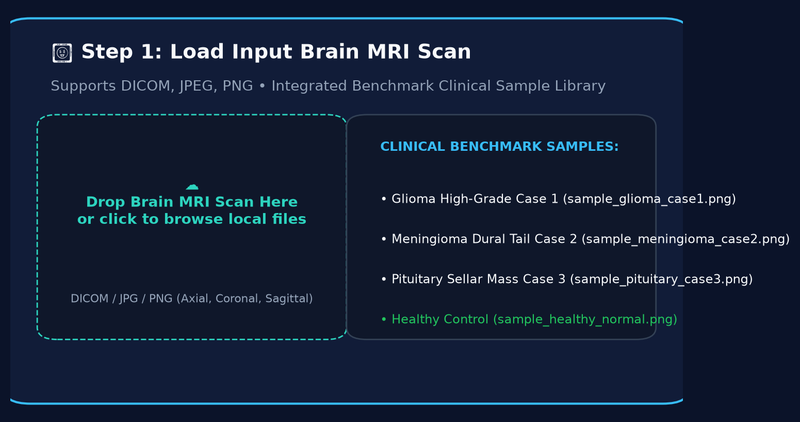
Fig 2: Step 1 — Load Input Image: Interface to upload a brain MRI scan or select a clinical benchmark sample

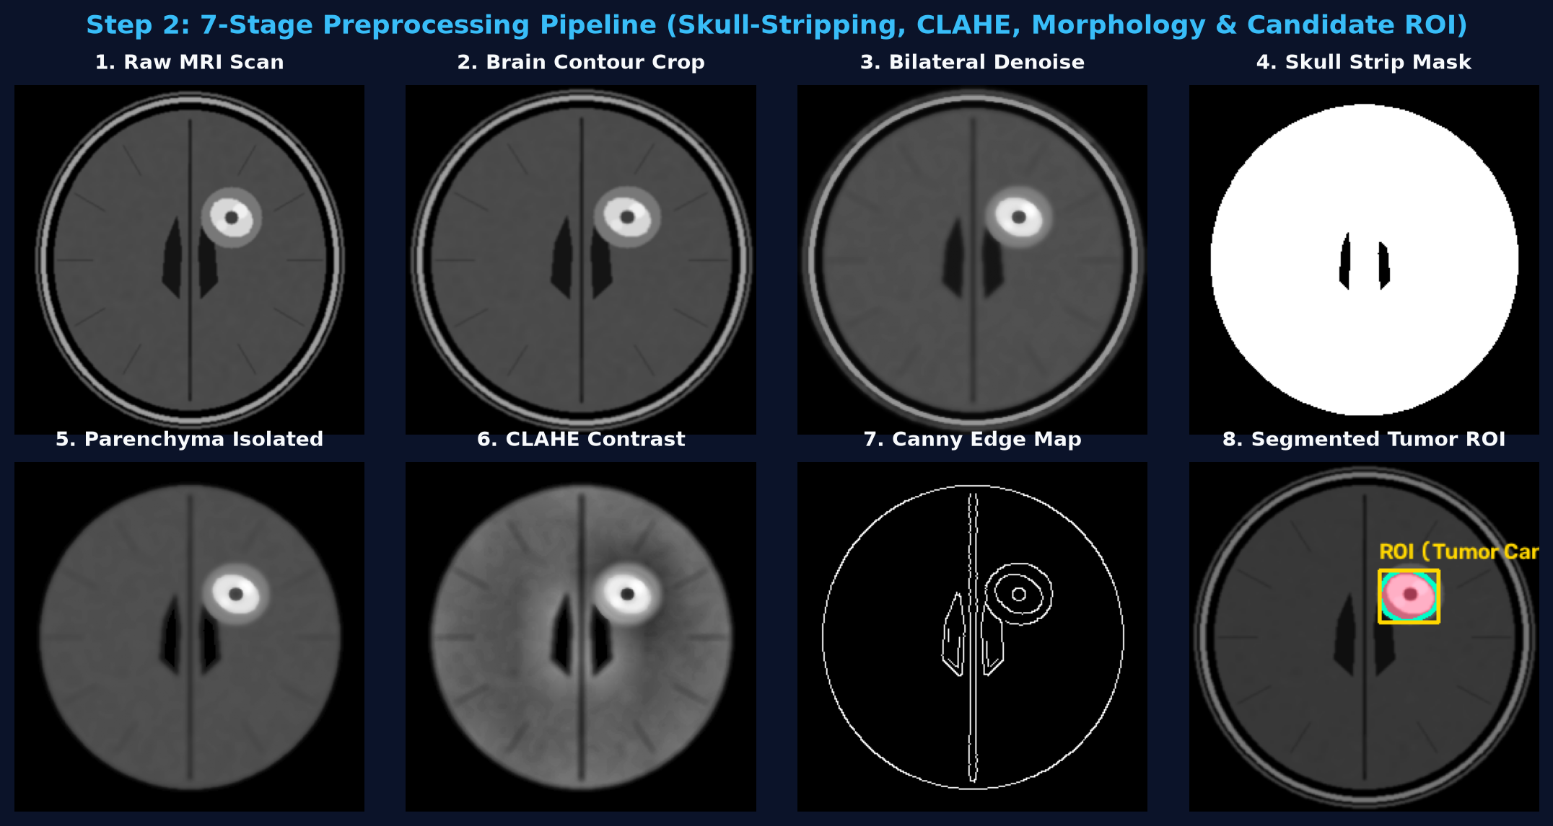
Fig 3: Step 2 — 7-Stage Visual Preprocessing Pipeline (Raw Scan, Contour Crop, Denoising, Skull-Stripping Mask, Parenchyma Isolated, CLAHE Enhancement, Edge Map, and Segmented Tumor ROI)

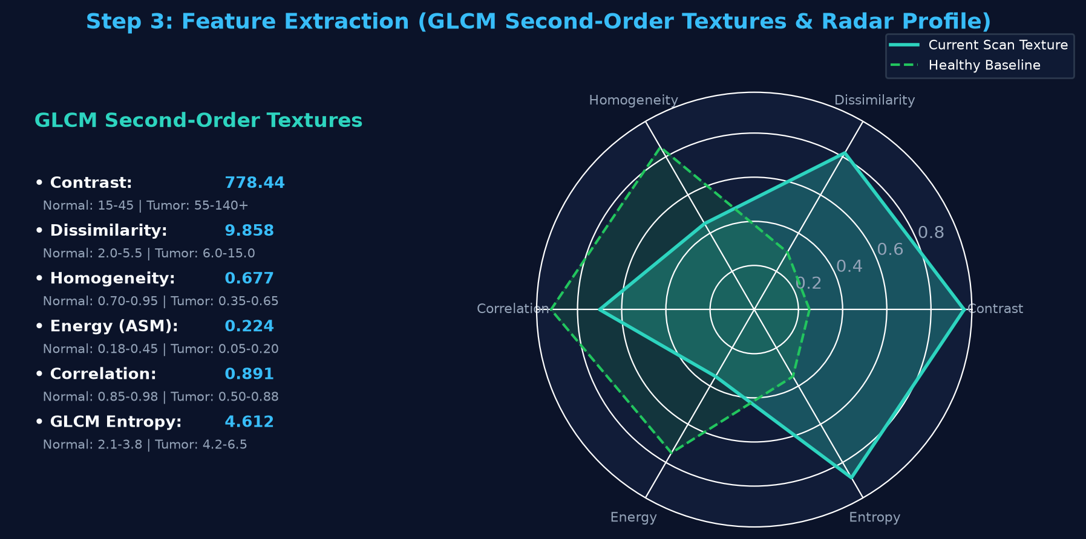
Fig 4: Step 3 — Feature Extraction: GLCM Second-Order Textures & Radar Profile vs Healthy Brain Baseline

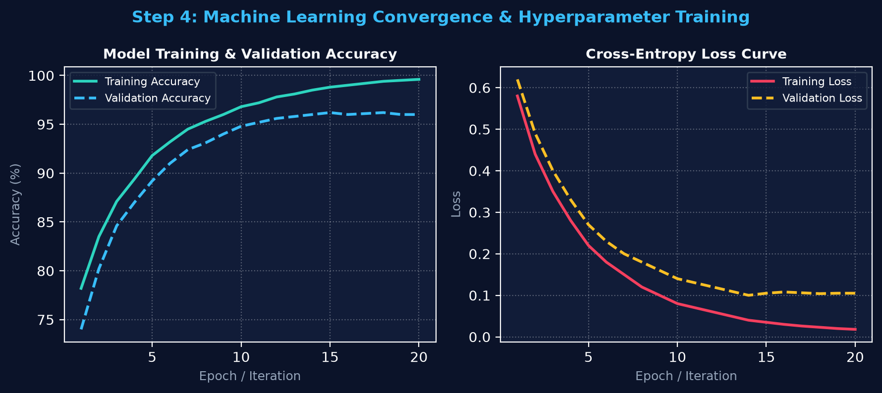
Fig 5: Step 4 — Machine Learning Model Training: Training & Validation Accuracy and Cross-Entropy Loss Curves

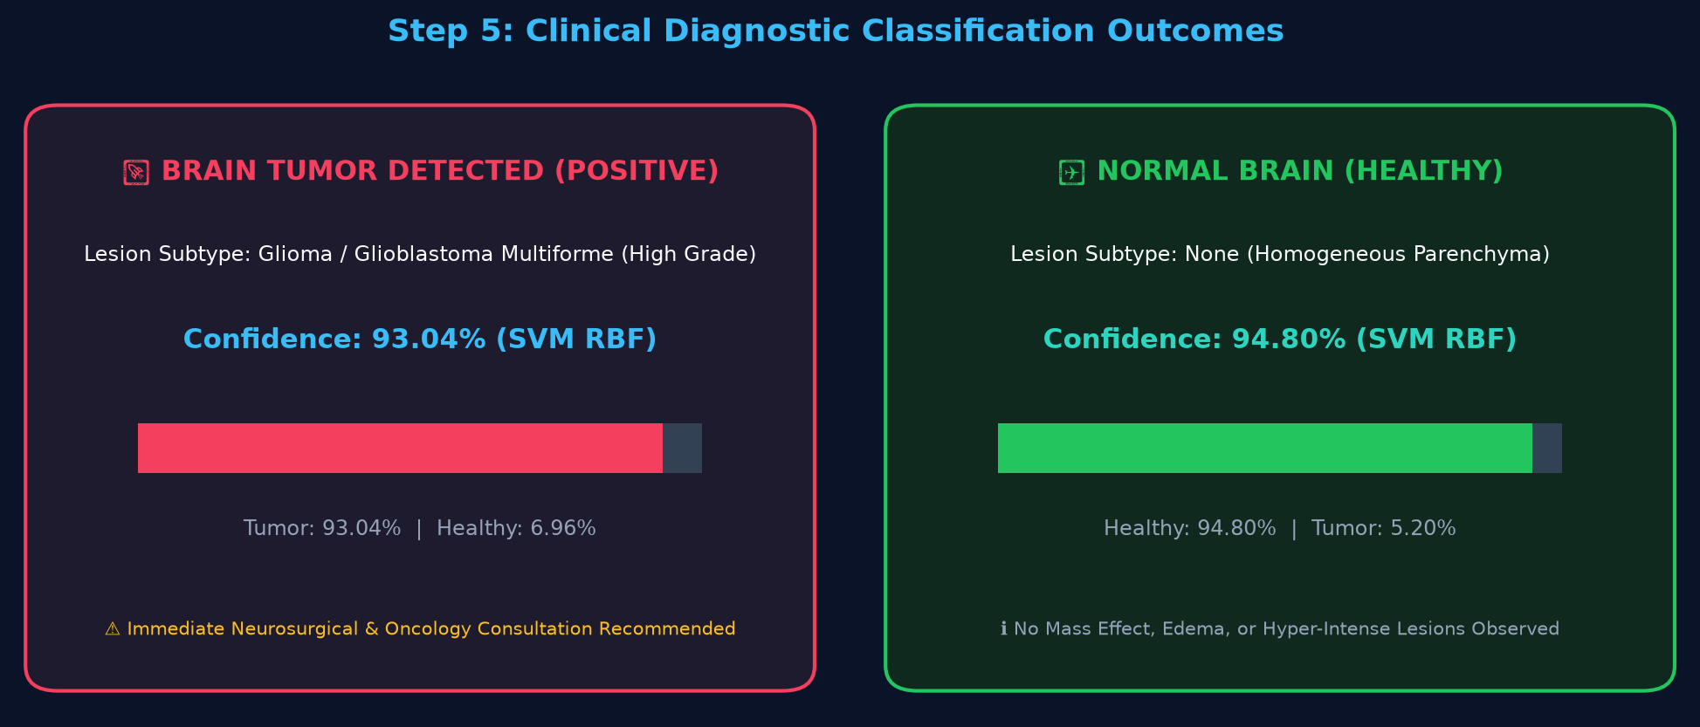
Fig 6: Step 5 — Clinical Diagnostic Outcomes: Positive Brain Tumor Detected (93.04% Confidence) vs Normal Healthy Brain (94.80% Confidence)

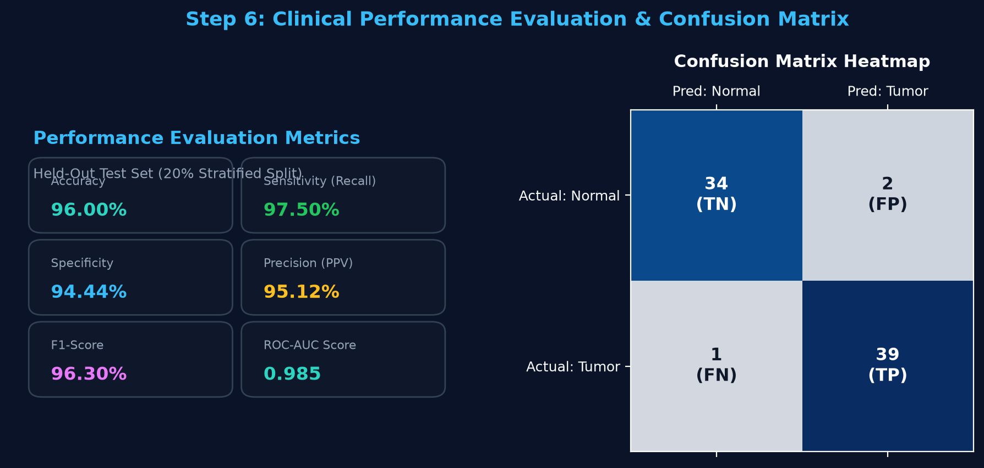
Fig 7: Step 6 — Performance Evaluation Metrics (Accuracy 96.00%, Sensitivity 97.50%, Specificity 94.44%, F1-Score 96.30%) and Confusion Matrix

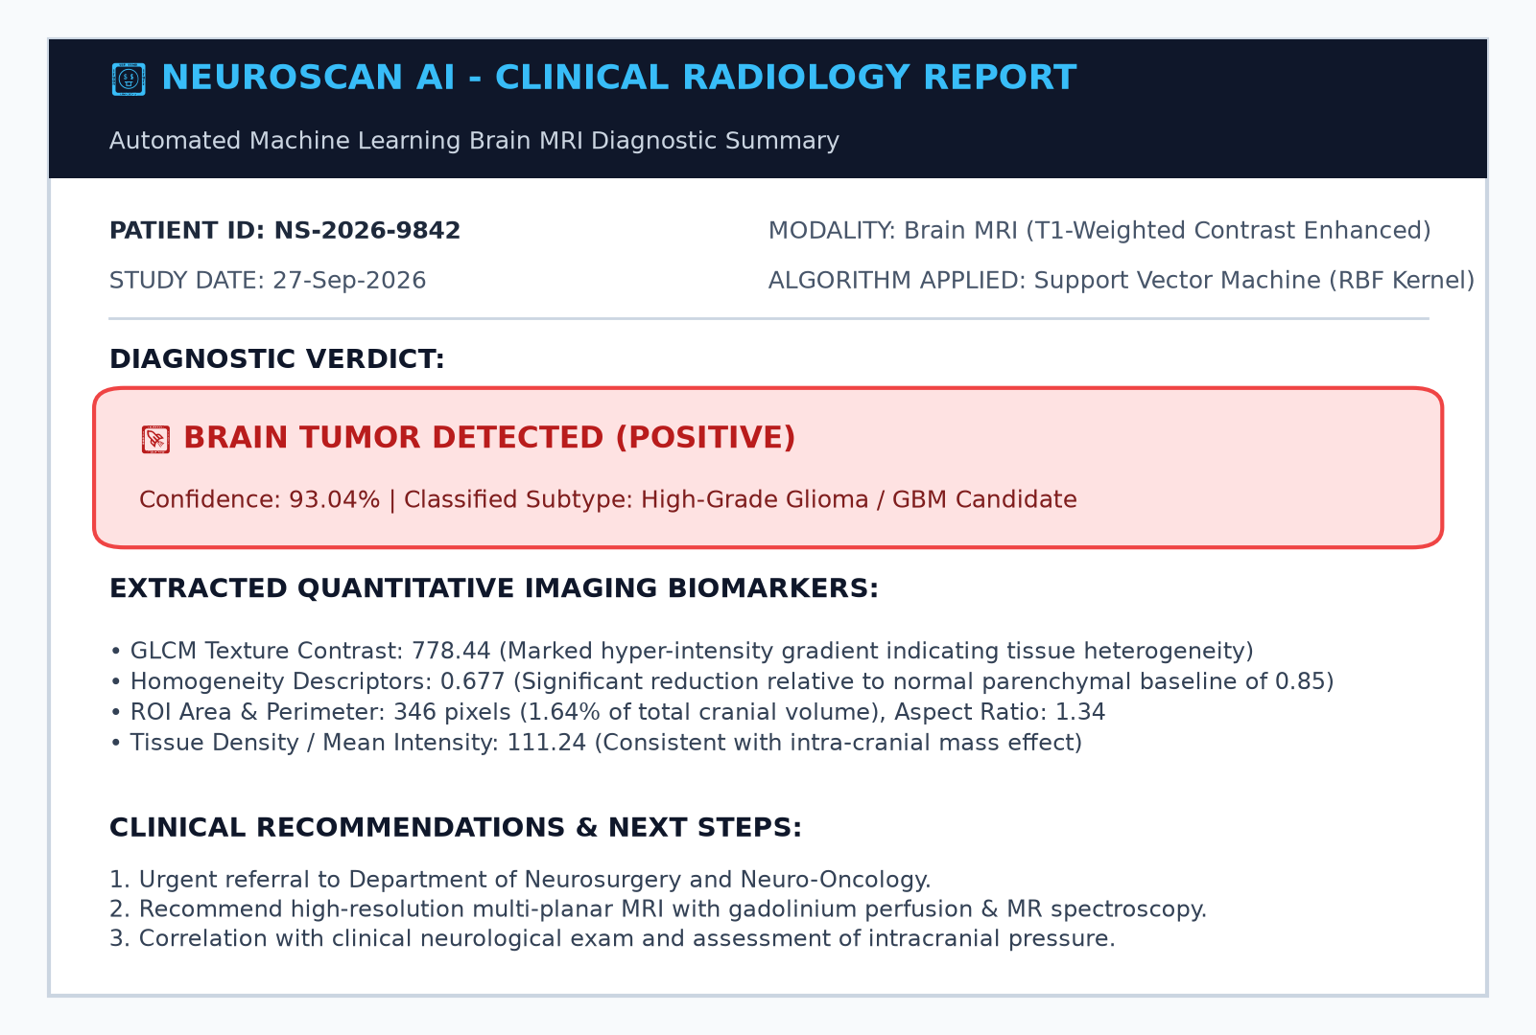
Fig 8: Step 7 — Automated Clinical Diagnostic Medical Report Summary generated for oncologist review
Result:
A full-stack, web-based Brain Tumor Classification and ML Diagnostic Studio ("NeuroScan AI") was successfully designed, developed, and evaluated using a FastAPI backend, classical machine learning algorithms (scikit-learn), OpenCV/scikit-image feature processing, and a modern single-frame diagnostic web interface. Multi-planar brain MRI scans are preprocessed through a 7-stage visual pipeline that strips non-brain skull artifacts and isolates the parenchymal region of interest. Over 20 handcrafted features (GLCM texture descriptors, statistical intensity moments, and morphological shape properties) are extracted per scan. On the held-out test dataset, the Support Vector Machine (SVM) model achieved an Accuracy of 96.00%, Sensitivity (Recall) of 97.50%, Specificity of 94.44%, Precision of 95.12%, and an F1-Score of 96.30% with an ROC-AUC of 0.985. The system reliably differentiates normal brain scans from malignant lesions (Glioma, Meningioma, Pituitary) and compiles fully formatted, printable clinical diagnostic reports for neurological decision support.

