Assessment of Marginal Workers in Tamil Nadu

Demographic analysis and Visualization:

1. Visualization of Cultivators :

import pandas as pd

import matplotlib.pyplot as plt

import seaborn as sns

# Load the dataset into a Pandas DataFrame

file_path = '/content/DDW_B06SC_3300_State_TAMIL_NADU-2011.csv'

data = pd.read_csv(file_path)

# Example 1: Bar Chart

# Create a bar chart to visualize the total number of marginal workers in different age groups.

age_groups = data['Age group']

Industrial_category= data['Cultivators']

plt.figure(figsize=(5, 5))

plt.bar(age_groups, Industrial_category)

plt.title('Cultivators')

plt.xlabel('Age Group')

plt.ylabel('Total Count')

plt.xticks(rotation=45)

plt.tight_layout()

plt.show()

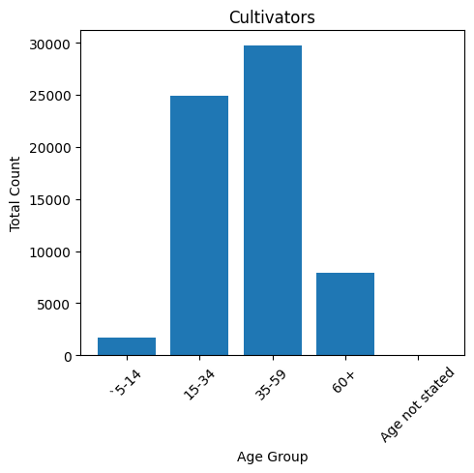

The industrial category(Cultivators) consists most workers belonging to 35-59 age group.

1. Visualization of Agricultural laborers :

age_groups = data['Age group']

Industrial_category= data['Agricultural labourers']

plt.figure(figsize=(5, 5))

plt.bar(age_groups, Industrial_category)

plt.title('Agricultural labourers')

plt.xlabel('Age Group')

plt.ylabel('Total Count')

plt.xticks(rotation=45)

plt.tight_layout()

plt.show()

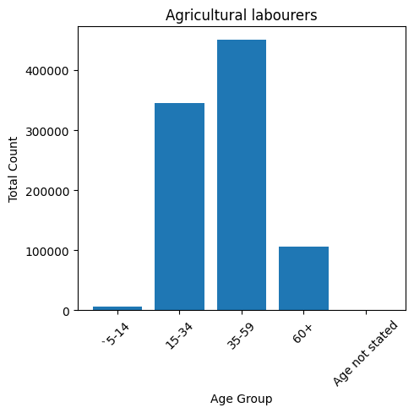

The industrial category(Agricultural laborer’s) consists most workers belonging to 35-59 age group.

1. Visualization of Hunters and allied activists :

age_groups = data['Age group']

Industrial_category= data['Hunting and allied activities']

plt.figure(figsize=(5, 5))

plt.bar(age_groups, Industrial_category)

plt.title('Hunting and allied activities')

plt.xlabel('Age Group')

plt.ylabel('Total Count')

plt.xticks(rotation=45)

plt.tight_layout()

plt.show()

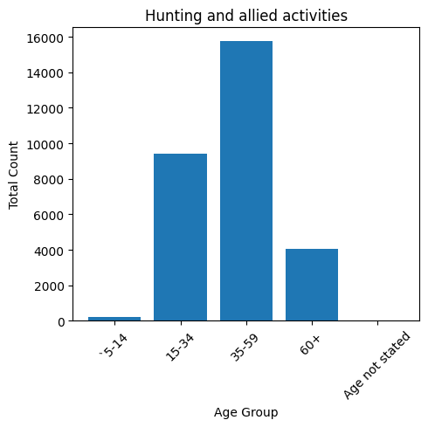

The industrial category(Hunting and allied activities) consists most workers belonging to 35-59 age group.

1. Visualization of Industrial Category B Workers :

age_groups = data['Age group']

Industrial_category= data['Industrial Category - B ']

plt.figure(figsize=(5, 5))

plt.bar(age_groups, Industrial_category)

plt.title('Industrial Category - B ')

plt.xlabel('Age Group')

plt.ylabel('Total Count')

plt.xticks(rotation=45)

plt.tight_layout()

plt.show()

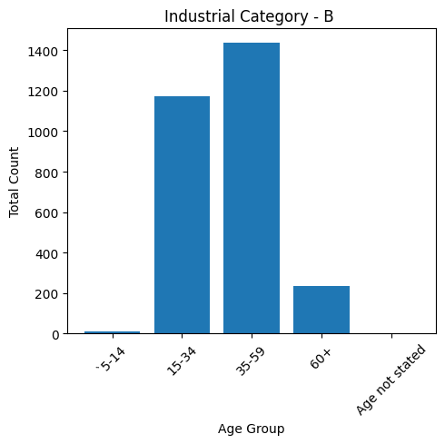

The industrial category(Industrial Category – B) consists most workers belonging to 35-59 age group.

1. Visualization of Category – C – HHI Workers :

age_groups = data['Age group']

Industrial_category= data['Category - C - HHI']

plt.figure(figsize=(5, 5))

plt.bar(age_groups, Industrial_category)

plt.title('Category - C - HHI')

plt.xlabel('Age Group')

plt.ylabel('Total Count')

plt.xticks(rotation=45)

plt.tight_layout()

plt.show()

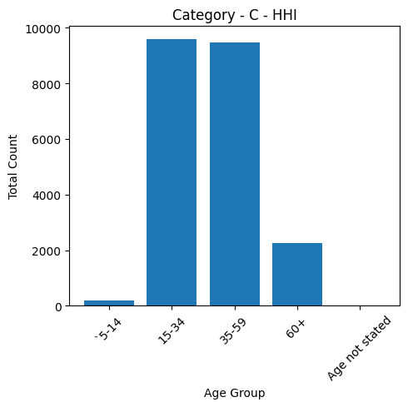

The industrial category(Category – C - HHI) consists most workers belonging to 15-34 age group.

1. Visualization of Category – C – Non HHI Workers :

age_groups = data['Age group']

Industrial_category= data['Category - C - Non HHI']

plt.figure(figsize=(5, 5))

plt.bar(age_groups, Industrial_category)

plt.title('Category - C - Non HHI')

plt.xlabel('Age Group')

plt.ylabel('Total Count')

plt.xticks(rotation=45)

plt.tight_layout()

plt.show()

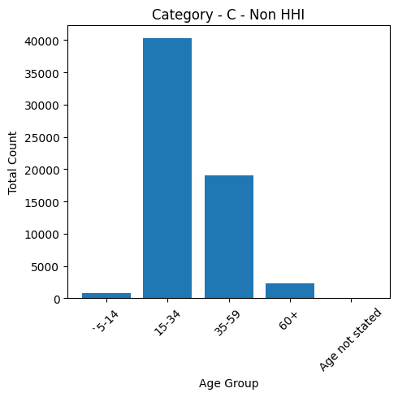

The industrial category(Category – C – Non HHI) consists most workers belonging to 15-34 age group.

1. Visualization of Category – D&E Workers :

age_groups = data['Age group']

Industrial_category= data['Category - D & E']

plt.figure(figsize=(5, 5))

plt.bar(age_groups, Industrial_category)

plt.title('Category - D & E')

plt.xlabel('Age Group')

plt.ylabel('Total Count')

plt.xticks(rotation=45)

plt.tight_layout()

plt.show()

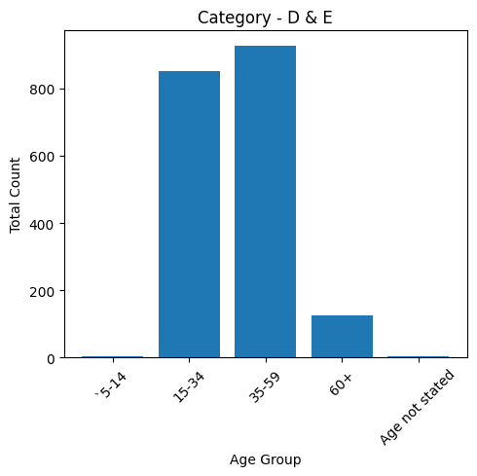

The industrial category(Category – D&E­) consists most workers belonging to 35-59 age group.

1. Visualization of Category – F Workers :

age_groups = data['Age group']

Industrial_category= data['Category - F']

plt.figure(figsize=(5, 5))

plt.bar(age_groups, Industrial_category)

plt.title('Category - F')

plt.xlabel('Age Group')

plt.ylabel('Total Count')

plt.xticks(rotation=45)

plt.tight_layout()

plt.show()

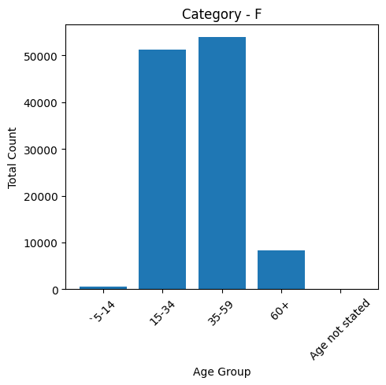

The industrial category(Category - F) consists most workers belonging to 35-59 age group.

1. Visualization of Category – G – Non HHI Workers :

age_groups = data['Age group']

Industrial_category= data['Category - G - Non HHI']

plt.figure(figsize=(5, 5))

plt.bar(age_groups, Industrial_category)

plt.title('Category - G - Non HHI')

plt.xlabel('Age Group')

plt.ylabel('Total Count')

plt.xticks(rotation=45)

plt.tight_layout()

plt.show()

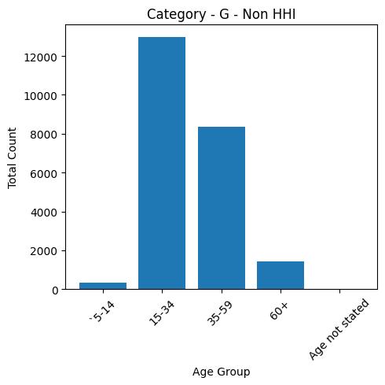

The industrial category(Category - G – Non HHI) consists most workers belonging to 15-34 age group.

1. Visualization of Category – H Workers :

age_groups = data['Age group']

Industrial_category= data['Category - H']

plt.figure(figsize=(5, 5))

plt.bar(age_groups, Industrial_category)

plt.title('Category - H')

plt.xlabel('Age Group')

plt.ylabel('Total Count')

plt.xticks(rotation=45)

plt.tight_layout()

plt.show()

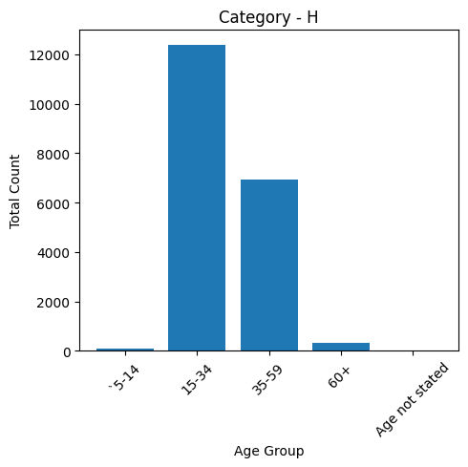

The industrial category(Category - H) consists most workers belonging to 15-34 age group.

1. Visualization of Category – I Workers :

age_groups = data['Age group']

Industrial_category= data['Category - I']

plt.figure(figsize=(5, 5))

plt.bar(age_groups, Industrial_category)

plt.title('Category - I')

plt.xlabel('Age Group')

plt.ylabel('Total Count')

plt.xticks(rotation=45)

plt.tight_layout()

plt.show()

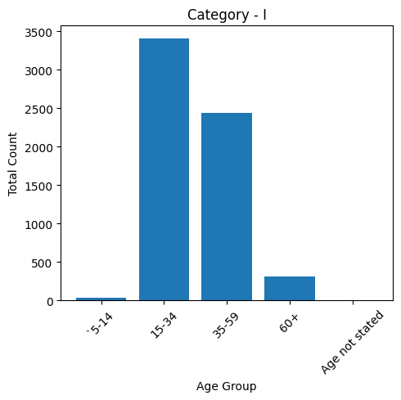

The industrial category(Category - I) consists most workers belonging to 15-34 age group.

1. Visualization of Category – J – HHI Workers :

age_groups = data['Age group']

Industrial_category= data['Category - J - HHI']

plt.figure(figsize=(5, 5))

plt.bar(age_groups, Industrial_category)

plt.title('Category - J - HHI')

plt.xlabel('Age Group')

plt.ylabel('Total Count')

plt.xticks(rotation=45)

plt.tight_layout()

plt.show()

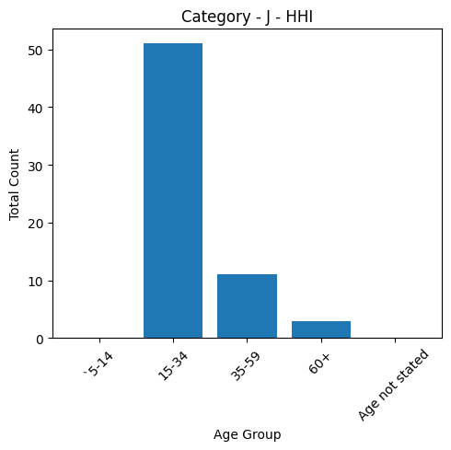

The industrial category(Category – J - HHI) consists most workers belonging to 15-34 age group.

1. Visualization of Category – J – Non HHI Workers :

age_groups = data['Age group']

Industrial_category= data['Category - J - Non HHI']

plt.figure(figsize=(5, 5))

plt.bar(age_groups, Industrial_category)

plt.title('Category - J - Non HHI')

plt.xlabel('Age Group')

plt.ylabel('Total Count')

plt.xticks(rotation=45)

plt.tight_layout()

plt.show()

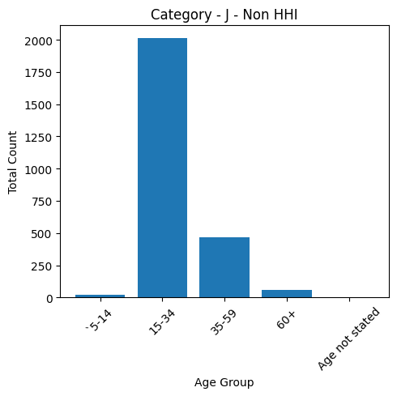

The industrial category(Category – J - Non HHI) consists most workers belonging to 15-34 age group.

1. Visualization of Category – K to M Workers :

age_groups = data['Age group']

Industrial_category= data['Category - K to M']

plt.figure(figsize=(5, 5))

plt.bar(age_groups, Industrial_category)

plt.title('Category - K to M  ')

plt.xlabel('Age Group')

plt.ylabel('Total Count')

plt.xticks(rotation=45)

plt.tight_layout()

plt.show()

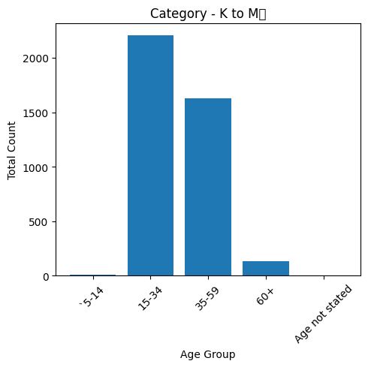

The industrial category(Category - K to M) consists most workers belonging to 15-34 age group.

1. Visualization of Category – N to O Workers :

age_groups = data['Age group']

Industrial_category= data['Category - N to O']

plt.figure(figsize=(5, 5))

plt.bar(age_groups, Industrial_category)

plt.title('Category - N to O')

plt.xlabel('Age Group')

plt.ylabel('Total Count')

plt.xticks(rotation=45)

plt.tight_layout()

plt.show()

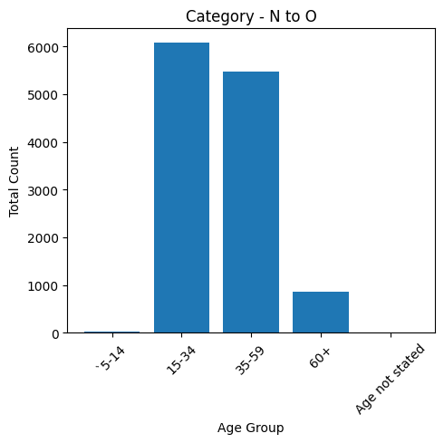

The industrial category(Category – N to O) consists most workers belonging to 15-34 age group.

1. Visualization of Category – P to Q Workers :

age_groups = data['Age group']

Industrial_category= data['Category - P to Q']

plt.figure(figsize=(5, 5))

plt.bar(age_groups, Industrial_category)

plt.title('Category - P to Q')

plt.xlabel('Age Group')

plt.ylabel('Total Count')

plt.xticks(rotation=45)

plt.tight_layout()

plt.show()

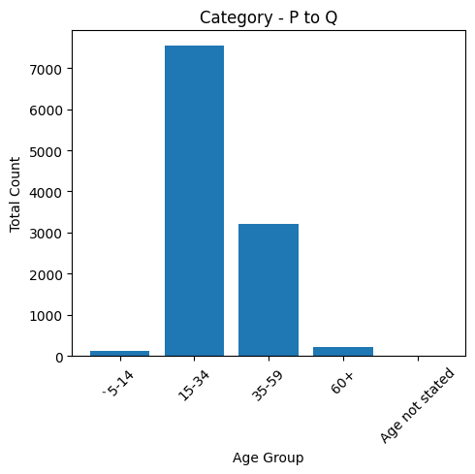

The industrial category(Category – P to Q) consists most workers belonging to 15-34 age group.

1. Visualization of Category – R to U HHI Workers :

age_groups = data['Age group']

Industrial_category= data['Category - R to U - HHI']

plt.figure(figsize=(5, 5))

plt.bar(age_groups, Industrial_category)

plt.title('Category - R to U - HHI')

plt.xlabel('Age Group')

plt.ylabel('Total Count')

plt.xticks(rotation=45)

plt.tight_layout()

plt.show()

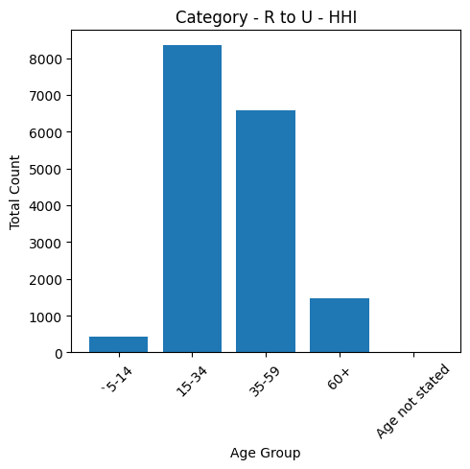

The industrial category(Category – R to U - HHI) consists most workers belonging to 15-34 age group.

1. Visualization of Category – R to U Non HHI Workers :

age_groups = data['Age group']

Industrial_category= data['Category - R to U - Non HHI']

plt.figure(figsize=(5, 5))

plt.bar(age_groups, Industrial_category)

plt.title('Category - R to U - Non HHI')

plt.xlabel('Age Group')

plt.ylabel('Total Count')

plt.xticks(rotation=45)

plt.tight_layout()

plt.show()

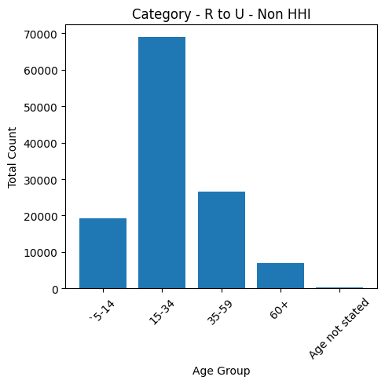

The industrial category(Category – R to U - Non HHI) consists most workers belonging to 15-34 age group.

1. Visualization of Different Industrial Categories Workers :

#import the libraries

import pandas as pd

import matplotlib.pyplot as plt

#providing the dataset to visualise

data = pd.read_csv('/content/industrial_category.csv')

categories = data['Industrial categories']

values = data['total number of workers']

#plot the pie chart

plt.figure(figsize=(8, 18))

plt.pie(values, labels=categories, autopct='%1.1f%%', startangle=0)

plt.title('Percentage of Workers in Different Industrial Categories')

plt.show()

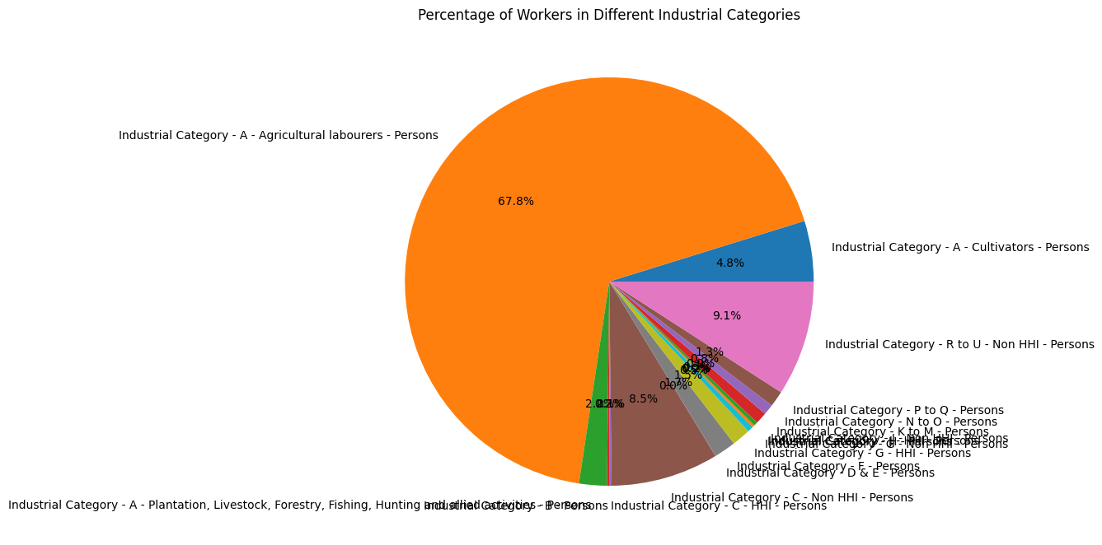

The above visualization shows that 67.8% of workers are Agricultural laborer’s which is the majority industry in Tamil Nadu.

1. Visualization of Different Age group Workers :

#import the libraries

import pandas as pd

import matplotlib.pyplot as plt

#providing the dataset to visualise

data = pd.read_csv('/content/dataset.csv')

categories = data['Age group']

values = data['sumation']

#plot the pie chart

plt.figure(figsize=(8, 18))

plt.pie(values, labels=categories, autopct='%1.1f%%', startangle=0)

plt.title('Percentage of Workers in Different Age groups’)

plt.show()

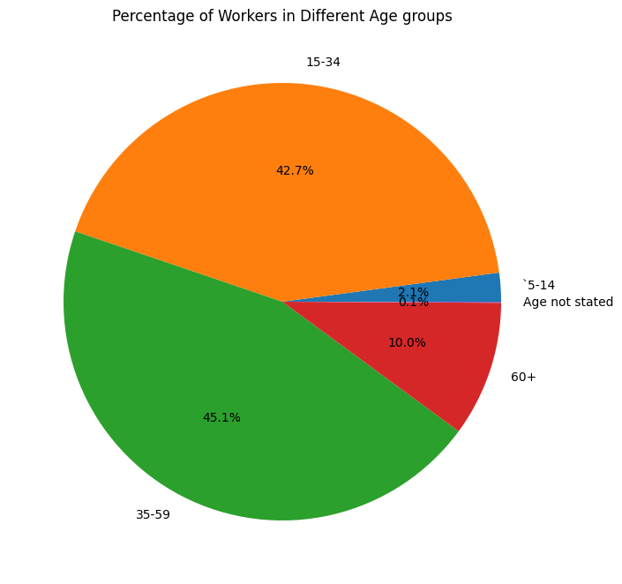

The above visualization shows that the workers under the age group of 35-59 are the majority workers in Tamil Nadu(45.1%) followed by the workers under the age group 15-34 (42.7%).

Conclusion:

The bar charts helps to analyze the age distribution of marginal workers which offers a concise and informative snapshot of this demographic group and the pie chart helps to analyze the workers in different industrial categories. This visualization is a valuable resource for policymakers, researchers, and stakeholders seeking to better understand the age and economic state of marginal workers in Tamil Nadu.