**Task 1: Conditional Statements**

In a bank, you have been given the task is to create a program that checks if a customer is eligible for a loan based on their credit score and income. The eligibility criteria are as follows:

* Credit Score must be above 700.
* Annual Income must be at least $50,000.

**Tasks:**

1. Write a program that takes the customer's credit score and annual income as input.

2. Use conditional statements (if-else) to determine if the customer is eligible for a loan.

3. Display an appropriate message based on eligibility.

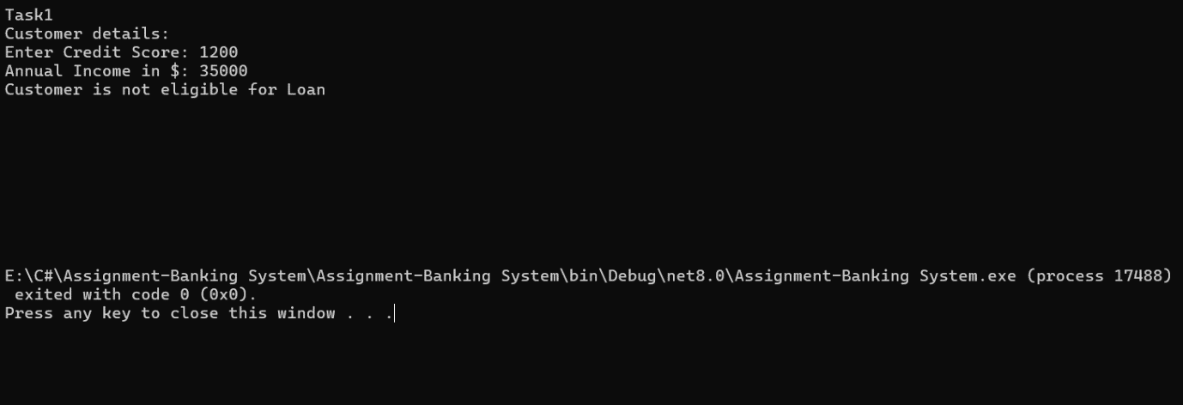

**Task 2: Nested Conditional Statements**

Create a program that simulates an ATM transaction. Display options such as "Check Balance," "Withdraw," "Deposit,". Ask the user to enter their current balance and the amount they want to withdraw or deposit. Implement checks to ensure that the withdrawal amount is not greater than the available balance and that the withdrawal amount is in multiples of 100 or 500. Display appropriate messages for success or failure.

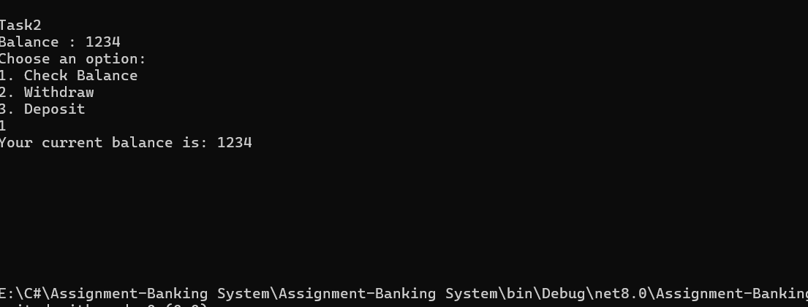

**Task 3: Loop Structures**

You are responsible for calculating compound interest on savings accounts for bank customers. You need to calculate the future balance for each customer's savings account after a certain number of years.

**Tasks:**

1. Create a program that calculates the future balance of a savings account.

2. Use a loop structure (e.g., for loop) to calculate the balance for multiple customers.

3. Prompt the user to enter the initial balance, annual interest rate, and the number of years.

*4.* Calculate the future balance using the formula: *future_balance = initial_balance * (1 + annual_interest_rate/100)^years.*

5. Display the future balance for each customer.

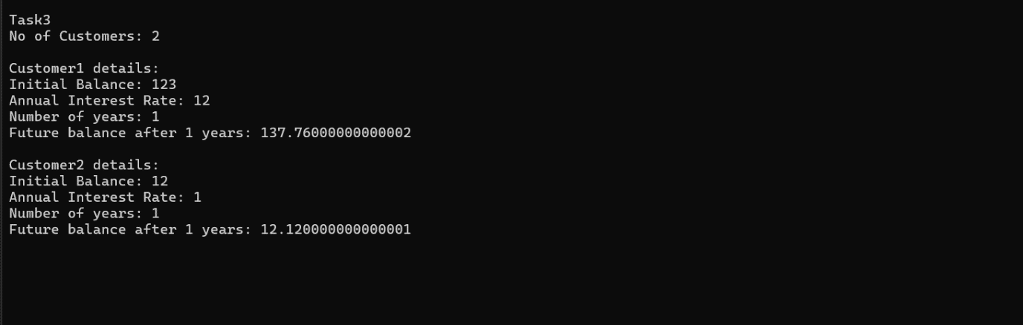

**Task 4: Looping, Array and Data Validation**

You are tasked with creating a program that allows bank customers to check their account balances. The program should handle multiple customer accounts, and the customer should be able to enter their account number, balance to check the balance.

**Tasks:**

1. Create a Python program that simulates a bank with multiple customer accounts.

2. Use a loop (e.g., while loop) to repeatedly ask the user for their account number and balance until they enter a valid account number.

3. Validate the account number entered by the user.

4.If the account number is valid, display the account balance. If not, ask the user to try again.

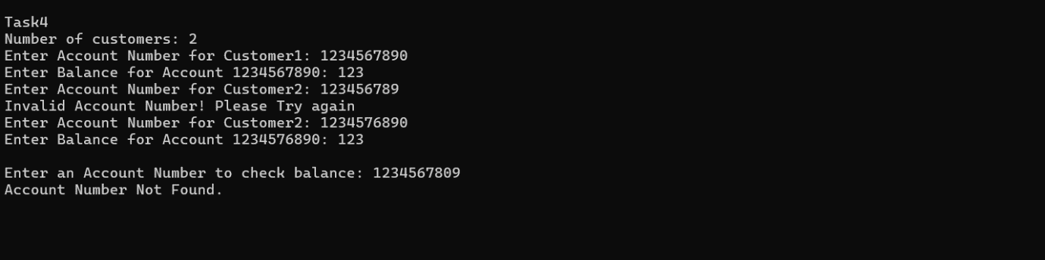

**Task 5: Password Validation**

Write a program that prompts the user to create a password for their bank account. Implement if conditions to validate the password according to these rules:

* The password must be at least 8 characters long.
* It must contain at least one uppercase letter.
* It must contain at least one digit.
* Display appropriate messages to indicate whether their password is valid or not.

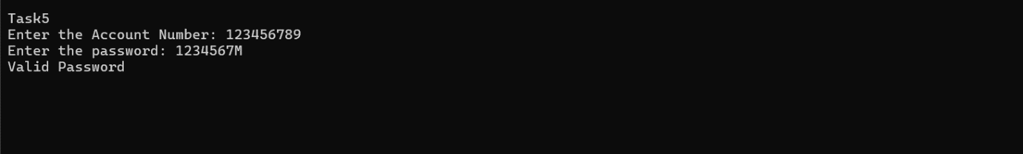

**Task 6: Password Validation**

Create a program that maintains a list of bank transactions (deposits and withdrawals) for a customer. Use a while loop to allow the user to keep adding transactions until they choose to exit. Display the transaction history upon exit using looping statements.

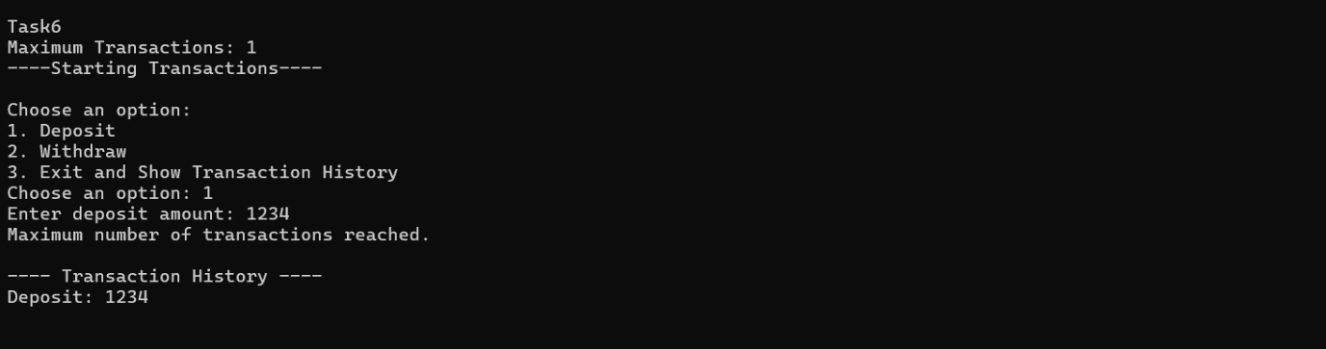

**Task7:**

1. Create a `Customer` class
2. Create an `Account` class
3. Create a Bank class to represent the banking system. Perform the following operation in main method: o create object for account class by calling parameter constructor.
   * 1. o deposit (amount: float): Deposit the specified amount into the account.
     2. o withdraw (amount: float): Withdraw the specified amount from the account.
     3. o calculate _interest (): Calculate and add interest to the account balance for savings accounts.

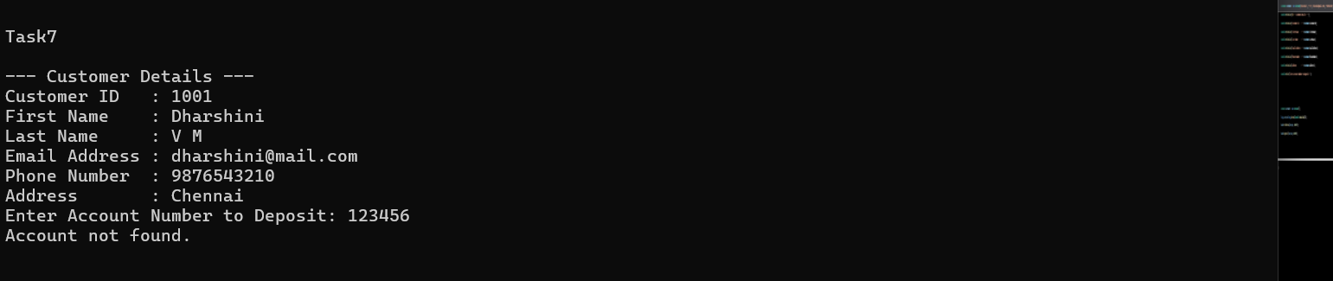

**Task 8: Inheritance and polymorphism**

1. Overload the deposit and withdraw methods in Account class

2.Create Subclasses for Specific Account Types

* + **SavingsAccount**: A savings account that includes an additional attribute for interest rate. **override** the calculate_interest () from Account class method to calculate interest based on the balance and interest rate.
  + **CurrentAccount**: A current account that includes an additional attribute overdraftLimit. A current account with no interest. Implement the withdraw () method to allow overdraft up to a certain limit (configure a constant for the overdraft limit).

1. Create a **Bank** class to represent the banking system. Perform the following operation in main method: Display menu for user to create object for account class by calling parameter constructor. Menu should display options `SavingsAccount` and `CurrentAccount`. user can choose any one option to create account. use switch case for implementation.

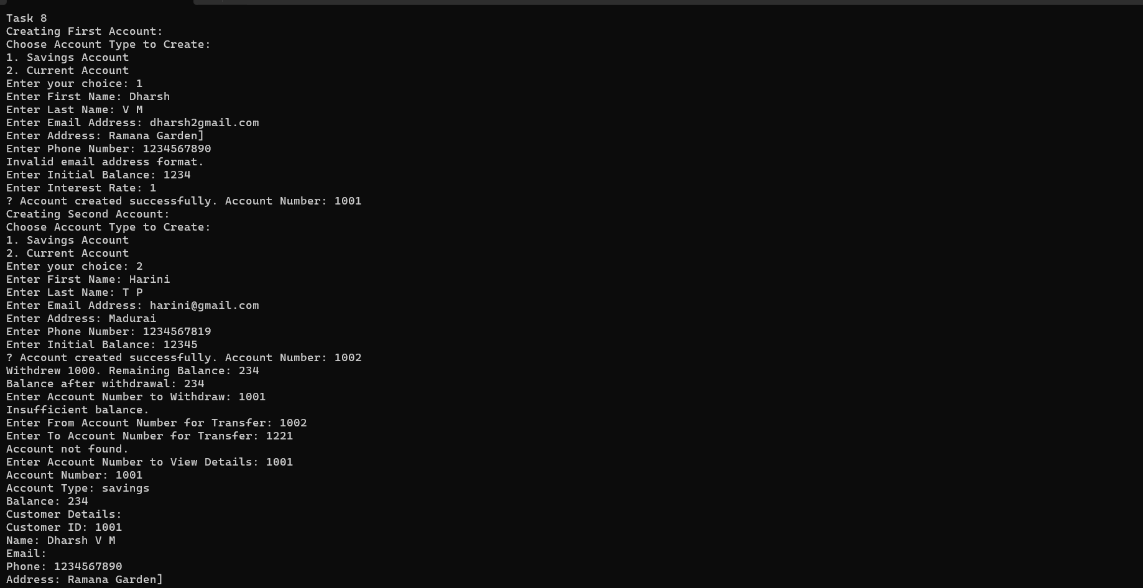

**Task 9: Abstraction**

* + 1. 1. Create an abstract class BankAccount that represents a generic bank account. It should include the following attributes and methods: Attributes:
    2. o Account number.
    3. o Customer name.
    4. o Balance.
    5. Constructors: Implement default constructors and overload the constructor with Account attributes, generate getter and setter, print all information of attribute methods for the attributes.
    6. Abstract methods: **deposit (amount: float):** Deposit the specified amount into the account.
    7. o **withdraw (amount: float):** Withdraw the specified amount from the account (implement error handling for insufficient funds).
    8. o **calculate_interest ():** Abstract method for calculating interest.
  1. 2. Create two concrete classes that inherit from **BankAccount**: **SavingsAccount**: A savings account that includes an additional attribute for interest rate. Implement the calculate_interest () method to calculate interest based on the balance and interest rate.
  2. **CurrentAccount**: A current account with no interest. Implement the withdraw () method to allow overdraft up to a certain limit (configure a constant for the overdraft limit).
  3. 3. Create a Bank class to represent the banking system. Perform the following operation in main method: Display menu for user to create object for account class by calling parameter constructor. Menu should display options `SavingsAccount` and `CurrentAccount`. user can choose any one option to create account. use switch case for implementation.

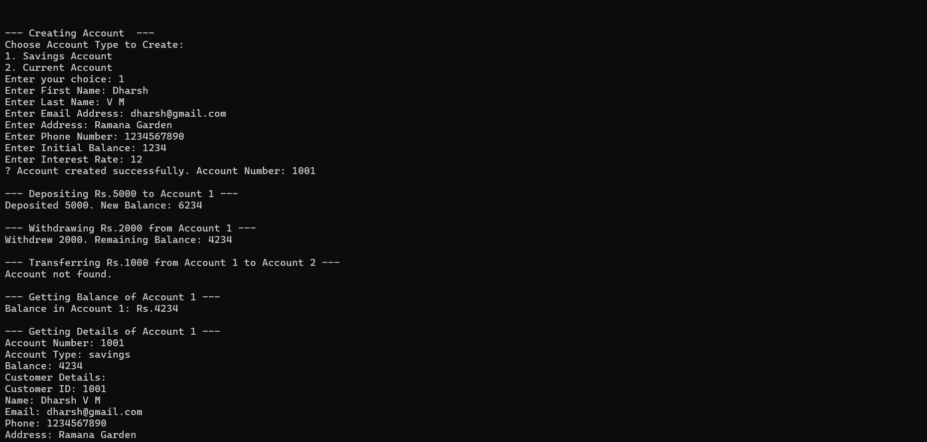

**Task 10: Has A Relation / Association**

1. Create a `Customer` class
2. Create an `Account` class
3. Create a Bank Class and must have following requirements:
   1. 1. Create a Bank class to represent the banking system. It should have the following methods: •**create_account (Customer customer, long accNo, String accType, float balance)**: Create a new bank account for the given customer with the initial balance.
   2. **get_account_balance (account_number: long)**: Retrieve the balance of an account given its account number. should return the current balance of account.
   3. **deposit (account_number: long, amount: float)**: Deposit the specified amount into the account. Should return the current balance of account.
   4. **Withdraw (account_number: long, amount: float)**: Withdraw the specified amount from the account. Should return the current balance of account.
   5. **Transfer (from_account_number: long, to_account_number: int, amount: float)**: Transfer money from one account to another.
   6. **getAccountDetails (account_number: long):** Should return the account and customer details.
4. Create a BankApp class with a main method to simulate the banking system. Allow the user to interact with the system by entering commands such as "create_account", "deposit", "withdraw", "get_balance", "transfer", "getAccountDetails" and "exit." create_account

should display sub menu to choose type of accounts and repeat this operation until user exit.

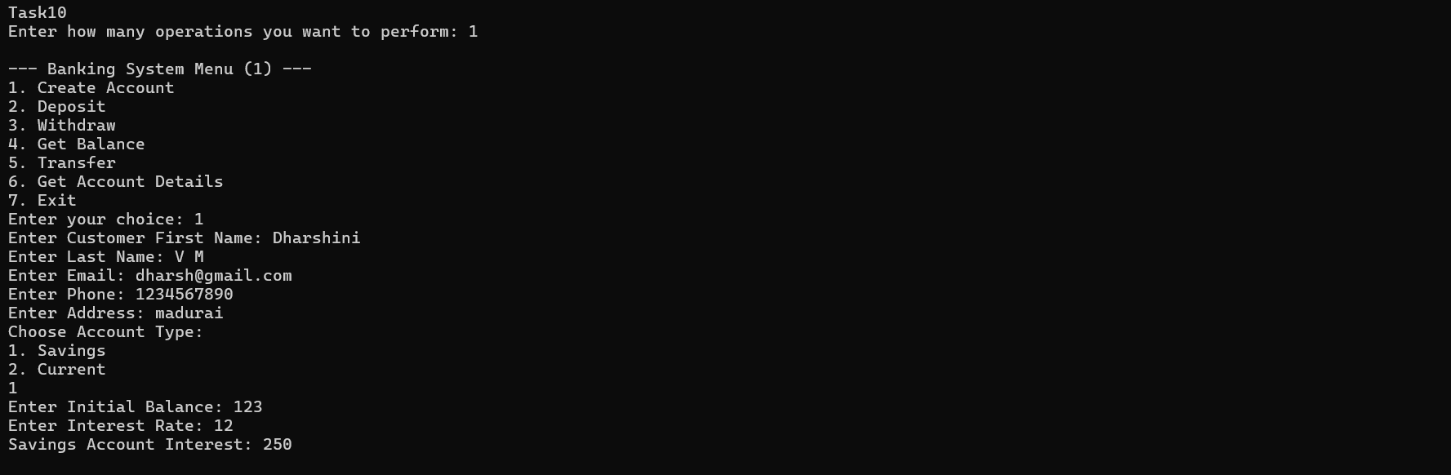

**Task 11: Interface/abstract class, and Single Inheritance, static variable**

1. Create a **‘Customer’** class
2. Create an class ‘**Account’**
3. Create three child classes that inherit the Account class and each class must contain below mentioned attribute: **SavingsAccount:** A savings account that includes an additional attribute for interest rate. Saving account should be created with minimum balance 500.
   1. **CurrentAccount:** A Current account that includes an additional attribute for overdraftLimit (credit limit). Withdraw () method to allow overdraft up to a certain limit. withdraw limit can exceed the available balance and should not exceed the overdraft limit.
   2. **ZeroBalanceAccount**: ZeroBalanceAccount can be created with Zero balance.

4. Create **ICustomerServiceProvider** interface/abstract class with following functions: **get_account_balance (account_number: long)**: Retrieve the balance of an account given its account number. should return the current balance of account.

* + **deposit (account_number: long, amount: float)**: Deposit the specified amount into the account. Should return the current balance of account.
  + **withdraw (account_number: long, amount: float)**: Withdraw the specified amount from the account. Should return the current balance of account. A savings account should maintain a minimum balance and checking if the withdrawal violates the minimum balance rule.
  + **Transfer (from_account_number: long, to_account_number: int, amount: float)**: Transfer money from one account to another.
  + **getAccountDetails (account_number: long):** Should return the account and customer details.
  + 5. Create **IBankServiceProvider** interface/abstract class with following functions: **create_account (Customer customer, long accNo, String accType, float balance)**: Create a new bank account for the given customer with the initial balance.
  + **listAccounts()**:Account[] accounts: List all accounts in the bank.
  + **calculateInterest ():** the calculate_interest () method to calculate interest based on the balance and interest rate.

1. Create **CustomerServiceProviderImpl** class which implements I**CustomerServiceProvider** provide all implementation methods.
2. Create **BankServiceProviderImpl** class which inherits from **CustomerServiceProviderImpl and implements IBankServiceProvider**

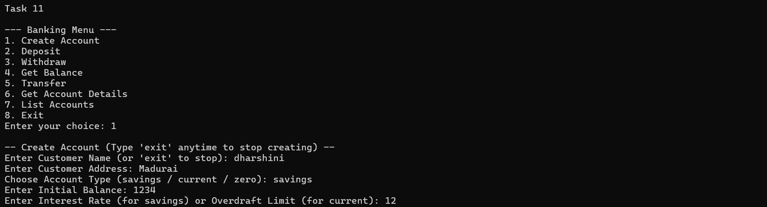

**Task 12: Exception Handling**

throw the exception whenever needed and Handle in main method,

1. **InsufficientFundException** throw this exception when user try to withdraw amount or transfer amount to another account and the account runs out of money in the account.

2. **InvalidAccountException** throw this exception when user entered the invalid account number when tries to transfer amount, get account details classes.

3. **OverDraftLimitExcededException** throw this exception when current account customer try to with draw amount from the current account.

4. **NullPointerException** handle in main method**.**

Throw these exceptions from the methods in HMBank class. Make necessary changes to accommodate these exception in the source code. Handle all these exceptions from the main program.

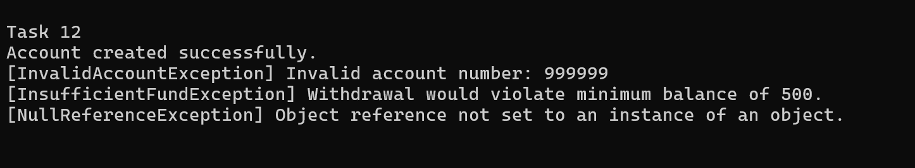

**Task 13: Collection**

1. From the previous task change the **HMBank** attribute Accounts to List of Accounts and perform the same operation.
   1. 2. From the previous task change the **HMBank** attribute Accounts to Set of Accounts and perform the same operation. Avoid adding duplicate Account object to the set.
   2. Create Comparator<Account> object to sort the accounts based on customer name when listAccounts () method called.
   3. 3. From the previous task change the HMBank attribute Accounts to HashMap of Accounts and perform the same operation.
   4. 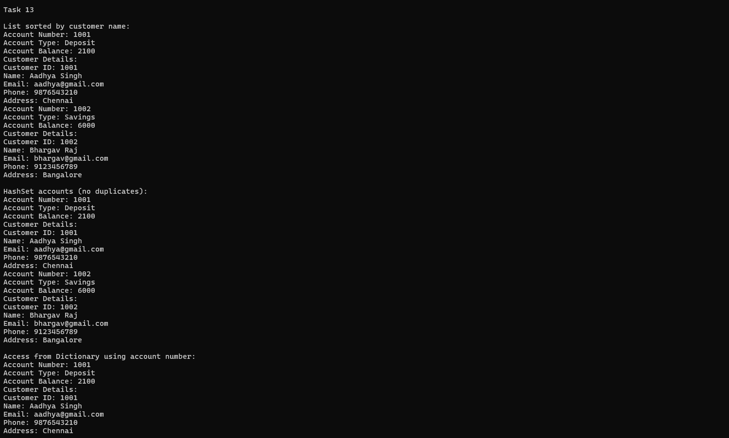
   5. **Task 14: Database Connectivity.** Create **DBUtil** class and add the following method.
   6. Establish a connection to the database and return Connection reference
   7. 