
Project Report Template

A CRM APPLICATION FOR SCHOOLS AND COLLEGES

INTRODUCTION:

  - Overview
This Project helps you to maintain and manage the school related problems which further can be modified based on the requirements.

Purpose
The project aim is to provide real-time knowledge for all the students who have basic knowledge of Salesforce and Looking for a real-time project. This project will also help those professionals who are in cross-technology and want to switch to Salesforce. With the help of this project they will gain knowledge and can include it into their resume as well.

Problem definition & Design Thinking

2.1 Empathy Map

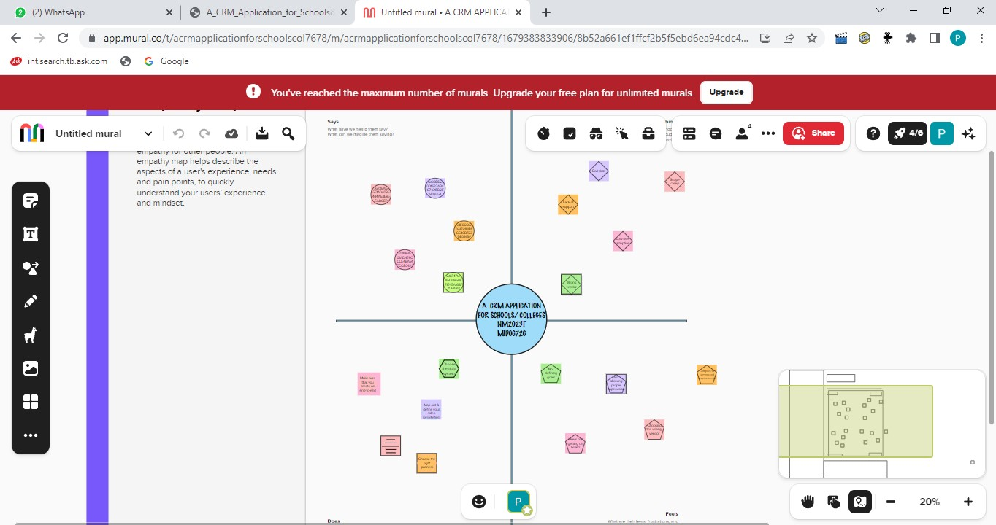

2.2 Ideation & Brainstorming Map

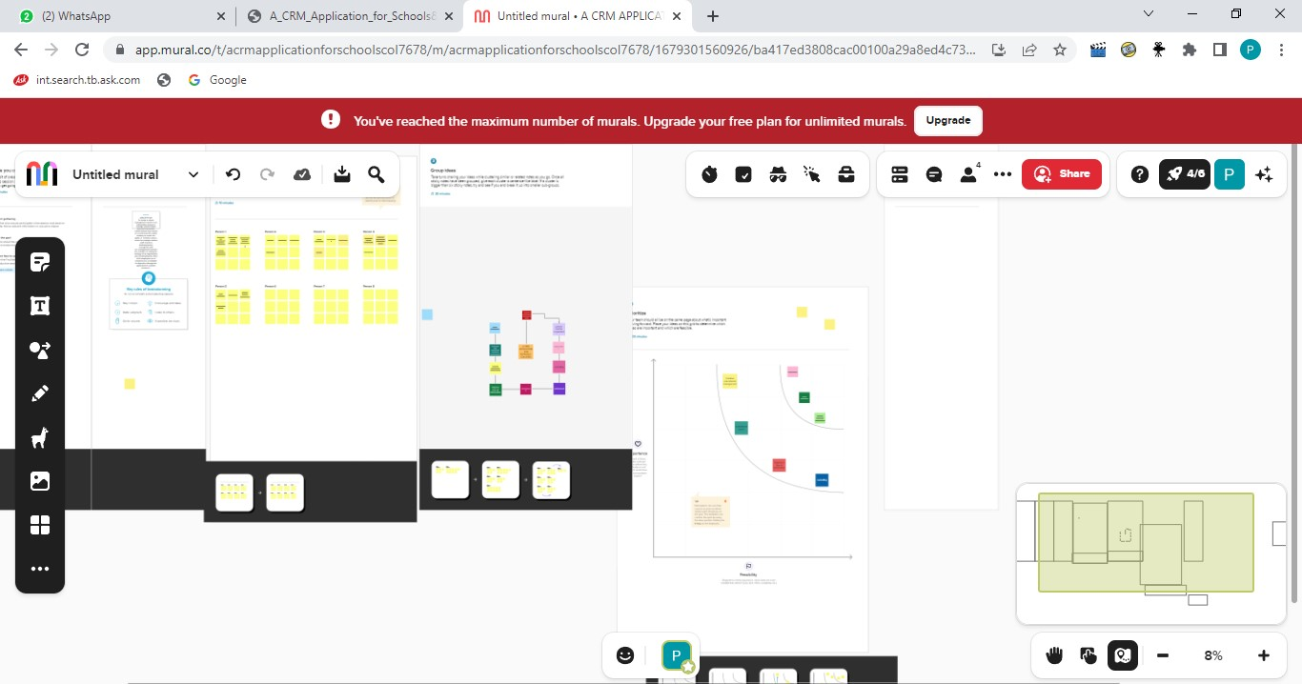

RESULT

3.1 Data Model :

Object name | Fields in the Object
obj1
SCHOOL MANAGEMENT |  | Field label | Data type
 |  | School | Text area
 |  | Phone number | Phone
obj2
STUDENT |  | Field label | Data type
 |  | Phone number | Phone
 |  | Parents address | Text artea

3.2Activity & Screenshot:

MILESTONE:2 OBJECT

Activity-1:Creation of school object

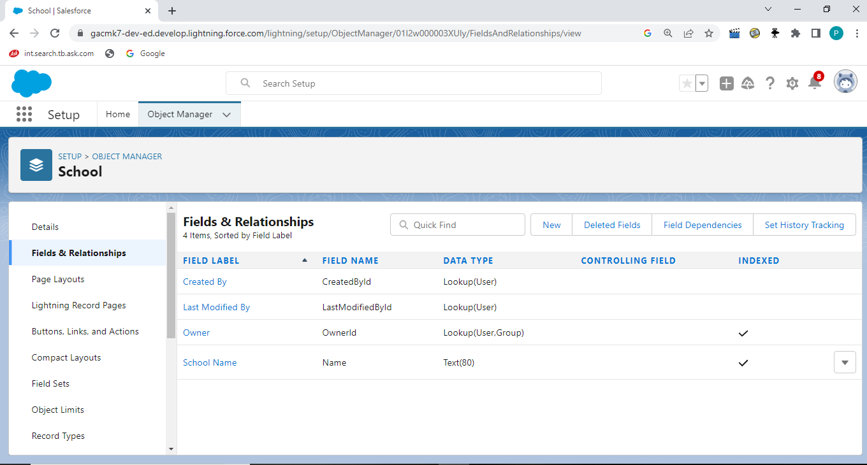

Activity-2Creating a school object

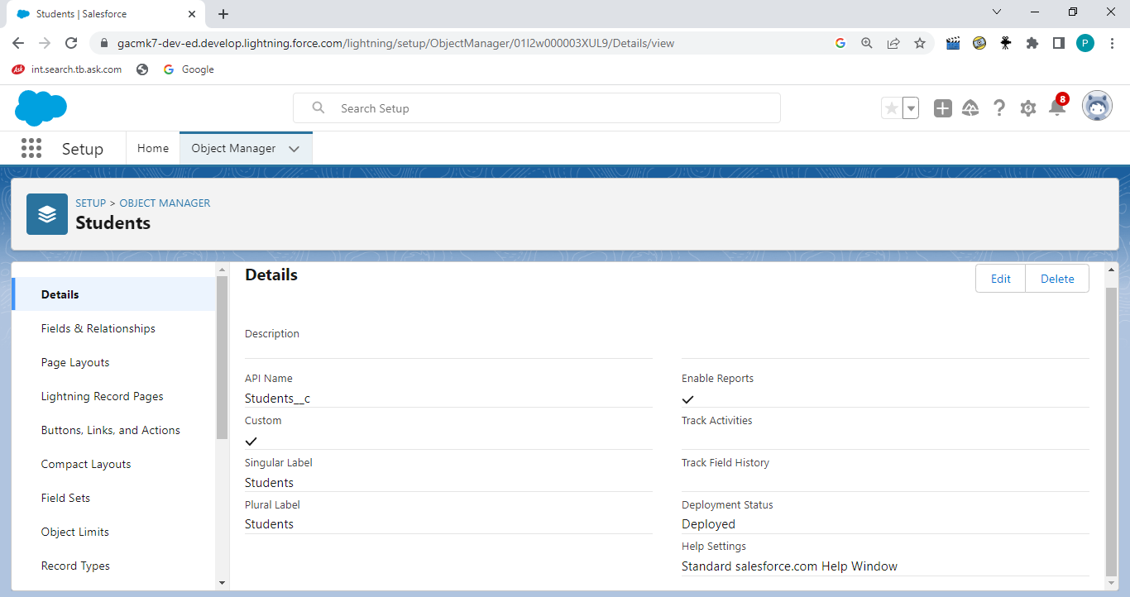

MILESTONE:3: LIGHTNING APP

Activity: Create the School Management App

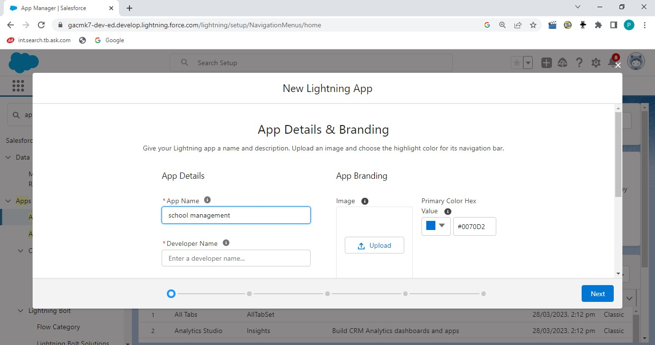

MILESTONE:4 : FIELDS AND RELATIONSHIP

Activity-1 Creation of fields for the objects

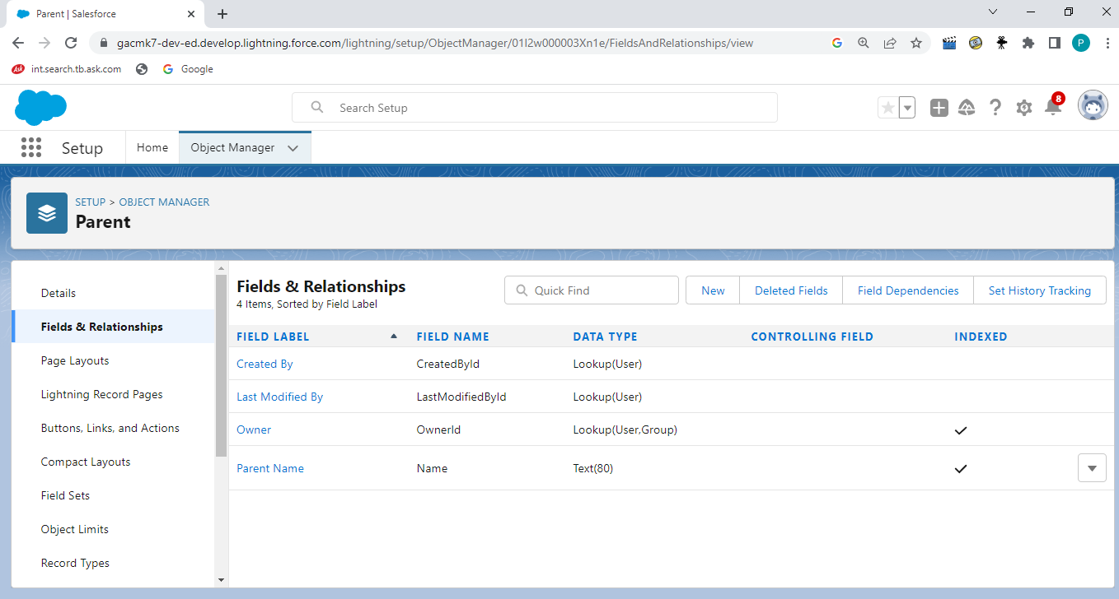

MILESTONE:5 : PROFILES

Activity-Creation on profiles

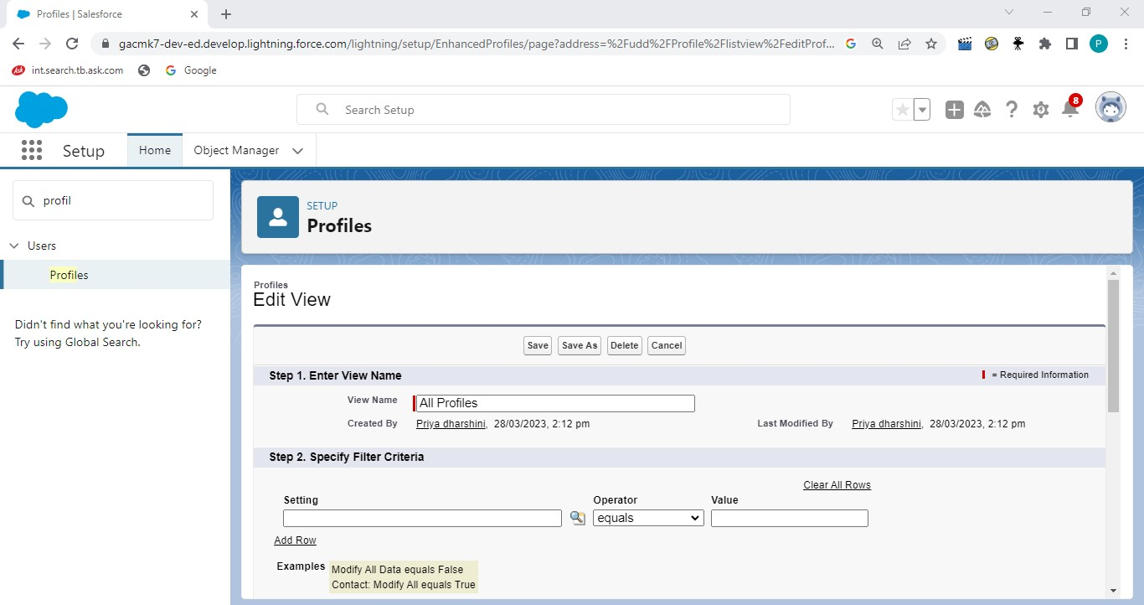

MILESTONE:6 USERS

Activity – Creating a users:

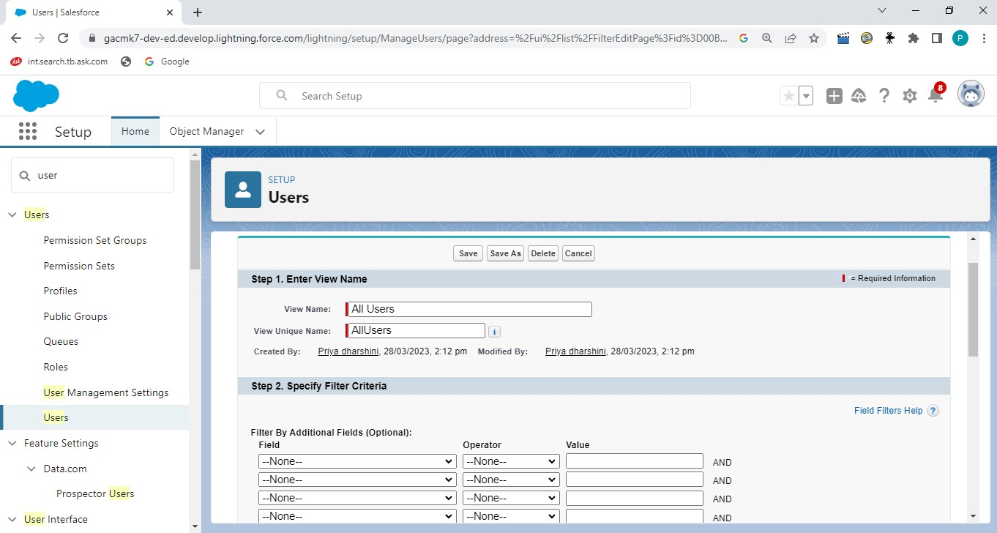

MILESTONE:7 PERMISSION SETS

Activity-1 Permission sets 1

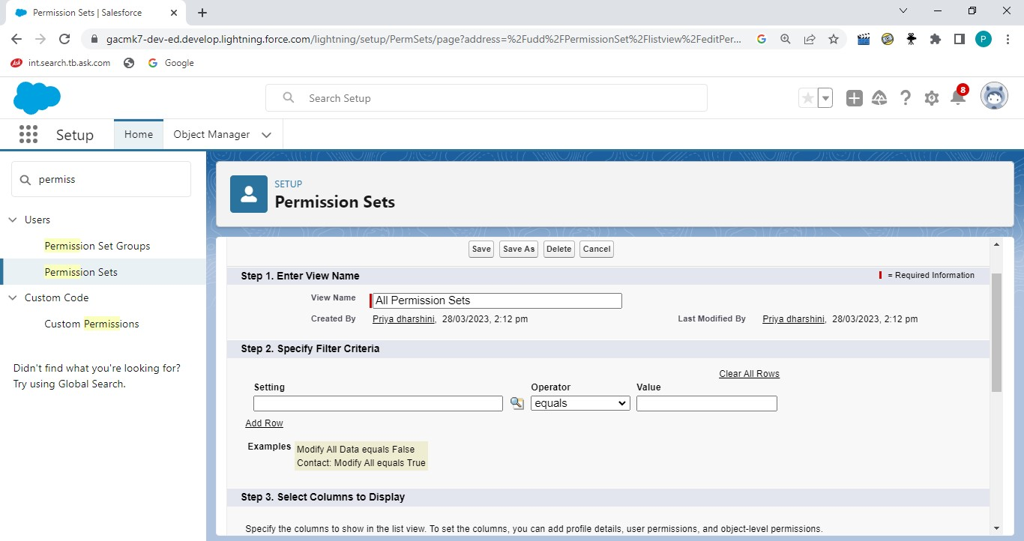

MILESTONE:8 REPORTS

Activity:

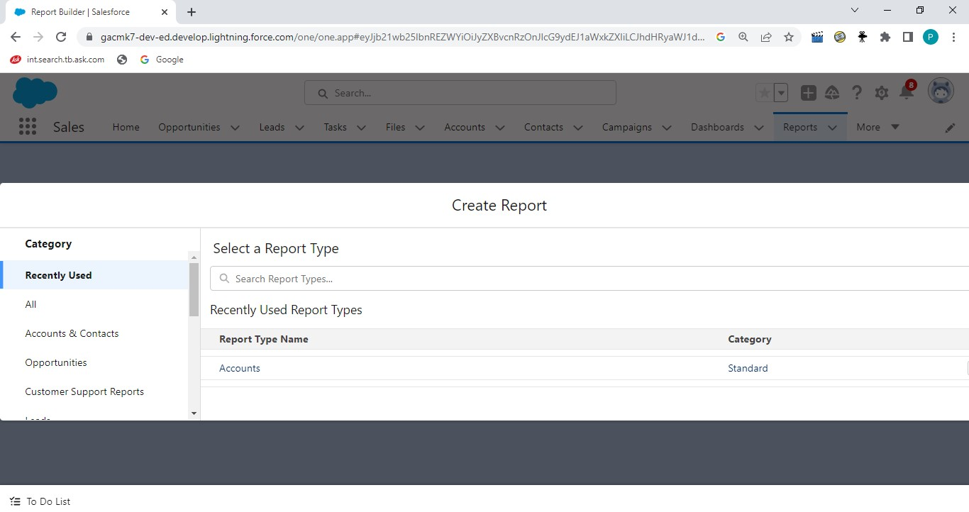

4.Trailhead Profile Public URL:

TEAM LEAD: https://trailblazer.me/id/pdharshinir1

TEAM MEMBER 2-http://trailblazer.me/id/ssathiyadevim

TEAM MEMBER 3-https://trailblazer.me/id/janad25

TEAM MEMBER4-https://trailblazer.me/id/llavimass

TEAM MEMBER 5-http://trailblazer.me/id/meenn7

ADVANTAGES & DISADVANTAGES:

Advantages:
- Improved Informational Organization. ...
- CRM for Enhanced Communication. ...
- CRM Improves Your Customer Service. ...
- Automation of Everyday Tasks. ...
- Greater efficiency for multiple teams. ...

Disadvantages:

- CRM costs. One of the greatest challenges to CRM implementation is cost. ...
- Business culture. A lack of commitment or resistance to cultural change from people within the company can cause major difficulties with CRM implementation. ...
- Poor communication. ...
- Lack of leadership.

APPLICATIONS:

- Tracking Customers
- Collecting Data for Marketing
- Improving Interactions and Communications
- Streamlining Internal Sales Processes
- Application 5: Planning Your Operations.

CONCLUSION:

- Event Management System is user friendly and cost
effective system/

- it is customized with activities related to event management
life style

FUTURE SCOPE:

1. It involves management, creation and development of events such as corporate conferences, wedding, festivities, formal parties etc…
2.. It involves a lot of research about the brand, target audience and the concept of the event before planning the actual event.

