**MICROSERVICES**

**Microservices with API gateway**

**Creating Microservices for account and loan**

**account-service :**

**application.properties :**

spring.application.name=account-service  
server:  
 port: 8081  
  
spring:  
 application:  
 name: account-service  
 datasource:  
 url: jdbc:h2:mem:accountdb  
 driverClassName: org.h2.Driver  
 username: sa  
 password:  
 jpa:  
 hibernate:  
 ddl-auto: update  
 show-sql: true

**Account.java :**

package com.example.account_service.model;  
import jakarta.persistence.*;  
  
@Entity  
public class Account {  
  
 @Id  
 @GeneratedValue(strategy = GenerationType.*IDENTITY*)  
 private Long id;  
  
 private String accountNumber;  
 private String accountType;  
 private Double balance;  
  
 public Account() {}   
  
 public Long getId() {  
 return id;  
 }  
  
 public String getAccountNumber() {  
 return accountNumber;  
 }  
  
 public String getAccountType() {  
 return accountType;  
 }  
  
 public Double getBalance() {  
 return balance;  
 }  
  
 public void setId(Long id) {  
 this.id = id;  
 }  
  
 public void setAccountNumber(String accountNumber) {  
 this.accountNumber = accountNumber;  
 }  
  
 public void setAccountType(String accountType) {  
 this.accountType = accountType;  
 }  
  
 public void setBalance(Double balance) {  
 this.balance = balance;  
 }  
}

**AccountRepository.java :**

package com.example.account_service.repository;  
import com.example.account_service.model.Account;  
import org.springframework.data.jpa.repository.JpaRepository;  
  
public interface AccountRepository extends JpaRepository<Account, Long> {}

**AccountService.java :**

package com.example.account_service.service;  
  
import com.example.account_service.model.Account;  
import com.example.account_service.repository.AccountRepository;  
import org.springframework.stereotype.Service;  
  
import java.util.List;  
  
@Service  
public class AccountService {  
 private final AccountRepository repo;  
  
 public AccountService(AccountRepository repo) {  
 this.repo = repo;  
 }  
  
 public List<Account> getAllAccounts() {  
 return repo.findAll();  
 }  
  
 public Account saveAccount(Account account) {  
 return repo.save(account);  
 }  
  
}

**AccountController.java :**

package com.example.account_service.controller;  
  
import com.example.account_service.model.Account;  
import com.example.account_service.service.AccountService;  
import org.springframework.web.bind.annotation.*;  
import java.util.List;  
  
@RestController  
@RequestMapping("/accounts")  
public class AccountController {  
 private final AccountService service;  
  
 public AccountController(AccountService service) {  
 this.service = service;  
 }  
  
 @GetMapping  
 public List<Account> getAll() {  
 return service.getAllAccounts();  
 }  
  
 @PostMapping  
 public Account create(@RequestBody Account account) {  
 return service.saveAccount(account);  
 }  
}

**OUTPUT :**

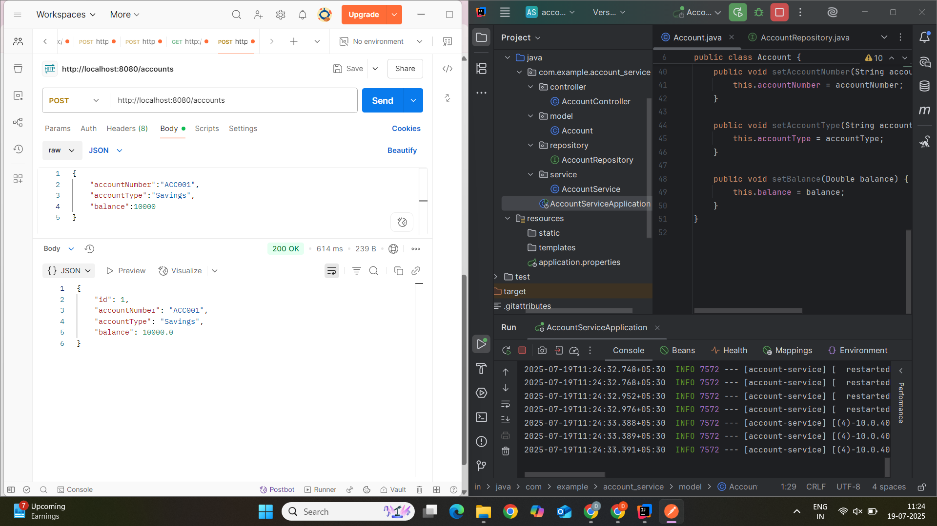

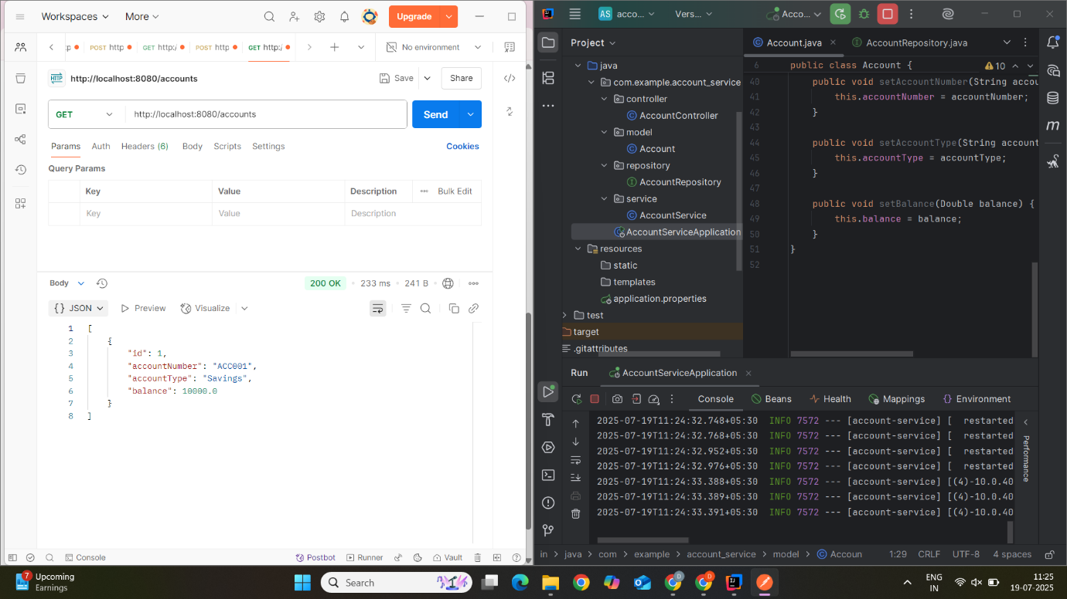

**loan-service :**

**application.properties :**

spring.application.name=loan-service  
server:  
 port: 8082  
spring:  
 application:  
 name: loan-service  
 datasource:  
 url: jdbc:h2:mem:loandb  
 driverClassName: org.h2.Driver  
 username: sa  
 password:   
 jpa:  
 hibernate:  
 ddl-auto: update  
 show-sql: true  
 h2:  
 console:  
 enabled: true

**Loan.java :**

package com.example.loan_service.model;  
import jakarta.persistence.*;  
  
@Entity  
public class Loan {  
  
 @Id  
 @GeneratedValue(strategy = GenerationType.*IDENTITY*)  
 private Long id;  
  
 private String loanNumber;  
 private String loanType;  
 private Double amount;  
  
 public Loan() {}  
  
 public Long getId() {  
 return id;  
 }  
  
 public String getLoanNumber() {  
 return loanNumber;  
 }  
  
 public String getLoanType() {  
 return loanType;  
 }  
  
 public Double getAmount() {  
 return amount;  
 }  
  
 public void setId(Long id) {  
 this.id = id;  
 }  
  
 public void setLoanNumber(String loanNumber) {  
 this.loanNumber = loanNumber;  
 }  
  
 public void setLoanType(String loanType) {  
 this.loanType = loanType;  
 }  
  
 public void setAmount(Double amount) {  
 this.amount = amount;  
 }  
}

**LoanRepository.java :**

package com.example.loan_service.repository;  
  
import com.example.loan_service.model.Loan;  
import org.springframework.data.jpa.repository.JpaRepository;  
  
public interface LoanRepository extends JpaRepository<Loan, Long> {}

**LoanService.java :**

package com.example.loan_service.service;  
  
import com.example.loan_service.model.Loan;  
import com.example.loan_service.repository.LoanRepository;  
import org.springframework.stereotype.Service;  
import java.util.List;  
  
@Service  
public class LoanService {  
 private final LoanRepository repo;  
  
 public LoanService(LoanRepository repo) {  
 this.repo = repo;  
 }  
  
 public Loan saveLoan(Loan loan) {  
 return repo.save(loan);  
 }  
  
 public List<Loan> getAllLoans() {  
 return repo.findAll();  
 }  
}

**LoanController.java :**

package com.example.loan_service.controller;  
import com.example.loan_service.model.Loan;  
import com.example.loan_service.service.LoanService;  
import org.springframework.web.bind.annotation.*;  
import java.util.List;  
  
@RestController  
@RequestMapping("/loans")  
public class LoanController {  
  
 private final LoanService service;  
  
 public LoanController(LoanService service) {  
 this.service = service;  
 }  
  
 @PostMapping  
 public Loan createLoan(@RequestBody Loan loan) {  
 return service.saveLoan(loan);  
 }  
  
 @GetMapping  
 public List<Loan> getLoans() {  
 return service.getAllLoans();  
 }  
}

**OUTPUT :**

