

AI POWERED INDIAN SIGN LANGUAGE

TRANSLATION SYSTEM

A MINI PROJECT REPORT

Submitted by

DHARSHINI K | (922524104033)

In partial fulfillment for the award of the degree

of

BACHELOR OF ENGINEERING
in

COMPUTER SCIENCE AND ENGINEERING

V.S.B. ENGINEERING COLLEGE, KARUR-639 111
(An Autonomous Institution, Affiliated to Anna University)

JULY 2026



AI POWERED INDIAN SIGN LANGUAGE

TRANSLATION SYSTEM

A MINI PROJECT REPORT

Submitted by

DHARSHINI K | (922524104033)

In partial fulfillment for the award of the degree

of

BACHELOR OF ENGINEERING
in

COMPUTER SCIENCE AND ENGINEERING

V.S.B. ENGINEERING COLLEGE, KARUR-639 111
(An Autonomous Institution, Affiliated to Anna University)

JULY 2026

BONAFIDE CERTIFICATE

Certified that this project report titled AI POWERED INDIAN SIGN LANGUAGE TRANSLATION SYSTEM is the bonafide work of DHARSHINI K (922524104033) who carried out the project under my supervision.

SIGNATURE
Mr. P. ANBUMANI M.E., Ph.D.,

HEAD OF THE DEPARTMENT
Computer Science and Engineering,
V.S.B. Engineering College
Karur -639111

SIGNATURE
Mrs.V MANIMALA.MCA.,
SUPERVISOR
Assistant Professor
Computer Science and Engineering,
V.S.B. Engineering College
Karur -639111

Submitted for Project Viva-Voce held on

INTERNAL EXAMINER EXTERNAL EXAMINER

DECLARATION

We jointly declare that the project report on “AI POWERED INDIAN SIGN LANGUAGE TRANSLATION SYSTEM” is the result of original work done by us and best of our knowledge, similar work has not been submitted to “ANNA UNIVERSITY CHENNAI” for the requirement of Degree, Bachelor of engineering. This project report is submitted on the partial fulfilment of the requirement of the award of Degree of Bachelor of engineering.
Signature
___________________
DHARSHINI K

Place: Karur
Date:

ACKNOWLEDGEMENT

First and foremost, we express my thanks to our parents for providing us with a very nice environment for doing this project. We wish to express our sincere thanks to our Founder and Chairman Shri.V.S.BALSAMY B.Sc., L.L.B., for his Endeavor in educating us in this premier institution.
We extend our gratitude to our Principal, Dr.C.VENNILA B.E., M.Tech., Ph.D., and Vice Principal Dr.T.S.KIRUBASANKAR M.E., Ph.D., for their encouragement and moral support during this project.
We are grateful to our head of the department Mr.P.ANBUMANI M.E., Ph.D., and our project coordinator Dr.M.SANGEETHA M.E., Ph.D., Associate Professor, Department of Computer Science and Engineering for their valuable support.
We express our thanks to the supervisor of our project Mrs.V.MANIMALA.MCA., Assistant Professor, Department of Computer Science and Engineering, for guidance throughout the course of our project.
Our sincere thanks to all the teaching staff of V.S.B Engineering College and our friends for their help in the successful completion of this project work.
Finally, we bow before God, the almighty who always had a better plan for us. We give our praise and glory to Almighty God for successful completion of this project.


V.S.B. Engineering College, Karur
(An Autonomous Institution, Affiliated to Anna University)
Department of Computer Science and Engineering
VISION, MISSION, POs, PEOs and PSOs

Vision of the Institution:
We endeavour to impart futuristic technical education of the highest quality to the student community and to inculcate discipline in them to face the world with self-confidence and thus we prepare them for life as responsible citizens to uphold human values and to be of service at large. We strive to bring of the Institution as an Institution of academic excellence of International standard.
Mission of the Institution:
We transform persons into personalities by the state-of the art infrastructure, time consciousness, quick response and the best academic practices through assessment and advice.
Vision of the Department:
- To produce competent Computer Science Engineers through Quality Education and Research.
Mission of the Department:
The Department strives to contribute to the expansion of knowledge in the discipline of Computer Science and Engineering by,
adopting an efficient teaching learning process in correlation with industrial needs.
- ensuring technical proficiency, facilitating to pursue higher studies and carry out R&D activities.
- developing problem solving and analytical skills with sound knowledge in basic sciences and Computer Science Engineering.
- inculcating managerial skills to become socially responsible, ethical and competitive professionals.
Program Educational Objectives (PEOs)
The Graduates of Computer Science and Engineering are able to
PEO #1:Work in Multinational companies and become successful IT professionals.
PEO #2:Pursue higher studies and have their career in educational institutions research organizations, or be entrepreneurs.
PEO #3:Possess social responsibility, team work skills, leadership capabilities and urge for learning in their professional fields.

Program Specific Outcome (PSO)
PSO#1: Addressing societal problems through design and development of software and firmware solutions using latest Computer Science tools and technologies.
PSO#2: Involving enthusiastically in software development, software testing, storage, computing and business intelligence sectors.
PSO#3: Use their technical expertise in latest technologies and update their knowledge continuously in Computer Science and Engineering to excel in their career.
Program Outcomes (PO)
PO1: Engineering knowledge: Apply the Mathematical knowledge and the basics of Science and Engineering to solve the problems pertaining to Computer Science and Engineering.
PO2: Problem analysis: Identify and formulate Computer Science and Engineering problems from research literature and be able to analyze the problem using first principles of Mathematics and Engineering Sciences.
PO3: Design/development of solutions: Come out with solutions for the complex problems and to design system components or process that fulfil the particular needs taking into account public health and safety and the social, cultural and environmental issues.
PO4: Conduct investigations of complex problems: Draw well-founded conclusions applying the knowledge acquired from research and research methods including design of experiments, analysis and interpretation of data and synthesis of information and to arrive at significant conclusion.
PO5: Modern tool usage: Form, select and apply relevant techniques, resources and Engineering and IT tools for Engineering activities like electronic prototyping, modelling and control of systems and also being conscious of the limitations.
PO6: The engineer and society: Apply reasoning informed by the contextual knowledge to assess societal, health, safety, legal and cultural issues and the consequent responsibilities relevant to the professional Computer Science and Engineering practice.
PO7: Environment and sustainability: Be aware of the impact of professional Engineering solutions in societal and environmental contexts and exhibit the knowledge and the need for sustainable Development.
PO8: Ethics: Apply the principles of Professional Ethics to adhere to the norms of the engineering practice and to discharge ethical responsibilities.
PO9: Individual and team work: Function actively and efficiently as an individual or a member/leader of different teams and multidisciplinary projects.
PO10: Communication: Communicate efficiently the engineering facts with a wide range of engineering community and others, to understand and prepare reports and design documents; to make effective presentations and to frame and follow instructions
PO11: Project management and finance: Demonstrate the acquisition of the body of engineering knowledge and insight and Management Principles and to apply them as member / leader in teams and multidisciplinary environments.
PO12: Life-long learning: Recognize the need for self and life-long learning, keeping pace with technological challenges in the broadest sense.
ABSTRACT
Communication is an essential aspect of everyday life, yet individuals with hearing and speech impairments often face significant challenges when interacting with people who are unfamiliar with sign language. To address this communication barrier, this project presents SignBridge AI – Indian Sign Language Translation System, an intelligent web-based application that translates Indian Sign Language (ISL) gestures into readable text and audible speech in real time.
The proposed system utilizes Artificial Intelligence, Computer Vision, and Machine Learning techniques to recognize hand gestures accurately. A live video stream captured through a webcam is processed using OpenCV for image acquisition and MediaPipe Hands for extracting hand landmarks. The extracted landmark coordinates are then classified using a trained Machine Learning model, which predicts the corresponding sign language gesture. The recognized gesture is immediately converted into text and synthesized into speech using a Text-to-Speech engine, enabling seamless communication between hearing-impaired individuals and the general public.
The application is developed using Python and the Flask web framework for backend processing, while HTML5, CSS3, and JavaScript are used to design a responsive and user-friendly interface. MySQL is integrated to manage user authentication and maintain translation history, allowing users to securely access and review their previous translations.
The proposed system offers an accurate, cost-effective, and real-time communication solution without requiring specialized hardware such as sensor gloves. By integrating gesture recognition, speech synthesis, secure user management, and database support into a single platform, SignBridge AI improves accessibility and promotes inclusive communication. The system has potential applications in educational institutions, healthcare facilities, government offices, customer service centers, and other public environments where effective communication with hearing-impaired individuals is essential.
Keywords: Indian Sign Language (ISL), Artificial Intelligence, Machine Learning, Computer Vision, OpenCV, MediaPipe, Flask, Gesture Recognition, Sign-to-Text, Text-to-Speech.

TABLE OF CONTENTS
CHAPTER NO | TITLE | PAGE NO
 | ABSTRACT |  | VIII
 | LIST OF FIGURES |  | XI
 | LIST OF TABLES |  | XII
 | LIST OF ABBREVIATIONS |  | XIII
1 | INTRODUCTION |  | 1
 | 1.1 INTRODUCTION |  | 1
 | 1.2 INDIAN SIGN LANGUAGE |  | 2
 | 1.3 PROBLEM STATEMENT |  | 3
 | 1.4 OBJECTIVES |  | 3
 | 1.5 SCOPE OF THE PROJECT |  | 4
 | 1.6 ADVANTAGES OF THE PROPOSED SYSTEM |  | 5
2 | LITERATURE SURVEY |  | 6
 | 2.1 INTRODUCTION |  | 6
 | 2.2 EXSITING SYSTEM |  | 7
 | 2.3 LITERATURE SURVEY |  | 7
 | 2.4 RESEARCH GAP |  | 9
 | 2.5 PROPOSED SOLUTION |  | 10
 | 2.6 COMPARISON OF EXSITING SYSTEM AND |  | 10
 | PROPOSED SYSTEM
 | 2.7 SUMMARY |  | 11
3 | SYSTEM DESIGN |  | 12
 | 3.1 EXISTING SYSTEM |  | 12
 | 3.2 DISADVANTAGES OF EXISTING SYSTEM |  | 13
 | 3.3 PROPOSED SYSTEM |  | 14
 | 3.4 ADVANTAGES OF PROPOSED SYSTEM |  | 15
 | 3.5 FEASIBILITY STUDY |  | 16
 | 3.5.1 TECHNICAL FEASIBILITY |  | 16
 | 3.5.2 ECONOMIC FEASIBILITY |  | 16
 | 3.5.3 OPERATIONAL FEASIBILITY |  | 16
 | 3.5.4 SOCIAL FEASIBILITY |  | 17
 | 3.6 SUMMARY |  | 17
4 | METHODOLOGY |  | 18
 | 4.1 SYSTEM DESIGN |  | 18
 | 4.2 DATA FLOW DIAGRAM(DFD) |  | 19
 | 4.3 USE CASE DIAGRAM |  | 21
 | 4.4 ACTIVITY DIAGRAM |  | 22
 | 4.5 SEQUENCE DIAGRAM |  | 24
 | 4.6 ER DIAGRAM |  | 25
 | 4.7MODULES DESCRIPTION |  | 26
 | 4.7.1 USER AUTHENTICATION MODULE |  | 26
 | 4.7.2 DASHBOARD MODULE |  | 27
 | 4.7.3 AI CAMERA MODULE |  | 27
 | 4.7.4 HAND DETECTION MODULE |  | 28
 | 4.7.5 GESTURE RECOGNITION MODULE |  | 28
 | 4.7.6 TRANSLATION MODULE |  | 28
 | 4.7.7 TEXT TO SPEECH MODULE |  | 29
 | 4.7.8 HISTORY MODULE |  | 29
 | 4.7.9 PROFILE MODULE |  | 29
 | 4.8 SOFTWARE REQUIREMENTS |  | 30
 | 4.9 HARDWARE REQUIREMENTS |  | 31
 | 4.10 DATABASE DESGIIN |  | 31
 | 4.11 IMPLEMENTATION |  | 32
5 | RESULTS AND DISCUSSION |  | 33
 | 5.1 INTRODUCTION |  | 33
 | 5.2 HOME PAGE |  | 33
 | 5.3 USER REGISTRATION |  | 34
 | 5.4 USER LOGIN |  | 35
 | 5.5 DASHBOARD |  | 36
 | 5.6 AI CAMERA DETECTION |  | 38
 | 5.7 GESTURE RECOGNITION |  | 39
 | 5.8 GESTURE TO TEXT TRANSLATION |  | 40
 | 5.9 TEXT-TO-SPEECH OUTPUT |  | 41
 | 5.10 TRANSLATION HISTORY |  | 42
 | 5.11 PROFILE MANAGEMENT |  | 43
 | 5.12 ABOUT AND CONTACT PAGES |  | 44
 | 5.13 PERFORMANCE ANALYSIS |  | 45
 | 5.14 DISCUSSION |  | 46
 | 5.15 SUMMARY |  | 47
6 | TESTING |  | 48
 | 6.1 INTRODUCTION |  | 48
 | 6.2 OBJECTIVES OF TESTING |  | 48
 | 6.3 TESTING METHODOLOGY |  | 49
 | 6.4 UNIT TESTING |  | 49
 | 6.5 INTEGRATION TESTING |  | 50
 | 6.6 SYSTEM TESTING |  | 51
 | 6.7 USER ACCEPTANCE TESTING |  | 52
 | 6.8 PERFORMANCE EVALUATION |  | 53
 | 6.9 ERROR HANDLING |  | 54
 | 6.10 SUMMARY |  | 55
7 | CONCLUSION AND FUTURE ENHANCEMENTS |  | 56
 | 7.1 CONCLUSION |  | 56
 | 7.2 FUTURE ENHANCEMENTS |  | 57
 | APPENDIX |  | 64
 | APPENDIX A - SOURCE CODE |  | 64
 | APPENDIX B - OUTPUT SCREENS |  | 65
 | REFERENCES |  | 72

LIST OF FIGURES

Figure No | Figure Name | Page No
Figure 5.1 | Home Page | 34
Figure 5.2 | Registration Page | 35
Figure 5.3 | Login Page | 36
Figure 5.4 | Dashboard | 37
Figure 5.5 | AI Camera Module | 39
Figure 5.6 | Gesture Recognition Output | 40
Figure 5.7 | Translation Output | 41
Figure 5.8 | History Page | 42
Figure 5.9 | Profile Page | 43
Figure 5.10 | About Page | 44
Figure 5.11 | Contact Page | 45

LIST OF TABLES
Table No. | Table Title | Page No.
Table 2.1 | Comparison of Existing System and Proposed System | 10
Table 4.1 | Software Requirements | 30
Table 4.2 | Hardware Requirements | 31
Table 5.1 | Performance Summary | 46
Table 6.1 | Unit Testing | 50
Table 6.2 | Integration Testing | 51
Table 6.3 | System Testing | 52
Table 6.4 | User Acceptance Testing | 53
Table 6.5 | Performance Analysis | 54

LIST OF ABBREVIATIONS

Abbreviation | Description
AI | Artificial Intelligence
ML | Machine Learning
ISL | Indian Sign Language
ASL | American Sign Language
CNN | Convolutional Neural Network
CV | Computer Vision
TTS | Text-to-Speech
UI | User Interface
UX | User Experience
HTML | HyperText Markup Language
CSS | Cascading Style Sheets
JS | JavaScript
API | Application Programming Interface
SQL | Structured Query Language
DBMS | Database Management System
RDBMS | Relational Database Management System
MySQL | My Structured Query Language
OpenCV | Open Source Computer Vision Library
JSON | JavaScript Object Notation
HTTP | HyperText Transfer Protocol
URL | Uniform Resource Locator
IDE | Integrated Development Environment
CPU | Central Processing Unit
RAM | Random Access Memory
GPU | Graphics Processing Unit
OS | Operating System
GUI | Graphical User Interface

CHAPTER 1
INTRODUCTION

1.1 Introduction
Communication is one of the most essential aspects of human life, enabling individuals to express ideas, emotions, and information effectively. However, communication becomes challenging for people with hearing and speech impairments, as they primarily rely on sign language to interact with others. Since a large portion of society is unfamiliar with Indian Sign Language (ISL), communication barriers often arise between hearing-impaired individuals and non-signing people.
Recent advancements in Artificial Intelligence (AI), Computer Vision, and Deep Learning have created opportunities to develop intelligent systems capable of understanding and translating sign language in real time. Such systems can significantly improve accessibility and inclusivity by reducing dependence on human interpreters.
The SignBridge AI – AI Powered Indian Sign Language Translation System is a web-based application designed to recognize Indian Sign Language gestures using Computer Vision and Artificial Intelligence. The system captures hand gestures through a webcam, detects hand landmarks using MediaPipe, classifies gestures using a trained TensorFlow model, and converts the recognized gestures into text and speech. The application also provides user authentication, gesture history management, and a responsive web interface using Flask and MySQL.
This project aims to bridge the communication gap between hearing-impaired individuals and non-signing users by providing an accurate, real-time, and user-friendly translation platform. By integrating modern AI technologies with web development, SignBridge AI contributes to creating a more inclusive digital environment.

1.2 Indian Sign Language
Indian Sign Language (ISL) is a structured visual language used by members of the deaf and hard-of-hearing community in India. Instead of spoken words, ISL relies on hand gestures, facial expressions, body movements, and finger spelling to convey information. Like spoken languages, ISL has its own grammar, vocabulary, and sentence structure.
Despite being widely used among hearing-impaired individuals, ISL is not commonly understood by the general public. As a result, communication between deaf individuals and non-signing people often requires a human interpreter. Unfortunately, interpreters may not always be available, creating communication challenges in educational institutions, hospitals, workplaces, banks, public offices, and emergency situations.
With the advancement of Artificial Intelligence and Computer Vision, automated sign language recognition systems have become increasingly important. These systems help convert sign language into text or speech, allowing users to communicate more effectively without relying on interpreters.
The SignBridge AI project focuses on recognizing common Indian Sign Language gestures and translating them into meaningful text and speech in real time. This enables efficient communication while promoting accessibility and social inclusion.

1.3 Problem Statement
People with hearing and speech impairments often face significant communication barriers because most individuals are not familiar with Indian Sign Language. In many situations, they must depend on interpreters, family members, or written communication, which may not always be practical or available.
Existing communication methods have several limitations, including delays, misunderstandings, limited accessibility, and high dependence on human assistance. Furthermore, many existing sign language recognition systems are expensive, require specialized hardware, or support only a limited set of gestures.
There is a growing need for an intelligent, affordable, and real-time system capable of recognizing Indian Sign Language gestures and translating them into text and speech with high accuracy. Such a system should also provide an easy-to-use interface, secure user authentication, and history management for future reference.
The SignBridge AI project addresses these challenges by developing a web-based AI-powered translation system that enables smooth communication between hearing-impaired individuals and non-signing users using only a standard webcam and modern AI techniques.

1.4 Objectives
The primary objective of the SignBridge AI project is to develop an intelligent web-based platform capable of recognizing Indian Sign Language gestures and translating them into readable text and audible speech in real time.
The specific objectives of the project are:
- To develop a real-time Indian Sign Language recognition system.
- To recognize hand gestures using Computer Vision techniques.
- To implement MediaPipe for accurate hand landmark detection.
- To classify gestures using a trained TensorFlow deep learning model.
- To convert recognized gestures into text.
- To generate speech from translated text using Text-to-Speech technology.
- To provide secure user registration and login facilities.
- To maintain translation history using a MySQL database.
- To design a responsive and user-friendly web application using Flask.
- To improve communication between hearing-impaired individuals and non-signing users.

1.5 Scope of the Project
The scope of the SignBridge AI project is to provide a practical and accessible communication platform for hearing-impaired individuals. The application performs real-time recognition of predefined Indian Sign Language gestures through a webcam and translates them into text and speech.
The system supports user authentication, allowing users to register, log in, manage their profiles, and view translation history. By integrating Artificial Intelligence, Deep Learning, Computer Vision, and web technologies, the project demonstrates how modern software solutions can improve accessibility and communication.
Although the current implementation focuses on a predefined set of gestures, the system has been designed with scalability in mind. Additional gestures, multilingual support, mobile applications, cloud deployment, and 3D avatar-based animation can be incorporated in future versions to expand its capabilities.

1.6 Advantages of the Proposed System
The SignBridge AI system provides several advantages over traditional communication methods and existing sign language translation systems.
- Real-time Indian Sign Language recognition.
- High gesture recognition accuracy using Deep Learning.
- Gesture-to-text translation.
- Text-to-speech conversion.
- User-friendly web interface.
- Secure login and registration system.
- Translation history storage using MySQL.
- Low-cost implementation using a standard webcam.
- Fast response time.
- Easy deployment using the Flask framework.
- Modular architecture for future expansion.
- Improved communication between hearing-impaired and non-signing individuals.
- Reduced dependence on human interpreters.
- Increased accessibility in educational institutions, healthcare, workplaces, and public services.

CHAPTER 2

LITERATURE SURVEY

2.1 Introduction
Communication is a fundamental part of human life. However, hearing-impaired and speech-impaired individuals often experience significant communication barriers because many people are unfamiliar with sign language. According to the World Health Organization (WHO), millions of people worldwide rely on sign language as their primary mode of communication. To address this challenge, researchers have explored Artificial Intelligence (AI), Computer Vision, and Machine Learning (ML) techniques to automatically recognize sign language gestures and convert them into understandable text or speech.
Recent advancements in Computer Vision have enabled contactless gesture recognition using ordinary webcams instead of expensive wearable devices. Technologies such as OpenCV, MediaPipe, TensorFlow, and Machine Learning algorithms have significantly improved the speed and accuracy of gesture recognition systems. This chapter presents a review of existing sign language recognition systems, identifies their limitations, and explains how the proposed SignBridge AI – Indian Sign Language Translation System addresses these challenges.

2.2 Existing System
Traditional sign language recognition systems were primarily based on sensor gloves, accelerometers, and data gloves that captured finger movements. Although these systems produced satisfactory recognition accuracy, they required users to wear specialized hardware, making them expensive, inconvenient, and unsuitable for everyday communication.
With the advancement of Artificial Intelligence and Computer Vision, researchers introduced vision-based systems that use webcams to recognize hand gestures. These systems employ image processing techniques, feature extraction methods, and machine learning algorithms to identify predefined sign language gestures. Modern systems frequently utilize OpenCV for image processing and MediaPipe for accurate hand landmark detection.
However, despite these improvements, many existing systems suffer from several limitations. Most applications focus on American Sign Language (ASL) rather than Indian Sign Language (ISL). Many systems support only static alphabet recognition and fail to recognize commonly used words or dynamic gestures. Additionally, several existing applications do not provide real-time speech generation, secure user authentication, translation history, or an integrated web-based platform.

2.3 Literature Review

Paper 1: Real-Time Hand Gesture Recognition Using MediaPipe and Machine Learning
This research proposes a real-time gesture recognition system using MediaPipe for extracting hand landmarks and a Machine Learning classifier for gesture prediction. The system accurately detects hand movements while maintaining low computational complexity. The research demonstrates that landmark-based recognition provides faster processing compared to traditional image-based approaches.
Limitations
- Supports only limited predefined gestures.
- Does not generate speech output.
- No database integration.
- No user authentication.

Paper 2: Deep Learning-Based Sign Language Recognition
This paper presents a deep learning approach for recognizing sign language gestures using Convolutional Neural Networks (CNNs). The proposed model achieves high recognition accuracy when trained on large image datasets. Deep learning improves feature extraction and classification performance.
Limitations
- Requires large training datasets.
- High computational cost.
- Longer training time.
- Difficult to deploy on systems with limited hardware resources.

Paper 3: Vision-Based Human–Computer Interaction Using Hand Gesture Recognition
This study focuses on improving human-computer interaction through real-time gesture recognition using OpenCV and MediaPipe. The system tracks hand movements and classifies gestures using machine learning algorithms. The proposed approach improves interaction speed and recognition accuracy.
Limitation
- Limited vocabulary support.
- No speech generation.
- No translation history.
- Lacks secure login and user management.

2.4 Research Gap
Based on the literature survey, the following research gaps have been identified:
- Most existing systems focus on American Sign Language instead of Indian Sign Language.
- Many applications recognize only alphabets or a limited number of predefined gestures.
- Real-time Sign-to-Speech functionality is absent in many existing systems.
- User authentication and personalized translation history are not provided.
- Several systems require expensive hardware such as sensor gloves.
- Existing applications often lack an interactive and user-friendly web interface suitable for real-world deployment.
These limitations highlight the need for an intelligent, web-based, real-time sign language translation system that integrates gesture recognition, speech synthesis, secure user management, and database support.

2.5 Proposed System
The proposed SignBridge AI – Indian Sign Language Translation System is designed to overcome the limitations identified in existing systems. The application captures live hand gestures through a webcam and processes them using OpenCV and MediaPipe Hands, which accurately detect twenty-one hand landmarks.
The extracted landmark coordinates are provided to a trained Machine Learning model that predicts the corresponding Indian Sign Language gesture. Once recognized, the predicted gesture is converted into readable text and spoken aloud using a Text-to-Speech engine. The application also provides secure user registration and login, stores translation history in a MySQL database, and offers a responsive web interface developed using HTML5, CSS3, JavaScript, and Flask.
Unlike existing systems, the proposed solution integrates Artificial Intelligence, Machine Learning, Computer Vision, and Web Technologies into a single platform that supports real-time communication and improves accessibility for hearing-impaired individuals.

2.6 Comparison of Existing System and Proposed System

Table 2.1:Comparison of Existing System and Proposed System
Feature | Existing System | Proposed SignBridge AI
Webcam-Based Recognition | ✓ | ✓
Indian Sign Language Support | Limited | ✓
Real-Time Gesture Detection | Partial | ✓
Sign-to-Text Conversion | ✓ | ✓
Sign-to-Speech Conversion | Limited | ✓
User Registration & Login | ✗ | ✓
Translation History | ✗ | ✓
MySQL Database Integration | ✗ | ✓
Responsive Web Interface | Limited | ✓
Easy-to-Use Dashboard | ✗ | ✓

2.7 Summary
This chapter reviewed the existing research on sign language recognition systems and analyzed their methodologies, advantages, and limitations. The literature survey revealed that most existing solutions provide only gesture recognition and lack features such as speech synthesis, secure authentication, translation history, and comprehensive web-based integration.
To address these limitations, the proposed SignBridge AI – Indian Sign Language Translation System combines Artificial Intelligence, Machine Learning, Computer Vision, and modern Web Technologies to provide an efficient, accurate, and user-friendly communication platform. The next chapter presents the system analysis, architecture, and design of the proposed solution.
CHAPTER 3
SYSTEM DESIGN

3.1 Existing System
The existing methods for communication between hearing-impaired individuals and non-signing people primarily depend on human interpreters, written communication, or basic sign language applications. Although these methods provide some level of assistance, they are not always efficient, accessible, or practical in real-life situations.
Traditional sign language communication requires both individuals to understand Indian Sign Language (ISL). In most public places such as hospitals, schools, banks, government offices, and workplaces, people are generally unfamiliar with ISL, making communication difficult.
Several research-based sign language recognition systems have been developed using image processing and machine learning techniques. However, many of these systems require specialized hardware such as data gloves or depth cameras, making them expensive and less suitable for everyday use. Some systems support only offline recognition or recognize a limited number of gestures, which restricts their practical application.
Existing web-based applications often lack integrated features such as user authentication, translation history, speech generation, and real-time processing. As a result, users experience limited functionality and reduced usability.

Features of Existing System
- Manual sign language interpretation.
- Human interpreter required.
- Limited online translation systems.
- Offline gesture recognition.
- Basic machine learning models.
- Limited vocabulary support.
- Minimal user interaction.
- No history management.
No speech generation in many systems.

3.2 Disadvantages of Existing System
Although existing systems provide basic communication support, they suffer from several limitations.

The major disadvantages include:
- Dependence on human interpreters.
- High implementation cost due to specialized hardware.
- Limited gesture recognition accuracy.
- Slow processing speed.
- Lack of real-time communication.
- Limited gesture vocabulary.
- Poor scalability.
- No user authentication.
- No translation history.
- Limited accessibility.
- Inability to generate speech in real time.
- Complex system configuration.
- Reduced usability in public environments.
These limitations highlight the need for a more efficient, intelligent, and user-friendly sign language translation system.

3.3 Proposed System
The proposed system, SignBridge AI – AI Powered Indian Sign Language Translation System, is a web-based application that recognizes Indian Sign Language gestures using Artificial Intelligence and Computer Vision.
The system captures live video from a webcam and processes each frame using OpenCV. MediaPipe detects hand landmarks from the captured images, and a TensorFlow deep learning model classifies the detected gesture. The predicted gesture is translated into readable text and further converted into speech using Text-to-Speech technology.
The application also includes secure user registration and login, profile management, translation history, and a responsive dashboard developed using Flask, HTML, CSS, and JavaScript. User information and gesture history are stored securely in a MySQL database.
Unlike conventional systems, SignBridge AI requires only a standard webcam, making it affordable, portable, and easy to deploy.

Working of Proposed System
- User logs into the system.
- Dashboard is displayed.
- User opens the AI Camera.
- Webcam captures live video.
- OpenCV processes each frame.
- MediaPipe detects hand landmarks.
- TensorFlow predicts the gesture.
- Predicted gesture is converted into text.
- Text is converted into speech.
- Translation history is saved in MySQL.
User can view previous translations anytime.

3.4 Advantages of Proposed System
The proposed system provides numerous benefits compared to traditional communication methods.

Advantages
- Real-time gesture recognition.
- High prediction accuracy.
- AI-powered translation.
- Gesture-to-text conversion.
- Text-to-speech conversion.
- Responsive web interface.
- Secure login and registration.
- Translation history management.
- User profile management.
- Low-cost implementation.
- Standard webcam support.
- Fast processing speed.
- Easy deployment.
- Improved accessibility.
- Scalable architecture.
- User-friendly interface.
Supports future expansion.

3.5 Feasibility Study
A feasibility study evaluates whether the proposed system can be successfully implemented.

3.5.1 Technical Feasibility
The project is technically feasible because it uses widely available technologies including Python, Flask, OpenCV, TensorFlow, MediaPipe, HTML, CSS, JavaScript, and MySQL. These technologies are open-source, well-documented, and suitable for developing AI-based web applications.

3.5.2 Economic Feasibility
The project is economically feasible because it requires only a standard computer and webcam. All software tools used are open-source and free of cost, significantly reducing the overall development expense.

3.5.3 Operational Feasibility
The application is designed with a simple and intuitive interface, allowing users to operate it without extensive technical knowledge. The real-time translation capability makes it practical for educational institutions, workplaces, healthcare facilities, and public service environments.

3.5.4 Social Feasibility
The system contributes to society by improving communication accessibility for hearing-impaired individuals. It promotes inclusivity and reduces dependence on interpreters, enabling more independent interaction in everyday life.

3.6 Summary
The analysis of existing systems demonstrates several limitations, including reliance on human interpreters, limited gesture recognition capabilities, and lack of real-time communication features. The proposed SignBridge AI system addresses these issues by integrating Artificial Intelligence, Computer Vision, and modern web technologies into a single platform. With features such as real-time gesture recognition, gesture-to-text translation, text-to-speech conversion, secure user authentication, and history management, the proposed system provides a practical, scalable, and user-friendly solution for enhancing communication between hearing-impaired individuals and non-signing users.

CHAPTER 4
SYSTEM DESIGN AND IMPLEMENTATION

4.1 System Design
System design is one of the most important stages in software development. It provides the blueprint for implementing the application by defining the architecture, modules, database, and interaction between different components. The SignBridge AI system is designed using a modular architecture that integrates Artificial Intelligence, Computer Vision, Deep Learning, and Web Technologies to recognize Indian Sign Language gestures and translate them into text and speech.
The application follows a client-server architecture. Users interact with the system through a web browser, while the Flask backend processes requests, performs gesture recognition using the trained TensorFlow model, and stores user information and gesture history in the MySQL database.
The major components of the system include:
- User Interface
- Flask Backend
- AI Recognition Module
- Translation Module
- Text-to-Speech Module
- Database Module

4.2 Data Flow Diagram (DFD)

Level 0 DFD
User

↓

Login

↓

AI Camera

↓

Gesture Detection

↓

Translation

↓

Speech

↓

History Database

Level 1 DFD
User

↓

Login Authentication

↓

Dashboard

↓

Camera Module

↓

MediaPipe Detection

↓

TensorFlow Model

↓

Predicted Gesture

↓

Text Translation

↓

Speech Output

↓

History Storage

4.3 Use Case Diagram

Actors
- User
- AI Recognition System
- Database

Use Cases
- Register
- Login
- Dashboard
- Open Camera
- Detect Gesture
- Translate Gesture
- Speak Translation
- Save History
- View History
- Update Profile
- Logout

4.4 Activity Diagram
Start

↓

User Login

↓

Dashboard

↓

Open Camera

↓

Capture Gesture

↓

Hand Detection

↓

Gesture Prediction

↓

Translation

↓

Speech Output

↓

Save History

↓

Logout

↓

End

4.5 Sequence Diagram
User

↓

Flask Application

↓

Camera Module

↓

MediaPipe

↓

TensorFlow

↓

Translation Module

↓

Speech Module

↓

Database

↓

Response to User

4.6 ER Diagram
Users

----------

User_ID (PK)

Username

Email

Password

↓

1 : M

↓

History

----------

History_ID (PK)

Gesture

Translation

Date

Time

User_ID (FK)

4.7 Modules Description

4.7.1 User Authentication Module
The authentication module provides secure registration and login functionality. User credentials are stored in the MySQL database and verified before granting access to the application.
Functions:
- Registration
- Login
- Logout
- Session Management

4.7.2 Dashboard Module
The dashboard serves as the main interface after login. It provides navigation to all modules including camera, translation history, profile, about, and contact pages.
Features:
- Navigation
- User Information
- Quick Access

4.7.3 AI Camera Module
This module captures live video using the webcam through OpenCV.
Functions:
- Webcam Initialization
- Frame Capture
- Video Streaming
- Real-time Processing

4.7.4 Hand Detection Module
MediaPipe detects hand landmarks from the captured image.
Functions:
- Landmark Detection
- Hand Tracking
- Coordinate Extraction

4.7.5 Gesture Recognition Module
TensorFlow predicts the gesture using the extracted landmarks.
Functions:
- Feature Extraction
- Gesture Classification
- Confidence Score Calculation

4.7.6 Translation Module
The predicted gesture is converted into readable English text.
Functions:
- Text Translation
- Display Translation
- Continuous Update

4.7.7 Text-to-Speech Module
The translated text is converted into speech using a Text-to-Speech engine.
Functions:
- Voice Generation
- Speech Playback
- Real-Time Audio Output

4.7.8 History Module
Stores all recognized gestures in the MySQL database.
Functions:
- Save Translation
- View Previous History
- Delete History (Optional)

4.7.9 Profile Module
Allows users to manage their personal information.
Functions:
- View Profile
- Update Profile
- Change Password

4.8 Software Requirements
Table 4.1:Software Requirements
Software | Version
Windows | 10 / 11
Python | 3.x
Flask | Latest
OpenCV | Latest
TensorFlow | Latest
MediaPipe | Latest
MySQL | 8.x
HTML | HTML5
CSS | CSS3
JavaScript | ES6
VS Code / Eclipse | Latest

4.9 Hardware Requirements
Table 4.1:Hardware Requirements
Hardware | Specification
Processor | Intel Core i3 or Above
RAM | 8 GB Minimum
Hard Disk | 20 GB Free Space
Webcam | HD Camera
Internet | Optional

4.10 Database Design

Users Table
Field | Type
User_ID | INT
Username | VARCHAR
Email | VARCHAR
Password | VARCHAR

History Table
Field | Type
History_ID | INT
Gesture | VARCHAR
Translation | VARCHAR
Date | DATE
Time | TIME
User_ID | INT

4.11 Implementation
The SignBridge AI application is implemented using Python Flask as the backend framework and HTML, CSS, and JavaScript for the frontend. OpenCV captures real-time video frames, while MediaPipe extracts hand landmarks. The extracted landmarks are processed by a TensorFlow deep learning model to recognize Indian Sign Language gestures. The predicted gesture is translated into text, converted into speech, and displayed to the user. User information and gesture history are stored securely in a MySQL database. The modular architecture allows easy maintenance, scalability, and future enhancements.

CHAPTER 5

RESULTS AND DISCUSSION

5.1 Introduction
The SignBridge AI – AI Powered Indian Sign Language Translation System was successfully developed and tested using Python, Flask, TensorFlow, OpenCV, MediaPipe, HTML, CSS, JavaScript, and MySQL. The system provides real-time recognition of Indian Sign Language (ISL) gestures through a webcam and converts the detected gestures into text and speech. This chapter presents the results obtained from each module and discusses the overall performance of the system.
The application was tested under different lighting conditions, hand positions, and user interactions to verify its functionality and reliability. All major modules, including user authentication, AI camera, gesture recognition, translation, speech generation, history management, and profile management, performed successfully.

5.2 Home Page
The Home Page serves as the entry point of the SignBridge AI application. It provides an attractive user interface with a brief introduction to the project, navigation menu, and a Get Started button. The page highlights the purpose of the system and its key features, making it easy for users to understand the application.

Features
- Professional user interface
- Responsive design
- Navigation menu
- Get Started button
- Project overview
Figure 5.1: Home Page
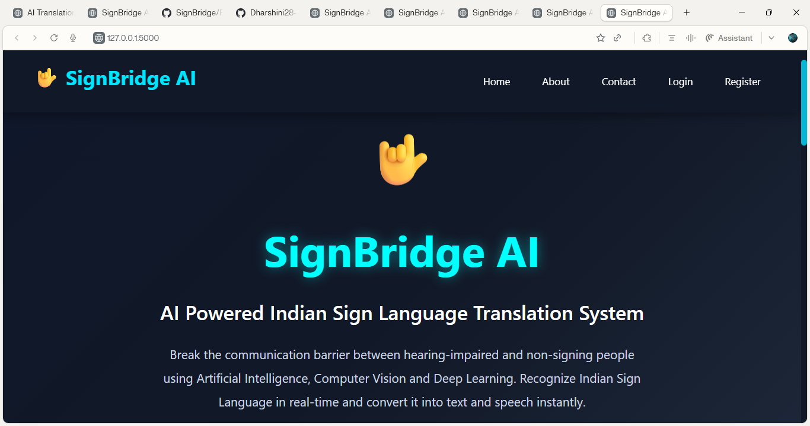

5.3 User Registration
The Registration Module allows new users to create an account by entering their username, email address, and password. The entered details are validated before being stored securely in the MySQL database. This module ensures that only authorized users can access the system.

Features
- User registration
- Input validation
- Secure data storage
- Database integration
Figure 5.2: Registration Page
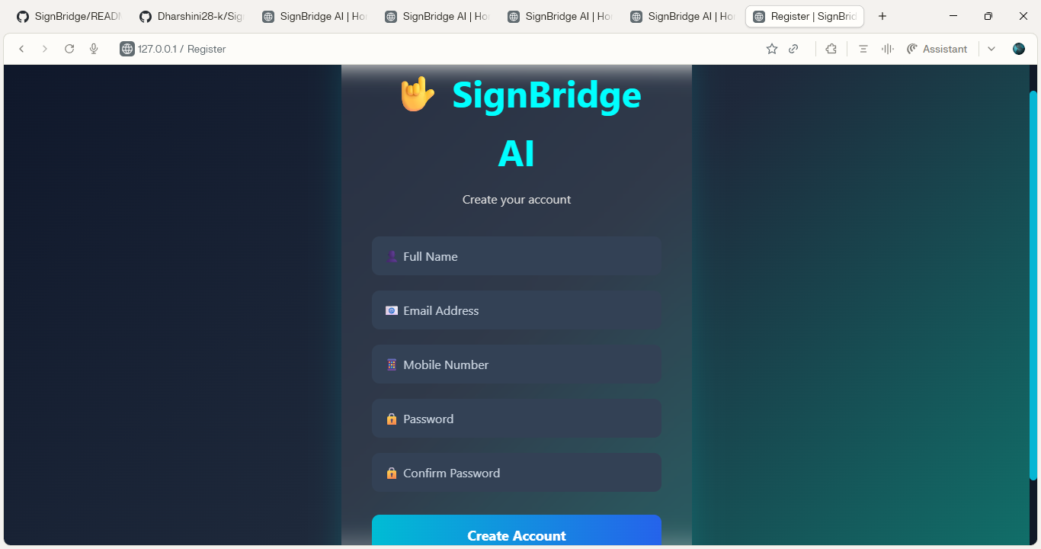

5.4 User Login
The Login Module authenticates registered users by verifying their email and password. Successful authentication redirects the user to the dashboard, while invalid credentials display an appropriate error message.

Features
- Secure login
- Authentication
- Session management
- User verification
Figure 5.3: Login Page
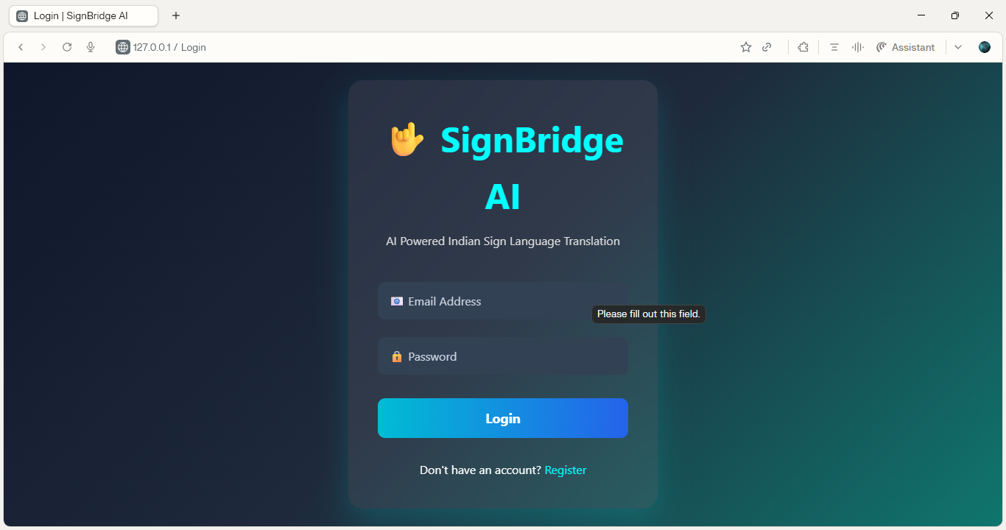

5.5 Dashboard
The Dashboard acts as the central control panel of the application. It provides navigation to all modules, including AI Camera, History, Profile, About, and Contact pages. The dashboard is designed with a modern and responsive interface for easy accessibility.

Features
- User navigation
- Quick access to modules
- Responsive layout
- Attractive interface
Figure 5.4: Dashboard
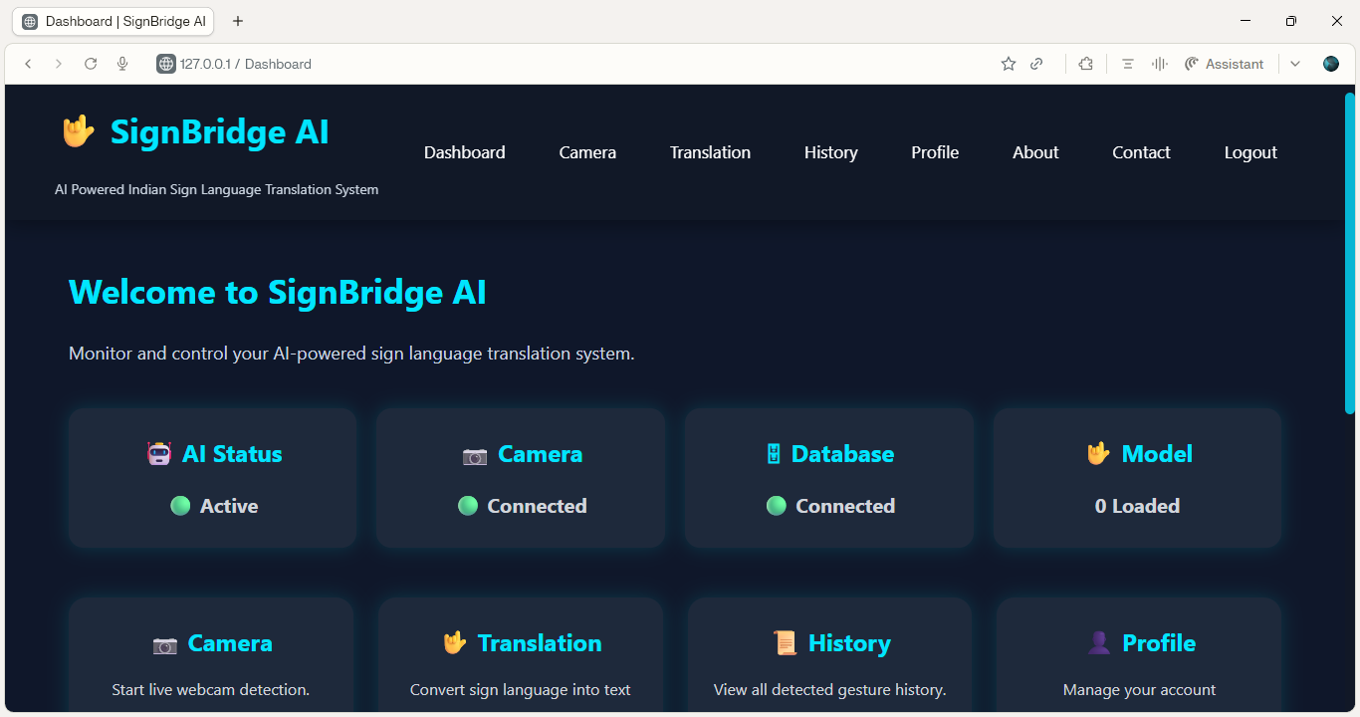
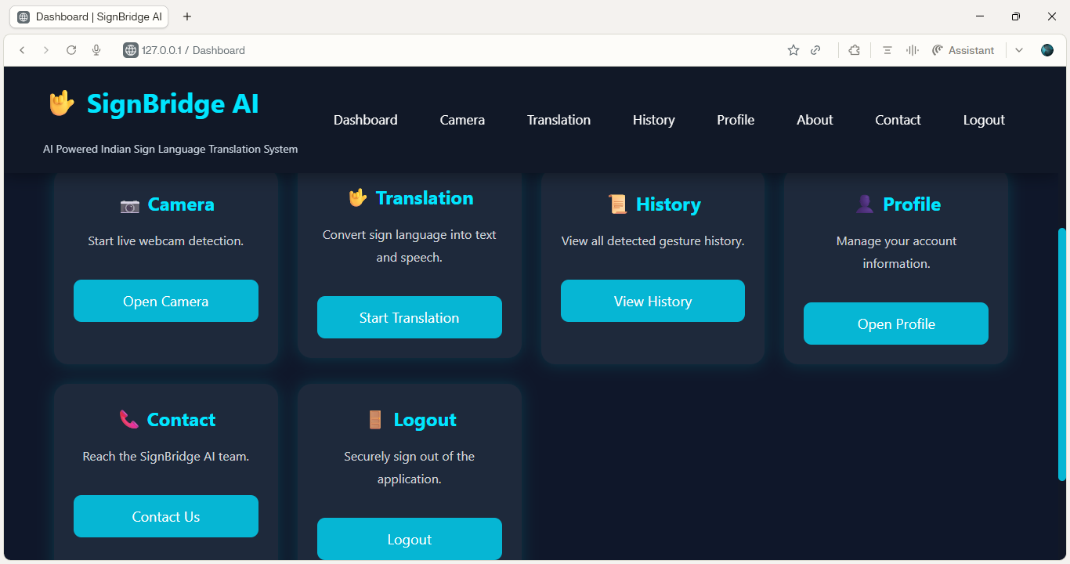

5.6 AI Camera Detection
The AI Camera Module is the core component of the application. It captures live video through the webcam using OpenCV. MediaPipe detects hand landmarks, and the trained TensorFlow model predicts the corresponding sign language gesture in real time.
The recognized gesture is displayed instantly on the screen with its confidence score.

Features
- Live webcam streaming
- Hand landmark detection
- Real-time gesture prediction
- Confidence percentage display

Figure 5.5: AI Camera Detection
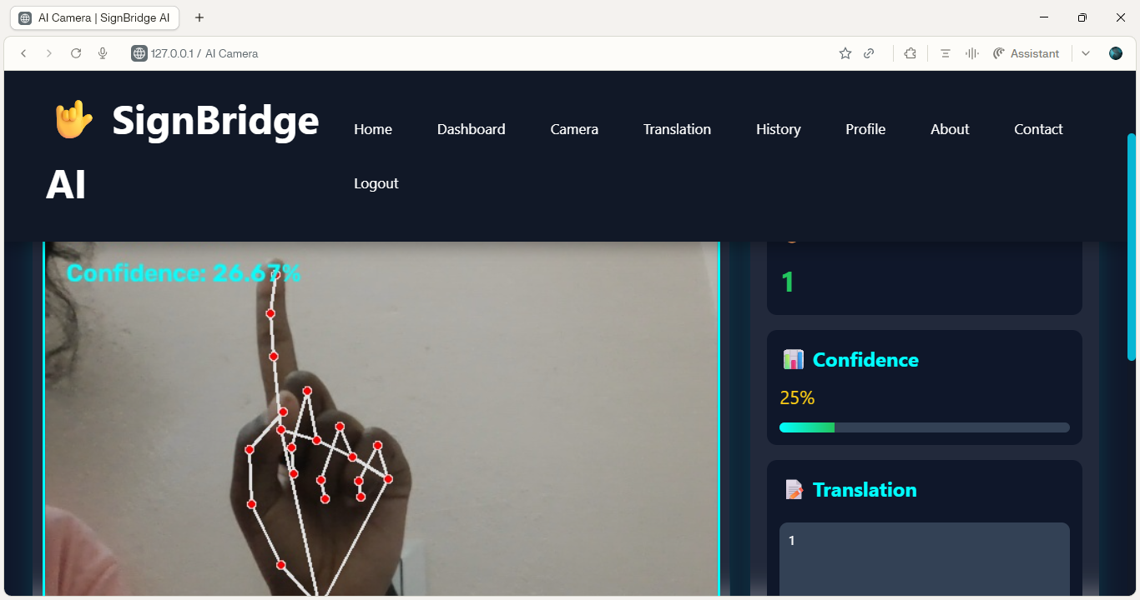

5.7 Gesture Recognition
After detecting the hand landmarks, the TensorFlow model classifies the gesture based on the trained dataset. The predicted gesture is displayed as readable text with high accuracy. The system continuously updates the prediction as new gestures are detected.

Features
- TensorFlow prediction
- Real-time recognition
- Accurate gesture classification
- Continuous detection

Figure 5.6: Gesture recognition Output
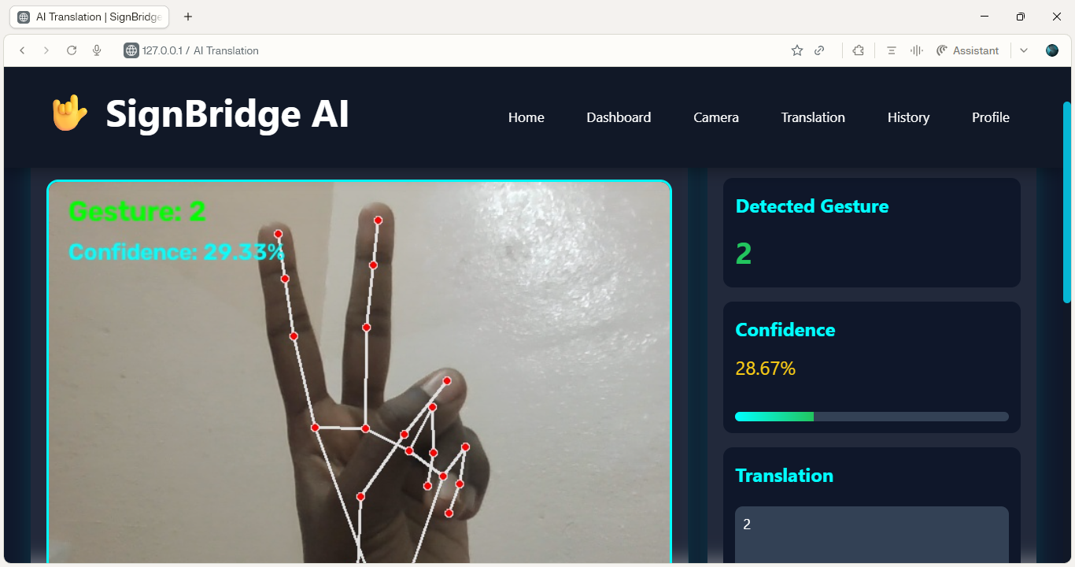

5.8 Gesture-to-Text Translation
The recognized gesture is automatically converted into text and displayed in the translation area. The translated text updates dynamically whenever a new gesture is detected.

Features
- Automatic translation
- Dynamic text update
- Easy readability
- Real-time conversion

Figure 5.7: Translation Output
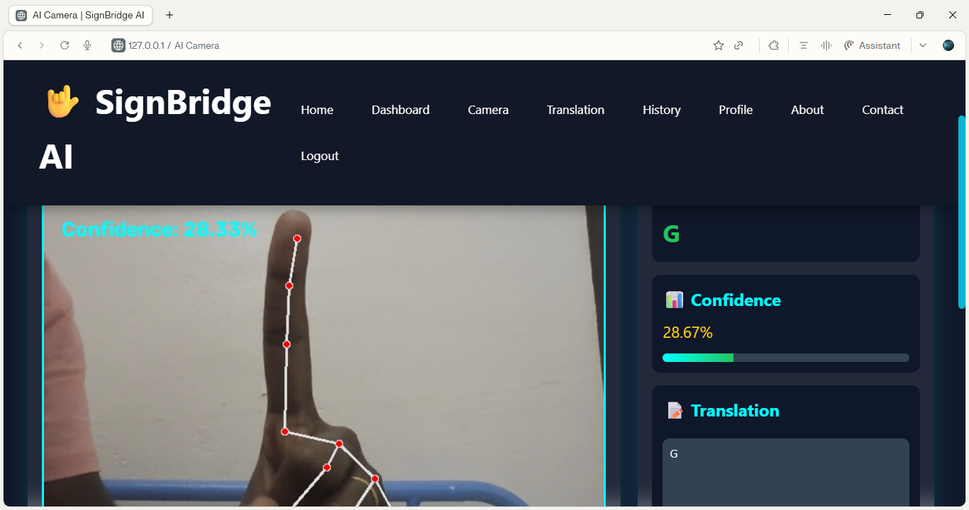

5.9 Text-to-Speech Output
The translated text is converted into speech using the integrated Text-to-Speech module. The generated voice enables hearing users to understand the intended message without reading the displayed text.

Features
- Speech generation
- Real-time voice output
- Natural pronunciation
- Improved communication

5.10 Translation History
Every detected gesture and its corresponding translation are stored in the MySQL database. Users can access previously recognized gestures through the History page for future reference.

Features
- Automatic history storage
- Database integration
- Previous translation retrieval
- Organized records
Figure 5.8: History Page
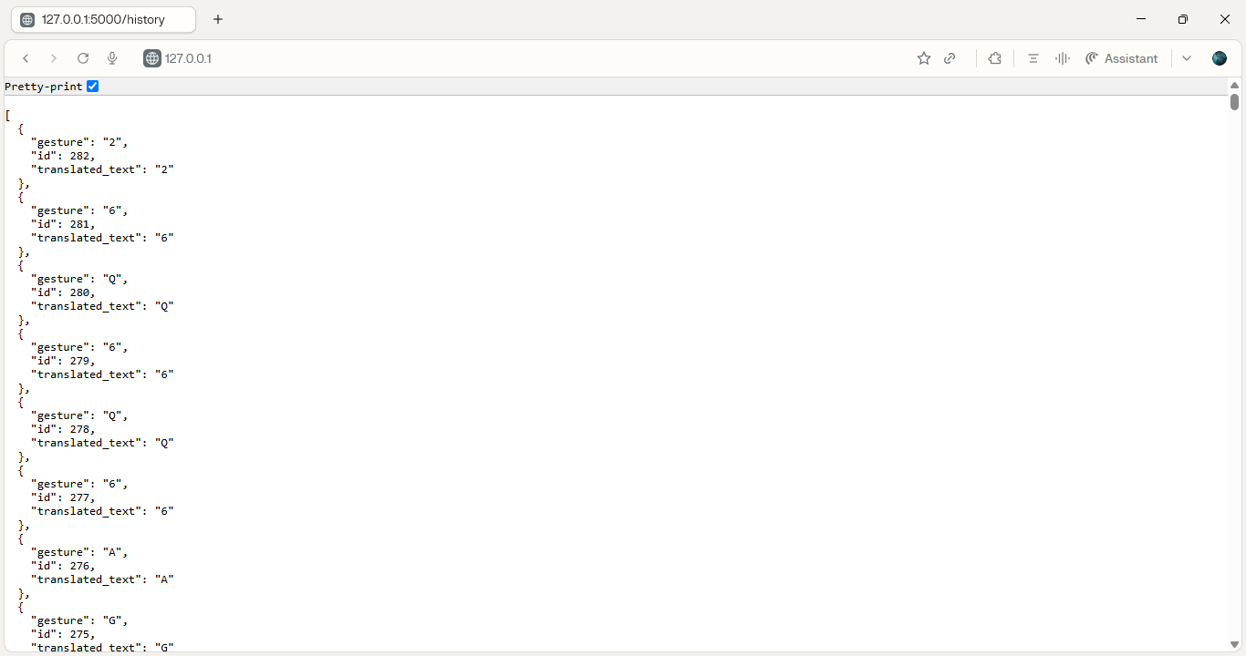

5.11 Profile Management
The Profile Module allows users to view and update their personal information. It provides a secure interface for managing account details.

Features
- View profile
- Update user information
- Secure access
- User account management
Figure 5.9: Profile Page
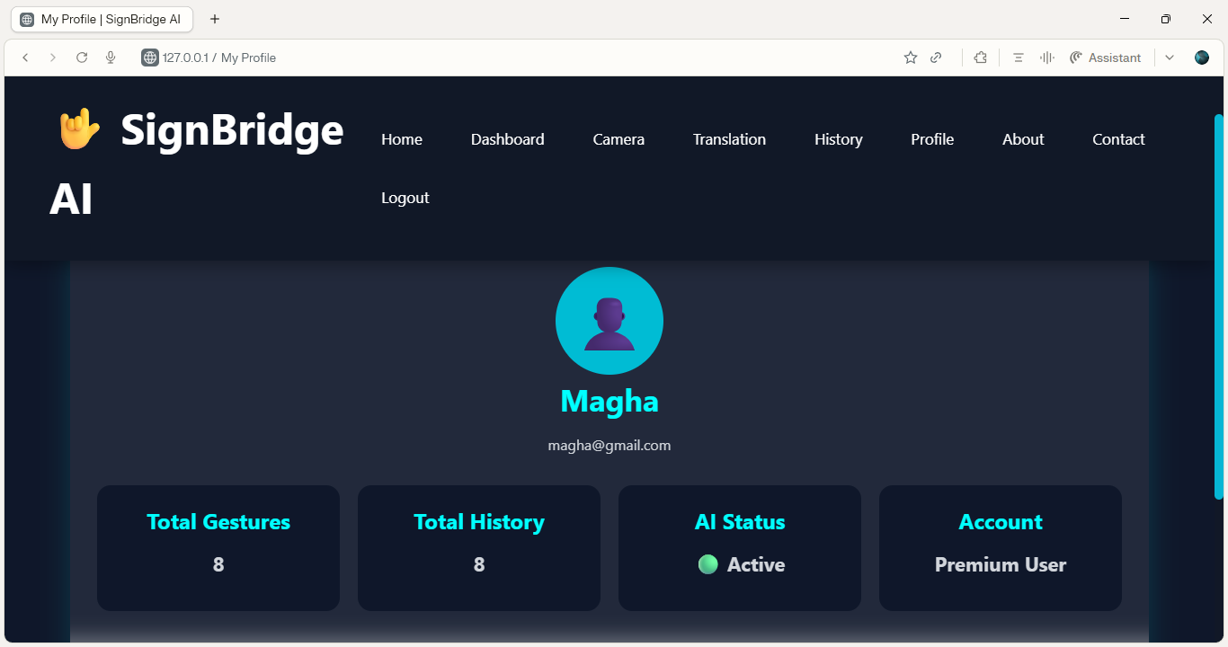

5.12 About and Contact Pages
The About Page describes the purpose, objectives, and technologies used in the SignBridge AI project. The Contact Page provides information for users to communicate with the development team or administrator.

Features
- Project information
- Technology overview
- Contact details
- User support
Figure 5.10: About Page
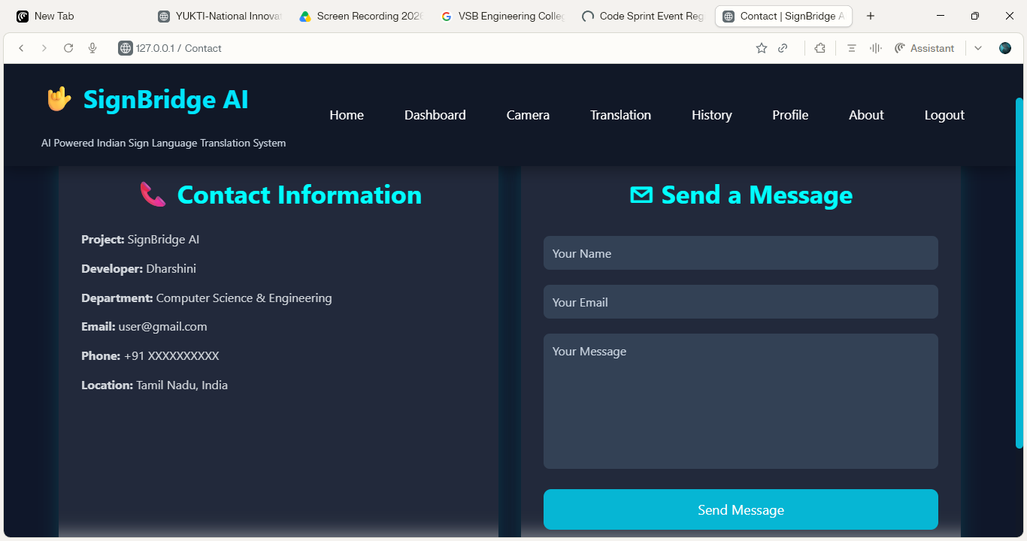

Figure 5.11: Contact Page


5.13 Performance Analysis
The application was tested using multiple hand gestures under different lighting conditions and camera positions. The system demonstrated stable performance and produced accurate predictions for the trained gesture set.

Performance Highlights
- Real-time gesture detection
- Smooth camera streaming
- Fast response time
- Accurate gesture recognition
- Reliable speech generation
- Efficient database operations
- User-friendly interface

Table 5.1 Performance Summary
Parameter | Result
Gesture Recognition | Successful
Live Camera | Successful
Gesture-to-Text | Successful
Text-to-Speech | Successful
User Login | Successful
Registration | Successful
History Storage | Successful
Profile Management | Successful
Overall System Performance | Excellent

5.14 Discussion
The experimental results demonstrate that the SignBridge AI system successfully achieves its primary objectives. The integration of MediaPipe and TensorFlow enables efficient and accurate hand gesture recognition, while Flask provides a responsive web interface for user interaction. The system performs gesture-to-text translation and text-to-speech conversion in real time, making communication between hearing-impaired individuals and non-signing users more effective.
The modular architecture ensures scalability and maintainability, allowing future enhancements such as multilingual translation, additional gesture support, mobile applications, and cloud deployment. Overall, the developed system is reliable, user-friendly, and suitable for real-world communication assistance.
5.15 Summary
This chapter presented the implementation results and performance evaluation of the SignBridge AI system. All modules—including user authentication, AI camera detection, gesture recognition, translation, speech output, history management, and profile management—were tested successfully. The system demonstrated reliable performance, real-time processing, and accurate translation capabilities, confirming that the project objectives were achieved.

CHAPTER 6

TESTING

6.1 Introduction
Testing is an essential phase in the software development life cycle that ensures the developed application meets the specified requirements and functions correctly under different operating conditions. The SignBridge AI system was tested thoroughly to verify the accuracy of gesture recognition, user authentication, database operations, translation, speech generation, and overall system performance.
Various testing techniques, including Unit Testing, Integration Testing, System Testing, and User Acceptance Testing, were carried out to identify and eliminate errors before deployment. The results indicate that all modules performed successfully and met the expected functional requirements.

6.2 Objectives of Testing
The main objectives of testing are:
- To verify the correctness of the developed system.
- To identify and eliminate software defects.
- To ensure all modules function properly.
- To validate gesture recognition accuracy.
- To verify database operations.
- To test user authentication.
- To evaluate overall system performance.
To improve software reliability.

6.3 Testing Methodology
The following testing techniques were used during the development of SignBridge AI:
- Unit Testing
- Integration Testing
- System Testing
- User Acceptance Testing (UAT)
Each testing phase ensures that the application performs according to the functional requirements

6.4 Unit Testing
Unit testing verifies the functionality of each individual module independently.
The following modules were tested:
- Registration Module
- Login Module
- Dashboard Module
- AI Camera Module
- Gesture Recognition Module
- Translation Module
- Speech Module
- History Module
- Profile Module
Each module was tested separately before integration

Table 6.1 Unit Testing
Test Case | Expected Result | Actual Result | Status
User Registration | User account created | Successful | Pass
User Login | Login successful | Successful | Pass
Dashboard | Dashboard displayed | Successful | Pass
Camera Module | Camera opened | Successful | Pass
Gesture Detection | Gesture detected | Successful | Pass
Translation | Text displayed | Successful | Pass
Speech Output | Audio generated | Successful | Pass
History Module | History saved | Successful | Pass
Profile Module | Profile displayed | Successful | Pass

6.5 Integration Testing
Integration testing verifies whether different modules work together correctly.
The following integrations were tested:
- Login → Dashboard
- Dashboard → Camera
- Camera → AI Model
- AI Model → Translation
- Translation → Speech
- Translation → History
- Profile → Database
All modules communicated successfully without errors.

Table 6.2 Integration Testing
Module Integration | Expected Result | Status
Login → Dashboard | Dashboard opens | Pass
Dashboard → Camera | Camera opens | Pass
Camera → TensorFlow | Prediction generated | Pass
Prediction → Translation | Text displayed | Pass
Translation → Speech | Voice generated | Pass
Translation → History | Stored in database | Pass

6.6 System Testing
System testing verifies the complete application after integrating all modules.
The SignBridge AI system was tested under different operating conditions, including varying lighting conditions, multiple hand gestures, and continuous camera usage.
The application performed successfully throughout the testing process.

Table 6.3 System Testing
Function | Result
Home Page | Pass
Registration | Pass
Login | Pass
Dashboard | Pass
Camera | Pass
Gesture Detection | Pass
Translation | Pass
Speech | Pass
History | Pass
Logout | Pass

6.7 User Acceptance Testing (UAT)
User Acceptance Testing was performed to ensure that the application satisfies user requirements.
The application was tested by multiple users to evaluate:
- Ease of use
- User interface
- Navigation
- Gesture recognition
- Translation accuracy
- Speech quality
The users reported that the system was easy to operate and provided satisfactory performance.

Table 6.4 User Acceptance Testing
Parameter | Rating
User Interface | Excellent
Navigation | Excellent
Gesture Recognition | Excellent
Translation | Excellent
Speech Output | Very Good
Overall Performance | Excellent

6.8 Performance Evaluation
The SignBridge AI system demonstrated good performance during testing.

Performance Metrics
- Fast gesture recognition
- Real-time processing
- Low response time
- Stable camera streaming
- Accurate translation
- Reliable speech generation
- Secure database operations

Table 6.5 Performance Analysis
Parameter | Performance
Recognition Speed | High
Translation Speed | High
Speech Generation | High
Camera Response | High
Database Access | High
User Experience | Excellent

6.9 Error Handling

The application includes proper error-handling mechanisms.
Examples include:
- Invalid login credentials display an error message.
- Camera access failures are handled gracefully.
- Database connection errors are reported appropriately.
- Empty gesture detection displays a waiting message.
- Unexpected exceptions are logged without crashing the application.

6.10 Summary
The testing process confirms that the SignBridge AI – AI Powered Indian Sign Language Translation System satisfies all functional and performance requirements. All modules—including user authentication, AI camera, gesture recognition, gesture-to-text translation, text-to-speech conversion, history management, and profile management—operated successfully.
The application demonstrated stable performance, accurate gesture recognition, secure database integration, and a user-friendly interface, making it suitable for real-time communication assistance between hearing-impaired individuals and non-signing users.

CHAPTER 7

CONCLUSION AND FUTURE ENHANCEMENTS

7.1 Conclusion
The SignBridge AI – AI Powered Indian Sign Language Translation System has been successfully designed, developed, and implemented to improve communication between hearing-impaired individuals and non-signing people. The system integrates Artificial Intelligence (AI), Computer Vision, Deep Learning, and Web Technologies to recognize Indian Sign Language (ISL) gestures in real time and translate them into readable text and audible speech.
The application captures hand gestures using a standard webcam and processes the video frames through OpenCV. MediaPipe is used to detect and extract hand landmarks with high precision, while a trained TensorFlow model classifies the gestures accurately. The recognized gestures are converted into text and further transformed into speech using a Text-to-Speech module, enabling seamless communication.
The system also includes secure user registration, login authentication, profile management, and translation history, all supported by a MySQL database. The web interface, developed using Flask, HTML, CSS, and JavaScript, provides an interactive, responsive, and user-friendly experience.
During testing, all modules—including user authentication, AI camera, gesture recognition, translation, speech generation, history management, and profile management—performed successfully. The application demonstrated stable performance, fast response time, and accurate recognition of trained Indian Sign Language gestures.
The objectives of the project have been successfully achieved. SignBridge AI offers an effective, low-cost, and scalable solution that reduces communication barriers and promotes accessibility and inclusion for hearing-impaired individuals. It demonstrates the practical application of Artificial Intelligence in solving real-world communication challenges and provides a strong foundation for future research and development.

7.2 Future Enhancements
Although the current implementation successfully recognizes predefined Indian Sign Language gestures, several improvements can further enhance the capabilities of the system.

The future enhancements include:

1. Recognition of More ISL Gestures
The existing system recognizes a predefined set of gestures. In future versions, the gesture dataset can be expanded to support hundreds of Indian Sign Language words and complete sentences.

2. Sentence Formation
Instead of translating individual gestures, the system can automatically construct meaningful sentences using Natural Language Processing (NLP), resulting in more natural communication.

3. Voice-to-Sign Translation
The application can be extended to convert spoken language into sign language animations, enabling two-way communication between hearing and hearing-impaired users.

4. 3D Avatar Integration
A three-dimensional animated avatar can be introduced to display translated signs visually, making communication more intuitive and accessible.

5. Mobile Application
The system can be developed as an Android and iOS application to allow users to access gesture recognition services using smartphones and tablets.

6. Cloud-Based Deployment
Deploying the application on cloud platforms would enable users to access the system from anywhere without requiring local installation.

7. Multilingual Translation
Future versions can support translation into multiple regional and international languages, allowing broader accessibility for diverse user groups.

8. Improved Deep Learning Models
Advanced deep learning architectures can be incorporated to improve recognition accuracy, reduce prediction time, and enhance performance under varying lighting conditions.

9. Facial Expression Recognition
Since facial expressions are an important component of sign language, integrating facial expression analysis can significantly improve translation accuracy.

10. Continuous Learning System
The application can be enhanced with adaptive learning techniques that allow the AI model to learn new gestures over time, improving performance through continuous training.

11. Wearable Device Integration
The system can be integrated with wearable devices and smart glasses to provide hands-free gesture recognition and real-time communication support.

12. Healthcare and Educational Applications
Future versions can be customized for hospitals, educational institutions, government offices, and public service centers to provide specialized communication assistance.

AI POWERED INDIAN SIGN LANGUAGE
TRANSLATION SYSTEM
ABSTRACT | PO'S MAPPING | PSO'S MAPPING
Communication barriers between hearing-impaired individuals and the general public create difficulties in daily communication, highlighting the need for an intelligent and accessible sign language translation system. | PO6, PO8 | PSO1
The proposed system utilizes Artificial Intelligence, Computer Vision, OpenCV, MediaPipe, and Machine Learning to recognize Indian Sign Language gestures in real time. | PO1, PO5 | PSO3
The recognized gestures are converted into readable text and natural speech through a Flask-based web application, enabling effective communication. | PO3, PO10 | PSO2
The system integrates Flask, MySQL, and Machine Learning to provide secure user authentication, gesture prediction, and translation history management. | PO3, PO5, PO11 | PSO2
Experimental results demonstrate high gesture recognition accuracy, real-time performance, and improved accessibility for hearing-impaired users using affordable webcam-based technology. | PO4, PO7, PO11 | PSO1
Existing sign language recognition systems suffer from limited gesture support, lack of user management, and absence of real-time speech generation, which are addressed by the proposed SignBridge AI system. | PO2 | PSO2

PO PSO MAPPING JUSTIFICATION
PO | JUSTIFICATION
PO1: | The project applies concepts of Artificial Intelligence, Computer Vision, Machine Learning, MediaPipe, OpenCV, Flask, and MySQL to design a real-time Indian Sign Language Translation System that converts gestures into text and speech.
PO2: | It analyses existing communication challenges faced by hearing-impaired individuals, identifies the limitations of traditional sign language recognition systems, and proposes an intelligent web-based solution.
PO3: | The project develops a complete real-time sign language translation system integrating gesture recognition, text and speech conversion, secure user authentication, and translation history, demonstrating engineering design skills.
PO4: | Evaluation of gesture recognition accuracy, system performance, response time, and functional testing involves detailed data analysis and experimentation.
PO5: | The system uses modern engineering tools such as Python, Flask, OpenCV, MediaPipe, NumPy, TensorFlow, MySQL, GitHub, and Visual Studio Code, demonstrating contemporary software development practices.
PO6: | By helping hearing-impaired individuals communicate effectively, the solution directly addresses social communication barriers and improves accessibility through intelligent technology.
PO7: | The project promotes sustainable and inclusive communication by reducing dependence on human interpreters and encouraging the adoption of affordable AI-based assistive technologies.
PO8: | The system ensures ethical handling of user information, secure authentication, accurate gesture recognition, and responsible use of Artificial Intelligence in communication technology.
PO9: | Developing the Machine Learning model, implementing the Flask web application, integrating the MySQL database, and testing the complete system require teamwork while allowing individual contributions across different modules.
PO10: | The project communicates technical outputs effectively through project reports, presentations, live demonstrations, user documentation, and proper technical documentation.
PO11: | Dataset preparation, Machine Learning model training, web application development, database integration, testing, and documentation are systematically planned and managed to complete the project successfully.
PO12: | The project requires continuous learning of emerging technologies such as Artificial Intelligence, Machine Learning, Computer Vision, MediaPipe, Flask Framework, and modern web development, encouraging lifelong learning.

PSO | JUSTIFICATION
PSO1: | The project provides an intelligent technological solution that addresses communication barriers faced by hearing-impaired individuals, thereby improving accessibility and contributing to societal welfare through inclusive communication.
PSO2: | The project demonstrates software engineering skills by integrating frontend development, backend programming, Machine Learning, database management, and real-time gesture recognition into a complete web application.
PSO3: | The project utilizes emerging technologies such as Artificial Intelligence, Machine Learning, OpenCV, MediaPipe, Flask, MySQL, and Computer Vision to develop an efficient and accurate real-time Indian Sign Language Translation System.

APPENDIX

Appendix A – Source Code
Include the important source code files:
- app.py
- camera.py
- model.py
- train_model.py
- login.py
- register.py
- database.py
- HTML templates (index.html, login.html, camera.html, etc.)
- CSS (style.css)
- JavaScript (script.js)

APPENDIX - B
OUTPUT SCREEN
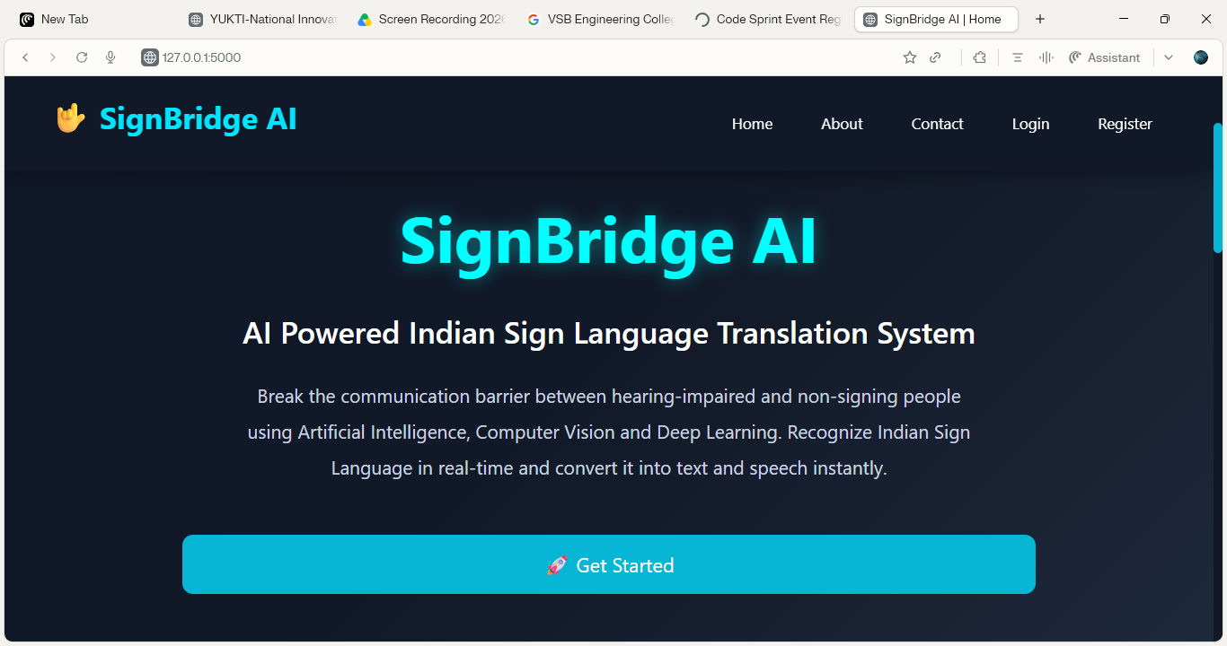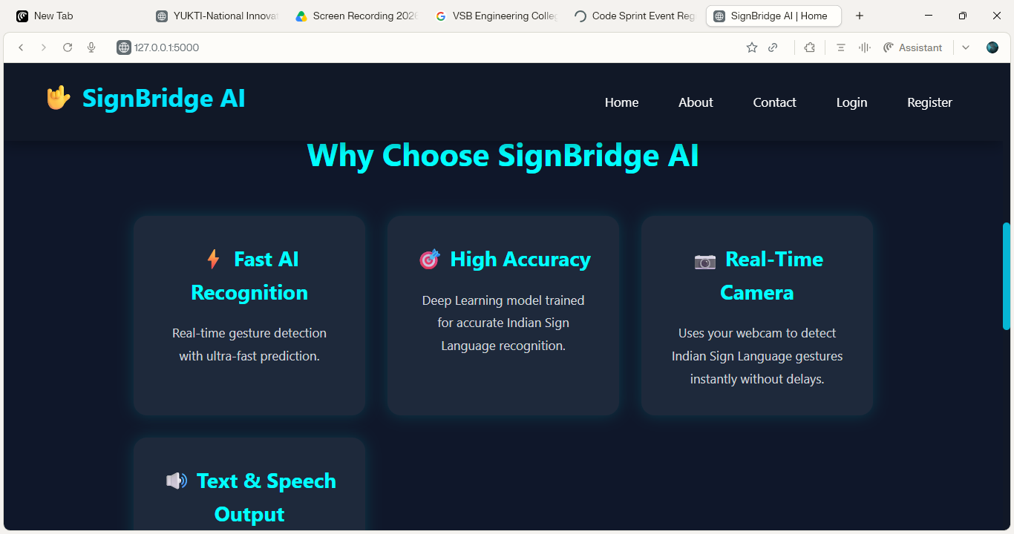
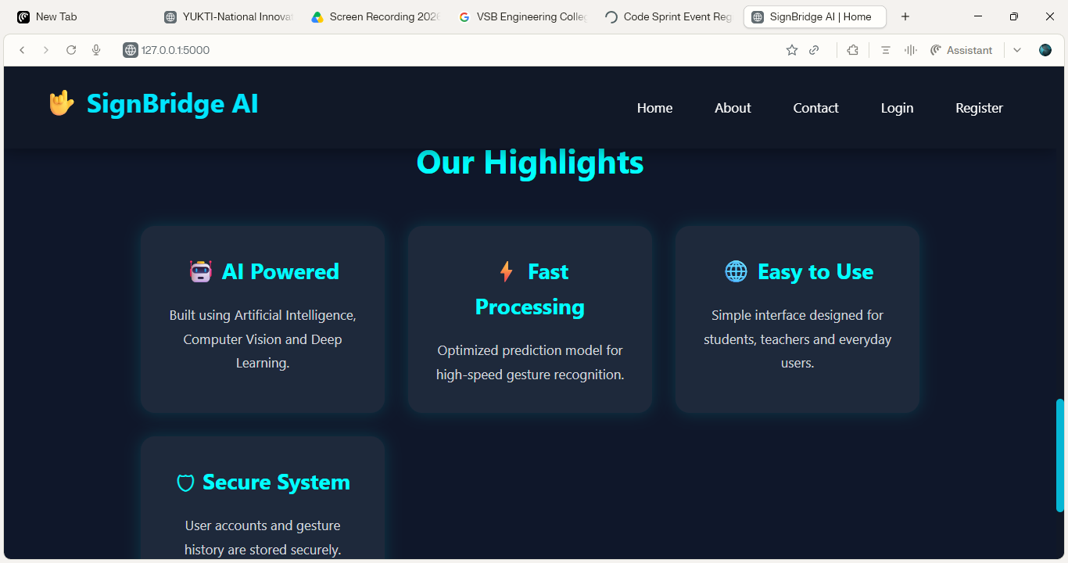
HOME PAGE

REGISTRATION PAGE


LOGIN PAGE


DASHBOARD PAGE

AI CAMERA
GESTURE RECOGNITION
TRANSLATION OUTPUT

HISTORY PAGE

PROFILE PAGE

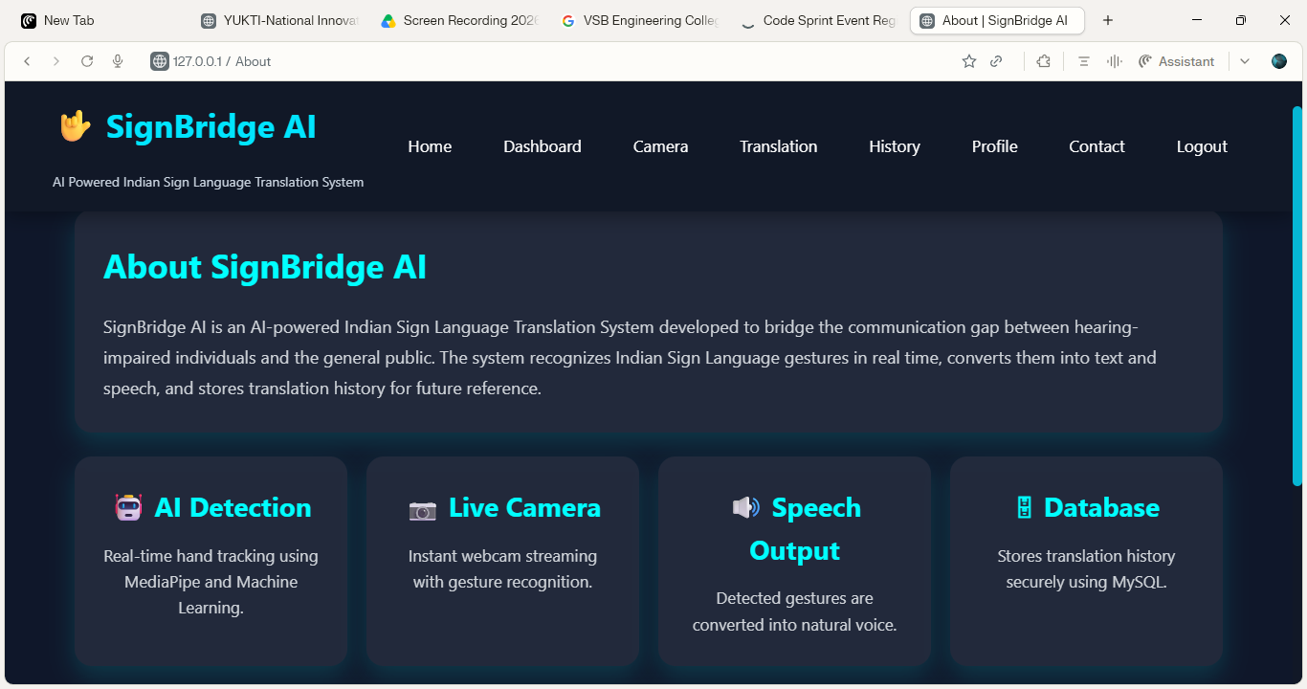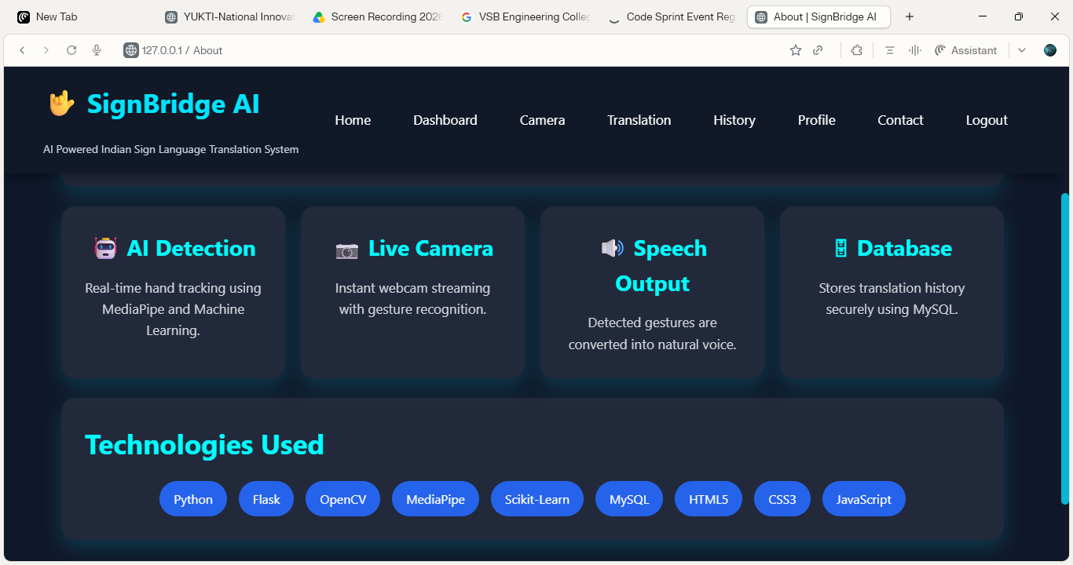
ABOUT PAGE

CONTACT PAGE
REFERENCES:
[1] G. Bradski, “The OpenCV Library,” Dr. Dobb’s Journal of Software Tools, vol. 25, no. 11, pp. 120–126, 2000.
[2] Google, “MediaPipe: Cross-Platform ML Solutions for Live and Streaming Media,” 2025. [Online]. Available: https://mediapipe.dev/
[3] TensorFlow Developers, “TensorFlow: An End-to-End Open Source Machine Learning Platform,” 2025. [Online]. Available: https://www.tensorflow.org/
[4] Python Software Foundation, “Python 3 Documentation,” 2025. [Online]. Available: https://docs.python.org/3/
[5] Pallets Projects, “Flask Documentation,” 2025. [Online]. Available: https://flask.palletsprojects.com/
[6] NumPy Developers, “NumPy User Guide,” 2025. [Online]. Available: https://numpy.org/doc/
[7] Oracle Corporation, “MySQL 8.0 Reference Manual,” 2025. [Online]. Available: https://dev.mysql.com/doc/
[8] T. Starner and A. Pentland, “Real-Time American Sign Language Recognition from Video Using Hidden Markov Models,” Proceedings of the International Symposium on Computer Vision, pp. 265–270, 1995.
[9] R. Bowden, D. Windridge, T. Kadir, A. Zisserman, and M. Brady, “A Linguistic Feature Vector for the Visual Interpretation of Sign Language,” European Conference on Computer Vision (ECCV), 2004.
[10] C. Keskin, F. Kıracı, Y. E. Kara, and L. Akarun, “Hand Pose Estimation and Hand Shape Classification Using Multi-Layered Randomized Decision Forests,” European Conference on Computer Vision (ECCV), pp. 852–863, 2012.
[11] A. Krizhevsky, I. Sutskever, and G. E. Hinton, “ImageNet Classification with Deep Convolutional Neural Networks,” Advances in Neural Information Processing Systems (NeurIPS), vol. 25, 2012.
[12] D. G. Lowe, “Distinctive Image Features from Scale-Invariant Keypoints,” International Journal of Computer Vision, vol. 60, no. 2, pp. 91–110, 2004.
[13] S. Ren, K. He, R. Girshick, and J. Sun, “Faster R-CNN: Towards Real-Time Object Detection with Region Proposal Networks,” IEEE Transactions on Pattern Analysis and Machine Intelligence, vol. 39, no. 6, pp. 1137–1149, 2017.
[14] S. Mitra and T. Acharya, “Gesture Recognition: A Survey,” IEEE Transactions on Systems, Man, and Cybernetics, Part C: Applications and Reviews, vol. 37, no. 3, pp. 311–324, 2007.
[15] World Health Organization (WHO), “World Report on Hearing,” Geneva, Switzerland,2021.[Online].Available: https://www.who.int/publications/i/item/world-report-on-hearing

