EX : 5

app.js

constexpress=require("express");
constbodyParser=require("body-parser"); const app = express();
app.use(bodyParser.urlencoded({extended:true})); app.use(express.static(dirname));
app.get("/", function(req,res){ res.sendFile(dirname+"/home.html");
});
app.post("/bmicalculator",function(req,res){ let username = req.body.username;
letage= req.body.age;
let height = parseFloat(req.body.height); letweight=parseFloat(req.body.weight);
letbmi=weight/(height*height); let category="";
letsuggestion="";
if(bmi < 18.5){ category="Underweight";
suggestion="Eatfoodslikemilk,eggs,nuts,bananasandrice.";
}
elseif(bmi<24.9){ category="Normal";
suggestion="Maintainbalanceddietwithfruits,vegetablesandexercise.";
}
else if(bmi < 29.9){ category="Overweight";
suggestion="Reducejunkfoodanddoexerciseslikejogging.";
}
else{ category="Obese";
suggestion="Consultadoctorandfollowacontrolleddiet.";
}

res.send(`
<html>
<head>
<title>BMIResult</title>
</head>

<body>

<h2>Hello${username}</h2>

<p>Age:${age}</p>

<h3>YourBMI:${bmi.toFixed(2)}</h3>

<h3>Category:${category}</h3>

<formaction="/suggestion"method="POST">
<inputtype="hidden"name="username"value="${username}">
<inputtype="hidden"name="suggestion"value="${suggestion}">

<button>ViewSuggestion</button>
</form>

</body>

</html>
`);
});
app.post("/suggestion",function(req,res){ let username=req.body.username;
letsuggestion=req.body.suggestion; res.send(`
<html>
<head>
<title>FoodSuggestion</title>
</head>

<body>

<h2>DietSuggestionfor${username}</h2>

<p>${suggestion}</p>
<br>

<ahref="/">GoHome</a>

</body>

</html>
`);
});

app.listen(3000,function(){ console.log("Serverrunningonport3000");
});

home.html

<!DOCTYPEhtml>
<html>
<head>
<title>HospitalWebsite</title>
</head>

<body>

<h1>CityCareHospital</h1>
<nav>
<ahref="/">Home</a>|
<ahref="index.html">BMICalculator</a>
</nav>

<hr>
<h2>WelcometoOurHospital</h2>
<p>Yourhealthisour priority.</p>

<imgsrc="https://images.unsplash.com/photo-1586773860418-d37222d8fce3"width="600">
</body>
</html>

Index.html
<!DOCTYPEhtml>
<html>
<head>
<title>BMICalculator</title>

<linkrel="stylesheet"href="https://cdn.jsdelivr.net/npm/bootstrap@5.3.2/dist/css/bootstrap.min.css">
<style> body{
background:linear-gradient(135deg,#cce7ff,#e6ccff); font-family:Arial;
}

.navbar{ background:#5f6fff;
}

.card{
margin-top:80px; border-radius:15px;
}

.btn-custom{ background:#5f6fff; color:white;
}

</style>
</head>
<body>
<navclass="navbarnavbar-expand-lg">
<divclass="container">
<aclass="navbar-brandtext-white"href="home.html">CityCareHospital</a>
<ulclass="navbar-navms-auto">
<liclass="nav-item">
<aclass="nav-linktext-white"href="home.html">Home</a>
</li>
</ul>
</div>
</nav>
<divclass="container">
<divclass="rowjustify-content-center">
<divclass="col-md-5">
<divclass="cardshadow-lgp-4">
<h3class="text-centermb-4">BMICalculator</h3>
<formaction="/bmicalculator"method="POST">
<divclass="mb-3">
<label>Username</label>
<inputtype="text"name="username"class="form-control"required>
</div>
<divclass="mb-3">
<label>Age</label>
<inputtype="number"name="age"class="form-control"required>
</div>
<divclass="mb-3">
<label>Height(m)</label>
<inputtype="number"step="0.01"name="height"class="form-control"required>
</div>
<divclass="mb-3">
<label>Weight(kg)</label>
<inputtype="number"step="0.1"name="weight"class="form-control"required>
</div>
<buttonclass="btnbtn-customw-100"> Calculate BMI
</button>
</form>
</div>
</div>
</div>
</div>
</div>
</body>
</html>

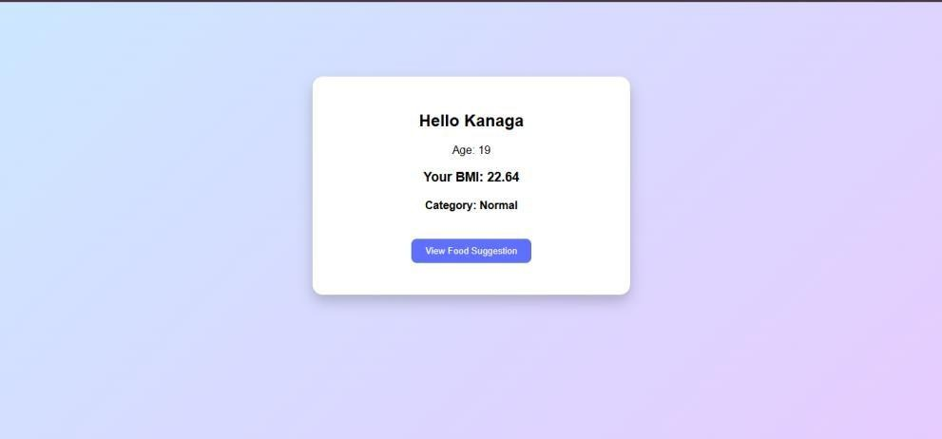

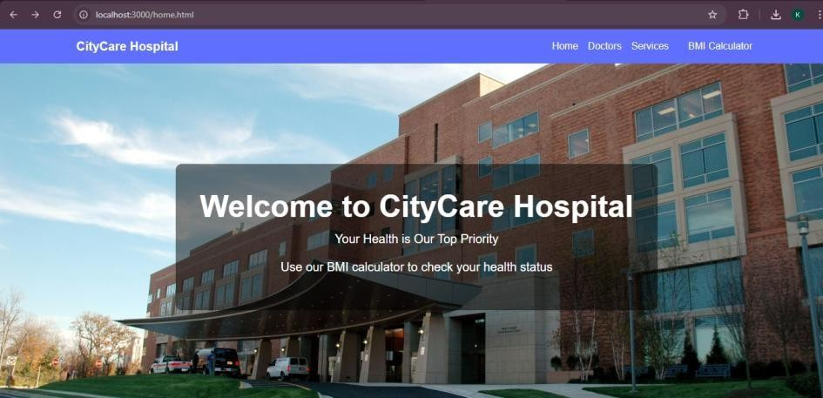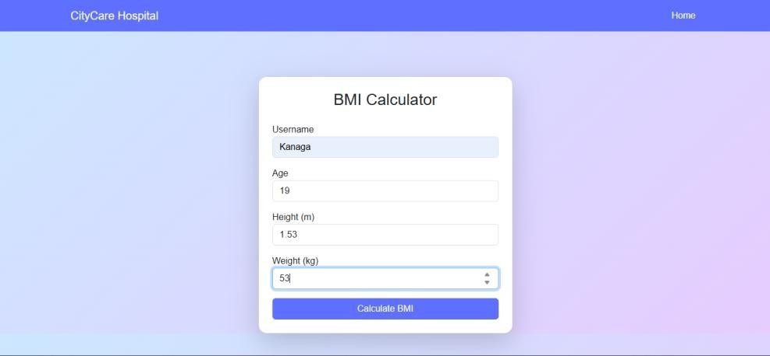Output:

