**PERSONAL BLOG STATIC WEB PAGE ON IBM CLOUD**

The project submission: Phase-5

**Travel.html:**

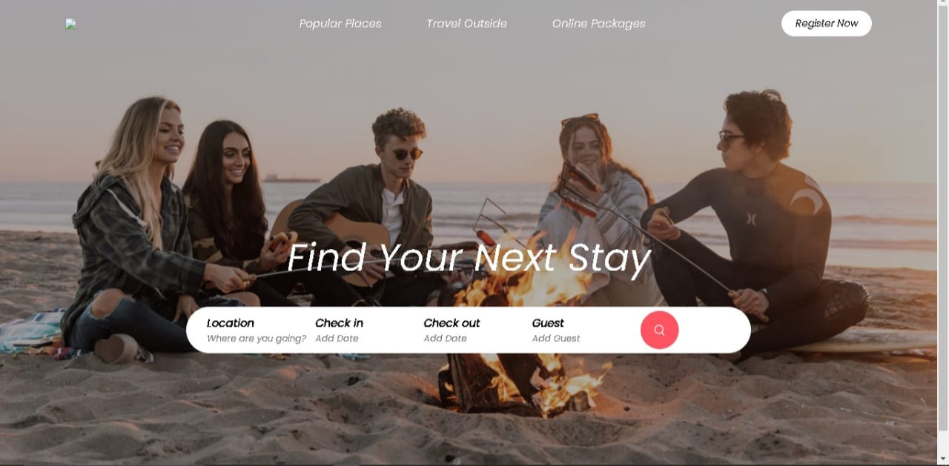

**<!DOCTYPE html>**

**<html lang="en">**

**<head>**

**<meta charset="UTF-8">**

**<meta name="viewport" content="width=device-width, initial-scale=1.0">**

**<title>Travel Blog</title>**

**<link rel="stylesheet" href="travel.css">**

**<link rel="preconnect" href="https://fonts.googleapis.com">**

**<link rel="preconnect" href="https://fonts.gstatic.com" crossorigin>**

**<link href="https://fonts.googleapis.com/css2?family=Poppins:ital@1&display=swap" rel="stylesheet">**

**<script src="https://kit.fontawesome.com/8eca44edb4.js" crossorigin="anonymous"></script>**

**<link rel="preconnect" href="https://fonts.googleapis.com">**

**<link rel="preconnect" href="https://fonts.gstatic.com" crossorigin>**

**<link href="https://fonts.googleapis.com/css2?family=Anton&family=Dancing+Script&family=Poppins:ital@1&display=swap" rel="stylesheet">**

**</head>**

**<body>**

**<div class="header">**

**<nav class="navBar">**

**<h2 class="logo">TravelTribe</h2>**

**<ul class="nav-links">**

**<li><a href="#" class="active">Popular Places</a></li>**

**<li><a href="#">Travel Outside</a></li>**

**<li><a href="#">Online Packages</a></li>**

**</ul>**

**<a href="#" class="register-btn" >Register Now</a>**

**<i class="fa-solid fa-bars" onclick="togglebtn()"></i>**

**</nav>**

**<div class="container">**

**<h1>Find Your Next Stay</h1>**

**<div class="search-bar">**

**<form>**

**<div class="Location-input">**

**<label>Location</label>**

**<input type="text" placeholder="Where are you going?">**

**</div>**

**<div>**

**<label>Check in</label>**

**<input type="text" placeholder="Add Date">**

**</div>**

**<div>**

**<label>Check out</label>**

**<input type="text" placeholder="Add Date">**

**</div>**

**<div>**

**<label>Guest</label>**

**<input type="text" placeholder="Add Guest">**

**</div>**

**<button type="submit"><img src="travelimg/search.png"></button>**

**</form>**

**</div>**

**</div>**

**</div>**

**<div class="container">**

**<h2 class="sub-title">Exclusives</h2>**

**<div class="exclusives">**

**<div>**

**<img src="travelimg/image-1.png">**

**<span>**

**<h3>Londan</h3>**

**<p>Starts @ $250</p>**

**</span>**

**</div>**

**<div>**

**<img src="travelimg/image-2.png">**

**<span>**

**<h3>Switzerland</h3>**

**<p>Starts @ $250</p>**

**</span>**

**</div>**

**<div>**

**<img src="travelimg/image-3.png">**

**<span>**

**<h3>Australia</h3>**

**<p>Starts @ $250</p>**

**</span>**

**</div>**

**<div>**

**<img src="travelimg/image-4.png">**

**<span>**

**<h3>France</h3>**

**<p>Starts @ $250</p>**

**</span>**

**</div>**

**<div>**

**<img src="travelimg/image-5.png">**

**<span>**

**<h3>Amsterdam</h3>**

**<p>Starts @ $250</p>**

**</span>**

**</div>**

**<div>**

**<img src="travelimg/image-6.png">**

**<span>**

**<h3>Netherlands</h3>**

**<p>Starts @ $250</p>**

**</span>**

**</div>**

**<div>**

**<img src="travelimg/image-7.png">**

**<span>**

**<h3>Newyork</h3>**

**<p>Starts @ $250</p>**

**</span>**

**</div>**

**<div>**

**<img src="travelimg/image-8.png">**

**<span>**

**<h3>Chicago</h3>**

**<p>Starts @ $250</p>**

**</span>**

**</div>**

**<div>**

**<img src="travelimg/image-9.png">**

**<span>**

**<h3>San Francisco</h3>**

**<p>Starts @ $250</p>**

**</span>**

**</div>**

**<div>**

**<img src="travelimg/image-10.png">**

**<span>**

**<h3>Shangai</h3>**

**<p>Starts @ $250</p>**

**</span>**

**</div>**

**</div>**

**</div>**

**<h2 class="sub-title" >Tranding Places</h2>**

**<div class="trending">**

**<div>**

**<img src="travelimg/dubai.png">**

**<h3>Dubai</h3>**

**</div>**

**<div>**

**<img src="travelimg/new-york.png">**

**<h3>New York</h3>**

**</div>**

**<div>**

**<img src="travelimg/paris.png">**

**<h3>Paris</h3>**

**</div>**

**<div>**

**<img src="travelimg/new-delhi.png">**

**<h3>New Delhi</h3>**

**</div>**

**</div>**

**<div class="cta">**

**<h3>Sharing <br> Earing Now</h3>**

**<p>Great opportunity to make money by <br>sharing your extra space</p>**

**<a href="#" class="cta-btn">Know More</a>**

**</div>**

**<h2 class="sub-title">Travellers Stories</h2>**

**<div class="Stories">**

**<div>**

**<img src="travelimg/story-1.png">**

**<p>Popular European countries with a budget of just $10000</p>**

**</div>**

**<div>**

**<img src="travelimg/story-2.png">**

**<p>Traveled more than 100 countries in less than a year</p>**

**</div>**

**<div>**

**<img src="travelimg/story-3.png">**

**<p>Best experience you get while travelling to Thailand</p>**

**</div>**

**</div>**

**<a href="#" class="start-btn">start making money</a>**

**<div class="about-msg">**

**<h2>about staybnb</h2>**

**<p>contrary to Popular belief,Lorem Ipsum is not simply random text.it has roots**

**in a piece of classical latin literature from 45 BC ,making it over 20 years**

**old.Richard mcClintock,a latin professor at Hampten-sydney College in Virginia, looked up one of the more obscure latin words,consectectur,from a lorem ipsum passage,and going through the cities of the word in classical literature,discovered the undoubtable source**

**</p>**

**</div>**

**<div class="footer">**

**<a href="https://facebook.com/"><i class="fa-brands fa-facebook-f"></i></a>**

**<a href="https://youtube.com/"><i class="fa-brands fa-youtube"></i></a>**

**<a href="https://twitter.com/"><i class="fa-brands fa-twitter"></i></a>**

**<a href="https://linkedin.com/"><i class="fa-brands fa-linkedin"></i></a>**

**<a href="https://instagram.com/"><i class="fa-brands fa-instagram"></i></a>**

**<hr>**

**<p>copyright © 2023,Easy Tutorial</p>**

**</div>**

**</div>**

**<script>**

**var navBar = document.getElementById(navBar);**

**function togglebtn(){**

**navBar.classList.toggle("hidemenu");**

**}**

**</script>**

**</body>**

**</html>**

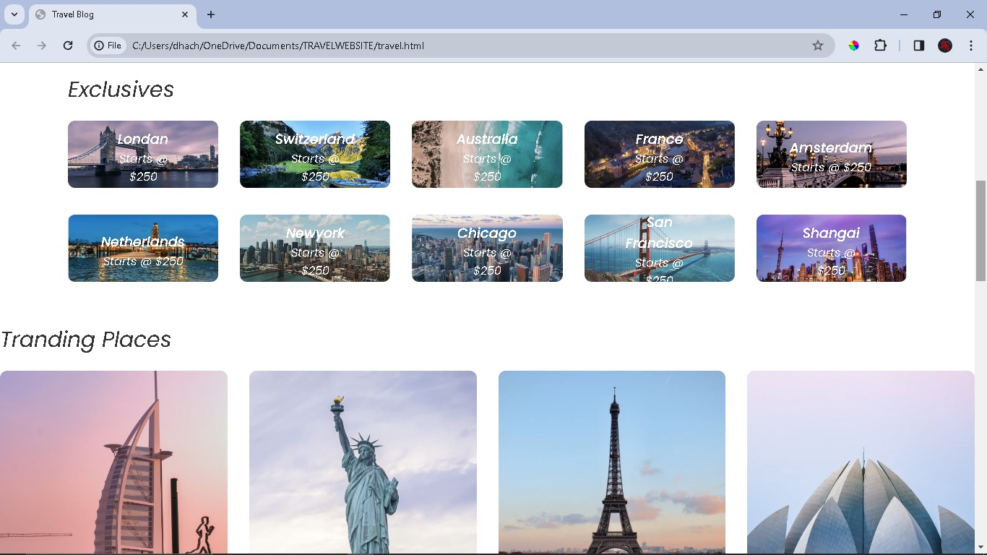

**Travel.css:**

**\***

**{**

**margin: 0;**

**padding: 0;**

**box-sizing:border-box;**

**font-family: 'Poppins', sans-serif;**

**}**

**.header{**

**min-height: 100vh;**

**width: 100%;**

**background-image: linear-gradient(rgba(0,0,0,0.3),rgba(0,0,0,0.3)),url(travelimg/banner.png);**

**background-size: cover;**

**background-position: center;**

**}**

**nav{**

**display: flex;**

**align-items: center;**

**justify-content: space-between;**

**padding: 20px 7%;**

**}**

**.logo{**

**font-family: 'Anton', sans-serif;**

**font-family: 'Dancing Script', cursive;**

**font-family: 'Poppins', sans-serif;**

**color: #fff;**

**}**

**h2{**

**color: #fff;**

**}**

**.nav-links li{**

**list-style: none;**

**display: inline-block;**

**margin: 10px 30px;**

**}**

**.nav-links li a{**

**text-decoration: none;**

**color: #fff;**

**}**

**.register-btn{**

**background: white;**

**color:#000;**

**padding: 8px 20px;**

**border-radius: 20px;**

**text-decoration: none;**

**font-size: 14px;**

**}**

**.container{**

**padding: 0 7%;**

**}**

**.header h1{**

**font-size: 4vw;**

**font-weight: 500;**

**color: #fff;**

**text-align: center;**

**padding-top: 22%;**

**}**

**.search-bar{**

**background: #fff;**

**width: 70%;**

**margin: 30px auto;**

**padding: 6px 10px 6px 30px;**

**border-radius: 50px;**

**}**

**.search-bar form{**

**display: flex;**

**align-items: center;**

**flex-wrap: wrap;**

**}**

**.search-bar form input{**

**display: block;**

**border: 0;**

**outline: none;**

**background: transparent;**

**}**

**.search-bar form button{**

**background: #ff5361;**

**width: 55px;**

**height: 55px;**

**border-radius: 50%;**

**border: 0;**

**outline: none;**

**cursor: pointer;**

**}**

**.search-bar form button img{**

**width: 15px;**

**margin-top: 7px;**

**}**

**.location-input{**

**flex: 1;**

**}**

**.search-bar form label{**

**font-weight: 600;**

**}**

**/-----exclusives---------/**

**.sub-title{**

**margin: 50px 0 20px;**

**font-size: 2.2vw;**

**font-weight: 500;**

**color: #333;**

**}**

**.exclusives{**

**display:grid;**

**grid-template-columns: repeat(auto-fit,minmax(200px, 1fr));**

**grid-gap:30px;**

**}**

**.exclusives div img{**

**width:100%;**

**border-radius:10px;**

**}**

**.exclusives div{**

**position:relative;**

**}**

**.exclusives div span{**

**position:absolute;**

**top:50%;**

**left:50%;**

**transform:translate(-50%,-50%);**

**text-align:center;**

**color:#fff;**

**}**

**/---------------------Trending places----------------------/**

**.trending{**

**display:grid;**

**grid-template-columns:repeat(auto-fit,minmax(200px,1fr));**

**grid-gap:30px;**

**margin-bottom:30px;**

**}**

**.trending h3{**

**font-weight:600;**

**margin-top:10px;**

**}**

**/-----------call to action----------/**

**.cta{**

**margin:80px;**

**background-image: linear-gradient(to right,#3f2321,transparent),url(travelimg/banner-2.png);**

**background-size:cover;**

**background-position:center;**

**border-radius:10px;**

**padding:5%;**

**color:#fff;**

**}**

**.cta h3{**

**font-size:4vw;**

**line-height:5.3vw;**

**font-weight:500;**

**}**

**.cta p{**

**font-size:18px;**

**margin:10px 0;**

**}**

**.cta-btn{**

**background:#ff5361;**

**color:#fff;**

**text-decoration:none;**

**padding:12px 30px;**

**border-radius:8px;**

**margin-top:20px;**

**display:inline-block;**

**}**

**/--------------Travellers stories---------------/**

**.Stories{**

**display:grid;**

**grid-template-columns: repeat(auto-fit,minmax(200px,1fr));**

**grid-gap:30px;**

**margin-bottom:30px;**

**}**

**.Stories div img{**

**width:100%;**

**border-radius:10px;**

**}**

**.Stories div{**

**position:relative;**

**text-align:center;**

**}**

**.Stories p{**

**width:80%;**

**position:absolute;**

**top:50%;**

**left:50%;**

**transform:translate(-50%,-50%);**

**color:#fff;**

**font-size:26px;**

**}**

**.start-btn{**

**text-decoration:none;**

**background:#ff5361;**

**color:#fff;**

**width:80%;**

**max-width:350px;**

**display:block;**

**text-align:center;**

**margin:60px auto;**

**padding:15px;**

**border-radius:30px;**

**font-size:20px;**

**}**

**.about-msg{**

**text-align: center;**

**margin: 80px 0;**

**color:#333;**

**font-size: 17px;**

**}**

**.about-msg h2{**

**font-size: 28px;**

**margin-bottom: 30px;**

**font-weight: 500;**

**}**

**/------footer------/**

**.footer{**

**margin: 80px 0 10px;**

**text-align: center;**

**}**

**.footer a{**

**text-decoration: none;**

**color: #999;**

**font-size: 22px;**

**margin: 0 10px;**

**}**

**.footer hr{**

**background: #999;**

**height: 1px;**

**width: 100%;**

**border: 0;**

**margin:20px 0;**

**}**

**.footer p{**

**padding-bottom: 15px;**

**}**

**.active{**

**position: relative;**

**}**

**.active::after{**

**content: '';**

**background: #fff;**

**width: 25px;**

**height: 2px;**

**position: absolute;**

**left: 50%;**

**transform: translateX(-50%);**

**bottom: -12px;**

**border-radius: 2px;**

**}**

**nav .fa-bars{**

**display: none;**

**}**

**/* for small screen device-----*/**

**@media screen and(max-width:700px){**

**.logo{**

**position: fixed;**

**top: 4%;**

**left: 7%;**

**}**

**.nav{**

**position: fixed;**

**top: 0;**

**z-index: 100;**

**display: inline-block;**

**width: 100%;**

**padding: 100px 7% 0;**

**background: #000;**

**text-align: right;**

**max-height: 100px;**

**overflow: hidden;**

**transition: max-height 0.5s;**

**}**

**nav .nav-link li{**

**margin: 10px 0;**

**display: block;**

**}**

**.register-btn{**

**margin: 15px 0 30px;**

**display: inline-block;**

**}**

**.register-btn{**

**margin: 15px 0 30px;**

**display: inline-block;**

**}**

**nav .fa-bars{**

**display:blocks;**

**position: fixed;**

**top: 4%;**

**right: 7%;**

**color: #fff;**

**font-size: 28px;**

**}**

**.active::after{**

**left: -40px;**

**transform: translate(0,50%);**

**bottom: 50%;**

**}**

**.hidemenu{**

**max-height: 300px;**

**}**

**.header h1{**

**padding-top: 200px;**

**font-size: 7vw;**

**}**

**.search-bar{**

**width: 90%;**

**margin: 30px auto;**

**padding: 20px 10px 30px;**

**border-radius: 5px;**

**position: relative;**

**}**

**.search-bar form{**

**display: block;**

**}**

**.search-bar form input{**

**border-bottom: 1px solid #ddd;**

**width: 100%;**

**margin-bottom: 20px;**

**margin-top: 10px;**

**padding-bottom: 10px;**

**}**

**.search-bar form button{**

**position:absolute;**

**bottom: 0;**

**left: 50%;**

**transform: translate(-50%,-50%);**

**}**

**.sub-title{**

**font-size: 6vw;**

**}**

**.cta{**

**padding: 15% 5%;**

**}**

**.cta h3{**

**font-size: 7vw;**

**line-height: 8vw;**

**}**

**cta p{**

**font-size: 14px;**

**}**

**.cta-btn{**

**padding: 6px 15px;**

**border-radius: 4px;**

**margin-top: 10px;**

**font-size: 14px;**

**}**

**.Stories p{**

**font-size: 22px;**

**}**

**.about-msg{**

**font-size: 15px;**

**}**

**}**

