INTRODUCTION

ABOUT THE PROJECT

The Library Management with Bounty System is a computerized application developed to automate and improve the overall management of library activities. The main objective of this project is to replace the traditional manual record-keeping system with an efficient, secure, and user-friendly digital platform that enhances operational accuracy and accessibility.

In many Educational institutions, library operations such as maintaining book records, issuing and returning books, tracking due dates, and managing student information are often handled manually using registers. This manual process is time-consuming, prone to human errors, and difficult to manage when the number of books and users increases. As the library grows, searching for book details, tracking issued books, and managing records becomes increasingly complex.

To overcome these limitations, the proposed system introduces an automated library management solution developed using modern programming tools. The system allows administrators to efficiently manage book records, student details, book issuance, returns, and fine calculations in a structured digital environment.

A key feature of this project is the Bounty Request System. When a student needs a book that is currently unavailable in the library, the student can post a bounty request for that book. Other students who currently possess the book can view the request and claim it by returning the book earlier through the library system. This feature helps improve book availability, reduces waiting time for students, and encourages better resource sharing among library users.

Overall, the Library Management System with Bounty Request System improves efficiency, reduces manual workload, and provides a smarter and more interactive approach to managing library resources.

  - SYSTEM SPECIFICATION

System specification describes the hardware and software requirements needed to develop and operate the Library Management System effectively. The system is designed to work efficiently on standard computer systems without requiring high-end infrastructure.
    - HARDWARE SPECIFICATION

Processor | : AMD Ryzen 3 7320U with Radeon Graohics
RAM | : 8.00 GB
Hard Disk | : 50.00 GB
Monitor | : 15-inch or Above
Input Devices | : Keyboard and Mouse
Output Devices | : Monitor

.1.2.2 SOFTWARE SPECIFICATION

Operating System | : Windows 11
Programming Language | : Python
GUI Framework | : Tkinter
Database | : SQL
Development Tool | : Visual Studio Code

ABOUT THE SOFTWARE

An operating system is the core system software that manages computer hardware and software resources and provides a platform for running application programs. It acts as an interface between the user and the computer system.
In this project, Windows 11 is used as the operating system, which offers a modern desktop environment with improved performance, security, and user experience. It allows efficient execution of development tools like Visual Studio Code and supports programming languages such as Python and Visual Basic. The desktop interface makes it easy to manage files, run applications, and perform multitasking efficiently.

FEATURES OF WINDOWS 11

Windows 11 is a modern operating system developed by Microsoft, designed to provide a smooth, secure, and user-friendly experience. It includes several advanced features that improve performance, multitasking, and overall usability, making it suitable for both general use and software development.

FEATURES:

- User-friendly and modern graphical interface
- Centered Start Menu and redesigned taskbar
- Improved performance and faster processing speed
- Enhanced security features like Windows Defender and Secure Boot
- Advanced multitasking with Snap Layouts and Snap Groups
- Better memory and resource management
- Virtual desktops for organized workspace
- Improved support for latest software and hardware
- Seamless updates and system stability

VISUAL STUDIO CODE

Visual Studio Code is a lightweight yet powerful source code editor developed by Microsoft. It is widely used by developers for writing, editing, and debugging code efficiently. It provides a flexible development environment with support for multiple programming languages and tools, making it highly suitable for building modern applications.

FEATURES OF VISUAL STUDIO CODE:

- Lightweight and fast performance
- Supports multiple programming languages (Python, C, Java, etc.)
- Built-in terminal for executing commands
- Extension support for adding new features
- Debugging tools for error detection and fixing
- IntelliSense for smart code completion and suggestions
- Git integration for version control
- Customizable interface and themes
- Auto-save and syntax highlighting

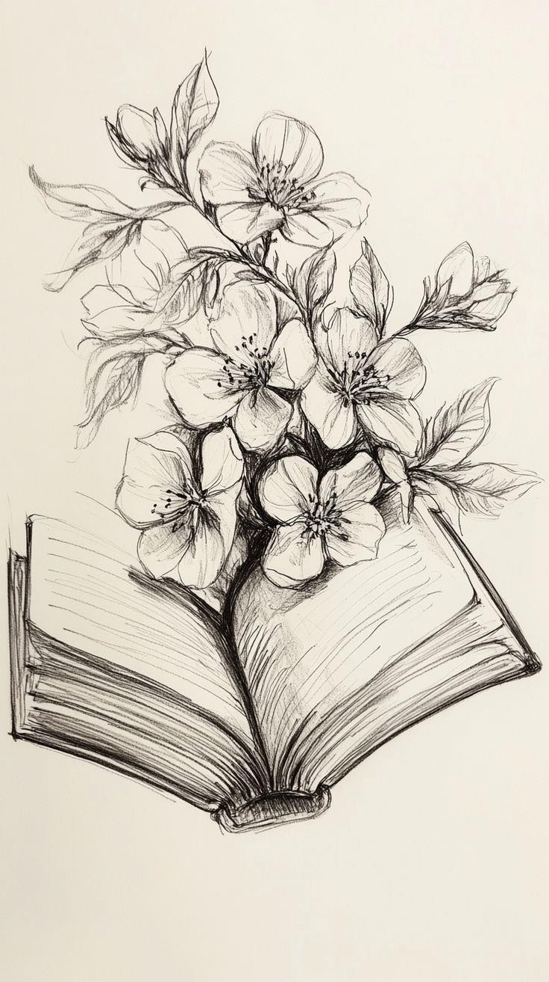

SYSTEM STUDY

SYSTEM STUDY

  - EXISTING SYSTEM

In modern Educational institutions, many libraries already use computerized Library Management Systems to manage their daily operations. These systems allow librarians to maintain digital records of books, students, book issuing, and return transactions. Popular library software solutions provide features such as book catalog management, automated issue and return tracking, fine calculation, and report generation.

In the existing digital systems, librarians can store book details including title, author, category, and quantity in a centralized database. Student records are also maintained digitally, allowing quick access to borrowing history and transaction details. When a book is issued, the system automatically records the issue date, due date, and return information.
Most current systems also provide search functionality to locate books quickly and generate reports such as overdue books, issued books list, and student borrowing history. These systems significantly reduce manual work and improve operational efficiency compared to traditional paper-based systems.

However, even though these systems automate basic library operations, they mainly focus on record management and transaction processing. They do not provide intelligent mechanisms to improve book availability when a required book is currently issued to another student.
When a book is unavailable, students usually have to wait until the current borrower returns it. There is no built-in feature in most library systems that allows students to request urgent access to a book or communicate their need to other borrowers.

  - DRAWBACKS OF EXISTING SYSTEM

In modern educational institutions, many libraries use computerized Library Management Systems to handle daily operations. These systems help in maintaining digital records of books, students, and transactions efficiently. They reduce manual work and improve accuracy compared to traditional methods. However, despite these advantages, existing systems still have several limitations.
Drawbacks:

    - No Solution for Book Unavailability
When a book is issued, other students must wait until it is returned, as there is no alternative mechanism to access it.
    - Lack of Communication Between Users
Existing systems do not allow students to communicate their need for a book to other borrowers.
    - No Priority-Based Access System
There is no feature to handle urgent requests or prioritize students who need a book immediately.
    - Inefficient Book Circulation
Books remain with borrowers until the due date, even if other students urgently require them.
    - Absence of Smart Features
Current systems lack intelligent functionalities that can improve availability and usage of books.
    - Delay in Accessing Required Books
Students often face delays in getting important books, which can affect their studies.

  - PROPOSED SYSTEM

To address the limitations of existing systems, the proposed Library Management with Bounty System introduces an enhanced digital solution that not only automates library operations but also improves book accessibility.
The system manages book records, student records, book issuing, returns, fine calculation, and report generation in a structured digital environment. The system provides a graphical user interface that is easy to operate and improves efficiency for library administrators.
The major innovation introduced in this project is the Bounty Request System. When a student needs a book that is currently unavailable in the library, the student can create a bounty request within the system specifying the required book.
Other students who currently possess the book can view these requests. If they are willing to return the book earlier through the library system, they can claim the bounty request. Once the book becomes available and is issued to the requesting student, the request is marked as completed.
This approach improves book circulation, reduces waiting time for students, and introduces a collaborative method of resource sharing within the library.

  - FEATURES OF PROPOSED SYSTEM

The proposed system introduces an innovative Bounty Request System to improve book availability in the library. When a required book is not available in stock, students do not have to wait until it is returned. Instead, the system allows them to request the book through a bounty mechanism. This approach improves book circulation, reduces waiting time, and provides a smarter way to access resources.
Features:

    - Bounty Request Creation
Students can place a bounty request when a required book is currently unavailable in the library.
    - Visibility to Other Students
The request is visible to students who have already borrowed that book.
    - Early Return Option
Students holding the book can choose to return it earlier by claiming the bounty request.
    - Improved Book Circulation
Books are circulated more efficiently instead of being held until the due date.
    - Reduced Waiting Time
Students can access important books faster without waiting for the normal return period.
    - Bounty Status Tracking
Each request is marked as Open when created and changes to Completed once the book is returned.
    - User-Friendly Interaction
The system provides a simple and clear way for students to request and respond to book needs.



SYSTEM DESIGN AND DEVELOPMENT

SYSTEM DESIGN AND DEVELOPMENT

  - FILE DESIGN

File design refers to the logical structure used to store and manage system data. In this project, data is stored using SQL database tables which ensure efficient storage and quick retrieval of records.

Each file (table) stores specific information such as book details, student information, issue transactions, return transactions, fine records, and bounty requests.

Primary keys are used to uniquely identify records in each table, while relationships between tables maintain consistency and prevent redundancy. The file design ensures that data can be easily inserted, updated, deleted, and retrieved without affecting other system operations.

  - INPUT DESIGN

Input design focuses on collecting accurate data from users through a user-friendly interface. The system provides various input forms such as book entry form, student registration form, issue book form, and return book form.
Validation techniques are applied to ensure correct data entry. The system checks mandatory fields, prevents duplicate entries, and ensures proper format for numerical and text inputs. The input design reduces user errors and improves data accuracy.

  - OUTPUT DESIGN

Output design presents processed information in a clear, structured, and user-friendly format. The system displays outputs such as book availability, student records, issued/returned books, error display, and bounty status. These outputs help users easily monitor library activities and track transactions.All results are shown through a Python Tkinter-based graphical interface for better readability. Data is retrieved using SQL queries and can also be printed for record- keeping.

  - DATABASE DESIGN

The database is designed using SQL to store and manage system data efficiently. The database contains multiple tables such as:
    - Books Table – Stores book details including book ID, title, author, category, and quantity.
    - Students Table – Stores student details including student ID, name, department, and contact information.
    - Transactions Table – Stores issue and return details including issue date, due date, and return date.
    - Bounty Table – Stores bounty requests including book title, requester ID, claim status, and student who claimed the request.

  - SYSTEM DEVELOPMENT

The system is developed using Python programming language with Tkinter for graphical user interface design. The application follows modular programming methodology, where each module is developed separately and later integrated into the main system.
Python libraries such as SQLite3 are used for database connectivity. Additional libraries like Pillow are used for image handling, while smtplib supports notification features. Threading is used to improve system performance by allowing background processing.
The development process includes planning, designing, coding, debugging, and testing to ensure proper functionality.

  - DESCRIPTION OF MODULES

Core Functionalities of the System

The Library Management System performs the following major operations:

- Book Management

- Add new books to the database

- Update book details (title, author, publisher, category, quantity)

- Delete book records

- Search books by title, author, or ID

- Track available and issued quantity

- Student/User Management

- Register new students

- Update student details

- Delete student records

- Maintain borrowing history for each student

- Book Issue Module

- Issue books to registered students

- Automatically record issue date

- Set return deadline

- Prevent issuing if book stock is unavailable

- Prevent issuing if student exceeds borrowing limit

- Book Return Module

- Record return date

- Automatically calculate fine for late return

- Update book stock

- Maintain transaction history

Unique Feature: Bounty System (Innovative Enhancement) Book Bounty Claim System
The Book Bounty Claim System is an innovative feature introduced to improve book availability and student collaboration.
In many cases, students require books urgently for academic purposes, but the book may already be issued to another student. To solve this problem, the system introduces a bounty request mechanism.

Working of Book Bounty Claim System

- Posting Bounty Request
  - If a required book is not available in the library, a student can post a bounty request.
  - The request contains book name, student ID, and urgency details.
- Viewing Bounty Requests
  - All bounty requests are displayed in the system.
  - Students who currently possess the requested book can view these requests.
- Claiming the Bounty
  - A student who has the book can claim the bounty request.
  - The claiming student can return the book earlier or transfer it through library approval.
- Completion of Request
  - Once the book becomes available and is issued to the requesting student, the bounty request is marked as completed.



SYSTEM TESTING AND IMPLEMENTATION

SYSTEM TESTING AND IMPLEMENTATION

  - SYSTEM TESTING

System testing is performed to ensure that the application works according to the requirements. Various testing methods are used including unit testing, integration testing, and user acceptance testing.

Unit Testing

Unit testing is performed on individual modules of the system to ensure each part works correctly. In this project, modules such as add book, add student, issue book, return book, and bounty posting are tested separately.

Points:

    - Tested book management functions (add, delete, view)
    - Verified student registration and data storage
    - Checked issue and return functions individually
    - Tested bounty posting and claiming separately
    - Ensured each function executes without errors

Integration Testing

Integration testing is conducted to ensure that all modules work together properly. It verifies that data flows correctly between GUI forms, backend logic, and the SQLite database.

Points:

    - Checked interaction between book issue and database update
    - Verified return module updates book quantity correctly
    - Ensured bounty system links with issue/return process

    - Tested combined execution of multiple modules
    - Confirmed smooth data flow between components

Validation Testing

Validation testing ensures that the system meets user requirements and handles inputs correctly. It checks whether the system accepts valid data and rejects invalid inputs.

Points:

    - Validated input fields (student ID, book ID, etc.)
    - Prevented issuing books when stock is zero
    - Restricted invalid or empty inputs
    - Ensured correct calculation of due dates and fines
    - Verified correct status update in bounty system

White Box Testing

White box testing is performed by analyzing the internal code logic of the system. The program flow, conditions, loops, and database queries are tested to ensure correctness.

Points:

    - Verified Python logic and conditions in functions
    - Checked loops and control statements
    - Tested SQL queries execution
    - Ensured proper error handling in code
    - Improved code efficiency and correctness

Black Box Testing

Black box testing is performed by testing the system from the user’s perspective without focusing on internal code. It ensures that the system produces correct output for given inputs.
Points:

    - Tested GUI forms for correct output
    - Checked user actions like issue, return, bounty claim
    - Verified system response for valid and invalid inputs
    - Ensured proper display of messages and results
    - Confirmed overall functionality from user side

  - SYSTEM IMPLEMENTATION

System implementation involves installing and running the application in a real-time environment. The software is installed on computers in the library, and necessary database configurations are completed.

Training is provided to users to help them operate the system effectively. The implementation process ensures smooth transition from manual system to computerized system. The system improves operational efficiency and reduces workload for librarians. The application is installed on the system, and the SQLite database is configured properly. The system is then made available for use by librarians and students through a user-friendly interface.
Points:

    - Installed Python environment and required libraries
    - Configured SQLite database for storing records
    - Deployed Tkinter-based GUI application
    - Tested system in real-time usage environment
    - Ensured smooth transition from manual to digital system



CONCLUSION

CONCLUSION

The Library Management with Bounty System successfully automates library operations and improves efficiency, accuracy, and reliability. The system replaces manual record keeping with a digital platform that simplifies book management, student tracking, book issuing and returning, fine calculation, and report generation.
The introduction of the Bounty Request System provides an innovative solution for situations when a required book is unavailable in the library. Students can request a book through the system, and other students who currently possess the book can claim the request by returning it earlier. This feature improves book circulation and reduces waiting time for students.
The project demonstrates the practical application of **Python programming, database management using SQL queries, and graphical user interface development with Tkinter. Overall, the system provides an efficient and scalable solution for managing library resources in educational institutions.

Future Enhancement
The system can be further enhanced by introducing a Smart Bounty Matching system using AI, which automatically connects users requesting a book with those who have it available, improving efficiency and reducing search time. Additionally, a Peer-to-Peer Lending feature can be implemented, allowing students to lend their personal books through the platform in exchange for bounty rewards. In cases where multiple students claim to provide the same requested book, a priority-based allocation mechanism can be introduced. This mechanism can decide the provider based on factors such as who responded first, user reliability score, past contributions, or proximity. These enhancements will make the system more intelligent, fair, and user-focused, while strengthening the uniqueness of the bounty-based approach.



BIBLIOGRAPHY

BIBLIOGRAPHY

Books:

- “Python Crash Course” – Eric Matthes, No Starch Press
- “Learning Python” – Mark Lutz, O’Reilly Media
- “Automate the Boring Stuff with Python” – Al Sweigart, No Starch Press
- “Head First Python” – Paul Barry, O’Reilly Media
- “Database System Concepts” – Abraham Silberschatz, Henry F. Korth, S. Sudarshan, McGraw-Hill
- “SQL for Beginners” – Allen G. Taylor, Wiley Publications
- “Software Engineering: A Practitioner’s Approach” – Roger S. Pressman, McGraw- Hill
- “Fundamentals of Database Systems” – Ramez Elmasri, Shamkant B. Navathe, Pearson

Web References:

- Python Official Documentation – https://docs.python.org
- SQLite Official Documentation – https://www.sqlite.org/docs.html
- Tkinter Documentation – https://docs.python.org/3/library/tkinter.html
- Visual Studio Code Documentation – https://code.visualstudio.com/docs
- W3Schools Python Tutorial – https://www.w3schools.com/python/
- GeeksforGeeks (Python & SQL) – https://www.geeksforgeeks.org/



APPENDICES

APPENDICES
Add Book Details
Book Database
Add Student Details
Student Database
Search Details
Search Records
Transaction Records
Issue / Return Book
Bounty System DB
Bounty System
STUDENT
ADMIN

- Data Flow Diagram

- Table Structure

  - Books Table

Field Name | Field Type | Size | Constraint | Description
Book_ID | Integer | 10 | Primary Key | Unique ID of the book
Title | Text | 100 | Not Null | Name of the book
Author | Text | 100 | Not Null | Author of the book
Category | Text | 50 | Not Null | Subject/category of the book
Quantity | Integer | 5 | Not Null | Total number of books available

This table stores information about all books available in the library.

  - Students Table

Field Name | Field Type | Size | Constraint | Description
Student_ID | Integer | 10 | Primary Key | Unique student ID
Name | Text | 100 | Not Null | Student name
Email | Text | 100 | Not Null | Student email address

This table stores details of students who are registered in the library system.

  - Table Name: Transactions

Field Name | Field Type | Size | Constraint | Description
Transaction_ID | Integer | 10 | Primary Key | Unique transaction ID
Book_ID | Integer | 10 | Foreign Key | References Books table
Student_ID | Integer | 10 | Foreign Key | References Students table
Issue_Date | Date | — | Not Null | Date when book was issued
Due_Date | Date | — | Not Null | Expected return date
Return_Date | Date | — | Null Allowed | Actual return date

  - Table Name: Bounties

Field Name | Field Type | Size | Constraint | Description
Bounty_ID | Integer | 10 | Primary Key | Unique bounty request ID
Book_Title | Text | 100 | Not Null | Title of the requested book
Requester_ID | Integer | 10 | Foreign Key | Student who posted request
Message | Text | 100 | Null Allowed | Request message
Status | Text | 20 | Not Null | Open / Claimed / Completed
Claimed_By | Integer | 10 | Foreign Key | Student who claimed request

  - Table Name: Policies

Field Name | Field Type | Size | Constraint | Description
Policy_ID | Integer | 10 | Primary Key | Unique policy identifier
Category | Text | 50 | Not Null | Book category
Max_Books | Integer | 5 | Not Null | Maximum books allowed
Issue_Days | Integer | 5 | Not Null | Number of days allowed
Fine_Rate | Integer | 5 | Not Null | Fine per late day

- Sample Coding

import sqlite3
from tkinter import *
from tkinter import messagebox, ttk from datetime import date, timedelta from PIL import Image, ImageTk import os
import smtplib
from email.mime.text import MIMEText
from email.mime.multipart import MIMEMultipart import threading

# ---------------- DATABASE ----------------
conn = sqlite3.connect("library.db") cur = conn.cursor()

cur.execute("""
CREATE TABLE IF NOT EXISTS books( book_id INTEGER PRIMARY KEY,
title TEXT, author TEXT,
quantity INTEGER, category TEXT,
reference INTEGER DEFAULT 0
) """)

cur.execute("""
CREATE TABLE IF NOT EXISTS students(
student_id INTEGER PRIMARY KEY,

name TEXT, email TEXT
)
""")

cur.execute("""
CREATE TABLE IF NOT EXISTS issues(
issue_id INTEGER PRIMARY KEY AUTOINCREMENT,
book_id INTEGER, student_id INTEGER, issue_date TEXT, due_date TEXT, return_date TEXT,
status TEXT DEFAULT 'Not Returned'
) """)

cur.execute("""
CREATE TABLE IF NOT EXISTS bounties(
bounty_id INTEGER PRIMARY KEY AUTOINCREMENT,
book_title TEXT, requester_id INTEGER, reward TEXT,
status TEXT DEFAULT 'Open', claimed_by INTEGER
) """)

cur.execute("""
CREATE TABLE IF NOT EXISTS policies(
category TEXT PRIMARY KEY,

max_books INTEGER, issue_days INTEGER, fine_rate REAL
)
""")

cur.execute("INSERT OR IGNORE INTO policies VALUES ('General', 3, 14, 1.0)") cur.execute("INSERT OR IGNORE INTO policies VALUES ('Reference', 1, 0, 0.0)") conn.commit()

# ---------------- EMAIL FUNCTION ----------------
def send_email_to_students(book_title, book_author): try:
# --- NEW CONNECTION INSIDE THREAD ---
conn_thread = sqlite3.connect("library.db") cur_thread = conn_thread.cursor()

sender_email = "dharshinike20@gmail.com" # your email sender_password = "wjujjlsdwedrjbfo" # App password without spaces

cur_thread.execute("SELECT email, name FROM students") students = cur_thread.fetchall()

if not students:
print("No students to send email to.") conn_thread.close()
return

subject = f"New Book Added: {book_title}" for student in students:
receiver_email, student_name = student

msg = MIMEMultipart() msg['From'] = sender_email msg['To'] = receiver_email msg['Subject'] = subject

body = f"Hello {student_name},\n\nA new book '{book_title}' by {book_author} has been added to the library. Check it out!\n\n- Library Team"
msg.attach(MIMEText(body, 'plain'))

try:
with smtplib.SMTP('smtp.gmail.com', 587) as server: server.starttls()
server.login(sender_email, sender_password) server.sendmail(sender_email, receiver_email, msg.as_string())
print(f"Email sent to {receiver_email}") except Exception as e:
print(f"Error sending email to {receiver_email}: {e}")

conn_thread.close() except Exception as e:
print("Email thread error:", e)

# ---------------- GUI ----------------
root = Tk()
root.title("Advanced Policy-Driven Library System") root.geometry("900x700")

# ---------------- BACKGROUND IMAGE ----------------
BASE_DIR = os.path.dirname(os.path.abspath( file )) BG_PATH = os.path.join(BASE_DIR, "library_bg.png")

if os.path.exists(BG_PATH): bg_img = Image.open(BG_PATH)
bg_img = bg_img.resize((1500, 900)) bg_photo = ImageTk.PhotoImage(bg_img) bg_label = Label(root, image=bg_photo)
bg_label.place(x=0, y=0, relwidth=1, relheight=1)
# -------- DARK OVERLAY FOR ELEGANCE --------
overlay = Frame(root, bg="#2B1B17") # deep chocolate brown overlay.place(relwidth=1, relheight=1)

overlay.lift() # bring overlay above bg overlay.lower() # keep bg at bottom

# ---------------- MAIN TITLE ----------------
title_label = Label( root,
text="LIBRARY\nMANAGEMENT SYSTEM",
font=("Georgia", 36, "bold"), bg="#2B1B17", fg="#F5E6D3",
justify="center"
)
title_label.place(relx=0.5, rely=0.12, anchor="center")

# ---------------- STYLISH BUTTON STYLE ----------------
def create_style(): style = ttk.Style()
style.theme_use("alt")

style.configure( "Custom.TButton",

font=("Segoe UI Semibold", 12), padding=10,
background="#3E2723", # dark brown foreground="#F5E6D3", # soft cream borderwidth=0
)

style.map( "Custom.TButton", background=[
("active", "#5D4037"), # lighter brown on hover ("pressed", "#2B1B17")
]
)

return style

# ---------------- BOOK ----------------
def add_book(): def submit():
try:
ref = 1 if ref_var.get() else 0 cur.execute(
"INSERT INTO books VALUES (?,?,?,?,?,?)",
(int(bid.get()), title.get(), author.get(), int(qty.get()), category.get(), ref)
)
conn.commit()
messagebox.showinfo("Success", f"Book '{title.get()}' added.") # Send emails in background

threading.Thread(target=send_email_to_students, args=(title.get(), author.get()), daemon=True).start()

win.destroy() except Exception as e:
messagebox.showerror("Error", e)

win = Toplevel(root) win.title("Add Book") win.geometry("400x350") win.resizable(False, False)

# Center window win.transient(root) win.grab_set()

# Table-style frame
frame = Frame(win, padx=20, pady=20) frame.pack(expand=True, fill=BOTH)

# Table headers
headers = ["Field", "Value"]
for i, header in enumerate(headers):
Label(frame, text=header, font=('Segoe UI', 10, 'bold'), bg='#f0f0f0', relief='solid', bd=1, padx=10, pady=8, width=15).grid(row=0, column=i, sticky='ew', pady=2)

# Table rows
Label(frame, text="Book ID", font=('Segoe UI', 9)).grid(row=1, column=0, sticky='w', pady=5)
bid = Entry(frame, font=('Segoe UI', 9), relief='solid', bd=1) bid.grid(row=1, column=1, sticky='ew', pady=5, padx=(5,0))

Label(frame, text="Title", font=('Segoe UI', 9)).grid(row=2, column=0, sticky='w', pady=5)
title = Entry(frame, font=('Segoe UI', 9), relief='solid', bd=1) title.grid(row=2, column=1, sticky='ew', pady=5, padx=(5,0))

Label(frame, text="Author", font=('Segoe UI', 9)).grid(row=3, column=0, sticky='w', pady=5)
author = Entry(frame, font=('Segoe UI', 9), relief='solid', bd=1) author.grid(row=3, column=1, sticky='ew', pady=5, padx=(5,0))

Label(frame, text="Quantity", font=('Segoe UI', 9)).grid(row=4, column=0, sticky='w', pady=5)
qty = Entry(frame, font=('Segoe UI', 9), relief='solid', bd=1) qty.grid(row=4, column=1, sticky='ew', pady=5, padx=(5,0))

Label(frame, text="Category", font=('Segoe UI', 9)).grid(row=5, column=0, sticky='w', pady=5)
category = Entry(frame, font=('Segoe UI', 9), relief='solid', bd=1) category.grid(row=5, column=1, sticky='ew', pady=5, padx=(5,0))

ref_var = IntVar()
Checkbutton(frame, text="Reference Book (Cannot be issued)", variable=ref_var, font=('Segoe UI', 9)).grid(row=6, column=0, columnspan=2, sticky='w', pady=5)

# Configure column weights frame.columnconfigure(1, weight=1)

style = create_style()
ttk.Button(frame, text="Add Book", style='Custom.TButton', command=submit).grid(row=7, column=0, columnspan=2, pady=20)

from tkinter import ttk

def view_books():
win = Toplevel(root) win.title("Books") win.geometry("900x400") win.configure(bg="#F4F6F9")

style = ttk.Style() style.theme_use("default")

style.configure("Treeview",
background="white", foreground="#111827", rowheight=25, fieldbackground="white")

style.configure("Treeview.Heading", background="#1F2933", foreground="white", font=('Segoe UI', 10, 'bold'))

tree = ttk.Treeview(win, columns=("ID","Title","Author","Qty","Category","Reference"), show="headings")

for col in tree["columns"]: tree.heading(col, text=col) tree.column(col, width=130)

tree.pack(fill=BOTH, expand=True)

cur.execute("SELECT * FROM books") rows = cur.fetchall()

for index, b in enumerate(rows): ref_status = "Yes" if b[5] else "No"
tree.insert("", END, values=(b[0], b[1], b[2], b[3], b[4], ref_status))

def delete_book(): def submit():
bid_v = bid.get()
cur.execute("SELECT * FROM books WHERE book_id=?", (bid_v,)) if not cur.fetchone():
messagebox.showerror("Error", "Book ID not found") return
cur.execute("DELETE FROM books WHERE book_id=?", (bid_v,)) conn.commit()
messagebox.showinfo("Deleted", "Book deleted successfully") win.destroy()

win = Toplevel(root) win.title("Delete Book") win.geometry("350x200") win.resizable(False, False) win.transient(root) win.grab_set()

frame = Frame(win, padx=20, pady=20)

Label(frame, text="Book ID", font=('Segoe UI', 9)).grid(row=1, column=0, sticky='w', pady=20)
bid = Entry(frame, font=('Segoe UI', 9), relief='solid', bd=1) bid.grid(row=1, column=1, sticky='ew', pady=20, padx=(5,0))

frame.columnconfigure(1, weight=1)

style = create_style()
ttk.Button(frame, text="Delete Book", style='Custom.TButton', command=submit).grid(row=2, column=0, columnspan=2, pady=10)

# ---------------- STUDENT ----------------
def add_student(): def submit():
try:
cur.execute(
"INSERT INTO students VALUES (?,?,?)",
(int(sid.get()), name.get(), email.get())
)
conn.commit()
messagebox.showinfo("Success", "Student added") win.destroy()
except Exception as e: messagebox.showerror("Error", e)

win = Toplevel(root) win.title("Add Student") win.geometry("400x300") win.resizable(False, False) win.transient(root) win.grab_set()

frame = Frame(win, padx=20, pady=20) frame.pack(expand=True, fill=BOTH)

headers = ["Field", "Value"]
for i, header in enumerate(headers):
Label(frame, text=header, font=('Segoe UI', 10, 'bold'), bg='#f0f0f0', relief='solid', bd=1, padx=10, pady=8, width=15).grid(row=0, column=i, sticky='ew', pady=2)

Label(frame, text="Student ID", font=('Segoe UI', 9)).grid(row=1, column=0, sticky='w', pady=5)
sid = Entry(frame, font=('Segoe UI', 9), relief='solid', bd=1) sid.grid(row=1, column=1, sticky='ew', pady=5, padx=(5,0))

Label(frame, text="Name", font=('Segoe UI', 9)).grid(row=2, column=0, sticky='w', pady=5)
name = Entry(frame, font=('Segoe UI', 9), relief='solid', bd=1) name.grid(row=2, column=1, sticky='ew', pady=5, padx=(5,0))

Label(frame, text="Email", font=('Segoe UI', 9)).grid(row=3, column=0, sticky='w', pady=5)
email = Entry(frame, font=('Segoe UI', 9), relief='solid', bd=1) email.grid(row=3, column=1, sticky='ew', pady=5, padx=(5,0))

frame.columnconfigure(1, weight=1)

style = create_style()
ttk.Button(frame, text="Add Student", style='Custom.TButton', command=submit).grid(row=4, column=0, columnspan=2, pady=20)

def view_students():

win = Toplevel(root) win.title("Students") win.geometry("700x400") win.configure(bg="#F4F6F9")

tree = ttk.Treeview(win, columns=("ID","Name","Email"), show="headings")

tree.heading("ID", text="ID") tree.heading("Name", text="Name") tree.heading("Email", text="Email")

tree.column("ID", width=100) tree.column("Name", width=200) tree.column("Email", width=300)

tree.pack(fill=BOTH, expand=True)

cur.execute("SELECT * FROM students") for s in cur.fetchall():
tree.insert("", END, values=s)

def delete_student(): def submit():
sid_v = sid.get()
cur.execute("SELECT * FROM students WHERE student_id=?", (sid_v,)) if not cur.fetchone():
messagebox.showerror("Error", "Student ID not found") return
cur.execute("DELETE FROM students WHERE student_id=?", (sid_v,)) conn.commit()

messagebox.showinfo("Deleted", "Student deleted successfully") win.destroy()

win = Toplevel(root) win.title("Delete Student") win.geometry("350x200") win.resizable(False, False) win.transient(root) win.grab_set()

frame = Frame(win, padx=20, pady=20) frame.pack(expand=True, fill=BOTH)

headers = ["Field", "Value"]
for i, header in enumerate(headers):
Label(frame, text=header, font=('Segoe UI', 10, 'bold'), bg='#f0f0f0', relief='solid', bd=1, padx=10, pady=8, width=15).grid(row=0, column=i, sticky='ew', pady=2)

Label(frame, text="Student ID", font=('Segoe UI', 9)).grid(row=1, column=0, sticky='w', pady=20)
sid = Entry(frame, font=('Segoe UI', 9), relief='solid', bd=1) sid.grid(row=1, column=1, sticky='ew', pady=20, padx=(5,0))

frame.columnconfigure(1, weight=1)

style = create_style()
ttk.Button(frame, text="Delete Student", style='Custom.TButton', command=submit).grid(row=2, column=0, columnspan=2, pady=10)

# ---------------- ISSUE / RETURN ----------------
def issue_book():

def submit():
book_name = book.get().strip() sid_v = sid.get().strip()

if not book_name or not sid_v.isdigit():
messagebox.showerror("Error", "Enter valid Book Name and Student ID") return

sid_v = int(sid_v)

# Check student exists
cur.execute("SELECT * FROM students WHERE student_id=?", (sid_v,)) if not cur.fetchone():
messagebox.showerror("Error", "Student ID not found") return

# Check book exists by NAME
cur.execute("SELECT * FROM books WHERE LOWER(title)=LOWER(?)", (book_name,))
book_data = cur.fetchone()

if not book_data:
messagebox.showwarning("Not Available", "Book not present in library") return

book_id = book_data[0] quantity = book_data[3] category = book_data[4] is_reference = book_data[5]

# Check stock

if quantity == 0:
messagebox.showwarning("Out of Stock", "Oops! Book is currently out of stock") return

# Check reference book if is_reference == 1:
messagebox.showwarning("Reference Book", "Cannot issue reference book") return

# Policy check
cur.execute("SELECT max_books, issue_days FROM policies WHERE category=?", (category,))
policy = cur.fetchone()

if not policy:
messagebox.showerror("Error", "Policy not defined for this category") return

max_books, issue_days = policy

cur.execute("""
SELECT COUNT(*) FROM issues
WHERE student_id=? AND return_date IS NULL """, (sid_v,))

if cur.fetchone()[0] >= max_books:
messagebox.showwarning("Limit Exceeded", "Maximum book issue limit reached")
return

# Issue book

due_date = date.today() + timedelta(days=issue_days)

cur.execute("UPDATE books SET quantity=quantity-1 WHERE book_id=?", (book_id,))
cur.execute("""
INSERT INTO issues (book_id, student_id, issue_date, due_date) VALUES (?,?,?,?)
""", (book_id, sid_v, date.today(), due_date))

conn.commit()
messagebox.showinfo("Issued", f"Book issued successfully!\nDue Date: {due_date}") win.destroy()

win = Toplevel(root) win.title("Issue Book") win.geometry("400x250") win.resizable(False, False) win.transient(root) win.grab_set()

frame = Frame(win, padx=20, pady=20) frame.pack(expand=True, fill=BOTH)

headers = ["Field", "Value"]
for i, header in enumerate(headers):
Label(frame, text=header, font=('Segoe UI', 10, 'bold'), bg='#f0f0f0', relief='solid', bd=1, padx=10, pady=8, width=15).grid(row=0, column=i, sticky='ew', pady=2)

Label(frame, text="Book Name", font=('Segoe UI', 9)).grid(row=1, column=0, sticky='w', pady=10)
book = Entry(frame, font=('Segoe UI', 9), relief='solid', bd=1)

book.grid(row=1, column=1, sticky='ew', pady=10, padx=(5,0))

Label(frame, text="Student ID", font=('Segoe UI', 9)).grid(row=2, column=0, sticky='w', pady=10)
sid = Entry(frame, font=('Segoe UI', 9), relief='solid', bd=1) sid.grid(row=2, column=1, sticky='ew', pady=10, padx=(5,0))

frame.columnconfigure(1, weight=1)

style = create_style()
ttk.Button(frame, text="Issue", style='Custom.TButton', command=submit).grid(row=3, column=0, columnspan=2, pady=20)

def return_book(): def submit():
bid_v = int(bid.get()) sid_v = int(sid.get())

cur.execute("""
SELECT issue_id FROM issues
WHERE book_id=? AND student_id=? AND return_date IS NULL """, (bid_v, sid_v))
issue = cur.fetchone() if issue:
cur.execute("UPDATE issues SET return_date=?, status='Returned' WHERE issue_id=?",
(date.today(), issue[0]))
cur.execute("UPDATE books SET quantity=quantity+1 WHERE book_id=?", (bid_v,))
conn.commit()
messagebox.showinfo("Returned", "Book returned successfully")

win.destroy() else:
messagebox.showwarning("Error", "No active issue found")

win = Toplevel(root) win.title("Return Book") win.geometry("400x250") win.resizable(False, False) win.transient(root) win.grab_set()

frame = Frame(win, padx=20, pady=20) frame.pack(expand=True, fill=BOTH)

headers = ["Field", "Value"]
for i, header in enumerate(headers):
Label(frame, text=header, font=('Segoe UI', 10, 'bold'), bg='#f0f0f0', relief='solid', bd=1, padx=10, pady=8, width=15).grid(row=0, column=i, sticky='ew', pady=2)

Label(frame, text="Book ID", font=('Segoe UI', 9)).grid(row=1, column=0, sticky='w', pady=10)
bid = Entry(frame, font=('Segoe UI', 9), relief='solid', bd=1) bid.grid(row=1, column=1, sticky='ew', pady=10, padx=(5,0))

Label(frame, text="Student ID", font=('Segoe UI', 9)).grid(row=2, column=0, sticky='w', pady=10)
sid = Entry(frame, font=('Segoe UI', 9), relief='solid', bd=1) sid.grid(row=2, column=1, sticky='ew', pady=10, padx=(5,0))

frame.columnconfigure(1, weight=1)

style = create_style()
ttk.Button(frame, text="Return", style='Custom.TButton', command=submit).grid(row=3, column=0, columnspan=2, pady=20)

# ===================================================== # ⭐⭐ BOUNTY SYSTEM ⭐⭐
# =====================================================

# POST BOUNTY
def post_bounty(): def submit():
try:
cur.execute("""
INSERT INTO bounties(book_title,requester_id,reward) VALUES (?,?,?)
""",(book.get(),int(student.get()),reward.get()))

conn.commit() messagebox.showinfo("Success","Bounty Posted") win.destroy()
except Exception as e: messagebox.showerror("Error",e)

win=Toplevel(root) win.title("Post Bounty") win.geometry("400x300") win.resizable(False, False) win.transient(root) win.grab_set()

frame = Frame(win, padx=20, pady=20)

frame.pack(expand=True, fill=BOTH)

headers = ["Field", "Value"]
for i, header in enumerate(headers):
Label(frame, text=header, font=('Segoe UI', 10, 'bold'), bg='#f0f0f0', relief='solid', bd=1, padx=10, pady=8, width=15).grid(row=0, column=i, sticky='ew', pady=2)

Label(frame, text="Book Title", font=('Segoe UI', 9)).grid(row=1, column=0, sticky='w', pady=5)
book=Entry(frame, font=('Segoe UI', 9), relief='solid', bd=1) book.grid(row=1, column=1, sticky='ew', pady=5, padx=(5,0))

Label(frame, text="Student ID", font=('Segoe UI', 9)).grid(row=2, column=0, sticky='w', pady=5)
student=Entry(frame, font=('Segoe UI', 9), relief='solid', bd=1) student.grid(row=2, column=1, sticky='ew', pady=5, padx=(5,0))

Label(frame, text="Reward / Message", font=('Segoe UI', 9)).grid(row=3, column=0, sticky='w', pady=5)
reward=Entry(frame, font=('Segoe UI', 9), relief='solid', bd=1) reward.grid(row=3, column=1, sticky='ew', pady=5, padx=(5,0))

frame.columnconfigure(1, weight=1)

style = create_style()
ttk.Button(frame, text="Post", style='Custom.TButton', command=submit).grid(row=4, column=0, columnspan=2, pady=20)

def view_bounties(): win = Toplevel(root) win.title("Bounties")

win.geometry("1000x400") win.configure(bg="#F4F6F9")

tree = ttk.Treeview(win, columns=("ID","Book","Requester","Reward","Status","ClaimedBy"), show="headings")

for col in tree["columns"]: tree.heading(col, text=col) tree.column(col, width=150)

tree.pack(fill=BOTH, expand=True)

cur.execute("SELECT * FROM bounties") for b in cur.fetchall():
tree.insert("", END, values=b)

# CLAIM BOUNTY
def claim_bounty(): def submit():
try:
cur.execute(""" UPDATE bounties
SET status='Claimed', claimed_by=? WHERE bounty_id=? AND status='Open' """,(int(student.get()),int(bid.get())))

if cur.rowcount==0:
messagebox.showwarning("Error","Already Claimed / Invalid") else:

conn.commit() messagebox.showinfo("Success","Bounty Claimed")

win.destroy() except Exception as e:
messagebox.showerror("Error",e)

win=Toplevel(root) win.title("Claim Bounty") win.geometry("400x250") win.resizable(False, False) win.transient(root) win.grab_set()

frame = Frame(win, padx=20, pady=20) frame.pack(expand=True, fill=BOTH)

headers = ["Field", "Value"]
for i, header in enumerate(headers):
Label(frame, text=header, font=('Segoe UI', 10, 'bold'), bg='#f0f0f0', relief='solid', bd=1, padx=10, pady=8, width=15).grid(row=0, column=i, sticky='ew', pady=2)

Label(frame, text="Bounty ID", font=('Segoe UI', 9)).grid(row=1, column=0, sticky='w', pady=10)
bid=Entry(frame, font=('Segoe UI', 9), relief='solid', bd=1) bid.grid(row=1, column=1, sticky='ew', pady=10, padx=(5,0))

Label(frame, text="Your Student ID", font=('Segoe UI', 9)).grid(row=2, column=0, sticky='w', pady=10)
student=Entry(frame, font=('Segoe UI', 9), relief='solid', bd=1) student.grid(row=2, column=1, sticky='ew', pady=10, padx=(5,0))

frame.columnconfigure(1, weight=1)

style = create_style()
ttk.Button(frame, text="Claim", style='Custom.TButton', command=submit).grid(row=3, column=0, columnspan=2, pady=20)

# ---------------- VIEW ISSUE RECORDS ----------------
def view_issues():
win = Toplevel(root) win.title("Issue Records") win.geometry("1100x500") win.configure(bg="#F4F6F9")

tree = ttk.Treeview(win, columns=("IssueID","Book","Student","Issue","Due","Return","Status"), show="headings")

for col in tree["columns"]: tree.heading(col, text=col) tree.column(col, width=150)

tree.pack(fill=BOTH, expand=True)

cur.execute("""
SELECT issues.issue_id, books.title, students.name,
issues.issue_date, issues.due_date, issues.return_date, issues.status FROM issues
JOIN books ON books.book_id = issues.book_id
JOIN students ON students.student_id = issues.student_id """)

for r in cur.fetchall(): tree.insert("", END, values=r)

# ---------------- POLICY MANAGEMENT ----------------
def manage_policies(): def submit():
try:
cur.execute("INSERT OR REPLACE INTO policies VALUES (?,?,?,?)", (category.get(), int(max_books.get()), int(issue_days.get()),
float(fine_rate.get())))
conn.commit()
messagebox.showinfo("Success", "Policy updated") win.destroy()
except Exception as e: messagebox.showerror("Error", e)

win = Toplevel(root) win.title("Manage Policies") win.geometry("400x350") win.resizable(False, False) win.transient(root) win.grab_set()

frame = Frame(win, padx=20, pady=20) frame.pack(expand=True, fill=BOTH)

headers = ["Field", "Value"]
for i, header in enumerate(headers):
Label(frame, text=header, font=('Segoe UI', 10, 'bold'), bg='#f0f0f0', relief='solid', bd=1, padx=10, pady=8, width=15).grid(row=0, column=i, sticky='ew', pady=2)

Label(frame, text="Category", font=('Segoe UI', 9)).grid(row=1, column=0, sticky='w', pady=5)
category = Entry(frame, font=('Segoe UI', 9), relief='solid', bd=1) category.grid(row=1, column=1, sticky='ew', pady=5, padx=(5,0))

Label(frame, text="Max Books", font=('Segoe UI', 9)).grid(row=2, column=0, sticky='w', pady=5)
max_books = Entry(frame, font=('Segoe UI', 9), relief='solid', bd=1) max_books.grid(row=2, column=1, sticky='ew', pady=5, padx=(5,0))

Label(frame, text="Issue Days", font=('Segoe UI', 9)).grid(row=3, column=0, sticky='w', pady=5)
issue_days = Entry(frame, font=('Segoe UI', 9), relief='solid', bd=1) issue_days.grid(row=3, column=1, sticky='ew', pady=5, padx=(5,0))

Label(frame, text="Fine Rate", font=('Segoe UI', 9)).grid(row=4, column=0, sticky='w', pady=5)
fine_rate = Entry(frame, font=('Segoe UI', 9), relief='solid', bd=1) fine_rate.grid(row=4, column=1, sticky='ew', pady=5, padx=(5,0))

frame.columnconfigure(1, weight=1)

style = create_style()
ttk.Button(frame, text="Update Policy", style='Custom.TButton', command=submit).grid(row=5, column=0, columnspan=2, pady=20)

# ---------------- TOP NAVBAR ----------------
topbar = Frame(root, bg="#0B3C5D", height=60) topbar.pack(side=TOP, fill=X)

Label(
topbar,
text="Library Management with Bounty System", bg="#0B3C5D",
fg="white",
font=("Segoe UI", 16, "bold")
).pack(expand=True, padx=20)

# ---------------- SIDEBAR ----------------
sidebar = Frame(root, bg="#08324A", width=220) sidebar.pack(side=LEFT, fill=Y)

# --- Admin Section ---
admin_frame = Frame(sidebar, bg="#08324A") admin_frame.pack(pady=20)

Label(admin_frame, text="Welcome to", fg="white", bg="#08324A", font=("Segoe UI", 10)).pack()

Label(admin_frame, text="Library", fg="white", bg="#08324A", font=("Segoe UI", 14, "bold")).pack(pady=5)
def sidebar_button(text, command): Button(
sidebar, text=text,
command=command, bg="#0E4A6C",
fg="white", relief="flat", anchor="w", font=("Segoe UI", 10),

padx=20, pady=8
).pack(fill=X, pady=2)

sidebar_button("Add Book", add_book) sidebar_button("View Books", view_books) sidebar_button("Add Student", add_student) sidebar_button("Issue Book", issue_book) sidebar_button("Return Book", return_book) sidebar_button("Policies", manage_policies)

# ---------------- MAIN CONTENT AREA ----------------
main_area = Frame(root, bg="#F5F5F5") main_area.pack(side=LEFT, fill=BOTH, expand=True) # ---------------- LOAD ICON FUNCTION ----------------
icon_images = {}

def load_icon(path):
img = Image.open(path) img = img.resize((250, 260))
return ImageTk.PhotoImage(img)
# ---------------- DASHBOARD / TILE GRID ----------------
dashboard_frame = Frame(main_area, bg="#F5F5F5") dashboard_frame.pack(padx=30, pady=30, fill=BOTH, expand=True)

# Define tile info (button text + function + color) from PIL import Image, ImageTk

tiles = [
("Add Book", add_book, "#00CFFF", "icons/add_book.png"),

("View Books", view_books, "#2ECC71", "icons/view_books.png"), ("Delete Book", delete_book, "#E74C3C", "icons/delete_book.png"), ("Add Student", add_student, "#F39C12", "icons/add_student.png"), ("View Students", view_students, "#00CFFF", "icons/view_students.png"),
("Delete Student", delete_student, "#2ECC71", "icons/delete_student.png"), ("Issue Book", issue_book, "#E74C3C", "icons/issue.png"),
("Return Book", return_book, "#F39C12", "icons/return.png"), ("Post Bounty", post_bounty, "#00CFFF", "icons/post_bounty.png"),
("View Bounties", view_bounties, "#2ECC71", "icons/view_bounty.png"), ("Claim Bounty", claim_bounty, "#E74C3C", "icons/claim.png"),
("View Issue Records", view_issues, "#F39C12", "icons/records.png"), ("Manage Policies", manage_policies, "#00CFFF", "icons/policy.png")
]

# Keep references so images don't get garbage collected tile_images = []

rows = 3
cols = 5

for idx, (text, func, color, icon_path) in enumerate(tiles): r = idx // cols
c = idx % cols

tile = Frame(dashboard_frame, bg=color, width=220, height=180) tile.grid_propagate(False)
tile.grid(row=r, column=c, padx=10, pady=10, sticky="nsew")

# Load icon if it exists
if os.path.exists(icon_path): img = Image.open(icon_path)

img = img.resize((240, 170)) # resize to fit tile photo = ImageTk.PhotoImage(img) tile_images.append(photo) # keep reference lbl_img = Label(tile, image=photo, bg=color) lbl_img.pack(pady=(10,5))
else:
lbl_img = None

lbl_text = Label(tile, text=text, bg=color, fg="white", font=("Segoe UI", 10, "bold")) lbl_text.pack()

tile.bind("<Button-1>", lambda e, f=func: f()) lbl_text.bind("<Button-1>", lambda e, f=func: f()) if lbl_img:
lbl_img.bind("<Button-1>", lambda e, f=func: f())

root.mainloop() conn.close()
frame.pack(expand=True, fill=BOTH)

headers = ["Field", "Value"]
for i, header in enumerate(headers):
Label(frame, text=header, font=('Segoe UI', 10, 'bold'), bg='#f0f0f0', relief='solid', bd=1, padx=10, pady=8, width=15).grid(row=0, column=i, sticky='ew', pady=2)

- SAMPLE INPUT

CATALOG
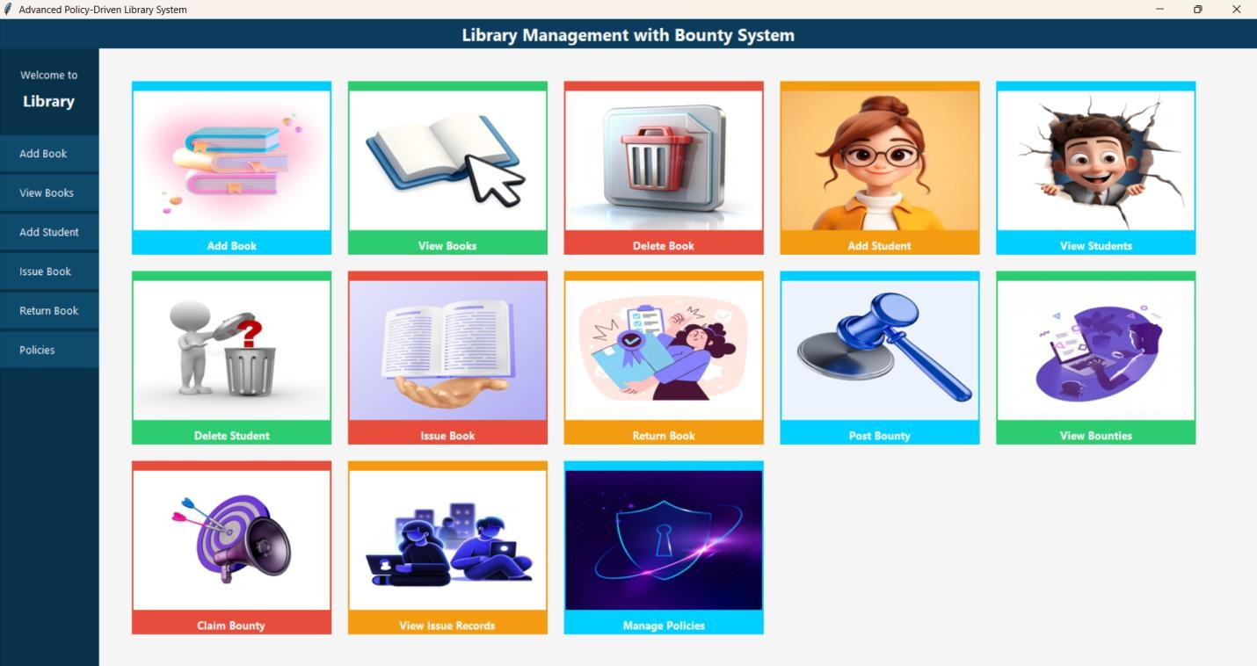

ADD STUDENT FORM
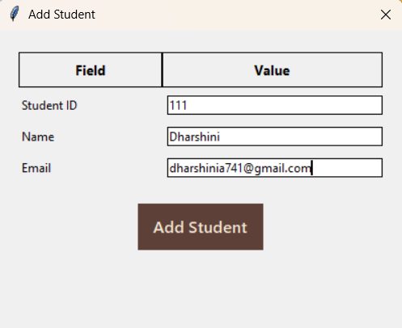

ADD BOOK FORM
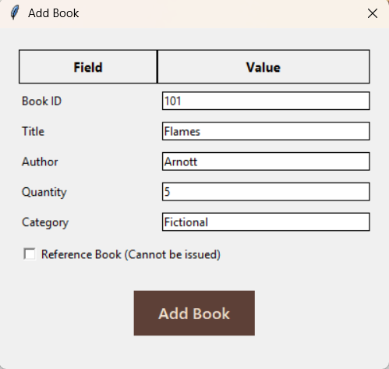

ISSUE BOOK FORM

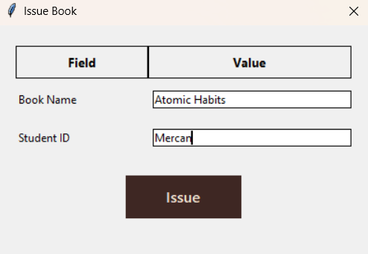

RETURN BOOK FORM

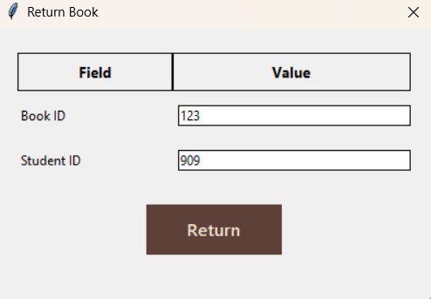

POST BOUNTY FORM

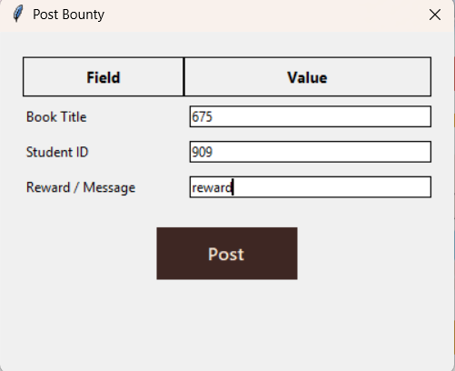

CLAIM BOUNTY FORM
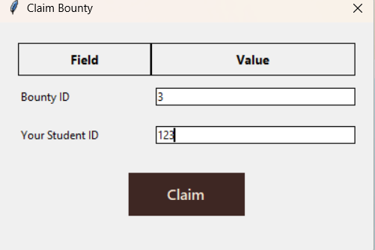

- SAMPLE OUTPUT:

VIEW BOOK FORM
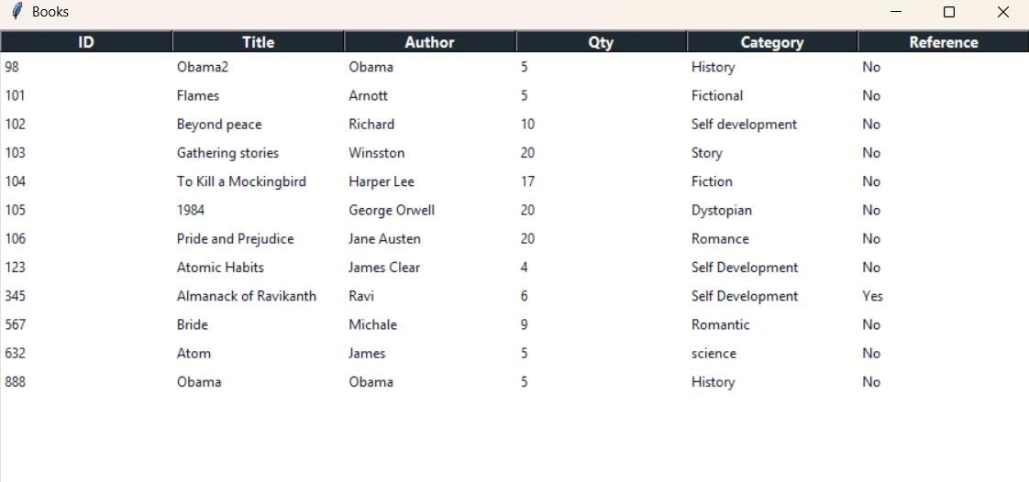

VIEW STUDENT FORM
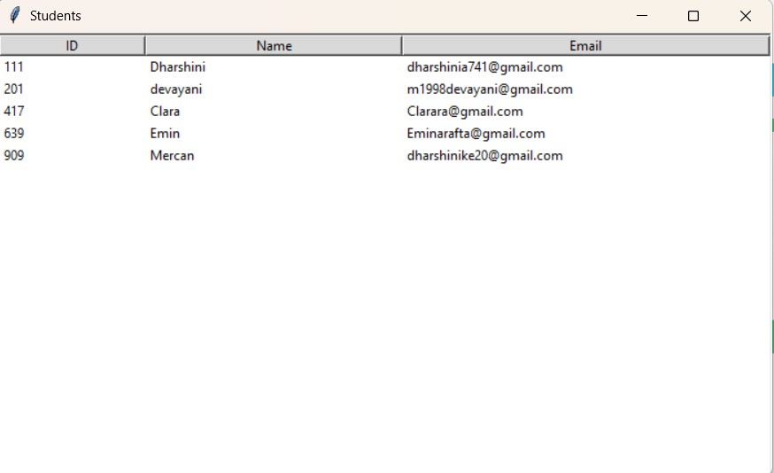

VIEW BOUNTY FORM

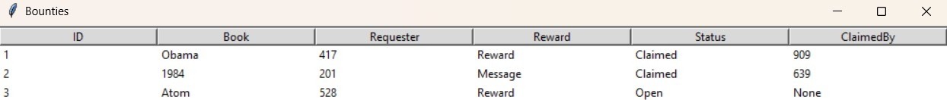

ISSUE RECORD FORM
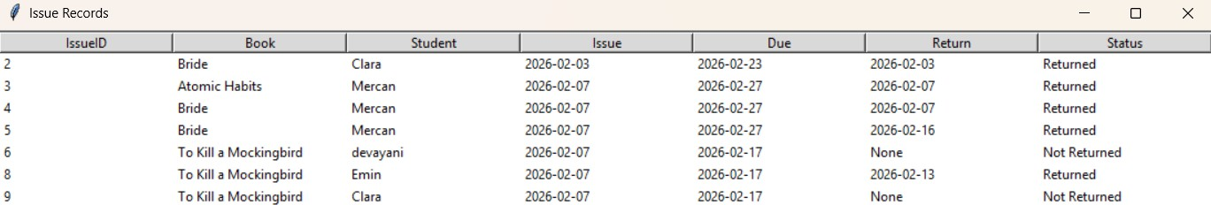

MAIL NOTIFICATION

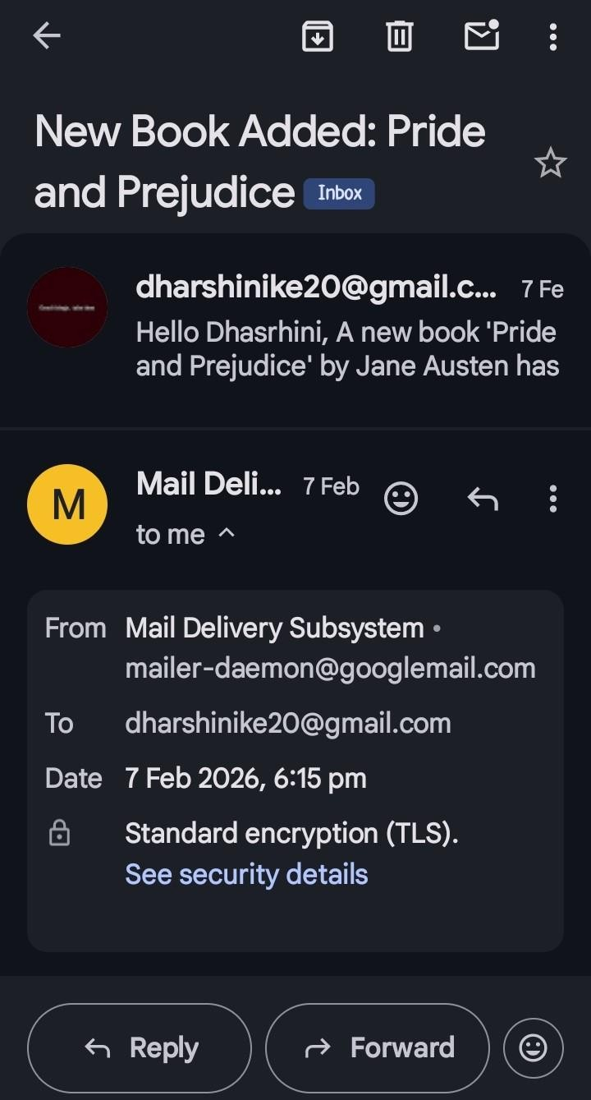

ERROR POP UP

Wrong Claim ID


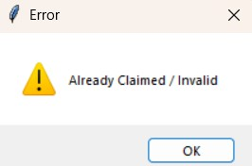

Wrong Issue Detail

