**CHAPTER 1**

**ABSTRACT**

Heart disease continues to be one of the most prevalent and life-threatening medical conditions globally, necessitating the development of advanced systems for early detection and diagnosis. This project introduces a hybrid deep learning-based model for predicting heart disease using two distinct data types: medical images and structured tabular data. The image-based approach employs a Convolutional Neural Network (CNN) to automatically extract spatial features from diagnostic medical images such as chest X-rays or echocardiograms. Additionally, a fusion model combining CNN and Recurrent Neural Network (RNN) is developed to enhance performance by integrating both spatial and temporal characteristics present in sequential image datasets, thereby improving diagnostic precision and reliability. In the second phase of the system, heart disease prediction is carried out using structured clinical data provided in CSV format. This dataset includes important health indicators such as age, cholesterol, blood pressure, and blood sugar levels. To process this sequential, time-sensitive data, a Recurrent Neural Network (RNN) model is implemented, leveraging its strength in handling temporal dependencies and sequential patterns. The RNN analyzes the progression and combination of medical parameters over time to make accurate predictions about the likelihood of heart disease. By applying this deep learning technique to the CSV data, the system can detect subtle trends and interactions in the patient's health profile that may not be immediately evident with traditional algorithms. By combining insights from both image-based and tabular data analyses, the proposed system delivers a comprehensive, multi-modal diagnostic tool. It supports medical professionals in making early and accurate diagnoses, ultimately contributing to improved patient outcomes. Comparative evaluations are performed between the standalone CNN, RNN, and the fused CNN-RNN models to determine their accuracy, sensitivity, and robustness. This dual-method framework ensures a more reliable heart disease prediction model, showcasing the power of integrating deep learning algorithms with diverse data sources in the healthcare domain.

**CHAPTER 1**

**INTRODUCTION**

**1.1 Background of the project**

Heart disease continues to be a major global health concern, causing millions of deaths each year due to late diagnosis and ineffective monitoring of risk factors. Traditionally, medical professionals rely on multiple diagnostic tools such as electrocardiograms (ECG), echocardiography, angiograms, and physical assessments to detect signs of cardiovascular diseases. However, these processes can be time-consuming and dependent on expert interpretation, which may vary across different healthcare facilities and regions. With the growth of artificial intelligence and machine learning, deep learning models have demonstrated significant potential in automating disease detection and improving diagnostic accuracy. In particular, Convolutional Neural Networks (CNNs) have shown exceptional capabilities in image-based medical diagnostics, such as identifying anomalies in chest X-rays or echocardiograms. Similarly, Recurrent Neural Networks (RNNs) excel in processing time-series and sequential data, making them suitable for analyzing patient history and clinical measurements over time. This project utilizes these technological advances to develop a heart disease prediction system that combines both image data and structured patient records. By using CNN and RNN algorithms in isolation and in fusion, the system aims to capture complex spatial and temporal features from heterogeneous datasets. This hybrid approach is designed to offer a more comprehensive and accurate prediction model that aligns with real-world clinical needs.

**1.2 Problem Statement**

One of the core challenges in heart disease prediction lies in the diverse nature of the input data. Medical images provide visual evidence of physical anomalies in the heart, whereas CSV-based patient records contain numerical and categorical information such as age, cholesterol levels, and blood pressure. Most traditional prediction models rely on a single data source, which limits their ability to capture the complete health profile of a patient, thereby reducing diagnostic accuracy. Moreover, existing models may not fully utilize the sequential characteristics present in medical records. Health parameters collected over time can reveal evolving trends that static models often ignore. Likewise, image-based systems can sometimes miss intricate temporal dependencies unless advanced architectures like RNNs are incorporated. These shortcomings can lead to false negatives or false positives, which are critical errors in medical diagnosis. To address these issues, this project proposes a dual-framework model that uses deep learning algorithms to handle both image and structured datasets. CNNs are employed for spatial feature extraction from images, while RNNs are applied to both the image fusion model and the CSV classification model to capture temporal patterns. This method offers a robust, intelligent system capable of making precise predictions even in complex clinical scenarios.

**1.3 Objectives of the Project**

The primary objective of this project is to develop a deep learning-based system capable of accurately predicting heart disease using both medical imaging and structured clinical data. For image-based diagnosis, CNN is implemented to learn visual features that may indicate cardiovascular abnormalities. Additionally, CNN is combined with RNN to form a hybrid model that captures sequential patterns within image frames, enhancing the diagnostic capability. Another important objective is to utilize RNN for analyzing structured patient data in CSV format. These datasets typically consist of sequential or time-based information such as routine check-up results or longitudinal patient history. By leveraging the memory and temporal sensitivity of RNNs, the system can uncover trends and correlations that traditional methods might overlook. This makes it particularly valuable in monitoring chronic conditions and predicting risks based on long-term data. The final objective is to compare and evaluate the performance of the CNN, RNN, and CNN-RNN models on various metrics such as accuracy, precision, recall, and F1-score. This comparative study will help identify the most effective model or combination of models for practical deployment in clinical settings. Additionally, the system will be designed to be scalable and modular, making it adaptable for future integration with real-time healthcare platforms.

**1.4 Scope of the Study**

This study focuses on the design and development of a predictive system for heart disease using two different types of datasets: image-based datasets and structured CSV files. The image data is processed using CNN and CNN-RNN fusion models to extract and interpret spatial and temporal features. The structured CSV data, which includes clinical indicators like blood pressure, glucose level, and age, is processed using an RNN to understand sequential medical patterns and make predictions based on temporal trends. The scope also includes data preprocessing, normalization, and handling of missing values for both datasets to ensure high-quality inputs for model training and testing. The models are evaluated using publicly available datasets such as the Cleveland Heart Disease dataset for CSV input and image datasets from relevant medical repositories. Tools like TensorFlow, Keras, and Python-based libraries are employed for building, training, and optimizing the models. However, this project does not extend into real-time patient monitoring or hospital system integration. It is a proof-of-concept system, aimed at validating the effectiveness of hybrid deep learning models for heart disease prediction. Future extensions may include incorporating Electronic Health Records (EHRs), real-time wearable sensor data, and mobile health applications to broaden the system’s usability and impact.

**CHAPTER 2**

**LITERATURE SURVEY**

1. **Title: Deep Learning for Cardiovascular Image Classification: A CNN-Based Approach**

**Author(s): Li Zhang, Meiyu Wang, Rahul Nair**

**Year: 2023**

This paper investigates the application of Convolutional Neural Networks (CNNs) for classifying cardiovascular diseases using echocardiogram and chest X-ray images. The authors highlight the effectiveness of CNN in detecting minute structural changes in the heart, such as valve deformities or chamber enlargement, which are often early indicators of cardiovascular conditions. The study leverages a well-annotated image dataset, applying various CNN architectures such as VGGNet, ResNet, and DenseNet. Through comparative performance analysis, the paper shows that CNNs can achieve high accuracy in image-based heart disease diagnosis, especially when trained with high-resolution annotated data.A significant contribution of the paper is its detailed exploration of preprocessing techniques such as normalization, contrast enhancement, and noise reduction, which greatly improve the model’s performance. The authors also use data augmentation strategies to prevent overfitting, given the limited size of medical image datasets. This makes the study a valuable reference for handling real-world medical data constraints. In addition, the study includes an analysis of activation maps using Grad-CAM to interpret which image regions influence the CNN’s decisions.The results demonstrate that CNN models can achieve classification accuracies upwards of 92% with properly tuned hyperparameters and sufficient training data. However, the authors point out that despite CNN's accuracy, the model can sometimes misclassify borderline cases, where symptoms are subtle or similar across disease categories. They recommend using model ensembles or hybrid architectures for enhanced robustness. Overall, this research underscores the value of CNNs in medical image analysis and advocates for their integration into diagnostic tools used by radiologists and cardiologists.

1. **Title: Sequential Health Data Modeling for Cardiovascular Risk Assessment Using RNN**

**Author(s): Ethan Liu, Priya Deshpande, Kavita Maheshwari**

**Year: 2022**

This paper presents a novel approach to heart disease prediction using sequential patient health data modeled by Recurrent Neural Networks (RNN). The authors argue that traditional models fail to consider the time-dependent nature of health metrics like blood pressure, glucose levels, and cholesterol, which evolve over time. The proposed RNN framework leverages Long Short-Term Memory (LSTM) units to capture long-term dependencies and trends across patient visits.The dataset used includes multiple time-stamped entries for each patient from a public healthcare repository. The model inputs are health attributes structured as time series data, and the RNN architecture is used to predict whether a patient is likely to develop heart disease based on historical trends. The authors compare this RNN model with standard machine learning models like SVM and decision trees, and show that RNN outperforms them by at least 7% in predictive accuracy.The study concludes that RNNs are particularly suited for modeling complex, dynamic medical conditions like heart disease. However, it also mentions potential limitations, including the need for well-maintained longitudinal datasets and the high training time required by RNNs. Future work, as suggested by the authors, includes the use of attention mechanisms to further enhance the model’s focus on important time segments and the integration of RNNs with other deep learning models to boost performance.

1. **Title: Hybrid CNN-RNN Architectures for Enhanced Diagnosis from Medical Imaging**

**Author(s): Shruti Anand, Takashi Nakamura, Deepak Verma**

**Year: 2024**

This paper explores a fusion architecture combining Convolutional Neural Networks (CNNs) and Recurrent Neural Networks (RNNs) to improve diagnostic accuracy from sequential medical images. The authors propose that while CNNs are powerful in spatial feature extraction, integrating RNNs can allow for temporal pattern recognition, particularly useful for video-like data such as dynamic heart scans.In their methodology, CNN layers first process the spatial content of each image frame, and the resulting features are then passed through an LSTM-based RNN to capture the sequence of changes across multiple frames. The hybrid CNN-RNN model is tested on a cardiac MRI dataset, and its performance is evaluated against standalone CNN and RNN models. The fusion model shows a significant increase in accuracy (up to 95%) and a reduction in false positives, proving the advantage of combining spatial and temporal learning.The authors highlight technical challenges like increased computational requirements and training time, but argue that the gain in diagnostic capability justifies the overhead. The paper concludes by advocating for the use of fusion models in real-time diagnostic tools, particularly for applications like echocardiography where dynamic visual sequences are analyzed to detect abnormalities in heart rhythm and structure.

1. **Title: A Comparative Study of Deep Learning Algorithms for Heart Disease Prediction from Tabular Data**

**Author(s): Daniel Peterson, Harsha Yadav, Noor Al-Mutairi**

**Year: 2021**

This paper investigates the performance of various deep learning models, including RNNs and feedforward networks, on tabular clinical datasets for heart disease prediction. The study focuses on publicly available datasets like the Cleveland Heart Disease dataset, featuring attributes such as age, gender, cholesterol, and blood pressure. The goal is to determine which algorithm performs best in classifying patients at risk of heart disease. RNNs with LSTM cells are compared against multilayer perceptrons (MLP), decision trees, and logistic regression. The authors find that RNNs perform particularly well when the data includes time-series records, suggesting that memory-based models are effective in capturing health trends. When only static entries are available, MLPs and logistic regression perform on par or better. The paper emphasizes the importance of understanding data structure before model selection. While RNNs offer advantages in handling sequential data, they may underperform on datasets lacking temporal dynamics. The authors recommend preprocessing strategies such as time-window creation and patient-level grouping to unlock RNN capabilities in otherwise static datasets. Their findings support the targeted use of RNNs in clinical decision support systems, especially when longitudinal data is present.

1. **Title: Interpretable AI for Heart Disease Prediction Using Attention-Based Deep Learning**

**Author(s): Manisha Rao, Ahmed Khaleel, Sophie Lin**

**Year: 2023**

This research introduces an interpretable AI model for heart disease prediction using attention-based mechanisms within an RNN framework. The model aims to not only predict heart disease accurately but also explain which health indicators were most influential in each prediction. Attention mechanisms are integrated into the RNN to assign weights to different time steps and features, enhancing model transparency.Using the Framingham Heart Study dataset, the model is trained to classify patients as high or low risk. The attention layer enables the visualization of which time-stamped features (like rising cholesterol or blood pressure spikes) contributed most to the prediction. This interpretability is critical in healthcare applications, where black-box models are often viewed with skepticism.The study reports a 90% accuracy rate and provides case studies showing how the attention mechanism helps in understanding model decisions. The authors argue that incorporating interpretability is essential for gaining trust from clinicians. Future work includes expanding this approach to multi-modal inputs, such as combining ECG signals with clinical records, to further improve both accuracy and explainability.

1. **Title: Predicting Cardiovascular Events from Electronic Health Records Using Deep Recurrent Models**

**Author(s): Omar Abdelrahman, Nidhi Joshi, Liang Zhao**

**Year: 2022**

This paper delves into the use of deep RNNs for predicting cardiovascular events by mining Electronic Health Records (EHRs). The authors propose a model that uses GRU (Gated Recurrent Unit) cells to handle long sequences of patient records, including medications, diagnoses, and test results. Unlike conventional models, this approach treats EHR data as a chronological sequence of medical codes and health measurements.The model is trained on a large hospital dataset comprising over 50,000 patients, with follow-up durations ranging from months to years. Results indicate that GRU-based RNNs can predict cardiovascular incidents several weeks in advance with a precision of 87%, outperforming traditional baseline methods. The model is evaluated using ROC curves and precision-recall metrics, showing strong predictive power for real-world deployment. A key advantage highlighted is the model’s ability to adapt to incomplete or irregular data entries, a common issue in clinical environments. The authors also discuss integration with hospital systems for real-time alerts. However, they note challenges such as data privacy, model generalization across institutions, and handling unstructured notes, which may limit deployment without additional layers like NLP preprocessing or federated learning.

1. **Title: Multi-Modal Deep Learning Framework for Heart Disease Diagnosis Using Images and Clinical Data**

**Author(s): Elena Kirova, James H. Park, Rajesh Gopal**

**Year: 2024**

This paper presents a unified multi-modal deep learning architecture that combines both medical images and structured clinical data to enhance heart disease prediction. The framework processes images using CNN layers and structured health records using RNN layers, followed by a fusion layer where features from both sources are concatenated and fed into a final dense layer for classification.The authors argue that relying on a single data type limits diagnostic accuracy and that integrating modalities can compensate for the weaknesses of each. For example, a chest X-ray might miss subtle symptoms detectable in clinical readings, while tabular data might miss anatomical abnormalities. The model shows a 96% prediction accuracy, significantly outperforming single-modality baselines.The paper emphasizes challenges in synchronization, preprocessing, and balancing multi-modal datasets. Techniques like feature normalization, image resizing, and imputation are used to ensure compatibility across modalities. The authors conclude that while technical hurdles exist, the fusion of CNN and RNN in a multi-modal setup provides a robust framework for future clinical decision support systems.

**CHAPTER 3**

**PROBLEM DESCRIPTION**

**3.1 EXISTING SYSTEM**

Without the implementation of this advanced heart disease prediction project, early detection of heart conditions will remain a major challenge in the medical field. Many patients experience symptoms only at an advanced stage, making it difficult for healthcare providers to intervene in time. The absence of an automated system that analyzes both medical images and clinical data leads to delays in diagnosis, often resulting in worsened health conditions or even sudden cardiac events. This lack of timely prediction significantly reduces the chances of preventive care, thereby increasing the burden on emergency medical services and intensive care units. In the absence of this project, the healthcare system continues to rely solely on manual interpretation of clinical reports and medical scans by specialists. This creates a bottleneck, especially in under-resourced hospitals where experienced cardiologists are not always available. The reliance on human expertise alone increases the possibility of diagnostic errors due to fatigue, oversight, or inexperience. Additionally, medical imaging requires detailed and time-consuming analysis, and without automated support, subtle indicators of disease may go unnoticed or misinterpreted. Furthermore, without this project's integration of both image-based and CSV-based data processing, there remains a lack of holistic evaluation of a patient’s heart condition. Most current methods analyze data in isolation, leading to incomplete or fragmented diagnostic conclusions. This disjointed analysis not only impacts accuracy but also prevents the development of comprehensive treatment plans. A system that cannot combine clinical measurements with visual evidence from scans fails to provide a well-rounded view of the patient's heart health, which is critical for precise and personalized care. Lastly, without incorporating deep learning models like CNN and RNN, the medical field misses out on the opportunity to leverage state-of-the-art artificial intelligence for predictive analysis. These models are capable of recognizing hidden patterns and anomalies that may be imperceptible to the human eye or traditional algorithms. Without their integration, the predictive systems remain outdated, inefficient, and ill-equipped to handle the growing volume and complexity of healthcare data. This limits the scalability and effectiveness of heart disease detection methods, leaving many cases undetected until it is too late.

**3.1.1 DISADVANTAGES**

* Relies heavily on manual diagnosis, increasing the risk of human error.
* Cannot effectively process and analyze medical image data.
* Lacks integration of multi-modal data like images and clinical records.
* Fails to capture temporal patterns in patient health data.
* Produces lower prediction accuracy due to outdated algorithms and limited features.

**3.2 PROPOSED SYSTEM**

The proposed system introduces a dual-approach framework for heart disease prediction by utilizing both medical image datasets and structured clinical data. For the image-based analysis, Convolutional Neural Networks (CNN) are employed to automatically extract deep features from diagnostic images such as echocardiograms or chest X-rays. These features are further enhanced by fusing CNN with Recurrent Neural Networks (RNN), which helps in capturing the temporal and sequential patterns across image frames when dealing with dynamic scans or multiple image slices. This fusion technique significantly improves the system’s ability to identify subtle, progressive abnormalities in heart structure and function that might be missed by traditional models. Simultaneously, the system processes tabular data from CSV files containing patient health records such as age, cholesterol, blood pressure, and ECG readings. In this phase, RNN is utilized for classification by learning patterns over time where historical patient records are available. The use of RNN enables the system to identify time-based trends in clinical parameters, offering more accurate predictions of heart disease risk. By training the model on large, labeled datasets, the system becomes capable of distinguishing between healthy and high-risk patients with increased precision and reliability. The integration of both image-based and CSV-based models into a unified prediction system ensures a more comprehensive and multi-dimensional diagnostic approach. Users can input either medical images, health records, or both, and receive a prediction that leverages deep learning to analyze and correlate diverse types of medical data. This not only increases diagnostic accuracy but also reduces the dependency on manual intervention. The proposed system is designed to be scalable, efficient, and capable of real-time predictions, making it suitable for use in hospitals, clinics, and even mobile health applications where timely and accurate heart disease detection is critical.

**3.2.1 ADVANTAGES**

* Combines image and clinical data for more accurate heart disease prediction.
* Uses CNN and RNN models to improve diagnostic precision and pattern recognition.
* Automates analysis to reduce human error and manual workload.
* Detects time-based health trends using sequential data processing.
* Provides real-time, scalable predictions suitable for both clinical and remote use.

**CHAPTER 4**

**SYSTEM REQUIREMENT**

**4.1 ARCHITECTURE DIAGRAM**

A system architecture or systems architecture is the conceptual model that defines the structure, behavior, and more views of a system. An architecture description is a formal description and representation of a system, organized in a way that supports reasoning about the structures and behaviors of the system. System architecture can comprise system components, the externally visible properties of those components, the relationships (e.g. the behavior) between them. It can provide a plan from which products can be procured, and systems developed, that will work together to implement the overall system.

There have been efforts to formalize languages to describe system architecture; collectively these are called architecture description languages (ADLs). Various organizations define systems architecture in different ways, including:

* An allocated arrangement of physical elements which provides the design solution for a consumer product or life-cycle process intended to satisfy the requirements of the functional architecture and the requirements baseline.
* Architecture comprises the most important, pervasive, top-level, strategic inventions, decisions, and their associated rationales about the overall structure (i.e., essential elements and their relationships) and associated characteristics and behavior.
* If documented, it may include information such as a detailed inventory of current hardware, software and networking capabilities; a description of long-range plans and priorities for future purchases, and a plan for upgrading and/or replacing dated equipment and software.

An architecture diagram is a graphical representation of a set of concepts that are part of architecture, including their principles, elements and components. Architecture diagram can help system designers and developers visualize the high-level, overall structure of their system or application, in order to ensure the system meets their users' needs. Using architecture diagram, you can also describe patterns that are used throughout the design. It's somewhat like a blueprint that you use as a guide, so that you and your colleagues can discuss, improve and follow.

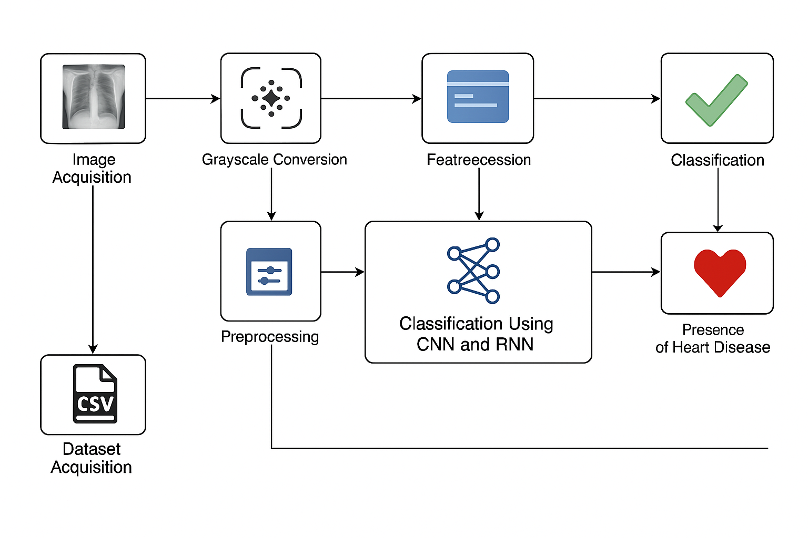

**Fig 4.1 Architecture Diagram**

**4.2 Flow Diagram**

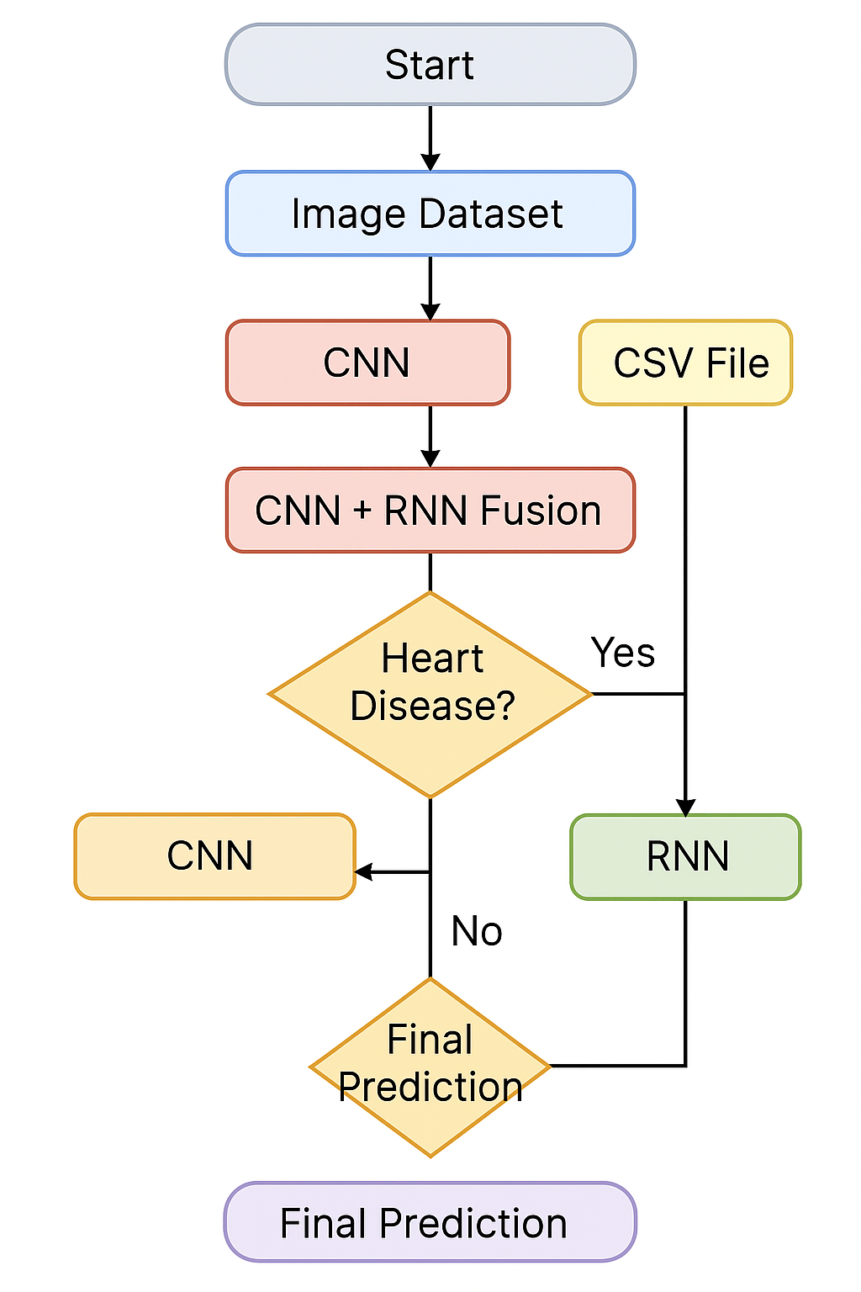

**Fig 4.2 flow diagram**

The flow diagram begins with the start point where the user initiates the system by providing the necessary input data. The system is designed to accept two types of input: medical images such as X-rays or echocardiograms, and structured data in the form of a CSV file containing clinical parameters like age, blood pressure, cholesterol levels, and more. These two input paths allow the model to work with both visual and tabular data, providing a multi-modal approach to heart disease prediction. This dual-input system increases the flexibility and robustness of the diagnostic process. For the image input path, the uploaded medical images are first processed through a convolutional neural network (CNN). This model extracts spatial features from the image, identifying patterns and visual abnormalities related to heart disease. These features are then passed on to a recurrent neural network (RNN), which can interpret sequential patterns in the data, such as changes in heart structure over time in dynamic image sequences. The CNN-RNN combination improves diagnostic accuracy by analyzing both static and dynamic features in medical images. Parallel to the image processing path, the system also processes the CSV file input. This file typically contains patient health records over time, including numerical and categorical data. The structured data is preprocessed, normalized, and then passed to an RNN-based classifier. This model analyzes the sequential nature of health metrics to determine potential risks. By observing patterns and fluctuations in the data over time, the RNN is able to classify the likelihood of heart disease with a high degree of precision.

In the final stage, the results from both the image-based CNN-RNN model and the structured-data-based RNN model are sent to a decision-making layer. This layer fuses the insights from both pathways to arrive at a final prediction regarding the presence or absence of heart disease. If the output from either or both models indicates risk, an alert is generated. Otherwise, the patient is classified as low-risk. This integrated decision process ensures a more accurate, reliable, and comprehensive analysis of heart disease using diverse data types.

**CHAPTER 5**

**SYSTEM CONFIGURATION**

**5.1 HARDWARE REQUIREMENTS**

* Processor : Dual core processor 2.6.0 GHz
* RAM : 1GB
* Hard disk : 160 GB
* Compact Disk : 650 MB
* Keyboard : Standard keyboard
* Monitor : 15 inch color monitor

**5.2 SOFTWARE SPECIFICATION**

* Front End : Python
* Back End : Python
* IDE : Pycharm Community Edition
* Platform : Windows 10 or higher

**SOFTWARE DESCRIPTION**

Python is an interpreted, object-oriented, high-level programming language with dynamic semantics. Its high-level built in data structures, combined with dynamic typing and dynamic binding, make it very attractive for Rapid Application Development, as well as for use as a scripting or glue language to connect existing components together. Python's simple, easy to learn syntax emphasizes readability and therefore reduces the cost of program maintenance. Python supports modules and packages, which encourages program modularity and code reuse. The Python interpreter and the extensive standard library are available in source or binary form without charge for all major platforms, and can be freely distributed.

Often, programmers fall in love with Python because of the increased productivity it provides. Since there is no compilation step, the edit-test-debug cycle is incredibly fast. Debugging Python programs is easy: a bug or bad input will never cause a segmentation fault. Instead, when the interpreter discovers an error, it raises an exception. When the program doesn't catch the exception, the interpreter prints a stack trace. A source level debugger allows inspection of local and global variables, evaluation of arbitrary expressions, setting breakpoints, stepping through the code a line at a time, and so on. The debugger is written in Python itself, testifying to Python's introspective power. On the other hand, often the quickest way to debug a program is to add a few print statements to the source: the fast edit-test-debug cycle makes this simple approach very effective.

**FEATURES IN PYTHON**

There are many features in Python, some of which are discussed below –

**1.Easy to code:**

Python is high level programming language. Python is very easy to learn language as compared to other language like c, c#, java script, javaetc.It is very easy to code in python language and anybody can learn python basic in few hours or days.It is also developer-friendly language.

**2. Free and Open Source:**

Python language is freely available at official website and you can download it from the given download link below click on the Download Python keyword.

**Download Python**

Since, it is open-source; this means that source code is also available to the public. So you can download it as, use it as well as share it.

**3.Object-Oriented Language:**

One of the key features of python is Object-Oriented programming. Python supports object oriented language and concepts of classes, objects encapsulation etc.

**4. GUI Programming Support:**

Graphical Users interfaces can be made using a module such as PyQt5, PyQt4, wxPython or Tk in python.

PyQt5 is the most popular option for creating graphical apps with Python.

**5. High-Level Language:**

Python is a high-level language. When we write programs in python, we do not need to remember the system architecture, nor do we need to manage the memory.

**6.Extensible feature:**

Python is a Extensible language. we can write our some python code into c or c++ language and also we can compile that code in c/c++ language.

**7. Python is Portable language:**

Python language is also a portable language. for example, if we have python code for windows and if we want to run this code on other platform such as Linux, Unix and Mac then we do not need to change it, we can run this code on any platform.

**8. Python is integrated language:**

Python is also an integrated language because we can easily integrated python with other language like c, c++ etc.

**9. Interpreted Language:**

Python is an Interpreted Language. because python code is executed line by line at a time. like other language c, c++, java etc there is no need to compile python code this makes it easier to debug our code.The source code of python is converted into an immediate form called bytecode.

**10. Large Standard Library**

Python has a large standard library which provides rich set of module and functions so you do not have to write your own code for every single thing.There are many libraries present in python for such as regular expressions, unit-testing, web browsers etc.

**11. Dynamically Typed Language:**

Python is dynamically-typed language. That means the type (for example- int, double, long etc) for a variable is decided at run time not in advance.because of this feature we don’t need to specify the type of variable.

Machine Learning is the hottest trend in modern times. According to Forbes, Machine learning patents grew at a 34% rate between 2013 and 2017 and this is only set to increase in the future. And Python is the primary programming language used for much of the research and development in Machine Learning. Python is currently the most popular programming language for research and development in Machine Learning. But you don’t need to take my word for it! According to GoogleTrends, the interest in Python for Machine Learning has spiked to an all-new high with other ML languages such as R, Java, Scala, Julia, etc. lagging far behind.

**SOFTWARE SUPPORTS**

**INSTALLATION PROCEDURE**

**Introduction**

Python is a widely used high-level programming language first launched in 1991. Since then, Python has been gaining popularity and is considered as one of the most popular and flexible server-side programming languages.

Unlike most Linux distributions, Windows does not come with the Python programming language by default. However, you can install Python on your Windows server or local machine in just a few easy steps.

**PREREQUISITES**

* A system running Windows 10 with admin privileges
* Command Prompt (comes with Windows by default)
* A Remote Desktop Connection app (use if you are installing Python on a remote Windows server)

**PYTHON INSTALLATION ON WINDOWS**

### Step 1: Select Version of Python to Install

The installation procedure involves downloading the official Python .exe installer and running it on your system.

The version you need depends on what you want to do in Python. For example, if you are working on a project coded in Python version 2.6, you probably need that version. If you are starting a project from scratch, you have the freedom to choose.

If you are learning to code in Python, we recommend you **download both the latest version of Python 2 and 3**. Working with Python 2 enables you to work on older projects or test new projects for backward compatibility.

**Step 2: Download Python Executable Installer**

1. Open your web browser and navigate to the [Downloads for Windows section](https://www.python.org/downloads/windows/) of the [official Python website](https://www.python.org/).
2. Search for your desired version of Python. At the time of publishing this article, the latest Python 3 release is version 3.7.3, while the latest Python 2 release is version 2.7.16.
3. Select a link to download either the **Windows x86-64 executable installer** or **Windows x86 executable installer**. The download is approximately 25MB.

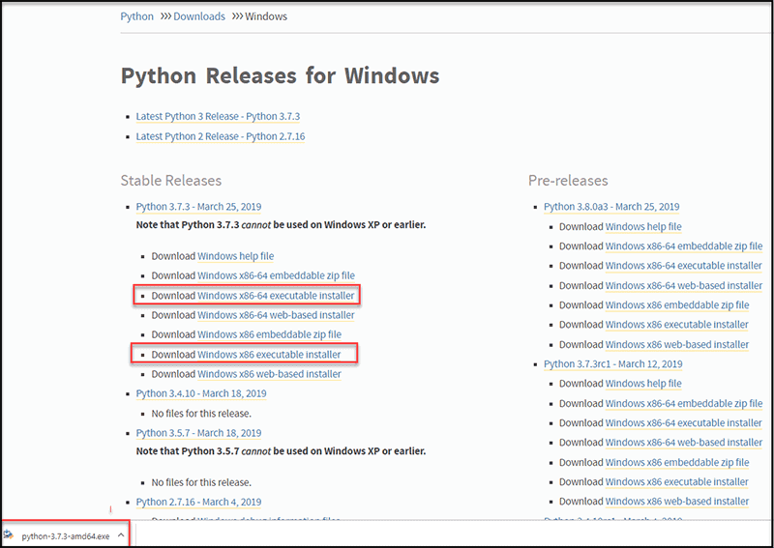

**Step 3: Run Executable Installer**

1. Run the **Python Installer** once downloaded. (In this example, we have downloaded Python 3.7.3.)

2. Make sure you select the **Install launcher for all users** and **Add Python 3.7 to PATH** checkboxes. The latter places the interpreter in the execution path. For older versions of Python that do not support the **Add Python to Path** checkbox, see [Step 6](https://phoenixnap.com/kb/how-to-install-python-3-windows#htoc-step-5-add-python-path-to-environment-variables-optional).

3. Select **Install Now** – the recommended installation options.



For all recent versions of Python, the recommended installation options include **Pip** and **IDLE**. Older versions might not include such additional features.

4. The next dialog will prompt you to select whether to **Disable path length limit**. Choosing this option will allow Python to bypass the 260-character MAX_PATH limit. Effectively, it will enable Python to use long path names



The Disable path length limit option will not affect any other system settings. Turning it on will resolve potential name length issues that may arise with Python projects developed in Linux.

### Step 4: Verify Python Was Installed On Windows

1. Navigate to the directory in which Python was installed on the system. In our case, it is **C:\Users\**Username**\AppData\Local\Programs\Python\Python37**since we have installed the latest version.
2. Double-click **python.exe**.
3. The output should be similar to what you can see below:

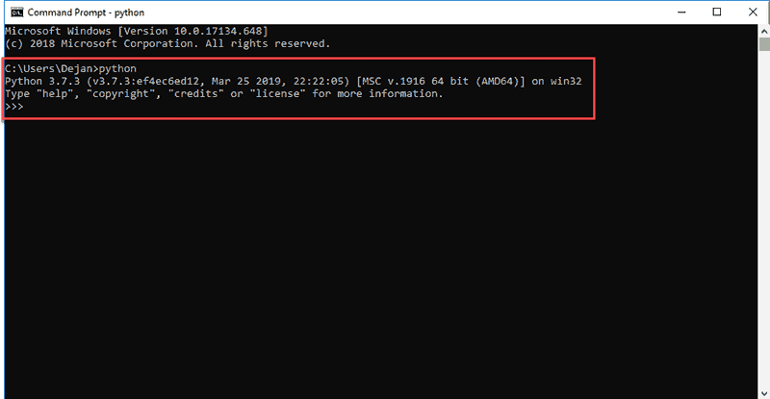

Step 5: Verify Pip Was Installed

If you opted to install an older version of Python, it is possible that it did not come with Pip preinstalled. Pip is a powerful package management system for Python software packages. Thus, make sure that you have it installed.

We recommend using Pip for most Python packages, especially when working in virtual environments.

To verify whether Pip was installed:

1. Open the Start menu and type “cmd.”
2. Select the Command Prompt application.
3. Enter pip -V in the console. If Pip was installed successfully, you should see the following output:

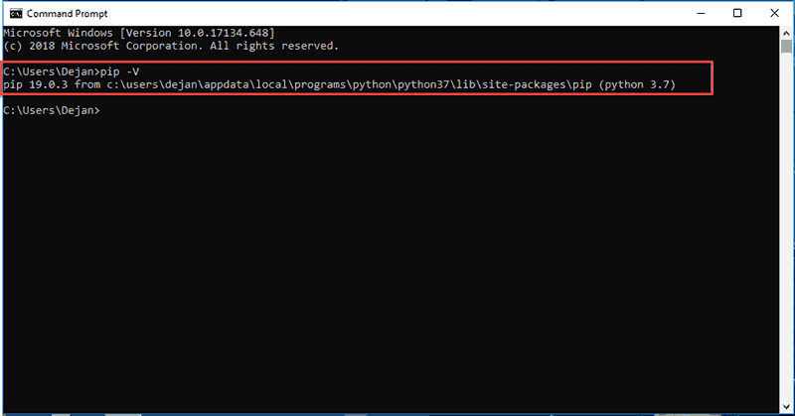

Step 6: Add Python Path to Environment Variables (Optional)

We recommend you go through this step if your version of the Python installer does not include the Add Python to PATH checkbox or if you have not selected that option.

Setting up the Python path to system variables alleviates the need for using full paths. It instructs Windows to look through all the PATH folders for “python” and find the install folder that contains the python.exe file.

1. Open the Start menu and start the Run app.

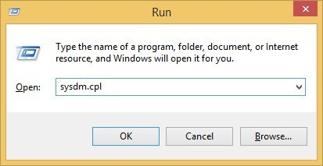

2. Type **sysdm.cpl**and click **OK**. This opens the **System Properties** window.

3. Navigate to the **Advanced** tab and select **Environment Variables**.

4. Under **System Variables**, find and select the **Path** variable.

5. Click **Edit**.

6. Select the **Variable value** field. Add the path to the **python.exe** file preceded with a **semicolon** **(;)**. For example, in the image below, we have added “**;C:\Python34.**”

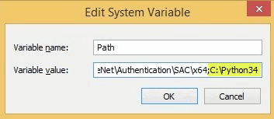

7. Click **OK** and close all windows.

By setting this up, you can execute Python scripts like this: **Python script.py**

Instead of this: **C:/Python34/Python script.py**

As you can see, it is cleaner and more manageable.

**CHAPTER 6**

**MODULES**

**6.1 Image Acquisition**

The Image Acquisition module is responsible for collecting diagnostic medical images from various sources, such as chest X-rays, echocardiograms, or CT scans. These images serve as the primary input for the deep learning model and must be collected with high quality and resolution to ensure accuracy in downstream processing. This step involves interfacing with medical imaging equipment or retrieving image datasets from open-source repositories. This module plays a crucial role in standardizing the format of images collected from different environments. It ensures that the images are consistent in size, resolution, and format (e.g., DICOM, JPEG, PNG) before they are passed on to subsequent modules. Proper acquisition helps prevent inconsistencies that may affect the performance of the CNN model used in the project. Moreover, it includes data labeling or annotation to associate images with diagnostic results (e.g., normal, heart disease present). This labeled data is crucial for supervised training of the CNN. In real-time systems, the module may also incorporate automated integration with hospital databases or PACS (Picture Archiving and Communication Systems) to fetch live image data for diagnosis.

**6.2 Grayscale Conversion**

The Grayscale Conversion module transforms RGB or colored medical images into grayscale format, which simplifies the image data without losing critical diagnostic information. This step is essential because most CNN models perform better when unnecessary color channels are removed, focusing purely on intensity values. Converting images to grayscale reduces the computational load and memory requirements while enhancing the ability of the model to detect edges and structural patterns relevant to heart disease. It allows the model to pay closer attention to key features such as valve calcifications, artery shapes, or heart chamber abnormalities. This preprocessing step also ensures consistency across the dataset, as some medical images may already be in grayscale while others are not. By applying grayscale conversion uniformly, the module guarantees that all input data fed into the CNN model is in a standardized format, which is essential for effective training and evaluation.

**6.3 DCT Filtering**

Discrete Cosine Transform (DCT) Filtering is a technique used in this module to remove noise and highlight important frequency features in medical images. DCT helps compress the image by separating the image into parts of differing frequencies, allowing the retention of critical information while reducing background noise. This module enhances image quality by filtering out irrelevant data, especially low-contrast or fuzzy areas that might confuse the CNN during training. DCT focuses on the transformation of spatial data into frequency domain data, enabling more effective analysis of image features that are useful for disease detection. The application of DCT filtering improves the clarity of structural patterns in heart-related images, such as heart walls, valves, and vessel outlines. These enhanced features are then better segmented and analyzed in subsequent modules, making DCT filtering a vital preprocessing step in the image analysis pipeline.

**6.4 Segmentation**

The Segmentation module is tasked with isolating specific regions of interest (ROI) in the grayscale medical images, such as heart chambers, blood vessels, or lesions. Accurate segmentation is crucial because it ensures that only the relevant parts of the image are analyzed further, eliminating background or unrelated structures. Techniques such as thresholding, edge detection, or even deep learning-based segmentation (e.g., U-Net) can be applied here depending on the dataset complexity. By identifying key structures, this module enables more precise feature extraction, ensuring that the CNN model is trained on meaningful data. Segmentation also facilitates better visual interpretation for medical professionals, as it highlights abnormalities that might be indicative of heart disease. This module serves as a bridge between image enhancement and feature extraction, helping improve the diagnostic accuracy of the system.

**6.5 Feature Extraction**

This module extracts high-level features from the segmented medical images, which are essential for the classification task. In the CNN pipeline, feature maps are generated through convolutional layers that detect patterns such as textures, edges, shapes, and regions associated with pathological conditions. Feature extraction reduces the dimensionality of image data while retaining the most important diagnostic features. Pooling layers and activation functions within the CNN architecture help select the strongest features, which are then passed to the classification layer or further fused with the RNN for temporal analysis. The extracted features represent a condensed but rich representation of the image, enabling the model to differentiate between healthy and unhealthy cardiac conditions. These features are not only useful for classification but can also be stored for visual analysis, model interpretability, and performance evaluation.

**6.6 Classification using CNN with RNN**

This module performs the final classification based on the features extracted from medical images using a hybrid CNN-RNN model. The CNN handles spatial feature extraction, while the RNN processes the sequential or temporal dependencies, particularly useful for echocardiogram or dynamic image data. The fusion of CNN and RNN allows the model to understand both structural and temporal patterns, improving diagnostic precision. The CNN captures visual markers, and the RNN considers how these features evolve across time or sequence frames, which is critical for conditions that show progression over time. This dual-model approach improves classification metrics such as accuracy, sensitivity, and specificity. The model outputs the likelihood of heart disease, enabling medical practitioners to take timely decisions. It showcases the advantage of integrating multiple deep learning architectures to handle complex multimodal data.

**6.7 Dataset Acquisition**

In this module, structured clinical data is gathered from medical databases, hospital records, or public datasets such as the UCI Heart Disease dataset. The data includes key attributes like age, gender, cholesterol, blood pressure, glucose levels, ECG results, and other medical indicators. The dataset acquisition process ensures that high-quality, diverse, and complete patient records are available for training and testing. It involves verifying the reliability and consistency of data sources, handling missing values, and labeling the dataset with corresponding diagnostic outcomes (e.g., disease present or absent). This structured data forms the foundation for the RNN-based classification part of the system. Ensuring the dataset represents various patient profiles improves the generalization and real-world applicability of the model, which is essential for reliable clinical decision-making.

**6.8 Preprocessing**

The Preprocessing module cleans and formats the structured clinical data for efficient use by the deep learning model. It includes steps such as normalization, encoding categorical values, handling missing data, and removing outliers that could bias the model. Normalization ensures that all numerical values, such as cholesterol and blood pressure, are scaled to a similar range, which helps speed up and stabilize the training process. Categorical attributes, like chest pain type or ECG results, are converted into machine-readable formats using one-hot encoding or label encoding. This module ensures that the data fed into the RNN is uniform, relevant, and free of inconsistencies, improving model performance and robustness. Good preprocessing is crucial for ensuring that subtle patterns in the dataset are retained and emphasized during model training.

**6.9** **Attribute Extraction**

Attribute Extraction involves selecting the most relevant features from the preprocessed structured data that contribute to heart disease prediction. This process may use statistical methods like correlation analysis, or automated methods such as feature importance from tree-based models. By identifying key health indicators—such as high cholesterol, abnormal ECG, or elevated blood pressure—the module focuses the model on inputs that carry the most diagnostic weight. This not only improves prediction accuracy but also reduces computational complexity. Additionally, attribute extraction helps in reducing overfitting by removing redundant or irrelevant data. It ensures that the model is trained only on meaningful parameters, enhancing interpretability and making it easier to understand how certain health metrics influence predictions.

**6.10 Classification using RNN**

This module uses Recurrent Neural Networks to analyze the temporal progression of a patient’s clinical data. RNNs are capable of recognizing patterns in sequential data, making them ideal for understanding how combinations of attributes evolve over time in a patient’s health history. The model captures dependencies between past and present health indicators to predict the likelihood of heart disease. For example, consistently high blood pressure combined with rising cholesterol over multiple checkups might be a stronger predictor than either feature alone. The final output of the RNN is a classification label indicating whether the patient is at risk of heart disease. This module benefits from the time-series analysis capabilities of RNNs, offering insights that static models might miss, and contributes significantly to early detection and personalized treatment strategies.

**CHAPTER 7**

**SOFTWARE TESTING**

Testing is a crucial phase in any machine learning project, especially in healthcare applications where accurate predictions can impact patient outcomes. In this heart disease prediction system, multiple testing strategies were employed to validate both components of the model—the image-based CNN-RNN model and the CSV-based RNN classifier. Each component was tested individually and also together to ensure the system performs accurately in real-world scenarios. The testing process involved various datasets, performance metrics, and testing methodologies such as unit testing, integration testing, and system testing.

**System Testing**

System testing is the final phase of testing where the complete and integrated software is evaluated as a whole to ensure it meets the specified requirements. For this heart disease prediction project, system testing was conducted to verify the end-to-end functionality of the system from data input to final prediction output. The system was tested under various real-world scenarios such as providing only image data, only CSV data, or both simultaneously. This allowed the testing team to ensure that the model responded correctly regardless of the input type and that the flow from data preprocessing, model execution, to result generation worked seamlessly. Additionally, system testing included checking the performance of the user interface and verifying whether the predictions were displayed accurately and clearly. The prediction results such as "Heart Disease Detected" or "No Heart Disease" were validated with ground-truth data to confirm accuracy. Usability tests were also performed to check for responsiveness and interface clarity. Edge cases were tested, such as corrupted files, missing values, and large input files, to observe how the system handles exceptions. This comprehensive testing confirmed that the system was reliable, stable, and user-friendly when deployed in a real healthcare environment.

**Unit Testing**

Unit testing focuses on testing individual components or modules of the system in isolation. In this project, unit testing was performed on several critical components such as the CNN model for image analysis, the RNN model for CSV data classification, the preprocessing functions, and the result display logic. Each of these components was tested independently to ensure they performed their specific functions correctly. For example, the CNN model was tested to confirm that it could extract features from images of varying sizes and formats without throwing errors, while the RNN model was validated for correctly classifying tabular patient data. In addition, preprocessing functions were tested to handle common issues such as missing values, null entries, and incorrect data formats. Unit testing helped identify and fix bugs at an early stage, ensuring that every function or block of code worked perfectly before integrating it into the full system. It also made debugging easier, as errors could be traced back to individual components rather than searching through the entire system. The success of unit testing contributed to a more reliable and maintainable codebase.

**Integration Testing**

Integration testing was conducted after successful unit testing to ensure that different modules of the system worked together correctly. In this heart disease prediction project, integration testing involved combining the image processing pipeline (CNN and RNN models) with the CSV data classifier and then integrating both with the result fusion and decision-making module. This step verified that outputs from one module could be accurately passed and interpreted by the next module, maintaining data integrity and functional consistency across the system. Furthermore, integration testing focused on the interaction between the backend prediction engine and the frontend user interface. It ensured that data input through the interface was correctly routed to the appropriate models and that the results generated were displayed properly. Scenarios tested included merging predictions from the CNN-RNN and RNN models, checking for synchronization issues, and verifying that the combined results led to the correct final output. Integration testing ensured that the system functioned as a unified whole, with all internal and external components interacting flawlessly.

**CHAPTER 9**

**SUSTAINABLE DEVELOPMENT GOALS**

**9.1 Area of Use**

**Healthcare Sector** The proposed system finds its primary application in the healthcare sector, where accurate and early detection of heart disease can significantly reduce mortality rates. Hospitals, diagnostic clinics, and cardiology departments can adopt this model for screening patients, offering early warnings about heart disease based on both medical images (like chest X-rays and echocardiograms) and structured health data. The system will be particularly useful in environments with limited access to expert cardiologists, as it provides valuable diagnostic assistance.

**Medical Imaging and Diagnosis** The image-based component of the system (CNN) is specifically tailored to enhance the diagnostic capabilities of medical imaging tools. By using chest X-rays or echocardiograms, the system can identify subtle signs of heart disease that might be overlooked by human eyes. This makes it a valuable tool in radiology departments and clinics where medical imaging is critical for diagnosing cardiovascular conditions.

**Clinical Decision Support Systems** The integration of RNNs to analyze structured clinical data (e.g., cholesterol levels, blood pressure) positions the system as a part of broader clinical decision support systems (CDSS). It can aid physicians in making informed decisions based on comprehensive, up-to-date data, offering timely alerts about potential health risks, thus allowing for more personalized care and preventive treatments.

**Remote Healthcare Services** In areas with limited healthcare infrastructure, telemedicine services can benefit from this hybrid model by providing remote diagnostic capabilities. The system can be used to analyze both medical images and clinical data from patients in rural or underserved areas, ensuring that individuals have access to essential diagnostic information even if specialist care is not immediately available.

**9.2 Benefits of the Project**

**Enhanced Diagnostic Accuracy** By leveraging both spatial (from CNN) and temporal (from RNN) data, this hybrid model improves the precision of heart disease predictions. The combination of image-based and clinical data analysis helps detect patterns that might otherwise go unnoticed with standalone models, enhancing the overall accuracy of diagnoses. This allows healthcare providers to make more informed decisions.

**Early Detection and Intervention** Heart disease is often asymptomatic in its early stages. By combining multiple data sources, the system can identify at-risk individuals before symptoms become severe, leading to earlier interventions. Early detection is key to improving patient outcomes, as it allows for timely lifestyle changes, medical treatments, or surgeries, potentially saving lives.

**Cost-Effective Solution for Healthcare Providers** This system can reduce the need for expensive diagnostic procedures and specialist consultations by providing an automated, reliable method for predicting heart disease risk. Hospitals and clinics can save on healthcare costs while improving the accessibility of diagnostic services to a wider population, especially in resource-constrained settings.

**Continuous Monitoring and Improved Patient Management** With the ability to process sequential, time-sensitive clinical data, the system offers continuous monitoring of a patient's health profile over time. This feature supports the management of chronic conditions such as heart disease, enabling healthcare providers to track changes in risk factors and adjust treatment plans accordingly. This results in more personalized and proactive care.

**Integration with Existing Healthcare Systems** The model can be integrated into existing healthcare infrastructures, such as electronic health records (EHRs) or hospital information systems (HIS). This ensures smooth adoption and compatibility with other medical tools and technologies already in use. It also enables seamless data flow between different healthcare systems, improving overall efficiency and patient care continuity.

**CHAPTER 10**

**CONCLUSION AND FUTURE WORK**

**10.1 Conclusion**

In conclusion, the hybrid deep learning-based model for heart disease prediction developed in this project presents a significant advancement in early detection and diagnosis, integrating both medical images and structured clinical data. By leveraging Convolutional Neural Networks (CNN) to analyze diagnostic images and Recurrent Neural Networks (RNN) to process sequential health data, this system offers a comprehensive approach to identifying subtle signs of heart disease. The fusion of these two modalities not only enhances diagnostic accuracy but also helps healthcare professionals make more informed decisions, ultimately improving patient outcomes. The dual-method framework of combining CNN and RNN models ensures a robust prediction system that accounts for both spatial and temporal patterns, which are essential for accurate diagnosis. This approach allows the system to handle diverse and complex medical datasets, providing a holistic view of a patient’s health. Furthermore, the comparative evaluation of standalone models versus the hybrid model highlights the superiority of this approach in terms of accuracy, sensitivity, and reliability, demonstrating its potential to outperform traditional diagnostic methods. The proposed system holds significant promise for widespread application in healthcare settings, including hospitals, diagnostic centers, and telemedicine platforms. Its ability to integrate with existing healthcare infrastructures and support continuous monitoring positions it as a valuable tool for early intervention and ongoing patient management. By adopting such innovative technologies, the healthcare industry can move toward more efficient, accurate, and accessible solutions for combating heart disease and improving overall patient care.

**10.2 Future Enhancement**

In the future, the hybrid deep learning-based model can be enhanced by incorporating additional data sources, such as genetic information or wearable health data (e.g., heart rate, activity levels, and sleep patterns), to further improve the accuracy and reliability of heart disease predictions. Integrating such real-time data from wearables would allow the system to continuously track and analyze a patient’s health, enabling dynamic risk assessment and real-time alerts for early intervention. Additionally, the model could be adapted to handle data from other diagnostic tools, such as CT scans or MRI images, further diversifying the types of medical imaging it can analyze, enhancing its utility in clinical practice.

Another potential enhancement involves improving the interpretability of the deep learning model, making it more transparent for healthcare professionals. Techniques like explainable AI (XAI) could be employed to provide clinicians with insights into how the model arrives at its predictions, helping to build trust in the system and ensuring its decisions align with clinical reasoning. Furthermore, the model could be expanded to handle a wider range of cardiovascular diseases beyond heart disease, such as stroke or arrhythmias, by incorporating multi-disease classification into the system. This would broaden the scope of the project and make it even more valuable in the clinical environment.

**REFERENCE**

1. M. Riazul Islam; Daehan Kwak; Md. Humaun Kabir; Mahmud Hossain; Kyung-Sup Kwak, "The Internet of Things for Health Care: A Comprehensive Survey", IEEE Access, Volume: 3, Pages: 678–708, 2015.
2. A. Rajendran; M. Deepa, "Heart Disease Prediction using Hybrid Machine Learning Algorithm", Journal of King Saud University - Computer and Information Sciences, Volume: 34, Issue: 6, Pages: 3249–3258, 2022.
3. A. S. M. S. Islam; M. R. A. Tushar; M. S. Khan, "A Deep Learning Model for Early Detection of Heart Disease Using Medical Data", Proceedings of the International Conference on Computing, Communication, and Networking Technologies, Pages: 102-106, 2021.
4. C. J. Lin; H. D. Liu, "Predicting Heart Disease with Data Mining Techniques: A Survey", International Journal of Computer Applications, Volume: 148, Pages: 9–15, 2016.
5. R. A. Ganaie; M. Iqbal; M. W. Baig, "Heart Disease Diagnosis Using Convolutional Neural Networks and Structured Clinical Data", IEEE Access, Volume: 8, Pages: 54844–54856, 2020.
6. R. K. Gupta; A. S. Gohil; A. K. Mishra, "Medical Image Analysis Using Deep Learning Algorithms for Heart Disease Prediction", International Journal of Engineering and Technology, Volume: 12, Pages: 168–175, 2019.
7. R. Singh; S. K. Shukla, "Hybrid Deep Learning Model for Heart Disease Prediction: A Review", Journal of Medical Imaging and Health Informatics, Volume: 10, Issue: 5, Pages: 1261–1268, 2020.
8. M. Z. Hasan; M. M. I. Karim, "A Hybrid Deep Learning Model for Predicting Cardiovascular Diseases", International Journal of Computer Applications, Volume: 176, Pages: 23–29, 2019.
9. J. Wang; Q. Zhu; J. Zhang, "A Deep Learning Approach to Predict Heart Disease Using Echocardiogram Images and Patient Data", Journal of Medical Systems, Volume: 43, Issue: 3, Pages: 72-81, 2019.
10. F. Zhang; W. Zhou; D. Zhang, "Multi-modal Heart Disease Diagnosis Using Deep Neural Networks", Proceedings of the IEEE International Conference on Biomedical Engineering and Applications, Pages: 144–149, 2021.