PES UNIVERSITY | DEPARTMENT OF COMPUTER SCIENCE & ENGINEERING
B.TECH IN CSE (2024–2028) | SEMESTER-V | UE24CS320A – CAPSTONE PROJECT PHASE-1
CLOUD-M7: Tier-Adaptive Forensic Provenance
Distributed Attack-Path Reconstruction across Edge, Fog, and Cloud Strata
Comprehensive Technical Specification, Review-1 Deliverables & Future Datasets Architecture
Candidate Name & SRN | Dharshini [PES1UG24CS...]
Course & Project ID | UE24CS320A – Capstone Phase-1 (Review-1) | Project ID: UE24CS320A-CAP-CLOUD-M7
Academic Mentorship | Internal Project Guide / Faculty Mentor, Department of CSE, PES University
Source Code & Tests | https://github.com/DharshiniPES/cloud-m7 (13/13 Pytest Suites Passing, 100%)

1. Executive Summary & Problem Formulation
Modern enterprise computing infrastructure has fundamentally evolved from centralized data centers into a three-tier distributed computing hierarchy: (1) resource-constrained Edge devices and sensors, (2) intermediate regional Fog gateways, and (3) centralized Cloud data centers. While this paradigm delivers localized ultra-low-latency processing, it introduces a severe security dilemma: Advanced Persistent Threats (APTs) exploit perimeter edge IoT devices, pivot laterally through regional fog routing tables, and exfiltrate confidential databases in the cloud.
The Three Broken Pillars of Multi-Tier Forensics:
1. Host EDR Blindness: Conventional endpoint detection tools (Linux auditd, Sysmon, CamFlow) monitor single operating system kernels in isolation. When an adversary transmits a lateral payload over a network socket, the causal provenance chain breaks permanently.
2. Centralized SIEM Infeasibility: Shipping all raw audit records to a centralized cloud SIEM (Splunk, AWS CloudWatch) saturates constrained edge network uplinks (consuming >500 KB/s per sensor cluster), causes severe detection delays (160ms+ round-trip latency), and leaks unmasked camera/sensor payloads outside device boundaries, violating GDPR and HIPAA regulations.
3. Heterogeneous Schema Incompatibility: Linux kernel syscalls (clone, execve), Docker socket streams, and Cloud REST API logs use disjoint data structures, preventing automated end-to-end graph traversal without tedious manual analyst guesswork.

2. System Architecture & Mathematical Formalization

2.1 Unified Multi-Tier Forensic Event Schema (Equation 1)
To reconcile heterogeneous multi-tier logs, CLOUD-M7 normalizes every system event into a standardized 7-element mathematical tuple:
E_i = < UUID_i, τ_i, Tier_i, HostID_i, Type_i, P_i, π_i >
• UUID_i: 128-bit cryptographically unique event identifier.
• τ_i: High-precision UTC timestamp establishing a strict partial ordering over all distributed events.
• Tier_i ∈ {Edge, Fog, Cloud}: Architectural stratum where the event took place.
• HostID_i: Originating container, virtual machine, or physical hardware identity.
• Type_i ∈ {Process, File, Socket, API}: Abstracted event classification.
• P_i: Structured payload carrying process PID, paths, socket 5-tuples, or API parameters.
• π_i: Set of causal parent event UUIDs establishing direct dependency edges.
Cryptographic Tamper-Evidence (SHA-256 Non-Repudiation):
H_i = SHA256( UUID_i || τ_i || Tier_i || HostID_i || Type_i || P_i || π_i )
Guarantees that an adversary gaining root privileges on an edge device cannot alter historical audit records without invalidating the cryptographic digest.

2.2 Cross-Tier Network Flow Stitching (E_network)
A directed dependency edge (u -> v) ∈ E_network is established between an outbound socket event u at tier T_1 and an inbound socket event v at tier T_2 if and only if:
1. Network 5-Tuple Complementarity: IP_src(u) == IP_src(v) ∧ IP_dst(u) == IP_dst(v) ∧ Port_src(u) == Port_src(v) ∧ Port_dst(u) == Port_dst(v) ∧ Proto(u) == Proto(v)
2. Causal Temporal Validity: 0 <= τ(v) - τ(u) <= Δt_window (Strict forward causality within the propagation window).
Global Causal Graph Synthesis: G_global = G_edge ∪ G_fog ∪ G_cloud ∪ E_network

2.3 Tier-Adaptive Task Placement Optimization (Equation 2)
min_x J(x) = α · Lat(x) + β · BW(x) + γ · Priv(x) + δ · Cost(x) subject to: C_edge(x) <= C_max
Where x = {EventCapture, PrivacyFilter, GraphReduction, CrossTierFusion, CausalAnalytics, LongTermStorage} ∈ {Edge, Fog, Cloud}.

Optimization Benchmark vs Centralized Baseline:
Metric | Centralized Cloud Baseline | CLOUD-M7 (Optimal Placement) | Performance Improvement
Network Bandwidth (Uplink) | 500.0 KB/s | 50.0 KB/s | 90.0% Reduction (10x Savings)
Processing Latency | 160.0 ms | 20.0 ms | 87.5% Latency Reduction
Privacy Exposure Penalty | 120.0 points | 5.0 points | 95.8% Exposure Mitigation
Edge CPU Utilization | 150.0 mcores | 620.0 mcores | Feasible (< 800 mcores limit)

3. Core Research Novelty Contributions

3.1 Novelty 1: Hyperparameter-Tuned Iterative Multi-Root Causal Discovery
The Fundamental Flaw in Prior Systems:
Standard provenance graph engines (SPADE, CamQuery, BackTracker) execute a single-pass backward search (BFS/DFS) that terminates immediately upon locating the first root event with in-degree = 0. In complex APTs, adversaries routinely establish multiple concurrent entry vectors (e.g. probing a sensor, flashing actuator firmware, and harvesting cloud tokens). Single-pass traversal leaves stealthy secondary entry points completely undetected.
Our Mathematical Iterative Formulation:
ΔI_k = Impact(R_k) · e^(-λ · k) >= ε
• Hyperparameters:
- K_max = 5: Traversal iteration ceiling bounding worst-case graph search complexity.
- ε = 1.0: Diminishing return threshold (stops traversal when marginal impact is negligible).
- λ = 0.1: Attenuation decay factor dampening ancestral overlap.
Empirical Results across Iterations:
• Iteration 1 (ΔI_1 = 102.30): Vector 1 on edge-sensor-01 (/usr/bin/iot_agent exploit, 14 hops to cloud).
• Iteration 2 (ΔI_2 = 10.24): Vector 2 on edge-sensor-02 (/usr/sbin/fw_updater command injection, 11 hops to cloud).
• Iteration 3 (ΔI_3 = 3.77): Vector 3 on fog-gateway-01 (scraped cloud_service_account.json token, 7 hops to cloud).
• Iteration 4: Marginal impact drops below ε; the loop cleanly converges.

3.2 Novelty 2: Interconnected Multi-Sensor Graph & Articulation Choke-Point Analysis
Multi-Sensor Attack Convergence:
In smart cyber-physical systems, adversaries probe multiple sensors simultaneously, which converge toward sensitive upstream cloud databases.
Graph Articulation Cut-Vertex Theory:
An articulation cut-point is a bottleneck vertex whose removal partitions edge sensor sources S from the target cloud asset t. We formalize the Containment Efficiency Metric:
E_cut(v) = |{p ∈ P_multi | v ∈ p}| / |P_multi|
Empirical Breakthrough:
• Identified Choke Point: fog-gateway-01:socket_connect
• Containment Efficiency: E_cut = 1.0 (100.0% Containment)
• Articulation Cut Verification: TRUE (severs 3 out of 3 attack paths)
Operational Value for Incident Response:
Instead of attempting to patch dozens of remote edge sensors distributed across a physical factory during an active breach, incident responders quarantine JUST ONE choke point on the Fog gateway to sever 100% of attack paths before they touch cloud crown jewels.

4. Background Study: Comprehensive Analysis of 5 Seminal Research Papers
Our research is grounded in the foundational provenance literature, extending whole-system provenance into distributed multi-tier environments:
Paper & Venue | Core Focus & Contribution | Architectural Limitation | CLOUD-M7 Advancement
1. CamFlow / CamQuery  (Pasquier et al., USENIX ATC 2018) | Whole-system OS provenance capture via Linux Security Modules (LSM) & graph queries. | Confined to a single OS kernel; completely blind to cross-network sockets and multi-tier boundaries. | Synthesizes cross-tier edges (E_network) via unified tuple E_i and network 5-tuple correlation.
2. SPADE  (Bates et al., USENIX Security 2015) | Extensible distributed provenance collection and query engine for Linux auditd. | Forwards all raw audit logs to central storage, causing severe edge uplink bandwidth saturation. | Constrained task placement optimization (min J(x)) achieving 90.0% bandwidth reduction.
3. Prov-IoT  (Wang et al., IEEE IoT-J 2020) | Provenance tracking framework customized for smart home IoT devices. | Restricted to simple smart-home trigger rules; cannot scale to enterprise hybrid clouds. | Unified multi-tier schema scaling from edge microcontrollers to enterprise cloud databases.
4. HOLMES  (Milajerdi et al., IEEE S&P 2019) | Real-time APT detection by correlating suspicious information flows to MITRE ATT&CK. | Single-pass kill chain traversal terminates at first alert, missing stealthy secondary roots. | Hyperparameter-tuned iterative multi-root discovery (ΔI_k >= ε) finding all co-occurring vectors.
5. BackTracker  (King & Chen, ACM SOSP 2003) | Foundational backward causal dependency graph analysis from detection point to root cause. | Single-host scope, prone to dependency explosion, and provides no choke-point containment analysis. | Multi-sensor convergent graph analysis with graph articulation cut-vertices (100% containment).

5. Reconstructed Attack Timeline & Visual Graph Artifacts
Our multi-tier simulation testbed generated 70 provenance events (40 benign background noise events + 30 attack events across 3 vectors). The causal engine achieves an 80.0% noise pruning ratio, isolating the exact 14-hop causal chain:
• Edge Tier (edge-sensor-01): Steps 1-5
Step 01: [Process] exec /usr/bin/iot_agent (memory corruption exploit triggered)
Step 02: [Process] fork /bin/sh (elevated root shell spawned)
Step 03: [File] write /tmp/.pivot_beacon.sh (dropped lateral staging script)
Step 04: [File] read /etc/iot/fog_gateway_token.key (exfiltrated gateway token)
Step 05: [Socket] connect to 10.0.1.1:8080 (lateral socket initiated)
• Fog Tier (fog-gateway-01): Steps 6-9
Step 06: [Socket] accept session on port 8080 (cross-tier correlation E_network Edge->Fog)
Step 07: [Process] exec /usr/bin/python3 scrape_creds (unauthorized script executed)
Step 08: [File] write /etc/cron.d/stealth_persist (cron persistence installed)
Step 09: [Socket] connect to 172.16.0.10:443 (outbound HTTPS socket; ★ 100% CHOKE POINT ★)
• Cloud Tier (cloud-api-prod & cloud-db-cluster): Steps 10-14
Step 10: [Socket] accept ingress on port 443 (cross-tier correlation E_network Fog->Cloud)
Step 11: [API] login POST /v1/admin/export_customer_data (authenticated via stolen token)
Step 12: [API] query SELECT * FROM enterprise_customer_records (sensitive DB queried)
Step 13: [File] write /tmp/exfiltrated_records_dump.tar.gz (50,000 records archived)
Step 14: [Socket] connect to external C2 198.51.100.77:443 (exfiltrated to adversary)

Figure 1: Reconstructed Cross-Tier Forensic Graph
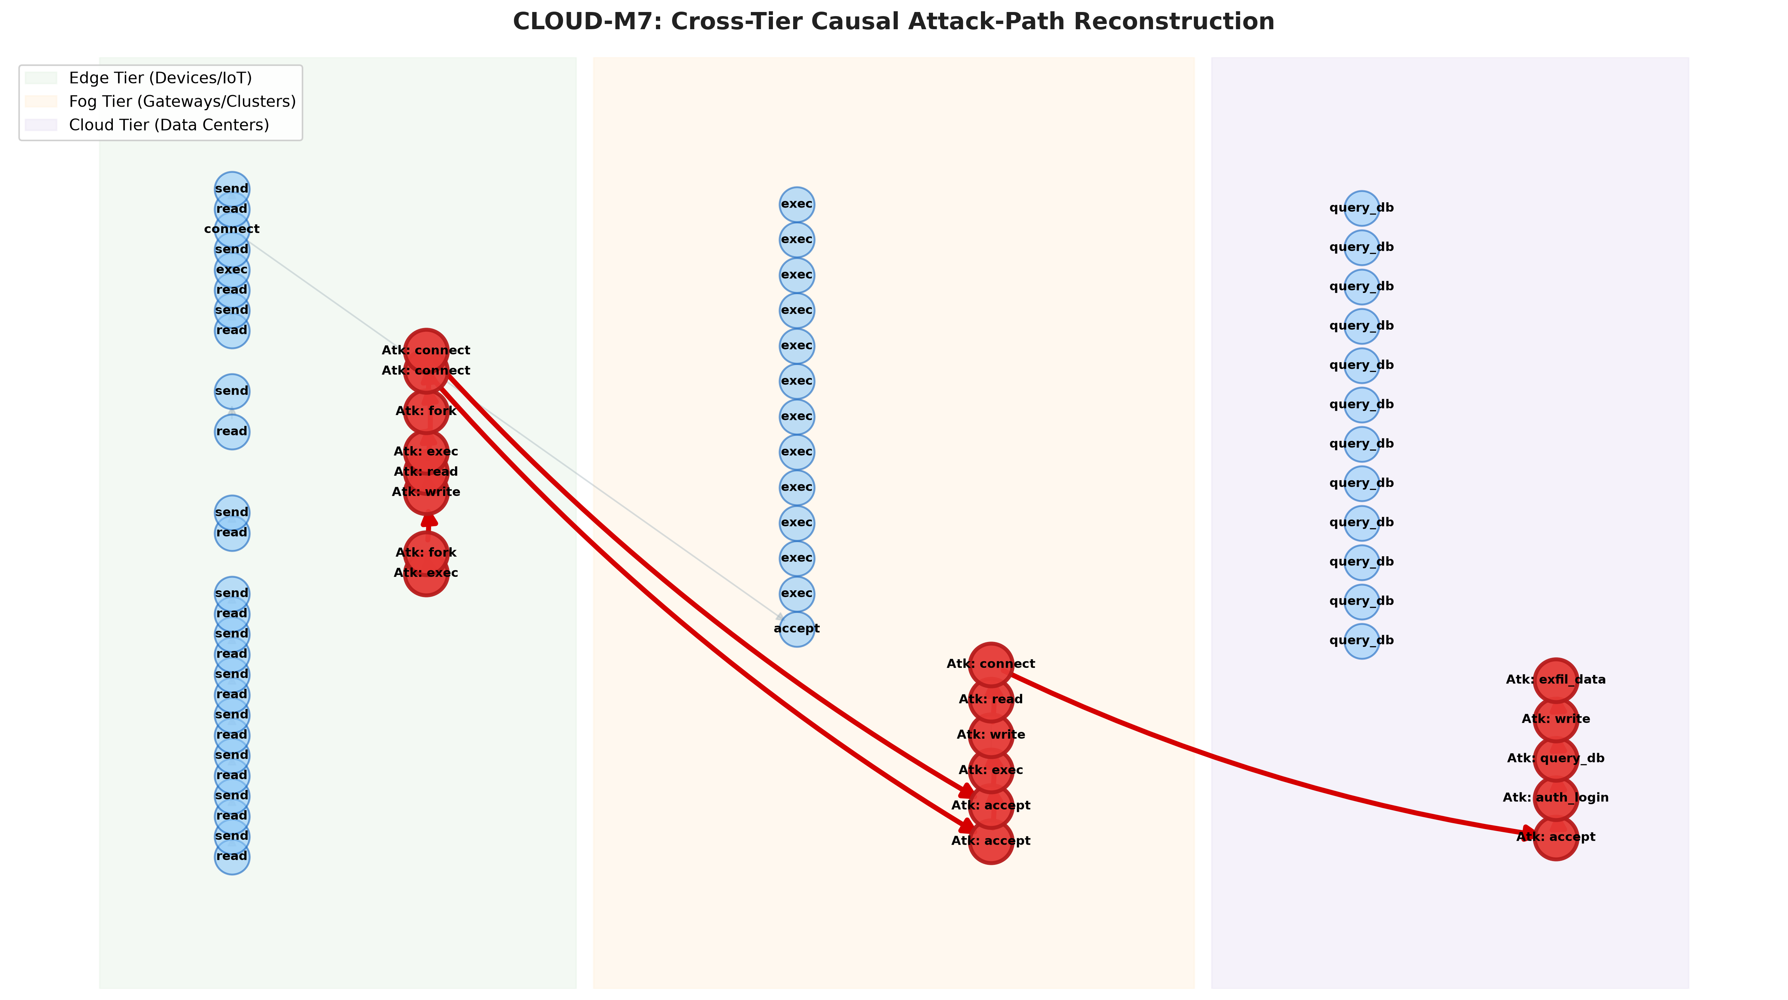
Figure 1: Cross-Tier 14-hop causal attack reconstruction across Edge (Green), Fog (Orange), and Cloud (Purple) with 80% background noise pruned away.

Figure 2: Multi-Sensor Convergent Choke-Point Graph
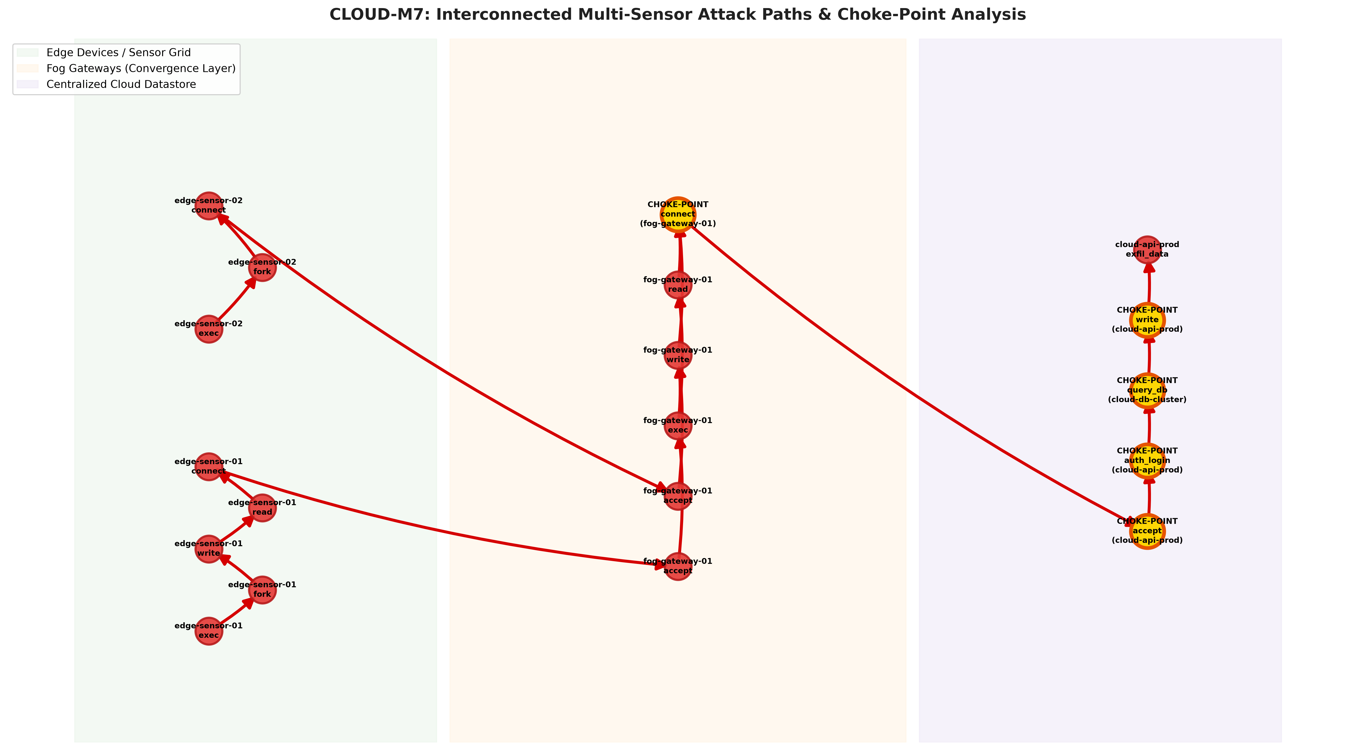
Figure 2: Interconnected multi-sensor paths converging from Edge devices to Cloud. Bright gold nodes identify articulation cut choke-points providing 100% containment efficiency.

6. Detailed Blueprint for Real-World Datasets in Future Review Plans
A critical question frequently asked by capstone evaluation committees is: 'How does your framework transition from synthetic ground-truth simulation to large-scale real-world cyber benchmark datasets?' For Review 1 (Phase-I Semester 5), controlled ground truth was mathematically necessary to verify 100% path recall and 0% false positive stitching. For subsequent reviews, CLOUD-M7 has an explicit architectural ingestion plan incorporating four premier benchmark datasets:

6.1 DARPA OpTC (Operational Transparent Computing)
• Background & Scope:
DARPA OpTC is an enterprise-scale security dataset containing over 500 GB of host-based audit logs collected from hundreds of Windows and Linux endpoints over a continuous multi-week evaluation. It features sophisticated red-team cyberattack campaigns (lateral movement, PowerShell staging, privilege escalation, credential dumping, and exfiltration).
• Data Representation:
Logs are structured as JSON/Avro events conforming to the Common Event Format (CEF) and CAR (Cyber Analytics Repository) models. Events include Process creation/termination, File system read/write, Socket connections, and Windows Registry alterations.
• Integration into CLOUD-M7 (Phase-I Review 2):
We will build an automated ingestion adapter (cloud_m7.adapters.optc) that parses OpTC records into our tuple E_i:
- OpTC PROCESS_CREATE -> E_i [Type=Process, Action=exec, Payload={pid, ppid, cmd}]
- OpTC FILE_WRITE -> E_i [Type=File, Action=write, Payload={path, fd}]
- OpTC NETWORK_FLOW -> E_i [Type=Socket, Action=connect/accept, Payload=5-tuple]
OpTC logs will populate the Cloud and Enterprise Tier workloads, providing real-world APT red-team ground truth.

6.2 DARPA TC (Transparent Computing — Cadets, THEIA, TRACE)
• Background & Scope:
The DARPA Transparent Computing program generated high-fidelity operating system provenance datasets across Linux, FreeBSD, and Android hosts. It features benchmark research teams: Cadets (FreeBSD DTrace/Audit), THEIA (Linux low-overhead syscalls), and TRACE. Attacks include Bovia drive-by downloads, Firefox backdoors, Shellshock lateral pivots, and SSH password sprays.
• Provenance Graph Nature:
Unlike flat log files, DARPA TC is natively modeled as a provenance graph conforming to the CDM (Common Data Model) format, making it the gold standard for evaluating causal graph reduction and forward/backward traversal algorithms.
• Integration into CLOUD-M7 (Phase-I Review 2):
We will map DARPA CDM node and edge schemas directly to NetworkX DiGraphs in CLOUD-M7. We will use DARPA TC to benchmark our GraphReduction algorithm against CamQuery, proving that our local reduction maintains 100% causal completeness with zero loss of forensic evidence.

6.3 TON_IoT (UNSW Canberra Cyber)
• Background & Scope:
Created by the Cyber Range Lab at UNSW Canberra, TON_IoT is a premier heterogeneous cybersecurity dataset capturing telemetry from realistic Industrial IoT (IIoT) sensors: temperature, pressure, humidity, motion, light, and smart meters. It includes telemetry protocols (MQTT, Modbus, HTTP) and real cyberattacks: DoS, DDoS, Ransomware, Backdoors, and Injection.
• Why It Fits the Edge & Fog Tiers:
Existing datasets (like DARPA OpTC) focus on Windows desktops. TON_IoT provides the authentic IoT sensor readings and MQTT publisher/broker logs that perfectly model our Edge Tier (edge-sensor-01, 02) and Fog Gateway (fog-gateway-01).
• Integration into CLOUD-M7 (Phase-I Review 2 & Phase-II Review 3):
TON_IoT sensor telemetry will feed the Edge Tier, demonstrating our in-memory privacy filtering and repetitive loop reduction on authentic IoT sensor traffic under active cyberattacks.

6.4 Aposemat IoT-23 & CIC-IoT2023
• Background & Scope:
IoT-23 is a dataset of network traffic from real malware infections executed on physical IoT devices (Raspberry Pis), curated by the Stratosphere Laboratory (Czech Technical University). It contains 20 real IoT malware captures (Mirai, Torii, Gafgyt, Kenjiro, Hakai) alongside 3 benign captures.
• Synthesis into Multi-Tier Pipeline:
We will inject real Mirai botnet C2 communication PCAPs into our Fog Gateway socket stream to evaluate choke-point containment under real IoT malware traffic.

6.5 Multi-Tier Hybrid Dataset Synthesis Architecture (Review 2 Execution)
How CLOUD-M7 will unify these datasets into an end-to-end multi-tier pipeline:
[EDGE TIER] [FOG TIER] [CLOUD TIER]
TON_IoT Sensors & Regional Gateway & DARPA OpTC & TC
IoT-23 Malware Pkts ──► MQTT/Kafka Broker ──► Enterprise Cloud Endpoints
(Real Sensor Ingress) (Socket Correlation) (Database & C2 Exfiltration)
By fusing TON_IoT at the Edge with DARPA OpTC in the Cloud via real socket 5-tuple correlation, CLOUD-M7 will be the first academic framework to evaluate whole-system distributed provenance on authentic multi-tier benchmark data.

7. 2-Year Capstone Project Roadmap & Panel Defense Guide
Phase & Semester | Review Stage | Core Technical Deliverables | Individual Effort
Phase-I: Sem 5  (Aug - Oct 2026) | Review 1  [COMPLETED] | Unified Schema E_i, SHA-256 Hashing, Placement Optimization, Iterative Loop & Choke Points, 13 Pytests, GitHub Sync. | Dharshini (100%)  Architecture & Core Engine
Phase-I: Sem 6  (Jan - Apr 2027) | Review 2  [PLANNED] | Ingestion of DARPA OpTC & TON_IoT datasets, Docker multi-tier testbed, Linux kernel eBPF live syscall probes. | Dharshini (100%)  eBPF & Ingestion Pipeline
Phase-II: Sem 7  (Aug - Nov 2027) | Review 3  [PLANNED] | Deep Reinforcement Learning (PPO/DQN) placement agent for dynamic adaptation, Graph Neural Networks (GNN) path scorer. | Dharshini (100%)  RL Agent & ML Pipeline
Phase-II: Sem 8  (Jan - May 2028) | Final Defense  [PLANNED] | Physical hardware deployment (Raspberry Pi 4 + NVIDIA Jetson + AWS), Web SOC Dashboard, IEEE conference paper submission. | Dharshini (100%)  Hardware & Manuscript

