Create a new React Application with the name “myfirstreact”, Run the application to print “welcome to the first session of React” as heading of that page.
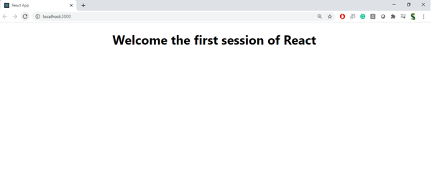
Create a react app for Student Management Portal named StudentApp and create a component named Home which will display the Message “Welcome to the Home page of Student Management Portal”. Create another component named About and display the Message “Welcome to the About page of the Student Management Portal”. Create a third component named Contact and display the Message “Welcome to the Contact page of the Student Management Portal”. Call all the three components.
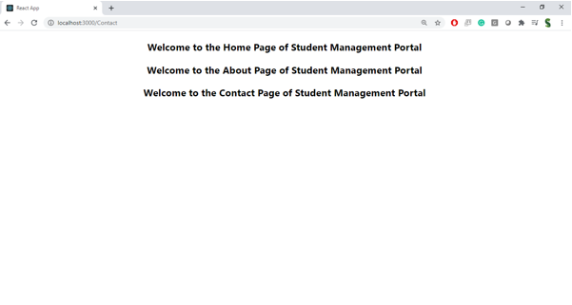Create a react app for Student Management Portal named scorecalculatorapp and create a function component named “CalculateScore” which will accept Name, School, Total and goal in order to calculate the average score of a student and display the same.
- 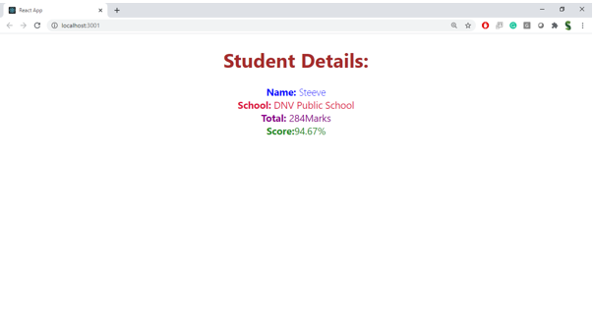Create a new react application using create-react-app tool with the name as “blogapp”
- Open the application using VS Code
- Create a new file named as Post.js in src folder with following properties

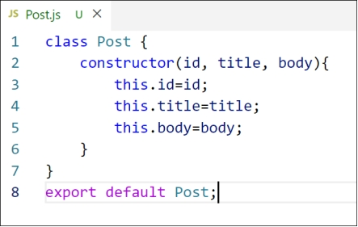
Figure 2: Post class
- Create a new class based component named as Posts inside Posts.js file
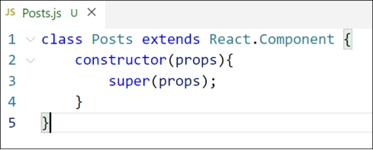
Figure 3: Posts Component
- Initialize the component with a list of Post in state of the component using the constructor
- Create a new method in component with the name as loadPosts() which will be responsible for using Fetch API and assign it to the component state created earlier. To get the posts use the url (https://jsonplaceholder.typicode.com/posts)

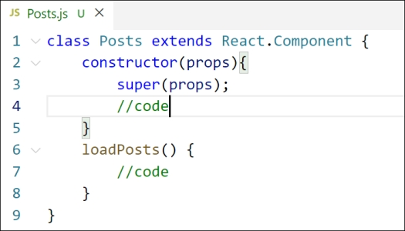
Figure 4: loadPosts() method
- Implement the componentDidMount() hook to make calls to loadPosts() which will fetch the posts

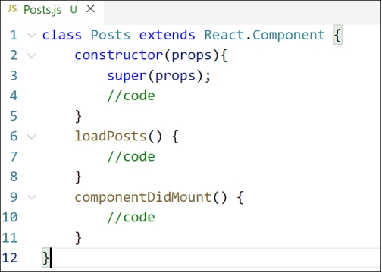
Figure 5: componentDidMount() hook
- Implement the render() which will display the title and post of posts in html page using heading and paragraphs respectively.

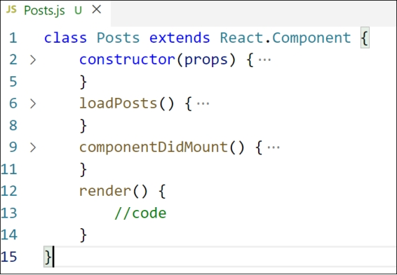
Figure 6: render() method
- Define a componentDidCatch() method which will be responsible for displaying any error happing in the component as alert messages.

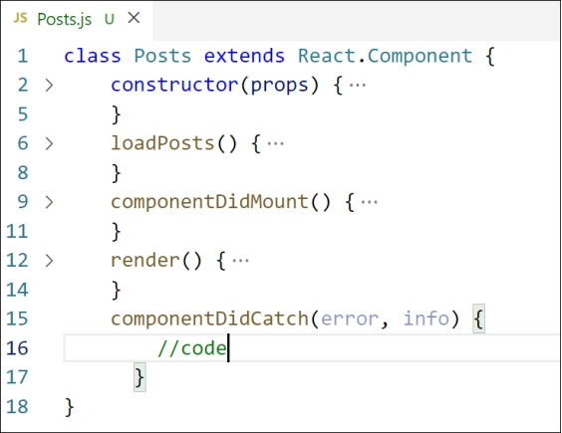
Figure 7: componentDidCatch() hook
- Add the Posts component to App component.
- Build and Run the application using npm start command.

My Academy team at Cognizant want to create a dashboard containing the details of ongoing and completed cohorts. A react application is created which displays the detail of the cohorts using react component. You are assigned the task of styling these react components. 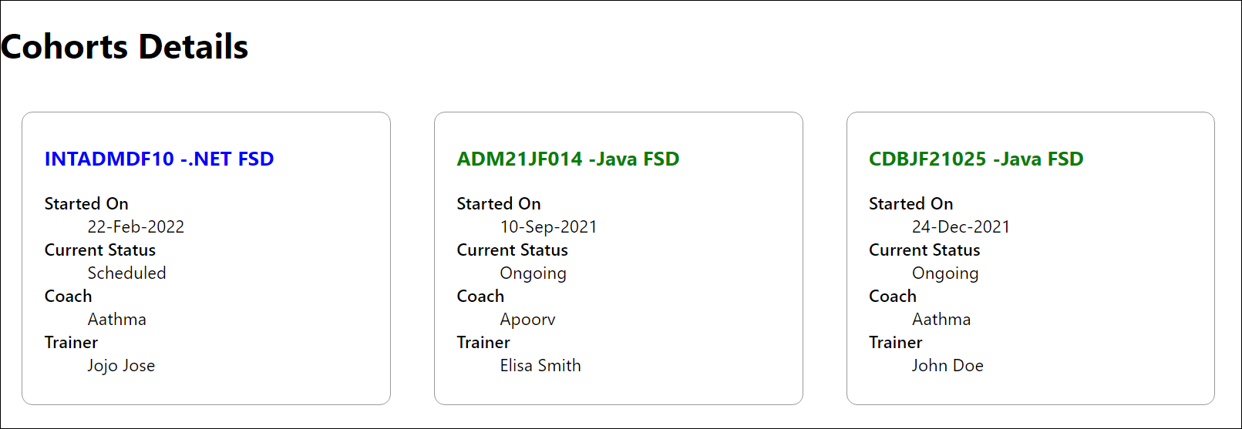Cognizant Academy teams want to maintain a list of trainers along with their expertise in a SPA using React as the technology. You are assigned the task of creating this React app.
The following trainers’ data application will deal.
- T-ID
- Name
- Phone
- Email
- Stream
- Skills
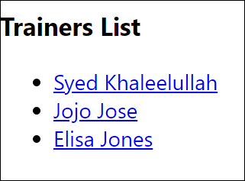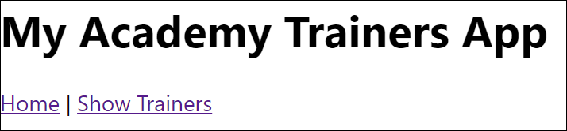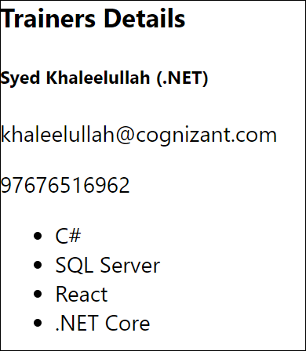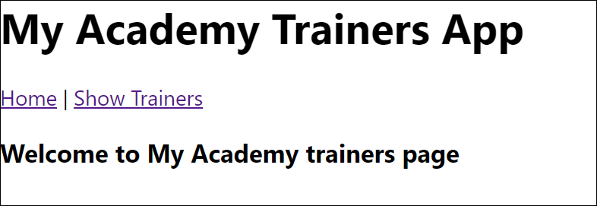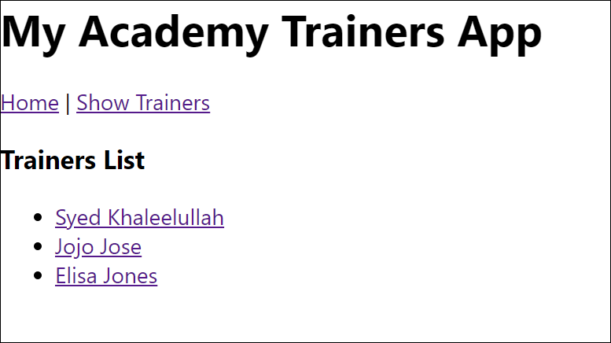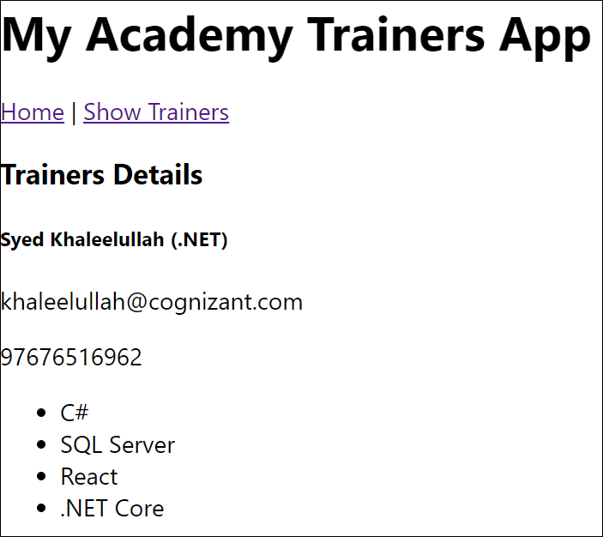
reate a React Application named “shoppingapp” with a class component named “OnlineShopping” and “Cart”.
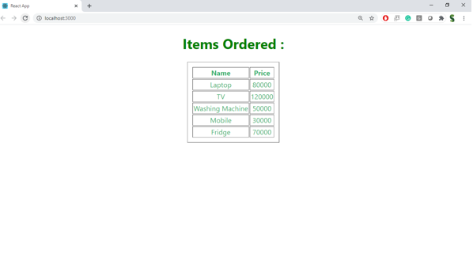Create a React App “counterapp” which will have a component named “CountPeople” which will have 2 methods.

UpdateEntry() à which will display the number of people who entered the mall.
UpdateExit() à which will display the number of people who exited the mall.
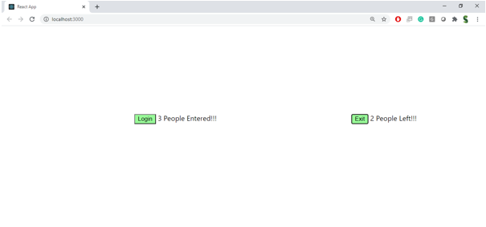Create a React Application named “cricketapp” with the following components:
- ListofPlayers
- IndianPlayers

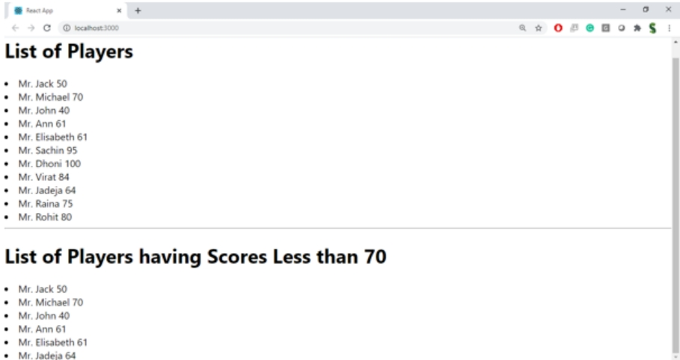

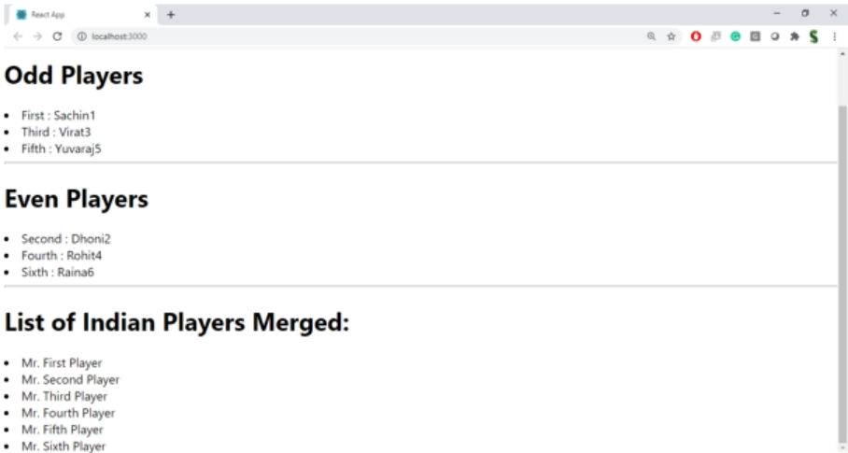Create a React Application named “officespacerentalapp” which uses React JSX to create elements, attributes and renders DOM to display the page.

Create an element to display the heading of the page.
Attribute to display the image of the office space
Create an object of office to display the details like Name, Rent and Address.
Create a list of Object and loop through the office space item to display more data.
To apply Css, Display the color of the Rent in Red if it’s below 60000 and in Green if it’s above 60000.
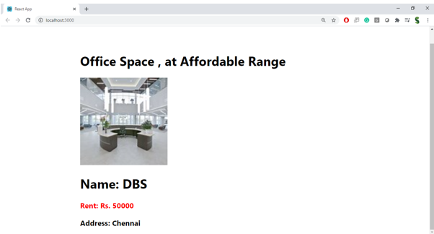
Create a React Application “eventexamplesapp” to handle various events of the form elements in HTML.

- Create “Increment” button to increase the value of the counter and “Decrement” button to decrease the value of the counter. The “Increase” button should invoke multiple methods.
  - To increment the value
  - Say Hello followed by a static message.
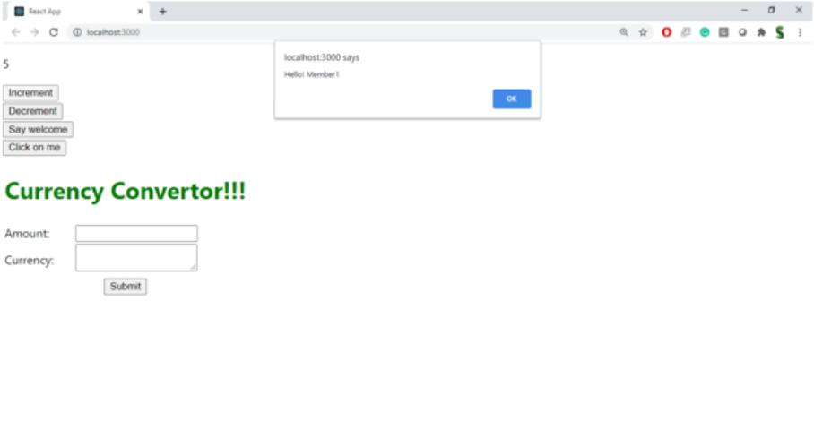

- Create a button “Say Welcome” which invokes the function which takes “welcome” as an argument.

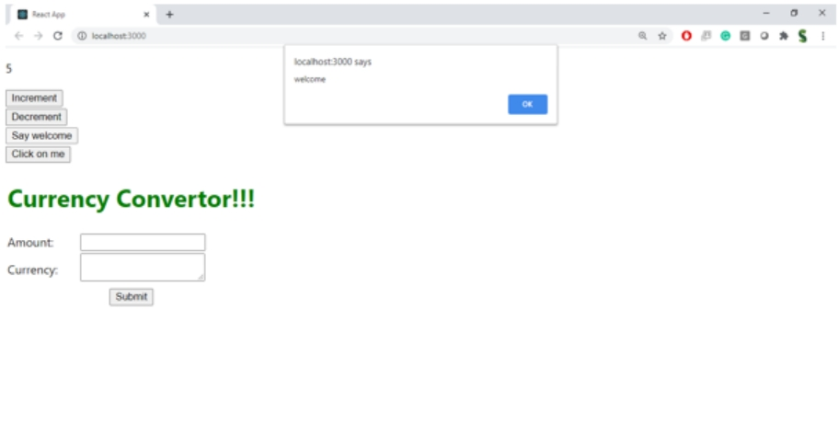

- Create a button which invokes synthetic event “OnPress” which display “I was clicked”

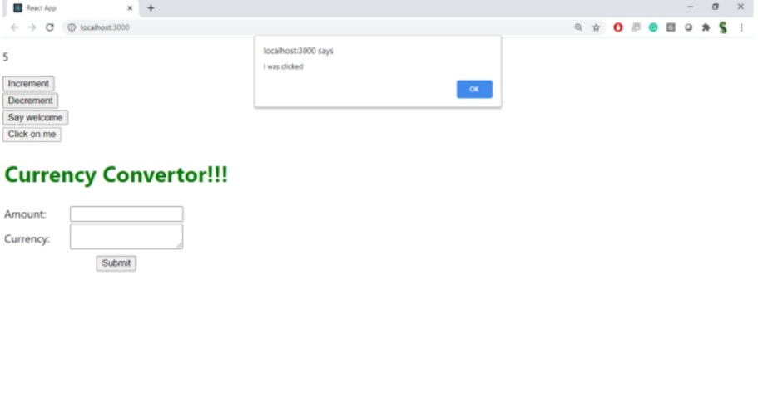

Create a “CurrencyConvertor” component which will convert the Indian Rupees to Euro when the Convert button is clicked.

Handle the Click event of the button to invoke the handleSubmit event and handle the conversion of the euro to rupees.

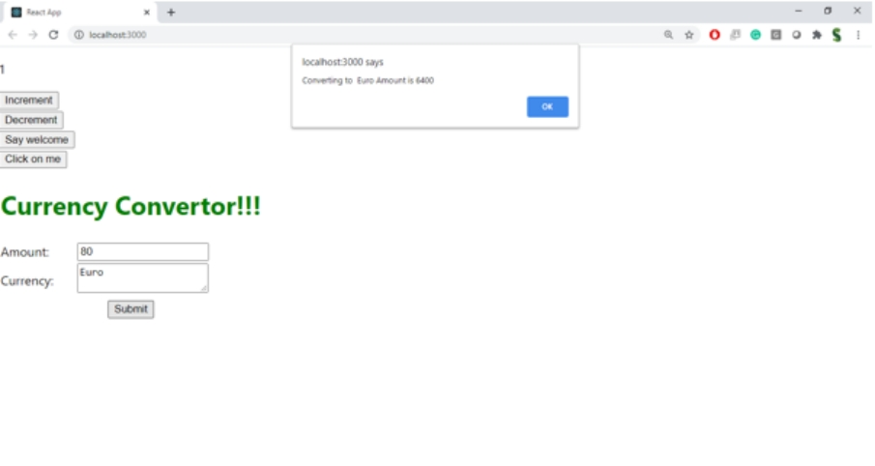

Create a React Application named “ticketbookingapp” where the guest user can browse the page where the flight details are displayed whereas the logged in user only can book tickets.

The Login and Logout buttons should accordingly display different pages. Once the user is logged in the User page should be displayed. When the user clicks on Logout, the Guest page should be displayed.

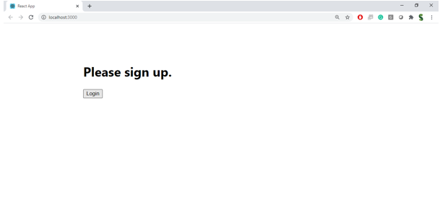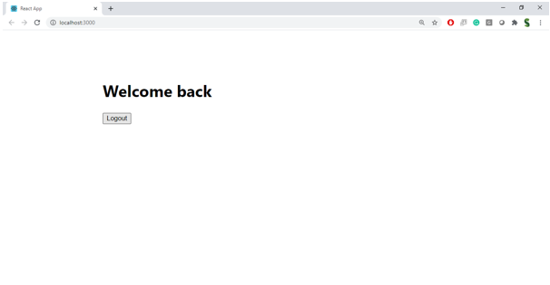
Create a React App named “bloggerapp” in with 3 components.

- Book Details
- Blog Details
- Course Details

Implement this with as many ways possible of Conditional Rendering.

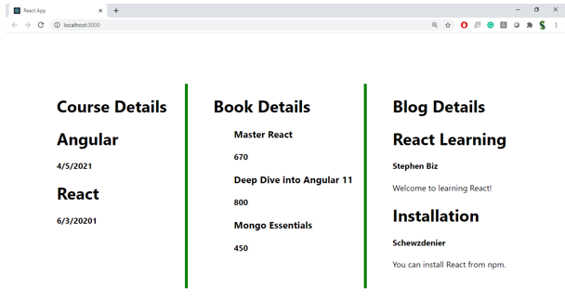
Create a React App named “ticketraisingapp” which will help to raise a complaint and get it resolved.

Create a component named “ComplaintRegister” with a form containing a textbox to enter the employee name and a textarea to enter the complaint. Use “handleSubmit” event of the button to submit the complaint and generate a Reference number for further follow ups in the alert box.

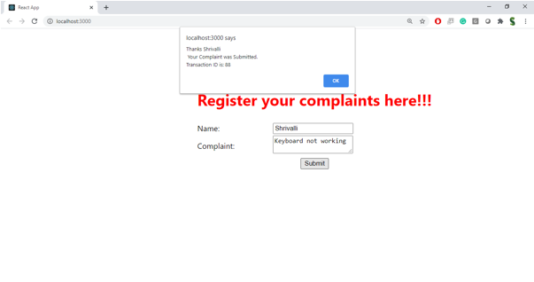Create a React App named “mailregisterapp” which will have a component named “register.js”. Create a form which accepts the name, email and password and validate the fields as per the following:

- Name should have atleast 5 characters
- Email should have @ and .
- Password should have atleast 8 characters.

Ensure that validations are implemented through eventhandle and eventsubmit of a form. 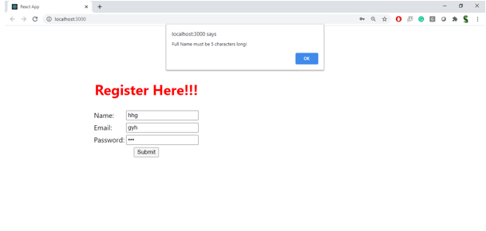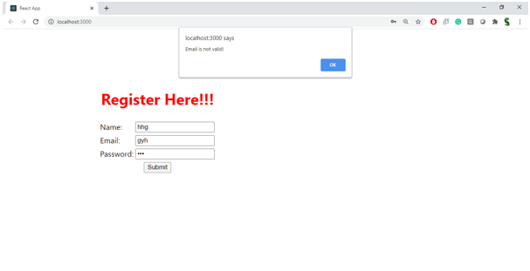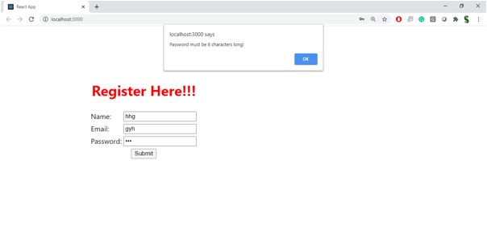Estimated time to complete this lab: 60 minutes.
Create a React Application “fetchuserapp” which will retrieve the user details from https://api.randomuser.me/ and display the title, firstname and image of a user.
Create a component named “Getuser” and in the asynchronous method “ComponentDidMount ()” invoke the URL using fetch method and the response can be displayed in the render method of the component.
