**Task 1: Linux Essentials & File Permissions**

**Goal:** Demonstrate basic file management and permission handling.

**What I did:**

* Created test files in /home/studentuser/projectX/
* Used chmod, chown, and ls -l to adjust and verify permissions.
* Faced and resolved Permission denied issues using sudo and proper file ownership.

**Learning:** Understanding Linux permissions is essential for security. Properly managing rwx rights avoids unauthorized access and maintains file integrity.

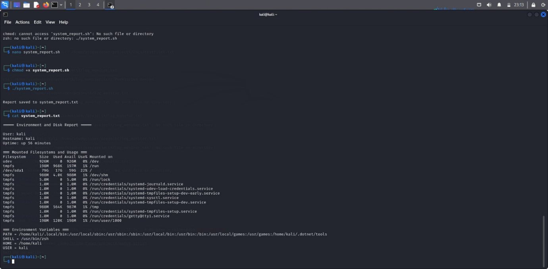

**Task 2: Networking Toolkit PoC**

**Goal:** Use basic networking commands to analyze system connectivity.

**Tools used:** ping, traceroute, ifconfig, ip a, netstat, ss

**What I did:**

* Checked live IP status with ping
* Used netstat and ss to list open ports
* Inspected the routing table using route -n

**Learning:** These tools are crucial for diagnosing network issues. I understood how to trace routes, check connectivity, and find listening services.

**Mini Server Monitor Script**

**Goal:** Create a script to monitor system health.

**Script actions:**

* Captured CPU and RAM usage
* Monitored disk space
* Logged results to a file with timestamps

**Task 4: File Watcher Script**

**Goal:** Watch a directory and log changes.

**What I did:**

* Used inotifywait in a loop to monitor /home/studentuser/projectX/logs
* Logged file create, modify, and delete events

**Learning:** Real-time file monitoring is vital for detecting tampering or unauthorized file changes. This task introduced the concept of reactive scripting.

**Task 5: SSH Login Audit**

**Goal:** Parse SSH login activity from /var/log/auth.log.

**Script output:**

* Successful logins
* Failed login attempts
* IP addresses involved

**Task 6: Crontab Practice**

**Goal:** Automate a task using cron.

**What I did:**

* Wrote a cron job to back up files every hour
* Used crontab -e to schedule the job
* Verified execution with log timestamps

**Learning:** Cron is a powerful automation tool for periodic tasks like backups, cleanups, or reports. I also learned how to redirect cron output to log files for debugging.

**Task 7: Port Scanner Script**

**Goal:** Scan ports 20-25 on a given IP.

**Used tools:** nc, timeout

Command:

timeout 1 nc -zv 192.168.1.1 22

Script program:

Scanning ports 20 to 25 on 192.168.1.1...

Port 22 is OPEN

All other ports are CLOSED

**Task 8: Website Availability Checker**

**Goal:** Check which websites are up from a list (sites.txt).

**Approach:**

* Used curl -Is <url> | head -n 1 to check HTTP status
* Logged results to site_status.log

**Task 9: Environment and Disk Report**

**Goal:** Generate a system info report.

**Report contents:**

* Current user: whoami
* Hostname: hostname
* Uptime: uptime
* Filesystems: df -h
* Environment: echo $PATH, echo $SHELL

**Task 10: Compress & Archive Automation**

**Goal:** Find and compress .log files >10MB in /home/studentuser/projectX/logs.

**Process:**

* Used find with -size +10M
* Archived matching files into archive_YYYYMMDD.tar.gz
* Moved archive to backup/ folder

**Learning:** This is useful for log rotation and cleanup. Regularly compressing and archiving large logs saves disk space and improves performance.

