Week 2 Exploratory Data Analysis and Visualization Report
Titanic Survival Prediction Dataset
Submitted by
Dharshini M
BTech Computer Science and Engineering Artificial Intelligence
Alliance University Bangalore
Yuvaintern Data Analytics Internship

1 Executive Summary
This report presents exploratory data analysis and visualization performed on the cleaned Titanic Survival Prediction dataset. The analysis examines passenger survival in relation to gender, passenger class, age, fare, embarkation port, title, and family size. The dataset contains 891 passenger records and 13 cleaned features. All retained columns have zero missing values, allowing comparisons without further imputation during the EDA stage.
The strongest pattern is the survival difference by gender and passenger class. The overall survival rate was 38.38%. Female passengers had a 74.20% survival rate, compared with 18.89% for male passengers. First-class passengers had the highest survival rate at 62.96%, while third-class passengers had the lowest at 24.24%. These findings indicate that gender and travel class were strongly associated with survival in this dataset.

2 Dataset and EDA Approach
Item | Details
Dataset | Titanic Survival Prediction cleaned dataset
Records | 891 passengers
Features used | 13 original cleaned variables plus AgeGroup
Target | Survived: 1 = survived, 0 = did not survive
Python libraries | Pandas, NumPy, Matplotlib, Seaborn
Source | Kaggle Titanic Machine Learning from Disaster

The Week 1 cleaning output was used as the input for this analysis. It already includes cleaned Age, Embarked, Deck, Title, FareLog, FamilySize, and IsAlone features. For this report, AgeGroup was created from Age so that survival outcomes could be compared across meaningful age intervals.
# Create age groups for comparison
df["AgeGroup"] = pd.cut(
df["Age"],
bins=[0, 12, 19, 35, 60, 100],
labels=["Child", "Teen", "Young Adult", "Adult", "Senior"],
include_lowest=True
)
# Calculate a survival-rate summary
class_summary = df.groupby("Pclass")["Survived"].mean() * 100
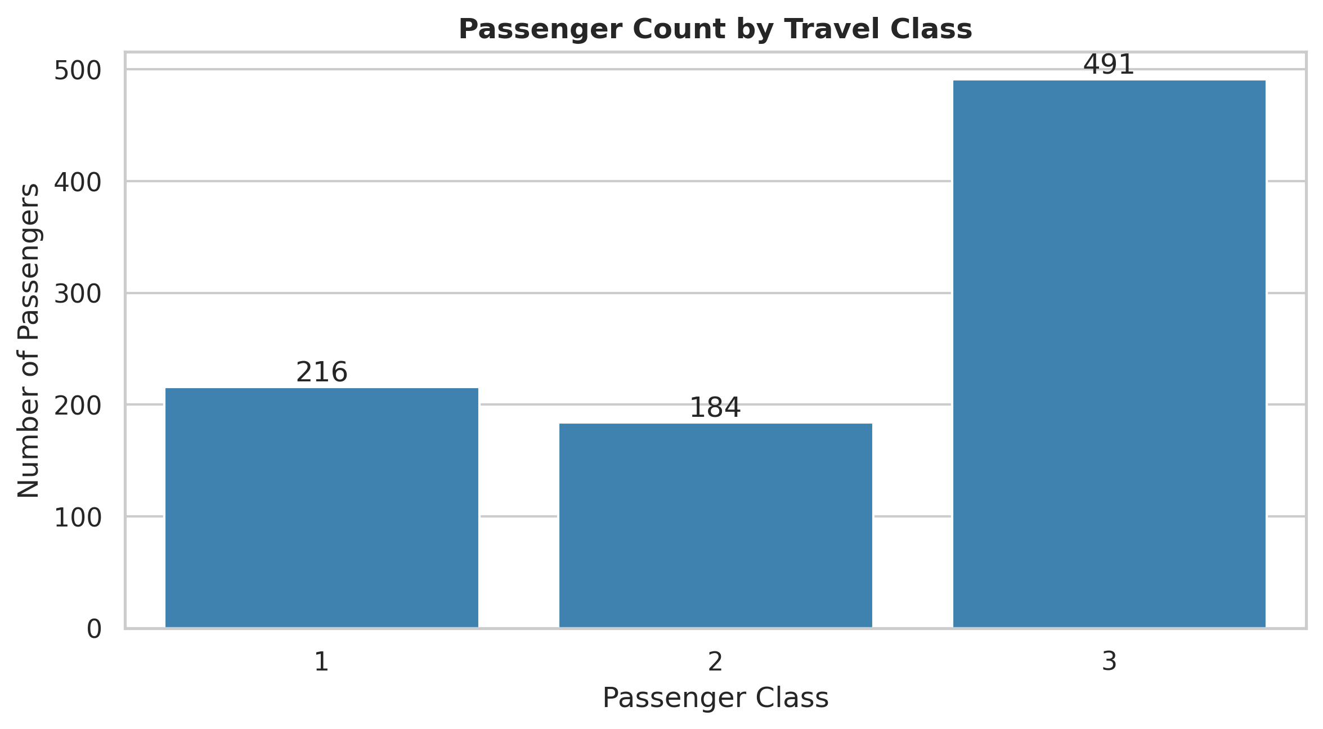
Figure 1: Passenger records by travel class. Third class contains 491 of the 891 passengers.

3 Initial Data Summary
Measure | Result | Interpretation
Missing values | 0 | All retained fields are complete after Week 1 preprocessing.
Duplicate rows | 107 | Repeated feature patterns may occur; the data was retained because duplicate rows can represent different passengers after identifier removal.
Mean age | 29.07 years | Most passengers were young adults or adults.
Median fare | 14.45 | Typical ticket price was much lower than the high-value fares.
Maximum fare | 512.33 | Shows a strongly right-skewed fare distribution.
Largest embarkation port | S: 646 passengers | Southampton accounts for most passenger records.

4 Survival Patterns
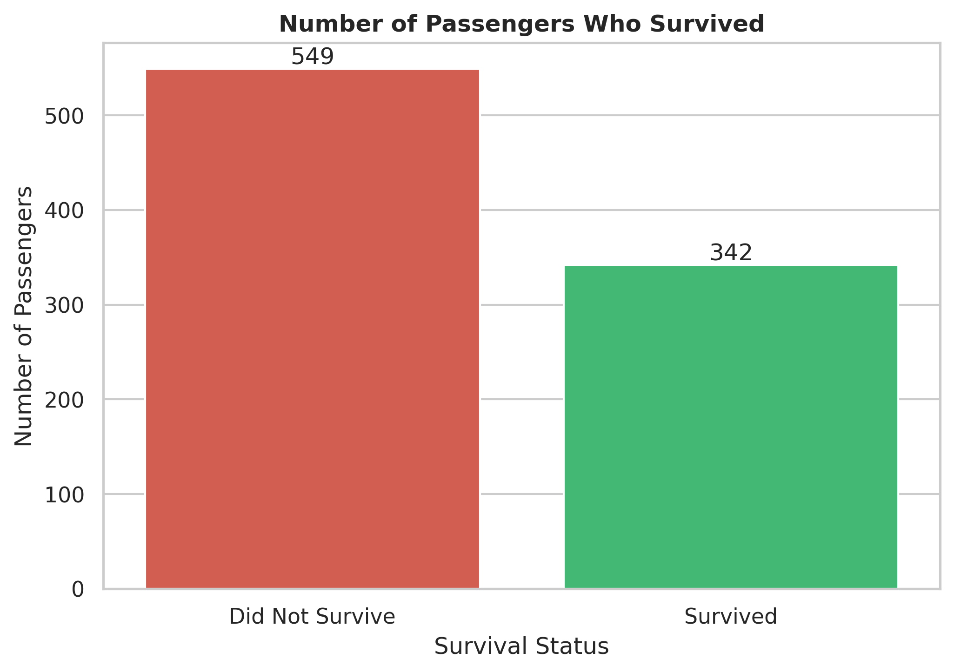
Figure 2: 342 passengers survived and 549 did not survive, giving an overall survival rate of 38.38%.
The count chart shows that non-survivors outnumber survivors. This makes survival an imbalanced but still usable target variable for descriptive analysis and later predictive modelling.
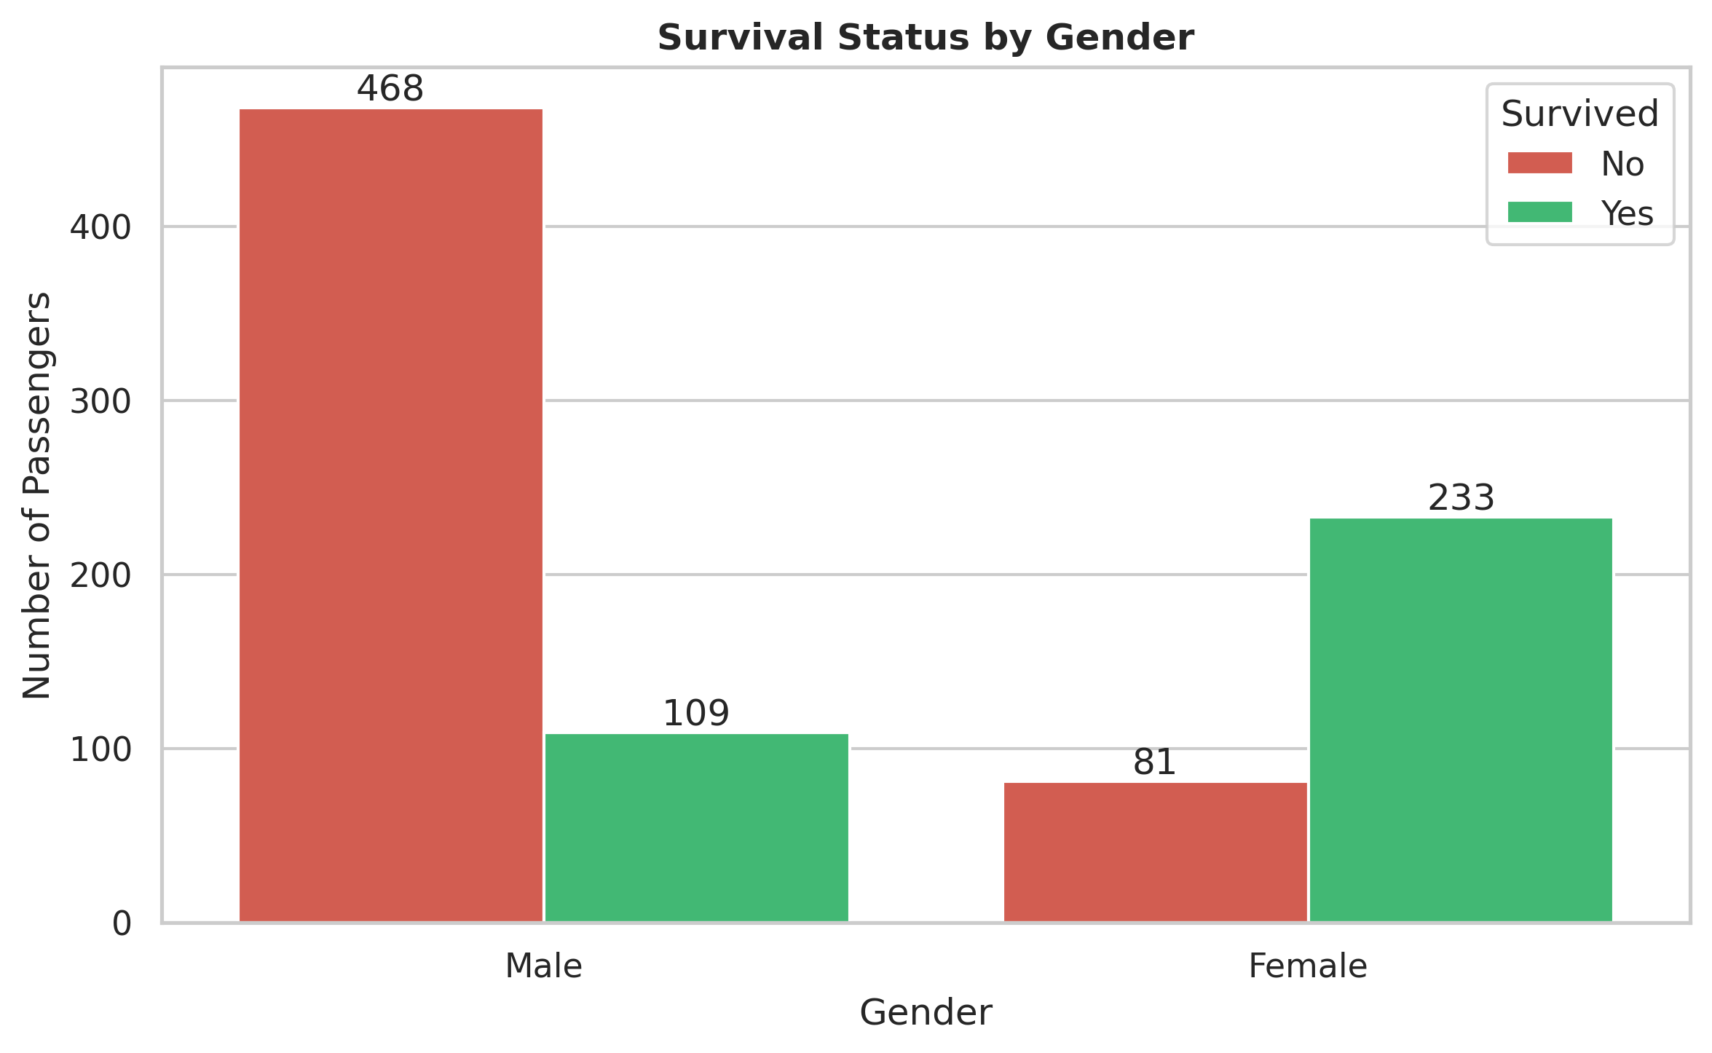
Figure 3: Female survival rate was 74.20%, compared with 18.89% for male passengers.
Gender is the clearest observed survival pattern. The large difference should be interpreted as an association in the historical passenger data, not as a causal claim from EDA alone.

5 Passenger Class and Age Findings
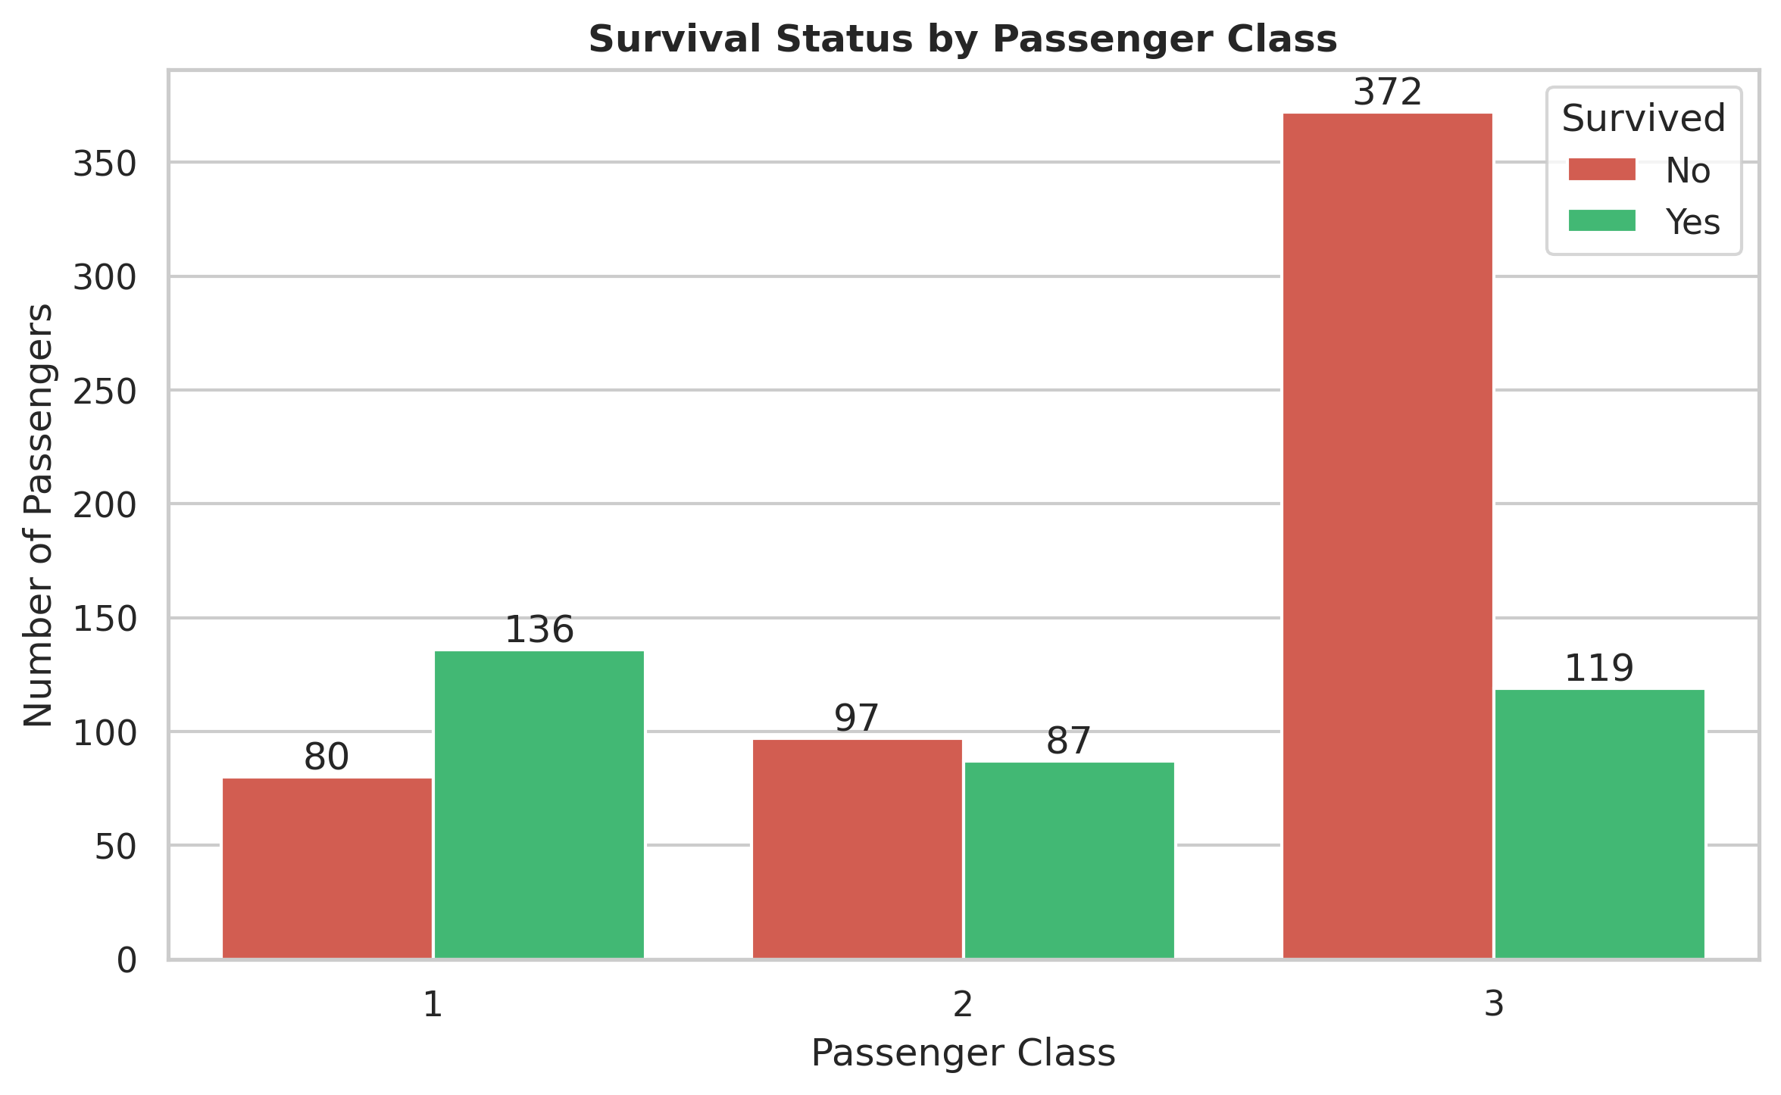
Figure 4: First class had a 62.96% survival rate, second class 47.28%, and third class 24.24%.
Survival decreases consistently from first to third class. This suggests that passenger class, which is also linked to ticket fare and location on the ship, was an important factor in the observed outcomes.
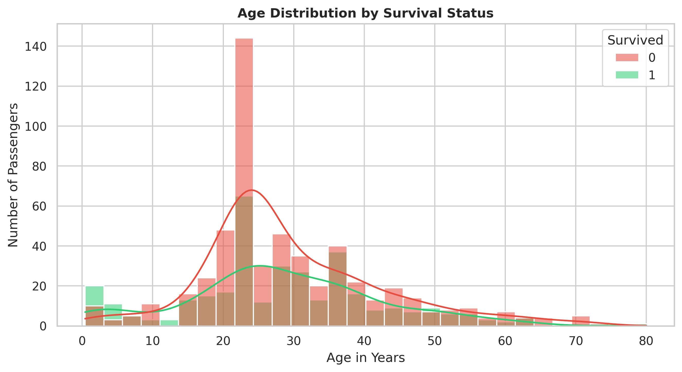
Figure 5: Age distribution by survival status. The analysis retains realistic child and senior observations rather than treating them as errors.
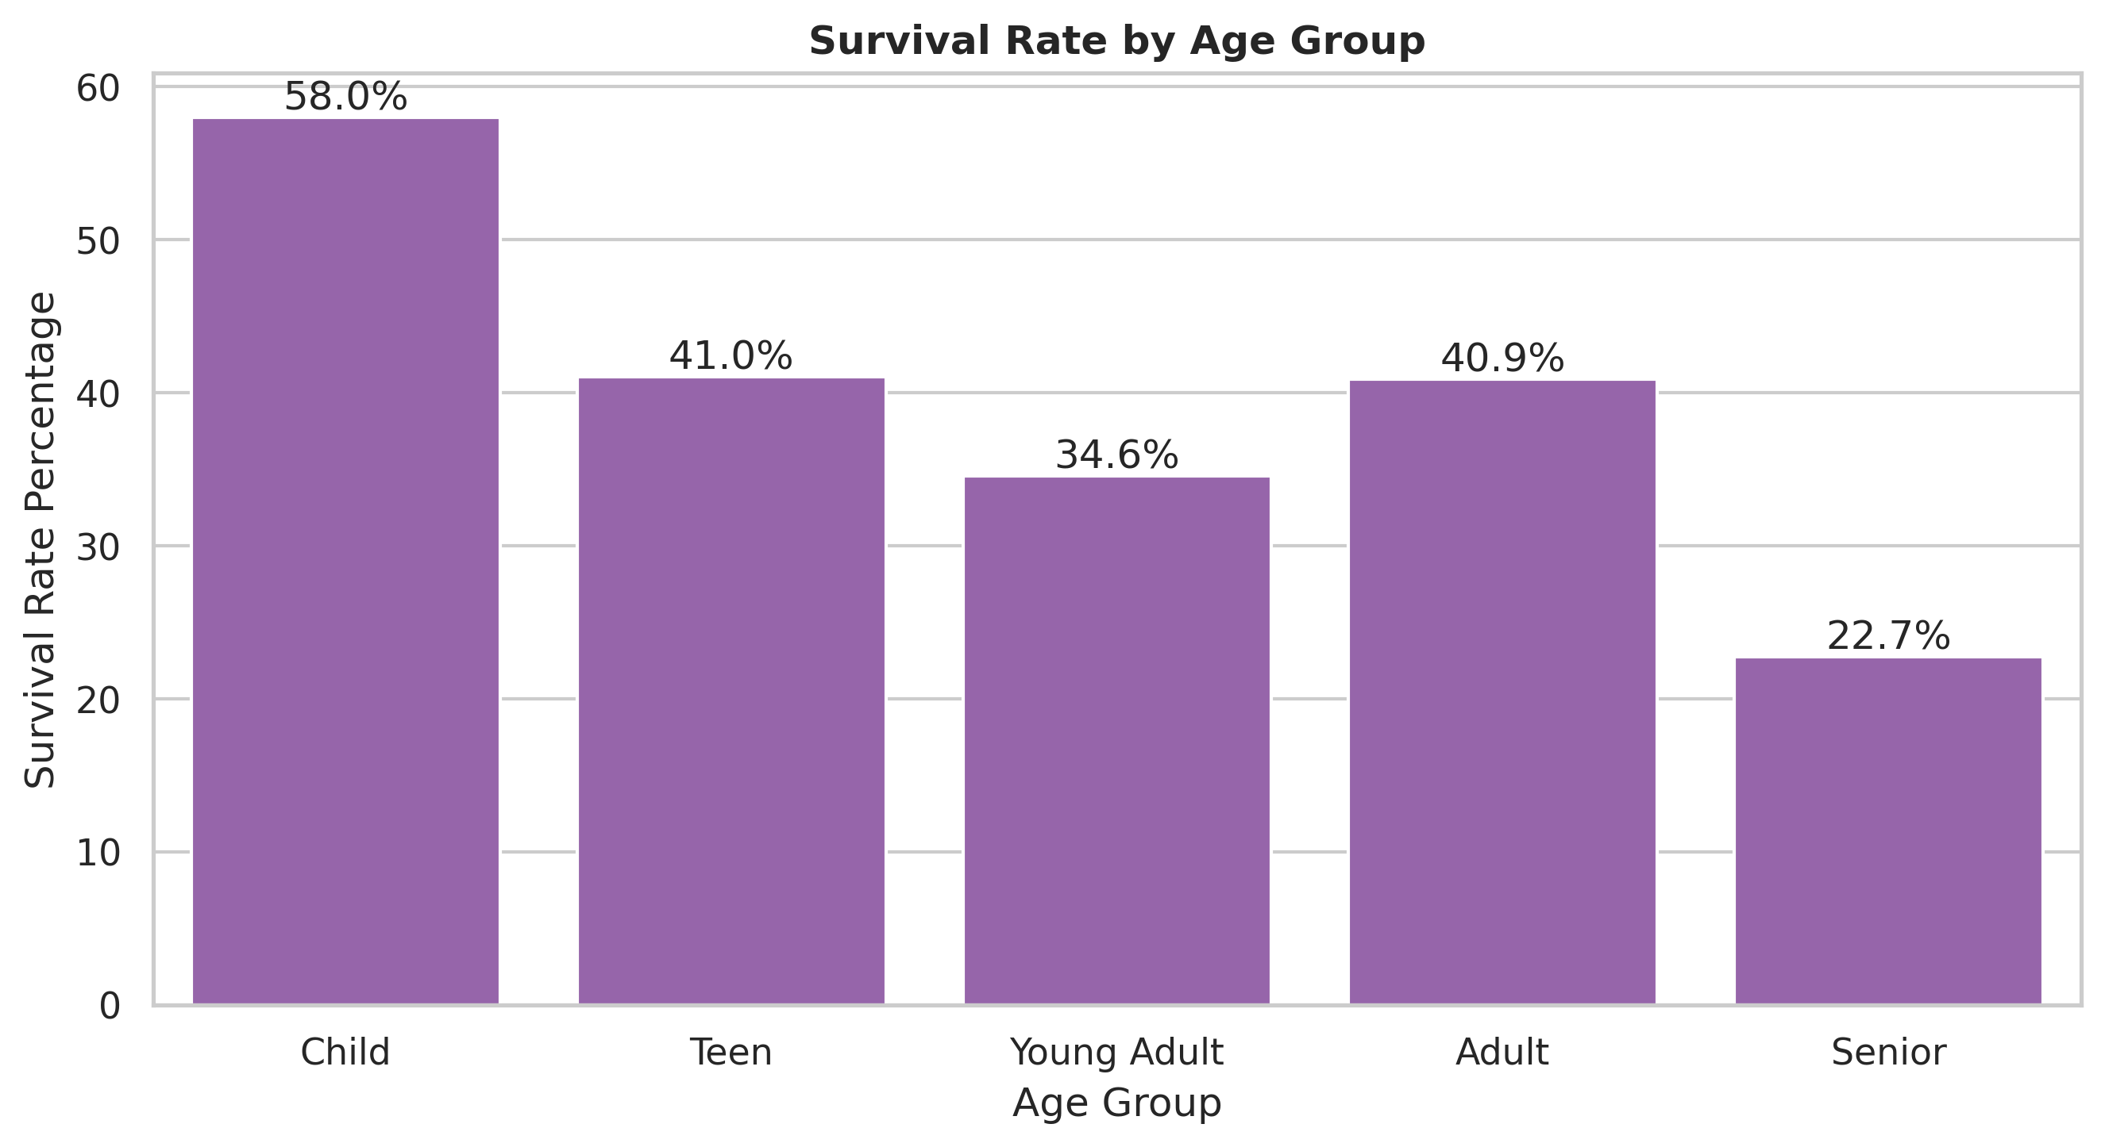
Figure 6: Children had the highest age-group survival rate at 57.97%; young adults formed the largest group with 480 passengers.

6 Fare and Embarkation Findings
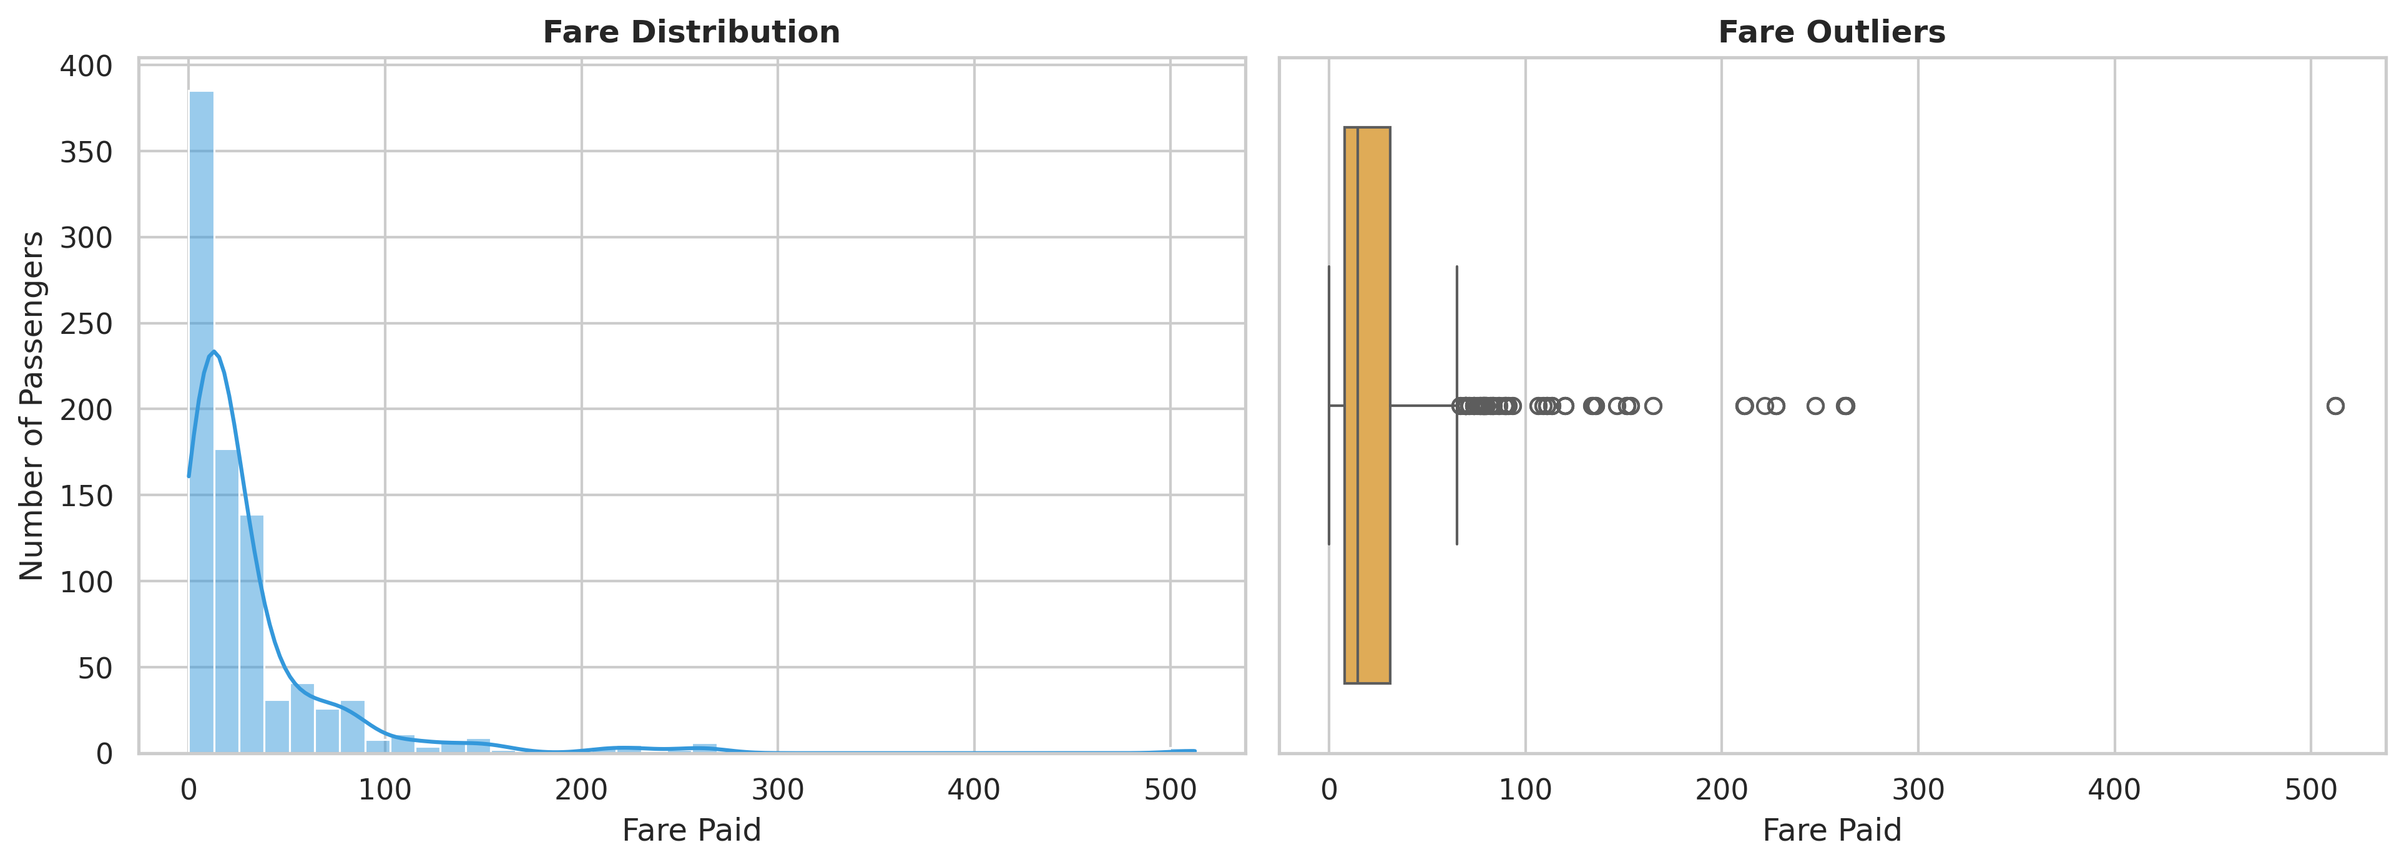
Figure 7: Fare is right-skewed; the median was 14.45 and the maximum was 512.33. High fares were retained as valid values.
The fare histogram and boxplot confirm that a small number of expensive tickets are far from the typical range. The values were not removed because they represent genuine first-class ticket prices. FareLog was created in Week 1 to reduce this skew for scale-sensitive analysis.
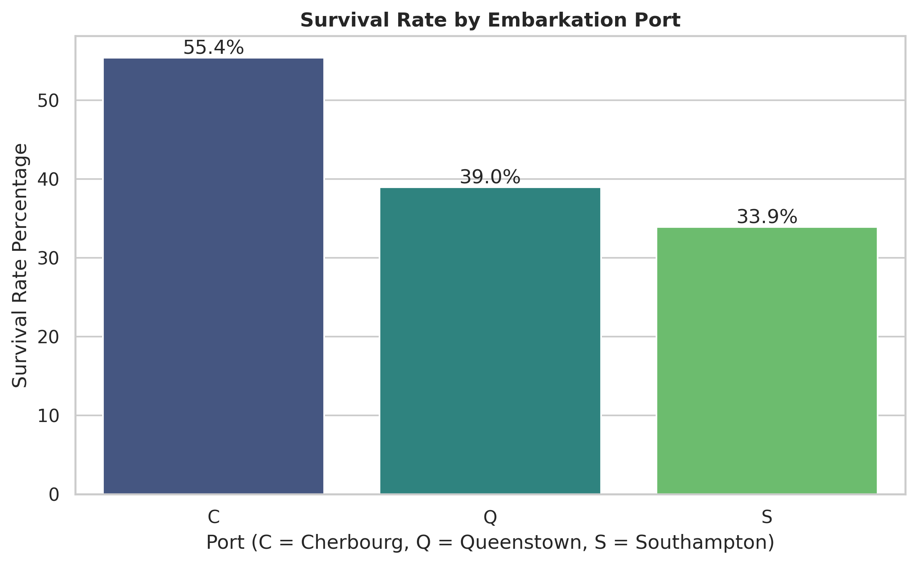
Figure 8: Cherbourg had the highest survival rate at 55.36%, followed by Queenstown at 38.96% and Southampton at 33.90%.
Embarkation port is associated with survival in this dataset. It may partly reflect the passenger-class composition at each port, so it should be studied alongside class and fare.

7 Family Size and Correlation
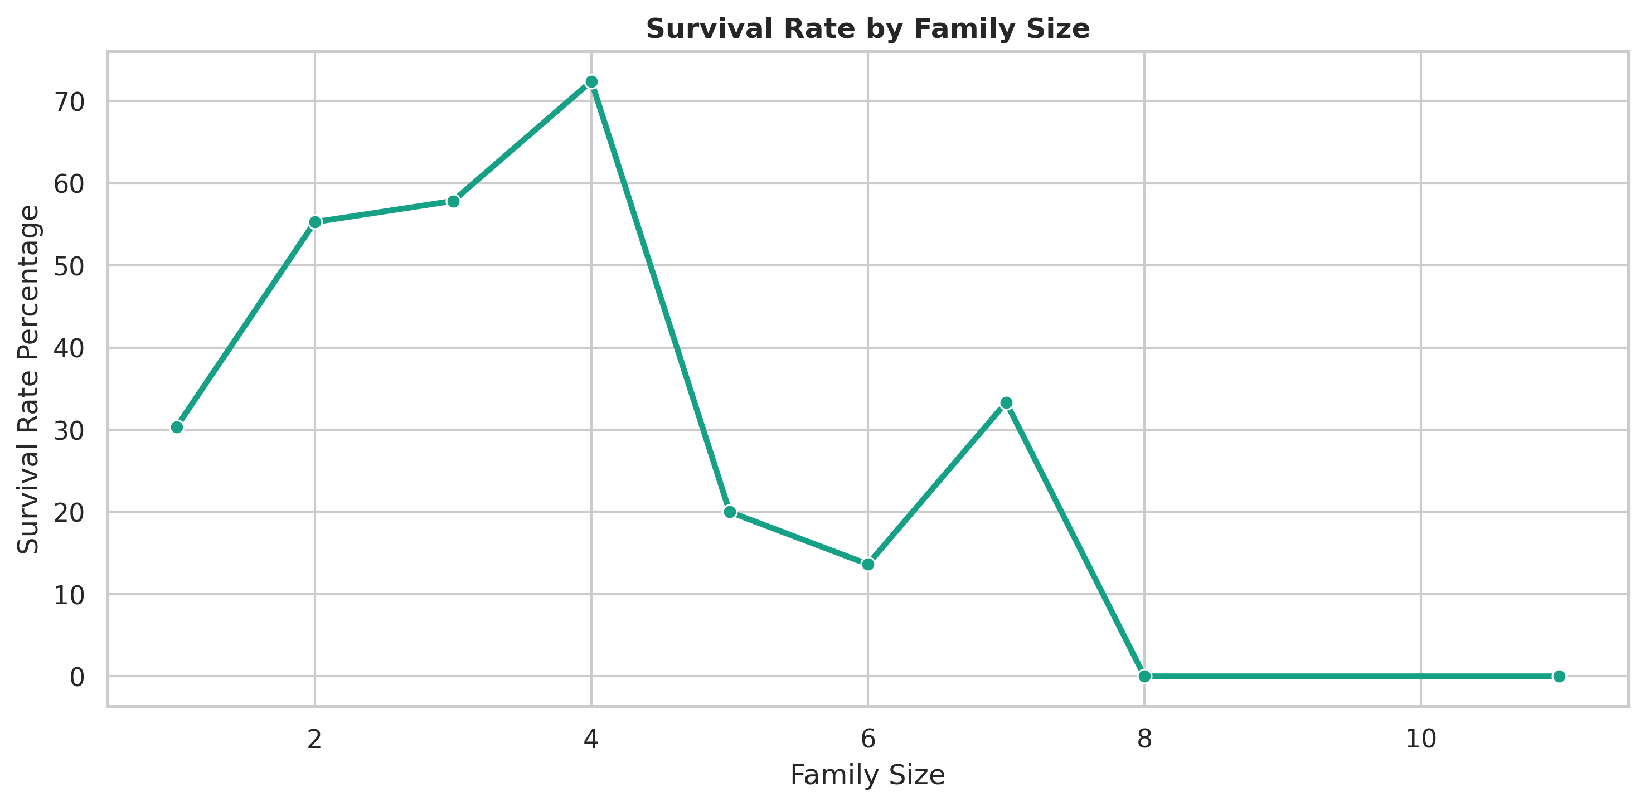
Figure 9: Survival varied by family size. Medium-size families performed better than passengers travelling alone or in very large groups.
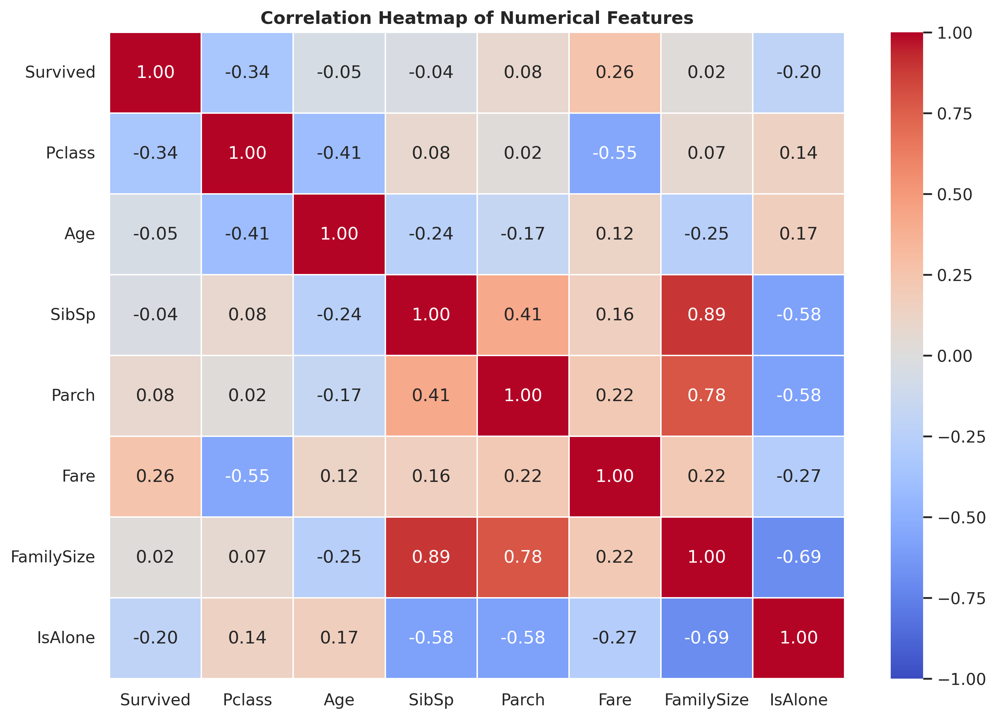
Figure 10: Correlation heatmap for numerical variables. Passenger class has a negative relationship with survival because class codes increase from first to third class.
The family-size chart shows that small and medium groups had better observed survival rates than very large groups. However, categories with very few passengers should be interpreted carefully because a small sample can produce extreme percentages.

8 Conclusion
The EDA reveals meaningful survival differences across gender, passenger class, fare, age group, embarkation port, and family size. The analysis is supported by labelled visualizations and calculated values rather than generic claims. The most useful features for a future survival-prediction model are likely Sex, Pclass, Fare or FareLog, Age, FamilySize, Embarked, Deck, and Title. The notebook used to create these visualizations is included in the GitHub repository for reproducibility.

References
Kaggle. Titanic Machine Learning from Disaster. Available at: https://www.kaggle.com/c/titanic/data
Python libraries used: Pandas, Matplotlib, and Seaborn.

