15. Perform transformation using Direct Linear Transformation.
AIM:- Transformation using Direct Linear Transformation.
PROGRAM:-
import cv2
import numpy as np
img = cv2.imread(r"C:\PROGRAM\Open CV\zara_003.png")
src = np.float32([
[0, 0],
[img.shape[1]-1, 0],
[0, img.shape[0]-1],
[img.shape[1]-1, img.shape[0]-1]])
dst = np.float32([
[50, 50],
[img.shape[1]-50, 50],
[50, img.shape[0]-50],
[img.shape[1]-50, img.shape[0]-50]])
H, _ = cv2.findHomography(src, dst)
result = cv2.warpPerspective(
img, H, (img.shape[1], img.shape[0]))
cv2.imshow("Original", img)
cv2.imshow("DLT Transformed", result)
cv2.imwrite("DLT_Transformed.jpg", result)
cv2.waitKey(0)
cv2.destroyAllWindows()
INPUT:-
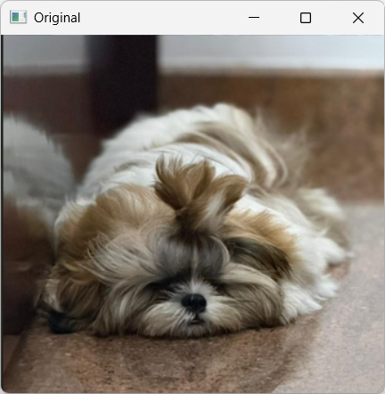
OUTPUT:-
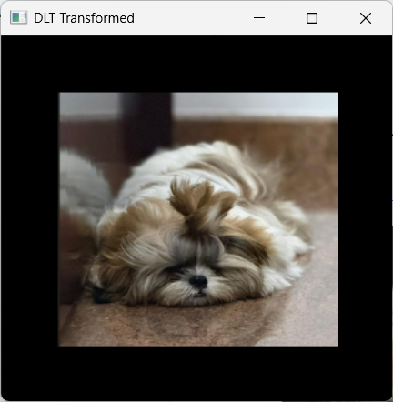
16. Perform Edge detection using canny method
AIM:- Edge detection using canny method
PROGRAM:-
import cv2
img = cv2.imread(r"C:\PROGRAM\Open CV\zara_003.png", 0)
edges = cv2.Canny(img, 100, 200)
cv2.imshow("Canny Edges", edges)
cv2.imwrite("Edges.jpg", edges)
cv2.waitKey(0)
cv2.destroyAllWindows()
INPUT:-
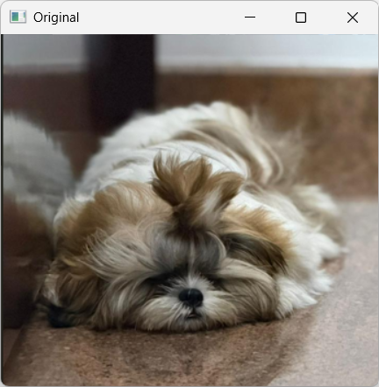
OUTPUT:-
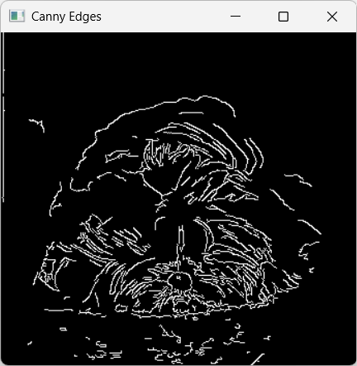
RESULT:-
Thus the program is executed successfully.
17. Perform Edge detection using Sobel Matrix along X axis
AIM:- Edge detection using Sobel Matrix along X axis
PROGRAM:-
import cv2
img = cv2.imread(r"C:\PROGRAM\Open CV\Zara_009.png", 0)
sobel_x = cv2.Sobel(img, cv2.CV_8U, 1, 0, ksize=5)
cv2.imshow("Original", img)
cv2.imshow("Sobel X", sobel_x)
cv2.imwrite("sobel_x.jpg", sobel_x)
cv2.waitKey(0)
cv2.destroyAllWindows()
INPUT:-
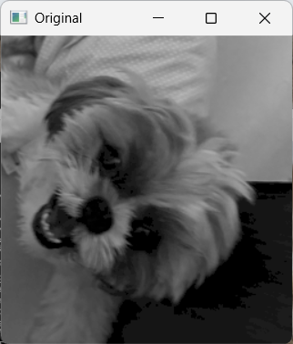
OUTPUT:-
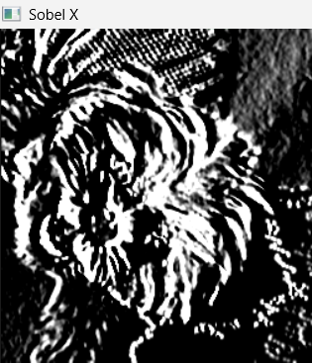
RESULT:-
Thus the program is executed successfully.
18. Perform Edge detection using Sobel Matrix along Y axis
AIM:- Edge detection using Sobel Matrix along Y axis
PROGRAM:-
import cv2
img = cv2.imread(r"C:\PROGRAM\Open CV\Zara_009.png", 0)
sobel_y = cv2.Sobel(img, cv2.CV_8U, 0, 1, ksize=5)
cv2.imshow("Original", img)
cv2.imshow("Sobel Y", sobel_y)
cv2.imwrite("sobel_y.jpg", sobel_y)
cv2.waitKey(0)
cv2.destroyAllWindows()
INPUT:-
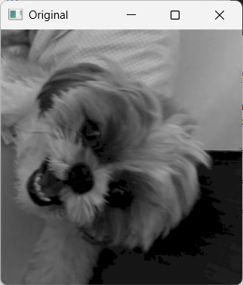
OUTPUT:-
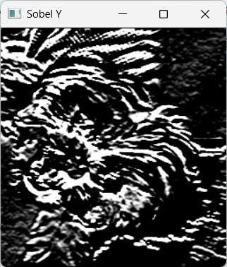
RESULT:-
Thus the program is executed successfully.
19. Perform Edge detection using Sobel Matrix along XY axis
AIM:- Edge detection using Sobel Matrix along XY axis
PROGRAM:-
import cv2
img = cv2.imread(r"C:\PROGRAM\Open CV\Zara_009.png", 0)
sobelx = cv2.Sobel(img, cv2.CV_64F, 1, 0, ksize=3)
sobely = cv2.Sobel(img, cv2.CV_64F, 0, 1, ksize=3)
edges = cv2.addWeighted(sobelx, 0.5, sobely, 0.5, 0)
cv2.imshow("Original", img)
cv2.imshow("Sobel XY", edges)
cv2.imwrite("Edge_detection.jpg", edges)
cv2.waitKey(0)
cv2.destroyAllWindows()
INPUT:-
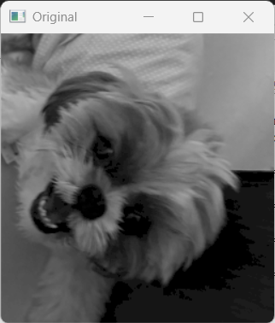
OUTPUT:-
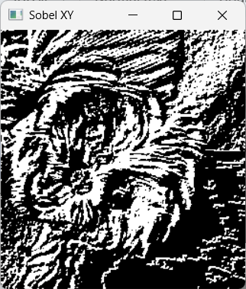
RESULT:-
Thus the program is executed successfully.
20. Perform Sharpening of Image using Laplacian mask with negative center coefficient.
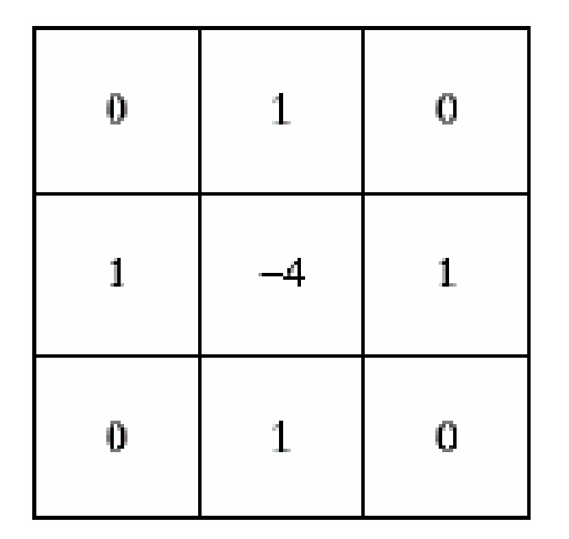
AIM:- Sharpening of Image using Laplacian mask with negative center coefficient.
PROGRAM:-
import cv2
import numpy as np
img = cv2.imread(r"C:\PROGRAM\Open CV\Zara_010.png")
kernel = np.array([[0,1,0],
[1,-4,1],
[0,1,0]])
sharp = cv2.filter2D(img, -1, kernel)
cv2.imshow("Original", img)
cv2.imshow("Sharpened", sharp)
cv2.imwrite("Sharpened_Image.jpg", sharp)
cv2.waitKey(0)
cv2.destroyAllWindows()
INPUT:-
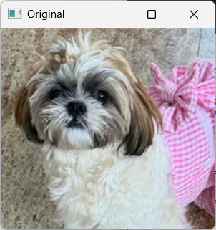
OUTPUT:-
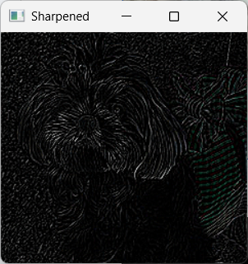
RESULT:-
Thus the program is executed successfully.
21. Perform Sharpening of Image using Laplacian mask implemented with an extension of diagonal neighbors.
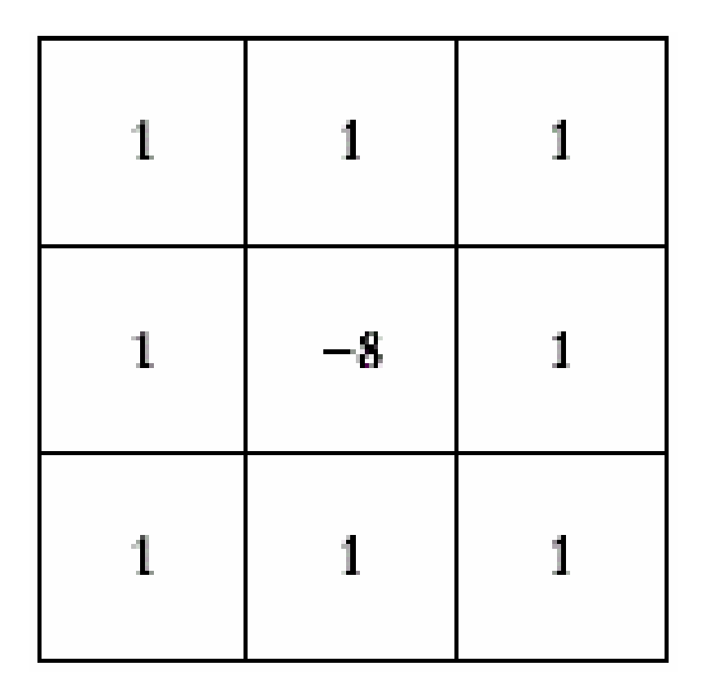
AIM:- Perform Sharpening of Image using Laplacian mask implemented with an extension of diagonal neighbors.
PROGRAM:-
import cv2
import numpy as np
img = cv2.imread(r"C:\PROGRAM\Open CV\Zara_010.png")
kernel = np.array([[1,1,1],
[1,-8,1],
[1,1,1]])
sharp = cv2.filter2D(img, -1, kernel)
cv2.imshow("Sharpened", sharp)
cv2.imwrite("Sharpened_Image.jpg", sharp)
cv2.waitKey(0)
cv2.destroyAllWindows()
INPUT:-

OUTPUT:-
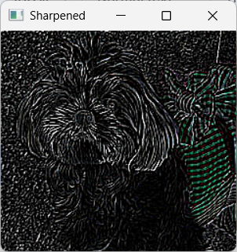
RESULT:-
Thus the program is executed successfully.
22. Perform Sharpening of Image using Laplacian mask with positive center coefficient.
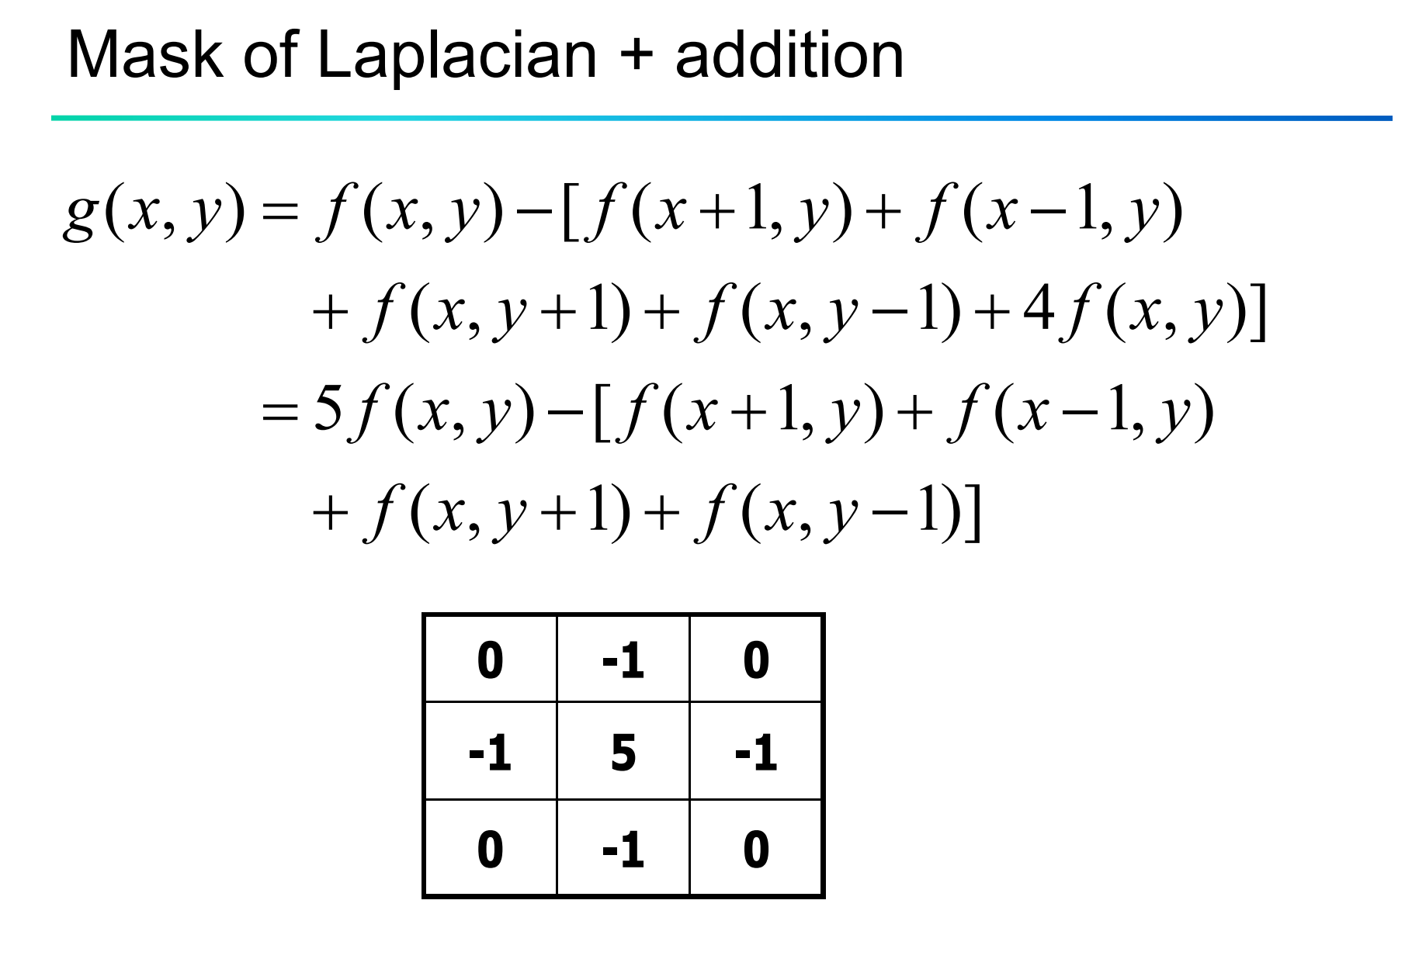
AIM:- Sharpening of Image using Laplacian mask with positive center coefficient.
PROGRAM:-
import cv2
import numpy as np
img = cv2.imread(r"C:\PROGRAM\Open CV\Zara_010.png")
kernel = np.array([[0,1,0],
[1,-8,1],
[0,1,0]])
sharp = cv2.filter2D(img, -1, kernel)
cv2.imshow("Original", img)
cv2.imshow("Sharpened", sharp)
cv2.waitKey(0)
cv2.destroyAllWindows()
INPUT:-
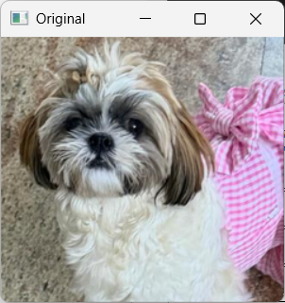
OUTPUT:-
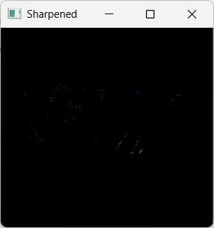
RESULT:-Thus the program is executed successfully.
23. Perform Sharpening of Image using unsharp masking.
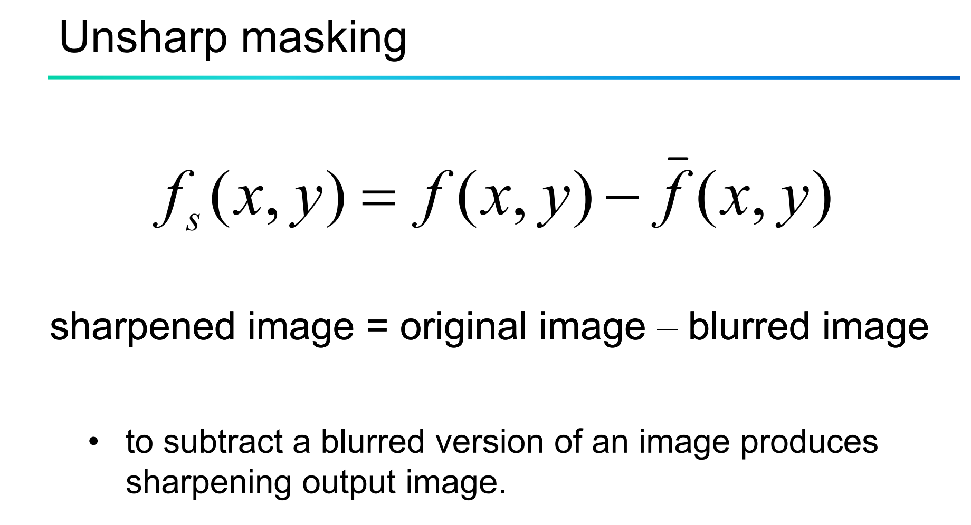
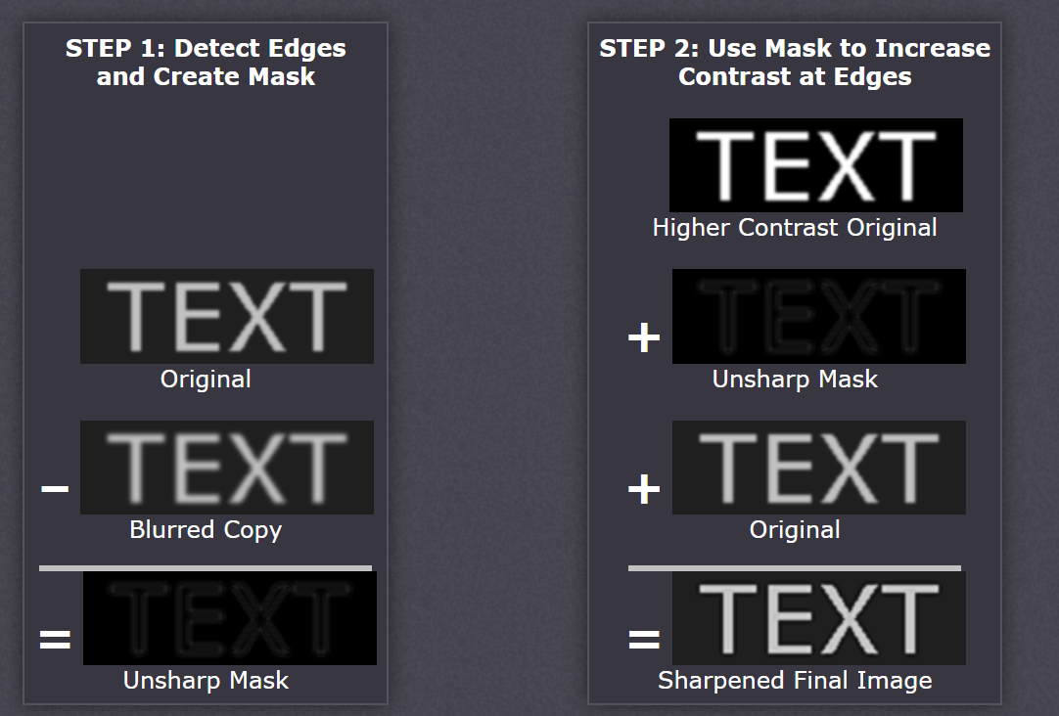
AIM:- Sharpening of Image using unsharp masking.
PROGRAM:-
from PIL import Image, ImageFilter
img = Image.open(r"C:\PROGRAM\Open CV\Zara_011.jpg")
sharp = img.filter(
ImageFilter.UnsharpMask(
radius=3,
percent=200,
threshold=5))
sharp.show()
INPUT:-

OUTPUT:-
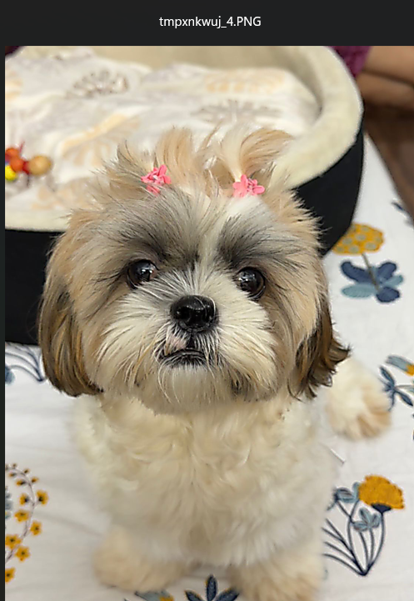
RESULT:-
Thus the program is executed successfully.

24. Perform Sharpening of Image using High-Boost Masks.
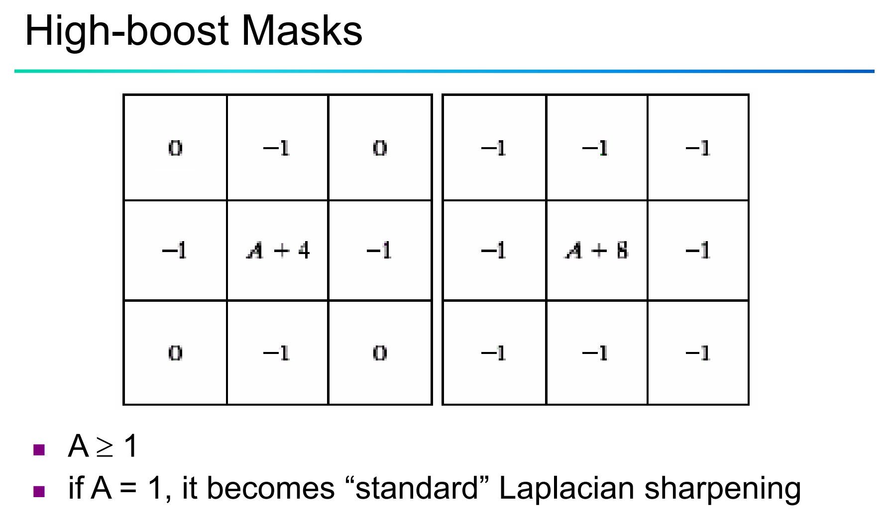
AIM:- Sharpening of Image using High-Boost Masks.
PROGRAM:-
import cv2
import numpy as np
img = cv2.imread(r"C:\PROGRAM\Open CV\zara_012.png")
kernel = np.ones((3, 3), np.float32) / 9blur = cv2.filter2D(img, -1, kernel)
boost = 1.5
mask = img.astype(np.float32) - blur.astype(np.float32)
sharp = img.astype(np.float32) + boost * mask
sharp = np.clip(sharp, 0, 255).astype(np.uint8)
cv2.imshow("Original", img)
cv2.imshow("Blur", blur)
cv2.imshow("High Boost", sharp)
cv2.imwrite("sharpened_image.jpg", sharp)
cv2.waitKey(0)
cv2.destroyAllWindows()
INPUT:-

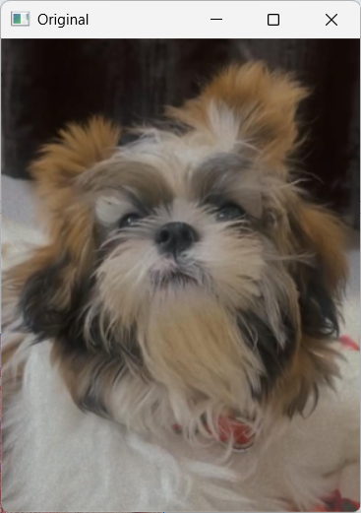
OUTPUT:-
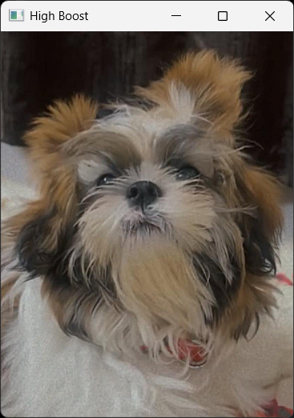
RESULT:-
Thus the program is executed successfully.
25. Perform Sharpening of Image using Gradient masking.
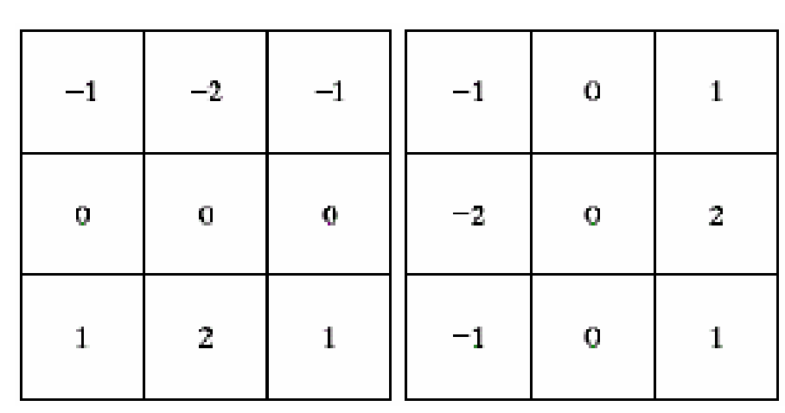
AIM:- Sharpening of Image using Gradient masking
PROGRAM:-
import cv2
img = cv2.imread(r"C:\PROGRAM\Open CV\zara_012.png")
gray = cv2.cvtColor(img, cv2.COLOR_BGR2GRAY)
gx = cv2.Sobel(gray, cv2.CV_64F, 1, 0, ksize=3)
gy = cv2.Sobel(gray, cv2.CV_64F, 0, 1, ksize=3)
gradient = cv2.subtract(gx, gy)
cv2.imshow("Original", img)
cv2.imshow("Gradient Mask", gradient)
cv2.imwrite("sharpened_image3.jpg", gradient)
cv2.waitKey(0)
cv2.destroyAllWindows()
INPUT:-
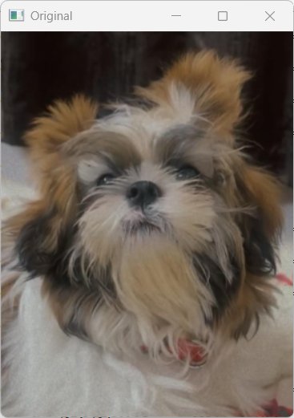
OUTPUT:-
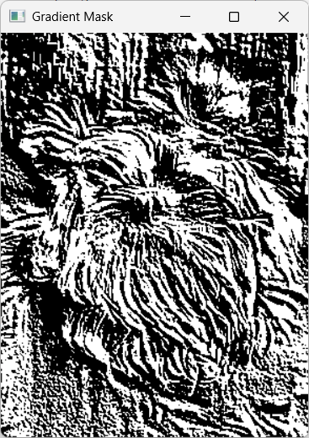
RESULT:-
Thus the program is executed successfully.

