Computer Vision with Open CV LAB Experiments
1. Perform basic Image Handling and processing operations on the image.
a. Read an image in python and Convert the given Image into Grayscale
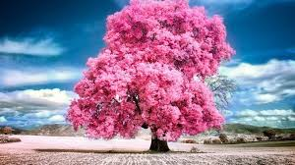
1. A

import cv2
import numpy as np
img = cv2.imread(r"path")
gray = cv2.cvtColor(img, cv2.COLOR_BGR2GRAY)

cv2.imshow("Gray", gray)
cv2.waitKey(0)
cv2.destroyAllWindows()
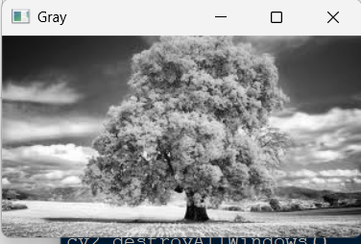

b. Read an image in python and Convert an Image to Blur using GaussianBlur.
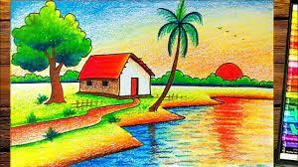
import cv2

img = cv2.imread(r"path")
blur = cv2.GaussianBlur(img, (7,7), 0)

cv2.imshow("Blur", blur)
cv2.waitKey(0)
cv2.destroyAllWindows()
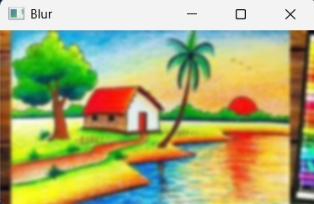
c. Read an image in python and Convert the given Image to show outline using Canny function.
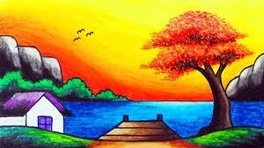
1.C

import cv2

img = cv2.imread(r"path",0)
edges = cv2.Canny(img,50,100)

cv2.imshow("Canny", edges)
cv2.waitKey(0)
cv2.destroyAllWindows()
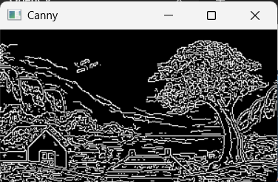
d. Read an image in python and Dilate an Image using Dilate function.
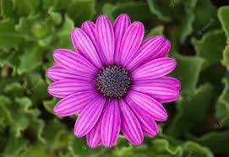
1.D

import cv2
import numpy as np

img = cv2.imread(r"path",0)
kernel = np.ones((5,5),np.uint8)
dilate = cv2.dilate(img,kernel,iterations=1)

cv2.imshow("Dilate", dilate)
cv2.waitKey(0)
cv2.destroyAllWindows()
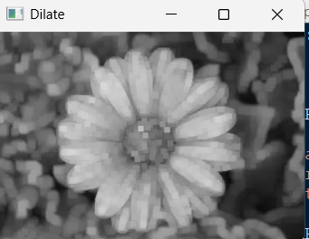
e. Read an image in python and Erode an Image using erode function.
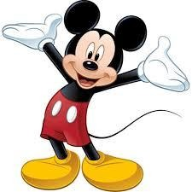
1.E
import cv2
import numpy as np

img = cv2.imread(r"path", 0)

kernel = np.ones((5,5), np.uint8)

erode = cv2.erode(img, kernel, iterations=1)

cv2.imshow("Erode", erode)
cv2.waitKey(0)
cv2.destroyAllWindows()
